Ben Postlethwaite
76676063

Physics 410
Propane Torch on Silver Sheet Simulation

This report documents the modeling of a hole being burned into a silver sheet by a propane torch. Many assumptions have gone into this simulation, which are listed below. The final time for the melting of a 1mm radius hole is: 0.059 seconds, while a 3mm hole is 0.1512

Assumptions:

- Thermal Diffusivity K is 165.8 mm²s⁻¹ as an average from multiple online sources documenting material properties.
- To model the 2mm sheet the heat capacity was doubled, this effectively reduces the Thermal Diffusivity by half. K = k/2
  - The built in assumption of this method is that in the z direction Thermal Diffusivity is infinite. That is there is instant communication between the layers. Error will arise but it will be small enough to give a reasonable approximation. Ie. Heat transfer between 1mm is very fast.
- Latent Heat of Melting is factored in: 88KJ/Kg * Mass of one unit ~ 1 J/mm³ , again, since we are melting a 2mm thick sheet, we look for time at which 2J/mm³ is reached.
  - The Latent Heat only accumulates when the temperature of silver is reached and has been capped at it’s melting Temp 1235K.
- The edge of the circular sheet at radius of 30mm away is held in a copper holder maintained at 293 K.
- The energy from the propane torch is conic in amplitude. That is the centre receives A Watts, the next 1mm ring gets 80% *A, 3rd ring has 60% *A while the final ring has 40% of the energy in the centre. The sum of the contributions multiplied by the respective area adds up to 5000W.
  - This works out to Forcing of S0 = 403 S1 = 322.7 S2 = 242 S4 = 161.3 where the forcing is in Kelvin. This is the most important determinant in this simulation. Focused energy at the centre results in a quick melt within a small region, while a constant Forcing across 4mm is much less pronounced. (See figures below)

Tests

The numerical simulation was done with both Explicit and Implicit methods. The differences between the two are so minimal that they mostly track identically across time and space. Two tests were completed to make sure conservation of energy was intact. First, I held the silver sheet at constant temperature with no forcing, and let the simulation run for as long as I could stand. The silver sheet remained at the constant temperature. (This figure is not plotted as it is 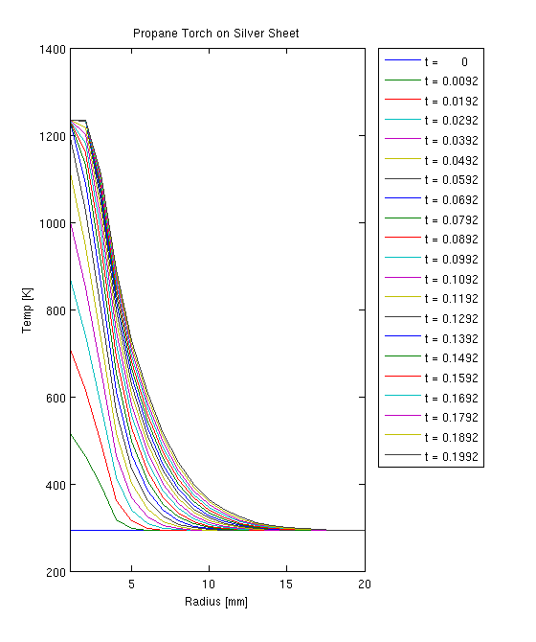incredibly boring.) More rigorously I ran another simulation with an temperature “bump” and let it diffuse over time, with both boundaries held in Neumann states (Figure 1).
The sheet begins at 293K accept for a 5mm section where it is stepwise starting at 300, 310, 320, 310 & 300 K. The final steady state temperature should be 295.5K

Eqn:

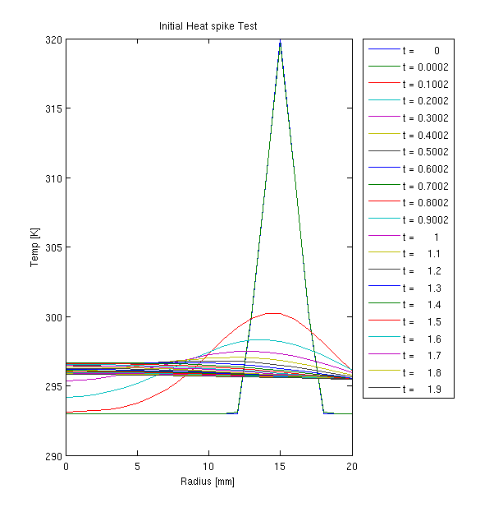

At each time interval the mean Temp on the disk was calculated and the relative error from 295K was calculated. We see that there is an initial increase in error (though low, 10-3) then a steady drop toward 295K. The increase in energy is likely due to the fact the we have discretized the sheet into rings, the inner radius of each band is smaller than the outer. Thus at steep temperature discontinuities, and areas of rapid change we have a geometrical truncation error. As the temperature diffuses, these errors linearly decrease. Energy is conserved in the model though there are issues with precision at sharp boundaries.

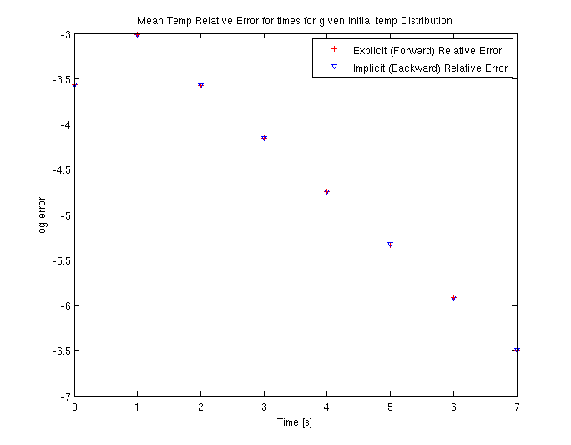

The next set of figures are for the primary simulation, calculated and plotted results are for the backward difference (implicit) method.

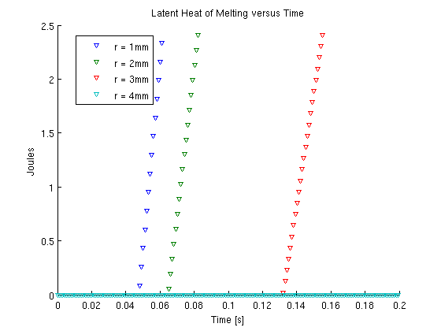

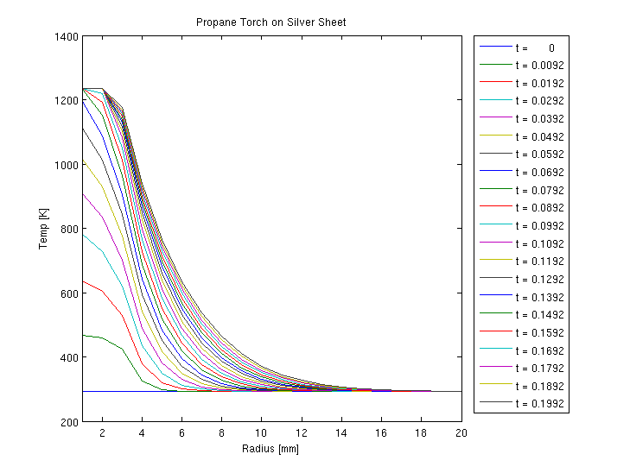

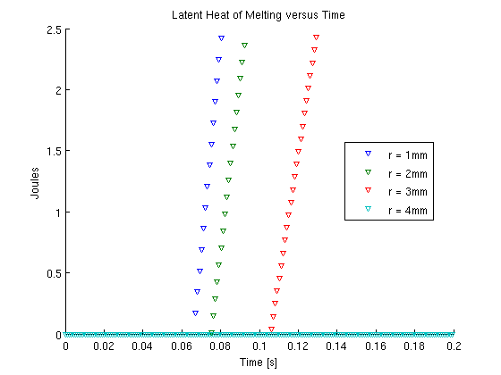

Results:

Time [s] | 1 mm hole | 2 mm hole | 3 mm hole | 4 mm hole
Conic Torch | 0.0592s | 0.0792s | 0.1512 | not reached
FlatHead Torch | 0.0782 | 0.0902 | 0.1236 | not reached

