



**REGISTRATION**

**GUIDE BOOK**

**BioMIC 2019**

**Prepared by:**

**B P P U G M**



**CONTENTS**

**PRESENTER TUTORIALS**

**ACCOUNT REGISTRATION** 3

**PAPER SUBMISSION** 6

**PAYMENT CONFIRMATION** 11

**CAMERA READY** 12

**NON-PRESENTER TUTORIALS**

**FOREIGN ATTENDANT** 13

**LOCAL ATTENDANT** 14

# **ACCOUNT REGISTRATION**

This tutorial will guide you through the registration of your [EDAS](https://www.edas.info/N24559) account. If you already have an EDAS account, please [log in](https://edas.info/N26009) to submit your paper using your registered account.

1. **Go to the BioMIC UGM 2019** [**EDAS**](https://www.edas.info/N24559) **site**

Click the [[ register ]](http://biomic.ugm.ac.id/2019/article/submissions.html) button on the BioMIC website.



Then, click the [[ submit paper ]](https://edas.info/N26009) button under the EDAS card, which will redirect you to the BioMIC UGM 2019 EDAS website.

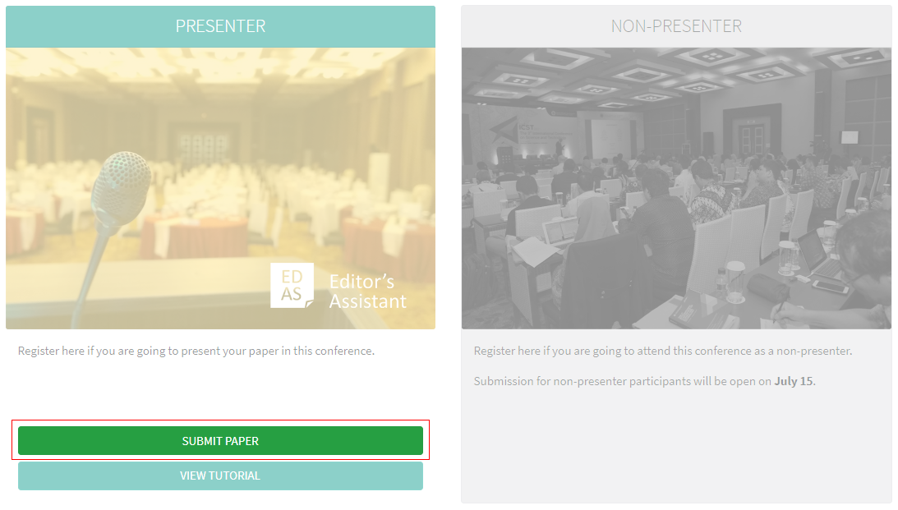

1. **Create a new account**

Below the login form, click [ create a new account ]

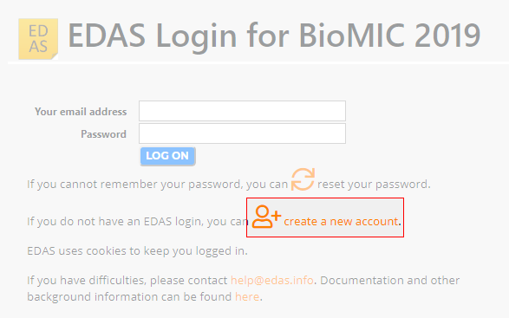

1. **Entry your details**

 Type your information in the required fields (marked with a red asterisk), you can complete other information after the registration.

At the end of the form, tick the box “I consent to the EDAS privacy and policies”, and click [ add this person ] to create your account.

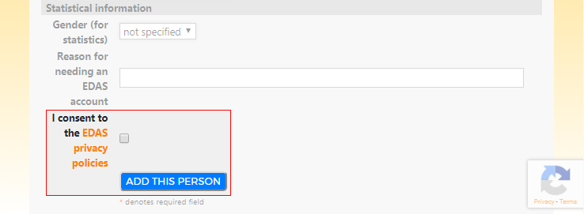

Your account has been created. Your username and ID number will be sent to your email**.**

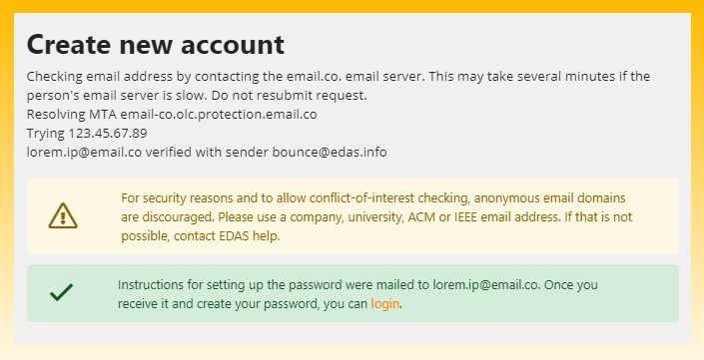

1. **Set up your password**

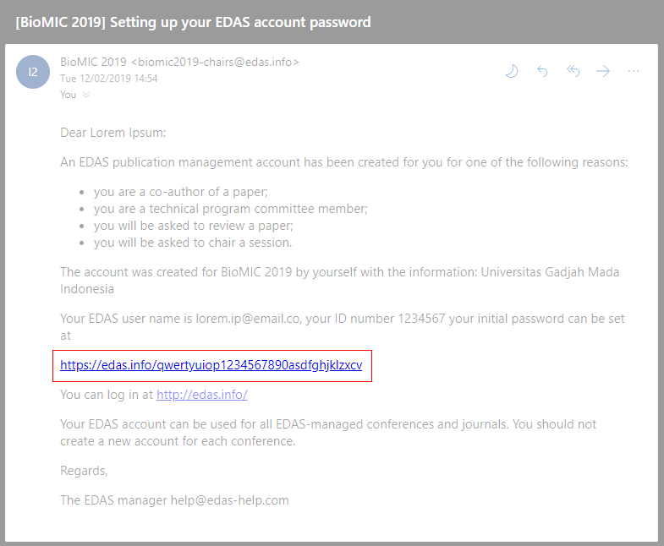Set up your initial password by clicking the link on your email. You could find the email in your inbox or spam mail.

Your initial password has been created.

If you still require further assistance, please feel free to [contact us.](mailto:biomic@ugm.ac.id)

# **PAPER SUBMISSION**

In order to maximize our services, you need to complete the following details before submitting your paper:

[**The registered EDAS account**](https://edas.info/N26009)  of all authors in your paper.

Paper format and content in accordance with the [**author guidelines**](http://biomic.ugm.ac.id/2019/article/author-guidelines.html) .

.



This tutorial will guide you through the submission of your paper.

1. **Login to the BioMIC UGM 2019 EDAS site**

Click the [[ register ]](http://biomic.ugm.ac.id/2019/article/submissions.html) button on the BioMIC website.



Then, click the [[ submit paper ]](https://edas.info/N26009) button under the EDAS card, which will redirect you to the BioMIC UGM 2019 EDAS website.



Log in to your EDAS account.

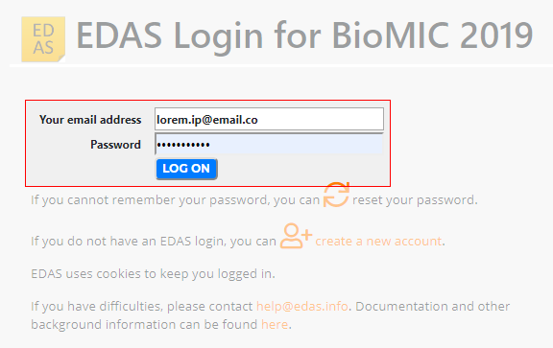

1. **Entry your paper details**

Once you are logged in, click the [ symposium name ]—under the Track column—that matches on your paper to be registered.

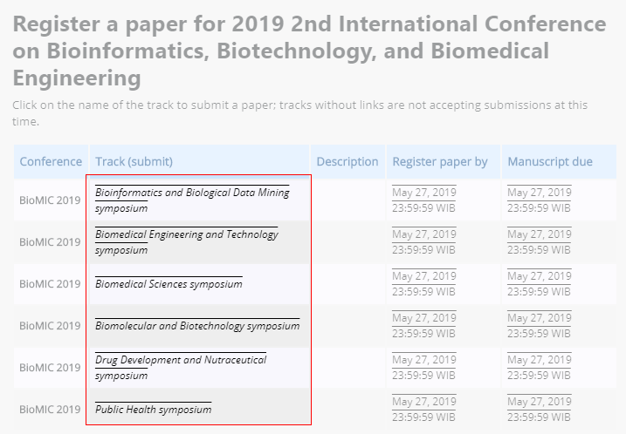

**Enter your paper details**, tick the box “Add yourself as author”, and click [ submit ] button to submit your paper.

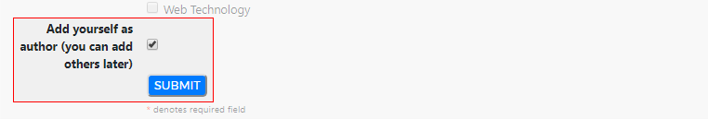

Your paper has been successfully submitted. You will now be able to view your paper in your EDAS account.

1. **Add your paper's author(s)**

Click [ add authors ] to add your co-authors (if available).

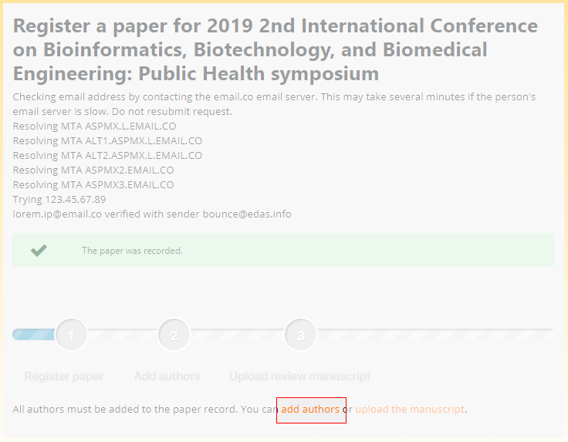

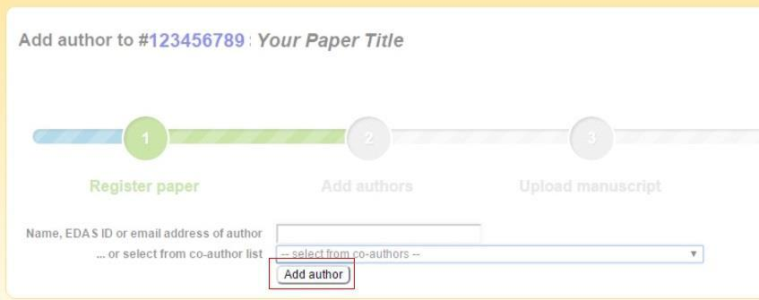**Write your co-author’s name, EDAS ID, or email.** Alternatively, you can simply select your co-author’s name from the co-author list. Then, click [ add author ] button.

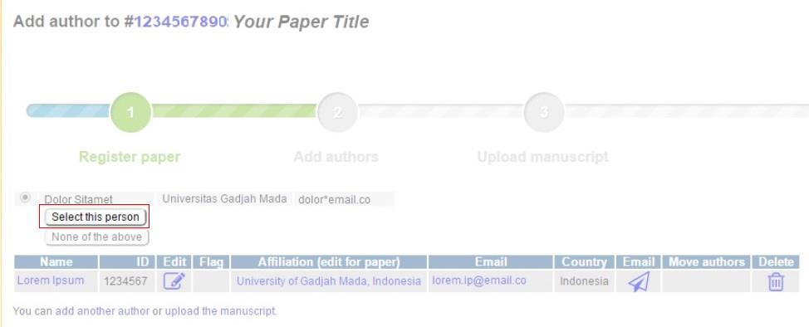Select the radio button before your co-author’s name and click [select this person] button to confirm it.

1. **Upload your paper’s document**

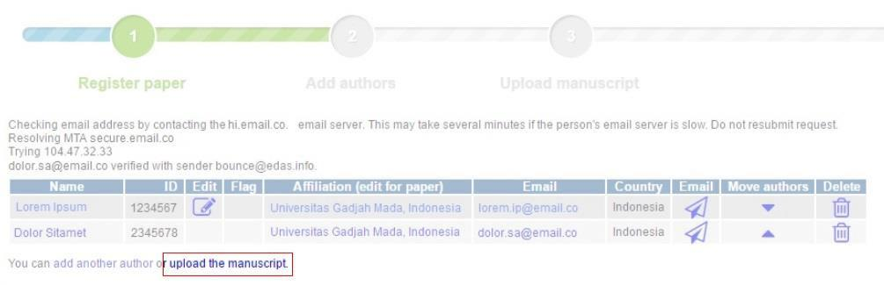 After adding your co-author, click [ upload the manuscript ] to upload your paper document.

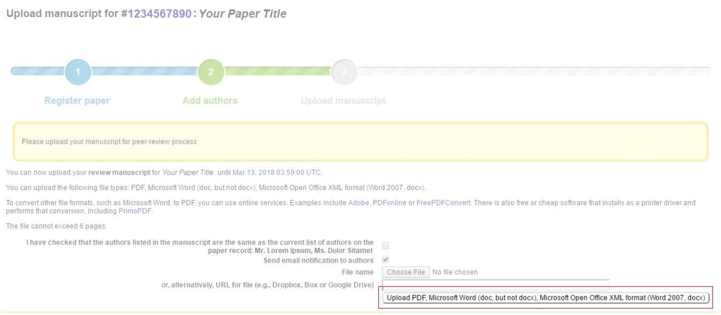Tick the box “I have checked that the authors listed in the manuscript are the same as the current list of authors on the paper record”, choose your paper document, and click [upload ...] button.

Please ensure your file is in DOC, DOCX, or PDF format

Your paper has been uploaded.

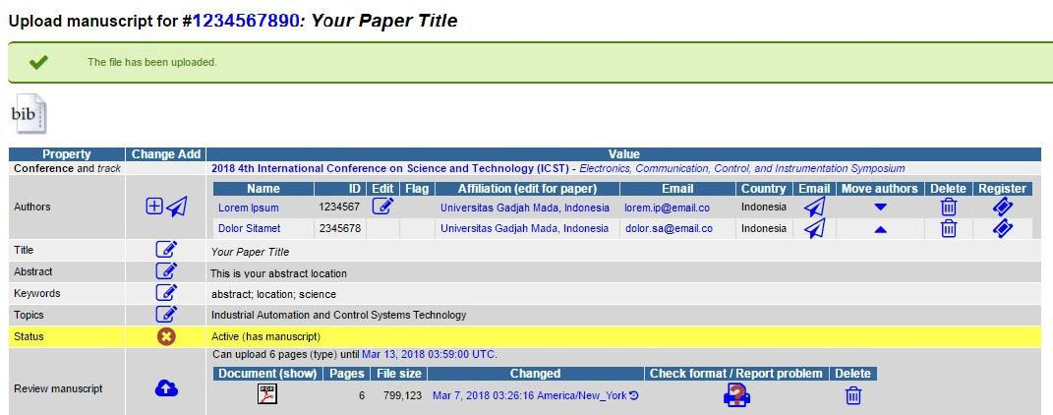

If you still require further assistance, please feel free to [contact us.](mailto:biomic@ugm.ac.id)

# **PAYMENT CONFIRMATION**



We will announce it after the paper submission deadline has passed.

# **CAMERA READY**



We will announce it after the paper submission deadline has passed

# **FOREIGN ATTENDANT**



We will announce it after the paper submission deadline has passed.

# **LOCAL ATTENDANT**



We will announce it after the paper submission deadline has passed.



BADAN PENERBIT DAN PUBLIKASI

UNIVERSITAS GADJAH MADA

UGM Main Office Building, 3rd Floor, Room B3-02

Bulaksumur, Yogyakarta, Indonesia 55281

(+62) 274-6491-963



biomic@ugm.ac.id



biomic.ugm.ac.id



@biomicugm



flic.kr/biomic