



**REGISTRATION**

**GUIDEBOOK**

**ICST 2019**

**Prepared by:**

**B P P U G M**



**CONTENTS**

**PRESENTER TUTORIALS**

**Editor’s Assistant (EDAS)**

ACCOUNT REGISTRATION 1

PAPER SUBMISSION 4

CAMERA-READY 9

**Scientific.Net**

ACCOUNT REGISTRATION 11

FULL PAPER SUBMISSION 17

CAMERA-READY 21

EDAS: ACCOUNT REGISTRATION

This tutorial will guide you through the registration of your [EDAS](https://www.edas.info/N24559) account. If you already have an EDAS account, please [log in](https://www.edas.info/N24559) to submit your paper using your registered account.

1. **Go to the ICST UGM 2019** [**EDAS**](https://www.edas.info/N24559) **site.**

Click the [[ register ]](http://icst.ugm.ac.id/2018/article/submissions.html) button on the ICST website.



Then, click the [[ submit paper ]](https://www.edas.info/N25894) button under the EDAS card, which will redirect you to the ICST UGM 2019 EDAS website.

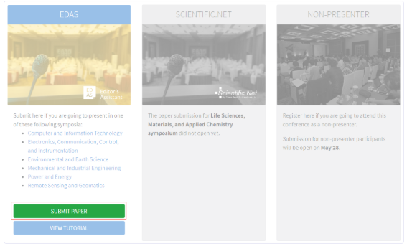

2. **Create a new account**

Below the login form, click [ create a new account ].

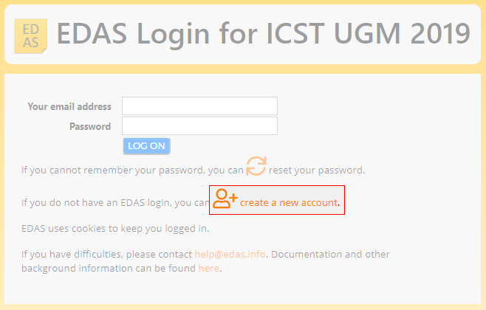

1. **Entry your details**



Type your information in the required fields (marked with a red asterisk), you can complete other information after the registration.

At the end of the form, tick the box “I consent to the EDAS privacy and policies”, and click [ Add this person ] to create your account.

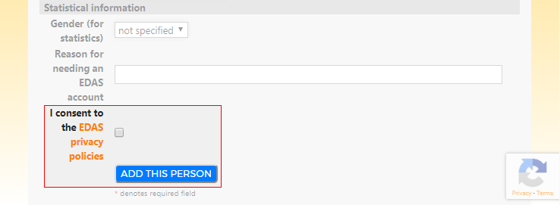

Your account has been created. Your username and ID number will be sent to your email**.**

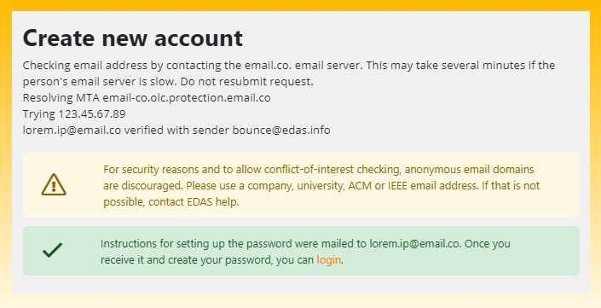

1. **Set up your password**

Set up your initial password by clicking the link on your email.

You could find the email in your inbox or spam mail.

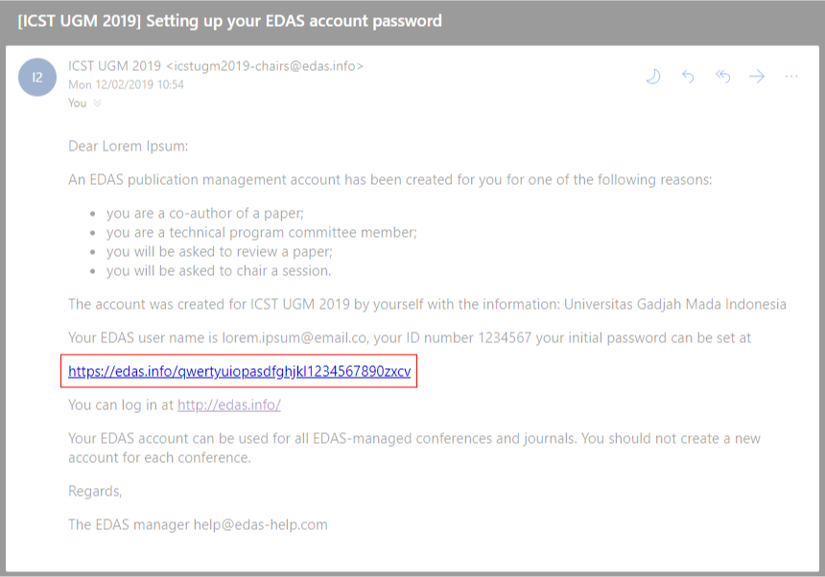

5. **Your initial password has been created**.

If you still require further assistance, please feel free to [ [contact us ].](mailto:icst@ugm.ac.id)

EDAS: PAPER SUBMISSION

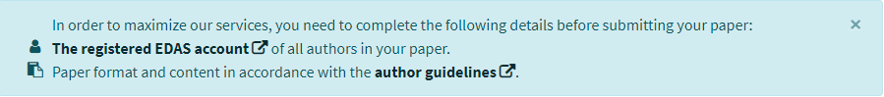.

This tutorial will guide you through the submission of your paper.

1. **Login to the ICST UGM 2019 [** [**EDAS ]**](https://www.edas.info/N25894) **site.**

Click the [[ register ]](http://icst.ugm.ac.id/2018/article/submissions.html) button on the ICST website.



Then, click the [[ submit paper ]](https://www.edas.info/N24559) button under the EDAS card, which will redirect you to the ICST UGM 2019 EDAS website.



Log in to your [ [EDAS ]](https://www.edas.info/N24559)  account.

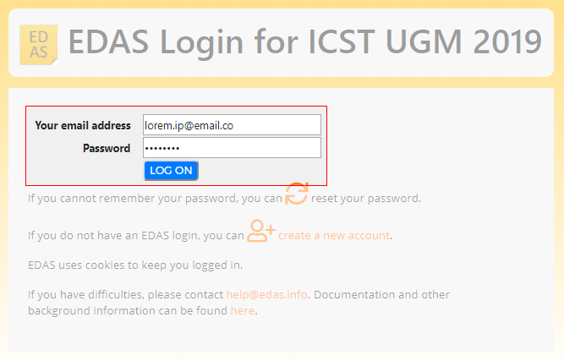



1. **Entry your paper details**

Once you are logged in, click the [ symposium name ]—under the Track column—that matches on your paper to be registered.

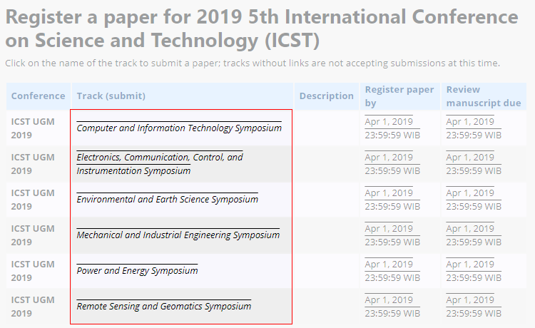

**Enter your paper details**, tick the box “Add yourself as author”, and click [ submit ] button to submit your paper.

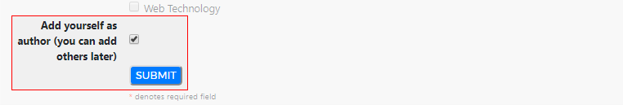

Your paper has been successfully submitted. You will now be able to view your paper in your EDAS account.

1. **Add your paper’s author(s)**

Click [ add authors ] to add your co-authors (if available).

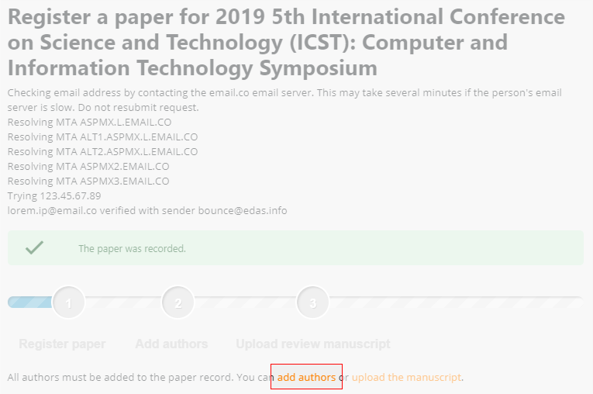

**Write your co-author’s name, EDAS ID, or email.** Alternatively, you can simply select your co-author’s name from the co-author list. Then, click [ add author ] button.

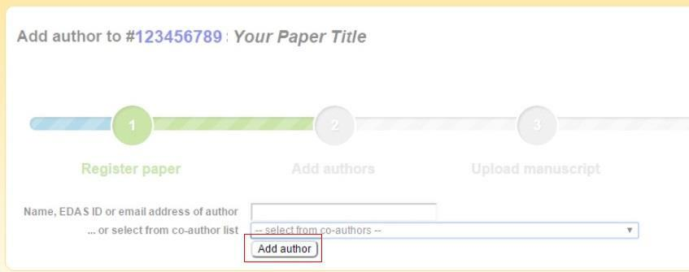

Select the radio button before your co-author’s name and click [ select this person ] button to confirm it.

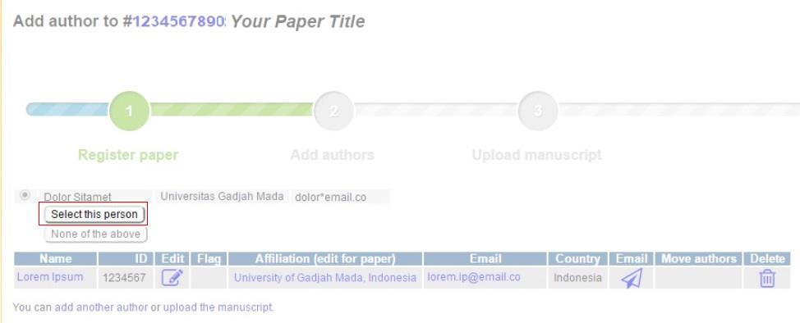

1. **Upload your paper’s document**

After adding your co-author, click [ upload the manuscript ] to upload your paper document.

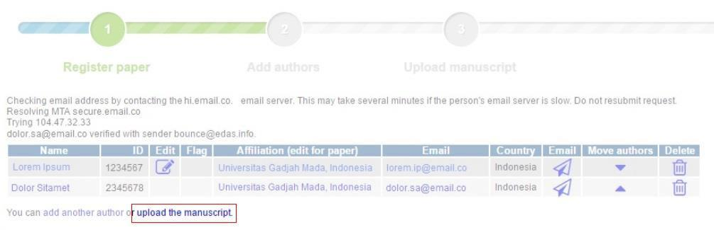

Tick the box “I have checked that the authors listed in the manuscript are the same as the current list of authors on the paper record”, upload your full paper’s file, and click [upload] button.



Please ensure your file is in DOC, DOCX, or PDF format

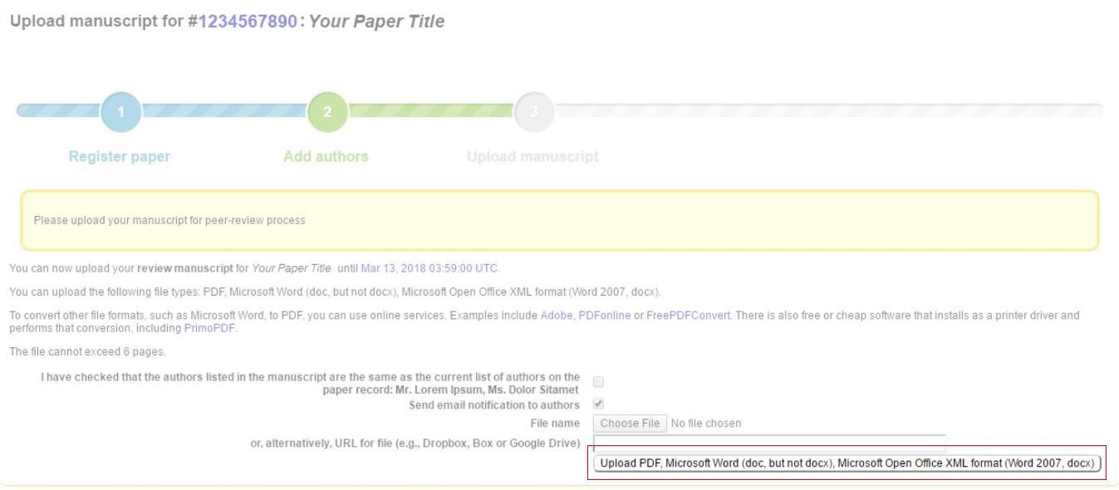

Your full paper has been uploaded.

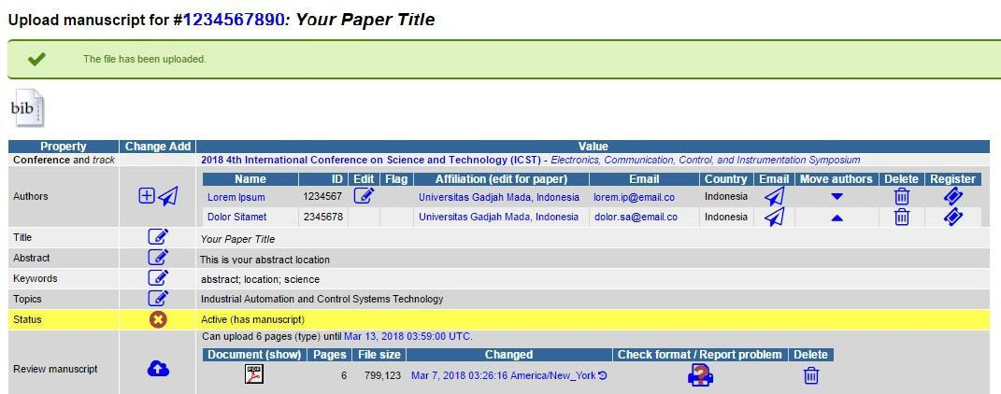

If you still require further assistance, please feel free to [[ contact us ].](mailto:icst@ugm.ac.id)

EDAS: CAMERA-READY

.

This tutorial will be available after the last notofication deadline**.**

SCIENTIFIC.NET: ACCOUNT REGISTRATION

This tutorial will guide you through the registration of your [Scientific.Net](https://www.scientific.net/) account. If you already have a Scientific.Net account, please get the invitation to submit your paper using your registered account.

1. Go to the  [Scientific.Net’s](https://www.scientific.net/account/login?) login site.

Click the [[ register ]](http://icst.ugm.ac.id/2018/article/submissions.html) button on the ICST website.

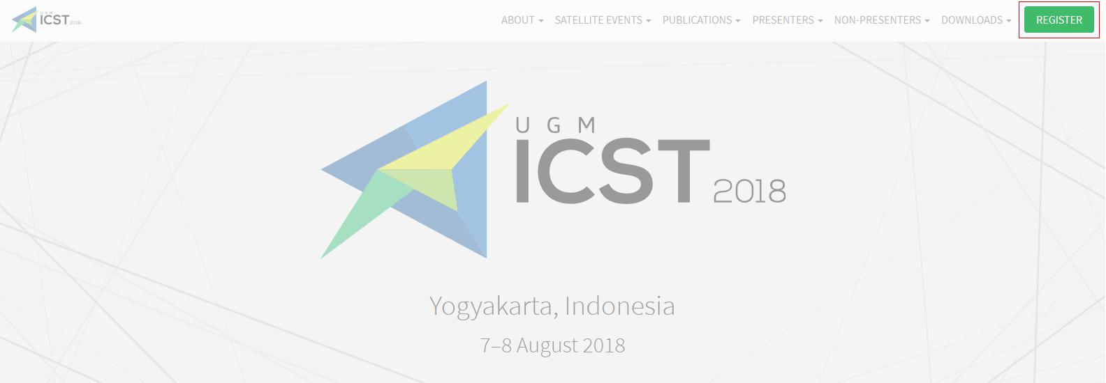

Then, click the [submit paper](https://www.scientific.net/account/login?) button under the Scientific.Net card, which will redirect you to the Scientific.Net website.

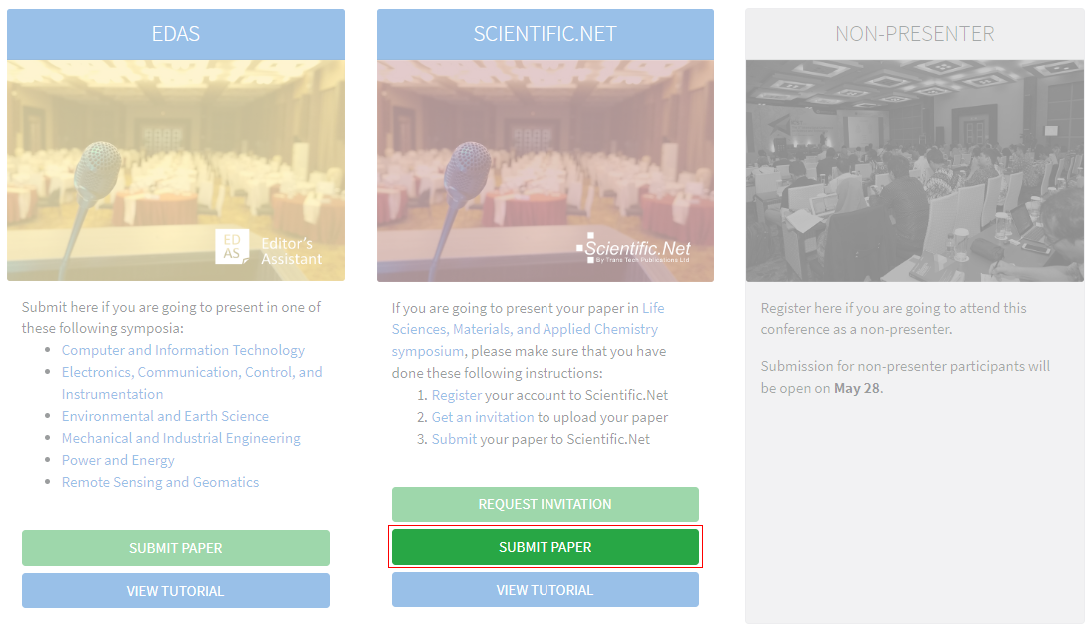

2. **Create a new account**

Below the login form, click [ register now ].

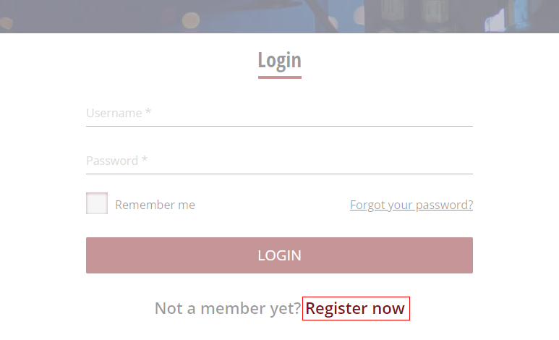

1. **Entry your details**

Type your information in the required fields (marked with an asterisk). Click [ register ] button to create your account.

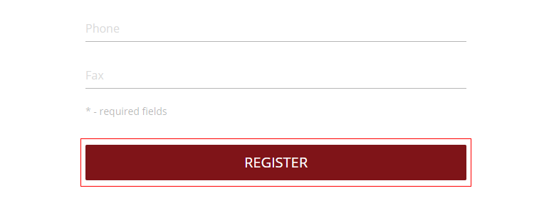

Your account has been created. Verify your account by clicking the [ link ] in your email

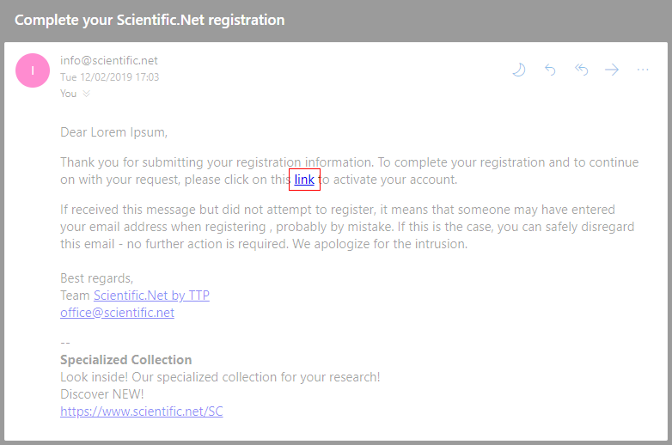

4. **Get your invitation**

Get your invitation by clicking the [ Request invitation ] button under the Scientific.Net card in the Submission page.

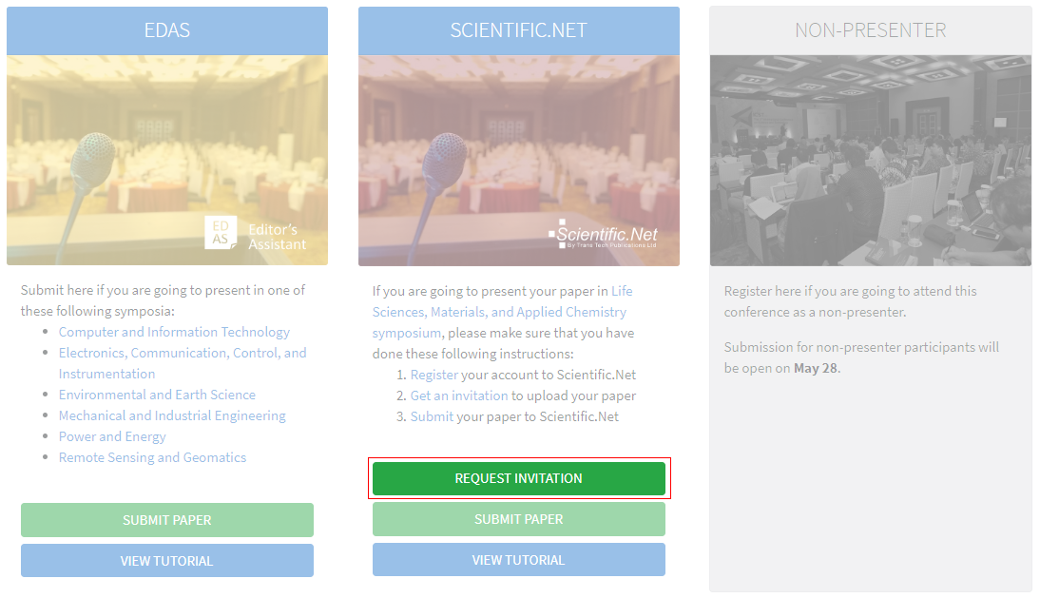

Type your Scientific.Net registered account details and click [ Submit ] button.

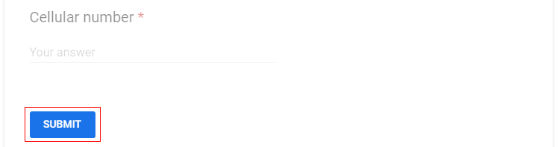

Your request has been sent. We will notify your invitation by email.

If you still require further assistance, please feel free to contact us.

SCIENTIFIC.NET: PAPER SUBMISSION TUTORIAL

This tutorial will guide you through the submission of your paper.

In order to make it easier and more efficient, you need to complete the following details before submitting your paper:

**The registered Scientific.Net account** of all authors in your paper.

Paper format and content in accordance with the **author guidelines** .

1. **Log in to the Scientific.Net site**

Click the [ Register ] button on the ICST website.

E:\Kerja\BPP UGM\Guidebook\register.png

Then, click the [ Submit paper ] button under the Scientific.Net card, which will redirect you to the Scientific.Net website.



Log in to your Scientific.Net account.

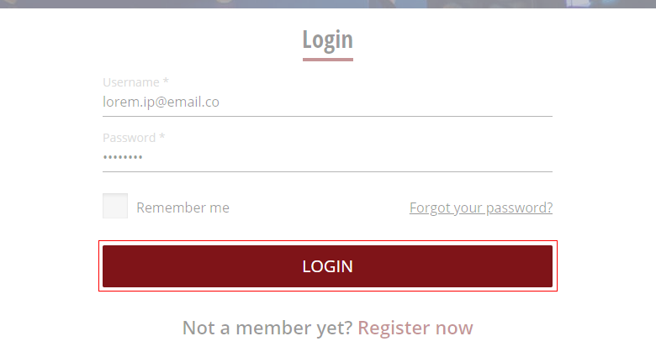

1. **Read Trans Tech Publications Ltd.' Policy and Ethics**

Once you are logged in , click [ Author ] on the top menu.

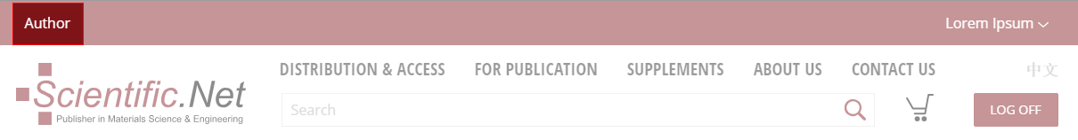

Click [ Policies and Ethics ] under the Author home tab to view the Trans Tech Publications Ltd.' Policy and Ethics .

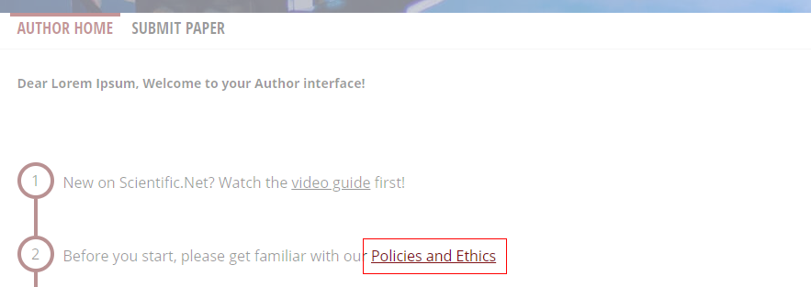

Please read it carefully before starting to upload your paper.

1. **Go to symposium's tab**

On the Author home tab, click [ Upload page ] to begin the paper submission.

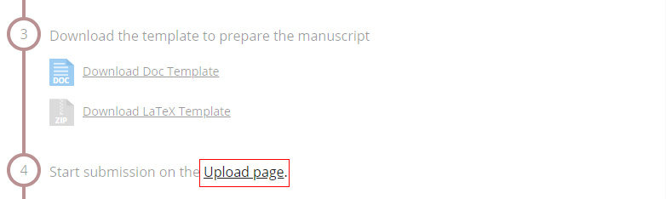

Select radio button on "Symposium of Materials Sciences and Chemistry" and click Continue.

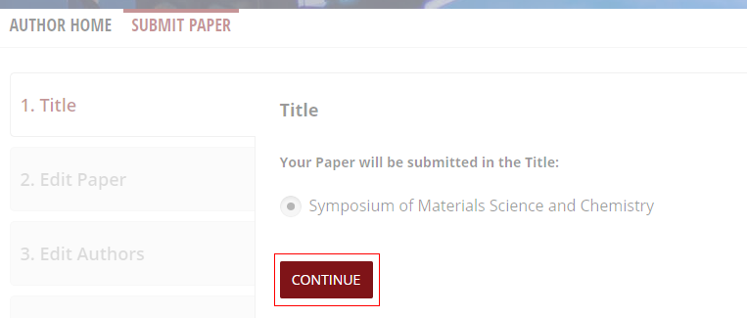

1. **Entry your paper details**

On the Edit paper tab, browse your [ DOC/DOCX/RTF/ZIP ] and [ PDF ] files.

Click [ Upload ] button to start uploading.

The uploaded files should be less than 64 Mb.

TTP: CAMERA-READY



We will announce it after the paper submission deadline has passed.



BADAN PENERBIT DAN PUBLIKASI

UNIVERSITAS GADJAH MADA

UGM Main Office Building, 3rd Floor, Room B3-02

Bulaksumur, Yogyakarta, Indonesia 55281

(+62) 274-6491-963



icst@ugm.ac.id



icst.ugm.ac.id



@icstugm



flic.kr/icst