**ENGLISH TITLE**

**Full author name [1]**

**Full author name [2]**

**Full author name [3]**

**ABSTRACT**

The text must be between 150 and 250 words, describing the summary of the work to be published. IT IS RECOMMENDED that it has to be a structured summary following relational coherence. Objectives, Theoretical Framework, Method, Results and Discussion, Research Implications, Originality/Value. With Times New Roman 10 font, single spacing. EXAMPLE.

**Objective:** The objective of this study is to investigate [insert specific research topic here], with the aim of [briefly explain the main purpose of the research].

**Theoretical Framework:** In this topic, the main concepts and theories that underpin the research are presented. [List relevant theories, models or frameworks] stand out, providing a solid basis for understanding the context of the investigation.

**Method:** The methodology adopted for this research comprises [concisely describe the study design, including approach, participants, instruments, procedures, etc.]. Data collection was carried out through [explain the specific methods used, such as interviews, questionnaires, observations, among others].

**Results and Discussion:** The results obtained revealed [synthesize the main results of the research]. In the discussion section, these results are contextualized in light of the theoretical framework, highlighting the implications and relationships identified. Possible discrepancies and limitations of the study are also considered in this section.

**Research Implications:** The practical and theoretical implications of this research are discussed, providing insights into how the results can be applied or influence practices in the field of [insert field of study]. These implications could encompass [list impacted areas or sectors].

**Originality/Value:** This study contributes to the literature by [highlighting the originality of the research, whether through the innovative approach, new discoveries or practical contributions]. The relevance and value of this research are evidenced by [explain how the results may impact the area of study or professional practice].

**Keywords:** Between 4 and 6 keywords, separated by commas. EXAMPLE: Red Palm Mite, Agroindustrial Waste, Alternative Management, Passiflora Edulis.

**TÍTULO EM PORTUGUÊS**

**RESUMO**

O texto deve ter entre 150 a 250 palavras, descrevendo o resumo do trabalho a ser publicado. RECOMENDA-SE que tem que ser um resumo estrututado seguindo a coerência relacional: Objetivos, Referencial Teórico, Método

Resultados e Discussão, Implicações da Pesquisa, Originalidade/Valor. Com a fonte Times New Roman 10, espaçamento simples. EXEMPLO.

**Objetivo:** O objetivo deste estudo é investigar [insira aqui o tema específico da pesquisa], com o intuito de [explique sucintamente o propósito principal da pesquisa].

**Referencial Teórico:** Neste tópico, são apresentados os principais conceitos e teorias que fundamentam a pesquisa. Destacam-se [liste as teorias, modelos ou frameworks relevantes], fornecendo uma base sólida para a compreensão do contexto da investigação.

**Método:** A metodologia adotada para esta pesquisa compreende [descreva de maneira concisa o desenho do estudo, incluindo abordagem, participantes, instrumentos, procedimentos etc.]. A coleta de dados foi realizada por meio de [explique os métodos específicos utilizados, como entrevistas, questionários, observações, entre outros].

**Resultados e Discussão:** Os resultados obtidos revelaram [sintetize os principais resultados da pesquisa]. Na seção de discussão, esses resultados são contextualizados à luz do referencial teórico, destacando-se as implicações e relações identificadas. Possíveis discrepâncias e limitações do estudo também são consideradas nesta seção.

**Implicações da Pesquisa:** As implicações práticas e teóricas desta pesquisa são discutidas, fornecendo insights sobre como os resultados podem ser aplicados ou influenciar práticas no campo de [insira o campo de estudo]. Essas implicações podem abranger [liste as áreas ou setores impactados].

**Originalidade/Valor:** Este estudo contribui para a literatura ao [destaque a originalidade da pesquisa, seja pela abordagem inovadora, novas descobertas ou contribuições práticas]. A relevância e o valor desta pesquisa são evidenciados por [explique como os resultados podem impactar a área de estudo ou a prática profissional].

**Palavras-chave:** Entre 4 e 6 palavras-chave, separadas por virgula. Exemplo: Ácaro Vermelho das Palmeiras, Resíduos Agroindustriais, Manejo Alternativo, *Passiflora Edulis*.

**TÍTULO EN ESPAÑOL**

**RESUMEN**

El resumen debe tener un mínimo de 150 y no máximo de 250 palabras, describiendo el resumen del trabajo a publicar. SE RECOMIENDA que sea un resumen estructurado siguiendo la coherencia relacional. Objetivos, Marco Teórico, Método Resultados y Discusión, Implicaciones de la Investigación, Originalidad/Valor. Con fuente Times New Roman 10, espaciado simple. EJEMPLO.

**Objetivo:** El objetivo de este estudio es investigar [insertar aquí un tema de investigación específico], con el objetivo de [explicar brevemente el propósito principal de la investigación].

**Marco Teórico:** En este tema se presentan los principales conceptos y teorías que sustentan la investigación. [Enumerar teorías, modelos o marcos relevantes] destacan, proporcionando una base sólida para comprender el contexto de la investigación.

**Método:** La metodología adoptada para esta investigación comprende [describir de manera concisa el diseño del estudio, incluido el enfoque, los participantes, los instrumentos, los procedimientos, etc.]. La recolección de datos se realizó mediante [explicar los métodos específicos utilizados, como entrevistas, cuestionarios, observaciones, entre otros].

**Resultados y Discusión:** Los resultados obtenidos revelaron [sintetizar los principales resultados de la investigación]. En la sección de discusión, estos resultados se contextualizan a la luz del marco teórico, destacando las implicaciones y relaciones identificadas. En este apartado también se consideran posibles discrepancias y limitaciones del estudio.

**Implicaciones de la Investigación:** Se discuten las implicaciones prácticas y teóricas de esta investigación, proporcionando información sobre cómo los resultados pueden aplicarse o influir en las prácticas en el campo de [insertar campo de estudio]. Estas implicaciones podrían abarcar [enumerar las áreas o sectores afectados].

**Originalidad/Valor:** Este estudio contribuye a la literatura al [destacar la originalidad de la investigación, ya sea a través del enfoque innovador, nuevos descubrimientos o contribuciones prácticas]. La relevancia y valor de esta investigación se evidencian en [explicar cómo los resultados pueden impactar el área de estudio o práctica profesional].

**Palabras clave:** Entre 4 y 6 palabras clave, separadas por comas. EJEMPLO: Ácaro Rojo de la Palma, Residuos Agroindustriales, Manejo Alternativo, Passiflora Edulis.

RGSA adota a Licença de Atribuição CC BY do Creative Commons (<https://creativecommons.org/licenses/by/4.0/>). 

**1 INTRODUCTION**

Describe the contextualization, research question and justification of the research, Times New Roman font 12, spacing 1,5. There are a maximum of **6 authors**, if the article has more than this, you should contact the journal to ask about the extra fee for adding another author.

Regarding the number of pages, a maximum of 17 pages, including references. Works can be written in Portuguese, English and Spanish.

At the end of the introduction, the objectives of the work must be clearly outlined, in a specific and measurable way. If you wish, you can create an exclusive subitem for the objective. Furthermore, it is essential that they are formulated in an achievable way, ensuring that the reader fully understands the scope of the study and what will be covered and evaluated.

**2 THEORETICAL FRAMEWORK**

The theoretical framework in a study comprises a critical and organized analysis of the literature relevant to the topic, providing a theoretical contextualization and defining the key concepts. It must comprehensively contain theories, models and previous research, identifying gaps, contradictions and consensuses in the literature that are important for the focus of the work being developed.

2.1 Tables

Authors must use the American Psychological Association (APA) standards for citations and references. In the case of images, every form of presentation used in the work must be named **Table** or **Figure**. **Everything that is not a table will be considered a figure**. Examples: drawing, scheme, flowchart, photograph, graph, map, organization chart, plan, picture, portrait, image, among others. And the tables “show exact numerical values, and the data are neatly arranged in rows and columns, facilitating comparison” (APA, 2001, p. 133).

The title of the table should be brief, clear and explanatory. It should be placed above the table, in the upper left corner, just below the word Table (with the initial capital letter) and accompanied by the number that designates it (tables should be numbered with Arabic numbers sequentially within the text as a whole). Example: Table 1, Table 2, Table 3, etc.

The table title font should be the same as the one used in the text, in bold type and with a spacing of 1.5 cm between the table number and the title of its identification that will appear below aligned to the left and in italics.

The citation font should be bold and simple spaced, below the left-aligned table, Times New Roman 10 font.

Indicate the source when the table is extracted from another work (**do not indicate if it is the author's own**). Please reference the consulted document.

For example:

**Table 1**

*Concentration-mortality curve, LC50 and LC90 of the aqueous extract of seeds of Passiflora edulis on Raoiella indica.*

|  |  |  |  |  |  |  |
| --- | --- | --- | --- | --- | --- | --- |
| N | Tilt (±EP) | LC50 (CI95) g/100 mL (%) | LC90 (CI95) g/100mL (%) | *X2* | Fd | p-value |
| 504 | 2.62 (0.52) | 4.72 (4.00; 5.60) | 14.53 (11.25; 20.98) | 27.99 | 4. | 0.99 |

N = number of individuals; CI = confidence interval; X2 = chi-square; Df = degree of freedom.

Source: LIMA, L.C.O. Local organic banana production arrangement. Report by

Research, Center for Research and Postgraduate Studies in Agribusiness, ICHS/DCE. Seropédica, 2006.

For example:

**Table 2**

*Concentration-mortality curve, LC50 and LC90 of the aqueous extract of seeds of Passiflora edulis on Raoiella indica.*

|  |  |  |  |  |  |  |
| --- | --- | --- | --- | --- | --- | --- |
| N | Tilt (±EP) | LC50 (CI95) g/100 mL (%) | LC90 (CI95) g/100mL (%) | *X2* | Fd | p-value |
| 507 | 7.62 (0.52) | 8.72 (4.00; 5.60) | 13.53 (11.25; 20.98) | 27.99 | 5 | 0.89 |

N = number of individuals; CI = confidence interval; X2 = chi-square; Df = degree of freedom.

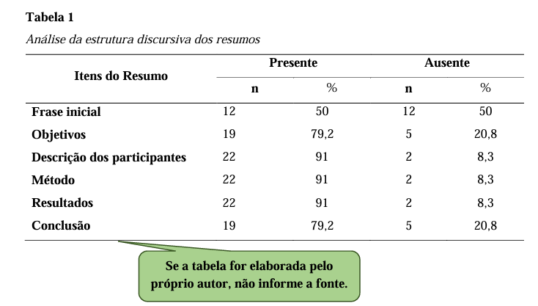

2.2 Figure Title

The title explains the figure concisely but discursively. The font in the title of the figure should be the same as that used in the text, in bold type and with a spacing of 1.5 cm between the figure number and the title of its identification, which will appear below in left-aligned italics. Numbered with Arabic numerals sequentially within the text as a whole, preceded by the word figure (with the initial capitalization). Example: Figure 1, Figure 2, Figure 3, etc.

The citation font should be bold and simple spaced, below the left-aligned figure, Times New Roman 10 font.

Indicate the source when the figure is extracted from another work (**do not indicate if it is the author's own**). Please reference the consulted document.

Any other information needed for clarification of the figure (such as unit of measurement, symbols, scales and abbreviations), which has not been included in the legend, should be

after the title.

For example figure:

**Figure 1**

*Place where the experiments were conducted.*

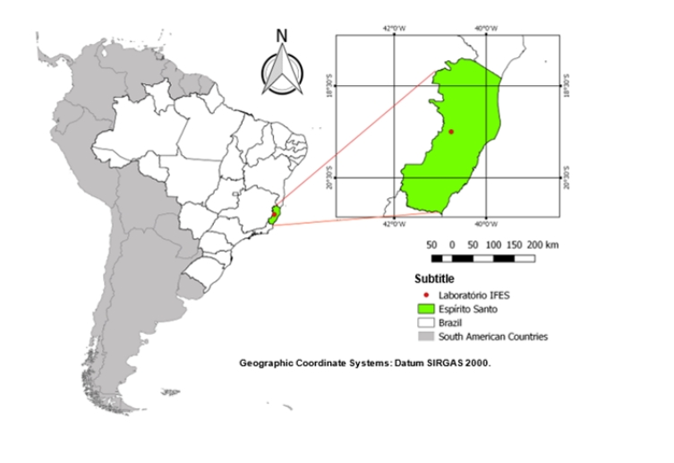

Source: Adapted from PIFFER, P. F. Maps of Brazil. Revista Mundos, v.1 n3, 2023.

**Figure 2**

*Performance of seventh-year students.*

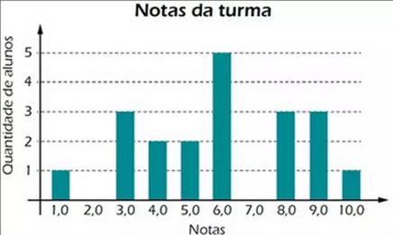

Source: Adapted from PIFFER, P. F. Maps of Brazil. Revista Mundos, v.1 n3, 2023.

**Figure 3**

*Place where the experiments were conducted.*

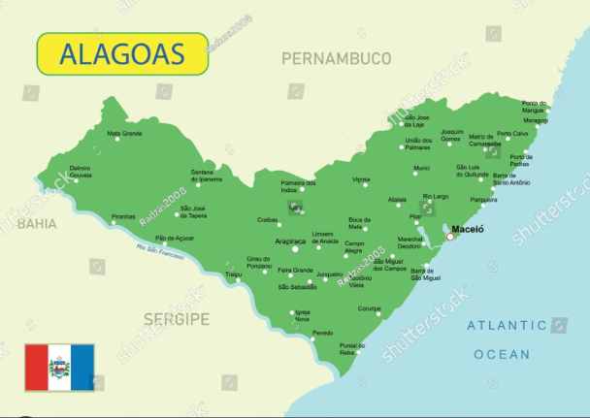

Source: Adapted from PIFFER, P. F. Maps of Brazil. Revista Mundos, v.1 n3, 2023.

Censored (intimate) figures, keep the stripes if the author says so. but if he didn't put it on his private parts, keep it as he ordered. Just take care of the patient's image.

Images taken of people must also have stripes on their faces, considering the protection of identity with respect for dignity and individual freedom.

**Figure 4**

*People walking along Avenida 15 de Novembro*

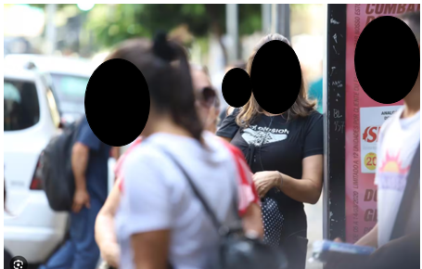

The illustration shall be quoted in the text and inserted as close as possible to the passage to which it refers.

2.3 Subtitles Section

Titles must be numbered, in capital letters, in bold, justified with Times New Roman font, size 12.

Subtitles must be numbered, in capital letters, without bold, justified with Times New Roman font, size 12.

Following example:

**Table 2**

*Title formation sequence*

|  |  |
| --- | --- |
| **Type** | **Format** |
| **Primary Section Title** | **1 INTRODUCTION** |
| **Secondary Section Title** | 1.1 Type of Search |
| **Tertiary Section Title** | **1.1.1 Definition of concepts** |
| **Title of the quaternary section** | 1.1.1.1. Concept options |
| **Title of section quinaria** | ***1.1.1.1.1 Bold and italicized*** |

**Source:** RGSA, 2024.

The citations in the body of work must follow the standards of the American Psychological Association (APA).

2.4 Direct citation in the APA Standards

The direct citation is the one that transcripts the author's text, without there being any modification. To make this kind of citation according to the APA standards, it is necessary to add the last name of the writer, and then the date of publication of the scientific article, book or internet material.

It is worth pointing out that there is a short direct quote - that is, the one with fewer than 40 words. In this case, you need to write the transcript of the text and enclose it in **quotation marks**.

**For example:**

According to Holland (2021) "digital marketing has grown 80% in the last 5 years promoting the evolution of companies".

Besides the short direct quote, there is also the long one - that is, the one with more than 40 words. In this case, you must include it in a new paragraph and format it as follows:

Indentation of 1.25 cm;

Single spacing;

Size 12;

Times New Roman font.

**For example:**

According to Holland (2021) "digital marketing has grown 80% in the last 5 years promoting the evolution of companies. As a result, sales of its products increased income from revenue and consequently promoted the expansion of jobs generation and regional development."

2.5 Indirect Citation in APA Standards

The indirect citation consists of writing down a writer's idea, but without transcribing it. In that case, you need to use your own words to present the idea of another author. To make the indirect citation, it is necessary to write the author's surname, and then the year of publication of his work.

**For example:**

According to Holland (2021), digital marketing has grown satisfactorily in the last five years, being 80%.

2.6 APA Citation

In order to quote the quote in accordance with the APA rules, it is necessary to include the name of the author of the original text, followed by the term "as quoted in", the name of the author who had access to his work, the year of publication and the page.

**For example:**

Digital marketing has grown satisfactorily in the last five years, with an increase of 80% (Bianca as quoted in Isabella, 2021, p. 59).

2.7 Quotation from Two Authors in the APA Standards

To quote two authors, it is necessary to enter the last name of the two authors, and then the year of publication. Below are two ways to write this type of quote:

**For example:**

Herculano and Holland (2021) or (Herculano & Holland, 2021)

2.8 Citation of Three or More Authors in the APA Standards

When there is a need to quote three or more authors, one must write the last name of the first author and then write the term "et al.". Finally, the year of publication should be included.

**For example:**

Herculano *et al*. (2021) or (Herculano *et al.,* 2021)

**3 METHODOLOGY**

The methodology of an article outlines the procedures employed to conduct the research, including the type of study, sample selection, data collection and analysis methods, ethical considerations, and limitations of the study. Its detailed and transparent description is essential to guarantee the replicability and reliability of the results, in addition to providing a solid basis for the interpretation and generalization of the findings.

3.1 FORMULAS AND EQUATION

In the midst of a text, formulas and equations should be represented in line. A larger spacing should be used to accommodate their elements (exponents, indices, and others). When presented outside the paragraph, they should be left-aligned. If there are multiple formulas or equations, they should be identified with sequential Arabic numerals throughout the text and enclosed in parentheses ( ) at the right end of the line. If formulas or equations are divided into multiple lines due to lack of space, they should be interrupted before the equal sign "=" or after addition and subtraction signs.

Example equation:

C:\Users\maria.bruns\AppData\Local\Microsoft\Windows\Clipboard\HistoryData\{20469AFE-B88C-4954-9384-4B92A81A6EA7}\{EE638172-755C-40CD-88EE-FF54107B5C48}\ResourceMap\{D77016F3-FDA1-4DE6-9CEA-59EA4AE35420}               (1)

where:

d(AB)= slope expressed as a percentage

dV= vertical distance (equidistance)

dH = horizontal distance

Example formulas:

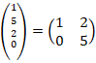                       (2)

3.2 Marker

Markers are enumerative divisions referring to a period of the paragraph. The following configuration:

a) the text preceding the first marker ends with a colon;

b) they begin at the paragraph indent and are written with normal spacing;

c) they are numbered with lowercase letters in alphabetical order, followed by a closing parenthesis. If the number of bullets exceeds the number of letters in the alphabet, use doubled letters: aa), ab), ac), etc;

d) the text of the marker begins with a lowercase letter, except if it begins with proper names, and is closed with a semicolon, except for the last one, which is closed with a period.

**As in the example below:**

a) markers are spaced at a left indentation of 0.75 by an offset of 0.5;

b) markers are spaced at a left indentation of 0.75 by an offset of 0.5;

c) markers are indented 0.75 to the left by an offset of 0.5.

**4 RESULTS AND** **DISCUSSIONS**

The results and discussions of an article must be presented in a clear and organized manner, based on the data collected and the analyzes carried out during the study. Initially, the results must be presented in an objective and concise way, using tables, graphs and statistics, if applicable, to highlight the main findings. Then, in the discussion section, the results are interpreted in light of existing literature, highlighting similarities, differences and implications for theory and practice.

Furthermore, limitations of the study and possible directions for future research are discussed. It is essential that both the results and the discussion are based on solid evidence and that they contribute significantly to the advancement of knowledge on the topic addressed.

**5 CONCLUSION**

The conclusion of an article should summarize the main findings of the study succinctly, highlighting the significant contributions to the research field. It should reiterate the objectives of the study and summarize the most important findings, emphasizing their relevance and practical or theoretical implications.

**ACKNOWLEDGEMENTS**

Optional section, where the author can thank the funding agencies, or other applicable thank you.

**REFERENCES**

References using American Psychological Association (APA) standards, placed in alphabetical order. Justified alignment, in the second line of the reference onwards, an indentation of 0.75 is made. Spacing after 12 points and single line spacing.

**Figure 4**

*Illustration of the location where the reference configuration should be carried out*

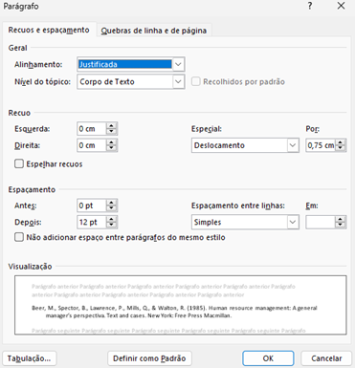

**Example:**

Beer, M., Spector, B., Lawrence, P., Mills, Q., & Walton, R. (1985). *Human resource management:* *A general manager's perspective.* Text and cases. New York: Free Press Macmillan.

**Book Chapter:** Last Name of the Author of the Chapter, First Names. (Year of publication). Title of the chapter. In Initials and Surname of the Book Editor (Ed.), *Title of the book in italics* (chapter pages). Publisher.

**Example:**

Brown, A. C. (2008). The role of technology in modern education. In S. L. Johnson (Ed.), *Technology in Education* (pp. 45-62). Publisher XYZ.

**Journal Article:** Author's Last Name, First Names. (Year of publication). Title of the article. *Title of the Journal in italics*, *volume* (number), start page - end.

**Example:**

Johnson, M. B. (2015). The impact of climate change on marine species. *Journal of Marine Ecology*, *25*(3), 112-130.

**Doctoral Thesis or Dissertation:** Author's Last Name, Initials of the Name. (Defense year). *Title of the thesis or dissertation in italics* (Doctoral Thesis or Master's Dissertation). Name of the Institution.

**Example:**

Silva, R. M. (2017). *Impact of Digital Advertising on Consumer Preferences* (Master's Dissertation). ABC University.

**Book:** Author's Last Name, First Names. (Year of publication). *Book title in italics*. Publisher.

**Example:**

Smith, J. A. (2010). *Applied Psychology*. ABC Publisher.

1. Training institution, City, State, Country. E-mail: [cccccccccccc@gmail.com](mailto:cccccccccccc@gmail.com)

   Orcid: <https://orcid.org/0000-0000-0000->0000
2. Training institution, City, State, Country. E-mail: [cccccccccccc@gmail.com](mailto:cccccccccccc@gmail.com)

   Orcid: [https://orcid.org/0000-0000-0000-](https://orcid.org/0009-0007-3310-1667)0000
3. Training institution, City, State, Country. E-mail: [accccccccccc@ifes.edu.br](mailto:accccccccccc@ifes.edu.br)

   Orcid: [https://orcid.org/0000-0000-0000-](https://orcid.org/0009-0007-3310-1667)0000