
ISSN 0024-9521
IJG Vol. 49, No.1, June 2017 (121 - 134)
© 2017 Faculty of Geography UGM and
The Indonesian Geographers Association

Title Must be Brief, Informative and Indicates the Main Point(s) of the Paper. ( 5-10 Words)

Rika Harini (Author’s Name)
harini_rika@yahoo.co.id (e-mail address)
Faculty of Geography, Universitas Gadjah Mada, Indonesia (institution’s address)

Abstract Should not be more than 150 words and is constructed in 1 paragraph which includes brief description of the paper and a summary of the key conclusions (written in two languages: Indonesian and English).

Key words: should be provided below the abstract to help with the electronic search (3-5 words).

Abstrak Abstrak terdiri dari kurang lebih lebih dari 150 kata dan disusun dalam 1 paragraf yang memuat uraian singkat dari naskah .

Kata kunci : diberikan di bawah abstrak untuk membantu dengan pencarian elektronik, terdiri dari 3-5 kata.

1. Introduction
This part gives details of research problems, problem solving plan and idea, research objectives, and a summary of theoretical review composed with or without title or sub-title.

2. The Methods
This part explains how the research is conducted, research design, data collecting techniques, instrument development, and data analysis techniques.

3. Result and Discussion
These are composed of a research result as displayed as words, tables, figure, and photographs. The limitation of using grapics and photos will be appreciated. However, it needs to be displayed if it can describe a better axplanation for research result. All of Figures and tables should be given continuing numbers and must be referred in the article.

127

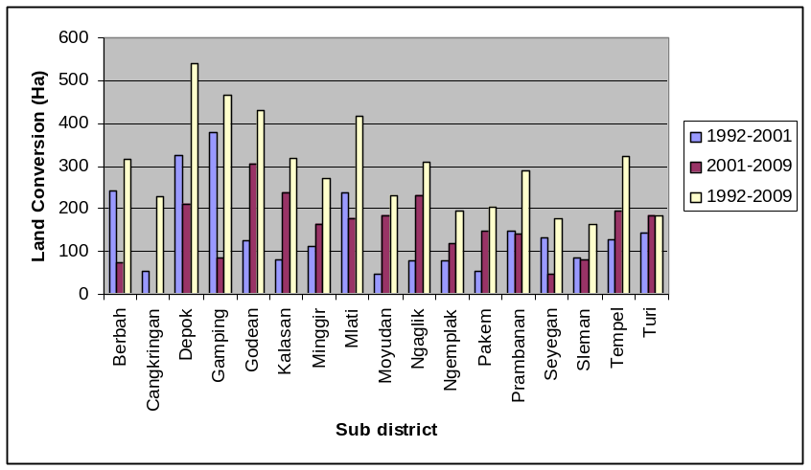

Figure 1. Graphs the Land Agricultural Conversion in Sleman Regency 1992-2009

Table 2. Estimated Regression Function Heteroscedasticity Model

Variabel | Coeficient Mean  Equation | P-Value
1.Population | 0,026797 | 0,000*
2.Regulation | -6,1859 | 0,000*
3.GDP | -0,068963 | 0,074**
4.Dummy Zone 1 | 7,6959 | 0,014*
5.Dummy Zone 2 | 8,3679 | 0,000*
6.Constanta | -0,0006569 | 0,011*
Source : secondary data processing

5. Conclusion
They consist of important conclusions of paper.

Acknowledgement
This may give an appreciation to institution or respons who help in research and report writing. This part may also describe the source of research fund use in the research.

References

Writing Bibliography follow APA Style. Only libraries that are actually referenced are included in the bibliography.

Note: Manuscript should not be longer than 20 pages

