Brian Preston

CSD-325

Module 1.2

Link to your GitHub repository.

<https://github.com/bprstn/csd-325>

Screenshot of your GitHub repository.

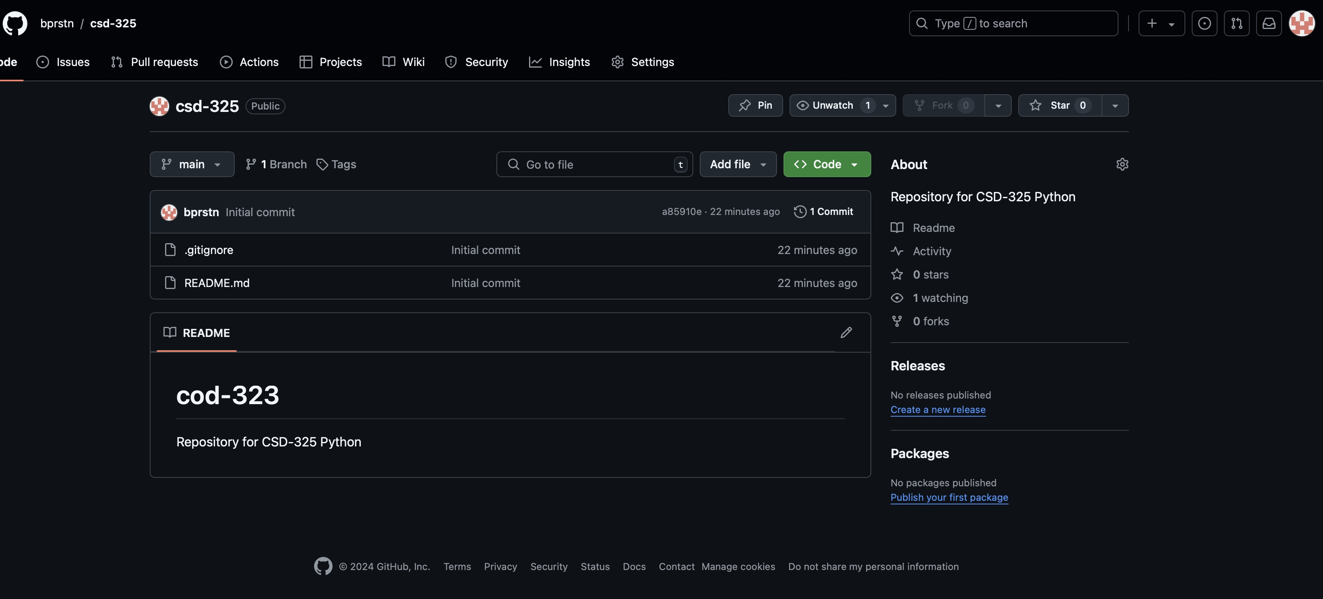

Screenshot of your local directory (properly formatted).

