Brian preston

CSD 325

Module 2.1 **Documented Debugging + Flowchart(s)**

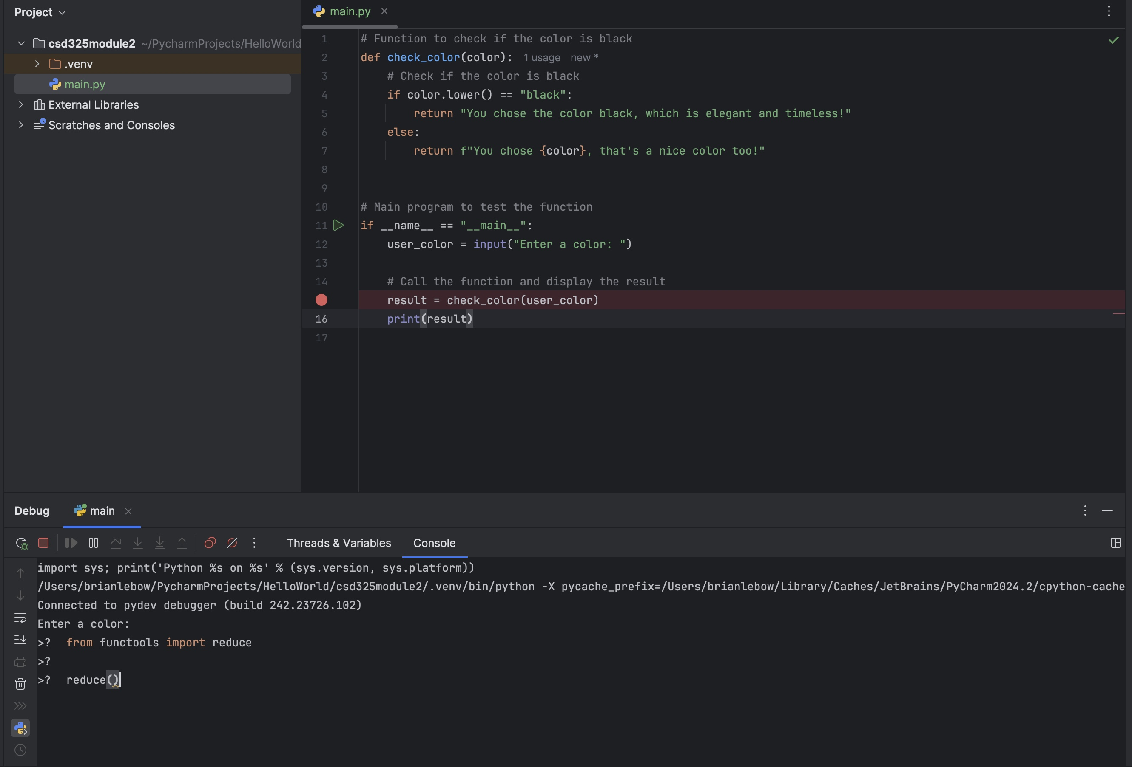

Stepping into the function

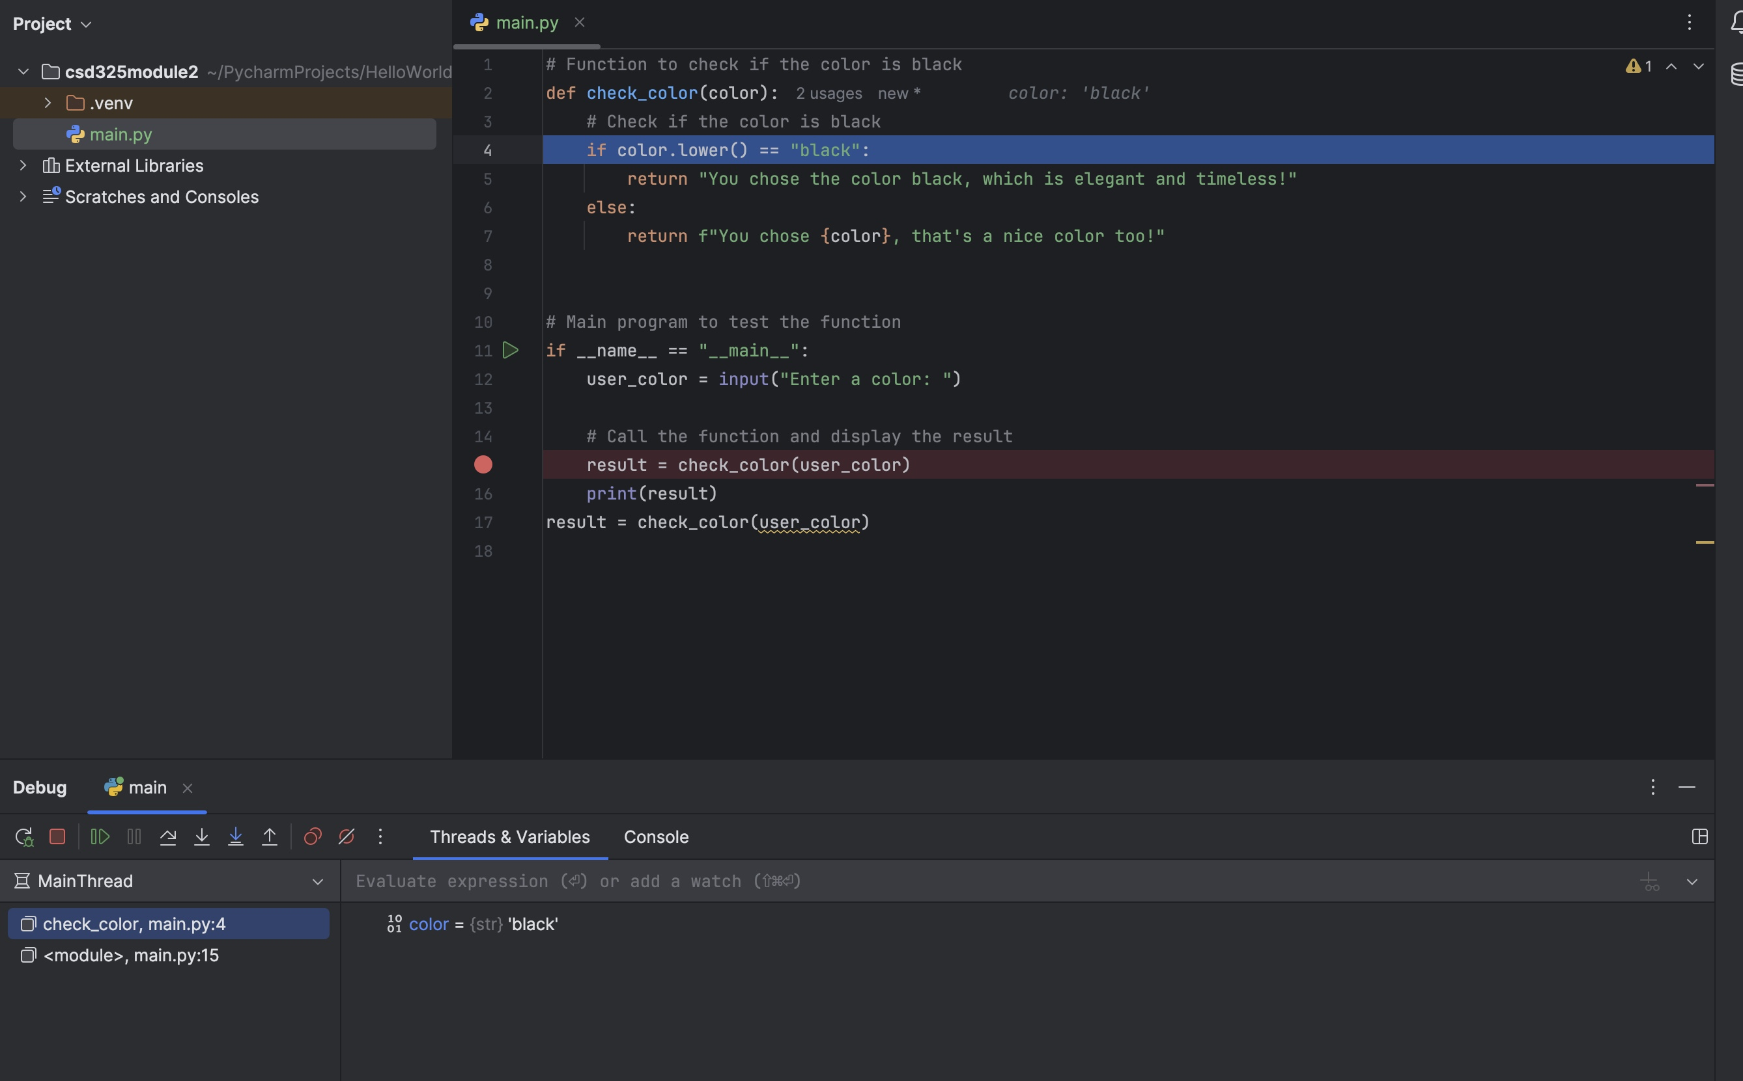

If the user enters "Black" (with an uppercase "B"), the function won't recognize it as "black" because the .lower()method is missing. By stepping through the function, you can observe how it handles the input incorrectly.

