* Link to my GitHub repository

<https://github.com/bprstn/csd-310>

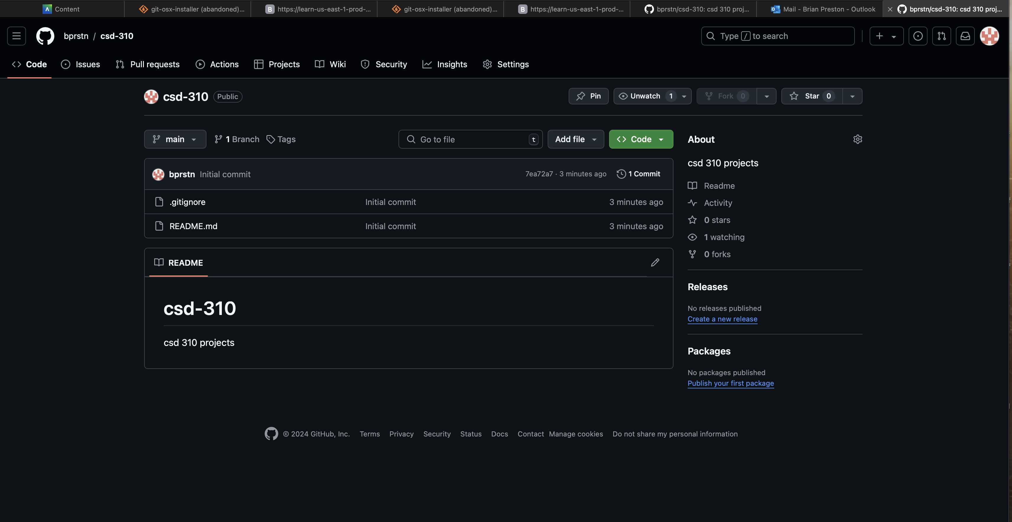

Screenshot of my GitHub repository

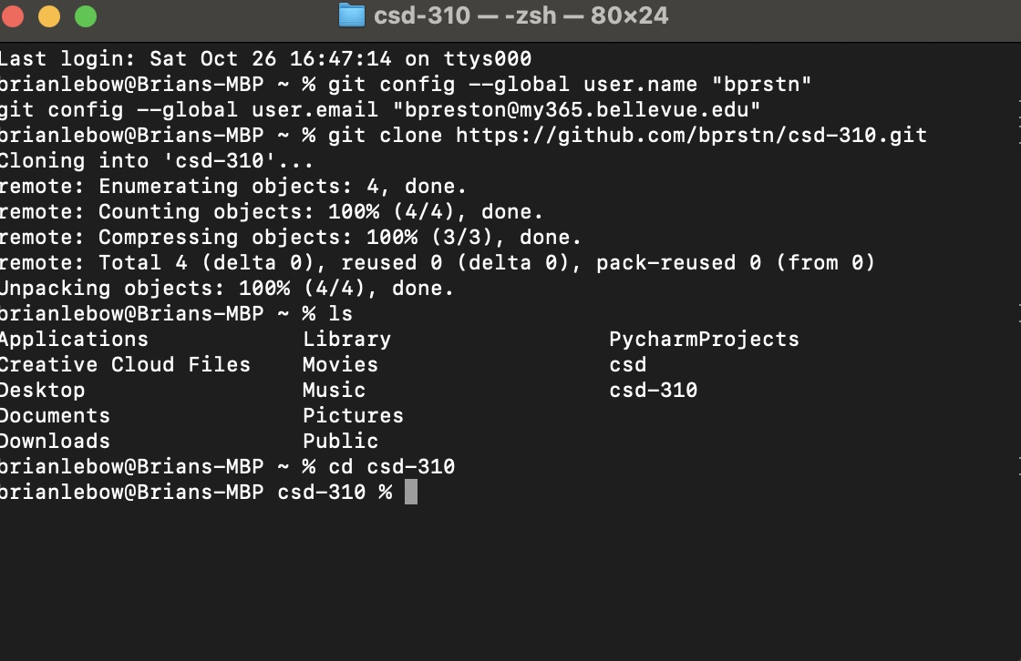

* Screenshot of my local directory

