Brian Preston

CSD-310

Module 2.3

***Translate the following business rules into one Entity relationship diagram (ERD) using Visual Paradigm.***

* + a USER has many ROLES.
  + a USER has one BIRTHDATE.
  + a USER can have many DEPENDENTS.

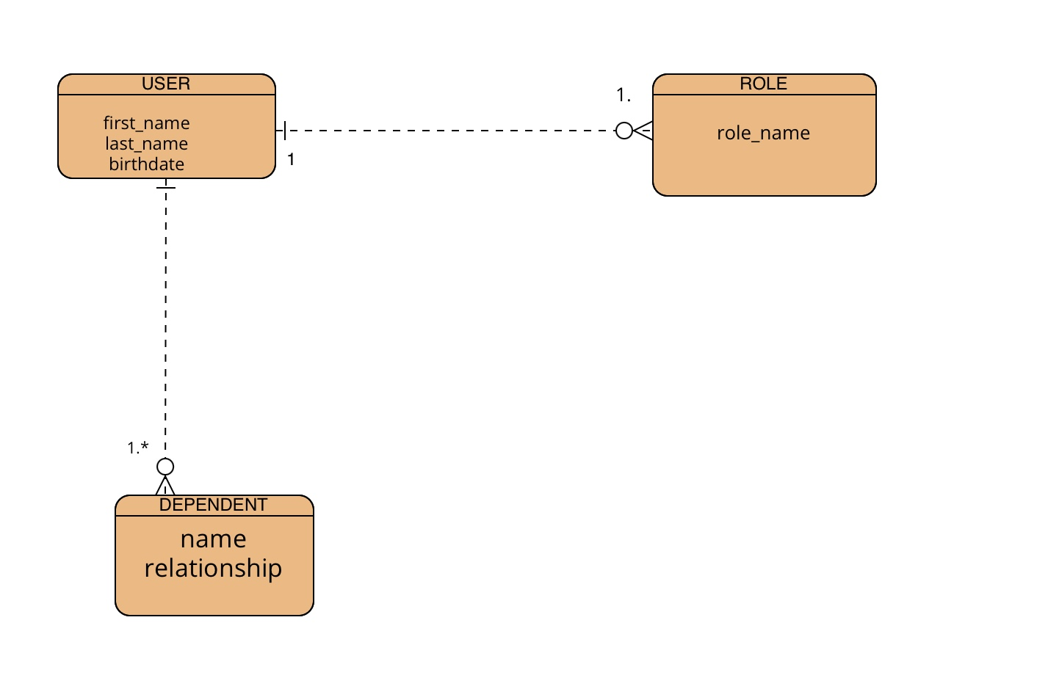

***Convert the translated diagram into one NoSQL data structure.***

One-to-many relationships: Person to car

{

"first_name": "John",

"last_name": "Doe",

"cars": [

{

"type": "Ford",

"color": "Red"

},

{

"type": "Toyota",

"color": "Blue"

}

]

}

Many-to-Many relationships and skill

{

"employee_name": "Alice Smith",

"skills": [

{

"skill_name": "Cooking"

},

{

"skill_name": "Customer Service"

}

]

}

One-to-one relationship: Employee to Restaurant

{

"employee_name": "Bob Johnson",

"restaurant": {

"restaurant_name": "The Best Diner",

"location": "123 Main Street"

}

}