Brian Preston

CSD 310

Module 2.2

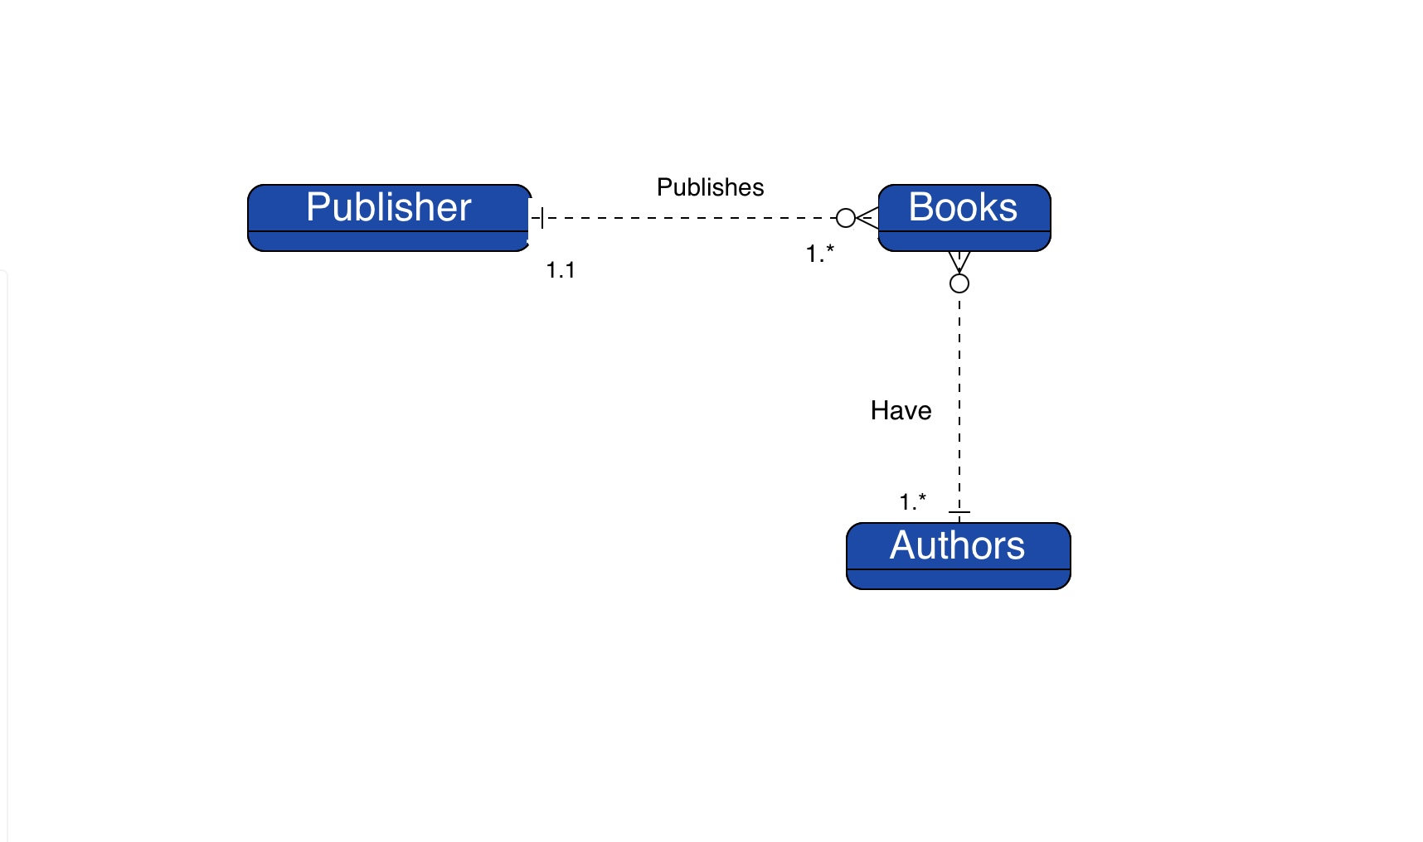

Hi Professor, Here is my attempt. I could not get the lines to change into non-dotted lines. I tried redrawing the lines and changing the lines from dotted to solid and watched many YouTube videos. If you have any suggestions, I would appreciate them very much.