Brian Preston

CSD 310

Module 7 Assignment

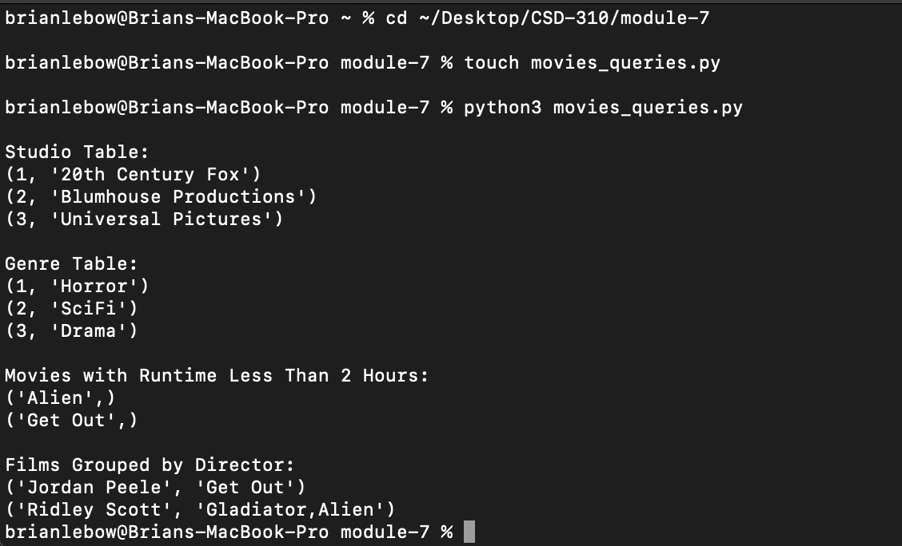

My GitHub

https://github.com/bprstn/csd-310