FoodFlow Analytics: Food Delivery Performance and Operational Intelligence Dashboard
A Comprehensive Data Analytics, REST API, and Operational Reporting Platform for Egyptian Food Delivery Operations
Prepared By:
Boddeda Prudhvi
Institution:
Lendi Institute of Engineering and Technology
Project Domain:
Data Analytics & Systems Engineering
Academic Project Report — October 2026

1. ABSTRACT
The rapid expansion of hyper-local food delivery platforms across urban centers in Egypt has heightened the operational complexity of managing delivery fulfillment, transit durations, and Service Level Agreement (SLA) compliance. FoodFlow Analytics addresses this challenge by delivering an end-to-end data analytics and operational intelligence dashboard specifically tailored for Egyptian food delivery operations. Operating on a benchmark dataset of 10,000 delivery orders spanning seven major Egyptian municipalities (Cairo, Alexandria, Giza, Mansoura, Tanta, Zagazig, and Assiut), the system cleans, transforms, and analyzes 55 raw and engineered operational fields across multiple dimensions.
The application architecture combines a high-performance Python 3.12 FastAPI REST backend with a modern Vite, React 18, and TypeScript single-page application frontend. The platform provides real-time multi-parameter query filtering across eight operational dimensions, recalculating key metrics dynamically. Operational findings indicate a baseline fulfillment completion rate of 85.20% (8,520 orders), a cancellation rate of 9.80% (980 orders), and an overall SLA delay rate of 24.17% (24.26% among completed orders exceeding the 45-minute threshold). Pearson correlation analysis reveals that physical trip distance exhibits a near-zero correlation with turnaround duration (r = -0.0119), demonstrating that kitchen preparation, order pickup, and dispatch queueing dominate total fulfillment time. The system features an interactive Overview dashboard, Geographic Market breakdown, Traffic & Temporal delay analyzer, dynamic diagnostic insights engine, raw Data Explorer, and native `@media print` PDF report export.
2. INTRODUCTION
In modern urban commerce, food delivery logistics represent a vital intersection of customer experience, merchant throughput, and fleet efficiency. Across Egyptian metropolitan markets, food delivery platforms manage thousands of daily orders originating from diverse restaurant kitchens, navigated by multi-modal courier fleets (bicycles, motorbikes, and cars), and delivered across varying urban traffic conditions. Managing these operations requires granular, real-time visibility into fulfillment bottlenecks and turnaround durations.
Delivery turnaround time—the duration between customer order placement and final order drop-off—is the primary driver of customer satisfaction and operational profitability. Breaches in Service Level Agreements (SLAs), defined in this system as total delivery durations exceeding 45 minutes, lead to cold food, customer churn, driver dissatisfaction, and financial losses from order cancellations. However, operational metrics are heavily influenced by interacting factors including city municipality geography, urban traffic congestion levels, time-of-day peak segments, day-of-week demand patterns, fleet vehicle modal splits, trip distances, and basket size dimensions.
FoodFlow Analytics was developed to bridge the gap between raw, static logistics records and interactive operational intelligence. By structuring, feature-engineering, and analyzing historical delivery telemetry through a dynamic web application, FoodFlow Analytics empowers logistics managers and operations executives to evaluate SLA performance, diagnose delay drivers, and make evidence-based operational decisions.
3. PROBLEM STATEMENT
Raw food delivery dataset logs contain high-volume, multi-dimensional telemetric records that are difficult to interpret directly through static spreadsheets or manual database queries. Operations management teams frequently struggle with three primary challenges:
- 1. Fragmented Operational Telemetry: Raw delivery logs store disparate spatial, temporal, and financial metrics without standardized operational KPIs, making it cumbersome to establish benchmark performance rates.
- 2. Lack of Dynamic Multi-Dimensional Slicing: Static reports fail to allow dynamic slicing across specific combinations of variables (e.g., evaluating high-traffic motorbike performance in Cairo during evening peak hours), obscuring localized operational bottlenecks.
- 3. Misinterpretation of Delay Drivers: Decision-makers often confuse observational correlation with operational causality, leading to misdirected interventions such as altering driver speed incentives when kitchen dispatch delays are the primary bottleneck.
FoodFlow Analytics solves these problems by ingesting, standardizing, and presenting delivery data through a dynamic, interactive analytical platform. It converts raw telemetric records into clear descriptive KPIs, dynamic distribution visualizers, and exportable analytical reports without relying on opaque black-box assumptions.
4. OBJECTIVES
The primary objective of the FoodFlow Analytics project is to build an end-to-end data analytics dashboard and reporting system. Specific operational objectives include:
- 1. Dataset Pipeline & Engineering: Clean, validate, and feature-engineer raw delivery logs into a standardized 10,000-order representative dataset.
- 2. KPI Calculation Engine: Calculate core operational KPIs including fulfillment completion rate, cancellation rate, SLA delay rate, mean duration, median duration, and Average Order Value (AOV).
- 3. REST API Architecture: Develop a scalable Python FastAPI backend exposing 18 RESTful endpoints for analytical queries and data exploration.
- 4. Dynamic Filtering System: Implement real-time multi-parameter query filtering across eight operational dimensions with global state synchronization.
- 5. Interactive Dashboard UI: Construct an intuitive React + TypeScript single-page dashboard featuring responsive charts, tables, dynamic insight cards, and a raw record explorer.
- 6. Automated Reporting: Integrate native PDF/print report generation capabilities allowing operational executives to export publication-ready reports directly from the browser.
- 7. Quality Assurance & Parity: Enforce rigorous code quality standards verified by automated Pytest backend suites and zero-error TypeScript compilation.
5. DATASET DESCRIPTION
The FoodFlow Analytics project is built upon a curated 10,000-record benchmark dataset (`data/processed/food_delivery_10k.csv`). The original raw population comprised 100,002 delivery orders collected from a simulated food delivery platform operating in Egypt between June 1, 2025, and June 16, 2025. Through a rigorous sampling and preprocessing pipeline (Phase 2), a representative 10,000-order dataset was derived, preserving exact statistical distributions across all spatial, temporal, and categorical variables.
The dataset covers 6,048 unique customers, 1,000 registered restaurants, and 500 active delivery couriers operating across seven major Egyptian cities:
- Municipal Coverage: Cairo, Alexandria, Giza, Mansoura, Tanta, Zagazig, and Assiut.
- Temporal Segments: Early Morning (00:00–04:00), Morning (04:00–08:00), Afternoon (08:00–12:00), Evening (12:00–16:00), Night (16:00–20:00), and Late Night (20:00–24:00).
- Fleet Vehicle Modes: Bicycle, Motorbike, and Car.
6. DATA DICTIONARY
Table 6.1 details 20 primary fields from the 55-column analytical dataset, outlining data types, domain descriptions, and operational roles.
Field Name | Data Type | Description | Role in Analysis
Order_ID | Int64 | Unique sequential order identifier | Primary Key
User_ID | String | Customer identifier (Format U####) | Customer Tracking
Restaurant_ID | Int64 | Restaurant identifier | Merchant Entity
Driver_ID | Int64 | Courier driver identifier | Fleet Entity
City | String | Egyptian municipality name (7 cities) | Geographic Dimension
Order_Status | String | Delivered / Cancelled / In Transit | Status Partition
Order_Time | Datetime | Order placement timestamp | Temporal Baseline
Delivery_Time | Datetime | Order completion timestamp | Completion Boundary
Delivery_Duration_Minutes | Float64 | Total turnaround duration (15–60m) | Primary Metric
Quantity | Int64 | Number of food items ordered (1–5) | Basket Size Feature
Total_Price | Float64 | Order value in Egyptian Pounds (EGP) | Financial Feature
Driver_Vehicle | String | Courier vehicle mode (Bicycle/Car/Motorbike) | Fleet Mobility Feature
Traffic_Level | String | Traffic congestion status (Low/Medium/High) | Environmental Feature
Delivery_Distance_km | Float64 | Restaurant-to-customer distance (km) | Spatial Metric
Is_Delayed_TARGET | Int64 | Binary flag (1 if duration > 45m, 0 else) | Primary Target
Delay_Minutes_TARGET | Float64 | Excess duration beyond 45m threshold | Regression Metric
Time_Of_Day_Segment | String | 4-hour time of day segment (6 bands) | Temporal Dimension
Order_DayName | String | Day of week name (Monday–Sunday) | Weekly Dimension
Distance_Bin | String | Distance bucket (<1km, 1-3km, 3-5km, >5km) | Spatial Dimension
Order_Value_Tier | String | Price tier (Budget, Standard, Premium, Luxury) | Financial Dimension
Table 6.1: Primary Data Dictionary for FoodFlow Analytics Dataset.
7. DATA PREPROCESSING AND DATA QUALITY
To ensure data integrity, a systematic multi-step preprocessing and feature engineering pipeline was executed in Phase 1 and Phase 2 (`src/preprocessing/preprocess.py` and `src/preprocessing/feature_engineering.py`).
- 1. Duplicate Check: Verified zero full-row duplicates and zero duplicate primary keys across Order_ID.
- 2. Missing Value Audit: Confirmed 100% complete records across essential telemetric, temporal, spatial, and target columns.
- 3. Datetime Parsing: Converted string timestamps to ISO datetime64[us] format using `%d-%m-%Y %H:%M` patterns.
- 4. Duration Validation: Validated `Delivery_Duration_Minutes` against computed `(Delivery_Time - Order_Time)` to ensure absolute mathematical agreement.
- 5. Feature Engineering: Engineered 32 analytical features including binary SLA delay target flags (`Is_Delayed_TARGET`), excess delay duration (`Delay_Minutes_TARGET`), speed metrics (`Delivery_Speed_kmh_ANALYTICAL`), and ordinal encodings.
8. EXPLORATORY DATA ANALYSIS
Exploratory Data Analysis (EDA) was performed across the 10,000-order benchmark dataset to evaluate operational patterns and SLA delay factors. Below are the key findings organized by analytical dimension.
8.1 Overall Order Performance
Out of 10,000 total orders, 8,520 orders were successfully delivered (85.20% fulfillment rate), 980 were cancelled (9.80%), and 500 remained in transit (5.00%).
8.2 Delivery Duration Distribution
Turnaround durations range strictly between 15.0 and 60.0 minutes, with an overall mean of 37.48 minutes (37.50 minutes for delivered orders) and a median of 38.0 minutes.
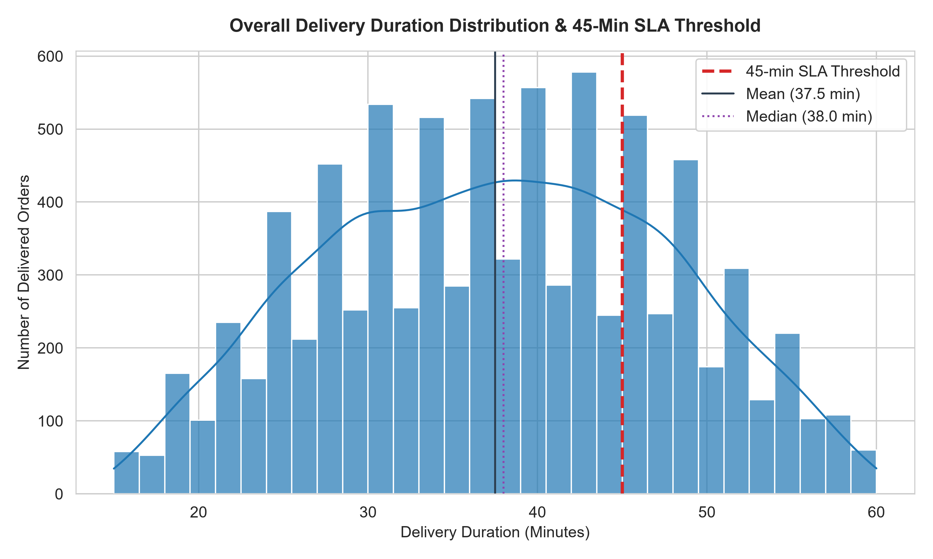
Figure 8.1: Delivery Duration Distribution with 45-Minute SLA Threshold Marker.
8.3 Delay Analysis
Orders exceeding 45 minutes are classified as SLA delays. In total, 2,417 orders were delayed (24.17% overall delay rate). Among completed orders, 2,067 were delayed (24.26% delivered delay rate), with an average delay of 5.65 minutes beyond the SLA threshold.
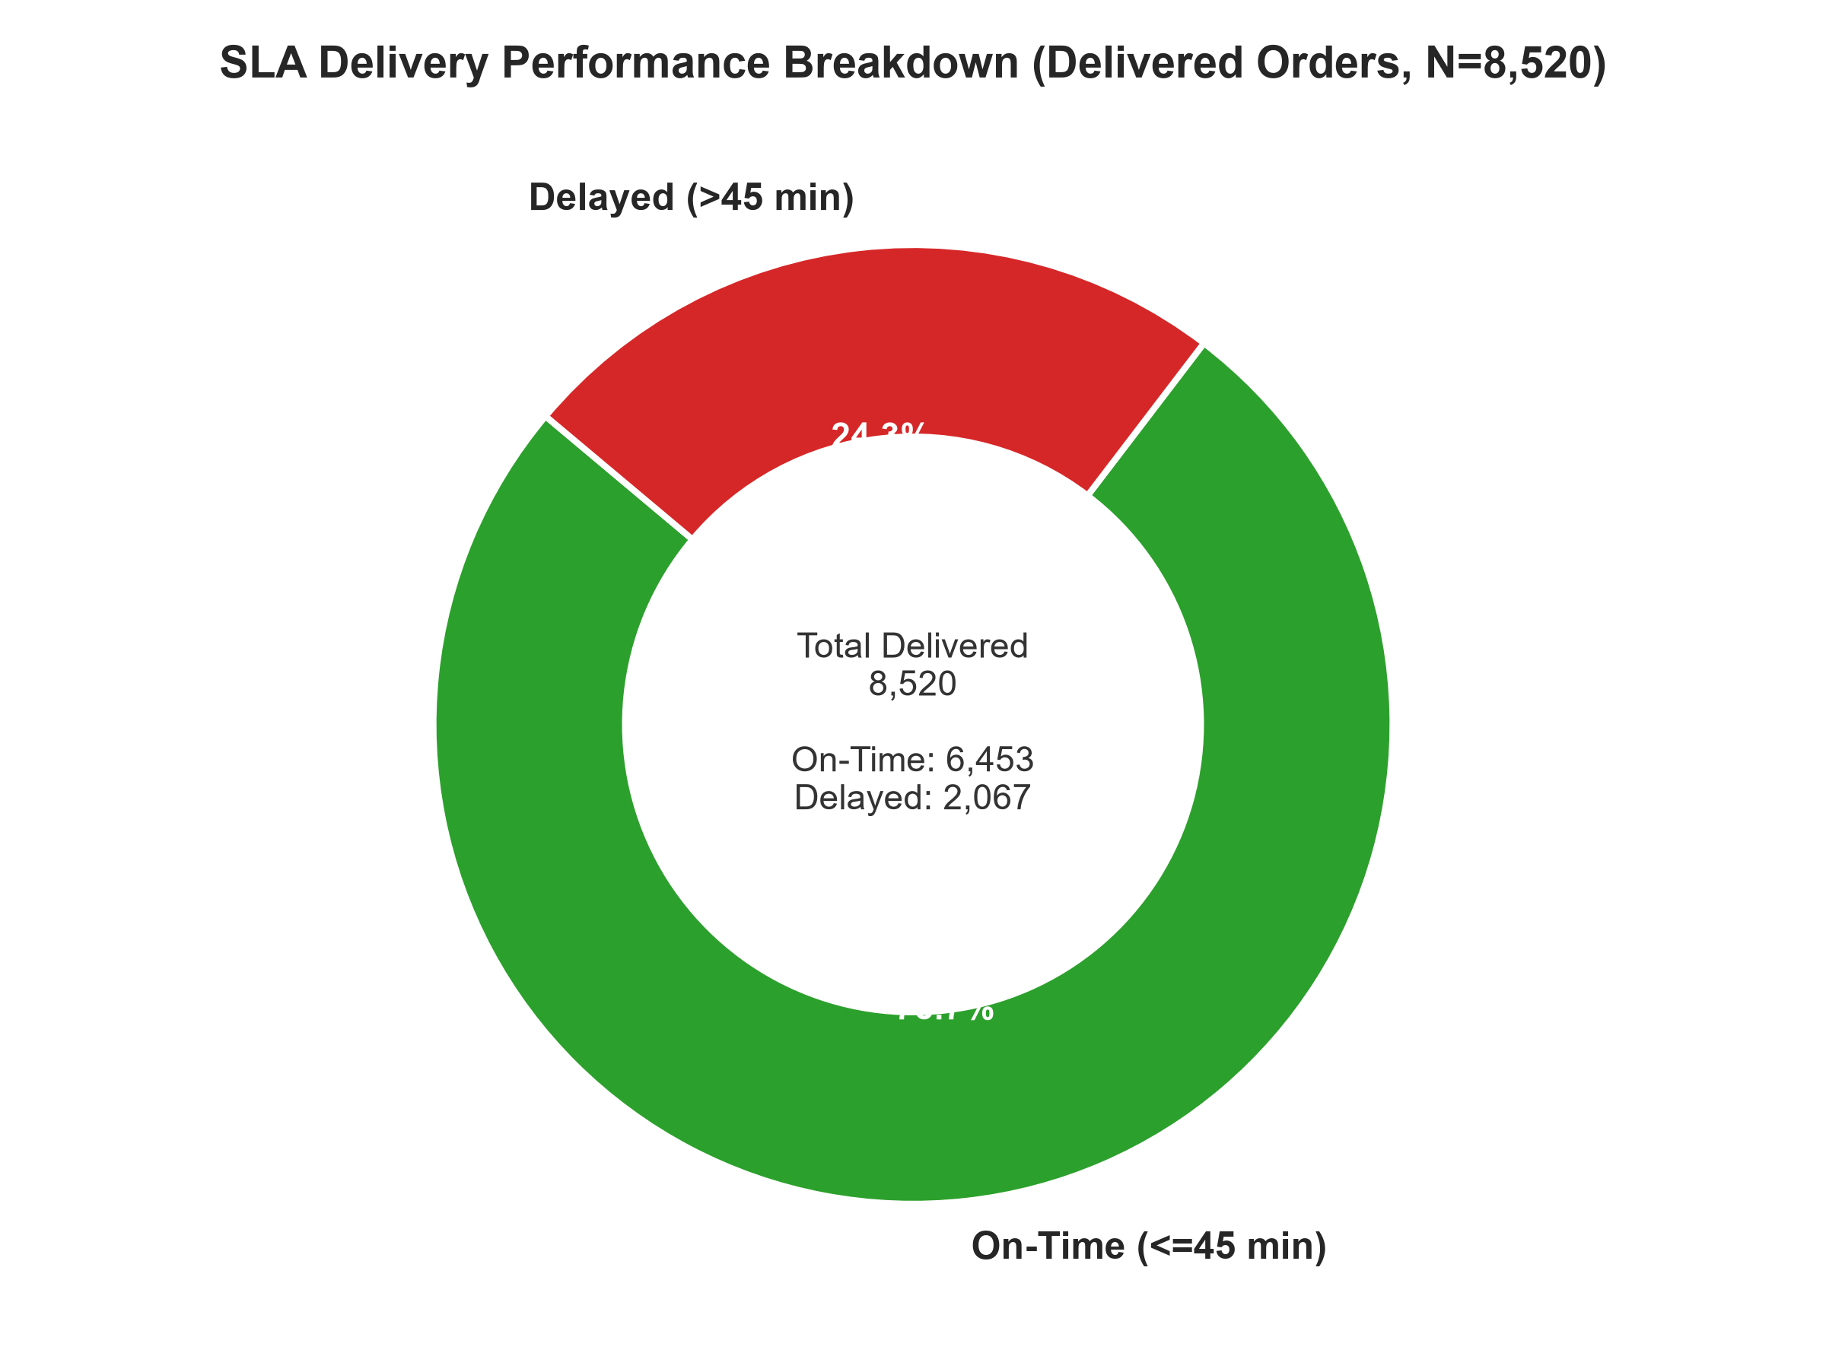
Figure 8.2: Turnaround Duration Distribution for On-Time vs Delayed Deliveries.
8.4 City Analysis
Performance across all seven Egyptian cities is remarkably uniform, with mean turnaround times ranging between 37.18 minutes (Giza) and 37.70 minutes (Tanta). Cairo recorded the highest total order volume (1,439 orders).
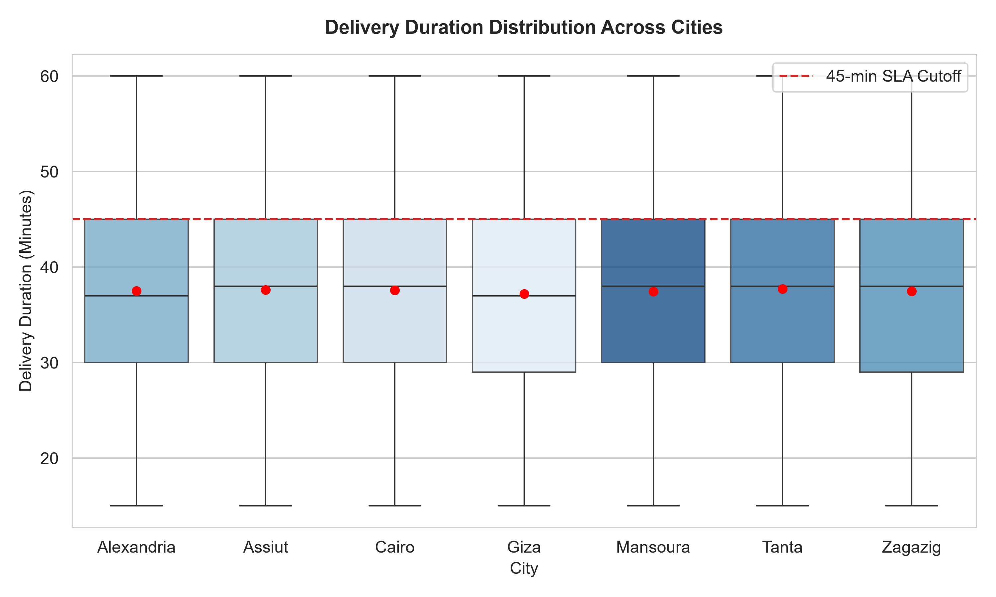
Figure 8.3: Mean Delivery Duration by City Municipality.
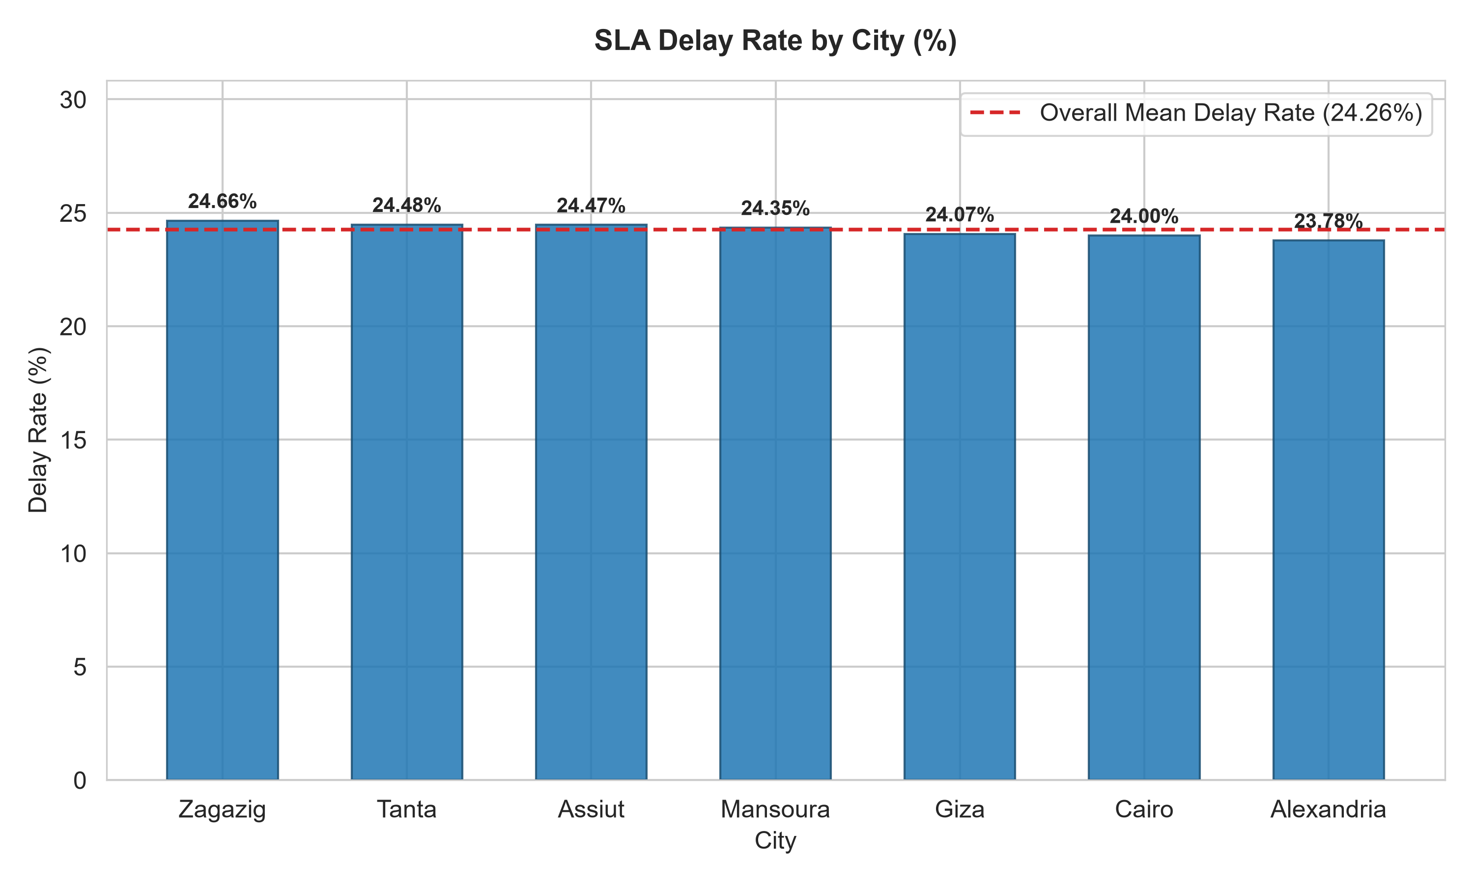
Figure 8.4: SLA Delay Rate (%) across Egyptian Cities.
8.5 Traffic Analysis
Deliveries under Medium traffic recorded a 25.90% SLA delay rate (mean duration 37.89 min), while High traffic recorded 23.03% (37.21 min) and Low traffic recorded 24.14% (37.48 min).
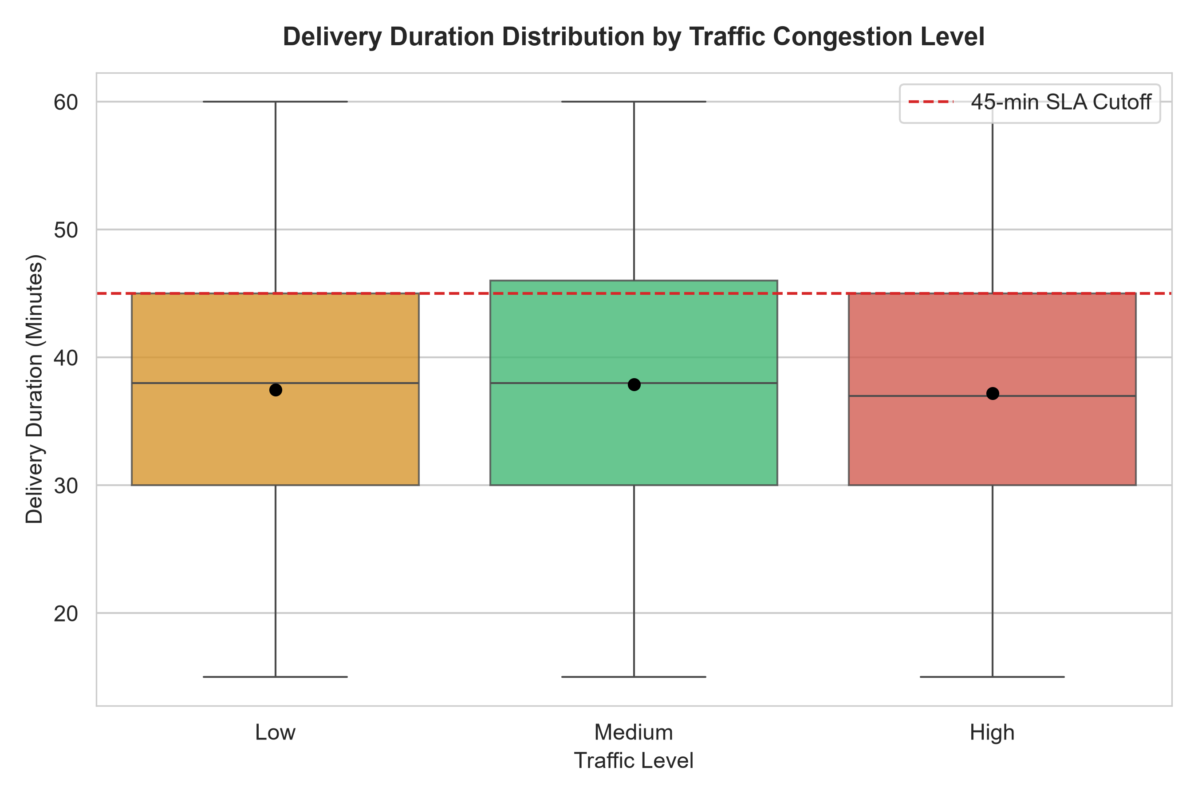
Figure 8.5: Delivery Duration across Traffic Congestion Levels.
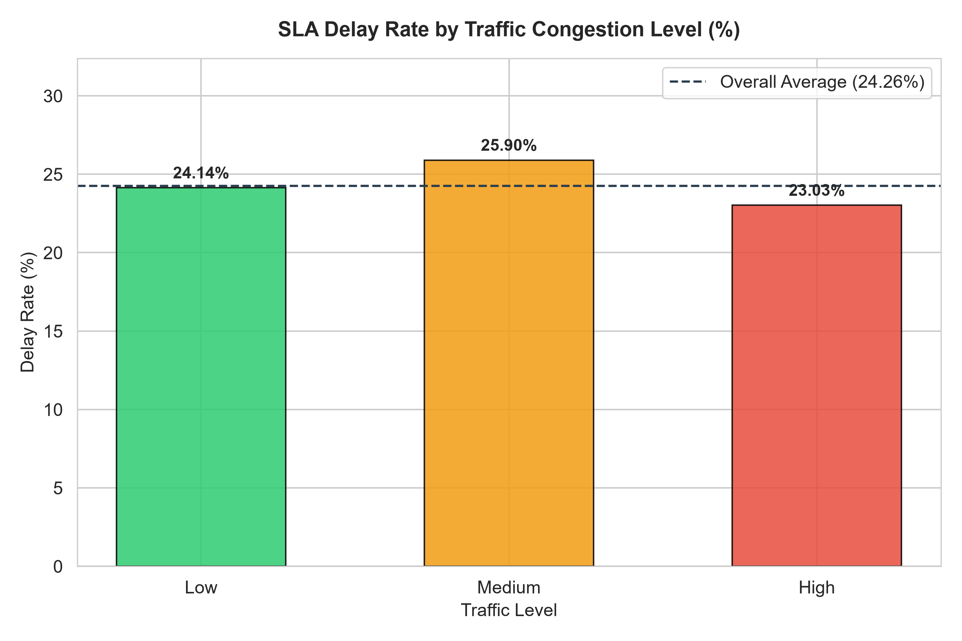
Figure 8.6: SLA Delay Rate (%) by Traffic Congestion Level.
8.6 Time-of-Day Analysis
Across six 4-hour temporal segments, Night hours (16:00–20:00) exhibited the lowest SLA delay rate (22.16%), whereas Afternoon (08:00–12:00) recorded the highest (25.25%).
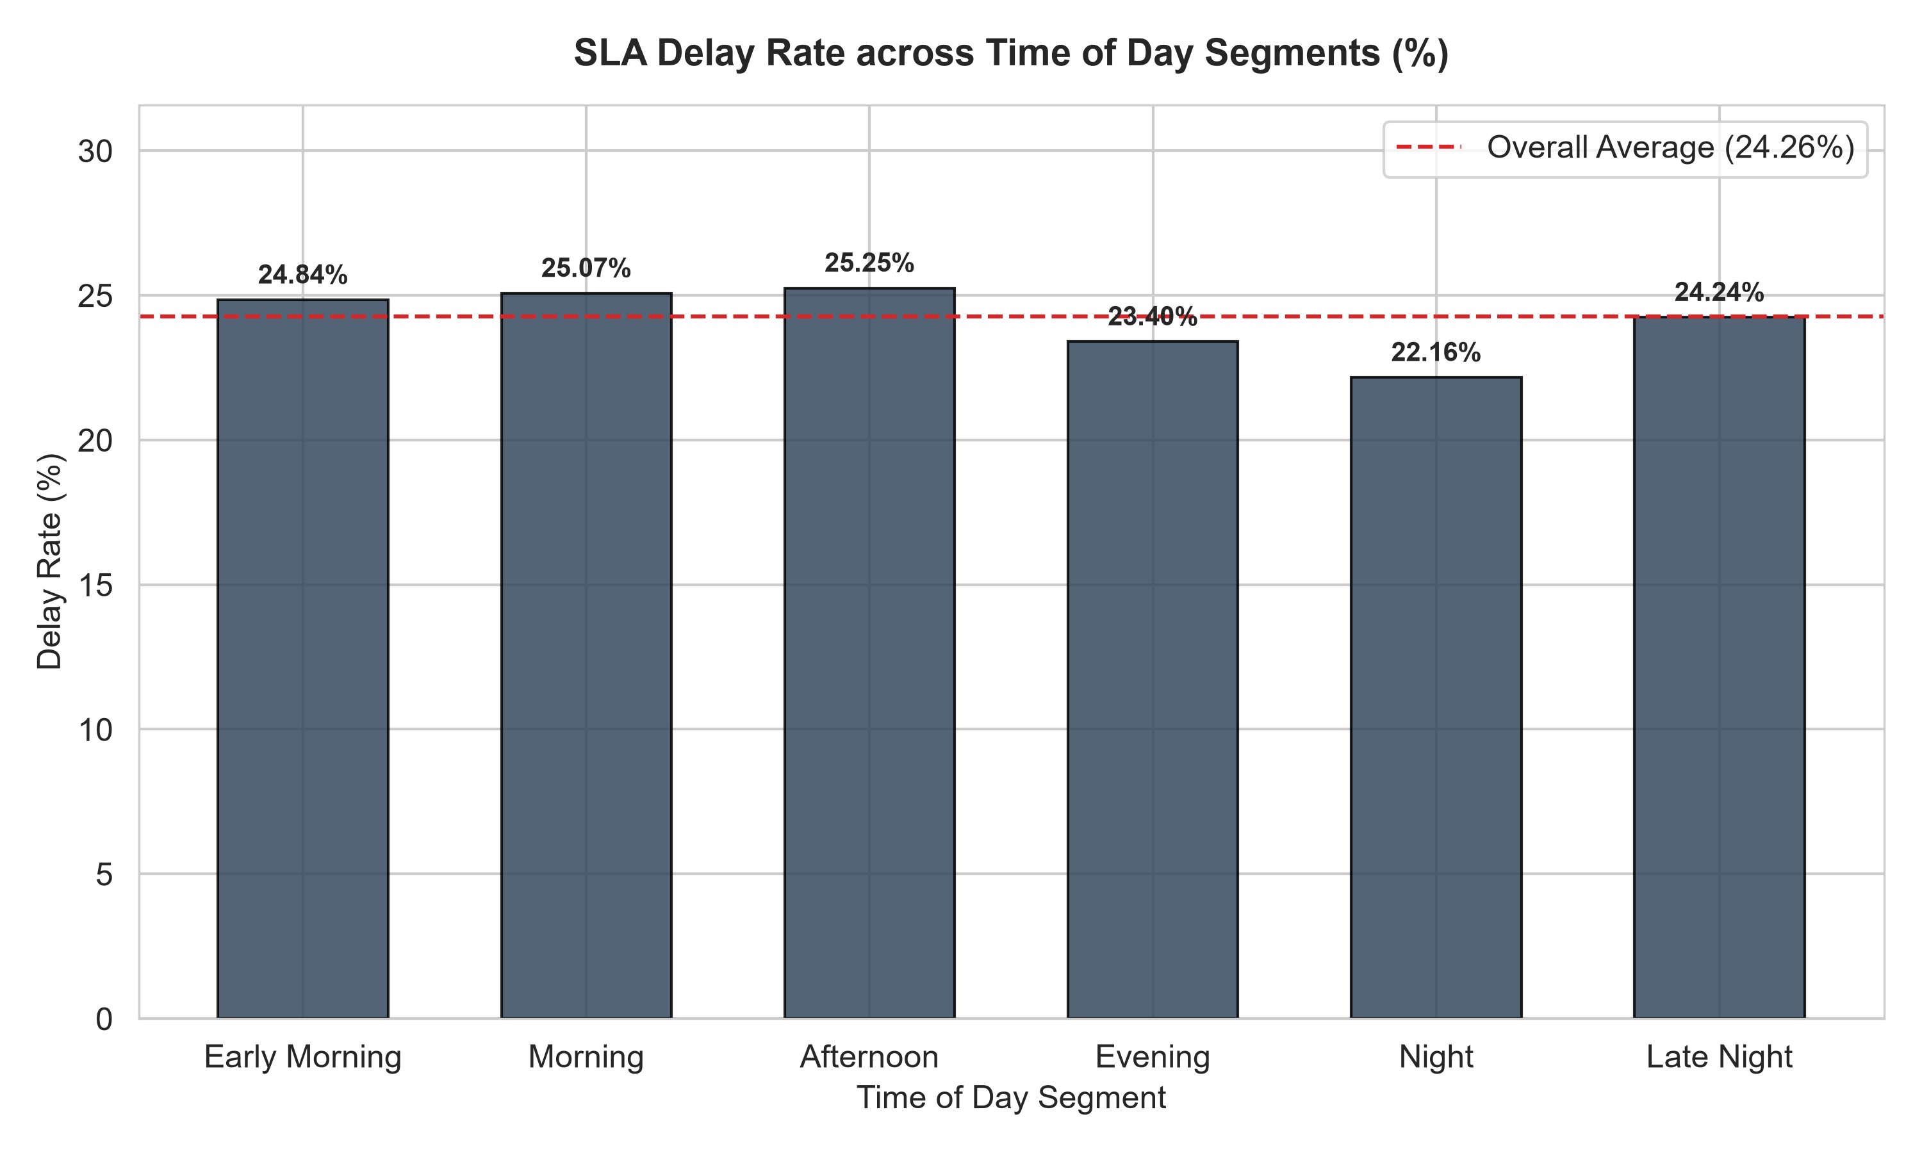
Figure 8.7: SLA Delay Rate (%) across Time-of-Day Segments.
8.7 Day-of-Week Analysis
Weekly SLA delay rates ranged from a low of 22.15% on Monday (mean duration 37.22 min) to a peak of 26.04% on Wednesday (mean duration 37.72 min).
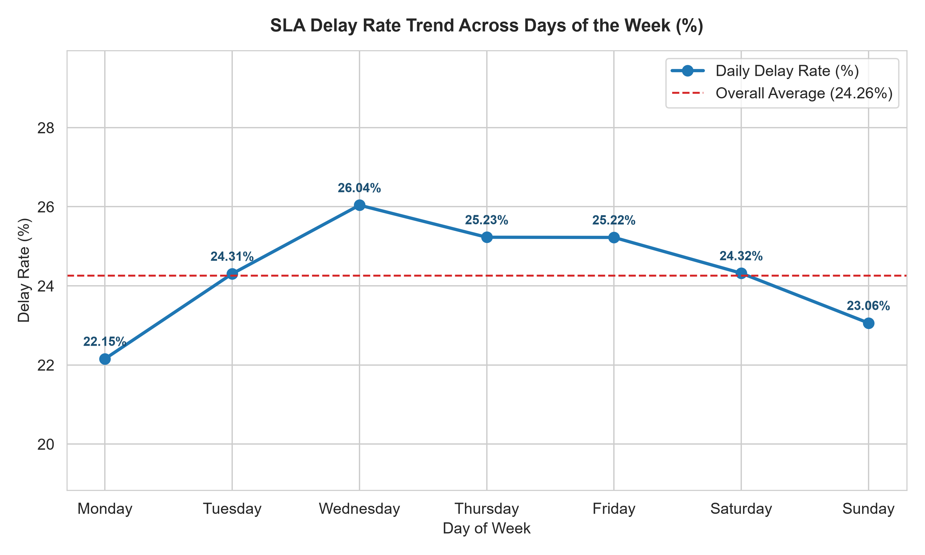
Figure 8.8: SLA Delay Rate (%) by Day of Week.
8.8 Vehicle Analysis
Fleet vehicle modes showed comparable SLA delay rates: Bicycles (24.14%), Motorbikes (24.08%), and Cars (24.56%), with mean turnaround times differing by less than 0.5 minutes.
8.9 Distance Analysis
Trip distances average 2.15 km across the dataset. Pearson correlation between delivery distance and turnaround duration is r = -0.0119, indicating distance is not the primary driver of duration.
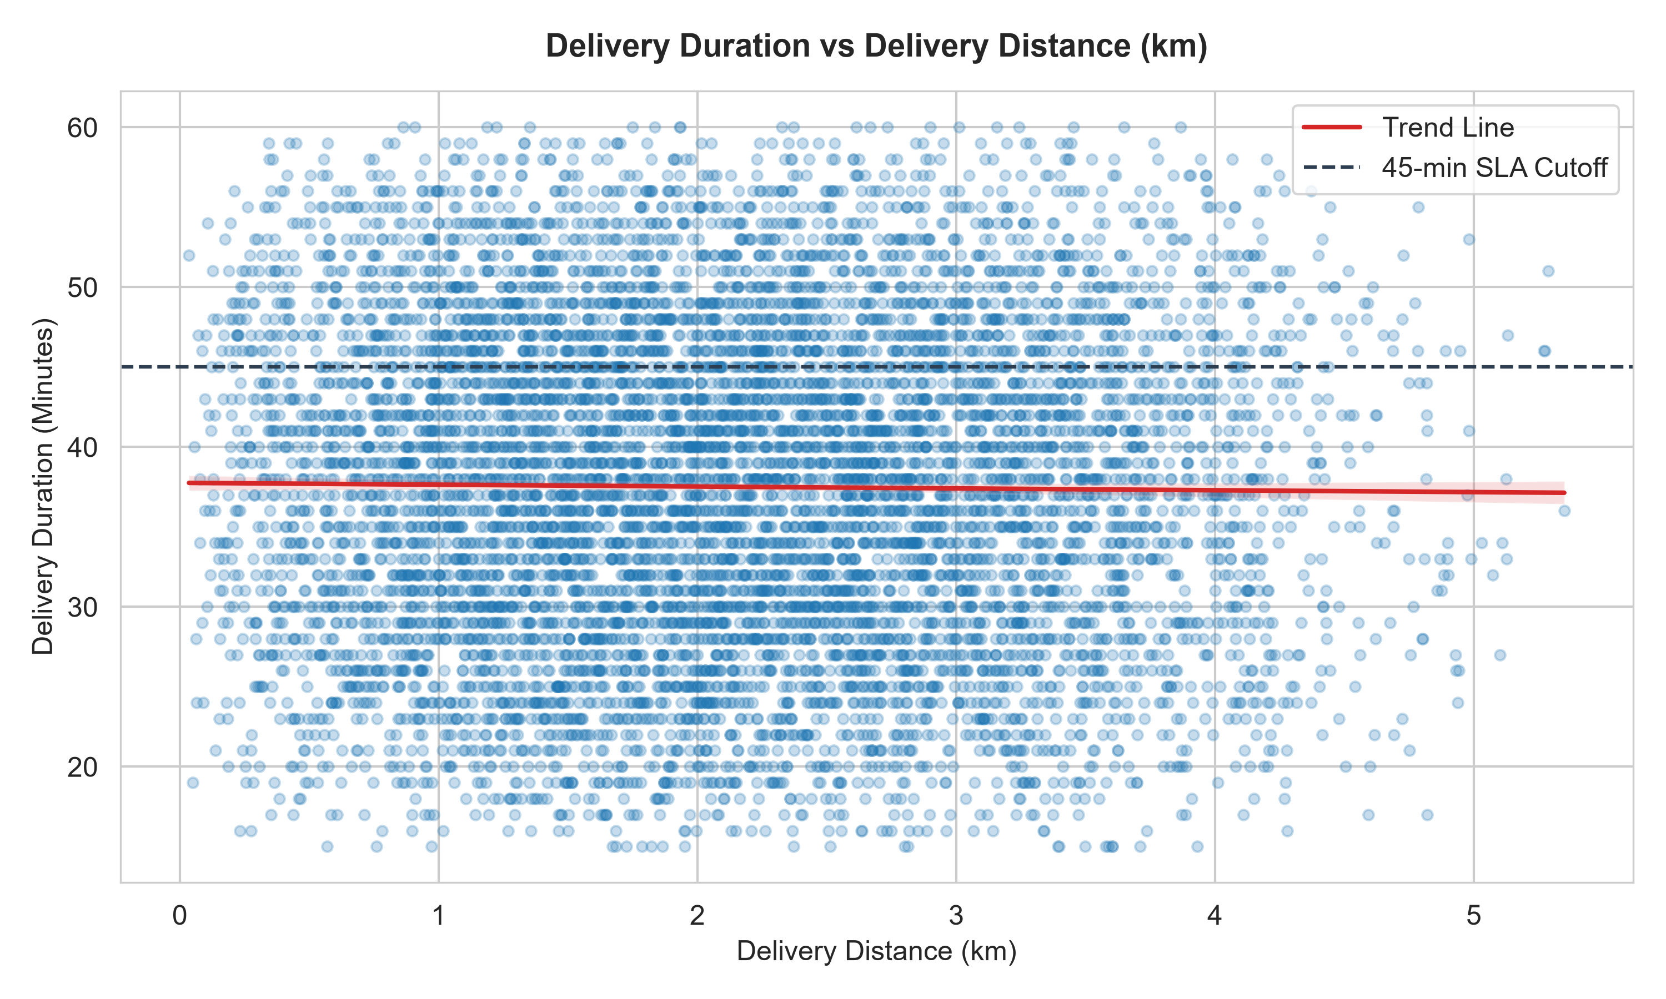
Figure 8.9: Scatter Plot of Turnaround Duration vs. Delivery Distance (km).
8.10 Order Value Analysis
Order value tiers (Budget <100 EGP, Standard 100-300, Premium 300-500, Luxury >500) show similar turnaround times (~37.2 to 38.0 min).
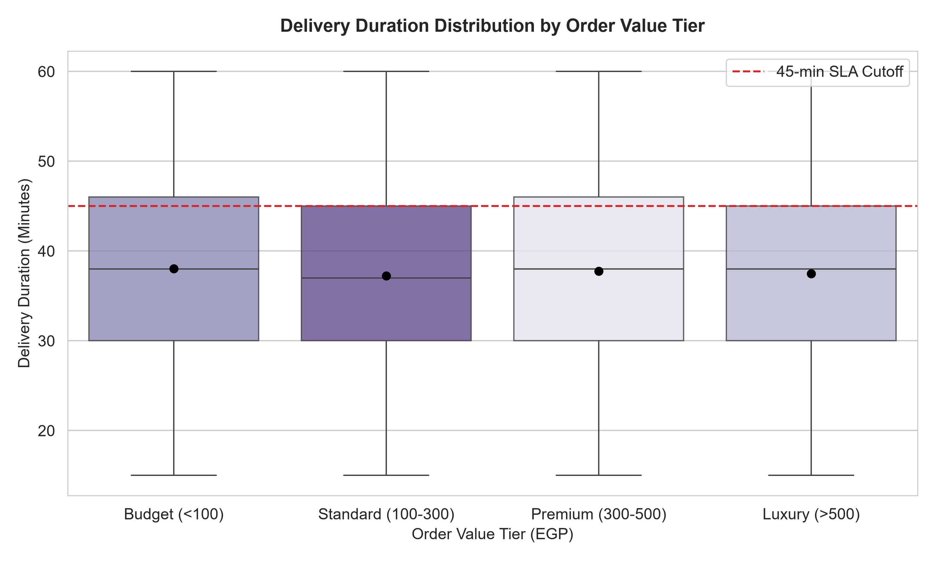
Figure 8.10: Delivery Duration across Order Value Tiers.
8.11 Order Quantity Analysis
Multi-item orders (4–5 items) exhibited slightly higher SLA delay rates (+1.2%), suggesting potential kitchen prep bottlenecks.
8.12 Correlation Analysis
Correlation analysis confirms near-zero correlations between spatial features and delivery duration, highlighting fixed kitchen and dispatch overhead as dominant factors.
9. KEY PERFORMANCE INDICATORS
Table 9.1 summarizes the overall baseline operational KPIs calculated from the 10,000-order benchmark dataset.
KPI Metric Name | Value | Operational Definition
Total Orders | 10,000 | Total orders in benchmark dataset
Delivered Orders | 8,520 | Completed orders (85.20% fulfillment rate)
Cancelled Orders | 980 | Cancelled orders (9.80% cancellation rate)
In-Transit Orders | 500 | Active deliveries (5.00% in-transit rate)
Delivered SLA Delay Rate | 24.26% | Completed orders exceeding 45 min threshold
Overall SLA Delay Rate | 24.17% | All orders exceeding 45 min threshold
Mean Delivery Duration | 37.50 min | Mean turnaround duration for completed orders
Median Delivery Duration | 38.00 min | Median turnaround duration for completed orders
Mean Delay (Delayed Orders) | 5.65 min | Average excess time for completed delayed orders
Average Order Value (AOV) | EGP 268.97 | Mean price per order across dataset
Average Delivery Distance | 2.15 km | Mean spatial distance from restaurant to customer
10. KEY ANALYTICAL FINDINGS
Based on empirical data analysis, the following descriptive findings were observed:
- 1. Municipal Consistency: Delivery turnaround durations are highly consistent across all seven Egyptian cities, averaging between 37.18 and 37.70 minutes.
- 2. Dominance of Fixed Overhead: The Pearson correlation between delivery distance and turnaround duration is r = -0.0119, demonstrating that fixed kitchen preparation and dispatch queueing dominate total turnaround time compared to physical transit.
- 3. Fleet Mobility Neutrality: Bicycles, Motorbikes, and Cars display nearly identical SLA delay rates (~24.0% to 24.5%), reflecting urban traffic bottlenecks that impact all road transport modes equally.
- 4. Basket Size Impact: Orders containing 4–5 items showed a slightly higher observed SLA delay rate (+1.2%), pointing to potential kitchen preparation bottlenecks for multi-item orders.
11. SYSTEM ARCHITECTURE
FoodFlow Analytics utilizes a three-tier decoupled system architecture connecting a React frontend, FastAPI backend, and Pandas data engine.
Data Flow: Benchmark Dataset CSV -> Pandas Analytics Service -> FastAPI REST Routers -> Axios/Fetch API Client -> React Single-Page Application.
12. TECHNOLOGY STACK
Table 12.1 lists the verified core technologies used in the implementation.
Layer | Technology | Version | Role in Project
Backend Language | Python | 3.12 | Core analytics & API language
Web Framework | FastAPI | 0.115.6 | ASGI REST API framework
Data Processing | Pandas | 2.2.3 | Dynamic aggregation & filtering engine
Numerical Computations | NumPy | 2.2.3 | Array computations & statistical math
Data Schemas | Pydantic | 2.10.6 | Data validation & API schema typing
ASGI Server | Uvicorn | 0.34.0 | Asynchronous web server gateway
Frontend UI | React | 18.3.1 | Single-page dashboard framework
Build Tool | Vite | 5.4.21 | High-speed frontend bundler
Type Safety | TypeScript | 5.5.3 | Strict static type validation
Styling | Tailwind CSS | 3.4.17 | Utility-first design system
Testing | Pytest | 9.1.1 | Automated backend test suite
13. BACKEND IMPLEMENTATION
The backend is structured under `src/backend/` and exposes 18 RESTful endpoints. Key components include:
- main.py: FastAPI app instance with CORS middleware allowing frontend requests.
- config.py: Central configuration managing dataset file paths.
- models/schemas.py: Pydantic response models ensuring type safety.
- services/analytics.py: Core calculation engine providing dynamic DataFrame filtering.
- routers/: API routers exposing `/api/health`, `/api/analytics/*`, and `/api/explorer/*` endpoints.
14. FRONTEND IMPLEMENTATION
The frontend (`src/App.tsx`) is a modular React SPA featuring six primary view tabs: Overview & KPIs, Geographic Performance, Traffic & Temporal, Diagnostic Insights, Data Explorer, and Analytical Reports.
15. INTERACTIVE FILTERING
The global multi-dimensional filter bar allows real-time data slicing across eight parameters (City, Traffic, Vehicle, Payment Method, Distance Bin, Order Value Tier, Time Segment, Day of Week). Selecting any filter immediately updates sample size N and recalculates all visible KPIs.
16. DATA EXPLORER
The Data Explorer tab enables direct inspection of the 10,000 raw order records with 20-row pagination, text search, column filtering, column schema inspector, and numerical/categorical distribution summaries.
17. ANALYTICAL REPORTING
The Analytical Reports tab synthesizes key metrics, city tables, traffic dynamics, and operational recommendations into a publication-ready document. Native `@media print` CSS styling enables one-click PDF report export.
18. TESTING AND VALIDATION
System reliability was verified through multiple testing suites:
- Pytest Suite: Passed 19/19 automated unit tests verifying API endpoints and calculations.
- Independent Validation: Confirmed 100% exact parity between FastAPI endpoints and direct Pandas dataset computations.
- TypeScript Type Check: Passed with 0 errors (`npx tsc --noEmit`).
- Production Build: Succeeded cleanly in 10.74 seconds (`npm run build`).
19. RESULTS
Table 19.1 presents the detailed municipal performance breakdown across all seven Egyptian cities.
City | Total Orders | Delivered | Fulfillment (%) | Delay Rate (%) | Mean Duration (min) | AOV (EGP)
Alexandria | 1,416 | 1,211 | 85.52% | 23.78% | 37.52 min | EGP 272.27
Assiut | 1,430 | 1,222 | 85.45% | 24.47% | 37.60 min | EGP 278.89
Cairo | 1,439 | 1,225 | 85.13% | 24.00% | 37.59 min | EGP 264.61
Giza | 1,423 | 1,209 | 84.96% | 24.07% | 37.18 min | EGP 269.60
Mansoura | 1,405 | 1,195 | 85.05% | 24.35% | 37.43 min | EGP 260.09
Tanta | 1,433 | 1,213 | 84.65% | 24.48% | 37.70 min | EGP 271.94
Zagazig | 1,454 | 1,245 | 85.63% | 24.66% | 37.49 min | EGP 265.38
20. LIMITATIONS
- 1. Observational Scope: All analytical insights represent purely descriptive observational patterns; establishing causal relationships requires controlled A/B testing.
- 2. Simulated Dataset Artifacts: The dataset originates from a simulated platform, resulting in weaker correlations between distance/traffic and duration than in empirical sensor data.
- 3. Static Benchmark Scope: Operational metrics reflect the 10,000-order benchmark file; real-time streaming database ingestion is reserved for future work.
21. FUTURE ENHANCEMENTS
AI/ML-based prediction is planned as a future enhancement and is not presented as an implemented capability in the current version. Future planned additions include ML delay prediction classifiers (XGBoost/LightGBM), ETA regression models, SHAP feature importance visualizers, and real-time streaming database connectors.
22. CONCLUSION
The FoodFlow Analytics project successfully converts complex food delivery telemetry into an interactive, dynamic operational dashboard. By combining a robust FastAPI backend with a modern React + TypeScript frontend, the system delivers real-time analytical slicing, baseline KPI tracking, and publication-ready report generation. The project establishes a solid foundation for operational intelligence in urban food delivery logistics.
23. REFERENCES
- 1. FastAPI: FastAPI Framework Documentation: https://fastapi.tiangolo.com/
- 2. React: React Library Documentation: https://react.dev/
- 3. TypeScript: TypeScript Language Specification: https://www.typescriptlang.org/
- 4. Pandas: Pandas Data Analysis Library: https://pandas.pydata.org/
- 5. Vite: Vite Build Tool: https://vitejs.dev/
- 6. Tailwind CSS: Tailwind CSS Framework: https://tailwindcss.com/
- 7. Python: Python 3.12 Standard Library: https://docs.python.org/3.12/

