Those losses, fueled by more than $270 million in spending to acquire nearly a dozen new players last summer, surpass limits imposed on teams allowed to compete in UEFA’s two main club competitions: the Champions League and the second-tier Europa League.
Two weeks ago, a Milan delegation led by the club’s chief executive, Marco Fassone, and Li’s top deputy at the club, David Han Li, visited UEFA’s lakeside headquarters in Nyon, Switzerland, but a four-hour meeting and 160-page presentation outlining a four-year plan and a variety of multiple financial forecasts only produced more questions.

UEFA sent a letter to the club requesting clarification on several matters last Friday, on the same day The New York Times published an article raising doubts about Mr. Li’s financial resources. The Times article reported that phosphate mines Mr. Li claimed as the centerpiece of his business empire appeared to be owned by others.
Milan is in a critical period on and off the field. Despite spending far more than any of its domestic rivals on players last summer, Mr. Li’s first since his purchase, Milan is struggling in seventh place in Italy’s top division, Serie A, and remains 11 points out of the fourth-place position that would grant it access to the glamour and the riches of the Champions League next season.
Even with that income, the club’s ability to break even seems unlikely. Without it, meeting the financial fair play limits would be all but impossible. At the same time, the team is facing a race against time to repay a high-interest, $354 million loan to the hedge fund firm Elliott Management — which financed Mr. Li’s purchase — by next year. Should it default, Elliot would be able to take control of the club.
Continue reading the main story
UEFA will decide Milan’s fate on Dec. 8. Since many new owners take control of troubled clubs, they are allowed some leeway on the financial fair play regulations — provided they can convince UEFA they can bankroll a financial turnaround. Mr. Li’s past financial disputes with regulators and others in China worry UEFA’s inspectors, according to a person familiar with the talks.

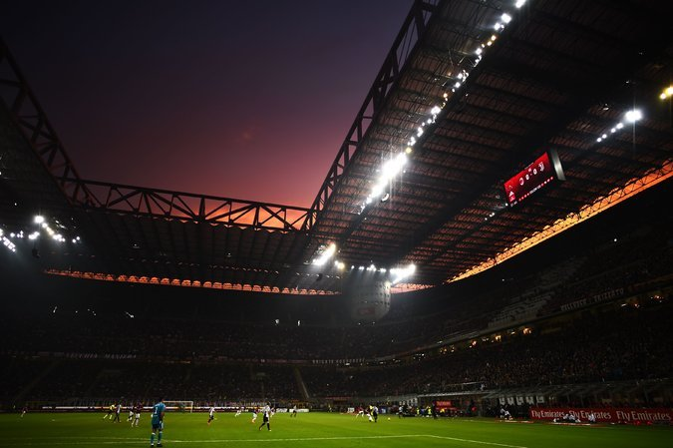
Should UEFA reject the request, Milan will face a range of penalties that could include exclusion from the competitions in which it made its name.
UEFA has so far excluded three clubs for financial fair play breaches: Russia’s Dynamo Moscow, Turkey’s Galatasaray and the Bulgarian club CSKA Sofia. Other penalties include fines — sometimes in the millions of euros — as well as reductions in squad sizes and bans on registering new players.
An A.C. Milan spokesman said Wednesday that the club’s management remains confident it can reach an agreement with UEFA.
Mr. Li’s $860 million takeover of Milan was the biggest among a number of Chinese buyouts in global soccer in recent years. It also was the most-protracted: Mr. Li missed several deadlines to complete the purchase and had to turn to Elliott at the last moment after potential business partners pulled out.
With the clock ticking on the Elliott loan, Mr. Li is rushing to refinance the debt with a different hedge fund, according to a person familiar with the talks. Italian news media reports said the talks are with HPS Investment Partners, formerly a subsidiary of J.P. Morgan Asset Management. A spokesman for the hedge fund declined to comment.

