The men appear on a tintype that is about the size of a man’s palm. (Tintypes are photographic images produced on thin sheets of metal. They became popular during the late 19th century and, as in this case, often show a version of reality that is reversed, left-to-right.)
In 2011, Mr. Abrams saw nothing more than a group of five men who looked like cowboys. He considered it a strange find, since most tintypes that ended up in North Carolina harkened back to the American South, not the Wild West. So he bought it for $10, he said in a phone interview, and put it up in his home. It hung in a room where he hosted Airbnb guests. Mr. Abrams used to jokingly tell them that it was a picture of Jesse James.
A similar find — a tintype that experts said showed Billy the Kid playing croquet with friends — was valued at around $5 million in 2015. The discovery motivated Mr. Abrams to take a closer look at his own picture.

He turned to Google and eventually zeroed in on the man on the right with the severe features and the dark hat. “Oh my gosh,” he recalled saying. “That is Pat Garrett in my picture.”
Continue reading the main story
Then, Mr. Abrams began to wonder about the man in the back with the prominent Adam’s apple. He eventually showed the tintype to Robert Stahl, a retired professor at Arizona State University and an expert on Billy the Kid.
Mr. Stahl encouraged Mr. Abrams to show the image to experts.
William Dunniway, a tintype expert, said the photograph was almost certainly taken between 1875 and 1880. “Everything matches: the plate, the clothing, the firearm,” he said in a phone interview. Mr. Dunniway worked with a forensics expert, Kent Gibson, to conclude that Billy the Kid and Mr. Garrett were indeed pictured.
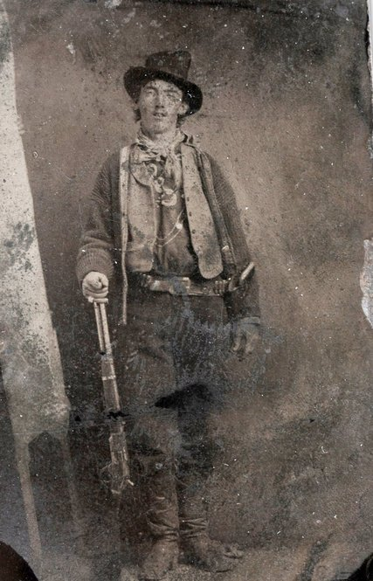
Photo

Mr. Stahl said that Mr. Garrett and Billy the Kid, who also went by William H. Bonney and Henry McCarty, were friends who once gambled together. But when Mr. Garrett was about to become the sheriff of Lincoln County, he urged the outlaw to hit the road.
“Garrett was saying, ‘If you leave New Mexico, I’m not going to pursue you. But if you stay in the territory, then no matter where you are, I have to come after you,’” Mr. Stahl said. That would have been around the time the photo was taken.
Once he became sheriff, Mr. Garrett’s men did indeed capture Billy the Kid. But the outlaw escaped, killing two deputies on the way out of jail. So Mr. Garrett tracked him down again. The story goes that in 1881, Mr. Garrett was in Fort Sumner visiting a friend of the outlaw’s when the Kid arrived unexpectedly; the men couldn’t really see each other, but Mr. Garrett recognized Billy’s voice and quickly shot him dead.

