Benjamin Paul Suntrup
Assignment 4
IS&T 5420
Dr. Hilgers

Plot 1
# Plot 1
dp <- ggplot(diamonds,aes(factor(clarity)))
dp + geom_bar()

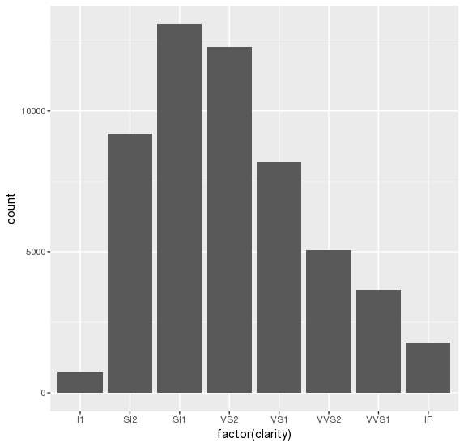

Plot 2

# Plot 2
ggplot(data = diamonds, aes(x = factor(clarity),
fill = factor(cut))) +
geom_bar()

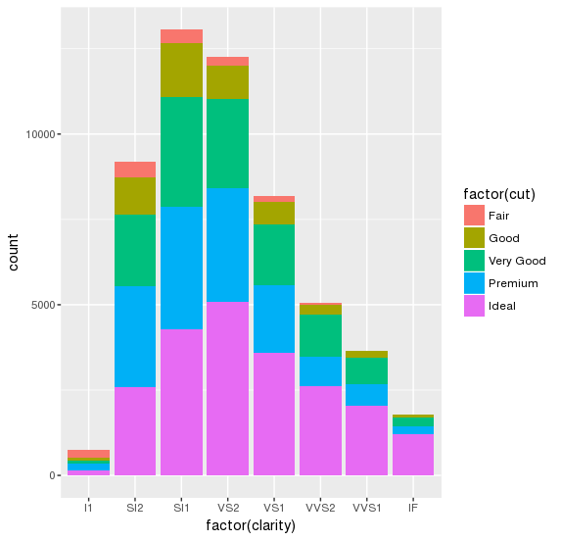

Plot 3

# Plot 3
ggplot(diamonds, aes(x=carat, y=price)) + geom_point()

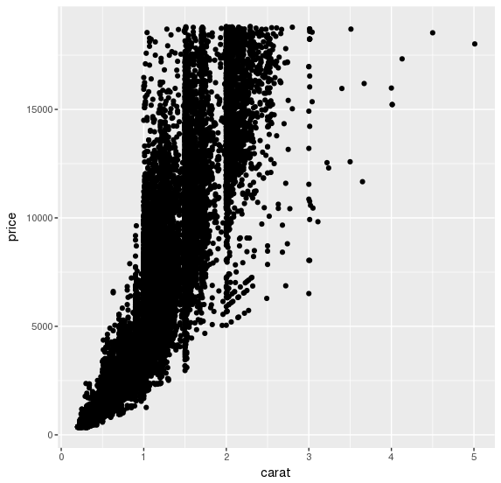

Plot 4

# Plot 4
ggplot(diamonds, aes(x=carat, y=price)) +
geom_point(aes(color=cut))

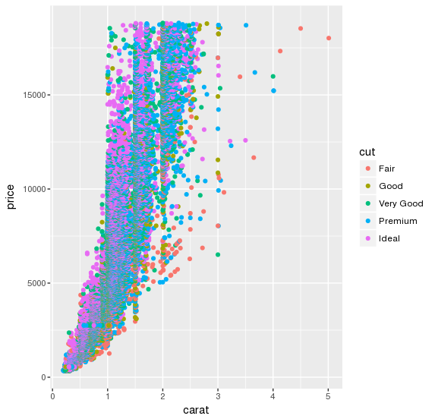

Plot 5

# Plot 5
ggplot(msleep,aes(x=sleep_total)) +
geom_histogram(fill="lightgreen")

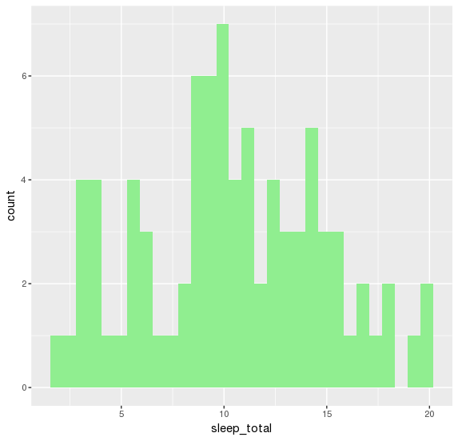
Plot 6
# Plot 6
# See https://stackoverflow.com/questions/34044725/r-split-histogram-according-to-factor-level
ggplot(msleep,aes(x=sleep_total,fill=vore))+
geom_histogram(position="identity",binwidth=1)

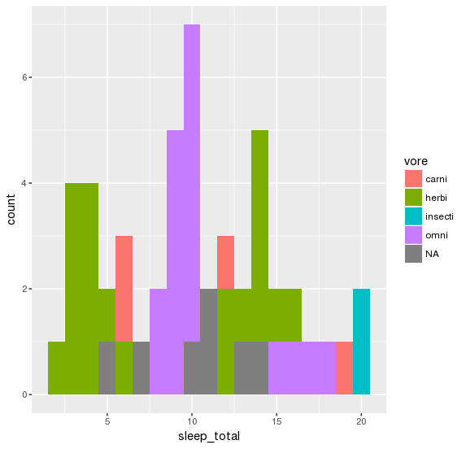
Plot 7
# Plot 7
# See http://t-redactyl.io/blog/2016/03/creating-plots-in-r-using-ggplot2-part-8-density-plots.html
ggplot(msleep, aes(x = sleep_total)) + geom_density() +
geom_vline(xintercept = mean(msleep$sleep_total), size = 1, colour = "#FF3721",
linetype = "dashed")

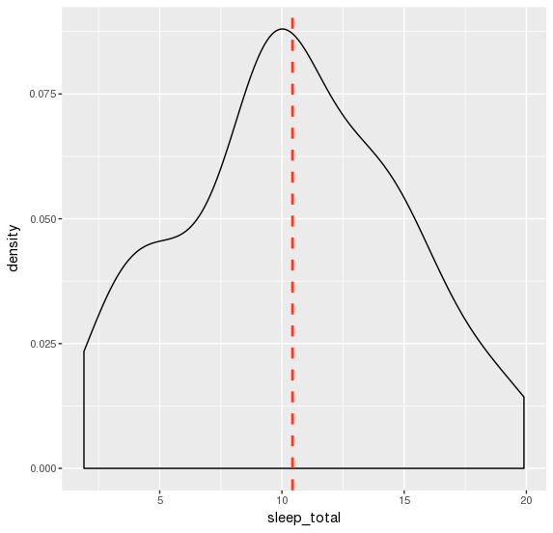

Plot 8
# Plot 8
ggplot(msleep, aes(x = sleep_total, fill = vore)) +
geom_density(position="identity", alpha=0.6) +
scale_x_continuous(name = "Total Sleep Density",
breaks = seq(0, 200, 25)) +
scale_y_continuous(name = "Density") +
ggtitle("Density plot Total Sleep") +
theme_bw() +
theme(plot.title = element_text(size = 14, family = "Tahoma", face = "bold"),
text = element_text(size = 12, family = "Tahoma")) +
scale_fill_brewer(palette="Accent")

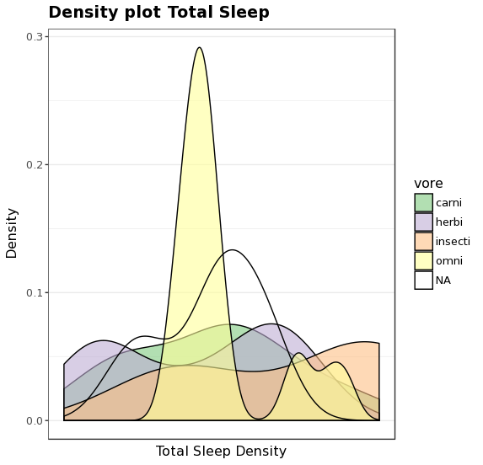

Plot 9

# Plot 9
ggplot(freeny, aes(x = income.level, y = price.index)) + geom_line()

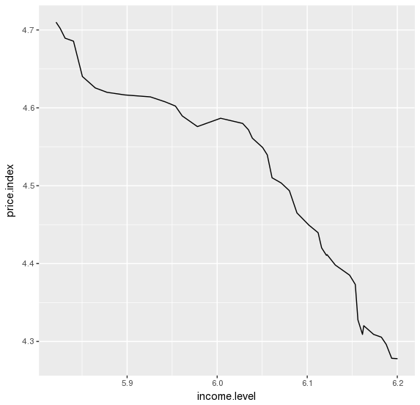
# Plot 9
ggplot(freeny, aes(x = income.level, y = price.index)) + geom_line()
Plot 10

# Plot 10
# Lines are straight.
ggplot(freeny, aes(x = income.level, y = price.index)) + geom_line() + geom_smooth(method = "lm", se = TRUE)

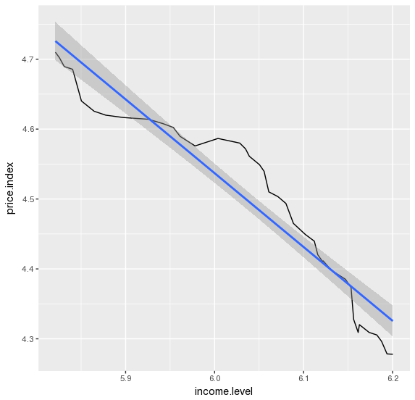
Plot 11

# Plot 11
ggplot(iris, aes(x=Sepal.Width, y=Petal.Width)) + geom_point(aes(color=Species))

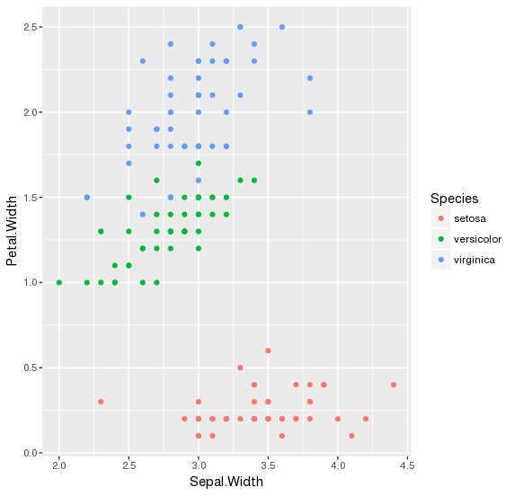

Plot 12

# Plot 12
ggplot(iris, aes(x=Sepal.Width, y=Petal.Width)) + geom_point(aes(color=Species)) + facet_grid(~ Species)

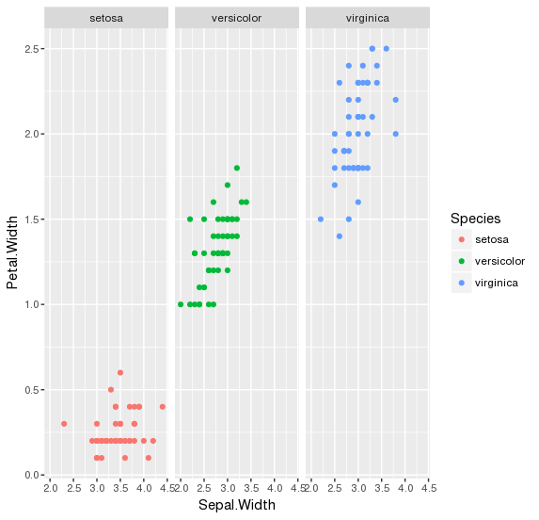
Plot 13

# Plot 13
myMpg <- mpg
myMpg$avg <- rowMeans(cbind(mpg$cty,mpg$hwy))
p13 <- ggplot(myMpg, aes(x=displ, y=avg))
p13 <- p13 + geom_point(aes(color=drv))
p13 <- p13 + facet_grid(~ drv)+ facet_grid(drv ~ cyl)
p13

