1. **Overview**

Buffer overflow is defined as the condition in which a program attempts to write data beyond the boundary of a buffer. This vulnerability can be used by a malicious user to alter the flow control of the program, leading to the execution of malicious code. The objective of this lab is for students to gain practical insights into this type of vulnerability, and learn how to exploit the vulnerability with attacks.

In this lab, students will be given a program with a buffer-overflow vulnerability; their task is to develop a scheme to exploit the vulnerability and finally gain root privilege. In addition to the attacks, students will be guided to walk through several protection schemes that have been implemented by operating systems to counter against buffer-overflow attacks. Students will need to evaluate whether the schemes work or not and explain why.

This lab covers the following topics:

* Buffer Overflow Vulnerability and Attacks
* Stack Layout
* Address Randomization, Non-Executable Stack and Stack Guard
* Shellcode (32/64 bit)

1. **Lab Setup**

Files needed for this lab are included in the Lab_03_BufferOverflow folder

**Turning Off Countermeasures**

Modern operating systems have implemented several security mechanisms to make the buffer-overflow attack difficult. To simplify our attacks, we need to disable them first. Later on, we will enable them and see whether our attack can still be successful or not.

**Address Space Randomization.** Ubuntu and several other Linux-based systems uses address space randomization to randomize the starting address of heap and stack. This makes guessing the exact addresses difficult; guessing addresses is one of the critical steps of buffer-overflow attacks. This feature can be disabled using the following command:

sudo sysctl -w kernel.randomize_va_space=0

**Configuring /bin/sh.** In the recent versions of Ubuntu, the /bin/sh symbolic link points to the /bin/dash shell. The dash program, as well as bash, has implemented a security countermeasure that prevents itself from being executed in a Set-UID process. Basically, if they detect that they are executed in a Set-UID process, they will immediately change the effective user ID to the process’s real user ID, essentially dropping the privilege.

Since our victim program is a Set-UID program, and our attack relies on running /bin/sh, the countermeasure in /bin/dash makes our attack more difficult. Therefore, we will link /bin/sh to another shell that does not have such a countermeasure (in later tasks, we will show that with a little bit more effort, the countermeasure in /bin/dash can be easily defeated). Please install zsh if it is not already installed and run the following command to link /bin/sh to it.

sudo ln -sf /bin/zsh /bin/sh

**StackGuard and Non-Executable Stack.** These are two additional countermeasures implemented in the system. They can be turned off during the compilation. We will discuss them later when we compile the vulnerable program.

**Shellcode**

The ultimate goal of buffer-overflow attacks is to inject malicious code into the target program, so the code can be executed using the target program’s privilege. Shellcode is widely used in most code-injection attacks. Let us get familiar with it in this task.

A shellcode is basically a piece of code that launches a shell. If we use C code to implement it, it will look like the following:

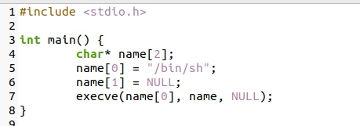

Unfortunately, we cannot just compile this code and use the binary code as our shellcode. The best way to write shellcode is to use assembly code. Below is an example of shellcode for a 32 bit program.

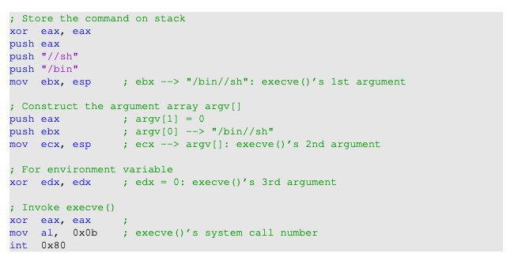

A few things to note:

* The third instruction pushes "//sh", rather than "/sh" into the stack. This is because we need a 32-bit number here, and "/sh" has only 24 bits. Fortunately, "//" is equivalent to "/", so we can get away with a double slash symbol.
* We need to pass three arguments to execve() via the ebx, ecx and edx registers, respectively. The majority of the shellcode basically constructs the content for these three arguments.
* The system call execve() is called when we set al to 0x0b, and execute "int 0x80".

**Question:** Why the shellcode using xor?

Below is a sample 64-bit shellcode. It is quite similar to the 32-bit shellcode, except that the names of the registers are different and the registers used by the execve() system call are also different. Some explanation of the code is given in the comment section, and we will not provide detailed explanation on the shellcode.

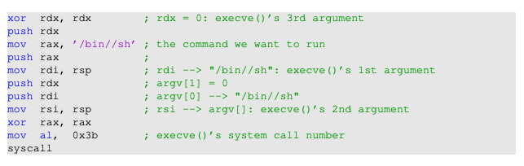

1. **Lab Tasks**
   1. **Task A: Invoking the shellcode**

We have generated the binary code from the assembly code above, and put the code in a C program called call shellcode.c inside the shellcode folder.

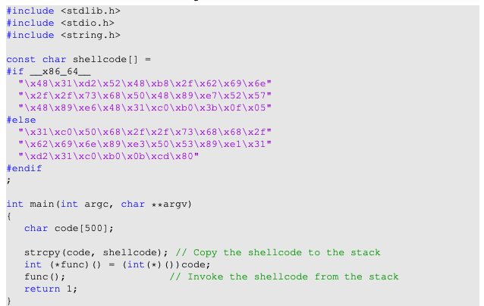

Listing 1 call_shellcode.c

The code above includes two copies of shellcode, one is 32-bit and the other is 64-bit. When we compile the program using the -m32 flag, the 32-bit version will be used; without this flag, the 64-bit version will be used. Using the provided Makefile, you can compile the code by typing make. Two binaries will be created, a32.out (32-bit) and a64.out (64-bit). Run them and describe your observations. It should be noted that the compilation uses the execstack option, which allows code to be executed from the stack; without this option, the program will fail.

* 1. **Task B: Understanding the Vulnerable Program**

The vulnerable program used in this lab is called stack.c, which is in the code folder. This program has a buffer-overflow vulnerability, and your job is to exploit this vulnerability and gain root privilege. The code listed below has some non-essential information removed, so it is slightly different from what you get from the lab setup file

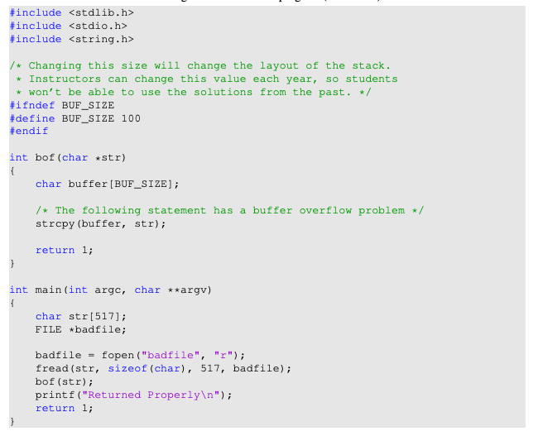

Listing 2 stack.c

The above program has a buffer overflow vulnerability. It first reads an input from a file called badfile, and then passes this input to another buffer in the function bof(). The original input can have a maximum length of 517 bytes, but the buffer in bof() is only BUF SIZE bytes long, which is less than 517. Because strcpy() does not check boundaries, buffer overflow will occur. Since this program is a root-owned Set-UID program, if a normal user can exploit this buffer overflow vulnerability, the user might be able to get a root shell. It should be noted that the program gets its input from a file called badfile. This file is under users’ control. Now, our objective is to create the contents for badfile, such that when the vulnerable program copies the contents into its buffer, a root shell can be spawned.

**Compilation**. To compile the above vulnerable program, do not forget to turn off the StackGuard and the non-executable stack protections using the -fno-stack-protector and "-z execstack" options. After the compilation, we need to make the program a root-owned Set-UID program. We can achieve this by first change the ownership of the program to root (Line ➀), and then change the permission to 4755 to enable the Set-UID bit (Line ➁). It should be noted that changing ownership must be done before turning on the Set-UID bit, because ownership change will cause the Set-UID bit to be turned off.

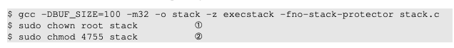

The compilation and setup commands are already included in Makefile, so we just need to type make to execute those commands.

* 1. **Task C: Launching Attack on 32-bit Program – Level 1**

To exploit the buffer-overflow vulnerability in the target program, the most important thing to know is the distance between the buffer’s starting position and the place where the return-address is stored. We will use a debugging method to find it out. Since we have the source code of the target program, we can compile it with the debugging flag turned on. That will make it more convenient to debug.

We will add the -g flag to gcc command, so debugging information is added to the binary. If you run make, the debugging version is already created. We will use gdb to debug stack-L1-dbg. We need to create a file called badfile before running the program.

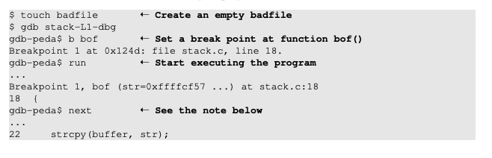

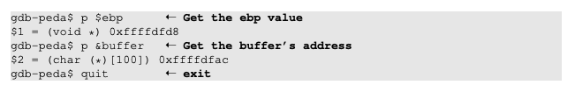

**Note 1.** When gdb stops inside the bof() function, it stops before the ebp register is set to point to the current stack frame, so if we print out the value of ebp here, we will get the caller’s ebp value. We need to use next to execute a few instructions and stop after the ebp register is modified to point to the stack frame of the bof() function.

**Note 2.** It should be noted that the frame pointer value obtained from gdb is different from that during the actual execution (without using gdb). This is because gdb has pushed some environment data into the stack before running the debugged program. When the program runs directly without using gdb, the stack does not have those data, so the actual frame pointer value will be larger. You should keep this in mind when constructing your payload.

To exploit the buffer-overflow vulnerability in the target program, we need to prepare a payload, and save it inside badfile. We will use a Python program to do that. We provide a skeleton program called exploit.py, which is included in the lab setup file. The code is incomplete, and students need to replace some of the essential values in the code

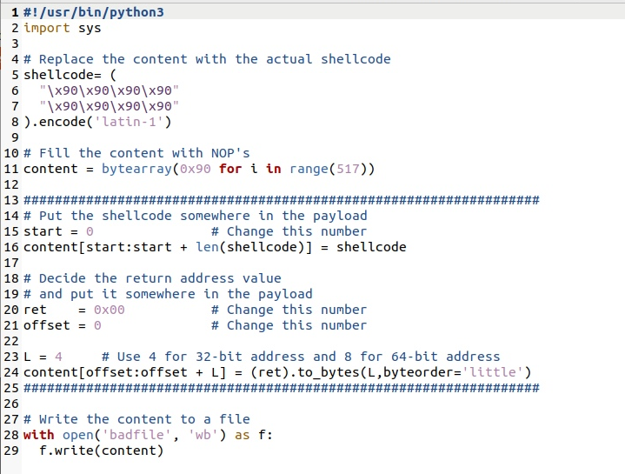

After you finish the above program, run it. This will generate the contents for badfile. Then run the vulnerable program stack. If your exploit is implemented correctly, you should be able to get a root shell:



* 1. **Task D: Launching Attack on 32-bit Program – Level 2**

In the Level-1 attack, using gdb, we get to know the size of the buffer. In the real world, this piece of information may be hard to get. For example, if the target is a server program running on a remote machine, we will not be able to get a copy of the binary or source code. In this task, we are going to add a constraint: you can still use gdb, but you are not allowed to derive the buffer size from your investigation. Actually, the buffer size is provided in Makefile, but you are not allowed to use that information in your attack.

Your task is to get the vulnerable program to run your shellcode under this constraint. We assume that you do know the range of the buffer size, which is from 100 to 200 bytes. Another fact that may be useful to you is that, due to the memory alignment, the value stored in the frame pointer is always multiple of four (for 32-bit programs).

Please be noted, you are only allowed to construct one payload that works for any buffer size within this range. You will not get all the credits if you use the brute-force method, i.e., trying one buffer size each time. The more you try, the easier it will be detected and defeated by the victim. That’s why minimizing the number of trials is important for attacks. In your lab report, you need to describe your method, and provide evidences.

* 1. **Task E: Launching Attack on 64-bit Program – Level 3**

In this task, we will compile the vulnerable program into a 64-bit binary called stack-L3. We will launch attacks on this program. The compilation and setup commands are already included in Makefile. Similar to the previous task, detailed explanation of your attack needs to be provided in the lab report.

Using gdb to conduct an investigation on 64-bit programs is the same as that on 32-bit programs. The only difference is the name of the register for the frame pointer. In the x86 architecture, the frame pointer is ebp, while in the x64 architecture, it is rbp.

**Challenges**. Compared to buffer-overflow attacks on 32-bit machines, attacks on 64-bit machines is more difficult. The most difficult part is the address. Although the x64 architecture supports 64-bit address space, only the address from 0x00 through 0x00007FFFFFFFFFFF is allowed. That means for every address (8 bytes), the highest two bytes are always zeros. This causes a problem. In our buffer-overflow attacks, we need to store at least one address in the payload, and the payload will be copied into the stack via strcpy(). We know that the strcpy() function will stop copying when it sees a zero. Therefore, if zero appears in the middle of the payload, the content after the zero cannot be copied into the stack. How to solve this problem is the most difficult challenge in this attack.

* 1. **Task F: Launching Attack on 64-bit Program – Level 4**

The target program (stack-L4) in this task is similar to the one in the Level 2, except that the buffer size is extremely small. We set the buffer size to 10, while in Level 2, the buffer size is much larger. Your goal is the same: get the root shell by attacking this Set-UID program. You may encounter additional challenges in this attack due to the small buffer size. If that is the case, you need to explain how your have solved those challenges in your attack.

* 1. **Task G: Defeating dash’s Countermeasures**

The dash shell in the Ubuntu OS drops privileges when it detects that the effective UID does not equal to the real UID (which is the case in a Set-UID program). This is achieved by changing the effective UID back to the real UID, essentially, dropping the privilege. In the previous tasks, we let /bin/sh points to another shell called zsh, which does not have such a countermeasure. In this task, we will change it back, and see how we can defeat the countermeasure. Please do the following, so /bin/sh points back to /bin/dash.



To defeat the countermeasure in buffer-overflow attacks, all we need to do is to change the real UID, so it equals the effective UID. When a root-owned Set-UID program runs, the effective UID is zero, so before we invoke the shell program, we just need to change the real UID to zero. We can achieve this by invoking setuid(0) before executing execve() in the shellcode.

The following assembly code shows how to invoke setuid(0). The binary code is already put inside call shellcode.c. You just need to add it to the beginning of the shellcode.

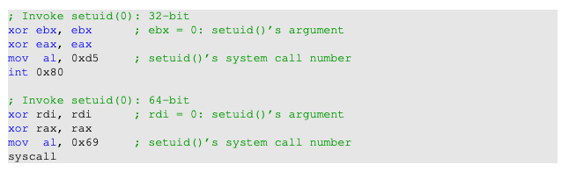

**Experiment**. Compile call shellcode.c into root-owned binary (by typing "make setuid"). Run the shellcode a32.out and a64.out with or without the setuid(0) system call. Please describe and explain your observations.

**Launching the attack again.** Now, using the updated shellcode, we can attempt the attack again on the vulnerable program, and this time, with the shell’s countermeasure turned on. Repeat your attack on Level 1, and see whether you can get the root shell. After getting the root shell, please run the following command to prove that the countermeasure is turned on. Although repeating the attacks on Levels 2 and 3 are not required, feel free to do that and see whether they work or not.



* 1. **Task H: Defeating Address Randomization**

On 32-bit Linux machines, stacks only have 19 bits of entropy, which means the stack base address can have 2^19 = 524, 288 possibilities. This number is not that high and can be exhausted easily with the brute-force approach. In this task, we use such an approach to defeat the address randomization countermeasure on our 32-bit VM. First, we turn on the Ubuntu’s address randomization using the following command. Then we run the same attack against stack-L1. Please describe and explain your observation.



We then use the brute-force approach to attack the vulnerable program repeatedly, hoping that the address we put in the badfile can eventually be correct. We will only try this on stack-L1, which is a 32-bit program. You can use the following shell script to run the vulnerable program in an infinite loop. If your attack succeeds, the script will stop; otherwise, it will keep running. Please be patient, as this may take a few minutes, but if you are very unlucky, it may take longer. Please describe your observations.

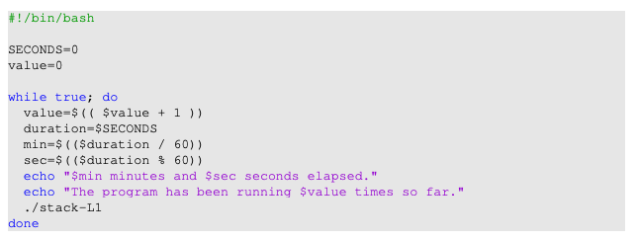

Brute-force attacks on 64-bit programs is much harder, because the entropy is much larger.

* 1. **Task I: Try with StackGuard**

Many compilers, such as gcc, implements a security mechanism called StackGuard to prevent buffer overflows. In the presence of this protection, buffer overflow attacks will not work. In our previous tasks, we disabled the StackGuard protection mechanism when compiling the programs. In this task, we will turn it on and see what will happen.

First, repeat the Level-1 attack with the StackGuard off, and make sure that the attack is still successful. Remember to turn off the address randomization, because you have turned it on in the previous task. Then, we turn on the StackGuard protection by recompiling the vulnerable stack.c program without the -fno-stack-protector flag. In gcc version 4.3.3 and above, StackGuard is enabled by default. Launch the attack; report and record your observations.

* 1. **Task J: Non-executable Stack Protection**

Operating systems used to allow executable stacks, but this has now changed: In Ubuntu OS, the binary images of programs (and shared libraries) must declare whether they require executable stacks or not, i.e., they need to mark a field in the program header. Kernel or dynamic linker uses this marking to decide whether to make the stack of this running program executable or non-executable. This marking is done automatically by the gcc, which by default makes stack non-executable. We can specifically make it nonexecutable using the "-z noexecstack" flag in the compilation. In our previous tasks, we used "-z execstack" to make stacks executable.

In this task, we will make the stack non-executable. We will do this experiment in the shellcode folder. The call shellcode program puts a copy of shellcode on the stack, and then executes the code from the stack. Please recompile call shellcode.c into a32.out and a64.out, without the "-z execstack" option. Run them, describe and explain your observations

**Defeating the non-executable stack countermeasure.** It should be noted that non-executable stack only makes it impossible to run shellcode on the stack, but it does not prevent buffer-overflow attacks, because there are other ways to run malicious code after exploiting a buffer-overflow vulnerability. The return-to-libc attack is an example.

1. **Submission**

Once you have finished all of the tasks, email your submission to [brian.swenson@gtri.gatech.edu](mailto:brian.swenson@gtri.gatech.edu). You submission should include your observations where requested in the lab and byte offsets used in badfile to obtain a root shell for the tasks in section 3. Include in your submission your name and the name of your partner if you worked on the lab in pairs.

1. **References**

This lab is based on the seed 2.0 labs created by Wenliang Du and is protected by the following license:

