1. **Overview**

The learning objective of this lab is for students to gain the first-hand experience on a race-condition vulnerability by putting what they have learned about the vulnerability in class into action. A race condition occurs when multiple processes access and manipulate the same data concurrently and the outcome of the execution depends on the particular order in which the access takes place. If a privileged program has a race-condition vulnerability, attackers can run a parallel process to “race” against the privileged program, with an intention to change the behavior of the program.

In this lab, students will be given a program with a race-condition vulnerability; their task is to develop a scheme to exploit the vulnerability and gain root privilege. In addition to the attacks, students will be guided to walk through several protection schemes that can be used to counter the race-condition attacks. Students need to evaluate whether the schemes work or not and explain why. This lab covers the following topics:

This lab covers the following topics:

* Race Condition Vulnerability
* Sticky Symlink Protection
* Principle of Least Privilege

1. **Lab Setup**

Files needed for this lab are included in the Lab_04_RaceCondition folder

**Turning Off Countermeasures**

Ubuntu has a built-in protection against the race condition attacks demonstrated in this lab. This scheme works by restricting who can follow a symlink. According to the documentation, “symlinks in world-writable sticky directories (e.g. /tmp) cannot be followed if the follower and directory owner do not match the symlink owner.” Ubuntu 20.04 introduced another security mechanism that prevents the root from writing to the files in /tmp that are owned by others. In this lab, we need to disable these protections. You can achieve that using the following commands:



The following program is a seemingly harmless program. It contains a race-condition vulnerability.

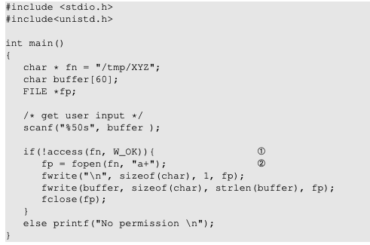

Listing 1 vulp.c

The program above is a root-owned Set-UID program; it appends a string of user input to the end of a temporary file /tmp/XYZ. Since the code runs with root privileges, i.e., its effective user ID is zero, it can overwrite any file. To prevent itself from accidentally overwriting other people’s files, the program first checks whether the real user ID has the access permission to the file /tmp/XYZ; that is the purpose of the access() call in Line ➀. If the real user ID indeed has the correct permissions, the program opens the file in Line ➁ and appends the user input to the file.

At first glance the program does not seem to have any problem. However, there is a race condition vulnerability in this program: due to the time window between the check (access) and the use (fopen), there is a possibility that the file used by access() is different from the file used by fopen(), even though they have the same file name /tmp/XYZ. If a malicious attacker can somehow makes /tmp/XYZ a symbolic link pointing to a protected file, such as /etc/passwd, inside the time window, the attacker can cause the user input to be appended to /etc/passwd, and can thus gain root privileges. The vulnerable program runs with root privileges, so it can overwrite any file.

**Set up the Set-UID program.** We first compile the above code, and turn its binary into a Set-UID program that is owned by the root. The following commands achieve this goal:



1. **Lab Tasks**
   1. **Task A:**

We would like to exploit the race condition vulnerability in the program. We choose to target the password file /etc/passwd, which is not writable by normal users. By exploiting the vulnerability, we would like to add a record to the password file, with a goal of creating a new user account that has root privileges. Inside the password file, each user has an entry, which consists of seven fields separated by colons (:). The entry for the root user is listed below:



For the root user, the third field (the user ID field) has a value zero. Namely, when the root user logs in, its process’s user ID is set to zero, giving the process root privileges. Basically, the power of the root account does not come from its name, but instead from the user ID field. If we want to create an account with root privileges, we just need to put a zero in this field. Each entry also contains a password field, which is the second field. In the example above, the field is set to "x", indicating that the password is stored in another file called /etc/shadow (the shadow file). If we follow this example, we have to use the race condition vulnerability to modify both password and shadow files, which is not very hard to do. However, there is a simpler solution. Instead of putting "x" in the password file, we can simply put the password there, so the operating system will not look for the password from the shadow file. The password field does not hold the actual password; it holds the one-way hash value of the password. To get such a value for a given password, we can add a new user in our own system using the adduser command, and then get the one-way hash value of our password from the shadow file. Interestingly, there is a magic value used in Ubuntu live CD for a password-less account, and the magic value is 6aMy0wojraho (the 6th character is zero, not letter O). If we put this value in the password field of a user entry, we only need to hit the return key when prompted for a password.

To verify whether the magic password works or not, we manually (as a superuser) add the following entry to the end of the /etc/passwd file. Please report whether you can log into the the account without typing a password, and check whether it has root privileges.

test:U6aMy0wojraho:0:0:test:/root:/bin/bash

After this task, please remove this entry from the password file. In the next task, we need to achieve this goal as a normal user. Clearly, we are not allowed to do that directly to the password file, but we can exploit a race condition in a privileged program to achieve the same goal.

**NOTE:** At this point please make a copy of the passwd file in case something bad happens to it.

sudo cp /etc/passwd /etc/passwd_back

* 1. **Task B: Launch Race Condition**

The goal of this task is to exploit the race condition vulnerability in the vulnerable Set-UID program listed earlier. The ultimate goal is to gain the root privilege. The most critical step of the attack, making /tmp/XYZ point to the password file, must occur within the window between check and use; namely between the access and fopen calls in the vulnerable program.

* **Simulate A Slow Machine**

Let us pretend that the machine is very slow, and there is a 10-second time window between the access() and fopen() calls. To simulate that, we add a sleep(10) between them. The program will look like the following:

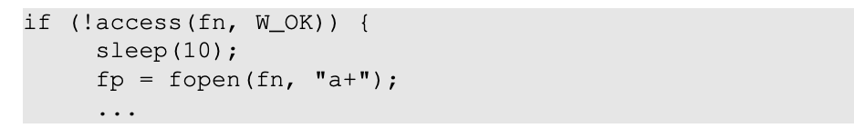

With this addition, the vulp program (when re-compiled) will pause and yield control to the operating system for 10 seconds. Your job is to manually do something, so when the program resumes after 10 seconds, the program can help you add a root account to the system. Please demonstrate how you would achieve this. You won’t be able to modify the file name /tmp/XYZ, because it is hardcoded in the program, but you can use symbolic links to change the meaning of this name. For example, you can make /tmp/XYZ a symbolic link to the /dev/null file. When you write to /tmp/XYZ, the actual content will be written to /dev/null. See the following example (the "f" option means that if the link exists, remove the old one first):

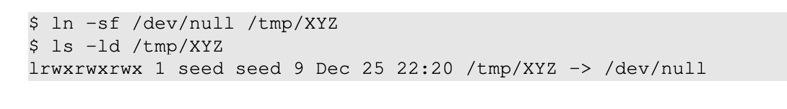

* **The Real Attack**

In the previous task, we have kind of “cheated” by asking the vulnerable program to slow down, so we can launch the attack. This is definitely not a real attack. In this task, we will launch the real attack. Before doing this task, make sure that the sleep() statement is removed from the vulp program. The typical strategy in race condition attacks is to run the attack program in parallel to the target program, hoping to be able to do the critical step within that time window. Unfortunately, perfect timing is very hard to achieve, so the success of attack is only probabilistic. The probability of a successful attack might be quite low if the window is small, but we can run the attack many many times. We just need to hit the race condition window once.

**Writing the Attack Program**

In the simulated attack, we use the "ln -s" command to make/change symbolic links. Now we need to do it in a program. We can use symlink() in C to create symbolic links. Since Linux does not allow one to create a link if the link already exists, we need to delete the old link first. The following C code snippet shows how to remove a link and then make /tmp/XYZ point to /etc/passwd. Please write your attack program

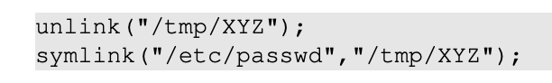

**Running the vulnerable program and monitoring results.**

Since we need to run the vulnerable program many times, we will write a program to automate this process. To avoid manually typing an input to the vulnerable program vulp, we can use input redirection. Namely, we save our input in a file, and ask vulp to get the input from this file using "vulp < inputFile". We can also use pipe (an example will be given later). It may take a while before our attack can successfully modify the password file, so we need a way to automatically detect whether the attack is successful or not. There are many ways to do that; an easy way is to monitor the timestamp of the file. The following shell script runs the "ls -l" command, which outputs several pieces of information about a file, including the last modified time. By comparing the outputs of the command with the ones produced previously, we can tell whether the file has been modified or not. The following shell script runs the vulnerable program (vulp) in a loop, with the input given by the echo command (via a pipe). You need to decide what should be the actual input. If the attack is successful, i.e., the passwd is modified, the shell script will stop. You do need to be a little bit patient. Normally, you should be able to succeed within 5 minutes.

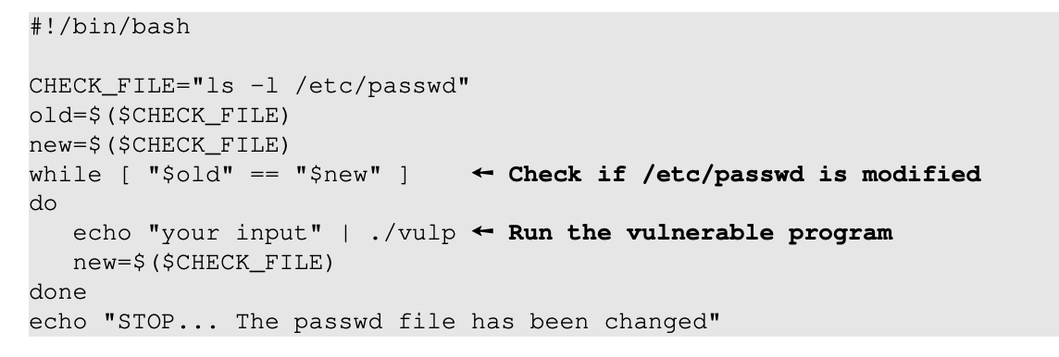

**Verifying success**

When your script terminates, test the success of your exploit by logging in as the test user and verifying root privileges. Then terminate the attack program by pressing Ctrl-C in the Terminal window in which you started the program.

**Note**: If after 10 minutes, your attack is still not successful, you can stop the attack, and check the ownership of the /tmp/XYZ file. If the owner of this file becomes root, manually delete this file, and try your attack again, until your attack becomes successful. Please document this observation in your lab report. In the next task, we will explain the reason and provide an improved attack method.

* **Improved Attack Method**

In the previous task, if you have done everything correctly, but still could not succeed in the attack, check the ownership of /tmp/XYZ. You will find out that /tmp/XYZ’s owner has become root (normally, it should be owned by student). If this happens, your attack will never succeed, because your attack program, running with the student privilege, can no longer remove or unlink() it. This is because the /tmp folder has a “sticky” bit on, meaning that only the owner of the file can delete the file, even though the folder is world-writable.

Previously, we let you use the root’s privilege to delete /tmp/XYZ, and then try your attack again. The undesirable condition happens randomly, so by repeating the attack (with the “help” from root), you will eventually succeed in the previous attack. Obviously, getting help from root is not a real attack. We would like to get rid of that, and do it without root’s help.

The main reason for that undesirable situation is that our attack program has a problem, a race condition problem, the exact problem that we are trying to exploit in the victim program. How ironic! The main reason for the situation to happen is that the attack program is context switched out right after it removes /tmp/XYZ (i.e., unlink()), but before it links the name to another file (i.e., symlink(). Remember, the action to remove the existing symbolic link and create a new one is not atomic (it involves two separate system calls), so if the context switch occurs in the middle (i.e., right after the removal of /tmp/XYZ), and the target Set-UID program gets a chance to run its fopen(fn, "a+") statement, it will create a new file with root being the owner. After that, your attack program can no longer make changes to /tmp/XYZ.

Basically, using the unlink() and symlink() approach, we have a race condition in our attack program. Therefore, while we are trying to exploit the race condition in the target program, the target program may accidentally “exploit” the race condition in our attack program, defeating our attack.

To solve this problem, we need to make unlink() and symlink() atomic. Fortunately, there is a system call that allows us to achieve that. More accurately, it allows us to atomically swap two symbolic links. The following program first makes two symbolic links /tmp/XYZ and /tmp/ABC, and then using the renameat2 system call to atomically switch them. This allows us to change what /tmp/XYZ points to without introducing any race condition.

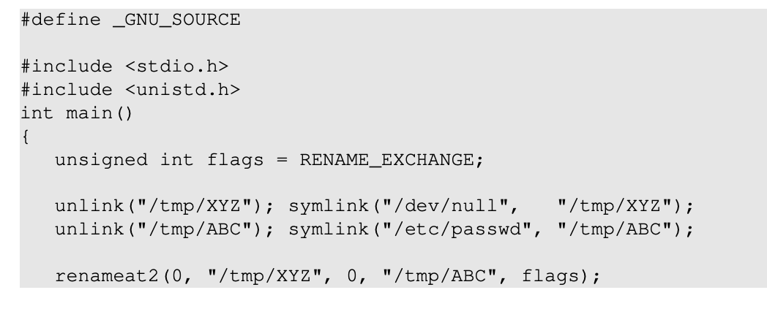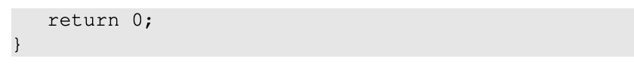

**Tasks**. Please revise your attack program using this new strategy, and try your attack again. If everything is done correctly, your attack should be able to succeed.

1. **Submission**

Once you have finished all of the tasks, email your submission to [brian.swenson@gtri.gatech.edu](mailto:brian.swenson@gtri.gatech.edu). You submission should include your observations where requested. Include in your submission your name and the name of your partner if you worked on the lab in pairs.

1. **References**

This lab is based on the seed 2.0 labs created by Wenliang Du and is protected by the following license:

