SE Attainment Tracker — Quick Start Guide
For Sales Engineers
App: https://se-quota-tracker.web.app
Last updated: July 2026

What this app does
The SE Attainment Tracker shows you, in real time, how your region is tracking against quota and what your estimated commission looks like. Closed Won data is pulled in automatically every night — there's no spreadsheet and no deal entry. You just sign in and check your numbers.
Two things to know up front:
- All amounts are in USD. Quotas are set in USD and converted to your local currency by the company when you're paid.
- Everything shown is an estimate to help you plan. Your actual commission is confirmed by Finance.

1. Sign in
- Go to https://se-quota-tracker.web.app
- Click Sign in with Google and choose your Simpro work account.
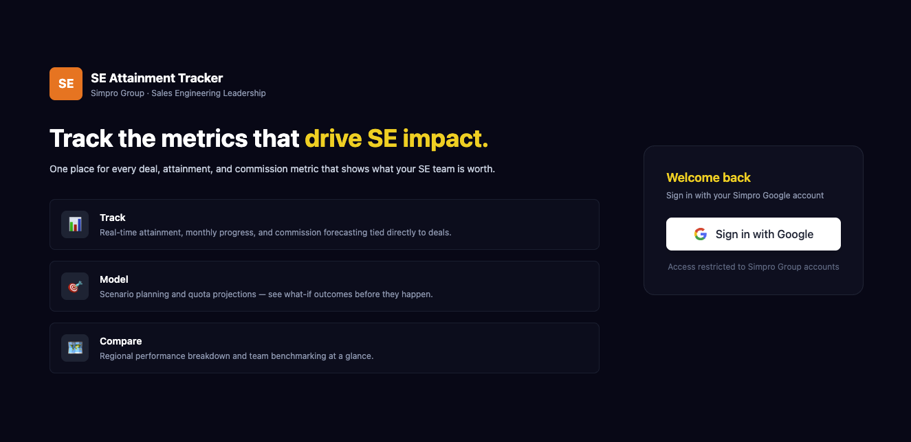

2. First-time setup (one time only)
The first time you sign in, a short setup wizard appears.
Step 1 — About you
- Your name (usually filled in automatically).
- Regions you support — tick one or more (most SEs tick just one). This tells the app which team's Closed Won counts toward your attainment.
Step 2 — Your comp plan
- Annual total OTE — your total on-target cash earnings for the year (base plus variable), used to derive the 30% commission target.
- Quarterly quotas (Q1–Q4) — your targets in USD, straight from your signed comp plan. Some regions pre-fill standard quotas — just check they're right.
Step 3 — Launch
- Click Launch Dashboard. You're set up. (You can change any of this later — see section 6.)
📷 Screenshot: The setup wizard (name + regions, then OTE & quotas)
Paste your screenshot here, then delete this placeholder line.

Your dashboard — a quick tour
- Top bar — your headline tiles for the selected month: attainment to quota, estimated commission, your region's Closed Won, and days remaining.
- Month selector (top right) — switch months to see past or current performance.
- Quota Progress bar — how your region's Closed Won is tracking against your personal monthly quota.
- 2026 Monthly Attainment chart — one bar per month with your attainment %, so you can see your trend across the year.
- Commission Earned This Month — your estimated payout for the month, with a projection of where you'll land.
- Quarterly Summary (right side) — your quarter so far and the projected quarterly commission.

4. How your commission works (the short version)
You don't need to do any math — the app does it — but here's the gist:
- You're measured on your region's Closed Won against your personal quota. Teammates share the same regional Closed Won pool, but attainment can differ if personal quotas differ.
- Each month is calculated independently using that month's eligible Closed Won, monthly quota, and monthly commission target.
- Commission begins with the first dollar of eligible Closed Won, and the monthly estimate is capped at 200% of the monthly commission target.

Getting paid
Commission is paid after each month closes:
Region | When
ANZ | +45 days after month-end
UK, US & BigChange | +30 days after month-end
For UK, US, BigChange, and ClockShark, June earned commission is expected as a July payment; ANZ follows its approximately 45-day schedule.
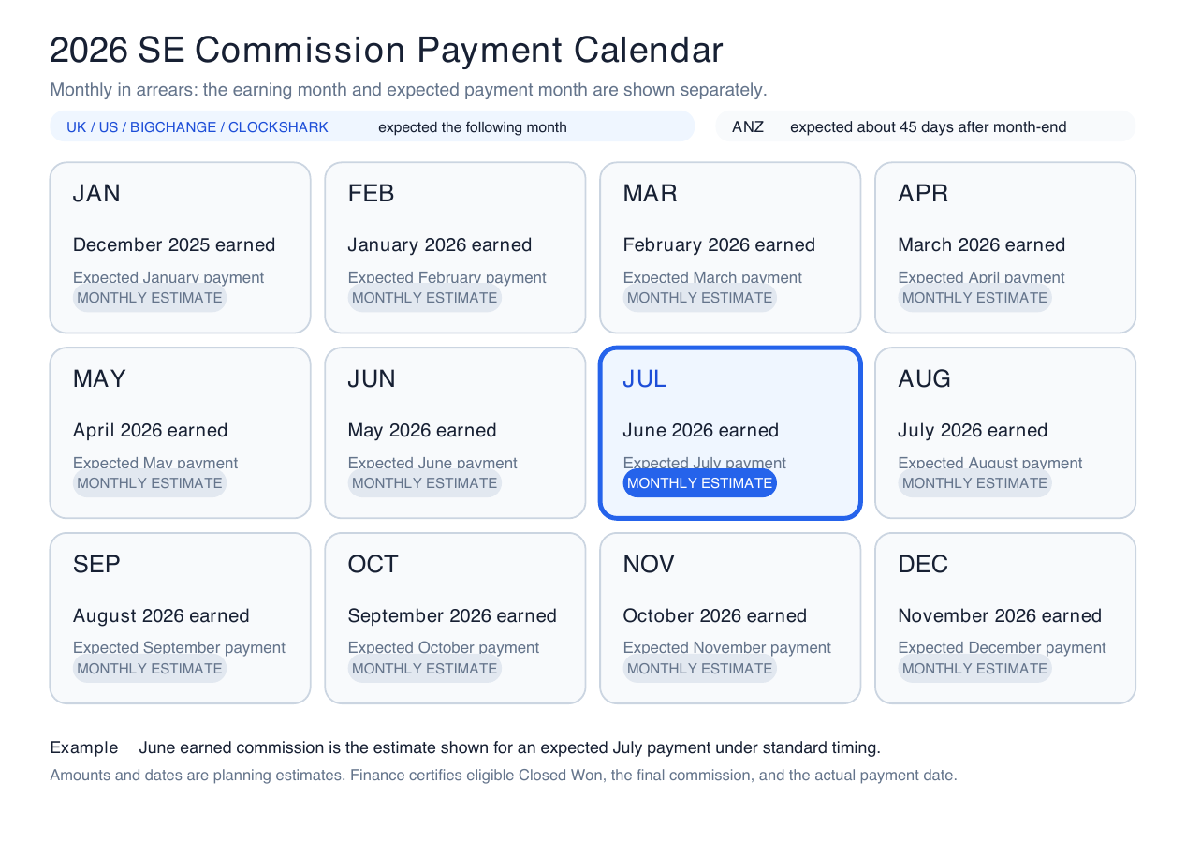

5. Try a "what-if"
Want to see what a certain amount of Closed Won would pay you? Use the Scenario box on your dashboard: type in a Closed Won figure and it shows the estimated commission for that month, the quarter, and an annual run-rate.
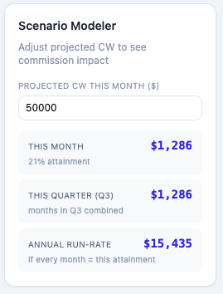

6. Update your comp plan
Your OTE and quotas aren't locked in. In the Comp Plan panel on the left of your dashboard you can update your Annual Total OTE or quarterly quotas at any time — changes save automatically. To start over, use Reset Profile / Re-run Setup.

Quick FAQ
Why might my attainment differ from a teammate's? Commission uses the same regional Closed Won pool for both of you, but each SE's personal monthly quota is authoritative. If the quotas differ, the attainment percentages differ.
Where do the numbers come from? Closed Won is pulled automatically from the company data warehouse every night. You don't enter any deal data yourself.
Why don't my numbers match the CRO / forecast tool? This app shows MRR; the CRO tool shows ARR (roughly 12× larger for the same deals). Same deals, different unit — not an error.
When will I actually be paid? See the "Getting paid" table in section 4.
Something looks off — who do I contact? Reach out to your SE leader (Brad Towers) or RevOps.

All figures are estimates for planning. Actual commission is certified by Finance and may vary.

