Ben Pung

Prof Orduz

Advanced Algorithms

8 December 2023

6.11

1.

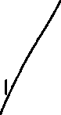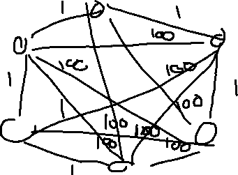

2. No it does not follow the triangle rule.