1. **Scope**

The purpose of creating a smart phone to PC voting system is to provide an easy way for attendants of the University of Pittsburgh Computer Science Day to vote on the best poster. This will enable users to tally their vote for their favorite project poster. Connecting an already common device, the mobile smart phone, with a simple, quick way to cast their vote should increase the number of participating attendants.

* 1. **Functions**
* Vote
  + Check if phone number is unique
  + Check if poster number exists
  + If phone number is unique, create database entry for voter
    - Phone number
    - Poster number
  + If poster number doesn’t exist, create database entry for poster
    - Poster number, Number of votes
  + Update Poster number of votes
* View Results
  + Retrieve each Poster database entry
    - Poster number, Number of votes
  + Display all Poster entries sorted in descending order by number of votes
* View Trends
  + Get votes from past three hours.
  + Get posters for each vote.
  + Get each tag from the posters.
  + Count each tag
  + Display top three tags
  1. **Performance**
* Be able to support 5,000 concurrent voters
* Be able to store information on 50,000 votes
* Be able to store information for 50,000 voters
  1. **Limitations**
* Can only receive 1 GB of incoming email data per day (max rate of 56 MB per min)
* Can only perform 50,000 write operations on votes/voters database per day
* Can only perform 50,000 read operations on votes/voter database per day
* Max database size of 1 GB
* Only receive votes through email
* Only 28 instance-hours for viewing voting results
* No changing votes
* Need FireFox installed to use Selenium test

1. **Tasks**

In order to successfully develop this application, there are five primary tasks that need to be accomplished:

* Creation of an email receiver based on a python server
* Creation and maintenance of a database to store information on voters and votes
* Creation of the actual application software that will gather necessary information from the database and provide results to the user interface
* Creation of well written and organized documentation of application commands
* Creation and implementation of a strong test plan to insure the final product meets our standards for quality

**3.0 Testing**

To test this application we have developed an automated testing scenario tool using Selenium for windows. The tool is a GUI executable that is written in Java. The test will follow the following procedure:

* Login as an admin
* Stop Voting
* Clear the database
* Start Voting
* Vote
* Login as a different user
* Vote
* Login as third user
* Vote
* Login as fourth and final user
* Vote
* View results
* Wait for a minute (literal)
* View results to see change in trends

**4.0 Source Code**

**There is far too much code for this project to display it in this document.**

**To find the source code navigate to the subdirectory “Source”.**

**5.0 Example Test**

**Double clicking Run_Trend_Test.exe will result in the picture below:**

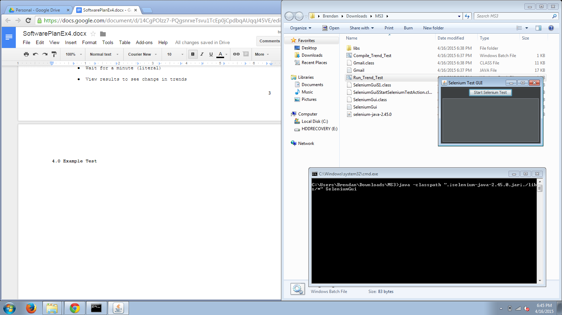

**Then click “Start Selenium Test”:**

**It will start FireFox and open the Google login and login as an admin.**

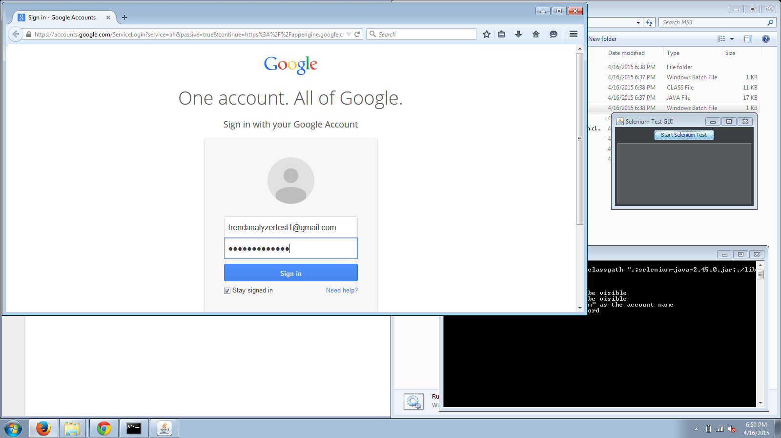

**Next the program will navigate to the website to stop voting.**

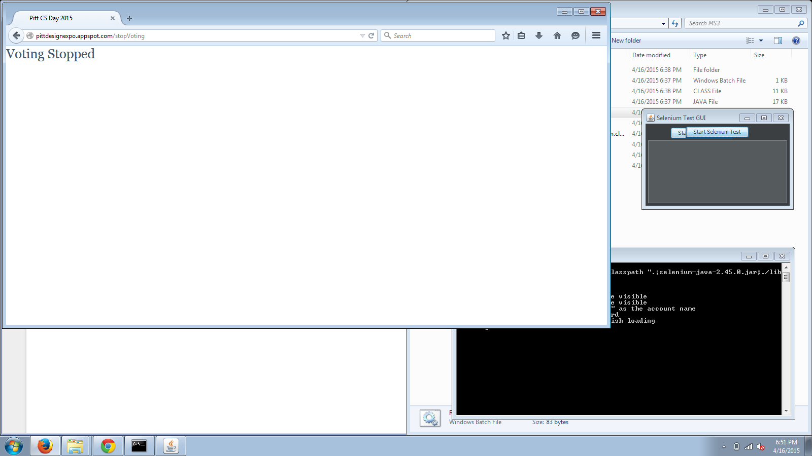

**Then it will clear the database.**

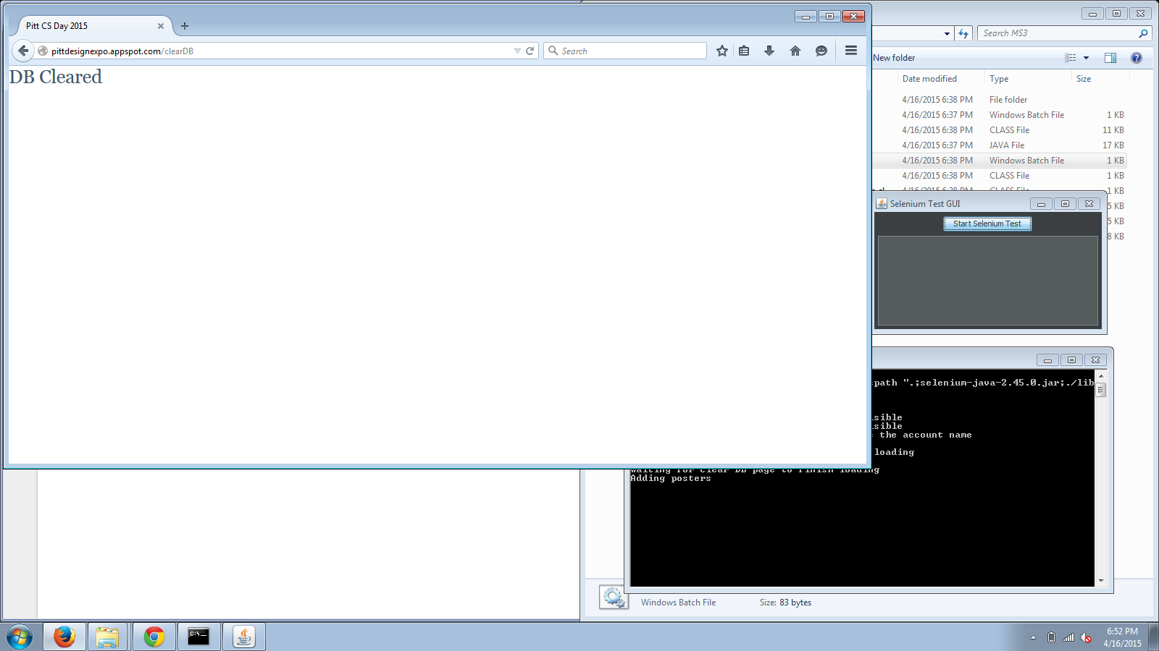

**Next the program will add default posters.**

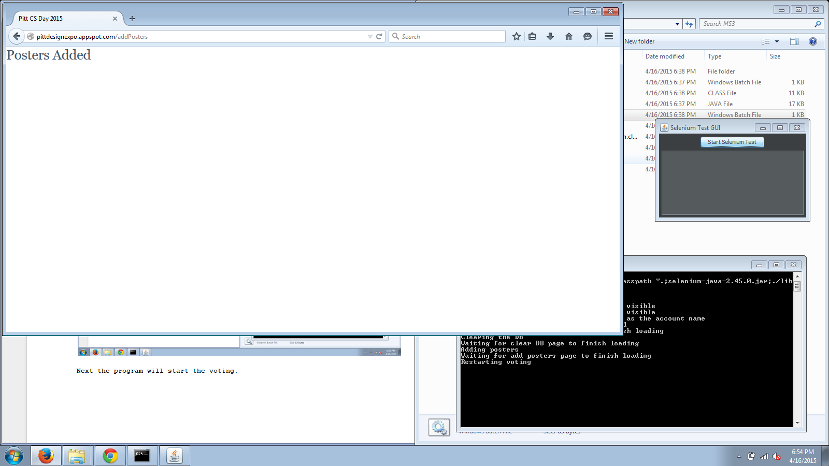

**After, the program will start the voting.**

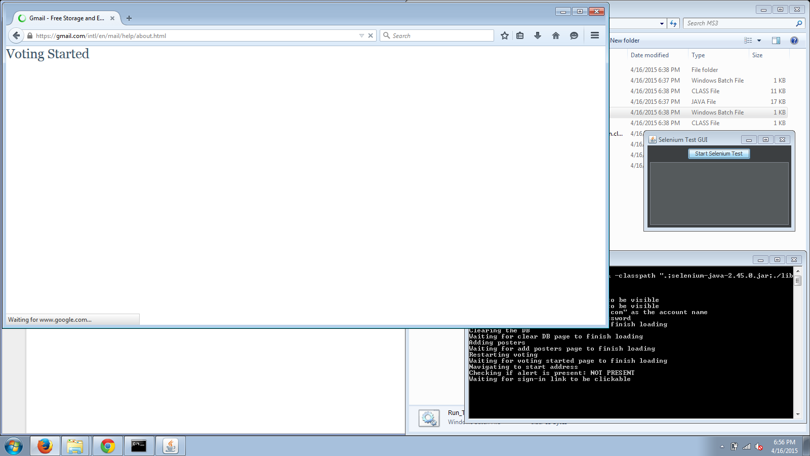

**Then the program will navigate to gmail and send a default vote.**

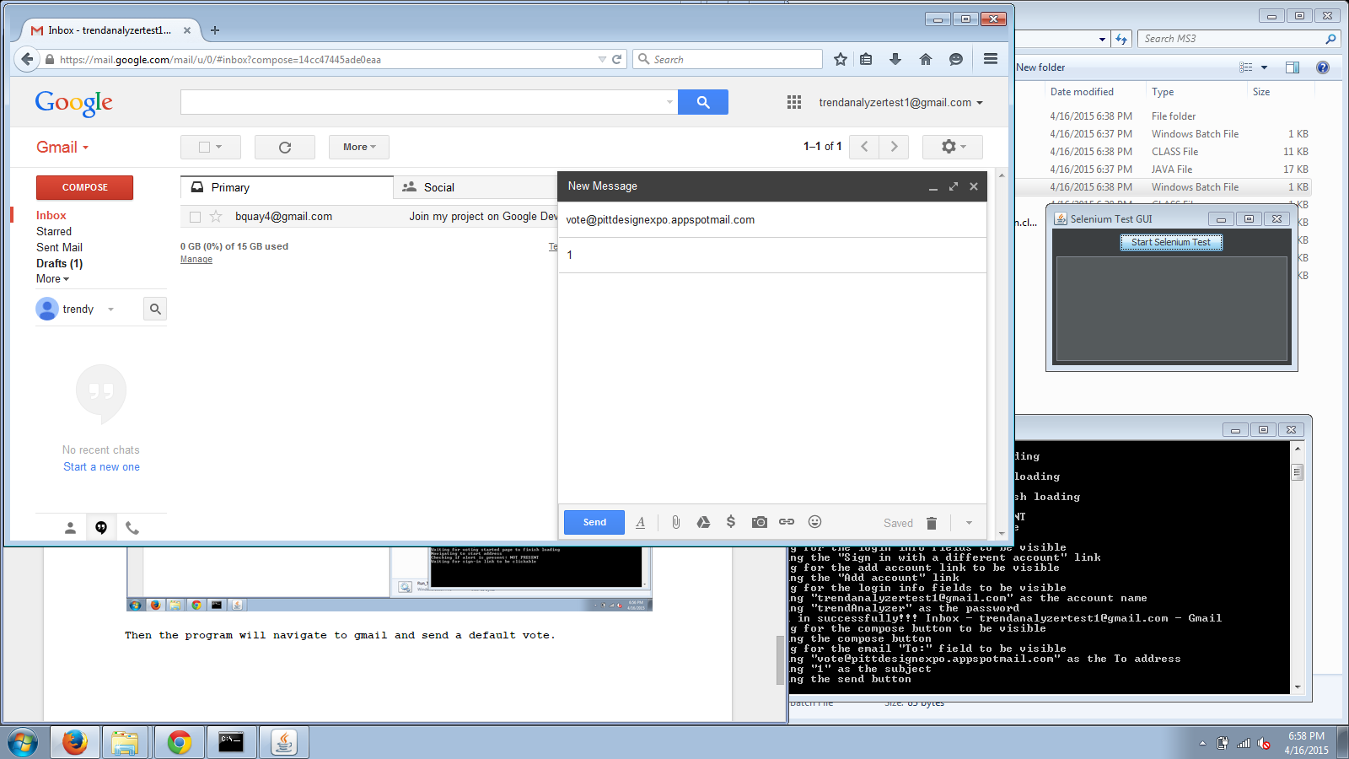

**The program will log out and login as a different user, one who is not an admin. It will repeat this for a total of 4 votes, each user voting for the next poster (1-4). The last vote is shown below:**

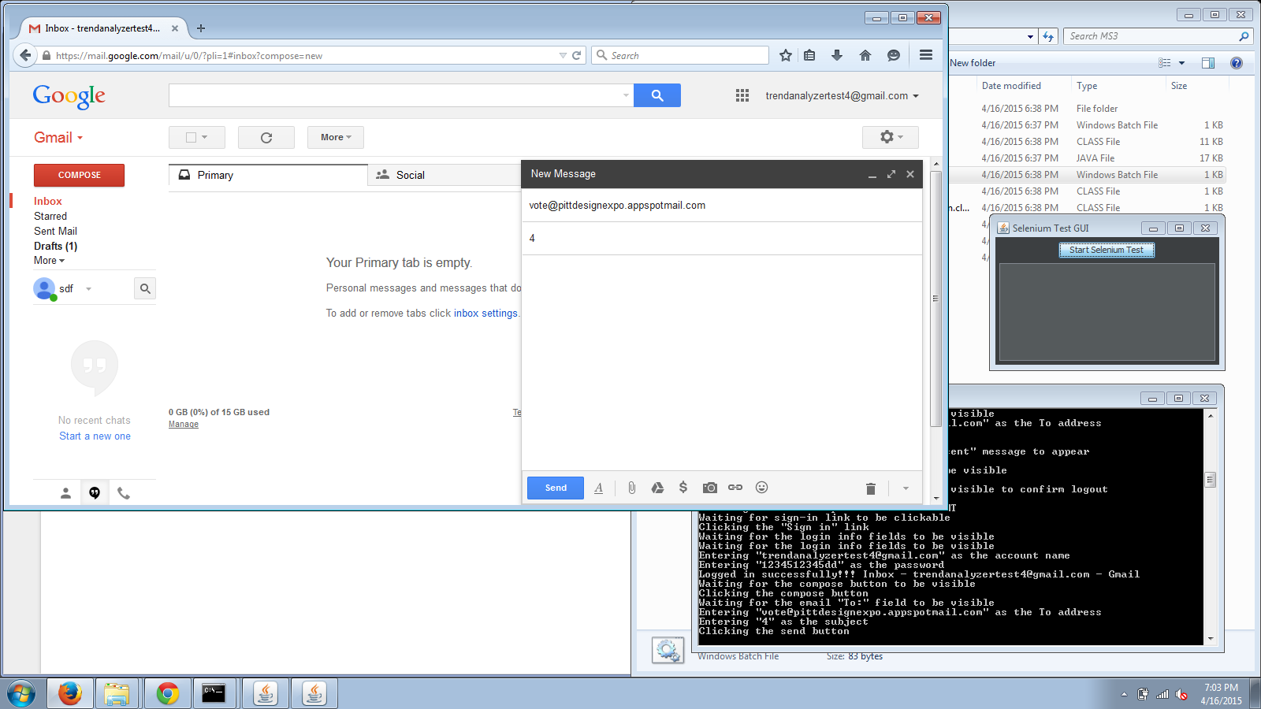

**Following the final vote, the program will navigate to the results page to show that each poster has been voted on:**

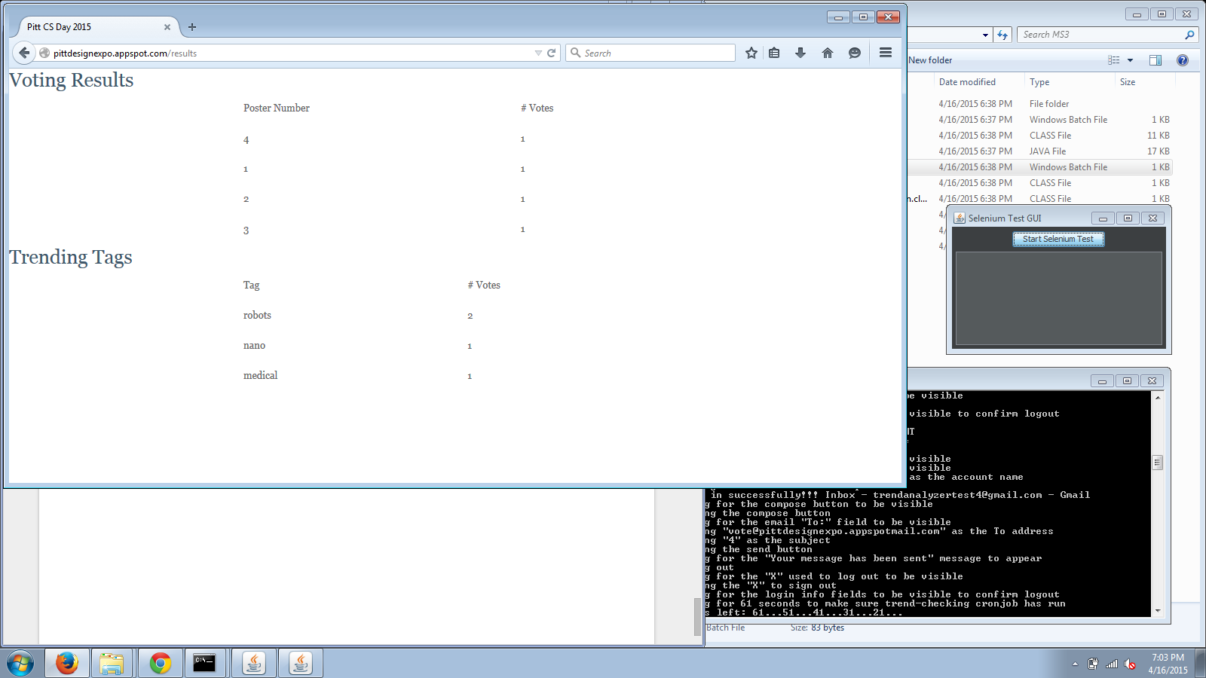

**Then, the program will wait 60 seconds before refreshing the page to show that the trending tags update:**

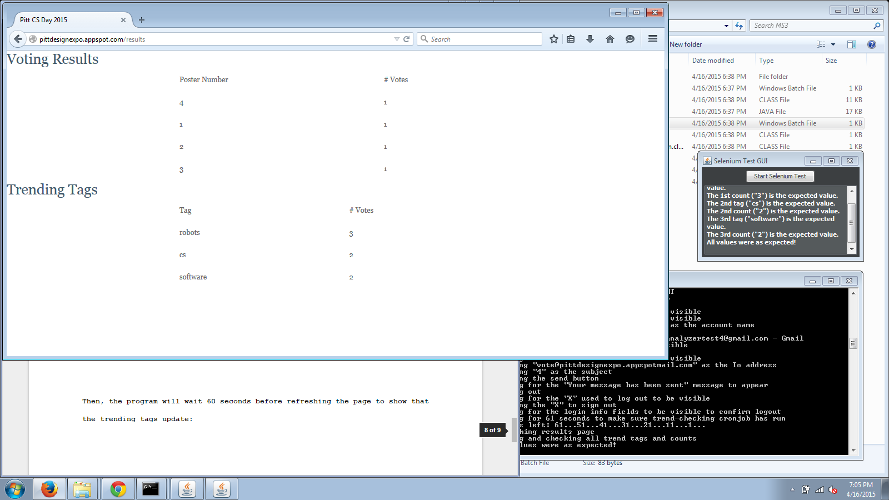

**Concluding the test a final report will be printed in the GUI:**



**If any values or unexpected, the text will be red and there will be an error message.**