2018

Jordan university of science and technology

DRUG BOX

Patient services ultimate edition robot

-

**Presented to the Departments of**

**Computer Engineering,**

**Network Engineering,**

**Software Engineering.**

Jordan University of Science and Technology

**Supervised by**:

***Dr:OSAMA AL-KHALEEL***

|  |  |  |
| --- | --- | --- |
| SE | 105020 | Ibrahim Baker Gharaibeh |
| CPE | 101604 | Bahaa Ahmad GDIESAT |
| NES | 104935 | Khaled Ahmad Hinde |

Abstract:

With increasing the numbers of patients, constitutes 65% of the hospital system and number of nurses 25% of the hospital system) in the hospital, we are trying to reduce the number of necessary routine moves and to increase the productivity of the work.

Smart phones provide a good options and specifications and provides an easy language to program their apps, Ex:Bluetooth, android studio.

building a hardware have become very easy, cheap and reliable.

Background:

The nurses are spending a lot of time doing the same routine work which is to go to the hospital pharmacy and take the medicine and give it to the patient, this operation takes time and effort that we can save to use it in other important things. Drug Boxultimate edition is a project based on the Bluetooth, android OS and tow separated hardware (room/box and a conveyor belt

overview

the doctor can specify the patient name , type of medicine that he takes , the quantity and the time of the medicine.

the device then will give every patient his medication on time with the accurate amount and time.

Problem Statement

In the United States of America the Nurses spend 42 minutes of each 8-hour resolving operational failures such as missing medications and broken or missing equipment ([Tucker 2004](https://www.ncbi.nlm.nih.gov/pmc/articles/PMC1713207/#b59)).

Other studies estimate that nurses spend from 10 percent ([Linden and English 1994](https://www.ncbi.nlm.nih.gov/pmc/articles/PMC1713207/#b32)) to 25 percent ([Miller, Diets, and Miller 1997](https://www.ncbi.nlm.nih.gov/pmc/articles/PMC1713207/#b39)) of their wasted time looking formissing medication.

our project gives you the solution.

it deals directly between the doctor's prescription and the patient medication so there will be absolutely no errors ,missing medications or wasted time.

project description:

the doctor of the hospital will enter the information of the patients.

Ex: patient name, medication name, medication amount/quantity, medication time etc...

the software will keep checking until the time come for the patient to take his medications.

the software well sends a note to the hardware box/room to inform it when the time comes for the patient to take his medications.

then the hardware room/box should drop the medication on the conveyor belt.

the conveyor belt should take the medications to the patient.

the app notifies the patient that the medicine is ready.

Project purposes & objectives:

reduce the number of necessary routine moves.

increase the productivity of the work by letting the nurses focus on the patients at all times.

reduce the number of missing medications.

give every patient his medication on the accurate time.

reduce wasted time of the nurses.

Prevent medications from being stolen by the nurses.

Project Stockholders:

Jordan university of science and technology.

Dr. Osama Al-KHALEEL.

Team members:  
Bahaa GDIESAT.   
 Khaled Al-Hinde.  
Ibrahim Al-GHARAIBEH.

System Users:

Doctors.  
 Patients.

# Proposed Work

Our box used to drop Drug for Patient in three times in one day , the box located in a Table with Wheels to locate it behind the patient .

The Drug Dropped in small Container then the patient take it with a water.

Components:

Hardware:

1. Arduino Mega Board
2. HC-06 Bluetooth Module
3. Resistors + wires + motors
4. Android device

Software:

1. software (IDE).
2. C/C++ programming.
3. Android programming

Description of the components:

Hardware:

1. Arduino Mega Board:

The **Arduino Mega**  is a microcontroller board ,It has 54 digital input/output pins 16 analog inputs, a 16 MHz crystal oscillator, a USB connection, a power jack, and a reset button. It contains everything needed to support the microcontroller, simply connect it to a computer with a USB cable or power it with a AC-to-DC adapter or battery to get started.

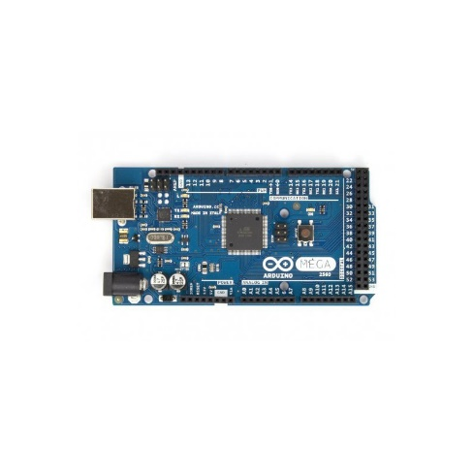

2-**HC**-**06 Bluetooth Module**:

**HC**-**06 Bluetooth Module** is an easy to use **Bluetooth** SPP (Serial Port Protocol) **module**, designed for transparent wireless serial connection setup. Its communication is via serial communication which makes an easy way to interface with controller or PC.

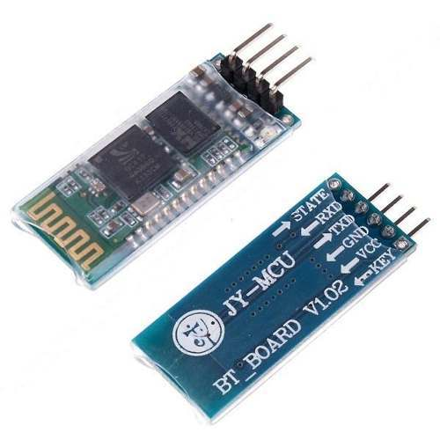

.

3) we need about 100 male-male wires 7cm

and 10 male-male wires 100cm.

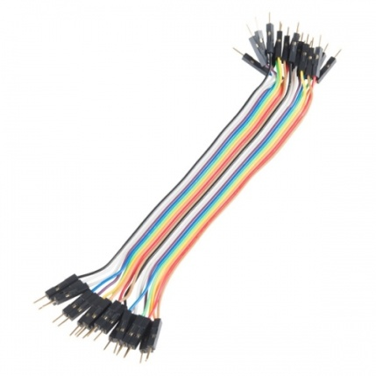

we also need one 2k-ohm Resistor and one 4.7k-ohm Resistor.

we need a high torque motor with metal gear box like "N20 MINI DC ELECTRIC MOTOR"

which can run on 1.5V-12V voltage and 120mAMP so we don't need h bridge because Arduino have 5Vpower.

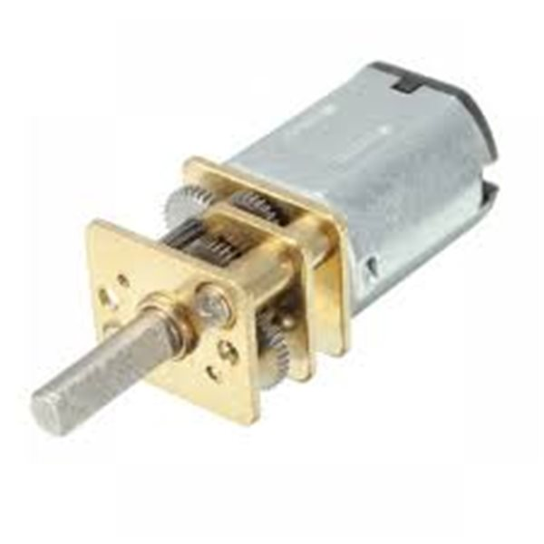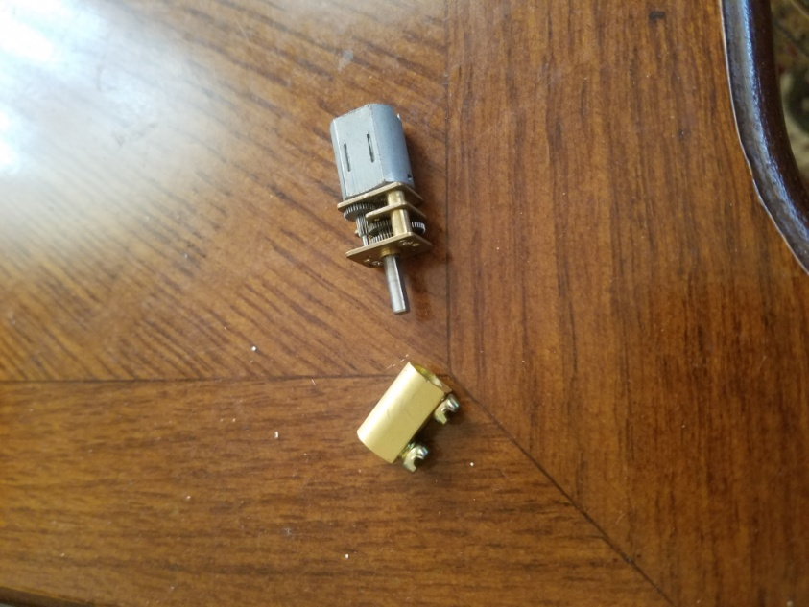

we also need1 plastic and 2 Rubbers and 2 woods and I metal all of this components are In the form of a cylinder except wood which in a circle form as below.

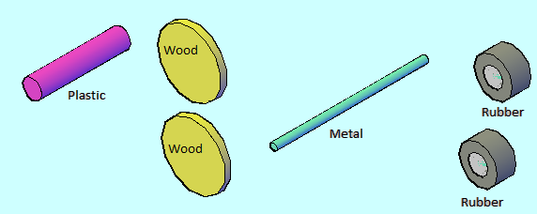

We use the components that show in the above picture to design each wheel ,which part of the convey belt ,first we need 5 pieces :1 plastic and 2 Rubbers and 2 woods and I metal all of this components are In the form of a cylinder except wood which in a circle form.

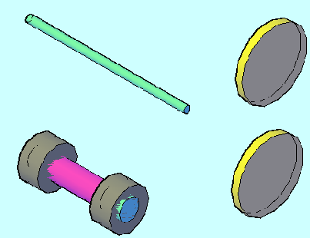

As we see here we connect 2 rubbers cylinder at both sides of the plastic cylinder

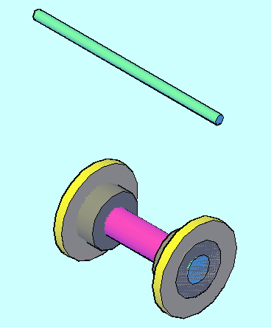

Now we add 2 wood pieces

On the rubbers that exist on Both side of plastic pieces

As I mentioned before.

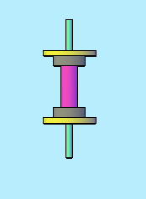

Finally, we add metal piece in the middle of plastic piece, and we got the wheel for the convey belt.

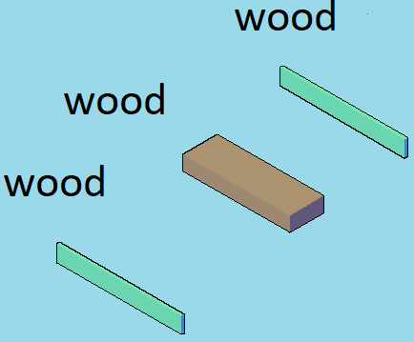

Here we can see the last components of convey belt

Which is 3 pieces of wood

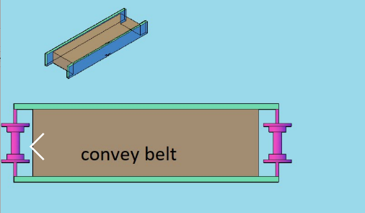

Now we connect 3 pieces of wood with each other

Then we can add 2 wheels on both side of convey belt as you can see in the picture above.

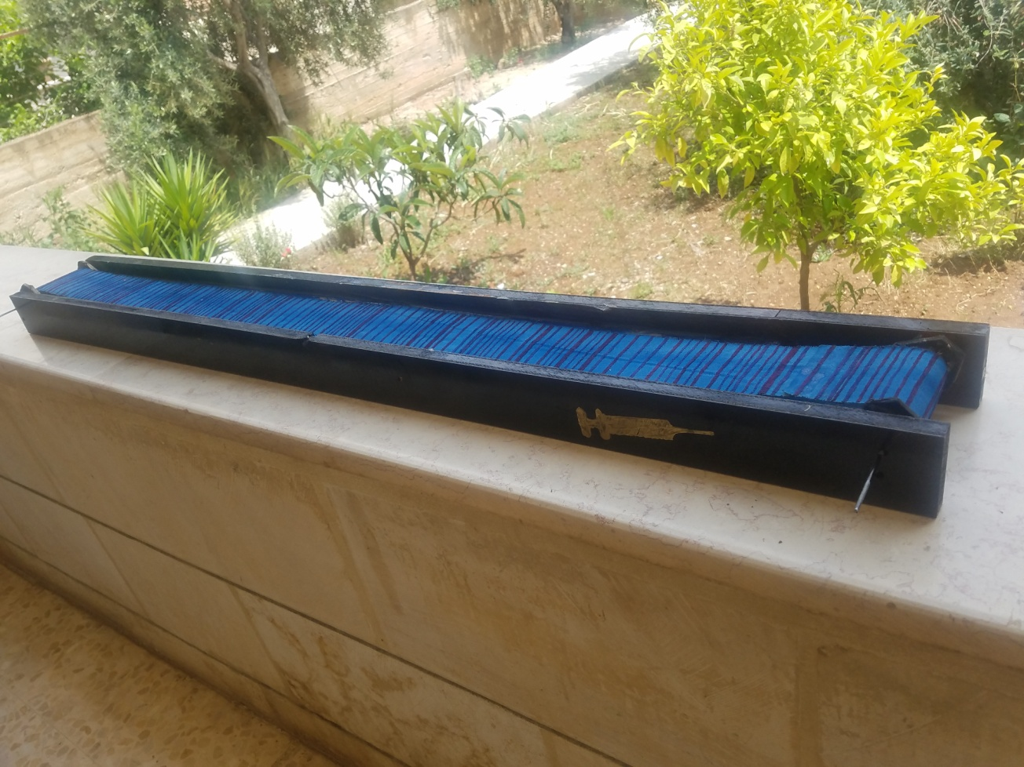

then use a cloth and connect it between the two wheels as above.

and to the final step connect the motor to the metal cylinder using the motor gearbox as shown below .

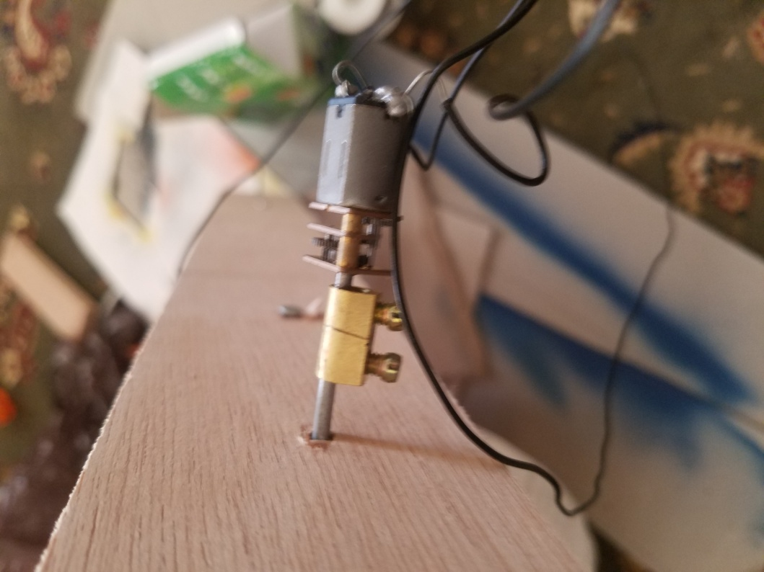

and then we move to implementation of the drugs box.

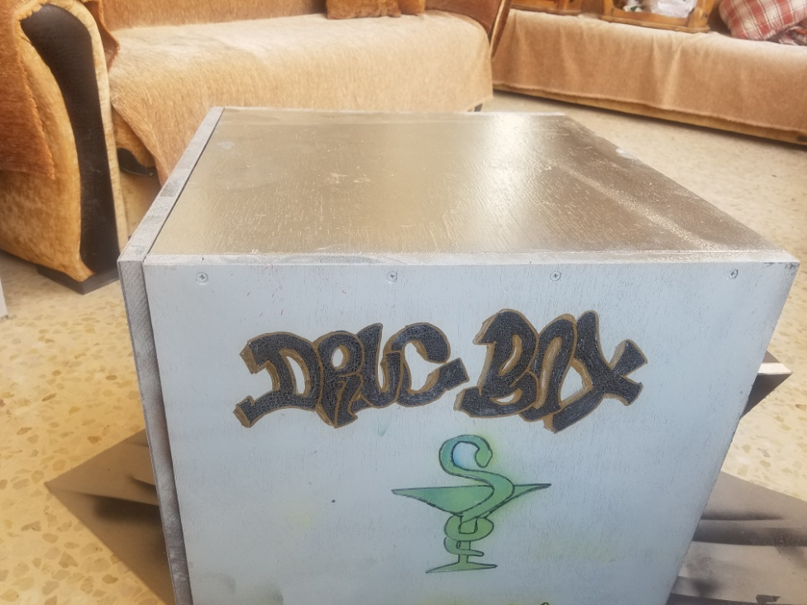

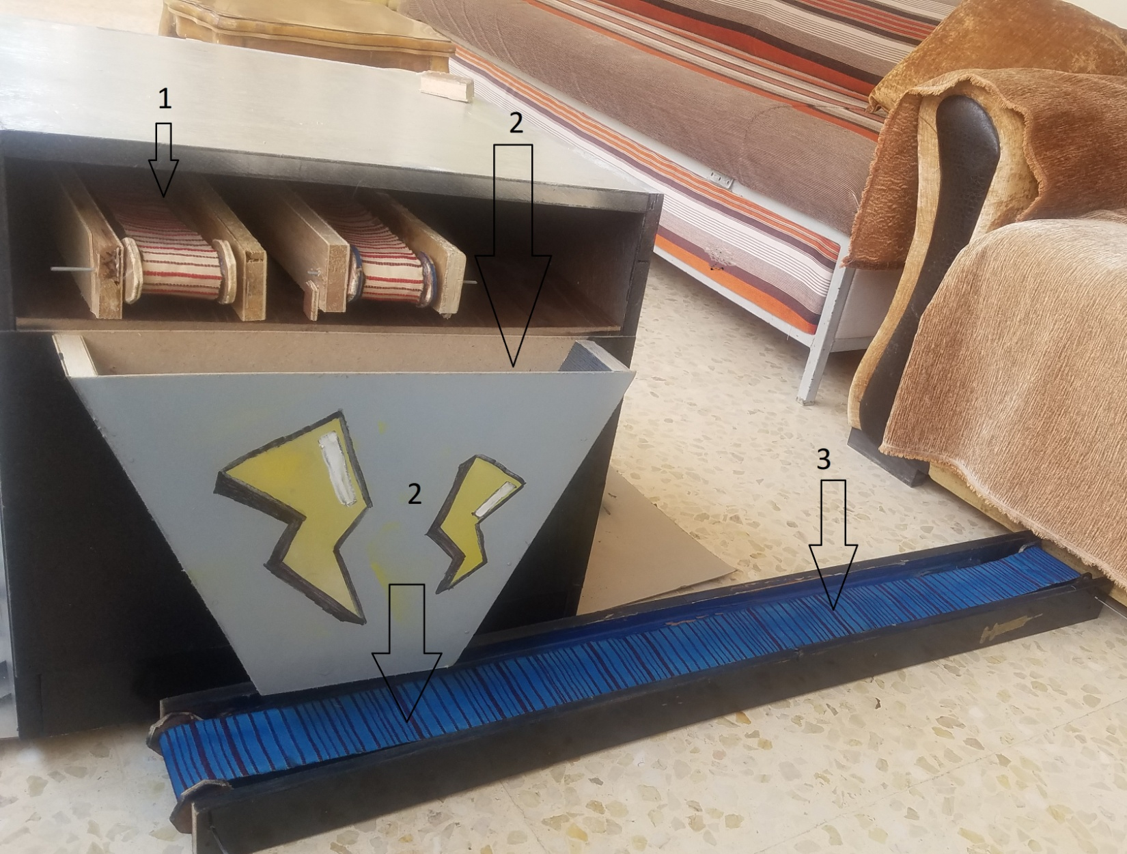

1-we put the medicine on the conveyor belts inside the box then the doctor chose the medicine throw the app .

2- the chosen medicine will be dropped from the box to the blue conveyor belt .

the blue conveyor belt will take it to the patient.

***EVREY CONVEY BELT COST 6JD FOR EACH***

Android device :

**Android** is an array of software intended for mobile **devices** that features an operating system, core applications and middleware. An **Android device** may be a smartphone, tablet PC, e-book reader or any type of mobile **device** that requires an OS. **Android** is developed by the Open Handset Alliance, which is led by Google.

[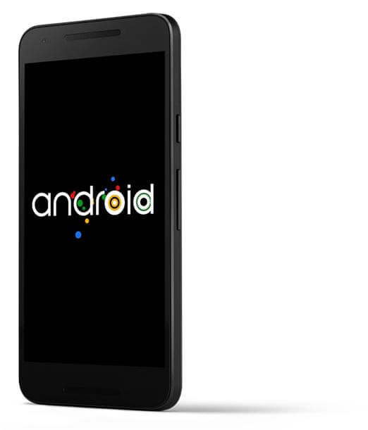](https://www.google.jo/url?sa=i&rct=j&q=&esrc=s&source=images&cd=&cad=rja&uact=8&ved=0ahUKEwirpov0sK_YAhUKbRQKHYpxCyMQjRwIBw&url=https://www.android.com/security-center/&psig=AOvVaw0V7ax_JUY-GtbMJYv8S7f9&ust=1514642414712448)

Software :

1. software (IDE).

The Arduino board can be programmed by using IDE software, the code is written using C/C++ language. Then, the code is compiled and a HEX file is uploaded to the board's memory.

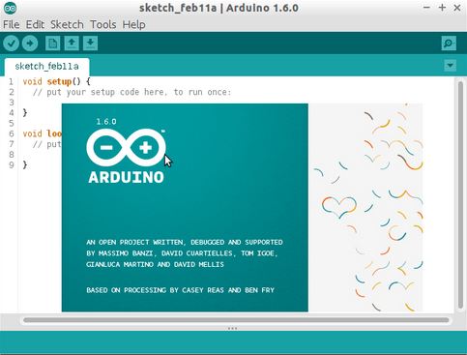

2- C/C++programming:

**C** is a high-level and general-purpose **programming language** that is ideal for developing firmware or portable applications. Originally intended for writing system software, **C** was developed at Bell Labs by Dennis Ritchie for the Unix Operating System in the early 1970s.

**C++** is a general-purpose object-oriented **programming** (OOP) **language**, developed by BjarneStroustrup, and is an extension of the **C language**. It is therefore possible to code **C++** in a "**C** style" or "object-oriented style." ... However, it was renamed **C++** in 1983.

1. - Android programming:

we will use Android Studio.  
SW-Eng Ibrahim prepared for this by taking android course elective in the university and advance android programming course outside the university. and for the Bluetooth connection network-eng Khalid al-Hindi who prepared this algorithm for the connection between the board and the phone.

Feasibility Study and Constraints

-Technical Feasibility Study and Manufacturability Constraints:

# Software resources needed to get the Project done meets the need of our project and it can be done (not hard to achieve).

#Hardware needed for the box/room is existing as components but need to edit it's functionality a little bit to meet the requirements and the need of the project.

#Hardware needed for the Conveyor belt can be achieved using raw material and needs to be controlled from the hardware to meet the requirements of the project.

#Network needed to Communicate between the Software and the hardware can be achievedand needs a code.

-Economy Feasibility Study andConstraints:

# Software resources needed to get the Project doneare free.

#Network needed to Communicate between the Software and the hardware is a Bluetooth chip and its cost 13jd.

#Hardware needed for the Conveyor beltand the box is cheap.

#all manpower we need is a SW-Eng and Computer Eng and a Network Eng.

Health and Safety Constraints:  
any medicine should not be out of its container for more than 24 hours in the temperature it must be stored in.   
Site and Location (environment) Feasibility Study andConstraints:

after letting the hospitals use our system we can release a home edition for the people (so they will not forget to take their medicine).

-Financial Feasibility Study andConstraints:

Users (hospitals): they will realize that the hospital will not need more nurses to service the patients.

organizational (project releases): can sell it at a very high cost but the project does not cost that much for the organization so the project has a high profit for them.

also, can sell it for the people so they can use it in their homes which means more profit.

The Drug box can be sold to them for 300jd

social values constrain:  
if the people who are using our product are having some problems with it or have a new idea they can report it back to the team members so they will study it and do the changes required from them

project life span (stages/phases) and methodology

Risk Management:

|  |  |  |  |  |
| --- | --- | --- | --- | --- |
| Risks | Internal / External | Probability | Impact | Risk Response Plan |
| Late Delivery | Internal | 80% | Very High | Accept risk |
| Technology will not meet expectations | External | 40% | High | Avoid the risk |
| Changes in requirements | External | 60% | Medium | Accept the risk  Have contingency plan |
| Deviation from software engineering standards | Internal | 10% | Medium | Avoid the risk |
| Cost Overhead | Internal | 99% | Low | Accept risk |
| Misunderstanding the requirements | Internal | 0.1% | High | Have contingency plan |

**Project Scheduling and Major milestones:**

|  |  |  |  |
| --- | --- | --- | --- |
| **Task Name** | **Duration** | **Start** | **Finish** |
| **1. Introduction** | 1 Day | 2/11/2017 | 3/11/2017 |
| **2. Prefeasibility study** | 1 Day | 2/11/2017 | 3/11/2017 |
| **3. Project Planning** | 2 Days | 3/11/2017 | 5/11/2017 |
| **4. Analysis** | 6 Days | 5/11/2017 | 11/11/2017 |
| **5. Design and Development** | 20 Days | 12/11/2017 | 2/12/2017 |
| **6. Implementation** | 40 Days | 15/1/2018 | 25/2/2018 |
| **7. User Documentation** | 2 Days | 27/2/2018 | 29/2/2018 |
| **8. final testing** | 6 Days | 1/3/2018 | 7/3/2018 |
| **9. maintenance** | Depends on testing | 29/12/2018 | 1/1/2018 |
| **10. Delivery** | ………….. | 2/4/2018 | 2/4/2018 |

Phase1:

|  |  |  |
| --- | --- | --- |
| **Time Frame** | **Task To Be Completed** | **Status** |
| 2/2/2018 | * Identifying system requirements, scope, and implementation platform. | Done |
| 6/2/2018 | * Training on the implementation environment. | Done |
| 26/2/2018 | * Development and deployment of a simple pilot program | Done |
| 31/3/2018 | * Report preparation and presentation. | Done |
| 1/4/2018 | * Field study and preliminary users’ feedback. | Done |
| 17/4/2018 | * Incorporating more requirements and users’ feedback. | Done |
| 25/4/2018 | * Source code Lock, followed by testing. | Done |
| 27/4/2018 | * Dissemination of research results. | Done |
| 29/4/2018 | * Final report and presentation. | Done |

Phase2:

|  |  |  |  |
| --- | --- | --- | --- |
| Task Name | Duration | Start | End |
| Detailed Design Development | 2 weeks | 20/2/2018 | 6/3/2018 |
| Design Review and Presentation | 2 Weeks | 6/3/2018 | 20/3/2018 |
| System Simulation, Optimization, Design Iteration, Construction and Testing | 4 Weeks | 20/3/2018 | 3/4/2018 |
| Final Design and Draft Report / Presentation | 3 Weeks | 3/4/2018 | 24/4/2018 |
| Final Report | 1 Week | 24/4/2018 | 1/5/2018 |
| Presentation / Assessment | 2days | 1/5/2018 | 3/5/2018 |

Roles and Responsibilities

Supervisor:  
Dr. Osama Al-KHALEEL

Instructor:  
Dr. Osama Al-KHALEEL

Project Manager:  
SE. Ibrahim Al-GHARAIBEH

Project Manager Assistant:  
Bahaa GDIESAT

Hardware Eng.:  
Bahaa GDIESAT

Network Architect:  
Khaled Al-Hinde

Hardware programmers:  
Bahaa GDIESAT

Developer:  
Ibrahim Al-GHARAIBEH

Testers:  
Bahaa GDIESAT  
Khaled Al-Hindi  
Ibrahim Al-GHARAIBEH

Technical process plan and methods used

in the software Eng. we are using the Agile method.

reasons/why Agile:

# High level of communication between the stockholders and the team members.  
 - Reduce the misunderstanding in Requirements.  
 - Increase the user involvement level.

# Helps to break down the project into smaller parts.  
 - Parallel Processing.  
 - Managed easier by the team leader.  
 - focus on implementation and testing each part.  
 - ease of Error detection and correction.  
 - focus on Quality.

# Adaptable when Requirements change or new Requirements Appear.

- new Requirements or change in Requirements can be planned and managed in the next iteration.

# a fast method (decrease the chance of delays and decrease the chance of late in project delivery).

Project Approval

This Project was approved by:

# chancellor of the IT:< Professor Ali Shatnawie >

# Head of the Software Eng. Department:

<Doctor LoayAlawneh>

# Head of the Computer Eng. Department:

< Professor Moath jarrah>

# Head of the Network Eng. Department:  
< Professor Eyad Taqi-aldeen>  
  
and the approval of the supervisor  
< Doctor Osama Al-KHALEEL>

ANALYSIS PHASE:

Required

Devices and Hardware / software / OS .

## Hardware Required:  
 -Smart phone (and supports Bluetooth).  
 -Bluetooth Chip.  
 -a Conveyor belt.  
 -the Box/room components.

## Software Required:  
 - Android Studio.  
 - Arduino Ide.

## OS Required:

- Android 5.0.1 or a Higher version of Android Operating System.

ANALYSIS PHASE: REQUIREMENTS

Functional Requirements:

|  |  |
| --- | --- |
| FEAT-1 | The System should Allow a the new doctors of the hospital to register throw the head of the hospital username and password . |
| FEAT-2 | The System should Allow the doctors to create a new patient profile. |
| FEAT-3 | The System should Allow the doctors to add/edit patients medications information (time , type and amount). |
| FEAT-4 | The System should Allow the doctors to delete a patient profile . |
| FEAT-5 | The System should Alert the patients when the medications are ready and to turn off that Alert when they command the system to turn it off throw the patient/user interface . |
| FEAT-6 | The System should send a message to the robot inform him about the type, time and the amount of the medicine. |

Logic modeling Decision Table:

|  |  |  |  |
| --- | --- | --- | --- |
| **Type of userActions /** | Patient | doctor | The head of the hospital |
| Receive Alert | X |  |  |
| Receive the medications | X |  |  |
| Turn off Alerts | X |  |  |
| Enter medication Information |  | X |  |
| Add a new patient |  | X |  |
| Edit / delete patient |  | X |  |
| Delete a doctor |  |  | X |
| Add a new doctor |  |  | X |

Detailed System Design:

Hardware:

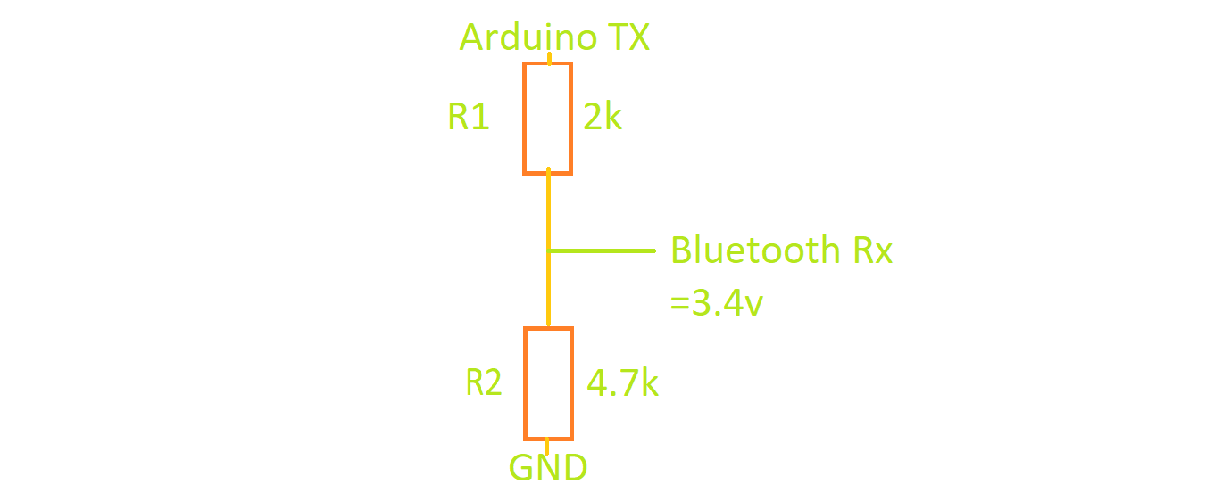

First, we need to connect Arduino board with Bluetooth chip which has 6 pins

we connect TX pin of Arduino board with 2k and 4k resistances, then connect RX pin that exist on Bluetooth chip between 2 resistances (2k,4.7k), now connect GND pin for the board with 2 resistances(2k,4.7k)

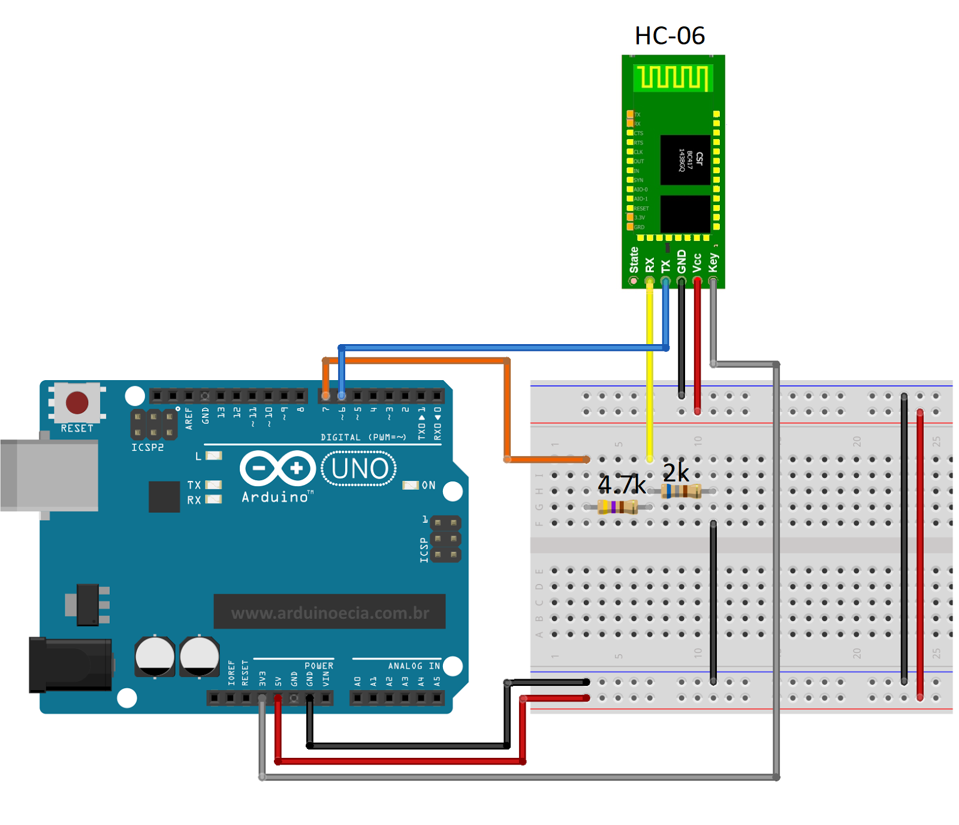

Cost:

|  |  |
| --- | --- |
| Components | Cost |
| Wood | 23jd |
| 4*Motors Metal Gear | 24jd |
| Plastic and Rubber | 5jd |
| Silicon and superglue | 5jd |
| Bluetooth chip | 13jd |
| Arduino board | 13jd |
| Paints | 5jd |
| Motor high Torque | 23jd |
| Resistances and wires | 5jd |
| Over head | 15jd |
| Total Cost | 126jd |