Estimating the effectiveness of syndromic screening at airports for Bundibugyo ebolavirus disease
Billy J Quilty
CMMID Bundibugyo Working Group
Table of contents

Abstract
We used a stochastic simulation model to estimate the effectiveness of combined exit and entry airport screening for Bundibugyo ebolavirus disease (BVD), using natural-history parameters from a Bayesian re-analysis of the 2012 Isiro outbreak. For a 12-hour international flight from DRC or Uganda at 86% screening sensitivity, under the model assumptions approximately 73% of infected people presenting for travel would evade combined exit and entry screening (95% CrI: 68–77%). Among those who successfully boarded, approximately 92% would arrive without detection (95% CrI: 90–94%). This high undetected fraction reflects the relative durations of the incubation period (approximately 7.7 days; Wamala et al. 2010) and the onset-to-severe-disease interval (approximately 4 days; Funk & Abbott 2026): most infected travellers board before symptom onset and are undetectable by any syndromic screen, whilst those who are symptomatic progress rapidly to illness severe enough to preclude travel. This is compounded during active epidemic growth, when recently exposed (and therefore pre-symptomatic) cases are overrepresented among travellers. Syndromic airport screening offers limited protection against BVD spread via air travel, and should be complemented by outbreak control at source, strengthened clinical surveillance in receiving countries with high travel connectivity to affected areas, and post-departure self-monitoring guidance for travellers from affected regions.

 Note
Data note: Natural-history parameters (incubation period, onset-to-severe-disease delay) are derived from the 2007 Uganda and 2012 DRC BVD outbreaks. Patient-level data from the current 2026 outbreak are not yet available. Case counts for the current outbreak are from Chamla et al. (2026) (Chamla et al. 2026). The epidemic doubling time range used in the growth-phase sensitivity analysis is estimated from the current outbreak (epiforecasts, 2026). The outbreak was declared a PHEIC on 17 May 2026 (World Health Organization 2026).

1 Introduction
Bundibugyo ebolavirus (BDBV) is one of six known ebolaviruses, previously identified in outbreaks in Uganda (2007) (Towner et al. 2008) and the Democratic Republic of the Congo (DRC; 2012) (Rosello et al. 2015). As of June 2026, an outbreak of Bundibugyo ebolavirus disease (BVD) affecting Ituri Province in DRC and with confirmed spread to Kampala, Uganda has been declared a Public Health Emergency of International Concern (PHEIC) by WHO (World Health Organization 2026). By late June 2026, 1,048 confirmed cases and 267 deaths had been recorded in DRC, with 20 confirmed cases and two deaths in Uganda; a basic reproduction number of 1.71 has been estimated from the confirmed case series (Chamla et al. 2026). Unlike previous Zaire ebolavirus outbreaks, no approved BVD-specific therapeutics or vaccines exist, and the outbreak is occurring against a backdrop of insecurity, high population mobility, and a large informal healthcare network. Together these features heighten concern about international spread via air travel. Clinical data from the 2026 outbreak indicate that at presentation, fever is recorded in approximately 74% of confirmed BVD cases and haemorrhagic signs in only 10%; gastrointestinal symptoms (diarrhoea 67%, vomiting 67%) predominate, complicating syndromic identification at ports of entry (Akilimali et al. 2026).
Syndromic airport screening (thermal scanning, symptom questionnaires, and direct clinical assessment) was deployed extensively during the 2014–2016 West Africa Ebola epidemic and again during the 2018–2020 DRC outbreaks of Zaire ebolavirus (Mabey, Flasche, and Edmunds 2014). Its effectiveness, however, is constrained by the natural history of infection: travellers who have been exposed but have not yet developed symptoms will not be febrile at the time of screening, and therefore will not be detected. Whether a traveller is symptomatic at departure or arrival depends on when they were exposed relative to their travel date, on the distribution of the incubation period (infection to symptom onset), and on the time from symptom onset to progression to severe, detectably ill disease.
For BVD specifically, three published incubation period estimates exist and were identified in a recent systematic review (Nash et al. 2024). Wamala et al. (2010) (Wamala et al. 2010) reported a mean of 7.68 days (SD 3.53; 95% CI 7.04–8.32; n = 116) from the 2007 Uganda outbreak. MacNeil et al. (2010) (MacNeil et al. 2010) reported 6.3 days (95% CI 5.2–7.3; n = 24 contacts with confirmed exposure dates) from the same outbreak. Kratz et al. (2015) (Kratz et al. 2015) reported 11.3 days (range 2–27; n = 3) from the 2012 Isiro DRC outbreak. We adopt the Wamala et al. (2010) estimate as our primary value throughout, given its substantially larger sample size, and use its own reported precision to propagate parameter uncertainty around this central value (see Methods); we do not pool this with the MacNeil and Kratz estimates, since MacNeil et al.’s contacts are drawn from the same 2007 Uganda outbreak as Wamala et al. (and so are not an independent replicate), and Kratz et al.’s estimate rests on only three cases. Instead, these two alternative point estimates define the range explored in a separate incubation-period sensitivity analysis (see Methods and Figure 4). Combined with a Bayesian reanalysis of the 2012 Isiro line list, which we conduct to estimate a mean onset-to-severe-disease interval of approximately 4 days (Funk & Abbott 2026; see Methods), these two values anchor the natural-history assumptions underlying the model developed below.
Total flight durations from DRC or Uganda to international destinations typically range from approximately 10 to 16 hours depending on destination, measured as end-to-end travel time including layovers rather than direct airborne time. We model a 12-hour flight as a representative default whilst examining how screening effectiveness varies across a range of flight durations and epidemiological scenarios.

2 Methods

2.1 Simulation model
We used a stochastic individual-based simulation model to evaluate the probability that an infected traveller would be detected at (i) exit screening before departure, (ii) as severely ill during the flight, (iii) at entry screening on arrival, or (iv) remain undetected throughout.
For each simulated traveller, an incubation period $t_{\text{inc}}$ and an onset-to-severe-disease interval $t_{\text{inf}}$ were drawn independently from Gamma distributions. The time at which a traveller commenced their flight relative to their infection was drawn uniformly from $\left[0, t_{\text{inc}}+t_{\text{inf}}+t_{\text{rec}}\right]$, where $t_{\text{rec}}$ is an individual-specific draw from the onset-to-death Gamma posterior (Funk & Abbott 2026), used as a proxy for the onset-to-recovery interval for asymptomatic cases. Travellers hospitalised before their scheduled departure were excluded.
Exit screening was assumed to detect any traveller who was symptomatic ($t_{\text{flight departure}}>t_{\text{inc}}$) with probability $p_{\text{exit}}$; travellers who became severely ill during the flight or remained symptomatic on arrival were subject to entry screening with probability $p_{\text{entry}}$. A proportion $ρ$ of all infections was assumed to be undetectable by fever-based syndromic screening throughout — comprising both truly asymptomatic infections and symptomatic-but-afebrile presentations, since thermal/fever screening cannot detect either — and remained undetected throughout. Full details are given in Quilty et al. (2020) (Quilty et al. 2020).

2.2 Parameters
Table 1: Model parameters for the BVD default scenario.
Parameter | Value | Source
Flight duration | 12 h (default) | DRC/Uganda via connecting hub (representative)
Exit screening sensitivity | 86% | Priest et al. 2011 (thermal image scanners)
Entry screening sensitivity | 86% | Priest et al. 2011 (thermal image scanners)
Proportion asymptomatic (undetectable via fever screening) | 25.7% | Derived as 1 − fever prevalence at presentation (Akilimali et al. 2026, 2026 DRC outbreak)
Incubation period mean | 7.68 days (95% CI: 7.04–8.32) | Wamala et al. 2010 (2007 Uganda BVD; n=116)
Incubation period variance | 12.46 days² (SD = 3.53 days) | Wamala et al. 2010
Between-estimate incubation SD | 0.328 days (Wamala et al. SE of the mean, SD/√n) | Wamala et al. 2010 (SD 3.53, n=116); not pooled with MacNeil/Kratz (see Introduction)
Onset → severe disease mean | 4.03 days (95% CrI: 3.08–5.46) | Funk & Abbott 2026 posterior median
Onset → severe disease variance | 13.72 days² | Funk & Abbott 2026 posterior median

Model parameters are listed in Table 1. The Isiro 2012 line list, the only publicly available BVD line list, lacks exposure dates and was re-analysed using doubly-censored Bayesian methods by Funk & Abbott (2026) (Funk and Abbott 2026) to estimate Gamma-distributed onset-to-severe-disease and onset-to-death delays (onset-to-severe-disease posterior median shape 1.18, scale 3.41).
As described in the Introduction, we use the Wamala et al. (2010) (Wamala et al. 2010) estimate as the primary incubation-period value and propagate parameter uncertainty via a Normal prior on the mean (mean 7.68 days, SD 0.328 days — Wamala et al.’s own standard error of the mean, truncated above 0.5 days), scaling the corresponding variance to preserve the coefficient of variation (CV ≈ 0.46; Gamma shape ≈ 4.73 held constant across draws), consistent with treating relative incubation-period variability as a stable biological property. Because this prior reflects only within-study sampling uncertainty, the wider range spanned by the MacNeil and Kratz estimates (not pooled here, per the Introduction) is instead explored via the incubation-period sensitivity analysis (Figure 4).
Thermal and syndromic screening can detect a traveller only if they are febrile at the time of screening. Clinical data from the 2026 outbreak indicate that fever was recorded in only 74.3% of confirmed BVD cases at presentation (Akilimali et al. 2026); the remaining 25.7% of symptomatic cases would never be detected by fever-based screening, regardless of scanner sensitivity or timing, and are therefore functionally equivalent to asymptomatic infection for the purposes of this model. We use this outbreak-specific, fever-negative fraction directly as the proportion asymptomatic parameter $ρ$ (25.7%), in place of a generic EVD-literature placeholder, since it is grounded in current-outbreak clinical data. Real-world syndromic screening is not necessarily limited to thermal detection, however; visual observation of other signs and symptom questionnaires may also identify some afebrile but otherwise symptomatic travellers, so our estimates of the undetected fraction may be conservative in this respect.

2.3 Uncertainty propagation
For each of 1000 posterior draws sampled at random from bdbv_posterior_gamma.csv, we ran the simulation with 2,000 simulated travellers. On each draw, the onset-to-severe-disease delay was taken from the BDBV posterior (draw-specific Gamma mean and variance from the Funk & Abbott 2026 analysis), and the incubation period mean was drawn from the Normal prior described above (Wamala et al.’s own standard error), with variance rescaled to preserve the coefficient of variation.

2.4 Sensitivity analyses
Four sensitivity analyses were conducted. First, we examined how the proportion undetected varied across flight durations of 1 to 20 hours, with full posterior uncertainty. Second, we explored the joint effect of the proportion of asymptomatic infection (0 to 60%) and the mean incubation period (1 to 14 days) on the proportion undetected for the default 12-hour flight using posterior-median natural-history parameters. Third, to address the limitation that the baseline model assumes a stable epidemic, we re-ran the posterior analysis across epidemic doubling times of 4.5 to 44 days (spanning the 90% credible interval from the epiforecasts BVD 2026 growth-rate estimates (Funk and Abbott 2026)). In a growing epidemic, recently infected individuals are overrepresented among travellers relative to those infected further in the past, so the uniform exposure-time assumption underestimates the pre-symptomatic fraction. Following Gostic et al. (K. M. Gostic, Kucharski, and Lloyd-Smith 2015; K. Gostic et al. 2020), we replaced the uniform draw on $\left[0,T_{max}\right]$ with a truncated-exponential distribution. Each doubling time $T_{d}$ was converted to an exponential growth rate $r=ln2/T_{d}$, and the time since infection for each simulated traveller was drawn by inverse-CDF sampling: $τ=−ln​\left(1−U \left(1−e^{−r T_{max}}\right)\right)/r$, where $U∼Uniform\left(0,1\right)$ and $T_{max}=t_{\text{inc}}+t_{\text{inf}}+t_{\text{rec}}$, as in the stable-epidemic case (see Simulation model). This weights the exposure distribution towards recent infections, as expected under exponential growth. Fourth, we varied exit and entry screening sensitivity independently from 0 to 100% to quantify the marginal contribution of each screening layer.

2.5 Software
All analyses were performed in R (version ≥ 4.1; R Core Team 2024). The simulation model is implemented in the airportscreening R package, available at github.com/bquilty25/airport_screening_ebola_bvd. An interactive Shiny application for exploring screening parameters is included in the repository and can be launched locally by running airportscreening::run_app() after installing the package.

3 Results

3.1 Detection outcomes at 12 hours
Table 2: Estimated screening outcomes for 100 infected BDBV travellers on a 12-hour connecting flight from DRC or Uganda. Values are percentages (medians) with 95% credible intervals.
Detection outcome | Baseline (86% exit / 86% entry) | Best-case (100% exit / 100% entry)
Unconditional (out of all infected travellers):
Detected at exit screening | 21.1 (16.9–25.5) | 24.3 (19.7–29.8)
Severely ill during flight | 0.6 (0.2–1.2) | 0.2 (0.0–0.6)
Detected at entry screening | 5.4 (4.1–6.7) | 3.3 (2.4–4.3)
Not detected | 72.9 (68.1–77.3) | 72.2 (67.0–76.4)
Conditional on boarding flight (only those who flew):
— Severely ill during flight | 0.8 (0.3–1.5) | 0.2 (0.0–0.8)
— Detected at entry screening | 6.8 (5.2–8.7) | 4.4 (3.2–5.7)
— Not detected (arrived undetected) | 92.3 (90.5–94.0) | 95.3 (94.1–96.6)

For a 12-hour connecting flight from DRC or Uganda under the baseline scenario (86% screening sensitivity at both departure and arrival), we estimate that 21.1% (95% CrI: 16.9–25.5%) of infected travellers would be detected at exit screening, 0.6% (95% CrI: 0.2–1.2%) would become severely ill during the flight, and 5.4% (95% CrI: 4.1–6.7%) would be detected at entry screening, leaving 72.9% (95% CrI: 68.1–77.3%) of infected travellers undetected on arrival (Table 2). Under the theoretical best-case scenario (100% exit / 100% entry screening sensitivity), exit detection rises to 24.3% (95% CrI: 19.7–29.8%), yet 72.2% (95% CrI: 67.0–76.4%) of infected travellers would still arrive completely undetected due to boarding while pre-symptomatic or asymptomatic.
Of those who successfully boarded the flight (excluding those detected at exit screening), the proportion who arrived undetected was 92.3% (95% CrI: 90.5–94.0%) under baseline screening, and 95.3% (95% CrI: 94.1–96.6%) under the best-case (100% exit / 100% entry) scenario. Under the baseline scenario, 0.8% (95% CrI: 0.3–1.5%) of boarded cases became severely ill during the flight and 6.8% (95% CrI: 5.2–8.7%) were detected at entry screening; under the best-case scenario, 0.2% (95% CrI: 0.0–0.8%) became severely ill during flight and 4.4% (95% CrI: 3.2–5.7%) were detected at entry screening.
The natural-history distributions underlying these estimates are shown in Figure 1: the incubation-period distribution is narrow, reflecting the tight within-study prior described in Methods, whereas the onset-to-hospitalisation and onset-to-death distributions are wider, reflecting the limited information available in the small Isiro 2012 line list.
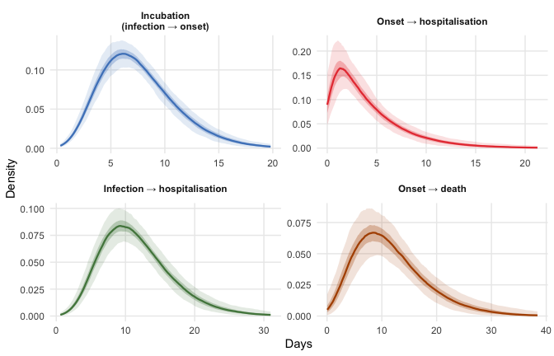
Figure 1: Posterior distributions of natural-history period durations for BVD. Each panel shows densities from 500 joint draws: the onset-to-hospitalisation and onset-to-death delays are drawn from the Bayesian BVD posterior (Funk & Abbott 2026); the incubation period (infection to symptom onset) is drawn from a Normal prior on the mean (7.68 days, SD 0.328 days — Wamala et al.’s own standard error of the mean) with CV preserved (Gamma shape fixed at 4.73). Shaded ribbons show 50% (dark) and 95% (light) pointwise credible bands across the 500 density curves; because the prior on the incubation mean reflects only within-study sampling uncertainty, the incubation-period ribbon is narrow relative to the other panels (see the incubation period sensitivity analysis below for structural uncertainty across the published range of estimates). The onset-to-hospitalisation distribution has shape ~1.2 (nearly exponential), reflecting the limited information in the Isiro 2012 line list.

3.2 Effect of flight duration on detection probability
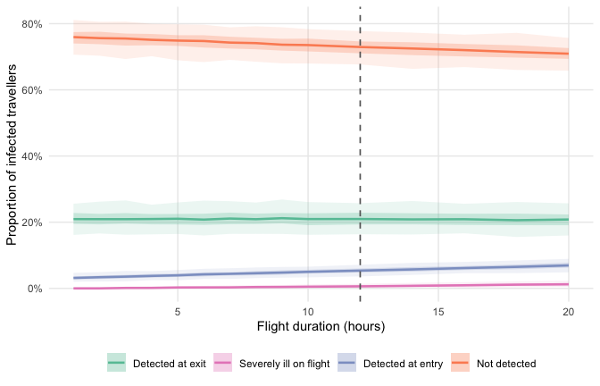
Figure 2: Detection probabilities as a function of flight duration, with uncertainty propagated across 1,000 posterior draws of the BVD onset-to-hospitalisation delay. Ribbons show 50% (dark) and 95% (light) credible intervals. The vertical dashed line marks 12 hours, the approximate DRC/Uganda connecting travel time to international destinations.
As flight duration increases, the probability of detecting an infected traveller at entry screening rises owing to progression of disease during travel (Figure 2), though the overall undetected fraction remains high throughout. Even for a 20-hour flight (the longest typical single-airline connection), the proportion undetected remains 70.9% (95% CrI: 65.2–75.6%), little changed from the 12-hour default reported above.

3.3 Detection outcome breakdown
Exit screening accounts for the largest share of detected cases; severely ill during flight and entry-detected cases together represent a small fraction, reflecting the short window between symptom onset and severe disease relative to the flight duration (Figure 3).
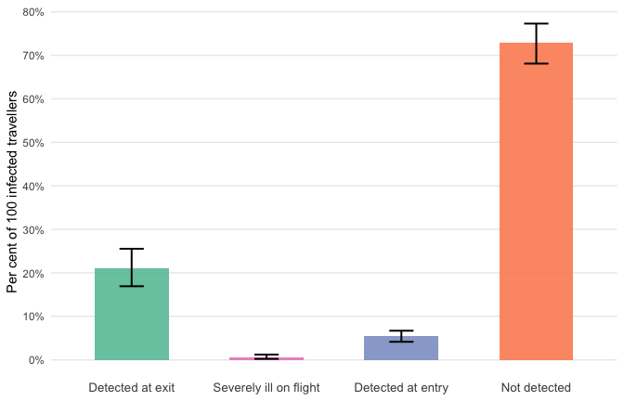
Figure 3: Estimated number of detected and undetected infected travellers per 100 infected travellers departing DRC or Uganda on a 12-hour connecting itinerary, stratified by detection outcome, with 95% credible intervals (whiskers).

3.4 Sensitivity analysis: asymptomatic proportion and incubation period
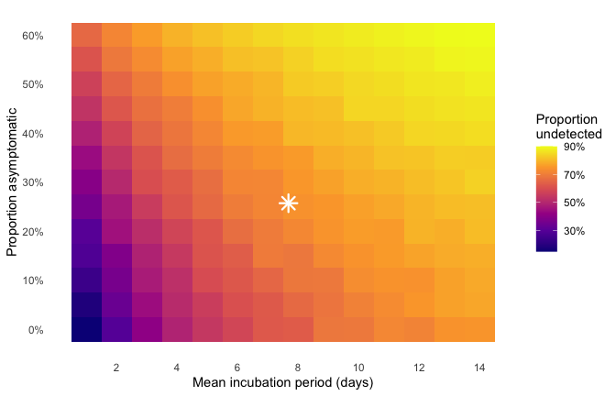
Figure 4: Sensitivity analysis: proportion of infected travellers undetected as a function of the mean incubation period (x-axis) and proportion of asymptomatic infection (y-axis), for a 12-hour flight with posterior-median BVD onset-to-hospitalisation parameters. As the mean incubation period varies, the variance is rescaled to preserve the coefficient of variation (CV = SD/mean ≈ 0.46, equivalent to a fixed Gamma shape of ≈ 4.73), consistent with the uncertainty propagation used in the main analysis. The star marks the primary BVD scenario (mean incubation 7.68 days, 25.7% asymptomatic). Full uncertainty propagation across the incubation period is shown in the main analysis.
The primary driver of the undetected fraction is the incubation period (Figure 4): even at our default undetectable-via-screening fraction of 25.7% (derived from 2026 outbreak fever-prevalence data; see Methods), the proportion undetected ranges from 36–82% across incubation periods of 1–14 days, with longer incubation periods allowing more travellers to depart before symptom onset. This fraction combines true asymptomatic infection, which is rare in EVD, with afebrile-but-symptomatic presentations that fail to trigger fever-based syndromic screening; the latter appear to be common for BVD based on current-outbreak clinical data (Akilimali et al. 2026). If the undetectable fraction were as high as 40%, the undetected fraction would rise to 49–86% across the same incubation range.

3.5 Sensitivity analysis: epidemic growth phase
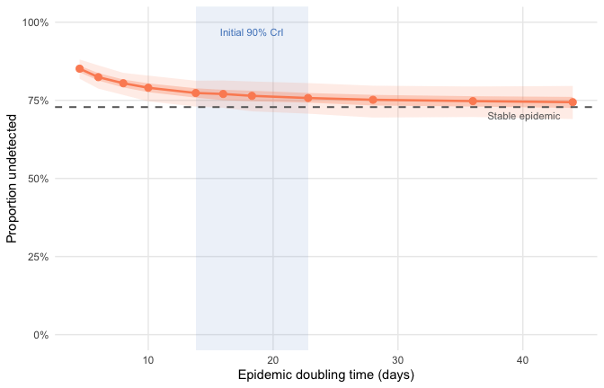
Figure 5: Effect of epidemic doubling time on the proportion of infected travellers going undetected. Each point shows the median across 500 posterior draws; ribbons show 50% (dark) and 95% (light) credible intervals. The shaded band marks the 90% credible interval for the initial doubling time of the current BVD outbreak (13.8–22.8 days; epiforecasts, 2026). The rightmost marker (dashed vertical) represents a stable epidemic (growth rate = 0; uniform exposure distribution).
The proportion of infected travellers going undetected increases as the epidemic doubling time shortens (Figure 5). If the true doubling time falls within the initial epiforecasts 90% credible interval (13.8–22.8 days), the model estimates a corresponding undetected fraction of approximately 76–77%. Under the more pessimistic latest-estimate lower bound (4.5 days), the undetected fraction rises to 85% (95% CrI: 82–88%), compared with 73% under a stable epidemic. This pattern is consistent with the general principle that screening performs less well during periods of rapid epidemic growth, when pre-symptomatic cases are overrepresented among travellers.

3.6 Sensitivity analysis: screening sensitivity at exit and entry
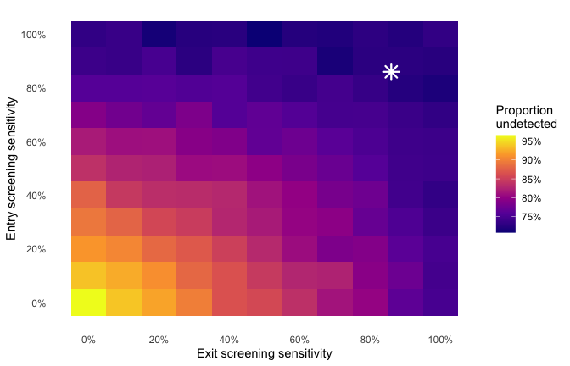
Figure 6: Joint sensitivity analysis: proportion of infected travellers undetected as a function of exit screening sensitivity (x-axis) and entry screening sensitivity (y-axis), for a 12-hour flight with posterior-median BVD natural-history parameters and stable-epidemic exposure distribution. The star marks the primary scenario (86% at both stages). Diagonal dashed lines indicate contours of equal combined coverage.
Exit screening sensitivity has a larger marginal effect on the undetected fraction than entry screening sensitivity, because it acts on a larger at-risk window: any traveller already symptomatic at departure can be caught at exit, whereas entry screening only adds value for those who become symptomatic during the flight or who were missed due to imperfect screening at exit (Figure 6). When exit screening is absent entirely (sensitivity 0%) but entry screening is maintained at 86%, 74% of travellers remain undetected, compared with 79% when entry screening is absent and exit is maintained at 86%. This asymmetry reflects the longer opportunity for symptom detection that the pre-flight period provides relative to the flight itself.

4 Discussion
At 86% sensitivity on a 12-hour international flight, combined syndromic exit and entry screening will fail to detect approximately 73% of infected travellers (95% CrI: 68–77%). The relatively short onset-to-severe-disease interval (mean approximately four days) means that symptomatic travellers progress to detectable illness quickly, yet the incubation period (approximately 7.7 days; Wamala et al. (2010)) means that most infected travellers will board before symptom onset.
The picture is consistent with prior modelling for Zaire ebolavirus and other viral haemorrhagic fevers, and with the empirical record of Ebola disease outside Africa. Van Zandvoort et al. (2026) reviewed all confirmed Ebola cases presenting outside Africa from 1976 to May 2026 and identified 28 cases in total; of these, only four were latent cases — travellers who passed through exit screening asymptomatically and developed symptoms during or after their journey — giving a crude rate of 0.17 traveller-associated cases per 1,000 reported Ebola cases in Africa since 2000 (Zandvoort et al. 2026). Notably, these four latent cases occurred among approximately 300,000 travellers screened by CDC-supported exit screening programmes in Guinea, Liberia, and Sierra Leone during the 2014–16 epidemic, and all four were asymptomatic (and hence undetectable) at the point of both exit and entry screening (Zandvoort et al. 2026). All four latent cases passed exit screening undetected, consistent with the model prediction that most infected travellers depart during the incubation period. Rapid detection of three of these four cases was ultimately achieved through post-travel self-monitoring protocols rather than airport screening, further underscoring the importance of structured self-monitoring guidance for returning travellers (Zandvoort et al. 2026). In practice, the US Centers for Disease Control and Prevention (CDC) implemented layered exit and entry screening at five designated US airports during the 2014 epidemic, combining temperature checks with structured exposure-risk questionnaires and post-arrival active monitoring for 21 days (Brown et al. 2014); our model captures only the syndromic (temperature-based) component of this layered approach, so real-world detection incorporating risk-questionnaire and active-monitoring pathways may exceed our syndromic-screening-only estimates.
Mabey et al. (2014) (Mabey, Flasche, and Edmunds 2014) estimated that exit screening during the 2014 West Africa ZEBOV epidemic would detect only 7–18% of infected travellers on typical long-haul routes, reflecting exit detection rates under active epidemic growth. Specifically, they estimated that if everyone with symptoms was denied boarding (100% exit screening sensitivity), entrance screening would detect 7% (95% CI: 3%–13%) of infected travellers on a 6.42-hour direct flight and up to 13% (95% CI: 7%–21%) on a 13-hour connecting flight. Under the same assumptions of 100% exit screening sensitivity, our BDBV model estimates entrance screening would detect 2.5% (95% CrI: 1.3%–3.9%) of travellers on a 6.42-hour flight and 5.0% (95% CrI: 3.2%–7.1%) on a 13-hour flight. This lower entry detection rate for BDBV, despite its shorter mean incubation period (7.7 vs 9.1 days), is explained by the lower variance in the BDBV incubation distribution (SD 3.5 days vs 7.3 days for ZEBOV), which reduces the density of rapid-onset cases who are most likely to transition to symptoms during transit. Under both pathogens, the primary driver of failure is departure during the incubation period; while the entry detection rate itself is sensitive to flight duration (nearly doubling as flight time increases from 6.42 to 13 hours), the overall public health outcome is robust to travel time, as the vast majority of infected travellers (over 93% in all cases) still enter undetected. Pitman et al. (2005) (Pitman et al. 2005) showed that even under the assumption of 100% screening sensitivity, entry-only screening for SARS would detect approximately one quarter of infected arrivals, with realistic instrument sensitivity (30–50%) reducing this to fewer than one in ten. Gostic et al. (2015) (K. M. Gostic, Kucharski, and Lloyd-Smith 2015) demonstrated that screening effectiveness is primarily determined by the ratio of the incubation period to the onset-to-severe-disease interval and by the proportion of asymptomatic infection; a subsequent application to COVID-19 estimated that even under best-case assumptions, combined departure and arrival screening would detect a median of only 30% (95% interval 10–53%) of infected travellers in a growing epidemic (K. Gostic et al. 2020). Our BVD estimates are of a similar order to those for ZEBOV and are somewhat more favourable than the COVID-19 results under low-asymptomatic assumptions, consistent with the relatively short BDBV incubation period and the low observed asymptomatic fraction. Across the plausible range for BVD, the incubation period is the dominant source of variation in the undetected fraction; the asymptomatic fraction is secondary, given the low rates observed for EVD. Only if patients are allowed to fly irrespective of symptoms would entrance screening be able to detect a substantial fraction of cases (43% if there is no direct flight, 95% CI 34%–53% in the ZEBOV model). Under this scenario, we estimate entrance screening for BDBV would detect 28.3% (95% CrI: 23.5%–33.7%).
This analysis has several limitations. The BVD-specific evidence base for the incubation period is sparse (only three estimates exist (Wamala et al. 2010; MacNeil et al. 2010; Kratz et al. 2015), as described in the Introduction, and the Kratz et al. (2015) estimate rests on only three cases), and the Isiro 2012 line list comprises only 52 cases. As explained in Methods, our propagated credible intervals reflect only within-study sampling uncertainty in the Wamala et al. estimate and likely understate the true uncertainty arising from between-outbreak biological variation or case-ascertainment differences; the incubation-period sensitivity analysis (Figure 4), which spans the wider MacNeil-to-Kratz range, should be consulted alongside the central estimates for this reason. The resulting posterior distributions, whilst appropriately wide, are based on a small sample. The Gamma shape and scale posteriors for the onset-to-admission delay have wide 95% credible intervals, and this uncertainty propagates directly into our screening effectiveness estimates. The model also assumes a single uniform flight duration of 12 hours; in reality, travellers from DRC and Uganda take a variety of itineraries with different durations, layovers, and connection points depending on destination. Our flight-duration sensitivity analysis (Figure 2) demonstrates that outcomes vary only modestly across the 10–16-hour range typical of connecting itineraries, so this simplification does not materially affect the conclusions. The assumed 86% screening sensitivity is derived from a study of thermal image scanning performance during influenza border screening (Priest et al. 2011) and was used in the original 2019-nCoV (later COVID-19) screening model (Quilty et al. 2020); actual sensitivity for EVD symptom detection in field conditions may differ substantially, given differences in fever thresholds, environmental conditions, operator training, and patient cooperation. Because the assumed sensitivity is not BDBV-specific, the screening sensitivity analysis (Figure 6) should be treated as a primary result alongside the central estimates, not as a secondary sensitivity check. Post-arrival healthcare-seeking behaviour is also not captured; infected travellers who develop symptoms after arrival are likely to seek medical care and, if BDBV is considered, to be diagnosed, representing an important additional detection pathway not captured here.
The model removes travellers from the departing pool once they have progressed to severe disease, treating onset-to-severe-disease as equivalent to the threshold for being too ill to travel. In DRC and Uganda, however, hospitalisation can lag clinical deterioration by hours to days owing to health-system access constraints, geographic barriers, and health-seeking norms. The effective “too ill to travel” threshold is therefore likely to be later than the biological severe-disease onset assumed here, meaning the model may underestimate the proportion of symptomatic travellers who successfully board, an anti-conservative bias in this specific direction.
The model does not account for traveller selection effects. During an active outbreak, some infected individuals may travel specifically to seek care that is unavailable locally, biasing the departing caseload towards symptomatic presentations; conversely, awareness of the outbreak, border communication campaigns, or voluntary self-isolation may deter others, reducing the infected fraction among travellers overall. These pressures operate in opposite directions and are difficult to quantify without data on travel volumes and health-seeking behaviour specific to the outbreak context. The baseline assumption, that infected travellers are drawn at random from the infected population with a uniform exposure-age distribution, is a simplification that may not hold in practice.
The simulation model also assumes that exposure times are distributed uniformly across the natural history window, which approximates a stable (non-growing) epidemic. In an actively growing outbreak, as the current DRC BDBV situation likely is, the distribution of infection ages among travelling cases is skewed towards recent exposure, because recent cases outnumber older ones. Under this scenario, a greater fraction of departing travellers will be pre-symptomatic, and the proportion undetected will be higher than our central estimates suggest. Gostic et al. (2015, 2020) (K. M. Gostic, Kucharski, and Lloyd-Smith 2015; K. Gostic et al. 2020) showed that this epidemic-phase effect can reduce detection, and our growth-phase sensitivity analysis (Figure 5) demonstrates a similar pattern for BVD: under the initial 90% credible interval for the current BVD outbreak doubling time (13.8–22.8 days; epiforecasts 2026 (Funk and Abbott 2026)), the undetected fraction increases relative to the stable-epidemic baseline, and under the most pessimistic scenario (doubling time 4.5 days, consistent with the lower end of uncertainty estimates from epiforecasts (Funk and Abbott 2026)) may be higher still; the central R of 1.71 estimated by Chamla et al. (2026) from the confirmed case series (Chamla et al. 2026) is broadly consistent with this range of doubling times. Our central estimates should therefore be interpreted as a lower bound on the undetected fraction during an active growth phase. The model does not include questionnaire-based exposure risk screening, which forms part of real-world EVD port-of-entry protocols. Since BVD transmission requires direct contact with a symptomatic or deceased case, travellers with known exposure history should, in principle, be detectable by structured risk questionnaires even before fever onset. Incorporating this pathway would increase modelled detection rates above the syndromic-screening-only estimates here. Finally, the model conditions on a traveller already being infected and therefore estimates the sensitivity of screening, defined as the probability of detecting an infected traveller, rather than predictive values. Translating these results into positive or negative predictive values, or into expected counts of imported cases, would require assumptions about the prevalence of infection among travellers departing affected areas, which is highly uncertain during an active outbreak and outside the scope of this analysis.
Syndromic airport screening for BVD is unlikely to detect most infected travellers. This conclusion is consistent with the PHEIC temporary recommendations issued by WHO (World Health Organization 2026), which advise exit screening in affected countries but explicitly state that entry screening outside the affected region is not considered necessary. Resources directed at airport screening in receiving countries carry an opportunity cost: equivalent investment in contact tracing capacity, isolation infrastructure, and healthcare worker protection in DRC and Uganda would more directly reduce onward transmission at the source. For receiving countries, the more actionable layer of protection is clinician preparedness: healthcare providers in low-incidence settings should consider BVD in the differential diagnosis of febrile illness with a travel history from affected regions, supported by clear referral pathways to high-consequence infectious disease units, pre-agreed diagnostic protocols at those centres, and timely communication between national public health authorities and point-of-care clinicians. Complementing syndromic screening with structured post-departure self-monitoring guidance and identification of travellers at high risk of exposure (for example, via exposure-history questionnaires as part of the screening protocol itself)—advising these travellers to monitor themselves for fever and other EVD symptoms for 21 days after departure and to contact healthcare services proactively if symptoms develop—would provide a further safety net for the pre-symptomatic cases that no airport screen can capture. This wider approach appears to have been successful during the 2014–16 epidemic: among returning healthcare workers, self-monitoring protocols that included clear guidance on procedures for symptom reporting ultimately led to rapid confirmation and isolation in three of the four latent cases identified worldwide (Zandvoort et al. 2026). Communication of this advice at both departure and destination airports, through travel health notices and airline briefings, could increase uptake.

Supplementary Material

4.1 Figure S1: Entry screening sensitivity by flight duration under 100% exit screening
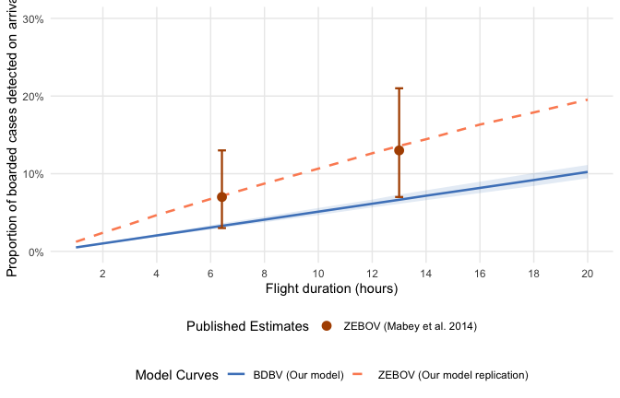
Figure 7: Entrance screening detection probability among successfully boarded travellers as a function of flight duration under a hypothetical 100% sensitive exit screening. The blue ribbon and line show the median and 95% credible intervals for BDBV (propagating Natural History uncertainty and assuming 25.7% asymptomatic-equivalent fraction). The orange line shows the point estimate for ZEBOV (assuming 0% asymptomatic fraction, mean incubation of 9.1 days, and SD of 7.3 days, following Mabey et al. 2014). The point markers with error bars represent the exact direct flight (6.42 hours) and connecting flight (13.0 hours) estimates and 95% confidence intervals from Mabey et al. (2014) for ZEBOV.

Acknowledgements
This work was conducted in response to a request for modelling from UK Foreign, Commonwealth & Development Office. The authors thank Timothy W Russell, Simon R Procter, and Joshua Lambert for working group review of the manuscript. The interactive screening Shiny application and airportscreening R package on which this analysis is based were originally developed for the COVID-19 pandemic response; the application was co-developed with Sam Clifford and the package with Pratik Gupte.

References
Akilimali, Pierre, Dav M. Ebengo, Samuel V. Scarpino, Adrienne Amuri-Aziza, Tony Wawina-Bokalanga, Placide Matondo-Mbundu, Benjamin Kanku, et al. 2026. “Clinical Characteristics of Patients Infected with Bundibugyo Virus, DRC 2026.” New England Journal of Medicine. https://doi.org/10.1056/NEJMc2608070.
Brown, Clive M., Anna E. Aranas, Grace A. Benenson, Gary Brunette, Martin Cetron, Tai-Ho Chen, et al. 2014. “Airport Exit and Entry Screening for Ebola — August–November 10, 2014.” MMWR Morbidity and Mortality Weekly Report 63 (49): 1163–67.
Chamla, Dick, Marie Roseline Darnycka Belizaire, Isaias Fernandes Co, Arisekola Jinadu, Ibrahim Mamadu, and Ajiri Okpure Atagbaza. 2026. “Size of the 2026 Ebola Outbreak and Risk of Cross-Border Spillover from Bundibugyo Virus in Ituri Province, DR Congo, and Its Implications for Preparedness: A Recalibrated Stochastic Modelling Study.” Lancet Infectious Diseases. https://doi.org/10.1016/S1473-3099(26)00320-8.
Funk, Sebastian, and Sam Abbott. 2026. “Bayesian Delay-Distribution and Stratified CFR Estimation from the 2012 Isiro Bundibugyo Ebola Virus Line List.” GitHub repository: https://github.com/epiforecasts/bdbv-linelist-analysis.
Gostic, Katelyn M., Adam J. Kucharski, and James O. Lloyd-Smith. 2015. “Effectiveness of Traveller Screening for Emerging Pathogens Is Shaped by Epidemiology and Natural History of Infection.” eLife 4: e05564. https://doi.org/10.7554/eLife.05564.
Gostic, Katelyn, Ana CR Gomez, Riley O Mummah, Adam J Kucharski, and James O Lloyd-Smith. 2020. “Estimated Effectiveness of Symptom and Risk Screening to Prevent the Spread of COVID-19.” eLife 9: e55570. https://doi.org/10.7554/eLife.55570.
Kratz, Thomas, Benjamin O. Black, Dani Cadar, Mariano Sanchez-Lockhart, Matthias Borchert, Thomas Laue, Pallab Patel, Beate M. Kummerer, Jonas Schmidt-Chanasit, and Stephan Gunther. 2015. “Ebola Virus Disease Outbreak in Isiro, Democratic Republic of the Congo, 2012: Signs and Symptoms, Management and Outcomes.” PLoS ONE 10 (6): e0129333. https://doi.org/10.1371/journal.pone.0129333.
Mabey, David, Stefan Flasche, and W. John Edmunds. 2014. “Airport Screening for Ebola.” BMJ 349: g6202. https://doi.org/10.1136/bmj.g6202.
MacNeil, Adam, Eileen C. Farnon, Joseph Wamala, Sam Okware, Deborah L. Cannon, Zachary Reed, Jonathan S. Towner, et al. 2010. “Proportion of Deaths and Clinical Features in Bundibugyo Ebola Virus Infection, Uganda.” Emerging Infectious Diseases 16 (12): 1969–72. https://doi.org/10.3201/eid1612.100627.
Nash, Rebecca K., Sangeeta Bhatia, Christian Morgenstern, Patrick Doohan, David Jorgensen, Kelly McCain, Ruth McCabe, et al. 2024. “Ebola Virus Disease Mathematical Models and Epidemiological Parameters: A Systematic Review.” The Lancet Infectious Diseases 24 (12): e762–73. https://doi.org/10.1016/S1473-3099(24)00374-8.
Pitman, Richard J., Ben S. Cooper, Caroline L. Trotter, Nigel J. Gay, and W. John Edmunds. 2005. “Entry Screening for Severe Acute Respiratory Syndrome (SARS) or Influenza: Policy Evaluation.” BMJ 331 (7527): 1242–43. https://doi.org/10.1136/bmj.38573.696100.3A.
Priest, Patricia C., Annette R. Duncan, Lance C. Jennings, and Michael G. Baker. 2011. “Thermal Image Scanning for Influenza Border Screening: Results of an Airport Screening Study.” PLoS ONE 6 (1): e14490. https://doi.org/10.1371/journal.pone.0014490.
Quilty, Billy J., Samuel Clifford, CMMID nCoV Working Group, Stefan Flasche, and Rosalind M. Eggo. 2020. “Effectiveness of Airport Screening at Detecting Travellers Infected with Novel Coronavirus (2019-nCoV).” Eurosurveillance 25 (5): pii=2000080. https://doi.org/10.2807/1560-7917.ES.2020.25.5.2000080.
Rosello, Alicia, Mathias Mossoko, Stefan Flasche, Albert Jan Van Hoek, Placide Mbala, Anton Camacho, W. John Edmunds, et al. 2015. “Ebola Virus Disease in the Democratic Republic of the Congo, 1976–2014.” eLife 4: e09015. https://doi.org/10.7554/eLife.09015.
Towner, Jonathan S., Tara K. Sealy, Marina L. Khristova, César G. Albariño, Sean Conlan, Scott A. Reeder, Phenix-Lan Quan, et al. 2008. “Newly Discovered Ebola Virus Associated with Hemorrhagic Fever Outbreak in Uganda.” PLoS Pathogens 4 (11): e1000212. https://doi.org/10.1371/journal.ppat.1000212.
Wamala, Joseph F., Luswa Lukwago, Mugagga Malimbo, Patrick Nguku, Zabulon Yoti, Monica Musenero, Jackson Amone, et al. 2010. “Ebola Hemorrhagic Fever Associated with Novel Virus Strain, Uganda, 2007–2008.” Emerging Infectious Diseases 16 (7): 1087–92. https://doi.org/10.3201/eid1607.091525.
World Health Organization. 2026. “Epidemic of Ebola Disease Caused by Bundibugyo Virus in the Democratic Republic of the Congo and Uganda Determined a Public Health Emergency of International Concern.” https://www.who.int/news/item/17-05-2026-epidemic-of-ebola-disease-in-the-democratic-republic-of-the-congo-and-uganda-determined-a-public-health-emergency-of-international-concern.
Zandvoort, Kevin van, Simon R Procter, James M Azam, Katharine Sherratt, and Nicholas G Davies. 2026. “The Risk of Global Ebola Virus Spread Is Low: Epidemiology of Ebola Disease Cases Outside Africa, 1976 to May 2026.” Eurosurveillance 31 (24): 2600508. https://doi.org/10.2807/1560-7917.ES.2026.31.24.2600508.

