**Rocket League Database – Report**

**Student No. 13328025**

**Application Description**

I have chosen to create an instance of a database that would be implemented to represent a session of the game Rocket League.

Rocket league is an online multilayer game. It has a sophisticated physics engine with its gameplay based around vehicular battles with the same basic rules of soccer. The games last four minutes and one score awarded for every goal scored. Each player has their own customisable vehicle with every vehicle having the same speed specifications. The only difference is aesthetic.

The database represents the basic formulae that makes up a gamers experience in a session. I decides to represent something of a 'snapshot' of the database in a certain moment of time as there can be many changes in the database over a matter of minutes or even seconds. The database is modelled relationally with the use of tables such as Player Profile, Game Mode, Arena, Car, Soundtrack, Match and Match Players.

The player profile table contains attributes for Username, a player’s name, nationality, age and hours logged playing rocket league online. Username is the primary key here, thus ensuring only one instance of a username can be used or in other words, players cannot have the same username. For this database I only implemented a handful of players but it is implied the player network is quite extensive.

The game mode table stores information regarding all the different type of game modes open to the player. Columns include GameMd which is the name of the game mode, rank level, team size, players online which is the amount of players playing that game mode (helps the player determine if it will be easy to find a game) and dedicated servers which is the amount of servers the developers wish to assign to the game mode. This allows the more popular game modes to run seamlessly.

The arena table is for storing the specifications for all of the arenas a player can play on. It hold information such as its name, turf type, the time of day it is set, the overall design of the arena, and the amount of speed booster on the pitch.

I also included a soundtrack table for holding the multitude of songs that rocket league have for games. The table has the song name, artist, producer, duration and age rating. The primary key here was song name which for most databases including would not be a primary key as there can be multiple reincarnations of songs but I felt that rocket leagues songs would all be quite distinct and there would only be a finite amount of songs which would only be decided upon by the developers.

The car class holds information for all the cars which have been made by the users. Every new incarnation of a car is given an id. The other fields include owner which is a foreign key of username, body type, decal, flag, hat and wheel type.

The Match table is where most of this database comes together. It represents the match that has just taken place between two opposing sides. It has foreign keys in the shape of Song used, Venue picked, game mode picked and MVP. Along with these it also has Final score and the primary key Match id. I only implemented two matches but thousands can take place at a time.

Finally there is the table match players which is closely related to Match as it contains all the groups of players taking part in games. The groups are decide upon by the foreign key game id (Match id) and also includes a player number for each player in each distinct game. It also has the foreign key player name which is taken from player profile. This table is used for my security constraint CK_CheckAge which I will talk more about later.

**Entity Relationship Diagram**

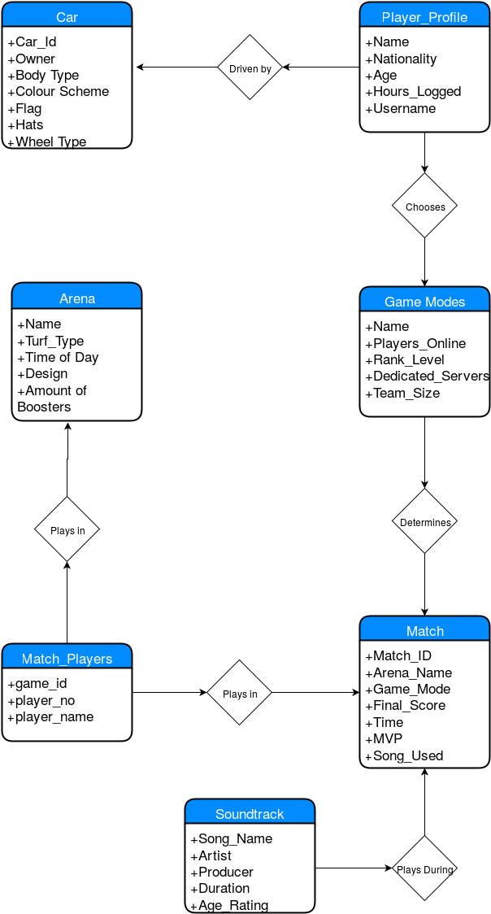

**Relational Schema**

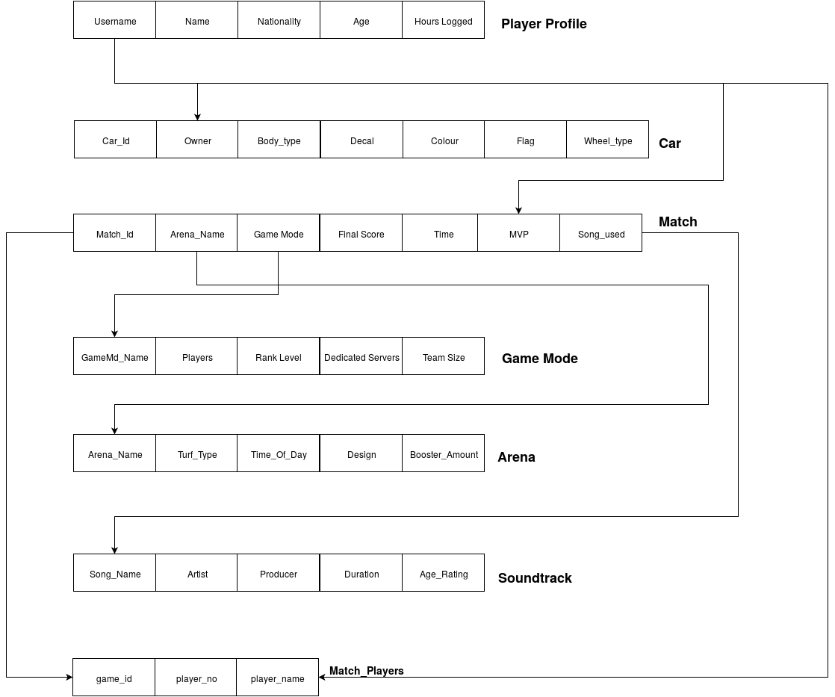

**\*Underlined attributes are Primary Keys**

**Functional Dependency Diagram**

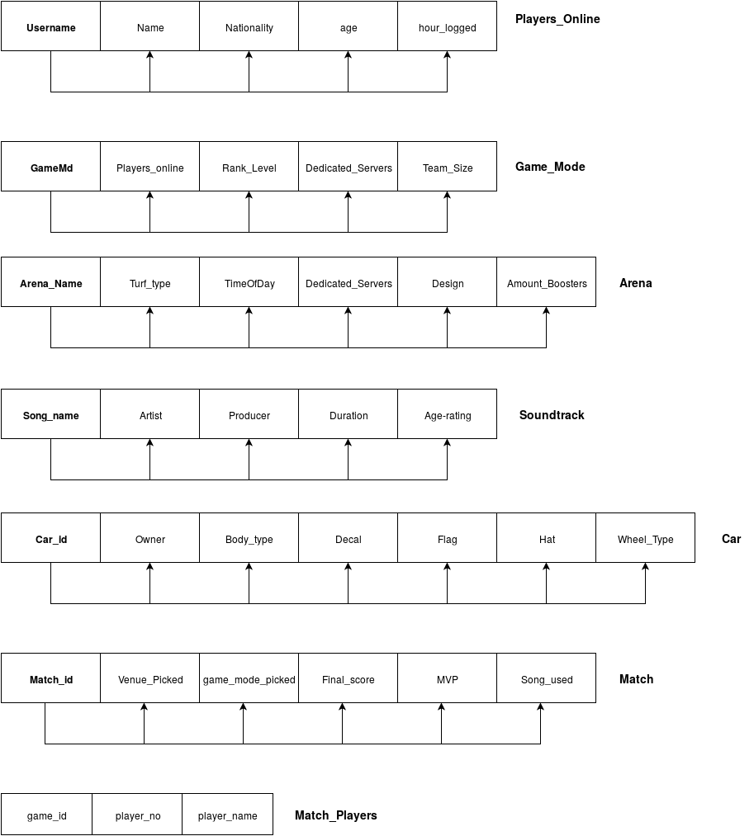

None of my relations needed any normalisation as the database does not contain any data redundancy.

**Semantic Constraints**

The database contains quite a few basic semantic constraints in the form of primary and secondary keys as well as NOT NULL statements. There also checks in game_mode to ensure the rank was correct and also in arena to check the time of day was a correct VARCHAR.

Other constraints I added were simple checks on for instance a players age had to be between that of 3 and 110, the ids for both match and car had bounded checks.

I also implemented quite important constraints on both the number of players on a team and the amount of boosters in an arena.

**Alter** **table** Player_Profile **ADD** **CHECK(**age **>**3 **AND** age**<**110**);**

**Alter** **Table** Game_Mode **ADD** **CHECK(**Team_size **>=** 1 **AND** Team_size **<=**4**);**

**Alter** **Table** Arena **ADD** **CHECK(**Amount_Boosters **>**12 **AND** Amount_Boosters **<=** 18**);**

**Alter** **Table** **Match** **ADD** **CHECK(**Match_id **>** 999 **AND** Match_Id **<** 10000**);**

**Alter** **Table** Car **ADD** **CHECK(**Car_id **>=**20000 **AND** Car_id **<** 99999**);**

**Alter** **Table** Soundtrack **ADD** **CHECK(**Age_Rating **>=** 3 **AND** Age_Rating **<=** 110**);**

Perhaps the most advanced and tricky to implement was the check added to Match for checking all players in a match were of an acceptable age to listen to the song playing during the match. I implemented this by creating a function which was called by the check. Its parameters were the song being used and it returned a Boolean value. 'True ‘if there was an ineligible player present and 'False' if all players were old enough. I felt I needed to create a function as it was the neatest implementation and allowed for efficient reading of other tables values (i.e. age from Player_Profile). The match players table was created to access players in a match.

**CREATE** **FUNCTION** Check_LobbyAge **(**

SongTocheck **VARCHAR(**25**)**

**)**

**RETURNS** **VARCHAR(**10**)**

**AS**

**BEGIN**

**DECLARE** AGE **int**

**SELECT** AGE **=** Age_Rating **FROM** Soundtrack **where** Song_Name **=** SongTocheck

**IF** **EXISTS** **(SELECT** age **FROM** Player_Profile **WHERE** age **<** AGE )

**return** 'True'

**return** 'False'

**END;**

**ALTER** **TABLE** **Match**

**WITH** **CHECK** **ADD** **CONSTRAINT** CK_CheckAge

**CHECK** **(**Check_LobbyAge**(**Song_used**)** **=** 'False'**);**

**Security**

To add security to my database I implemented two roles as an example. There are named dev_ADMIN which would be top in the hierarchy of GRANT commands. I have given dev create, delete and alter table privileges. Thus, this gives dev all power over the database. Access is restricted by the password rocLPassword.

**Create** ROLE dev_ADMIN **IDENTIFIED** **by** rocLPassword**;**

**Grant** **create** **table** **to** dev_ADMIN**;**

**Grant** **delete** **table** **to** dev_ADMIN**;**

**Grant** **alter** **table** **to** dev_ADMIN**;**

**REVOKE** **Grant** **create** **table** **FROM** dev_ADMIN**;**

The second role is the server_Admin. The server table is given the view Lobbies. This view has all of the game lobbies that have been created and are grouped by the game each user shares. This role is protected by the password server Password.

**Create** **view** Lobbies **AS** **Select**

Username**,** age**,** nationality**,**game_id **From**

player_profile**,** match_players**,** **Match** **Where** **(**Match_Id **=** game_id**)** **AND** **(**username **=** player_name**);**

**Create** role server_ADMIN **identified** **by** serverPassword**;**

**Grant** **select** **on** **table** Lobbies **to** server_ADMIN**;**

**Trigger**

The trigger I implemented dealt with the deletion of a player’s profile. As the players username is shared over multiple tables this trigger updates rows effected in these tables by setting the username to NULL.

**Create** **OR** **Replace** **TRIGGER** Player_Deletion

**After** **DELETE** **On** Player_Profile

**For** **each** **row**

**when** **(OLD.**username **IS** **NOT** **NULL)**

**Declare**

deleted_username **VARCHAR(**20**);**

**BEGIN**

deleted_username **:=** **:OLD.**username**;**

**UPDATE** **MATCH** **SET** MVP **=** **NULL** **where** MVP **=** deleted_username**;**

**UPDATE** Car **SET** Owner **=** **NULL** **where** Owner **=** deleted_username**;**

**UPDATE** Match_Players **SET** player_name **=** **NULL** **where** player_name **=** deleted_username**;**

**END** Player_Deletion**;**

**.**

RUN**;**

**Appendix**

**CREATE** **TABLE** Player_Profile **(**

Username **VARCHAR(**20**)** **NOT** **NULL,**

Name **VARCHAR(**20**)** **NOT** **NULL,**

Nationality **VARCHAR(**20**)** **NOT** **NULL,**

age **INT** **NOT** **NULL,**

hours_logged **INT** **NOT** **NULL,**

**PRIMARY** **KEY(**Username**));**

**INSERT** **INTO** Player_Profile **VALUES(**'FlowerPlucker13'**,** 'Bryan Quirke'**,**

'Irish'**,** 21**,** 48**);**

**INSERT** **INTO** Player_Profile **VALUES(**'flyinBadger'**,** 'Derek McGee'**,**

'Scottish'**,** 15**,** 178**);**

**INSERT** **INTO** Player_Profile **VALUES(**'johnnyDeppWho'**,** 'Orlando Bloom'**,**

'American'**,** 35**,** 2**);**

**INSERT** **INTO** Player_Profile **VALUES(**'mcSquared'**,** 'Alfonso Einstein'**,**

'German'**,** 85**,** 12**);**

**INSERT** **INTO** Player_Profile **VALUES(**'shakeNbake'**,** 'John C Reily'**,**

'American'**,** 41**,** 17**);**

**INSERT** **INTO** Player_Profile **VALUES(**'oracle'**,** 'Larry Ellison'**,**

'American'**,** 71**,** 150**);**

**INSERT** **INTO** Player_Profile **VALUES(**'iLuvDonuts'**,** 'Keith Burn'**,**

'German'**,** 24**,** 46**);**

**INSERT** **INTO** Player_Profile **VALUES(**'F11'**,** 'Mike Ross'**,**

'American'**,** 34**,** 2**);**

**INSERT** **INTO** Player_Profile **VALUES(**'gladiator2'**,** 'Russell Crowe'**,**

'Austrailian'**,** 53**,** 50**);**

**CREATE** **TABLE** Game_Mode **(**

GameMd **VARCHAR(**20**)** **NOT** **NULL,**

Players_Online **INT** **NOT** **NULL,**

Rank_level **VARCHAR(**20**)** **NOT** **NULL,**

Dedicated_servers **INT** **NOT** **NULL,**

Team_size **INT** **NOT** **NULL,**

**PRIMARY** **KEY(**GameMd**),**

**CHECK(**Rank_Level **IN** **(**'Rookie'**,** 'Semi-Pro'**,** 'Pro'**,** 'Veteran'**,** 'Expert'**)));**

**INSERT** **INTO** Game_Mode **VALUES(**'Duel'**,**7001**,**'Pro'**,**25**,** 1**);**

**INSERT** **INTO** Game_Mode **VALUES(**'Doubles'**,**84501**,**'Rookie'**,**80**,** 2**);**

**INSERT** **INTO** Game_Mode **VALUES(**'Standard'**,**100000**,**'Semi-Pro'**,**100**,** 3**);**

**INSERT** **INTO** Game_Mode **VALUES(**'Chaos'**,**4561**,**'Pro'**,**12**,** 4**);**

**INSERT** **INTO** Game_Mode **VALUES(**'Mutator Mashup'**,**20500**,**'Rookie'**,**140**,** 3**);**

**CREATE** **TABLE** Arena **(**

Arena_Name **VARCHAR(**20**)** **NOT** **NULL,**

Turf_Type **VARCHAR(**20**)** **NOT** **NULL,**

TimeOfDay **VARCHAR(**10**)** **NOT** **NULL,**

Design **VARCHAR(**25**)** **NOT** **NULL,**

Amount_Boosters **INT** **NOT** **NULL,**

**PRIMARY** **KEY(**Arena_Name**),**

**CHECK(**TimeOfDay **IN** **(**'Morning'**,** 'Midday'**,** 'Midnight'**,** 'Dusk'**,** 'Dawn'**)));**

**INSERT** **INTO** Arena **VALUES(**'DFH Stadium'**,** 'Grass'**,** 'Midday'**,** 'Conventional Stadium'**,**18**);**

**INSERT** **INTO** Arena **VALUES(**'Urban Central'**,** 'Tarmac'**,** 'Midnight'**,** 'Basketball Court'**,** 18**);**

**INSERT** **INTO** Arena **VALUES(**'Mannfield'**,** 'Grass'**,** 'Midday'**,** 'Conventional Stadium'**,** 18**);**

**INSERT** **INTO** Arena **VALUES(**'Beckwith Park'**,** 'Grass'**,** 'Dawn'**,** 'Pitch set in Forest'**,** 18**);**

**INSERT** **INTO** Arena **VALUES(**'Utopia Coliseum'**,** 'Grass and Clay'**,** 'Midday'**,** 'Roman Coliseum'**,** 18**);**

**INSERT** **INTO** Arena **VALUES(**'WasteLand'**,** 'Sand'**,** 'Dusk'**,** 'Mad Max-esque Arena'**,** 18**);**

**CREATE** **TABLE** Soundtrack **(**

Song_Name **VARCHAR(**25**)** **NOT** **NULL,**

Artist **VARCHAR(**25**)** **NOT** **NULL,**

Producer **VARCHAR(**25**)** **NOT** **NULL,**

Duration **VARCHAR(**10**)** **NOT** **NULL,**

Age_Rating **INT** **NOT** **NULL,**

**PRIMARY** **KEY(**Song_Name**));**

**INSERT** **INTO** Soundtrack **VALUES(**'Rocket League Theme'**,** 'Mike Ault'**,** 'Mike Ault'**,** '1:28'**,** 12**);**

**INSERT** **INTO** Soundtrack **VALUES(**'Angel Wings'**,** 'Mike Ault'**,** 'Mike Ault'**,** '6:08'**,** 12**);**

**INSERT** **INTO** Soundtrack **VALUES(**'Darkness'**,** 'Christian de la Torre'**,** 'Mike Ault'**,** '7:30'**,** 16**);**

**INSERT** **INTO** Soundtrack **VALUES(**'Seeing Whats Next'**,** 'Hollywood Principle'**,** 'Simon Hebbler'**,** '3:19'**,** 12**);**

**INSERT** **INTO** Soundtrack **VALUES(**'FACK'**,** 'Eminem'**,** 'Dr. Dre'**,** '3:26'**,** 18**);**

**CREATE** **TABLE** Car **(**

Car_id **INT** **NOT** **NULL,**

Owner **VARCHAR(**20**)** **NOT** **NULL,**

Body_Type **VARCHAR(**25**)** **NOT** **NULL,**

Decal **VARCHAR(**20**),**

Flag **VARCHAR(**20**),**

Hat **VARCHAR(**20**),**

Wheel_Type **VARCHAR(**20**)** **NOT** **NULL,**

**PRIMARY** **KEY(**Car_id**));**

**INSERT** **INTO** Car **VALUES(**20000**,** 'FlowerPlucker13'**,** 'Backfire'**,**'Flames'**,**'Camo Flag'**,** 'Sombrero'**,**'Lucci'**);**

**INSERT** **INTO** Car **VALUES(**20001**,** 'flyinBadger'**,** 'Breakout'**,**'Wings'**,**'Scotland Flag'**,** **NULL,** 'Mountaineer'**);**

**INSERT** **INTO** Car **VALUES(**20002**,** 'mcSquared'**,**'Paladin' **,**'Racing Strip'**,** **NULL,** 'Wizard Hat'**,** 'Vortex'**);**

**INSERT** **INTO** Car **VALUES(**20003**,** 'shakeNbake'**,** 'Road Hog'**,** **NULL,**'Safety'**,** 'Hard Hat' **,** 'Sleek'**);**

**INSERT** **INTO** Car **VALUES(**20004**,** 'oracle'**,** 'Gizmo'**,** **NULL,**'SQL Flag'**,** 'Halo' **,** 'Californian'**);**

**CREATE** **TABLE** **Match** **(**

Match_Id **INT** **NOT** **NULL,**

Venue_picked **VARCHAR(**20**)** **NOT** **NULL,**

game_mode_picked **VARCHAR(**20**)** **NOT** **NULL,**

Final_score **VARCHAR(**5**)** **NOT** **NULL,**

MVP **VARCHAR(**20**)** **NOT** **NULL,**

Song_used **VARCHAR(**25**),**

**PRIMARY** **KEY(**Match_Id**));**

**INSERT** **INTO** **Match** **VALUES(**3000**,** 'Urban Central'**,**'Doubles'**,** '3-2'**,** 'mcSquared'**,** 'Seeing Whats Next'**);**

**INSERT** **INTO** **Match** **VALUES(**3001**,** 'Urban Central'**,**'Mutator Mashup'**,** '10-2'**,** 'oracle'**,** 'Darkness'**);**

**INSERT** **INTO** **Match** **VALUES(**3002**,** 'WasteLand'**,**'Chaos'**,** '1-0'**,** 'shakeNbake'**,** 'Rocket League Theme'**);**

**INSERT** **INTO** **Match** **VALUES(**3003**,** 'Urban Central'**,**'Doubles'**,** '3-0'**,** 'mcSquared'**,** **NUll);**

**INSERT** **INTO** **Match** **VALUES(**3004**,** 'DFH Stadium'**,**'Standard'**,** '7-4'**,** 'flyinBadger'**,** 'Darkness'**);**

**Create** **TABLE** Match_Players**(**

game_id **INT** **NOT** **NULL,**

player_no **INT** **NOT** **NULL,**

player_name **VARCHAR(**20**)** **NOT** **NULL,**

**FOREIGN** **KEY(**game_id**)** **REFERENCES** **Match(**Match_Id**),**

**FOREIGN** **KEY(**player_name**)** **REFERENCES** Player_Profile**(**Username**));**

**INSERT** **INTO** Match_Players **VALUES(**3000**,**1**,**'mcSquared'**);**

**INSERT** **INTO** Match_Players **VALUES(**3000**,**2**,**'oracle'**);**

**INSERT** **INTO** Match_Players **VALUES(**3000**,**3**,**'shakeNbake'**);**

**INSERT** **INTO** Match_Players **VALUES(**3000**,**4**,**'FlowerPlucker13'**);**

**INSERT** **INTO** Match_Players **VALUES(**3001**,**1**,**'flyinBadger'**);**

**INSERT** **INTO** Match_Players **VALUES(**3001**,**2**,**'oracle'**);**

**INSERT** **INTO** Match_Players **VALUES(**3001**,**3**,**'F11'**);**

**INSERT** **INTO** Match_Players **VALUES(**3001**,**4**,**'gladiator2'**);**

**INSERT** **INTO** Match_Players **VALUES(**3001**,**5**,**'iLuvDonuts'**);**

**INSERT** **INTO** Match_Players **VALUES(**3001**,**6**,**'johnnyDeppWho'**);**

-- Foreign Keys

**Alter** **Table** **Match** **ADD** **FOREIGN** **KEY(**Song_used**)** **REFERENCES** Soundtrack**(**Song_Name**);**

**Alter** **Table** **Match** **ADD** **FOREIGN** **KEY(**Venue_picked**)** **REFERENCES** Arena**(**Arena_Name**);**

**Alter** **Table** **Match** **ADD** **FOREIGN** **KEY(**game_mode_picked**)** **REFERENCES** Game_Mode**(**GameMd**);**

**Alter** **Table** **Match** **ADD** **FOREIGN** **KEY(**MVP**)** **REFERENCES** Player_Profile**(**Username**);**

**Alter** **Table** Car **ADD** **FOREIGN** **KEY(**Owner**)** **REFERENCES** Player_Profile**(**Username**);**

-- Constraints

**Alter** **table** Player_Profile **ADD** **CHECK(**age **>**3 **AND** age**<**110**);** --ageism

**Alter** **Table** Game_Mode **ADD** **CHECK(**Team_size **>=** 1 **AND** Team_size **<=**4**);**

**Alter** **Table** Arena **ADD** **CHECK(**Amount_Boosters **>**12 **AND** Amount_Boosters **<=** 18**);**

**Alter** **Table** **Match** **ADD** **CHECK(**Match_id **>** 999 **AND** Match_Id **<** 10000**);**

**Alter** **Table** Car **ADD** **CHECK(**Car_id **>=**20000 **AND** Car_id **<** 99999**);**

**Alter** **Table** Soundtrack **ADD** **CHECK(**Age_Rating **>=** 3 **AND** Age_Rating **<=** 110**);** -- ageism.....again

-- SECRUITY

**Create** **view** Lobbies **AS** **Select**

Username**,** age**,** nationality**,**game_id **From**

player_profile**,** match_players**,** **Match** **Where** **(**Match_Id **=** game_id**)** **AND** **(**username **=** player_name**);**

-- TRIGGERS

**Create** **OR** **Replace** **TRIGGER** Player_Deletion

**After** **DELETE** **On** Player_Profile

**For** **each** **row**

**when** **(OLD.**username **IS** **NOT** **NULL)**

**Declare**

deleted_username **VARCHAR(**20**);**

**BEGIN**

deleted_username **:=** **:OLD.**username**;**

**UPDATE** **MATCH** **SET** MVP **=** **NULL** **where** MVP **=** deleted_username**;**

**UPDATE** Car **SET** Owner **=** **NULL** **where** Owner **=** deleted_username**;**

**UPDATE** Match_Players **SET** player_name **=** **NULL** **where** player_name **=** deleted_username**;**

**END** Player_Deletion**;**

**.**

RUN**;**