Game Sample
A 10-30-second rough very-simplified animated sample of the game in action. This game sample must be suitable for demonstration in class to the instructor. It is due 2 weeks after the start of this project.
Steps:
1. Build a Proof-of-Concept doc containing:
a. A mini-level design.
Design is simple Galaga style arcade shooter with the player’s ship at the bottom and the enemy aliens at the top speeding downwards. The aliens shoot laser which if any hit the player would cause the ship to be destroyed and end the level. The players are capable of shooting back and destroying the aliens. However, once an alien is destroyed, another spawns in its place.
b. Describe the key feature you want to focus on in the Sample.
We wanted to just to make sure that the basic movement, aliens and shooting would work.
c. How will it look? Backgroud, foreground objects, avatars, movement, actions/moves
i. In the rough simplified Sample;
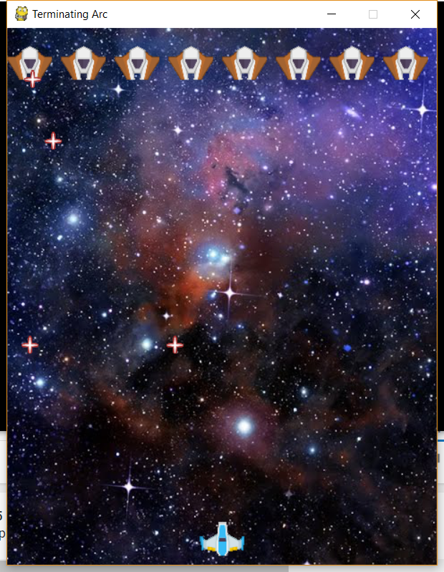

ii. In the scaled-up Game
In the scaled up version, we’re going to have an upgrade shop with multiple levels
d. What development steps will you need to build the Sample. 2. Dev Tasks to be addressed:
- Rough background (eg, hand-drawn, scanned)
- Rough foreground & objects
- Rough avatars/NPCs: look (eg, maybe only 1 moving limb, etc) (if the game has an avatar/NPC)
- Rough action: how avatars/NPCs move, interact with the environment
- How the controls affect the animation
Notes:
1. If your game is not level-oriented, but e.g., a scroller, then show the initial screen-sized exploration or
action area that seems roughly equivalent to the detail of a mini-level. 2. For a board-game, the pieces may have little movement on their own. 3. For a puzzle-game, there may be no avatar to speak of.
d. What development steps will you need to build the Sample. 2. Dev Tasks to be addressed:
- Rough background (eg, hand-drawn, scanned)
- Rough foreground & objects
- Rough avatars/NPCs: look (eg, maybe only 1 moving limb, etc) (if the game has an avatar/NPC)
- Rough action: how avatars/NPCs move, interact with the environment
- How the controls affect the animation
Notes:
1. If your game is not level-oriented, but e.g., a scroller, then show the initial screen-sized exploration or
action area that seems roughly equivalent to the detail of a mini-level. 2. For a board-game, the pieces may have little movement on their own. 3. For a puzzle-game, there may be no avatar to speak of.
Weighting of Project Issues
- 60% for a playable game
- 5% for a clear Rough Concept Spec
- 15% for a clear understandable Game Sample
- 5% for clear Summary and Design Report
- 5% for clear well-documented source code.
• 5% for a reasonable README.txt file
• 5% for following the Submission rules

