Boundary — corrective capstone release
18 October 2026 · Franchise research studio

Release results
31 core regressions; 41 workflow checks; 5 local browser checks. Failures: 0; errors: 0. These checks do not establish live provider quality, deployed rebuild completion or independent expert usefulness.
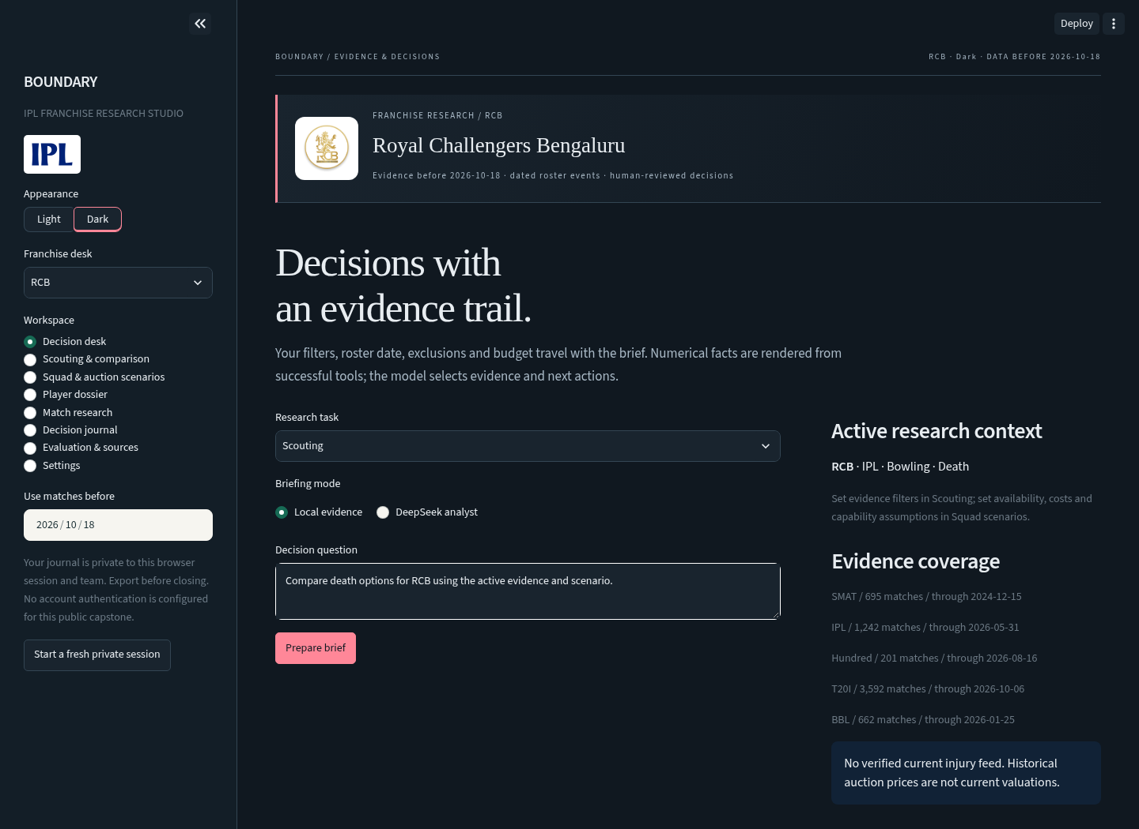

Corrective release
The intensive audit exposed unsupported bowling depth, historical roster misuse, alias failures, shared journals, ignored AI scenario constraints, stale answers on outage and a model that failed a stronger baseline. This release corrects those paths before the visual redesign.
Data and identities: unique planning IDs for unregistered players; canonical aliases preserved; sourced dated roster events; pre-2026 roster guard; reduced-innings powerplays; phase wickets and dismissals; unchanged raw total statistics.
Decision tools: recency and wicket/dismissal-aware descriptive scoring; separate competition groups; matching uncertainty scope; exact joint XI/phase workload plan; complete scenario prices and justified capability assumptions; explicit insufficient-evidence behavior.
Assistant: bounded protocol-valid tool turns; active scenario inheritance; scoped cache fingerprints; locally rendered tool facts; no free generated numerical claims; clear prior answer before failures. Local evidence remains available without the provider.
Forecasts and records: failed stronger-baseline gate, served training chase baseline, canonical venue aliases, strict snapshot guard; random session/team-scoped journals, cache and reviews, no legacy shared records or prefilled expert ratings.
Interface: franchise crests, scalable IPL text mark, ten franchise accent palettes, Light/Dark control, custom typography, responsive layout, themed research tables/charts and visible scope. Sources and trademarks are documented. The team marks are raster artwork embedded in SVG wrappers and sized for the interface; the IPL text mark is vector.
Remaining limits: partial squad verification, no current injury feed, no authenticated accounts, no durable shared-team database, no complete competition-rules certification, no proven forecast edge, no measured expert-quality score and no live-provider quality test in the restricted build environment. These are disclosed in the product and report.
Actual regression, UI and browser results are stored in `data/release_checks.json` and its referenced artifacts. Local rendering does not prove the deployed host has completed its automatic rebuild.

Evidence and methods
The supplied archives produce 6,392 eligible men's matches and 141,377 named player-match records. `data/audit.json` records archive SHA-256 hashes and per-competition coverage. Women's matches, duplicate IDs, super-over player statistics and voided IPL match 1473495 are excluded. The supplied auction CSV has 970 rows and covers 2013–2022 (one missing year); price units and transaction types remain unverified.
Registry IDs join match evidence. Shared UNREGISTERED_DOMESTIC_SQUAD placeholders are converted to unique franchise/name planning IDs and cannot join real historical evidence. Canonical display corrections preserve raw aliases. Names alone do not prove an identity match. Known dated roster changes are sourced in `data/squad_events.json`; the remaining supplied 2026 snapshot has not been fully reverified. Pre-2026 roster reconstruction is blocked.
Batting balls include no-balls but exclude wides. Legal bowling balls exclude wides and no-balls. Bowler-conceded runs include batter runs, wides and no-balls; byes, leg-byes and penalty extras are excluded. Run outs count as dismissals, not bowler wickets. Phase wickets and dismissals reconcile with total counts.
Powerplay uses recorded innings boundaries, including fractional-over delivery ordinals in reduced innings. Where metadata is missing, a proportional fallback is used: up to six overs or roughly 30% of scheduled T20 overs; Hundred uses its five groups. Death is an analytical final fifth of scheduled innings after the powerplay, with a minimum six-ball window. It is not an official field-restriction label. Rates normalize to six legal balls, including Hundred.
All evidence dates are strictly before the selected cutoff and on or after the selected start. Scores apply a one-year half-life and a 120-ball pool-rate prior. Batting score: 100 times shrunk runs-per-ball residual minus 1,800 times shrunk dismissal-rate residual. Bowling score: six times conceded-rate improvement plus 72 times wicket-rate improvement. These coefficients are transparent heuristics, not empirically validated player values. Raw displayed totals are not weighted. ALL keeps league-specific baselines and groups rather than assuming equivalent competition strength.
Observed-rate intervals use 500 seeded match bootstrap samples, require five relevant match samples and assume independent matches. They share the active competition, phase and date scope. They do not quantify future player performance, cross-league translation or selection bias.
XI planning combines batting score/10 plus bowling score. Default bowling support requires 120 observed IPL legal balls over the rolling three-year window; phase support requires 36 PP / 36 middle / 24 death balls. The exact mixed-integer program jointly selects eleven and allocates 36/60/24 balls, with at most four overseas, at least one keeper, five supported bowling options and five observed batting options. Curated pace/spin tags are reference assumptions. These checks are not full official eligibility or Impact Player certification. Unobserved players require explicit justified utility/capability assumptions. Costs are analyst-entered XI assumptions.
Prediction uses prior result form, Elo and canonical venue chase history. All matches on a date are forecast before that date updates state. Training: before 2023. Validation: 2023. Test: 2024 onward. Gate: research post-toss Brier must beat a training-derived chase-rate baseline in BOTH validation and test. The current model fails; baseline estimates are served, and research results remain available. No forecast edge, injury responsiveness or lineup-based forecast is established.
The DeepSeek assistant can select existing tool facts and approved actions. It cannot publish arbitrary generated prose, prices or new numerical claims. Up to three provider requests and four unique tools per enabled turn; duplicates reuse results and excess calls receive deferred responses. Failed/empty tool results do not create facts. This limits unsupported factual text but does not prove relevance, completeness or tactical quality. Controlled fixtures test orchestration; live provider quality and independent expert usefulness remain unvalidated.
SQLite caches and journals require random session-and-team scope and do not read the legacy shared database. They do not authenticate accounts. Local installation allowance is not cross-replica accounting. Secrets never belong in source, exports or examples. See `assets/sources.json` for marks and `data/release_checks.json` for actual validation scope.

Analyst workflow
Choose a franchise, Light or Dark appearance and an exclusive evidence cutoff in the sidebar. Dark mode is the default. Changes rerun the analysis; no API request occurs until you explicitly select DeepSeek and prepare a brief.
1. **Scouting:** choose league, discipline, phase, start date and minimum sample. Inspect raw balls and score assumptions. ALL keeps competitions separate. Compare up to three IDs. Intervals describe the observed rate; they are not future performance bounds.
2. **Player dossier:** search a name, archive alias or registry ID, then confirm identity. The dossier follows the active competition, dates and phase. Historical auction results require manual matching and are not current valuations.
3. **Squad scenarios:** inspect the evidence coverage first. Exclude unavailable players, lock selections and set supported spin/pace requirements. The solver allocates 36 PP, 60 middle and 24 death balls, at most 24 per player. If no supported solution exists it abstains. Written overrides are assumptions, never verified new evidence.
4. **Budget:** turn on XI budget and edit every player cost. Placeholder prices are explicitly assumptions; the budget applies to the XI, not a complete auction squad. Capability assumptions let you test one justified player override at a time.
5. **Decision desk:** choose a research task. Local evidence uses the same tools without API cost; DeepSeek chooses retrieved facts and approved next actions. Inspect the active filters and trace. Numerical facts are rendered locally. Ambiguous or missing evidence produces an insufficiency response. Save or download the brief.
6. **Match research:** select two different teams, venue and chasing side. The model failed its stronger baseline gate, so the baseline is primary. Current-snapshot estimates are blocked for earlier cutoffs. Squad edits are not prediction features.
7. **Journal:** records belong to this browser session and team. Export before closing. Switching teams or starting a fresh session hides those records. This is session scoping, not authenticated account access.
8. **Evaluation:** read actual release results and source records. Reviewer ratings start as Not assessed and do not become authenticated expert evaluations.
Hosting secrets supply the shared DeepSeek credential; Settings can use your own in-memory session key. A scoped connection test checks connectivity only. Provider limits are six requests per session and thirty per installation per UTC day; a brief can make up to three requests. Local evidence remains usable when the provider is unavailable.
The supplied 2026 squad is only partially verified. Known sourced trade events apply on dates strictly before the cutoff. Historical squad reconstruction before 2026 is rejected. Confirm availability, eligibility, bowling-style references and acquisition status before any practical decision.

Planning and evaluation
The integrated product supports a franchise analyst's complete research path: define a role, retrieve scoped match evidence, compare candidates, confirm identity, construct a supported XI/workload scenario, inspect uncertainty, preserve a brief and collect a real review.
SWOT: strengths are traceable match records, exact local constraints and visible assumptions; weaknesses are heuristic weights, partial squad verification and absent forecast edge; opportunities are dated roster registries, expert role assessment and historical decision evaluation; threats are stale availability, unsupported evidence, source drift and public credential spend.
Quantitative acceptance: unique identities and records; phase/total reconciliation; strict cutoff invariance; matching filters; feasible supported plans for all ten franchises; bounded grounded agent output; isolated records; prediction gate against a stronger learned baseline. UI acceptance: all eight workspaces, ten teams, both themes, mobile layout, working bundled marks and visible failure states.
Qualitative assessment requires real reviewers completing named tasks with evidence support, role relevance, clarity and usefulness ratings. No expert judgment is simulated. Future improvements should start with verified date-versioned squads, authenticated durable storage and expert-labelled scouting tasks, followed by historical role-fit validation. No extra paid data is required to demonstrate the current capstone.

