  - CAPSTONE PROJECT / AI DRIVEN DATA SCIENCE

BOUNDARY

An Evidence-Based AI Agent for Franchise Cricket Analysis and Scouting
Project report · architecture, methods, implementation, evaluation and reproduction

B.R. Abishek
AI Driven Data Science
18 October 2026

Application version 3.0.2
Frozen implementation commit: 7f891c75fe82b7aff309e0e6d2d7c27117a5470d
Independent educational project. League and franchise marks identify the subject; no endorsement is implied.

Abstract
Boundary is an independent educational application for cricket franchise analysis and scouting. It addresses a common research problem: a decision must be supported by evidence with clear player identity, date range, competition, phase and assumptions. The project combines a Streamlit interface, structured match analytics, constrained selection and bowling scheduling, an optional DeepSeek fact-selection step, and reproducible decision exports.
The supplied frozen data contains 6,392 eligible men's matches, 141,377 player-match records and 6,618 archive player identities across IPL, BBL, The Hundred, T20I and SMAT. Deterministic Python tools calculate descriptive batting and bowling scores. A mixed-integer optimizer chooses eleven players and assigns all twenty overs under stated workload, role, availability and budget constraints. DeepSeek can select only existing fact IDs and approved next actions; it cannot create statistics or change calculation controls.
Local evaluation includes 68 automated tests, 57 browser checks and independent reconciliation of 3,393,048 numeric fields against the supplied delivery archives, with zero ingestion mismatches. A separate sample of 194 official-source numeric checkpoints produced 188 matches, five measured coverage gaps and one unresolved conflicting figure. A chronological research forecast failed its stronger-baseline gate, so the application displays the historical baseline. The result is an inspectable capstone research tool. Complete official coverage, full current-roster verification, demonstrated tactical benefit and production team access remain future work.
Keywords: cricket analytics; constrained AI workflow; DeepSeek; mixed-integer optimization; evidence provenance; Streamlit.

Contents
Section | Page
Abstract | 2
1. Introduction and project objectives | 4
2. Background, scope and comparison | 5
3. Requirements and acceptance criteria | 6
4. Architecture and component flow | 7
5. Datasets and coverage | 8
6. Processing rules and temporal integrity | 9
7. Agent orchestration and task agreement | 10
8. DeepSeek integration and reliability controls | 11
9. Scouting scores and observed uncertainty | 12
10. Player identity and dossier interpretation | 13
11. Joint XI selection and bowling scheduling | 14
12. Availability, assumptions and counterfactuals | 15
13. Chronological model and baseline gate | 16
14. Interface design and workspace behaviour | 17
15. Storage, exports and reproducibility | 18
16. Quantitative verification and research design | 19
17. External accuracy and credibility boundaries | 20
18. Demonstration and practical interpretation | 21
19. Deployment, resources and cost plan | 22
20. SWOT, limitations and future work | 23
21. Conclusion | 24
22. References | 25
Appendix A. Source map and reproduction | 26
Appendix B. Submission and evidence register | 27

The report follows the corrected released product. The separate user guide provides the full step-by-step operating instructions.

1. Introduction and project objectives
Cricket analysts must answer practical questions: which players deserve a closer scouting review, how a squad changes when a bowler is unavailable, and whether a statistical model is useful enough to display. A number without its scope can be misleading. A team list without a complete bowling schedule can hide an operational problem.
Boundary starts with the decision and confirms its evidence context. The analyst inspects calculated facts, assumptions and limitations before saving a brief. The application supports ten franchise desks and four research tasks: Scouting, XI planning, Player evidence and Match research.
The project integrates transparent data science and a bounded AI workflow. It does not claim to train a new language model or prove better recruitment outcomes. The human analyst remains responsible for current sources, video review, tactical judgment and the final decision.
Objective | Implemented result
O1: traceable evidence | Registry-linked records; explicit competition, phase and exclusive cutoff.
O2: practical planning | Joint eleven-player selection and legal twenty-over scheduling.
O3: constrained AI | Optional model selection from validated fact IDs and approved actions.
O4: reproducibility | Decision packs with assumptions, version, context fingerprint and source hashes.
O5: honest evaluation | Local tests, raw reconciliation, sampled official comparisons and baseline gating.

Evidence: Application v3.0.2, app.py and boundary_core modules.

2. Background, scope and comparison
A conventional dashboard makes historical metrics visible but may leave the user to reconcile identities, sample sizes and selection constraints. An unconstrained language-model answer can be fluent while lacking a reproducible numerical source. Boundary uses structured controls and deterministic calculations to make those claims inspectable.
The product is best described as an application-controlled agentic research workflow. The server chooses one permitted tool for the confirmed task, validates the result, and optionally asks DeepSeek to select useful existing fact IDs. Retrieval uses structured DataFrame filters and aggregations. There is no vector database, semantic document-search layer, multi-agent delegation framework or unrestricted code-execution agent.
The implemented scope is historical research and scenario rehearsal. The twenty-over planner uses a supplied 2026 research pool and a three-year IPL evidence window. It does not certify full Impact Player rules, future seasons, match-day fitness, NOCs or current acquisition prices. Match forecasts do not use player lineups, injuries, weather or pitch reports.
Approach | Boundary design choice
Historical dashboard | Keep raw totals, rates, scope and source context visible.
Natural-language answer | Accept only checked fact IDs and approved actions from the provider.
Static best-XI list | Solve all twenty over assignments together with selection.
Single accuracy claim | Separate functional tests, source consistency, coverage and usefulness.

Evidence: Design comparison; not a benchmark of commercial products.

3. Requirements and acceptance criteria
The primary user is a franchise analyst or scout. A reviewer needs to understand what the system does, reproduce a result and distinguish measured evidence from assumptions. The following requirements connect product behaviour to executable checks.
ID / requirement | Acceptance criterion / evidence
FR01 — confirm task and scope | Reject conflicting competition, discipline, phase, season, player, franchise, matchup or budget; tests/test_accuracy.py.
FR02 — rank and compare | Apply relevant-ball threshold and separate competition groups; test_core phase/sample checks and 144 expanded settings.
FR03 — inspect a player | Require an explicit ambiguous identity; label archive/phase totals; all 257 pool dossier cases.
FR04 — construct an XI | Eleven distinct players, keeper, overseas and role constraints; all-team solver tests.
FR05 — schedule every over | Twenty assignments, 120 legal balls, no consecutive bowler and workload/phase caps; independent validator.
FR06 — handle assumptions | Apply exclusions, locks, costs and justified overrides; retain sourced status blocks.
FR07 — constrain provider output | Validate JSON, IDs and completeness; reject prose/tool changes; fixture tests.
FR08 — save and reproduce | Scoped journal; versioned manifests and fingerprints; stale-brief and export checks.
FR09 — explain and export | In-app guide, PDF/Word and allowlisted project ZIP; browser download checks.
NFR01 — reproducibility and limits | Fixed source snapshot and method version; no unsupported prediction/coverage claim.
NFR02 — interface and privacy | Ten desks/workspaces, themes and reduced motion; local browser/session checks.

Local timings are evidence of functional execution, not a production latency or concurrency service level.

4. Architecture and component flow
The Streamlit interface owns navigation and structured controls. The context checker translates those confirmed controls into a fixed task scope and compares the question against it. A single permitted analytics tool retrieves records and calculates the result. The server then checks targets, completeness, source facts and any bowling schedule.
Optional DeepSeek selection receives the question, context and available fact IDs. It returns selected IDs and approved next actions as JSON. The server validates them and renders the supported facts itself. Invalid or unavailable selection uses a labeled checked local fallback.
A content-fingerprinted runtime loader keeps the boundary_core modules coherent across reruns. SQLite stores browser/team-scoped journals, cache and atomic request allowances. CSV and ZIP exports preserve the task context and source SHA-256 values.
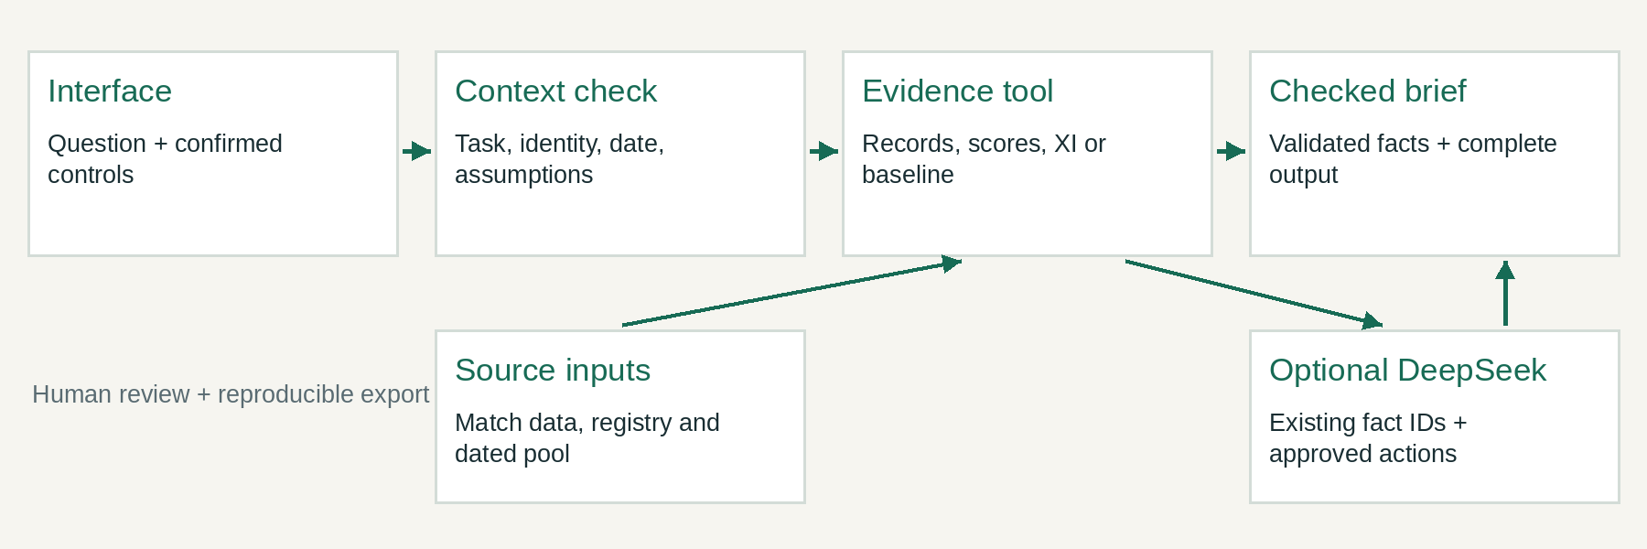
Diagram: released-input process or scenario. Methods and constraints are described in the text.
Layer | Principal files
Interface and coherent runtime | app.py; boundary_runtime.py
Analytics and schedule validation | boundary_core/analytics.py
Agent and provider boundary | boundary_core/agent.py
Provenance and scoped state | boundary_core/evidence.py; storage.py

Evidence: See the source file map in Appendix A.

5. Datasets and coverage
The source is a frozen collection of supplied Cricsheet JSON archives. Only eligible men’s matches are included. The processed release contains 6,392 matches and 141,377 player-match records. The local registry retains 6,618 archive identities and their supplied aliases.
There is 2026 evidence, but the endpoints differ by competition. An earliest/latest date is not proof of complete intervening coverage. The archive is not a live feed. Known T20I career gaps and a small 2024/25 SMAT sample are explicitly disclosed.
A separate supplied 2026 squad pool contains 257 entries. Dated trades and fourteen selected availability notices adjust planning status. Verification remains partial, and seven documented replacements are missing verified planning metadata. The auction CSV covers historical 2013–2022 source records; it is a manual lookup with unverified transaction/units and is not a current valuation input.
Competition | Matches | Earliest | Latest
IPL | 1,242 | 2008-04-18 | 2026-05-31
BBL | 662 | 2011-12-16 | 2026-01-25
The Hundred | 201 | 2021-07-22 | 2026-08-16
T20I | 3,592 | 2005-02-17 | 2026-10-06
SMAT | 695 | 2016-01-02 | 2024-12-15

Evidence: data/audit.json, player_registry.json, roster_status.json and official_validation.csv.

6. Processing rules and temporal integrity
match_data.py reads the delivery archives, filters eligible records, links players by registry ID and calculates full and phase totals. Duplicate match IDs and the identified voided IPL match are excluded. Super overs are not added to regular innings totals.
Batter balls exclude wides under the source convention. Legal bowling balls exclude wides and no-balls. Bowler conceded runs exclude byes and leg byes. Bowler-credited wickets exclude run-outs and other non-bowler dismissal kinds. Batting dismissals follow the explicit processing inclusion list.
Powerplay follows recorded innings metadata. Missing metadata uses a documented proportional fallback; six innings used it in the reconciliation. Death is the analytical final fifth of the scheduled innings after the powerplay; it is not an official field-restriction period. Middle contains the remaining regular deliveries. Reduced targets and Hundred five-ball groups are handled explicitly. Over notation such as 10.3 is not a decimal number of overs.
A query includes matches strictly before the selected cutoff. Model features use past outcomes only, and every match on a date is forecast before results from that date update ratings. The 2026 roster pool is not used to invent historical squads for earlier or future seasons.
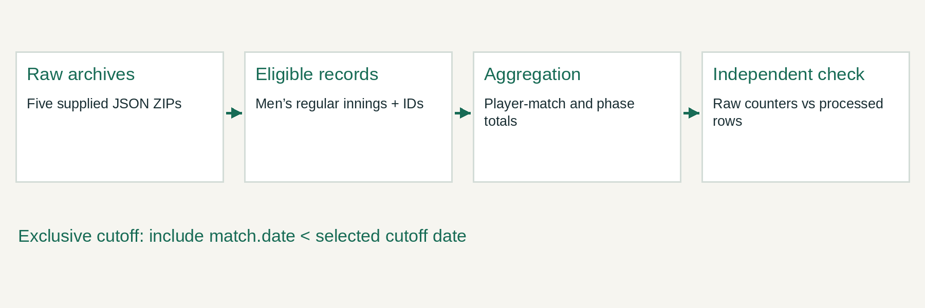
Diagram: released-input process or scenario. Methods and constraints are described in the text.
Evidence: match_data.py; tools/verify_raw.py; analytics.select_window; prediction.chronology.

7. Agent orchestration and task agreement
The four supported intents map to four permitted tools: scout_players, optimize_xi, player_dossier and match_prediction. The server fixes the tool and arguments from the analyst’s controls. A provider response cannot change the task or run a new tool.
Before calculation the context checker tests agreement between the question and confirmed scope. Examples include a request for T20I while IPL is selected, batting while Bowling is selected, IPL 2016 outside a three-year window, a different XI franchise, an unconfirmed exclusion, or a different matchup. These requests need matching controls or clarification.
Unsupported age or handedness eligibility cannot be inferred from this dataset. Complete official career totals are not certified by the archive. A request involving multiple phases or competitions needs separate scoped briefs. Named exclusions are distinguished from positive comparison candidates.
Each accepted brief is bound to the question, complete context, application version and relevant source hashes. Changing any of those makes the previous result stale. The application hides stale save/export actions until the result is prepared again.
Task | Deterministic result
Scouting | Scoped descriptive ranks, rates, samples and dates.
XI planning | Selected players, complete schedule, checks and assumptions.
Player evidence | Registry-linked totals in the confirmed archive scope.
Match research | Gated baseline, matchup context and chronological evidence.

Evidence: boundary_core/agent.py: task_context, dispatch, prepare and render.

8. DeepSeek integration and reliability controls
DeepSeek is optional. Local evidence mode performs the same supported calculations without an API key. Live selection uses deepseek-chat with temperature zero, a JSON response format and a bounded output token setting. Temperature zero is not a promise of identical external responses.
The model can choose only supplied fact IDs and approved review actions. It cannot generate arbitrary statistical prose, alter filters, set prices or execute code. The server validates the response, rejects unknown IDs and retains required completeness: an XI must include all eleven player facts and a player task must retain the requested identities. The server renders the bowling schedule.
An invalid, incomplete or unavailable selection falls back to the supported local facts with an explicit label. Fixtures test these paths without spending provider credits. They do not measure live provider intelligence, uptime or hosted latency.
Actual keys belong in private hosting Secrets, a local ignored secrets file or an optional temporary password field. They are excluded from source and exports. Request reservation is atomic: six calls per browser session per UTC day across desks and thirty per installation. A brief uses at most two calls. These demo allowances are not authenticated user accounts or a hard currency cap.
Control | Reason
Fixed tool and filters | Prevent task drift.
Existing fact-ID selection | Prevent unsupported model-created statistics.
Output/completeness checks | Prevent partial XI/player evidence.
Exact-context fingerprint | Prevent stale or mismatched evidence reuse.
Local fallback and quotas | Retain inspectable results and limit demo API usage.

Evidence: agent.py and storage.py. Live provider connectivity/quality is not certified by the local results.

9. Scouting scores and observed uncertainty
A raw batting strike rate is 100 × runs / balls. Bowling economy is 6 × conceded runs / legal balls. The six-ball normalization also gives a readable rate for Hundred records, but it does not establish equal competition strength.
Recent matches receive greater weight: weight = 2^(−age in days / 365). A 120-ball prior shrinks small weighted samples toward the selected competition/phase baseline. Raw totals remain visible and unweighted. ALL keeps competition groups separate rather than applying an unsupported league-strength conversion.
For batting, let R, B and D be weighted runs, balls and dismissals; r0 and d0 are scope baseline rates. r* = (R + 120r0)/(B + 120), d* = (D + 120d0)/(B + 120). Bat score = 100(r* − r0) − 1800(d* − d0).
For bowling, let C, L and W be weighted conceded runs, legal balls and wickets; c0 and w0 are baseline rates. c* = (C + 120c0)/(L + 120), w* = (W + 120w0)/(L + 120). Bowl score = 6(c0 − c*) + 72(w* − w0). These coefficients are explicit research heuristics, not proven optimal talent values.
Sample weight equals weighted relevant balls / (weighted relevant balls + 120). It measures effective sample volume, not success probability. Observed-rate intervals use 500 match-level resamples with a fixed seed and need at least five relevant matches. They describe the observed sample under an independent-match assumption, not future performance.
Evidence: boundary_core/analytics.py. Score weights require further independent tactical validation.

10. Player identity and dossier interpretation
The registry links supplied archive IDs, aliases and selected reviewed display corrections. A text search can return several people. Three distinct IDs share the display name Rohit Sharma, so the dossier requires an explicit choice with observed teams and competitions when the name is ambiguous. Some international full names remain searchable only through initials, a source alias or the registry ID.
Player overview shows all supplied phases for a chosen competition from its earliest archive date to before the cutoff. Runs in archive is labeled as the supplied sample. Use active research filters switches deliberately to the selected research phase and dates. The minimum-ball threshold applies to scouting ranks, not dossier visibility. Discipline selects the uncertainty measure; both batting and bowling totals still use the selected phase.
For Virat Kohli, the IPL Death phase from 2023-10-18 to before 2026-10-18 contains 114 runs, while all phases in that same window contain 2,073. The supplied IPL overview contains 9,336 through 2026-05-31. The 2024, 2025 and 2026 all-phase season totals are 741, 657 and 675. These are different scopes and must not be compared as interchangeable career totals.
The dossier includes seasons, match evidence, observed-rate intervals and a historical manual auction lookup. Named-record appearances can include matches with zero relevant phase balls; the app explains relevant phase appearances separately.
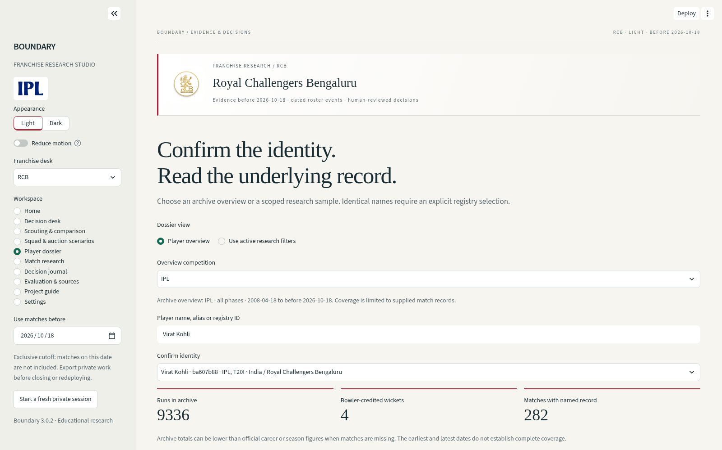
Figure 3. Actual local Player dossier in archive-overview mode. Snapshot v3.0.2.
Evidence: All numbers above are archive totals; the three season values match RCB primary pages listed in official_validation.csv.

11. Joint XI selection and bowling scheduling
The optimizer uses the dated 2026 research pool and previous three years of IPL evidence. A default supported bowling option needs 120 observed legal balls. Phase support needs 36 powerplay, 36 middle or 24 death balls. Default batting support needs 30 balls. These are research thresholds, not registration rules.
Let binary x_i select a player, and y_i,o assign that player to over o. Exactly eleven players are selected and every one of twenty overs has one selected bowler. A player can bowl at most four overs, within total and phase caps. The same bowler cannot bowl consecutive overs. The plan also enforces a keeper, at most four overseas players, active role minima, locks, exclusions and any assumed budget.
The utility is bat_score/10 + bowl_score. The first mixed-integer solve maximizes selected-player utility while enforcing the schedule. A second solve fixes the XI and improves the over allocation using phase bowling scores. The returned schedule is independently validated before display. A successful optimum under these declared constraints is not a proven best tactical XI.
Fixed full-T20 planning phases are overs 1–6, 7–16 and 17–20: 36, 60 and 24 legal balls. This is separate from reduced-innings archival phase calculations. Full Impact Player and every competition regulation are outside the current model.
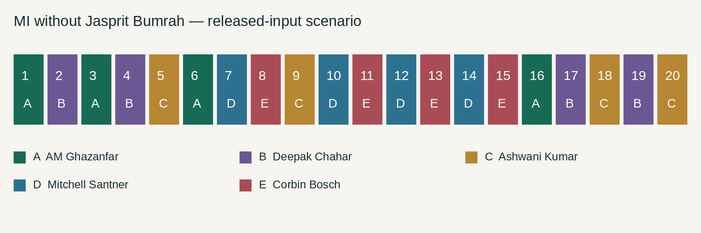
Diagram: released-input process or scenario. Methods and constraints are described in the text.
Evidence: analytics.optimize and validate_schedule; SciPy mixed-integer optimization.

12. Availability, assumptions and counterfactuals
An analyst can exclude unavailable players, lock required players and change supported role minima. Alternatives can be forced to show who enters, who leaves and how the schedule changes. A deliberately impossible budget or conflicting lock returns an explanation rather than a fabricated legal team.
When a budget is active, prices are analyst assumptions. Initial one-crore values are placeholders, not live market prices. The complete assumption table and XI cost are exported. The historical auction source is not automatically joined into a current valuation.
Capability overrides need a written reason and legal whole-over workload/phase caps. An unobserved player also needs an explicit finite utility assumption. Overrides cannot remove a documented sourced selection block.
The supplied pool can contain an outgoing player and a replacement together. Fourteen selected primary notices block outgoing players after publication and existing replacements before their recorded join date. The app reports seven documented replacements with missing verified metadata instead of inventing it. Other registration, fitness, NOC and reinstatement status still requires review.
Example | Expected result
MI without Bumrah | Solve and validate every over if the remaining evidence supports it.
Excluded and locked player | Reject the contradictory scenario.
Budget below any feasible XI | Return an unsupported-constraint explanation.
Override of sourced unavailability | Keep the sourced selection block.
Cutoff outside 2026 | Require a separately verified roster for that season.

Evidence: roster_status.json, squad_events.json, scenario controls and solver regressions.

13. Chronological model and baseline gate
The research forecast is a fixed regularized logistic model. Pre-toss inputs are team Elo and exponential result form. Post-toss inputs add chasing status and prior venue chase outcomes. There are no player-lineup, injury, weather or pitch-report features. Changing a proposed XI therefore does not change this baseline.
The fit uses 946 eligible IPL matches before 2023. Validation uses 73 in 2023 and the held-out test uses 215 from 2024 onward. State updates happen after all matches on each date have been forecast. The training chase rate is about 55.07%. Fixed regularization and rating constants were not selected from validation/test performance.
The acceptance gate requires the research post-toss model to beat the training-derived chase-rate Brier score in both validation and test. It improves validation slightly, but not the held-out test. The gate fails, so the app displays the baseline. A pre-toss 50% means no validated edge; it is not evidence that true team strengths are identical.
Brier score measures squared probability error; lower is better. Threshold accuracy alone is inadequate. The model and baseline both have about 54.88% test threshold accuracy, but different probability quality. Season dependence and limited sample size remain important limitations.
Brier score (lower is better) | Validation, n=73 | Test, n=215
Research post-toss model | 0.256489 | 0.248577
Training chase-rate baseline | 0.257440 | 0.247619
Acceptance gate | Better in both required | Not passed → serve baseline

Evidence: data/prediction_report.json and prediction_holdout.csv.

14. Interface design and workspace behaviour
The interface is organized around a franchise desk and a stable sidebar. Home explains the workflow and gives guided examples. Decision desk prepares a checked brief. Scouting & comparison exposes raw rates, ranks and samples. Squad & auction scenarios exposes full planning assumptions. Player dossier makes identity and scope explicit.
Match research shows the accepted baseline and dated evaluation. Decision journal keeps scoped saved work. Evaluation & sources contains release checks, audits, a historical role study, review tasks, sources and SWOT. Project guide explains use and reproduction. Settings manages optional private provider access and allowances.
The visual design uses restrained spacing, readable type, franchise identification marks and team accents. Light and Dark appearances are available. Reduced-motion controls and the system preference are respected. Tables keep their data hierarchy and use their own scrolling where needed. The labels distinguish observed archive evidence from current eligibility and unsupported inference.
Local Chromium checks cover desktop and 390-pixel mobile views, controls, guide/source downloads, themes, motion preferences and journal isolation. They are not an accessibility certification or a completed professional usability study. Brand marks identify this educational subject; no league or franchise endorsement is implied.
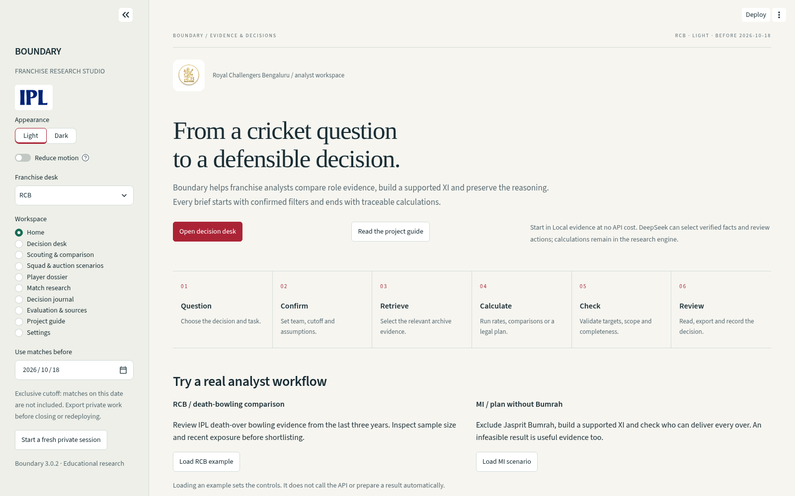
Figure 5. Actual local Home page, Light appearance, selected RCB desk.
Evidence: app.py, branding.py and browser acceptance records.

15. Storage, exports and reproducibility
SQLite stores saved briefs, scenarios, private reviews, exact-context provider cache and atomic request counts. Records are scoped by browser session and selected franchise. Fresh visitors cannot read another session’s journal. This is not authenticated, durable, multi-device team collaboration. Export work before closing, resetting or redeploying.
A CSV includes scope metadata such as team, exclusive cutoff, evidence start, competition, phase, task, method version and context fingerprint. Decision ZIPs contain manifest.json with full assumptions and SHA-256 source hashes. XI packs also contain schedule.csv, alternatives.csv and checks.json. Brief packs contain checked evidence and the rendered brief.
Reproduction needs the same project release, source inputs and every filter, price, override, lock and exclusion in the manifest. Tied optimal schedules may differ while satisfying the same objective. A changed candidate universe or source file can change scores. A hash identifies a file version; it does not certify that the file is complete or true.
The source download uses an explicit allowlist. It includes code, processed data, documentation, assets and tests, and excludes actual credentials, runtime databases, caches and environments. The submitted source ZIP is frozen to application commit 7f891c75fe82b7aff309e0e6d2d7c27117a5470d.
Artifact | Preserves
manifest.json | Question, context, version, assumptions and source fingerprints.
data CSV | Relevant result rows with scope metadata.
schedule.csv + checks.json | Complete over allocation and validation for XI tasks.
checked_evidence.json + brief.md | Supported fact records and server-rendered brief.

Evidence: evidence.py, storage.py and downloads.py.

16. Quantitative verification and research design
The current automated suite has 68 passing tests: 44 core, three startup, seven interface, six runtime, seven accuracy regressions and one dossier interface regression. The interface matrix exercises all ten franchise desks and all ten workspaces. Controlled provider fixtures test rejection, fallback and quotas without measuring live provider quality.
Real local Chromium acceptance has 57 checks. Final browser downloads were also checked against current allowlisted source files, and the long audit report was inspected at mobile width. The evidence pack includes the completed logs and machine-readable summaries.
Independent raw reconciliation processed 1,455,366 deliveries and compared 3,393,048 numeric fields with zero ingestion mismatches. All 6,618 IDs were retained; phase sums passed 163,416 checks across 27,236 player/competition/season groups. These establish consistency with the supplied inputs, not complete official coverage.
The expanded workflow audit covers 144 scouting settings, 90 team scenarios and 257 forced-player requests. Fifty team scenarios supported a legal plan, and 214 forced-player requests did. Rejections were explained; no successful plan violated the independent checks. All 257 supplied-pool dossier displays matched stored input totals or explicitly reported a missing identity.
A separate historical scouting study has 24 fixed rolling-origin settings and two methods, with 48 rows. It compares the descriptive score with raw-rate ranks. Exposure/survivorship bias, correlated seasons and unmeasured tactical context prevent a superiority claim. Twenty human review tasks are supplied; authenticated professional review count is zero.
Evidence unit | Interpretation
Automated / browser passes | Implemented behaviour under the tested local conditions.
Raw field comparisons | Consistency with exact uploaded archives.
Official checkpoints | A sampled comparison against external primary records.
Role study / future human review | Research on usefulness; no proven professional advantage.

Evidence: data/release_checks.json, workflow_accuracy_checks.json and scouting_benchmark_report.json.

17. External accuracy and credibility boundaries
The external sample includes 194 numeric checkpoints from fifteen primary pages covering all ten IPL teams and all five archive competitions. It includes six IPL match reports, played/won/lost/no-result/points for all teams in the 2026 league stage, season leaders, three Kohli IPL seasons, seven India T20I career records, a BBL final, Hundred season leaders and a SMAT quarterfinal.
There are 188 matches, five measured T20I coverage gaps and one unresolved conflict. The table below preserves the gaps against the ICC reference before 2024-07-01. The SMAT 2024/25 supplied sample contains only eight matches. No missing deliveries or runs have been invented to fill these gaps.
For Kamboj in GT–CSK match 1529309, the IPL article says 57 conceded, while the archive gives 56; an independently retrieved Cricbuzz bowling record also says 56. The final primary bowling card was not accessible in the audit. The archive value remains unchanged with the conflict recorded. Net run rate was not independently reconstructed.
This is a sampled external verification, not certification of every player or official match. The hosted Streamlit URL was inaccessible to the permitted interactive tool, so the tests ran the exact repository application locally. A published commit does not prove a successful hosting rebuild.
Player, T20I runs | Archive | ICC | Gap
Virat Kohli | 3,963 | 4,188 | 225
Rohit Sharma, India ID | 4,027 | 4,231 | 204
Yashasvi Jaiswal | 430 | 502 | 72
Shubman Gill | 312 | 335 | 23
KL Rahul | 2,134 | 2,265 | 131

Evidence: data/official_validation.csv; primary URLs and dates are preserved in every checkpoint.

18. Demonstration and practical interpretation
Demo A: start on Home and load the RCB example. Confirm IPL, Bowling, Death, 120 relevant balls and the exclusive cutoff. Prepare a Local evidence brief. Compare raw economy, wickets, legal balls and last relevant match with the descriptive score. Open the evidence trace, record availability questions and download the brief pack.
The first rank is not a recruitment instruction. A score trades off recent economy and wicket-taking under declared weights; a candidate may be unavailable, unattainable or a poor tactical fit. The next steps are current-source checks, video and human review.
Demo B: load the MI scenario with Jasprit Bumrah excluded. Inspect the eleven selected players and the over-by-over plan. Confirm all twenty overs, phase caps, no consecutive bowler and overseas limit. Force an alternative or try an impossible budget, then read the explanation. Export the full plan and assumptions.
A separate dossier check should show Kohli’s 114 phase runs versus 2,073 all-phase runs for the same window. Search Rohit Sharma and demonstrate explicit identity selection. Finish with the model gate and external audit. If the hosting service is unavailable, the frozen source can run locally; that contingency is a reproducible offline demo, not evidence of live-provider success.
Diagram: released-input process or scenario. Methods and constraints are described in the text.
Evidence: The sample MI schedule is calculated from the frozen released inputs with one spin and two pace minimums.

19. Deployment, resources and cost plan
The submission includes processed data, so no additional paid dataset or raw archive download is needed for normal reproduction. Use compatible Python 3.11+; Python 3.12 is the recommendation used for the recorded environment. The runtime packages are Streamlit, pandas, NumPy, SciPy and Altair. requirements.txt contains compatible ranges and BUILD_ENVIRONMENT.json records the tested versions.
Extract the source ZIP, create an isolated environment, install requirements and run python -m streamlit run app.py. Local evidence needs no API key. Optional document-generation dependencies are separated from runtime. A private local secrets file or hosting Secrets can enable DeepSeek selection.
For Streamlit Community Cloud, select the repository main branch, entry app.py and a compatible Python version. Add a private provider key only when needed. Confirm Home, a local example, downloads and one permitted live provider request after deployment. Local checks do not prove this hosted step succeeded.
The cost-effective capstone path is local/free-tier hosting where available and limited optional provider use. No fixed currency estimate is claimed: DeepSeek charges depend on its current token prices and actual usage. The six/ thirty daily demo allowances and two-call brief bound reduce exposure but are not a financial spending cap; use the provider’s spending controls.
A professional service would add a reviewed data refresh process, complete roster verification, authenticated durable storage, backups, monitoring and live latency/concurrency evaluation. Those requirements are separate from the current educational deployment.
Resource | Current use
Compute | Local Python/Streamlit or available community hosting.
Data | Bundled frozen processed release; no live paid feed.
Language model | Optional DeepSeek fact selection; Local evidence available.
Persistence | Local scoped SQLite; export before redeployment.
Operational evaluation | Local functional timings; no production load/SLA claim.

Evidence: requirements.txt, BUILD_ENVIRONMENT.json and USER_GUIDE.md.

20. SWOT, limitations and future work
Strengths: traceable match evidence, explicit legal scheduling, bounded provider output, reproducible exports and documented tests. These make the capstone inspectable and useful for teaching evidence-based decisions.
Weaknesses: incomplete frozen coverage, limited full-name registry, partially verified current pools, heuristic score weights, no player-lineup forecast and no demonstrated predictive or scouting superiority. A supported mathematical plan is not a complete tactical or regulatory certification.
Opportunities: obtain missing scorecards; finish a dated identity/availability registry; add reviewed video/scout notes; evaluate role/venue-specific decisions on untouched periods; and collect independent analyst feedback using the twenty provided tasks.
Threats: stale status information, source changes, scope misinterpretation, provider outages, public-demo allowance abuse and overconfidence from polished presentation. These are managed partly by explicit labels, dates, checks, fallback and bounded outputs; they are not eliminated.
Future work should start with evidence integrity and measurement. Complete verified replacement metadata and resolve source conflicts before claiming current rosters. Add authentication, durable team storage and operational monitoring before production collaboration. Retain the forecast baseline until an alternative beats it on genuinely untouched future periods.
Priority | Completion evidence needed
1 — data and roster | Reviewed scorecards, source version, verified dated registration/status.
2 — tactical usefulness | Independent analyst assessments and outcome/role evaluation.
3 — operations | Hosted/provider checks, authenticated access, backups and monitoring.
4 — model research | Better validation and untouched-test performance than credible baselines.

Evidence: ACCURACY_AUDIT.md and the final release limits.

21. Conclusion
Boundary demonstrates a coherent capstone implementation of a constrained AI-assisted research process. It brings together registry-linked delivery evidence, scoped descriptive analytics, joint selection and bowling scheduling, optional model fact selection and versioned decision exports.
The strongest result is reproducibility and inspectability under the implemented rules. Local tests and raw reconciliation support the functioning of the calculations and controls. The separate official-source sample shows why that does not establish full coverage: measured gaps and conflicts must remain visible.
The research forecast failed its stronger-baseline gate, so the baseline remains in the product. This is a valid research finding and an important product boundary. Current evidence does not establish professional tactical superiority.
The submitted package enables an examiner to read the explanation, inspect the code, run the application locally, reproduce the tested workflows and evaluate the stated limits. The human analyst retains the final selection, recruitment and tactical decision.
Delivered | Evidence
Working research application | Frozen v3.0.2 source and processed data.
AI workflow | Fixed tools, validated fact IDs and local fallback.
Practical planning | Complete legal schedules and counterfactual scenarios.
Reproducible evaluation | Tests, raw/official comparisons, model and role-study artifacts.
Submission materials | Editable presentation/report, guide, evidence and demo instructions.

Evidence: Frozen application: https://github.com/br-abishek-07/boundary-cricket-capstone/tree/7f891c75fe82b7aff309e0e6d2d7c27117a5470d

22. References
[01] Released Boundary implementation and tests
https://github.com/br-abishek-07/boundary-cricket-capstone/tree/7f891c75fe82b7aff309e0e6d2d7c27117a5470d
[02] Boundary user guide
https://github.com/br-abishek-07/boundary-cricket-capstone/blob/7f891c75fe82b7aff309e0e6d2d7c27117a5470d/docs/USER_GUIDE.md
[03] Boundary accuracy audit
https://github.com/br-abishek-07/boundary-cricket-capstone/blob/7f891c75fe82b7aff309e0e6d2d7c27117a5470d/docs/ACCURACY_AUDIT.md
[04] Primary numerical checkpoint register
https://github.com/br-abishek-07/boundary-cricket-capstone/blob/7f891c75fe82b7aff309e0e6d2d7c27117a5470d/data/official_validation.csv
[05] Cricsheet archive source
https://cricsheet.org/
[06] ICC: India opening options after Rohit and Kohli, 30 June 2024
https://www.icc-cricket.com/news/india-s-big-conundrum-at-the-top-who-replaces-rohit-and-kohli-in-t20is
[07] IPL 2026 points table
https://www.iplt20.com/points-table
[08] IPL: GT v CSK, match 66, 2026 report
https://www.iplt20.com/news/article/tata-ipl-2026-match-66-gt-v-csk-match-report
[09] RCB: Kohli 2026 season checkpoint
https://www.royalchallengers.com/rcb-cricket-news/news/virat-is-a-very-instinctive-player-freddie-wilde-on-rcb-stars-explosive
[10] Streamlit documentation
https://docs.streamlit.io/
[11] pandas documentation
https://pandas.pydata.org/docs/
[12] NumPy documentation
https://numpy.org/doc/
[13] SciPy mixed-integer linear programming
https://docs.scipy.org/doc/scipy/reference/generated/scipy.optimize.milp.html
[14] Altair documentation
https://altair-viz.github.io/
[15] DeepSeek API documentation
https://api-docs.deepseek.com/
Project claims use the frozen source and recorded audit reviewed on 18 October 2026. The checkpoint register preserves the primary URLs and numerical scopes. Technology links support implementation; they are not performance evidence. Asset credits are in assets/sources.json.

Appendix A. Source map and reproduction
Path | Responsibility
app.py | Pages, controls, display and navigation.
boundary_runtime.py | Coherent content-fingerprinted module loading and cache invalidation.
boundary_core/analytics.py | Ranking, dated roster support, optimization and schedule validation.
boundary_core/agent.py | Context agreement, permitted tools, fact selection and rendering.
boundary_core/prediction.py | Chronological research model and accepted baseline.
boundary_core/evidence.py / storage.py | Fingerprints/exports and scoped SQLite state.
boundary_core/branding.py / downloads.py | Themes, bundled marks and allowlisted source ZIP.
match_data.py / tools / tests | Raw processing, reproducible audits/document generation and checks.
data / assets / docs | Processed release inputs, credits, guides and audit artifacts.

Run the app
python -m pip install -r requirements.txt
python -m streamlit run app.py

Run the recorded regression suite
python -m unittest discover -s tests -v

Run expanded checks
python tools/check_workflows.py --output work/audit
python tools/check_all_dossiers.py --output work/audit

Recalculate the dated official checkpoints
python tools/compare_official_checkpoints.py --output work/audit

Reconcile exact raw inputs
python tools/verify_raw.py --source /path/to/raw-data
Raw verification needs the exact five input archives. Official-checkpoint recalculation uses transcribed references and does not fetch live records. See the included user guide for environment activation, private Secrets and deployment steps.

Appendix B. Submission and evidence register
File | Purpose
Boundary_Capstone_Presentation.pptx / .pdf | 44-slide editable deck and portable viewing copy; ten technical appendix slides.
Boundary_Project_Report.docx / .pdf | This editable academic explanation and reading copy.
Boundary_Project_Source_v3.0.2.zip | Frozen runnable application, processed data, tests, assets and guide.
Boundary_Validation_Evidence.zip | Completed local logs and raw/official/workflow/model evidence.
Boundary_Project_Guide.pdf / .docx | Full simple-English setup and operating guide from the release.
Boundary_Abstract.pdf | Standalone project abstract.
Boundary_Demo_and_Viva_Guide.pdf / .docx | Presentation route, live demo, examiner questions and checklist.
Presentation_Speaker_Notes.md | Editable per-slide explanations, also embedded in PowerPoint notes.
START_HERE.md / SHA256SUMS.txt | Submission file map, required additions and integrity hashes.

Institution-specific front matter must follow the actual prescribed format. Add the register number, college/department, academic year, supervisor details, approved certificate and signed declaration only when required and correctly supplied. This package does not fabricate signatures, approvals or a declaration of unaided authorship.
Before the review, extract the source in a clean folder, run the app, open the presentation and PDF, test the demo links and check required portal formats. Preserve the source commit and all evidence scopes. The hosted rebuild and live-provider quality remain unverified by these local records.
Prepared for B.R. Abishek · AI Driven Data Science · 18 October 2026.

