**COMPANY OVERVIEW**   
**Company Name**: Apple Inc.

**Industry**: Consumer Electronics   
**Sector**: Technology   
**Business Description**:   
Apple Inc. designs, manufactures, and markets smartphones, personal computers, tablets, wearables, and accessories worldwide.

The company offers iPhone, a line of smartphones; Mac, a line of personal computers; iPad, a line of multi-purpose tablets; and wearables, home, and accessories comprising AirPods, Apple TV, Apple Watch, Beats products, and HomePod.

**BUSINESS AND MARKET POSITION Market Position:**  
• Market Cap: $3673.3B  
• Shares Outstanding: 15115.8M  
• Float: 15091.2M   
**Key Statistics:**  
• EV/EBITDA: 27.55 (Peer avg: 13.12)  
• P/E TTM: 39.91 (Peer avg: 22.74)

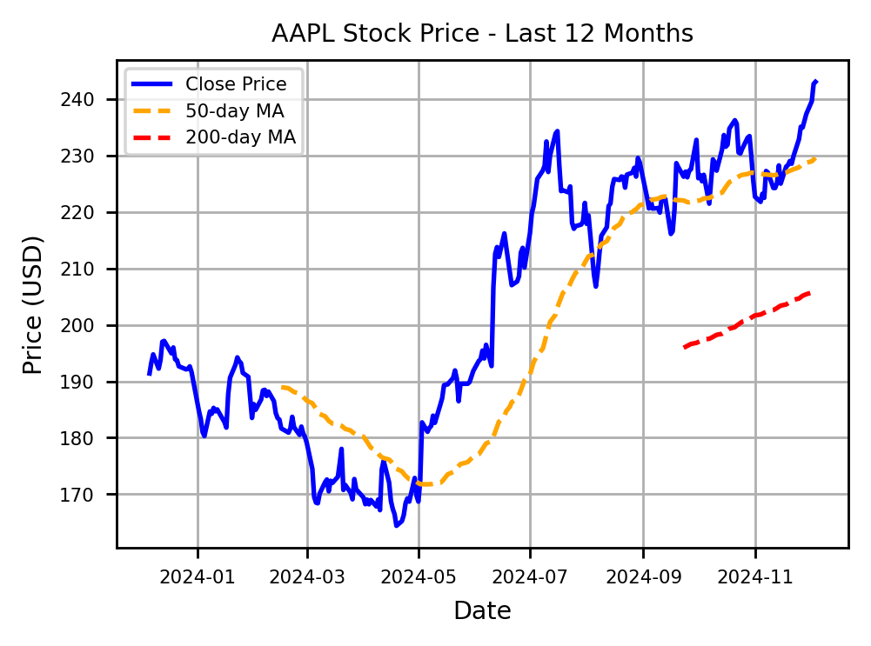

**FINANCIAL TABLE (in millions USD)**

|  |  |  |  |  |  |
| --- | --- | --- | --- | --- | --- |
| **Year** | **Revenue** | **EBIT** | **Net Profit** | **EBITDA** | **ROI** |
| 2024 | 391,035 | 123,216 | 93,736 | 134,661 | 25.68% |
| 2023 | 383,285 | 114,301 | 96,995 | 125,820 | 27.51% |
| 2022 | 394,328 | 119,437 | 99,803 | 130,541 | 28.29% |
| 2021 | 365,817 | 108,949 | 94,680 | 123,136 | 26.97% |
| 2020 | N/A | N/A | N/A | N/A | nan% |

**KEY STRENGTHS**  **GROWTH CATALYSTS**

- Strong brand recognition: Apple is globally recognized for its innovation and premium quality, fostering loyal customer bases across various markets.

- Robust financial performance: Consistently strong financial results and cash flow enable sustained investment in research and   
development, ensuring continued growth and innovation.

- Ecosystem integration: Apple's diverse range of products and services are tightly integrated, creating a seamless user experience that encourages long-term user retention and cross-product sales.

**INVESTMENT THESIS**

- New Product Launches: Upcoming innovations and product developments can drive significant consumer interest and boost sales.

- Expansion in Services: Growing Apple's services segment offers recurring revenue and diversifies away from hardware dependency.

- Advances in Technology: Continuous advancements in areas like AI, AR, and silicon chips enhance product capabilities and user experience.

**RISK ANALYSIS AND MITIGATION**

|  |  |  |
| --- | --- | --- |
| **Financial Health:** | **Analyst Insights:** | - Market Saturation: As smartphone and personal device markets mature, growth opportunities may slow. Mitigation involves Apple diversifying its product lines and increasing services revenue to offset potential declines. |
| • Cash Position: $65.2B | • Analyst Rating (1-5): 1.9 |
| • Total Debt: $119.1B | • Recommendation: BUY |
| • Debt to Equity: 209.06 | • Number of Analysts: 42 | - Supply Chain Disruptions: Apple's reliance on a complex global supply chain can lead to production bottlenecks. Mitigating this risk involves increasing supply chain transparency and  developing alternative supplier relationships to ensure continuity. |
| • Current Ratio: 0.87 | • Mean Target Price: $244.5 |
| • Implied Upside: 0.6% |

• **Ex-Dividend Date**: 08-11-2024  
 • **Dividend Rate**: $1.00  
 • **Dividend Yield**: 0.41%