**COMPANY OVERVIEW**   
**Company Name**: Brookfield Renewable Partners L.P.

**Industry**: Utilities - Renewable   
**Sector**: Utilities   
**Business Description**:   
Brookfield Renewable Partners L.P. owns a portfolio of renewable power generating facilities primarily in North America, Colombia, and Brazil. The company generates electricity through hydroelectric, wind, solar, distributed generation, and pumped storage, as well as   
renewable natural gas, carbon capture and storage, recycling,   
cogeneration biomass, nuclear services, and power transformation.

**BUSINESS AND MARKET POSITION Market Position:**  
• Market Cap: $15.9B  
• Shares Outstanding: 285.1M  
• Float: 205.5M   
**Key Statistics:**  
• Price-to-FFO: 2.77 (Peer avg: 8.64)  
• EV/EBITDA: 8.81 (Peer avg: 11.24)

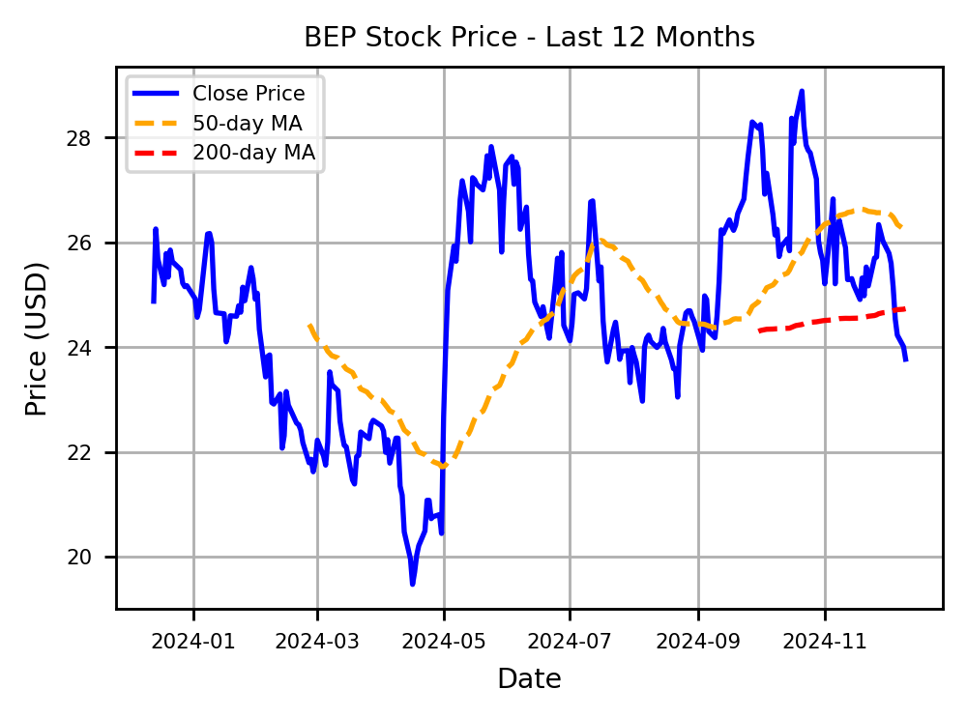

**FINANCIAL TABLE (in millions USD)**

|  |  |  |  |  |  |
| --- | --- | --- | --- | --- | --- |
| **Year** | **Revenue** | **EBIT** | **Net Profit** | **EBITDA** | **ROI** |
| 2023 | 5,038 | 1,037 | -50 | 4,058 | -0.07% |
| 2022 | 4,711 | 1,430 | -122 | 2,958 | -0.19% |
| 2021 | 4,096 | 870 | -136 | 2,444 | -0.24% |
| 2020 | 3,810 | 694 | -130 | 2,160 | -0.26% |

**KEY STRENGTHS**  **GROWTH CATALYSTS**

- Renewable Energy Focus: Brookfield Renewable Partners (BEP) specializes in generating power from renewable resources, including hydroelectric, wind, and solar, contributing significantly to sustainable energy solutions.

- Strong Global Asset Base: BEP boasts a diverse portfolio of assets spread across various countries, enhancing operational stability and reducing geographical risks.

- Strategic Partnerships: Through strategic alliances and joint ventures, BEP enhances its market access and accelerates growth opportunities in the renewable sector.

**INVESTMENT THESIS**

- Expansion in renewable energy projects: BEP is investing heavily in new and existing renewable energy infrastructure, driving long-term growth.

- Strategic acquisitions: By acquiring strategic assets, BEP is enhancing its portfolio and increasing its market share in the green energy sector.

- Partnership with global leaders: Collaborating with industry leaders in different regions helps BEP to expand its technological capabilities and geographical reach.

**RISK ANALYSIS AND MITIGATION**

|  |  |  |
| --- | --- | --- |
| **Financial Health:** | **Analyst Insights:** | - Regulatory Changes: $BEP operates in the renewable energy sector, which is highly sensitive to policy shifts and subsidy changes, potentially impacting profitability. Staying informed and advocating for favorable policies can help mitigate this risk. |
| • Cash Position: $1.7B | • Analyst Rating (1-5): 2.1 |
| • Total Debt: $29.9B | • Recommendation: BUY |
| • Debt to Equity: 106.96 (Peer avg: 158.32) | • Number of Analysts: 14 | - Market Price Fluctuations: The volatility in energy markets can affect the revenue streams of $BEP, given its dependence on power purchase agreements. Diversifying the energy portfolio and securing long-term contracts can help stabilize revenue. |
| • Mean Target Price: $30.9 |
| • Current Ratio: 0.73 (Peer avg: 1.89) |
| • Implied +/-: 29.8% (Peer avg: 16.5%) |

• **Ex-Dividend Date**: 29-11-2024  
 • **Dividend Rate**: $1.42  
 • **Dividend Yield**: 5.97%