**COMPANY OVERVIEW**   
**Company Name**: BlackRock, Inc.

**Industry**: Asset Management   
**Sector**: Financial Services   
**Business Description**:   
BlackRock, Inc. is a publicly owned investment manager. The firm primarily provides its services to institutional, intermediary, and individual investors including corporate, public, union, and industry pension plans, insurance companies, third-party mutual funds, endowments, public institutions, governments, foundations, charities, sovereign wealth funds, corporations, official institutions, and banks.

**BUSINESS AND MARKET POSITION Market Position:**  
• Market Cap: $162.1B  
• Shares Outstanding: 154.9M  
• Float: 154.9M   
**Key Statistics:**  
• P/AUM: 0.11 (Peer avg: 0.07)  
• P/E TTM: 25.74 (Peer avg: 18.95)

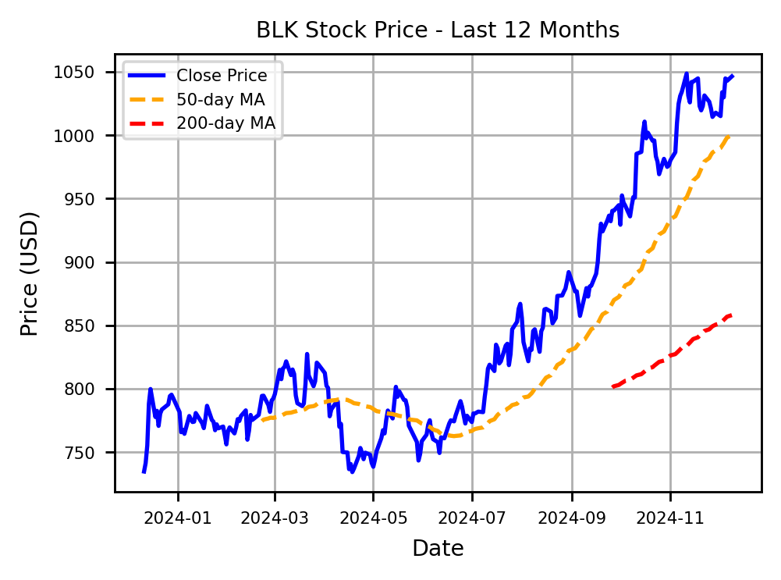

**FINANCIAL TABLE (in millions USD)**

|  |  |  |  |  |  |
| --- | --- | --- | --- | --- | --- |
| **Year** | **Revenue** | **EBIT** | **Net Profit** | **EBITDA** | **ROI** |
| 2023 | 17,859 | 6,333 | 5,502 | 7,874 | 4.47% |
| 2022 | 17,873 | 6,489 | 5,178 | 6,920 | 4.40% |
| 2021 | 19,374 | 7,488 | 5,901 | 8,793 | 3.87% |
| 2020 | 16,205 | 6,313 | 4,932 | 7,087 | 2.79% |

**KEY STRENGTHS**  **GROWTH CATALYSTS**

**- Strong Market Position**: BLK (BlackRock) is the world's largest asset manager, providing it with significant influence and stability in the financial markets.

- Diversified Product Offerings: BlackRock offers a wide range of investment products across asset classes, appealing to a broad spectrum of clients and reducing risk.

- Innovative Technology: The company invests heavily in technology and data-driven solutions like Aladdin, enhancing its operational efficiency and client service.

**INVESTMENT THESIS**

- Strategic Acquisitions: BlackRock continues to expand its product offerings and market reach through targeted   
acquisitions, which drive growth and diversification.

- ETF Expansion: The company's leadership in exchange-traded funds, particularly under the iShares brand, strengthens its position in the investment management industry.

- Sustainable Investing: Increasing focus on environmental, social, and governance (ESG) offerings attracts new investors and aligns with global trends toward sustainable finance.

**RISK ANALYSIS AND MITIGATION**

|  |  |  |
| --- | --- | --- |
| **Financial Health:** | **Analyst Insights:** | - Risk 1: Market Volatility - As a large investment management firm, $BLK is exposed to market fluctuations, which can lead to significant asset value changes and impact revenue. Mitigation: Diversifying its investment products and maintaining strong liquidity can help cushion against sudden market shifts. |
| • Cash Position: $14.3B | • Analyst Rating (1-5): 1.7 |
| • Total Debt: $14.2B | • Recommendation: BUY |
| • Debt to Equity: 32.50 (Peer avg: 17.88) | • Number of Analysts: 17 | - Risk 2: Regulatory Changes - $BLK faces risks from evolving financial regulations that can impose new compliance costs or alter operational practices. Mitigation: Proactive engagement with regulators and investing in compliance infrastructure can help adapt quickly to new regulations. |
| • Mean Target Price: $1102.2 |
| • Current Ratio: 2.60 (Peer avg: 1.14) |
| • Implied +/-: 5.3% (Peer avg: -1.4%) |

• **Ex-Dividend Date**: 05-12-2024  
 • **Dividend Rate**: $20.40  
 • **Dividend Yield**: 1.96%