**CSC420 Homework 1**

**Question 1: Nearest Neighbours and the Curse of Dimensionality**

**Question 1a: Expectation and Variance of V**

**Final Answer (work below)**: $E\left(Z\right)=\frac{1}{6}, V\left(Z\right)=\frac{7}{180}$

We know:

$Z={\left(X-Y\right)}^{2}$

$X\sim Uniform\left(0, 1\right)$

$Y\sim Uniform\left(0, 1\right)$

1. $X, Y$ are independent

Using additive property of expectation $E\left(A+B\right)=E\left(A\right)+E\left(B\right)$ to obtain $E(Z)$

$$E\left(Z\right)=E\left({\left(X-Y\right)}^{2}\right)$$

$$⇒E(Z)=E\left(X^{2}+Y^{2}-2XY\right)$$

$$⇒E(Z)=E\left(X^{2}\right)+E\left(Y^{2}\right)-2E\left(XY\right)$$

Since $X, Y$ are independent: $E\left(XY\right)=E\left(X\right)E(Y)$

$$⇒E\left(Z\right)=E\left(X^{2}\right)+E\left(Y^{2}\right)-2E(X)E(Y)$$

Since $X,Y$ are sampled from the identical distributions, all their moments must be the same

$$∀n∈R, E\left(X^{n}\right)=E(Y^{n})$$

$$⇒E\left(Z\right)=2E\left(X^{2}\right)-2E{\left(X\right)}^{2}$$

$$⇒E(Z)=2(E\left(X^{2}\right)-E{\left(X\right)}^{2})$$

Recall properties of uniform distributions: $X\sim Uniform\left(a, b\right)$

$$f\left(x\right)=\frac{1}{b-a}$$

Thus for $X\sim Uniform(0, 1)$

$$f\left(x\right)=1$$

Creating an equation for $X$’s n-th moment about 0 ($E(X^{n})$)

$$E\left(X^{n}\right)=\int_{0}^{1}{x^{n}f\left(x\right)dx}=\int_{0}^{1}{x^{n}dx}={\left.\frac{1}{n+1}x^{n+1}\right|}_{0}^{1}=\frac{1}{n+1}\left(1-0\right)=\frac{1}{n+1}$$

Using the above $E\left(X\right)=\frac{1}{2}, E\left(X^{2}\right)=\frac{1}{3}$

$$E\left(Z\right)=2\left(E\left(X^{2}\right)-E{\left(X\right)}^{2}\right)$$

$$⇒2\left(\frac{1}{3}-{\left(\frac{1}{2}\right)}^{2}\right)=2\left(\frac{1}{3}-\frac{1}{4}\right)=\frac{2}{12}$$

$$⇒E(Z)=\frac{1}{6}$$

**Question 1a, continued…**

Definition of variance in terms of expectations

$$V\left(Z\right)=E\left(Z^{2}\right)-E{\left(Z\right)}^{2}$$

Using the additive property of expectation to obtain $E(Z^{2})$

$$E\left(Z^{2}\right)=E{(\left({\left(X-Y\right)}^{2}\right)}^{2})$$

$$⇒E\left(Z^{2}\right)=E\left({\left(X-Y\right)}^{4}\right)$$

$$⇒E\left(Z^{2}\right)=E\left(X^{4}-4X^{3}Y+6X^{2}Y^{2}-4XY^{3}+Y^{4}\right)$$

$$⇒E\left(Z^{2}\right)=E\left(X^{4})-4{E(X}^{3}Y)+6{E(X}^{2}Y^{2})-4E(XY^{3})+{E(Y}^{4}\right)$$

Since $X,Y$ are independently sampled: $E\left(X^{n}Y^{m}\right)=E\left(X^{n}\right)E(Y^{m})$

$$⇒E\left(Z^{2}\right)=E\left(X^{4}\right)-4E\left(X^{3}\right)E\left(Y\right)+6E\left(X^{2}\right)E\left(Y^{2}\right)-4E\left(X\right)E\left(Y^{3}\right)+E(Y^{4})$$

Since $X,Y$ are sampled from identical distributions $∀n∈R, E\left(X^{n}\right)=E(Y^{n})$

$$⇒E\left(Z^{2}\right)=2E\left(X^{4}\right)-8E\left(X^{3}\right)E\left(X\right)+6E{\left(X^{2}\right)}^{2}$$

Using the previous moment equation $E\left(X^{n}\right)=\frac{1}{n+1}⇒E\left(X^{3}\right)=\frac{1}{4}, E\left(X^{4}\right)=\frac{1}{5}$

$$⇒E\left(Z^{2}\right)=\frac{2}{5}-\left(\frac{8}{4}*\frac{1}{2}\right)+6\left({\frac{1}{3}}^{2}\right)$$

$$⇒E\left(Z^{2}\right)=\frac{2}{5}-1+\frac{6}{9}$$

$$⇒E\left(Z^{2}\right)=\frac{1}{15}$$

Using all prior results to compute $V(Z)$

$$\left(E\left(Z^{2}\right)=\frac{1}{15}\right)∧\left(E\left(Z\right)=\frac{1}{6}\right)∧\left(V\left(Z\right)=E\left(Z^{2}\right)-E{\left(Z\right)}^{2}\right)$$

$$⇒V\left(Z\right)=\frac{1}{15}-\frac{1}{36}$$

$$⇒V(Z)=\frac{7}{180}$$

**Question 1b: Expectation and Variance of R**

**Final Answer (work below):**

$$E\left(R_{d}\right)=\frac{d}{6}, V\left(R_{d}\right)=\frac{7d}{180}$$

Define $R_{d}$ to be the squared Euclidean distance between two unit-uniformly distributed $d$-dimensional points

$$R_{d}=\sum_{i=1}^{d}{Z_{i}}$$

Expectation of $R_{d}$ (simplify using the additive property of expectation)

$$E\left(R_{d}\right)=E\left(\sum_{i=1}^{d}{Z_{i}}\right)=\sum_{i=1}^{d}{E(Z_{i})}$$

Since all $X_{i},Y_{i}$ are drawn from identical distributions, and all $Z_{i}$ have the same relationship with $X_{i}$ and $Y_{i}$, all $Z_{i}$ must also be drawn from identical distributions. Therefore, all $Z_{i}$ have identical expectations:

$$∀\left(i, j\right):i≠j∈\left\{1…d\right\}×\left\{1…d\right\} :E\left(Z_{i}\right)=E(Z_{j})$$

According to the above, we can turn the summation in $E(R_{d})$ into a multiplication of $E\left(Z\right)$

$$\left(E\left(Z\right)=E\left(Z_{1}\right)=…=E\left(Z_{d}\right)\right)$$

$$⇒E\left(R_{d}\right)=\sum_{i=1}^{d}{E\left(Z_{i}\right)}=\sum_{i=1}^{d}{E\left(Z\right)}$$

$$⇒E\left(R_{d}\right)=dE\left(Z\right)$$

Since $Z$ is distributed the same as in part (a), $E\left(Z\right)=\frac{1}{6}$

$$⇒E\left(R_{d}\right)=\frac{d}{6}$$

Since each $Z_{i}$ is independent of its peers (i.e. $i≠j⇒P\left(Z_{i},Z_{j}\right)=P\left(Z_{i}\right)P(Z_{j})$), all variances can simply be summed together

$$V\left(R_{d}\right)=V\left(\sum_{i=1}^{d}{Z_{i}}\right)=\sum_{i=1}^{d}{{V(Z}_{i})}$$

Since $Z$ is distributed identically, we can turn the above summation into a multiplication of $V\left(Z\right)$, and use the previous result $V\left(Z\right)=\frac{7}{180}$

$$\left(V\left(Z\right)=V\left(Z_{1}\right)=…=V\left(Z_{d}\right)\right)⇒V\left(R_{d}\right)=\sum_{i=1}^{d}{{V(Z}_{i})}=dV\left(Z\right)=\frac{7d}{180}$$

**Question 2: Decision Trees**

**Question 2b: Output of select_model (tested over both criteria, and depths 2-6, inclusive)**

|  |
| --- |
| Model(depth=2, criteria=entropy): score = 0.6346938775510204  Model(depth=3, criteria=entropy): score = 0.6857142857142857  Model(depth=4, criteria=entropy): score = 0.7061224489795919  Model(depth=5, criteria=entropy): score = 0.689795918367347  Model(depth=6, criteria=entropy): score = 0.689795918367347  Model(depth=2, criteria=gini): score = 0.7040816326530612  Model(depth=3, criteria=gini): score = 0.7040816326530612  Model(depth=4, criteria=gini): score = 0.7040816326530612  Model(depth=5, criteria=gini): score = 0.6877551020408164  Model(depth=6, criteria=gini): score = 0.7 |

**Question 2c: Visualization of Best Model**

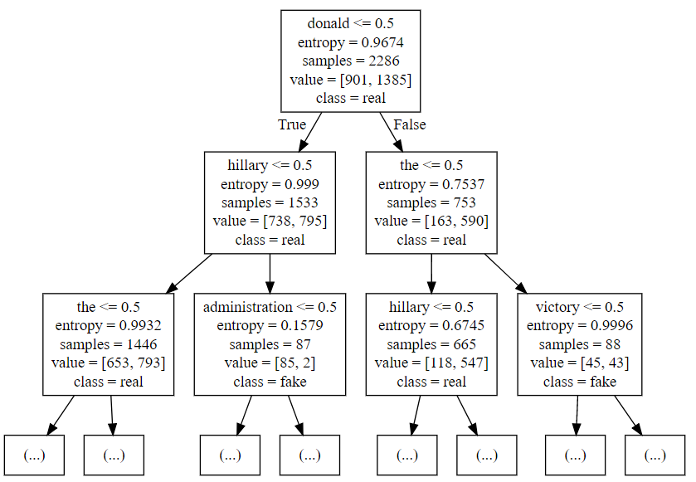

**Question 2d: Output from compute_information_gain**

Bolded is the topmost label (“donald”)

|  |
| --- |
| **Information Gain in Label by splitting on donald: 0.03412305015881989**  Information Gain in Label by splitting on hillary: 0.026697700148983317  Information Gain in Label by splitting on clinton: 0.007298694213891288  Information Gain in Label by splitting on korea: 0.011570446505243082  Information Gain in Label by splitting on america: 0.00849756958300818  Information Gain in Label by splitting on putin: 0.0017367934909430227 |