**CSC411 Homework 5**

**Question 1: Gaussian Discriminant Analysis**

**Part A, B: Average Conditional Log Likelihood, Accuracy**

Output of program:

Part A: Average Conditional Log-Likelihoods

Train: -0.12462443666863048

Test: -0.19667320325525584

Part B: Accuracy

Train Accuracy: 0.9814285714285714

Test Accuracy: 0.97275

**Part C: Visualizing Leading Covariance Eigenvectors**

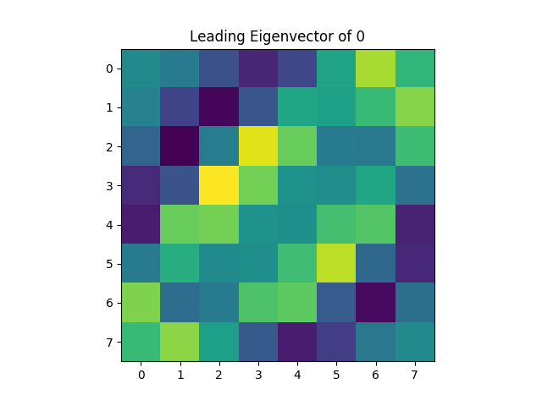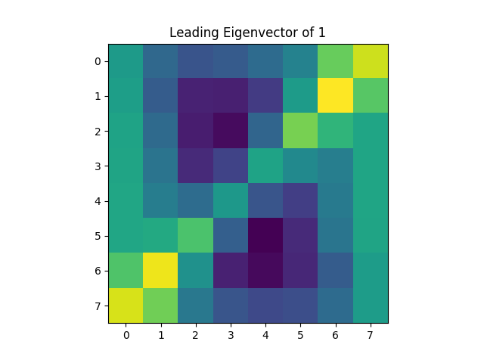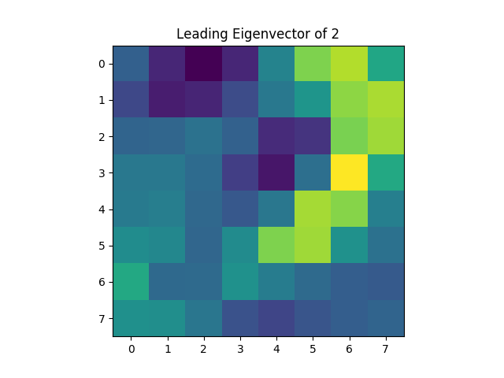

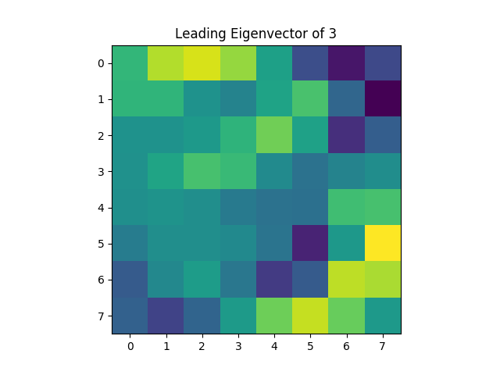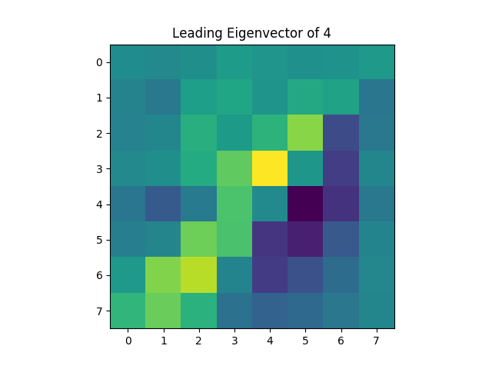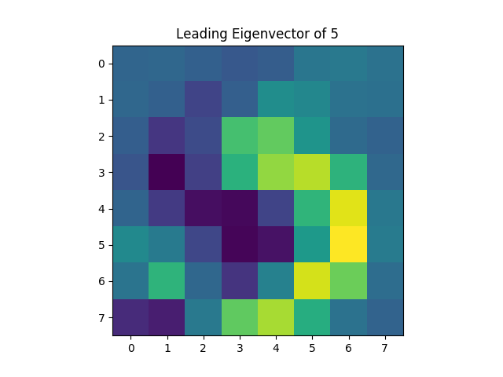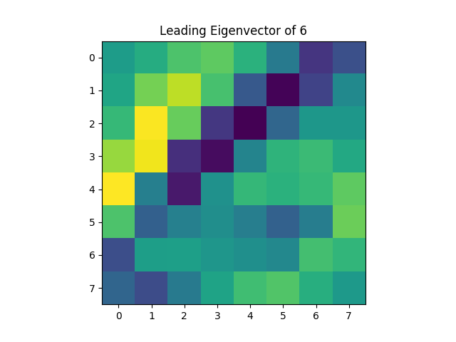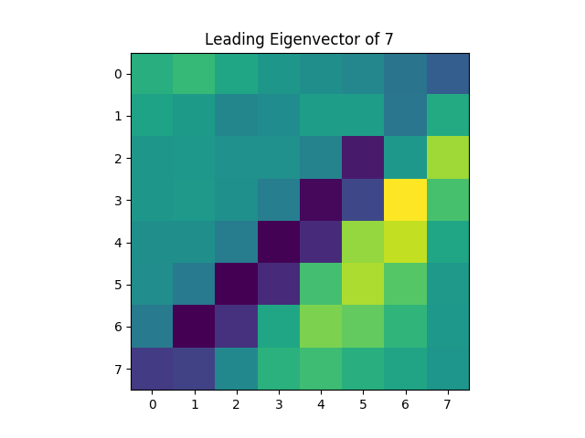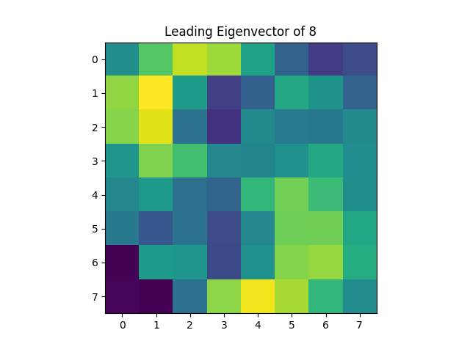

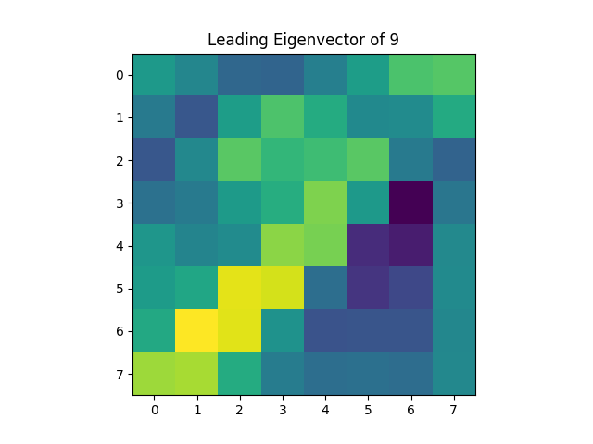

**Question 2**

**Part A: Posterior Distribution**

Bayes rule:

$$p\left(θ | D\right)=\frac{p\left(D | θ\right)p(θ)}{p(D)}$$

Dirichlet as prior:

$$p\left(θ\right)=\frac{Γ\left(\sum_{i=1}^{K}{a_{i}}\right)}{\prod_{i=1}^{K}{Γ\left(a_{i}\right)}}\prod_{i=1}^{K}{θ_{i}^{a_{i}-1}}$$

Likelihood of data $x_{1…N}$ given $θ$

$$p\left(D | θ\right)=\prod_{i=1}^{N}{\prod_{j=1}^{K}{θ_{j}^{x_{j}^{\left(i\right)}}}}$$

Note that $x$ is a one-hot vector. This means that all elements of $θ$ except for the element corresponding to the correct class will “cancel out” of the product. If class j has $N_{j}$ occurences, then the total power of $θ_{j}$ will be $N_{j}$

$$p\left(D | θ\right)=\prod_{j=1}^{K}{θ_{j}^{N_{j}}}$$

For the purposes of this question, we can reason about $p(θ|D)$ in proportional terms:

$$p\left(θ | D\right) α p\left(D | θ\right)p\left(θ\right)$$

$$p\left(θ\right) α\prod_{i=1}^{K}{θ_{i}^{a_{i}-1}}$$

$$⇒p\left(θ | D\right) α\prod_{j=1}^{K}{θ_{j}^{N_{j}}}\prod_{i=1}^{K}{θ_{i}^{a_{i}-1}}$$

Merging the two products together:

$$⇒ p\left(θ | D\right) α \prod_{i=1}^{K}{θ_{i}^{N_{i}+a_{i}-1}}$$

Note that the above proportionality means that the conditional probability also obeys a Dirichlet distribution

$$⇒p\left(θ | D\right) \sim Dirichlet(N_{1}+a_{1},…,N_{K}+a_{k})$$

Posterior predictive probability

Let

$$x_{k}∈R^{K}, x_{k}[i]=\left\{\begin{aligned}1 if i=k \\ 0 otherwise\end{aligned}\right.$$

Probability of $x_{k}$ must be integrated over all possible $θ$.

$$p\left(x_{k} | D\right)=\int{p\left(x_{k}\left[k\right]=1\right)p\left(θ | D\right)dθ}$$

Probability of $x_{k}\left[k\right]=1$ is equal to $θ_{k}$

$$⇒p\left(x_{k} | D\right)=\int{θ_{k}p\left(θ | D\right)dθ}$$

Integration over $θ$ means the above is an expectation of $θ_{k}$

$$⇒p(x_{k}|D)=E_{Dirichlet(N_{1}+a_{1},…,N_{K}+a_{k})}(θ_{k})$$

Recalling expectation of Dirichlet distribution

$$⇒p\left(x_{k} | D\right)=\frac{N_{k}+a_{k}}{\sum_{i=1}^{K}{N_{i}+a_{i}}}$$

N is the sum of all $N_{i}$

$$⇒p(x_{k}|D)=\frac{N_{k}+a_{k}}{N+\sum_{i=1}^{K}{a_{i}}}$$

**Part B: MAP of $θ$**

Recall proportionality of $p(θ|D)$:

$$p\left(θ | D\right) α \prod_{i=1}^{K}{θ_{i}^{N_{i}+a_{i}-1}}$$

Since $p(θ|D)$ is directly proportional to the product of powers of theta, we need only maximize the product

$$argmax_{θ}p\left(θ | D\right)=argmax_{θ}\prod_{i=1}^{K}{θ_{i}^{N_{i}+a_{i}-1}}$$

Logarithm function is monotonic, so maximizing the logarithm is also equivalent to maximizing the input of the logarithm

$$argmax_{θ}\prod_{i=1}^{K}{θ_{i}^{N_{i}+a_{i}-1}}=argmax_{θ}\log\left(\prod_{i=1}^{K}{θ_{i}^{N_{i}+a_{i}-1}}\right)$$

Applying the logarithm to the product

$$\log\left(\prod_{i=1}^{K}{θ_{i}^{N_{i}+a_{i}-1}}\right)=\sum_{i=1}^{K}{(N_{i}+a_{i}-1)}\log{θ_{i}}$$

Note that $∑θ_{j}=1$, so Lagrange multipliers must be used for maximization

$$\sum_{i=1}^{K}{θ_{i}=1}⇒argmax_{θ}\left(\sum_{i=1}^{K}{\left(N_{i}+a_{i}-1\right)}\log{θ_{i}}\right)$$

$$=argmax_{θ}\left(\sum_{i=1}^{K}{\left(N_{i}+a_{i}-1\right)}\log{θ_{i}}-λ\left(\sum_{i=1}^{K}{θ_{i}}-1\right)\right)$$

$$=argmax_{θ}\left(\sum_{i=1}^{K}{\left(\left(N_{i}+a_{i}-1\right)\log{θ_{i}}-λθ_{i}\right)}-λ\right)$$

Taking derivatives of the Lagrangian equation:

$$\frac{d}{dθ_{j}}\left(\sum_{i=1}^{K}{\left(\left(N_{i}+a_{i}-1\right)\log{θ_{i}}-λθ_{i}\right)}-λ\right)$$

$$=\frac{d}{dθ_{j}}\left(\sum_{i≠j}^{K}{\left(\left(N_{i}+a_{i}-1\right)\log{θ_{i}}-λθ_{i}\right)}\right)+\frac{d}{dθ_{j}}\left(\left(N_{j}+a_{j}-1\right)\log{θ_{j}}-λθ_{j}\right)$$

$$=\frac{N_{j}+a_{j}-1}{θ_{j}}-λ$$

$$\frac{d}{dλ}\left(\sum_{i=1}^{K}{\left(\left(N_{i}+a_{i}-1\right)\log{θ_{i}}-λθ_{i}\right)}-λ\right)=-\sum_{i=1}^{K}{θ_{i}}-1$$

Setting derivatives to zero to find maximum

$$\left(0=\frac{N_{j}+a_{j}-1}{θ_{j}}-λ\right)⇒\left(λ=\frac{N_{j}+a_{j}-1}{θ_{j}}\right)⇒\left(θ_{j}=\frac{N_{j}+a_{j}-1}{λ}\right)$$

$$\left(0=-\sum_{i=1}^{K}{θ_{i}}-1\right)⇒\left(\sum_{i=1}^{K}{θ_{i}}=1\right)$$

Combining these equalities, we get:

$$\left(\sum_{i=1}^{K}{\frac{N_{i}+a_{i}-1}{λ}}=1\right)⇒\left(\sum_{i=1}^{K}{\left(N_{i}+a_{i}-1\right)}=λ\right)⇒\left(λ=N+\sum_{i=1}^{K}{a_{i}}-K\right)$$

Substituting $λ$ back into the definition of $θ_{j}$

$$θ_{j}=\frac{N_{j}+a_{j}-1}{N+\sum_{i=1}^{K}{a_{i}}-K}$$