# General Nrf1 background

**Nrf1,** also referred to as **NFE2L1** (nuclear factor erythroid-derived 2-like 1 or nuclear factor erythroid 2-related factor 1), **TCF11** (transcription factor 11, 120 kDa glycosylated long isoform) or **LCR-F1** (locus control region factor-f1, 55 kDa deglycosylated short isoform), is a cap n collar transcription factor in the same family as Nrf2 and Nrf3. It is different from NRF1, the official gene name for nuclear respiratory factor 1.

* [Entrez Gene](http://www.ncbi.nlm.nih.gov/gene/18023): “This gene encodes a protein that is involved in globin gene expression in erythrocytes. **Confusion has occurred in bibliographic databases due to the shared symbol of NRF1 for this gene, NFE2L1, and for "nuclear respiratory factor 1" which has an official symbol of NRF1.**”
* NFE2L1 neonatal KO is embryonically lethal, adult KO leads to NASH and hepatic neoplasia1.
* NFE2L1 is produced in the ER2 and may be involved in the ER stress response3, although previous work shows inhibition by ER stress4,5. It may also be involved in the antioxidant response5,6, but its role is unclear7.
* Epoxomicin: + control, p97 inhibitor: - control
* ER stress drugs:
  + Tunicamycin blocks N-linked glycosylation
  + Thapsigargin is a SERCA inhibitor

# Nrf1 in metabolic homeostasis

Nrf1 seems to be important in overall cellular homeostasis, and specifically in defending against metabolic stress in multiple tissue types (liver-scott, pancreatic beta cells-kosei, macrophages-me and Benny, adipose-Alex B.)

* Liver: mediates adaptive response to high cholesterol to prevent cholestasis
* Macrophages: Nrf1 also responds to excess free cholesterol and may regulate cholesterol efflux and reverse cholesterol transport. Macrophages are a critical cell type in inflammation, in metabolic homeostasis, and in atherosclerosis. This was especially relevant after we found a role for Nrf1 in the cellular adaptive response to sterol loading.
* Beta cells: Nrf1 may defend against islet cholesterol accumulation, which decreases insulin production.
* Brown adipose: Nrf1 is important for BAT maintenance

# Nrf1 and proteasome function

A major function of NFE2L1 is control of proteasome subunit gene expression2,8-11. The N-terminal domain is anchored to the luminal ER membrane12. NFE21L1 undergoes ER-associated degradation2: The C-terminal bZIP fragment retrotranslocates through the ER membrane to the cytosolic side with the help of p97 and is then ubiquitinated, triggering the proteasome to degrade the entire protein. When the proteasome is absent or partially inhibited (and thus needs to be produced), the bZIP fragment is cleaved by a protease and travels to the nucleus to induce transcription of proteasome subunits. The protease may be the proteasome itself9, or another unidentified protease. Evidence suggests that entry into the nucleus also occurs by retrotranslocation[13](#_ENREF_13" \o "Zhang, 2014 #83). **This method of proteolytic processing is similar to the SREBPs****14****.**

The *Nature* paper from the Manning and Hotamisligil labs on mTOR15 extended these results by providing a framework for the role of NFE2L1 in protein synthesis and degradation. From abstract: “as well as increasing protein synthesis, mTORC1 activation in mouse and human cells also promotes an increased capacity for protein degradation. Cells with activated mTORC1 exhibited elevated levels of intact and active proteasomes through a global increase in the expression of genes encoding proteasome subunits. The increase in proteasome gene expression, cellular proteasome content, and rates of protein turnover downstream of mTORC1 were dependent on induction of the transcription factor nuclear factor erythroid-derived 2-related factor 1 (NRF1; also known as NFE2L1). Genetic activation of mTORC1 through loss of the tuberous sclerosis complex tumour suppressors, TSC1 or TSC2, or physiological activation of mTORC1 in response to growth factors or feeding resulted in increased NRF1 expression in cells and tissues. We find that this **NRF1-dependent elevation in proteasome levels serves to increase the intracellular pool of amino acids, which thereby influences rates of new protein synthesis.”**

From Zhang and Manning 201516: Figure 1. The mTORC1-SREBP-NRF1-Proteasome pathway. Growth factors and nutrients activate mTORC1, which promotes an increase in cellular protein synthesis. mTORC1 also stimulates activa- tion of the SREBP1 transcription factor by promoting its processing and nuclear accumulation, which requires its trafficking to the Golgi, where it is proteolytically cleaved by 2 proteases, result- ing in release of the N-terminus encompassing the mature active transcription factor. Mature SREBP1 binds to SRE sequences in the promoters of genes, including the enzymes of de novo lipid synthesis and NFE2L1, encoding the NRF1 transcription factor. NRF1 is synthesized as an ER trans- membrane protein and must be processed to release the active transcription factor. Proteasome inhibitors stimulate this processing, but the nature of the physiological signal is currently unknown. Once activated, NRF1 goes to the nucleus and turns on a subset of genes containing AREs in their promoter, including those encoding all, or nearly all, subunits of the proteasome, leading to an increase in cellular proteasome content. See text for more details.

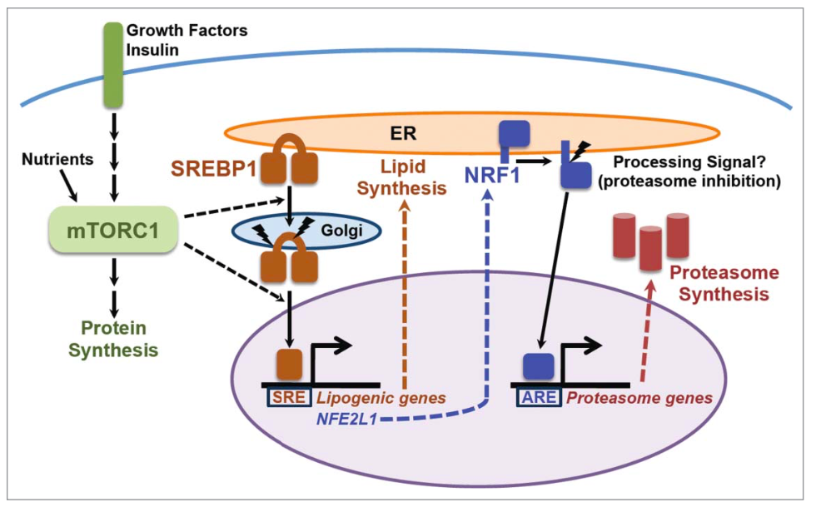

**ERAD**

From [nature.com](http://www.nature.com/subjects/er-associated-degradation): “ER-associated degradation (ERAD) is the process by which the endoplasmic reticulum (ER) directs the degradation of misfolded or inappropriate proteins. The steps of ERAD include recognition of a misfolded protein – for instance for its inappropriate exposure of glycan residues – retro-translocation of the protein into the cytosol, and ubiquitin-dependent degradation by the proteasome.”

Vembar and Brodsky17

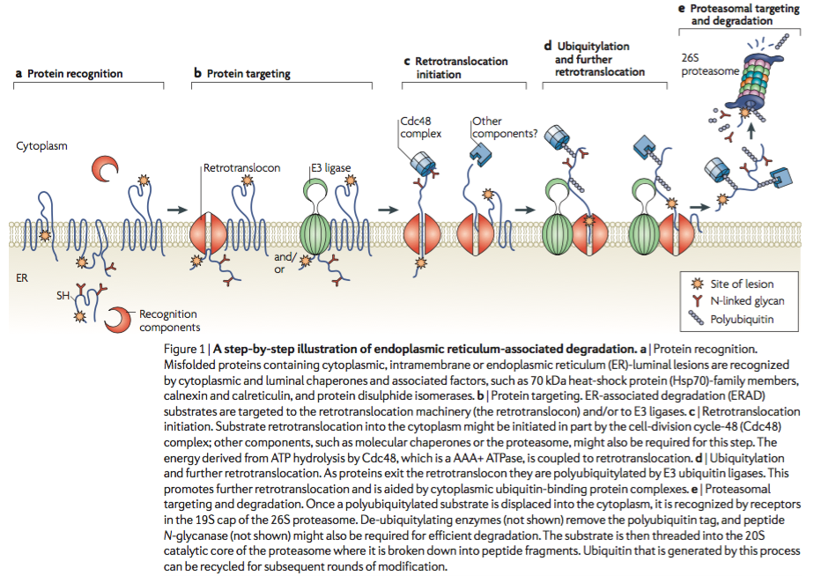

# Cholesterol metabolism background

- Receptor-mediated endocytosis and cholesterol trafficking

- Dissertation p.3: “The majority of LDL particles are cleared from the circulation through the use of the hepatic LDLR in a process known as receptor- mediated endocytosis22-25. Receptor-mediated endocytosis was discovered through studies of the LDLR, and is now recognized as a general cellular strategy for internalization of large particles and their cargo26. This process begins with recognition of ApoB100 by LDLRs located in clathrin-coated extracellular pits. Binding of LDL to LDLRs triggers formation of vesicles that are rapidly internalized and fuse with lysosomes. Once LDL enters the lysosome, its protein components are digested to amino acids, and its cholesterol is subject to the actions of two Niemann-Pick C (NPC) proteins, NPC1 and NPC2. Recent studies support the existence of a cooperative handoff mechanism whereby NPC2 binds cholesterol, with cholesterol’s hydrophobic iso-octyl side chain buried in NPC2’s binding pocket, forms a closed channel with NPC1, and hands off the cholesterol molecule27. NPC1 may then be able to move cholesterol through the membrane for exit from the lysosome and transport to the endoplasmic reticulum (ER), but this step is not fully understood.”

From cholesterol treatment protocol:

* Cholesterol aligns with phospholipids in membranes. It is most abundant in the plasma membrane, which contains 0.8 mol cholesterol/mol phospholipids in fibroblasts, whereas the ER cholesterol pool is 0.05 mol cholesterol/mol phospholipids3. Cholesterol equilibrates between these two organelles. When the plasma membrane cholesterol level increases above the phospholipid complexing capacity, the cholesterol has increased “escape tendency,” meaning it is more likely to exit the membrane, and is referred to as “active cholesterol”3,4. Active cholesterol rapidly exits the plasma membrane and equilibrates with intracellular membranes, particularly the ER and mitochondria.

- Cholesterol is esterified in the ER and stored in lipid droplets. Nrf1 is located in the ER membrane like SREBPs, so it may affect cholesterol handling in the ER.

- SREBPs mediate the cellular response to low cholesterol.

- The cellular response to high cholesterol is not as well understood.

- Steck TL, Lange Y. Cell cholesterol homeostasis: Mediation by active cholesterol. Trends Cell Biol. 20:680–687 (2010).

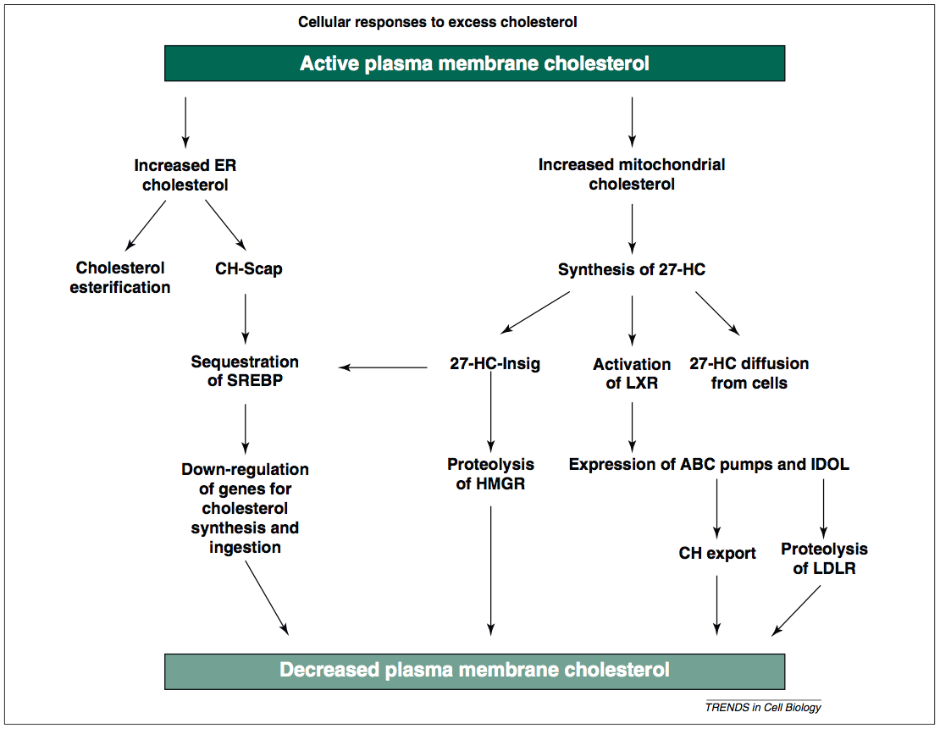

- It seems to result in increased ABCA1 and G1, though how this is achieved is not fully known.

- See figure 2 in Sharpe LJ, Cook ECL, Zelcer N, Brown AJ. The UPS and downs of cholesterol homeostasis. Trends Biochem. Sci. 39:527–535 (2014).

- Nrf1 coordinates the cellular adaptive response to elevated cholesterol.

- See Servier presentations.

- RNA-Seq data indicate that Nrf1 regulates the transcriptional response to a cellular cholesterol challenge.

- Nrf1 seems to mediate the conversion of cholesterol into bile.

- It may interact with Insig proteins (Vanessa is working on this).

- Note: I doubt that Nrf1 directly binds cholesterol. The recent paper on the cholesterol-binding proteome from Ben Cravatt’s lab did not return Nrf1 as a hit, even though the majority of cholesterol-binding proteins were ER proteins. However, this was in HeLa cells, so it may not apply to other cell types.

- Hulce JJ, Cognetta AB, Niphakis MJ, Tully SE, Cravatt BF. Proteome-wide mapping of cholesterol-interacting proteins in mammalian cells. Nat. Methods 10:259–64 (2013).

# Bile metabolism background

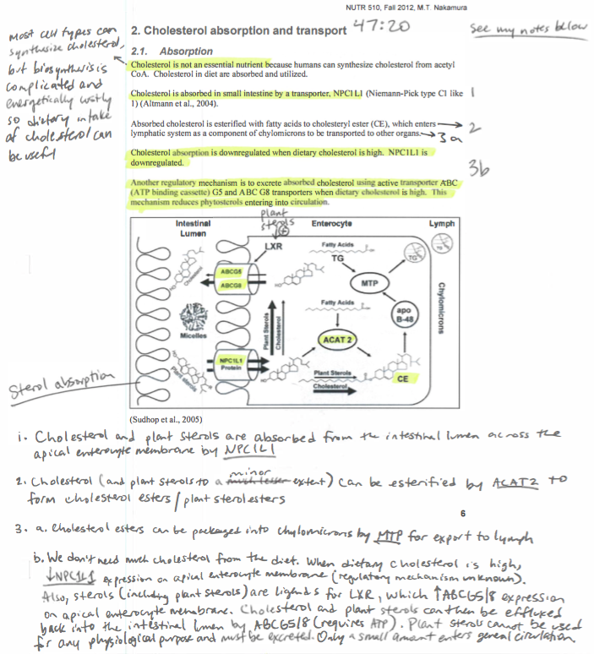

- Dawson PA, Karpen SJ. Intestinal Transport and Metabolism of Bile Acids. J. Lipid Res. (2014).

- Iqbal J, Hussain MM. Intestinal lipid absorption. Am. J. Physiol. Endocrinol. Metab. 296:E1183–94 (2009).

- Comparison of rodents and humans

- Dietschy JM, Turley SD. Control of cholesterol turnover in the mouse. J. Biol. Chem. 277:3801–3804 (2002).

- Sterol Metabolism in the Mouse Compared with Other Mammalian Models: In many respects, cholesterol turnover in the mouse is both quantitatively and qualitatively different from other animal models, particularly primates. As shown in Table I, on a typi- cal, cereal-based animal diet the mouse ingests about 30 mg of cholesterol/day/kg of body weight whereas other species, in- cluding humans, usually eat much less (column A). In different strains of mice, as well as in different humans, the amount of this dietary sterol load that is absorbed varies between 30 and 70%. Typically, the mouse synthesizes 􏰎160 mg/day/kg of cho- lesterol whereas the human makes only 􏰎10 mg/day/kg (col- umn B). As in other rodents, the liver of the mouse is relatively more important as a site for this synthesis (􏰎40%) than is true in the primate (10–12%) (column C). Because the pool of cho- lesterol in the whole animal is similar in the rodent and human (􏰎2200 mg/kg) and does not change with age, the total input of sterol from the diet and synthesis in the mouse (􏰎190 mg/day/ kg) is much greater than in the other species and, in particular, is 13-fold higher than in the human (􏰎15 mg/day/kg). There is a similar, marked difference in the handling of cholesterol carried in circulating LDL. Although the liver is the primary site for the removal of LDL from the plasma in all species (column E), the rate of entry of cholesterol into the LDL pool in the mouse (􏰎50 mg/day/kg) is only 4-fold higher than in the human (􏰎13 mg/day/kg) (column D), but the rate of hepatic LDL clearance in this animal (􏰎500 ml/day/kg) is 40-fold greater than in the human (􏰎12 ml/day/kg) (12, 13). As a consequence, the steady-state concentration of cholesterol car- ried in LDL in the mouse is usually 􏰎7 mg/dl whereas in the human this value usually exceeds 100 mg/dl (column F). De- spite these variations, however, most animals, including the mouse, ultimately excrete cholesterol in the feces in approxi- mately equal amounts as neutral (column G) and acidic (col- umn H) sterols.

- rodents increase cyp7a1 expression in response to dietary cholesterol

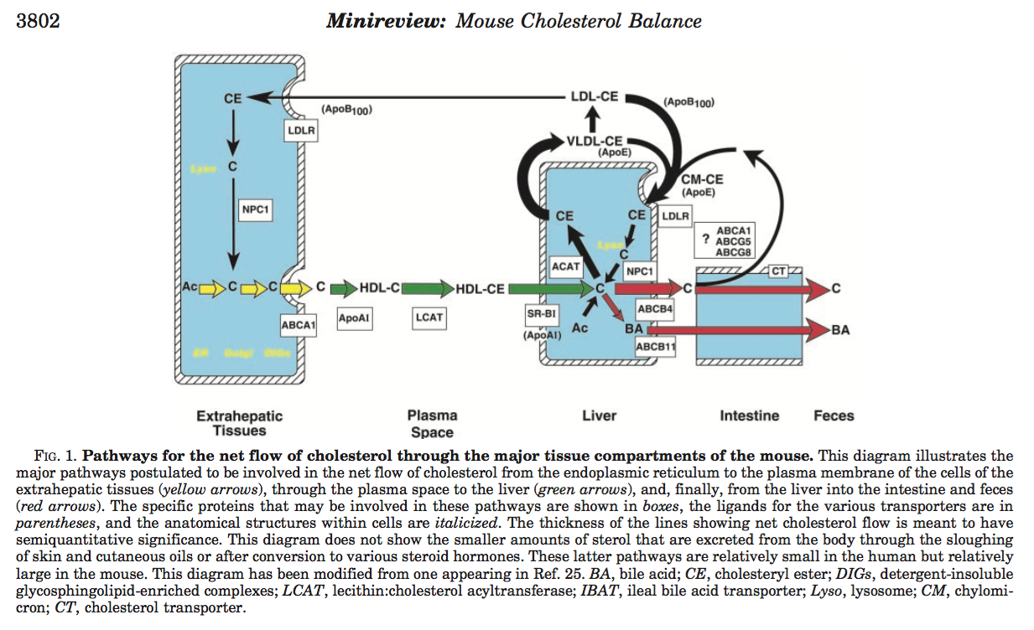

- Davis RA, Miyake JH, Hui TY, Spann NJ. Regulation of cholesterol-7alpha-hydroxylase: BAREly missing a SHP. J. Lipid Res. 43:533–543 (2002).

- Mouse ABCA1 has similar functions in intestinal cholesterol excretion

- Oram JF, Lawn RM. ABCA1. The gatekeeper for eliminating excess tissue cholesterol. J. Lipid Res. 42:1173–1179 (2001).

- Repa JJ, Buhman KK, Farese RV, Dietschy JM, Turley SD. ACAT2 deficiency limits cholesterol absorption in the cholesterol-fed mouse: impact on hepatic cholesterol homeostasis. Hepatology 40:1088–1097 (2004).

# References

1. Xu Z, Chen L, Leung L, Yen TS, Lee C, Chan JY. Liver-specific inactivation of the Nrf1 gene in adult mouse leads to nonalcoholic steatohepatitis and hepatic neoplasia. *Proc. Natl. Acad. Sci. USA* 102:4120-4125 (2005).

2. Ye J. Nrf1 to the rescue. *eLife* 3:e02062 (2014).

3. Ho DV, Chan JY. Induction of Herpud1 expression by ER stress is regulated by Nrf1. *FEBS Lett.* (2015).

4. Zhang Y, Lucocq JM, Hayes JD. The Nrf1 CNC/bZIP protein is a nuclear envelope-bound transcription factor that is activated by t-butyl hydroquinone but not by endoplasmic reticulum stressors. *Biochem. J.* 418:293-310 (2009).

5. Sykiotis GP, Bohmann D. Stress-activated cap'n'collar transcription factors in aging and human disease. *Sci. Signal.* 3:re3 (2010).

6. Kwong EK, Kim KM, Penalosa PJ, Chan JY. Characterization of Nrf1b, a novel isoform of the nuclear factor-erythroid-2 related transcription factor-1 that activates antioxidant response element-regulated genes. *PloS one* 7:e48404 (2012).

7. Chepelev NL, Zhang H, Liu H, McBride S, Seal AJ, Morgan TE, Finch CE, Willmore WG, Davies KJ, Forman HJ. Competition of nuclear factor-erythroid 2 factors related transcription factor isoforms, Nrf1 and Nrf2, in antioxidant enzyme induction. *Redox Biol.* 1:183-189 (2013).

8. Radhakrishnan SK, den Besten W, Deshaies RJ. p97-dependent retrotranslocation and proteolytic processing govern formation of active Nrf1 upon proteasome inhibition. *eLife* 3:e01856 (2014).

9. Sha Z, Goldberg AL. Proteasome-mediated processing of Nrf1 is essential for coordinate induction of all proteasome subunits and p97. *Curr. Biol.* 24:1573-1583 (2014).

10. Tsuchiya Y, Taniguchi H, Ito Y, Morita T, Karim MR, Ohtake N, Fukagai K, Ito T, Okamuro S, Iemura S *et al.* The casein kinase 2-nrf1 axis controls the clearance of ubiquitinated proteins by regulating proteasome gene expression. *Mol. Cell. Biol.* 33:3461-3472 (2013).

11. Steffen J, Seeger M, Koch A, Kruger E. Proteasomal degradation is transcriptionally controlled by TCF11 via an ERAD-dependent feedback loop. *Mol. Cell* 40:147-158 (2010).

12. Wang W, Chan JY. Nrf1 is targeted to the endoplasmic reticulum membrane by an N-terminal transmembrane domain. Inhibition of nuclear translocation and transacting function. *J. Biol. Chem.* 281:19676-19687 (2006).

13. Zhang Y, Ren Y, Li S, Hayes JD. Transcription factor Nrf1 is topologically repartitioned across membranes to enable target gene transactivation through its acidic glucose-responsive domains. *PloS one* 9:e93458 (2014).

14. Brown MS, Ye J, Rawson RB, Goldstein JL. Regulated intramembrane proteolysis: a control mechanism conserved from bacteria to humans. *Cell* 100:391-398 (2000).

15. Zhang Y, Nicholatos J, Dreier JR, Ricoult SJ, Widenmaier SB, Hotamisligil GS, Kwiatkowski DJ, Manning BD. Coordinated regulation of protein synthesis and degradation by mTORC1. *Nature* 513:440-443 (2014).

16. Zhang Y, Manning BD. mTORC1 signaling activates NRF1 to increase cellular proteasome levels. *Cell cycle* 14:2011-2017 (2015).

17. Vembar SS, Brodsky JL. One step at a time: endoplasmic reticulum-associated degradation. *Nat. Rev. Mol. Cell Biol.* 9:944-957 (2008).