**DML**

**Name:** Roshan Shetty **Roll No:** 525

|  |  |
| --- | --- |
| Sr.  No | List of Practical Experiments |
| 1 | Write a program to implement Simple Linear Regression |
| 2 | Write a program to implement multiple Linear Regression |
| 3 | Write a program to implement Support Vector Machine |
| 4 | Write a program to implement K-nearest Neighbors (K-NN) |
| 5 | Write a program to implement Hierarchical clustering. |
| 6 | Write a program to implement K-means clustering. |
| 7 | Write a program to build ANN. |
| 8 | Write a program to build CNN. |

**Practical 1**

**Aim:** Write a program to implement Simple Linear Regression

**Code:**

import numpy as np

import matplotlib.pyplot as plt

import pandas as pd

dataset = pd.read_csv("Salary_Data.csv")

X = dataset.iloc[ : , : -1].values

y = dataset.iloc[ : , -1].values

print(X)

print("\n\n\n")

print(y)

from sklearn.model_selection import train_test_split

X_train, X_test, y_train, y_test = train_test_split(X, y, test_size = 1/4, random_state = 0)

print(X_train)

print("\n\n\n")

print(X_test)

print("\n\n\n")

print(y_train)

print("\n\n\n")

print(y_test)

from sklearn.linear_model import LinearRegression

linear_regression = LinearRegression()

linear_regression.fit(X_train, y_train)

y_train_pred = linear_regression.predict(X_train)

y_test_pred = linear_regression.predict(X_test)

plt.scatter(X_train, y_train, color = "green", marker = "+", label = "Observed data")

plt.plot(X_train, y_train_pred, color = "red", label = "Predicted data")

plt.xlabel("Years of experience")

plt.ylabel("Salary")

plt.title("Years of experience v/s Salary (Training dataset)")

plt.legend()

plt.show()

plt.scatter(X_test, y_test, color = "green", marker = "+", label = "Observed data")

plt.plot(X_test, y_test_pred, color = "red", label = "Predicted data")

plt.xlabel("Years of experience")

plt.ylabel("Salary")

plt.title("Years of experience v/s Salary (Testing dataset)")

plt.legend()

plt.show()

**Output:**

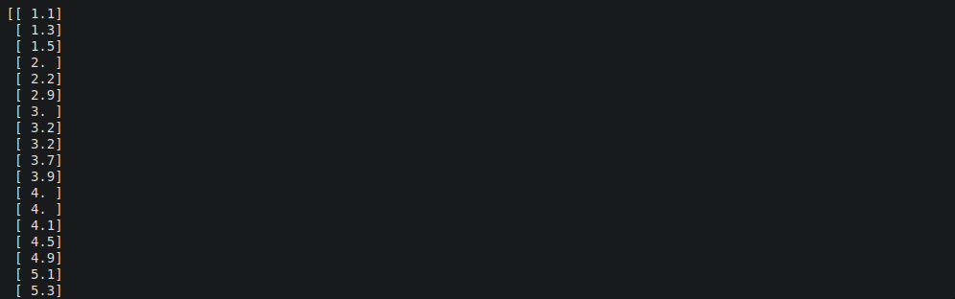

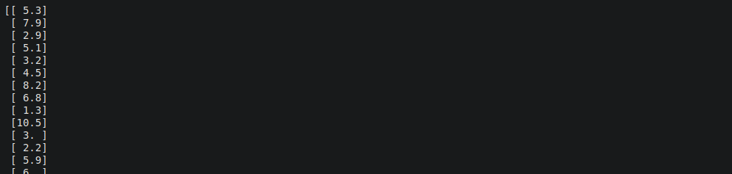

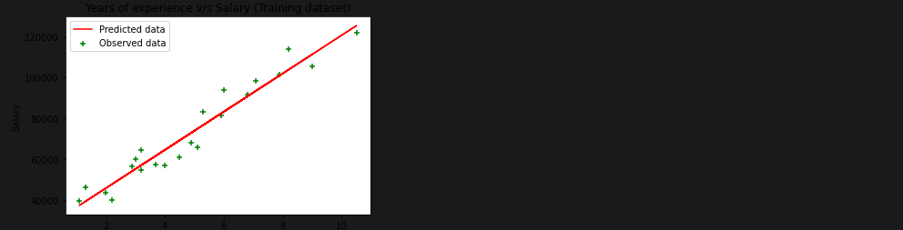

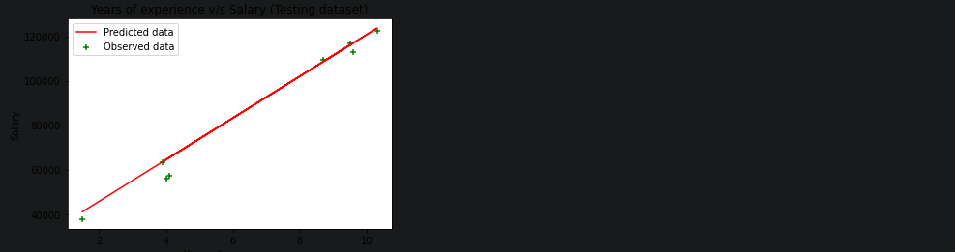

**Practical 2**

**Aim:** Write a program to implement multiple Linear Regression

**Code:**

import numpy as np

import matplotlib.pyplot as plt

import pandas as pd

dataset = pd.read_csv('/content/50_Startups-2.csv')

x = dataset.iloc[:, :-1].values

y = dataset.iloc[:, -1].values

print(x)

print(y)

from sklearn.compose import ColumnTransformer

from sklearn.preprocessing import OneHotEncoder

ct = ColumnTransformer(transformers=[('encoder', OneHotEncoder(), [3])], remainder='passthrough')

x = np.array(ct.fit_transform(x))

print(x)

from sklearn.model_selection import train_test_split

x_train, x_test, y_train, y_test = train_test_split(x, y, test_size=0.2, random_state=0)

from sklearn.linear_model import LinearRegression

regressor = LinearRegression()

regressor.fit(x_train, y_train)

y_pred = regressor.predict(x_test)

np.set_printoptions(precision=2)

print(np.concatenate((y_pred.reshape(len(y_pred),1), y_test.reshape(len(y_test),1)),1))

**Output:**

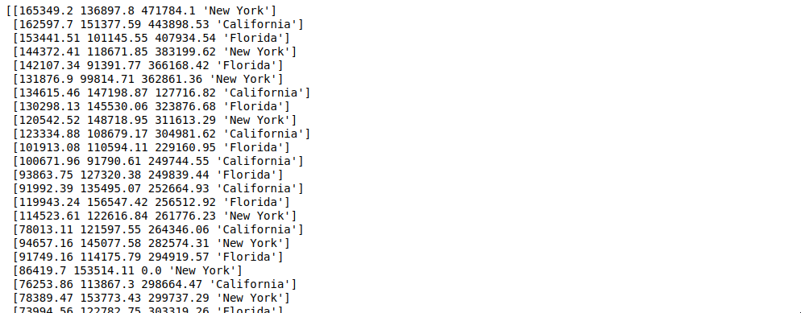

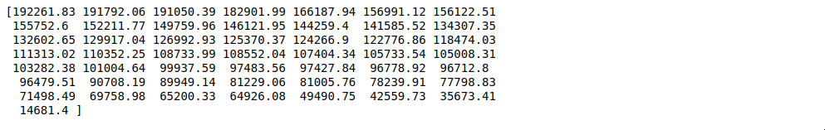

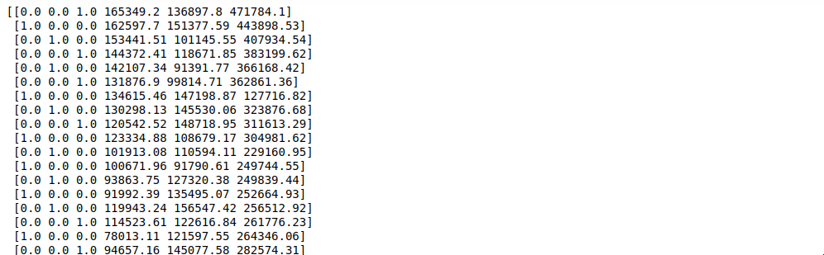

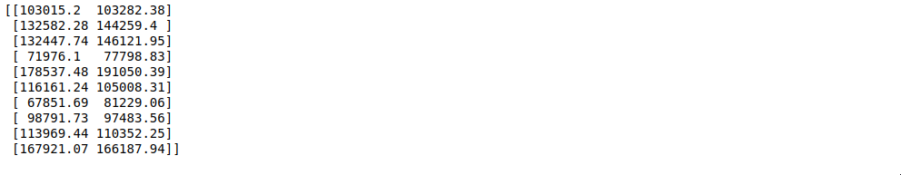

**Practical 3**

**Aim:** Write a program to implement Support Vector Machine

**Code:**

import matplotlib.pyplot as plt

import numpy as np

import pandas as pd

dataset = pd.read_csv('/content/Social_Network_Ads.csv')

x = dataset.iloc[:, :-1].values

y = dataset.iloc[:, -1].values

print(x)

print(y)

from sklearn.model_selection import train_test_split

x_train, x_test, y_train, y_test = train_test_split(x, y, test_size=0.25, random_state=0)

print(x_train)

print(y_train)

print(x_test)

print(y_test)

from sklearn.preprocessing import StandardScaler

sc = StandardScaler()

x_train = sc.fit_transform(x_train)

x_test = sc.transform(x_test)

print(x_train)

print(x_test)

from sklearn.svm import SVC

classifier = SVC(kernel='linear', random_state=0)

classifier.fit(x_train, y_train)

print(classifier.predict(sc.transform([[30,200000]])))

y_pred = classifier.predict(x_test)

print(np.concatenate((y_pred.reshape(len(y_pred),1), y_test.reshape(len(y_test),1)),1))

from sklearn.metrics import confusion_matrix, accuracy_score

cm = confusion_matrix(y_test, y_pred)

print(cm)

accuracy_score(y_test, y_pred)

**Output:**

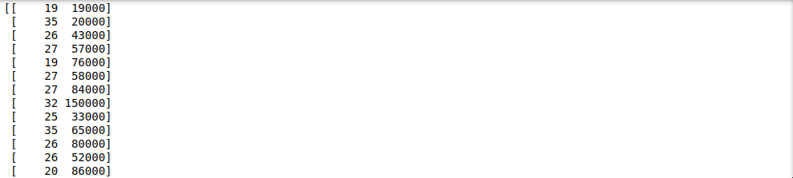

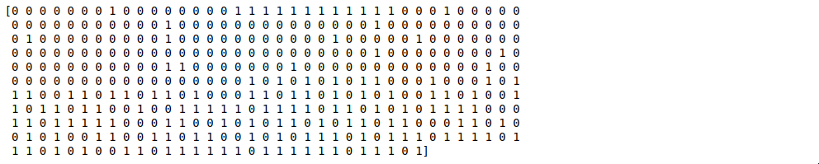

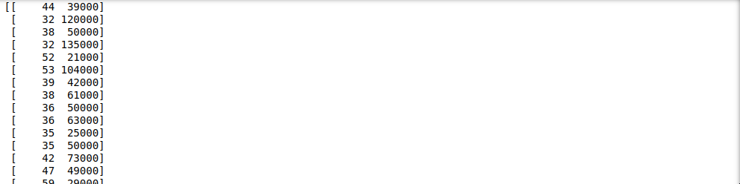

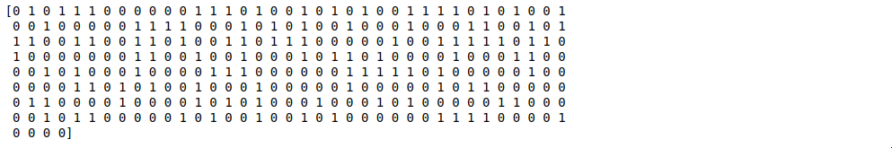

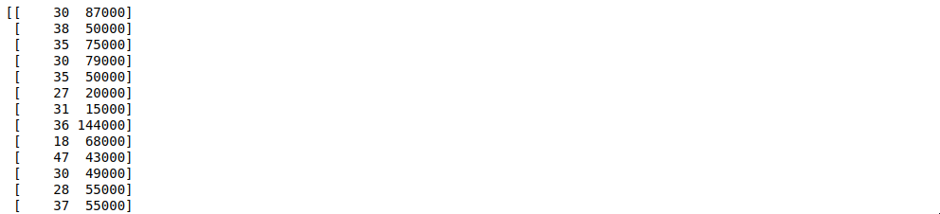



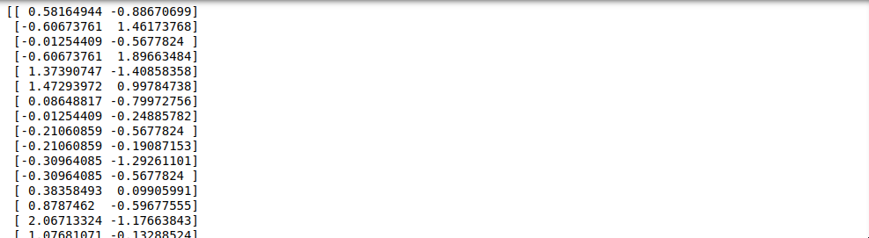

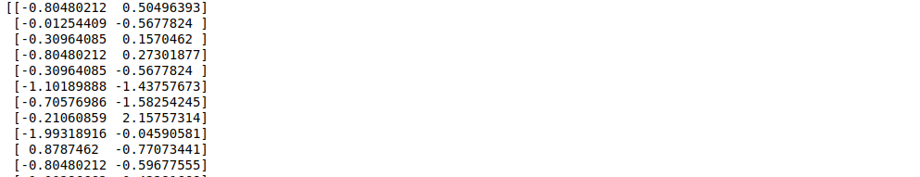

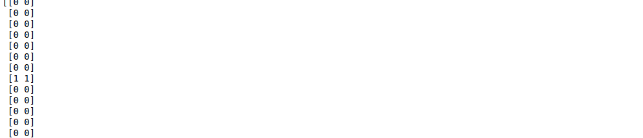

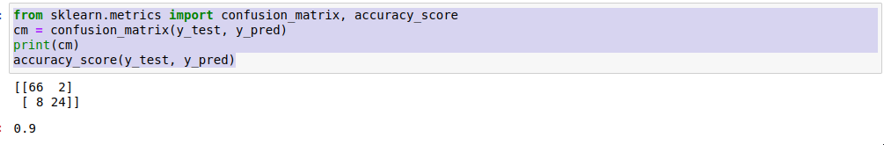

**Practical 4**

**Aim:** Write a program to implement K-nearest Neighbors (K-NN)

**Code:**

import matplotlib.pyplot as plt

import pandas as pd

import numpy as np

dataset = pd.read_csv('/content/Social_Network_Ads.csv')

x = dataset.iloc[:, :-1].values

y = dataset.iloc[:, -1].values

print(x)

print(y)

from sklearn.model_selection import train_test_split

x_train, x_test, y_train, y_test = train_test_split(x, y, test_size=0.25, random_state=0)

print(x_train)

print(y_train)

print(x_test)

print(y_test)

from sklearn.preprocessing import StandardScaler

sc = StandardScaler()

x_train = sc.fit_transform(x_train)

x_test = sc.transform(x_test)

print(x_train)

print(x_test)

from sklearn.neighbors import KNeighborsClassifier

classifier = KNeighborsClassifier(n_neighbors=5, metric='minkowski', p=2)

classifier.fit(x_train, y_train)

print(classifier.predict(sc.transform([[40, 200000]])))

y_pred = classifier.predict(x_test)

print(np.concatenate((y_pred.reshape(len(y_pred),1), y_test.reshape(len(y_test),1)),1))

from sklearn.metrics import confusion_matrix, accuracy_score

cm = confusion_matrix(y_test, y_pred)

print(cm)

accuracy_score(y_test, y_pred)

**Output:**

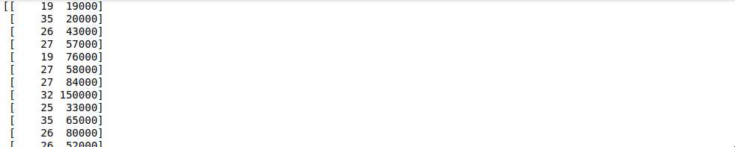

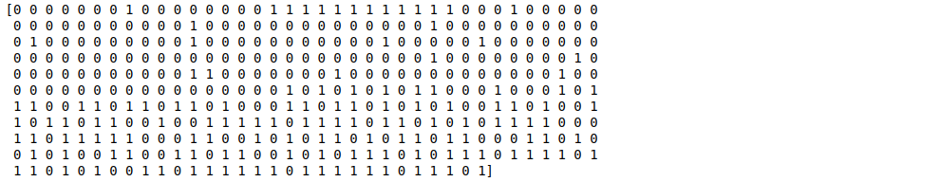

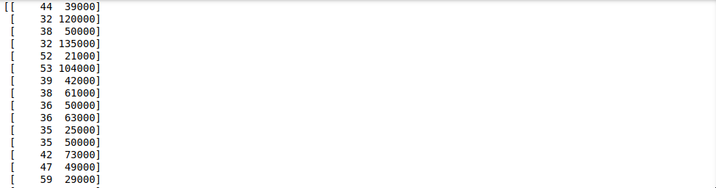

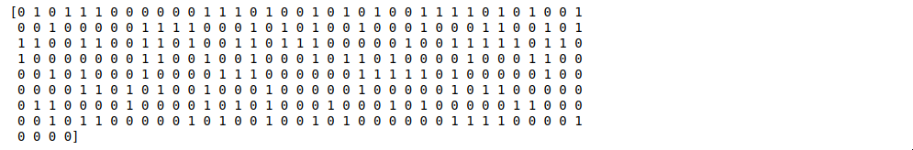

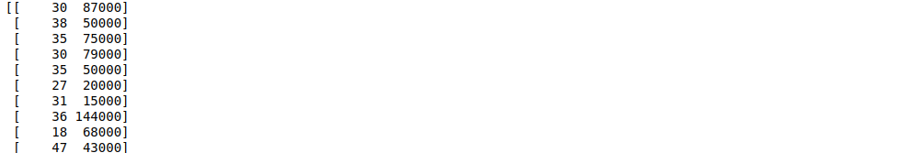



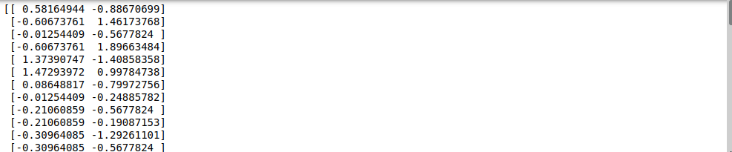

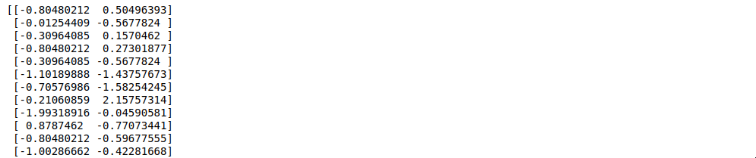

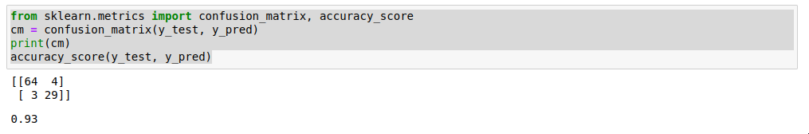

**Practical 5**

**Aim:** Write a program to implement Hierarchical clustering.

**Code:**

import numpy as np

import pandas as pd

import matplotlib.pyplot as plt

dataset = pd.read_csv('/content/Mall_Customers.csv')

X = dataset.iloc[:, [3,4]].values

print(X)

from sklearn.cluster import AgglomerativeClustering

hc = AgglomerativeClustering(n_clusters=5, affinity='euclidean', linkage='ward')

y_hc = hc.fit_predict(X)

print(y_hc)

plt.scatter(X[y_hc==0,0], X[y_hc==0,1], s=100, c='red', label='Cluster 1')

plt.scatter(X[y_hc==1,0], X[y_hc==1,1], s=100, c='green', label='Cluster 2')

plt.scatter(X[y_hc==2,0], X[y_hc==2,1], s=100, c='blue', label='Cluster 3')

plt.scatter(X[y_hc==3,0], X[y_hc==3,1], s=100, c='cyan', label='Cluster 4')

plt.scatter(X[y_hc==4,0], X[y_hc==4,1], s=100, c='magenta', label='Cluster 5')

plt.title('Clusters of customers')

plt.xlabel('Annual Income (k$)')

plt.ylabel('Spending Score (1-100)')

plt.legend()

plt.show()

**Output:**

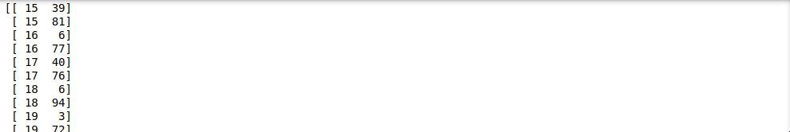

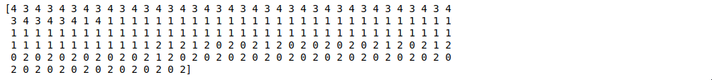

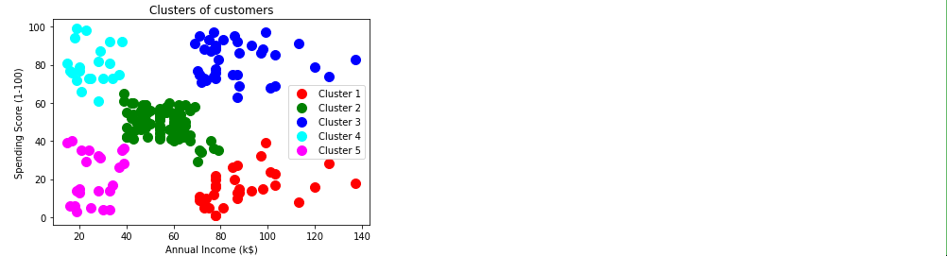

**Practical 6**

**Aim:** Write a program to implement K-means clustering.

**Code:**

import numpy as np

import matplotlib.pyplot as plt

import pandas as pd

dataset = pd.read_csv('Mall_Customers.csv')

X = dataset.iloc[:, [3, 4]].values

from sklearn.cluster import KMeans

kmeans = KMeans(n_clusters = 5, init = 'k-means++', random_state = 42)

y_kmeans = kmeans.fit_predict(X)

print(y_kmeans)

plt.scatter(X[y_kmeans == 0, 0], X[y_kmeans == 0, 1], s = 100, c = 'red', label = 'Cluster 1')

plt.scatter(X[y_kmeans == 1, 0], X[y_kmeans == 1, 1], s = 100, c = 'blue', label = 'Cluster 2')

plt.scatter(X[y_kmeans == 2, 0], X[y_kmeans == 2, 1], s = 100, c = 'green', label = 'Cluster 3')

plt.scatter(X[y_kmeans == 3, 0], X[y_kmeans == 3, 1], s = 100, c = 'cyan', label = 'Cluster 4')

plt.scatter(X[y_kmeans == 4, 0], X[y_kmeans == 4, 1], s = 100, c = 'magenta', label = 'Cluster 5')

plt.scatter(kmeans.cluster_centers_[:, 0], kmeans.cluster_centers_[:, 1], s = 300, c = 'yellow', label = 'Centroids')

plt.title('Clusters of customers')

plt.xlabel('Annual Income (k$)')

plt.ylabel('Spending Score (1-100)')

plt.legend()

plt.show()

**Output:**

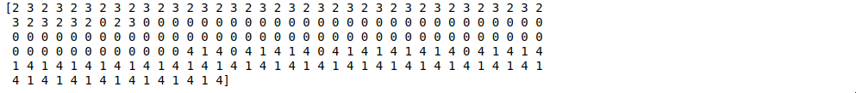

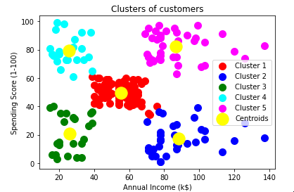

**Practical 7**

**Aim:** Write a program to build ANN.

**Code:**

import numpy as np

import pandas as pd

import tensorflow as tf

dataset = pd.read_csv('Churn_Modelling.csv')

X = dataset.iloc[:, 3:-1].values

y = dataset.iloc[:, -1].values

print(X)

print(y)

from sklearn.preprocessing import LabelEncoder

le = LabelEncoder()

X[:, 2] = le.fit_transform(X[:, 2])

print(X)

from sklearn.compose import ColumnTransformer

from sklearn.preprocessing import OneHotEncoder

ct = ColumnTransformer(transformers=[('encoder', OneHotEncoder(), [1])], remainder='passthrough')

X = np.array(ct.fit_transform(X))

print(X)

from sklearn.model_selection import train_test_split

X_train, X_test, y_train, y_test = train_test_split(X, y, test_size = 0.2, random_state = 0)

from sklearn.preprocessing import StandardScaler

sc = StandardScaler()

X_train = sc.fit_transform(X_train)

X_test = sc.transform(X_test)

ann = tf.keras.models.Sequential()

ann.add(tf.keras.layers.Dense(units=6, activation='relu'))

ann.add(tf.keras.layers.Dense(units=6, activation='relu'))

ann.add(tf.keras.layers.Dense(units=1, activation='sigmoid'))

ann.compile(optimizer = 'adam', loss = 'binary_crossentropy', metrics = ['accuracy'])

ann.fit(X_train, y_train, batch_size = 32, epochs = 100)

print(ann.predict(sc.transform([[1, 0, 0, 600, 1, 40, 3, 60000, 2, 1, 1, 50000]])) >0.5)

y_pred = ann.predict(X_test)

y_pred = (y_pred > 0.5)

print(np.concatenate((y_pred.reshape(len(y_pred),1), y_test.reshape(len(y_test),1)),1))

from sklearn.metrics import confusion_matrix, accuracy_score

cm = confusion_matrix(y_test, y_pred)

print(cm)

accuracy_score(y_test, y_pred)

**Output:**

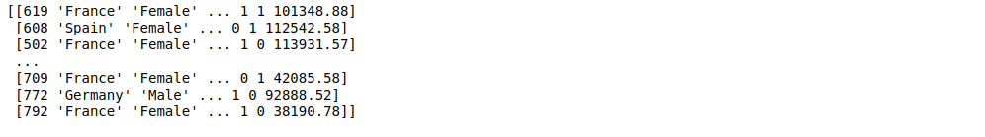



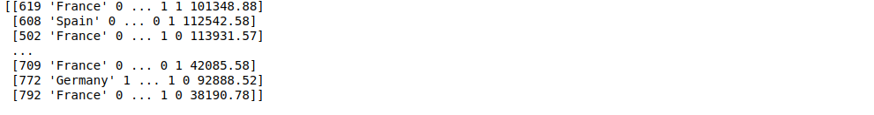

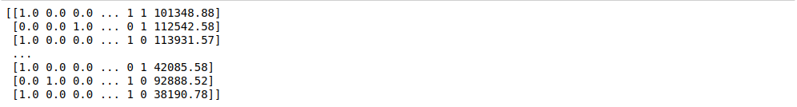

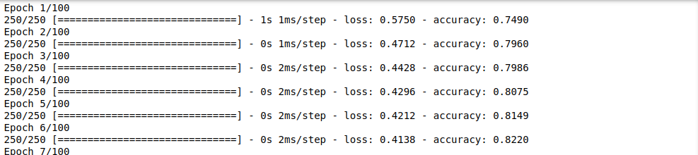

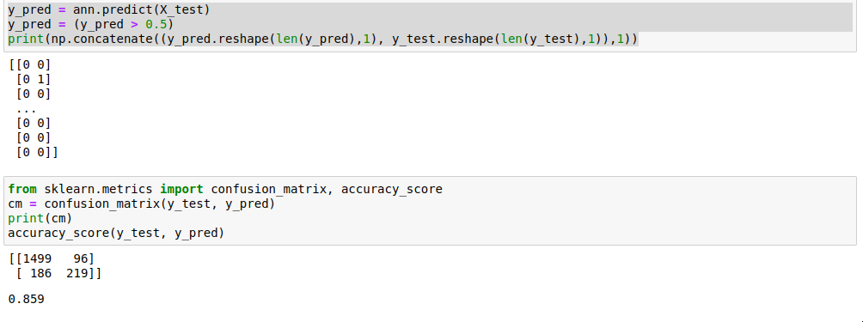

**Practical 8**

**Aim:** Write a program to build CNN.

**Code:**

import tensorflow as tf

from keras.preprocessing.image import ImageDataGenerator

train_datagen = ImageDataGenerator(rescale=1./255, shear_range=0.2, zoom_range=0.2, horizontal_flip=True)

training_set = train_datagen.flow_from_directory('/content/drive/MyDrive/small_dataset/training_set', target_size=(64,64), batch_size=32, class_mode='binary')

train_datagen = ImageDataGenerator(rescale=1./255, shear_range=0.2, zoom_range=0.2, horizontal_flip=True)

test_set = train_datagen.flow_from_directory('/content/drive/MyDrive/small_dataset/test_set', target_size=(64,64), batch_size=32, class_mode='binary')

cnn = tf.keras.models.Sequential()

cnn.add(tf.keras.layers.Conv2D(filters=32, kernel_size=3, activation='relu', input_shape=[64,64,3]))

cnn.add(tf.keras.layers.MaxPool2D(pool_size=2, strides=2))

cnn.add(tf.keras.layers.Conv2D(filters=32, kernel_size=3, activation='relu'))

cnn.add(tf.keras.layers.MaxPool2D(pool_size=2, strides=2))

cnn.add(tf.keras.layers.Flatten())

cnn.add(tf.keras.layers.Dense(units=128, activation='relu'))

cnn.add(tf.keras.layers.Dense(units=1, activation='sigmoid'))

cnn.compile(optimizer='adam', loss='binary_crossentropy', metrics=['accuracy'])

cnn.fit(x=training_set, validation_data=test_set, epochs=25)

import numpy as np

from keras.preprocessing import image

test_image=image.load_img('/content/drive/MyDrive/small_dataset/single_prediction/cat_or_dog_1.jpg', target_size=(64,64))

test_image=image.img_to_array(test_image)

test_image=np.expand_dims(test_image, axis=0)

result=cnn.predict(test_image)

training_set.class_indices

if result[0][0]==1:

prediction='dog'

else:

prediction='cat'

print(prediction)

**Output:**

