DML

Name: Roshan Shetty Roll No: 525

Sr.  No | List of Practical Experiments
1 | Write a program to implement Simple Linear Regression
2 | Write a program to implement multiple Linear Regression
3 | Write a program to implement K-nearest Neighbors (K-NN)/SVM
4 | Write a program to implement Naïve Bayse / DT
5 | Write a program to implement K-means clustering.
6 | Write a program to implement Hierarchical clustering.
7 | Write a program to build ANN.
8 | Write a program to build CNN.
9
10

Practical 1

Aim: Write a program to implement Simple Linear Regression

Code:

import numpy as np
import matplotlib.pyplot as plt
import pandas as pd

dataset = pd.read_csv("Salary_Data.csv")
X = dataset.iloc[ : , : -1].values
y = dataset.iloc[ : , -1].values

print(X)
print("\n\n\n")
print(y)

from sklearn.model_selection import train_test_split
X_train, X_test, y_train, y_test = train_test_split(X, y, test_size = 1/4, random_state = 0)

print(X_train)
print("\n\n\n")
print(X_test)
print("\n\n\n")
print(y_train)
print("\n\n\n")
print(y_test)

from sklearn.linear_model import LinearRegression
linear_regression = LinearRegression()
linear_regression.fit(X_train, y_train)

y_train_pred = linear_regression.predict(X_train)
y_test_pred = linear_regression.predict(X_test)

plt.scatter(X_train, y_train, color = "green", marker = "+", label = "Observed data")
plt.plot(X_train, y_train_pred, color = "red", label = "Predicted data")
plt.xlabel("Years of experience")
plt.ylabel("Salary")
plt.title("Years of experience v/s Salary (Training dataset)")
plt.legend()
plt.show()

plt.scatter(X_test, y_test, color = "green", marker = "+", label = "Observed data")
plt.plot(X_test, y_test_pred, color = "red", label = "Predicted data")
plt.xlabel("Years of experience")
plt.ylabel("Salary")
plt.title("Years of experience v/s Salary (Testing dataset)")
plt.legend()
plt.show()

Output:

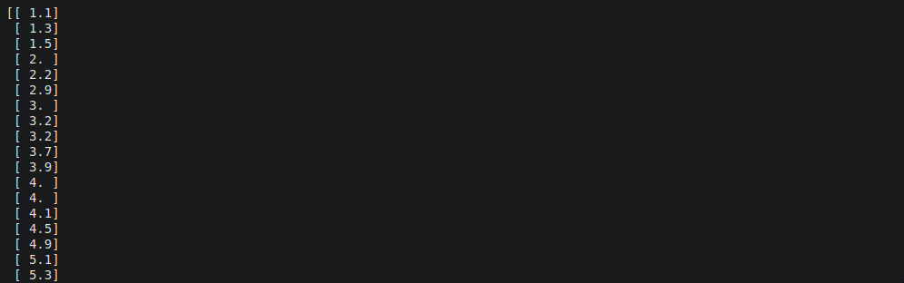
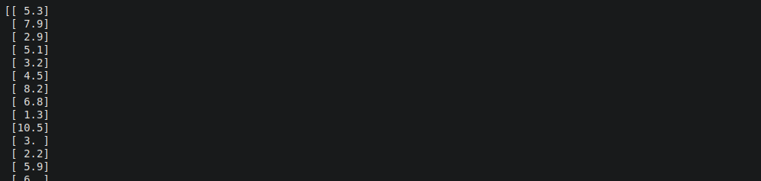
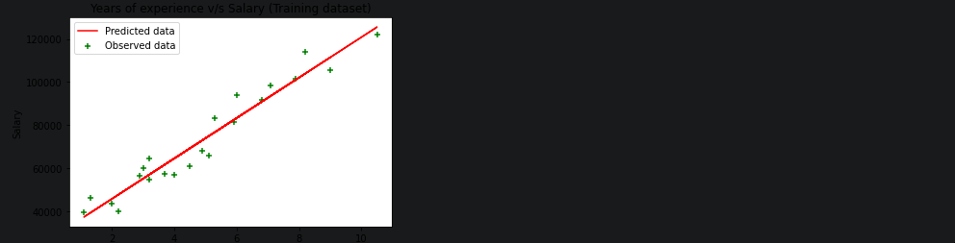
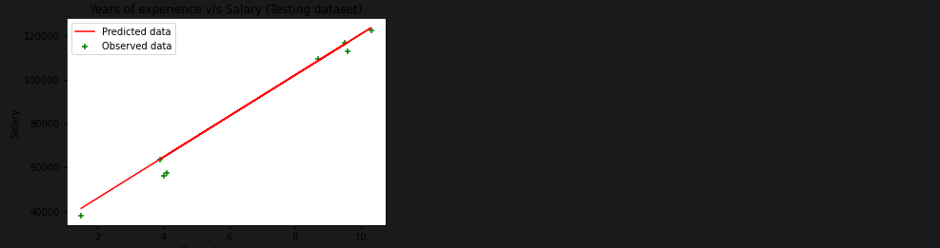

Practical 2

Aim: Write a program to implement multiple Linear Regression

Code:

import numpy as np
import matplotlib.pyplot as plt
import pandas as pd

dataset = pd.read_csv('/content/50_Startups-2.csv')
x = dataset.iloc[:, :-1].values
y = dataset.iloc[:, -1].values

print(x)

print(y)

from sklearn.compose import ColumnTransformer
from sklearn.preprocessing import OneHotEncoder
ct = ColumnTransformer(transformers=[('encoder', OneHotEncoder(), [3])], remainder='passthrough')
x = np.array(ct.fit_transform(x))

print(x)

from sklearn.model_selection import train_test_split
x_train, x_test, y_train, y_test = train_test_split(x, y, test_size=0.2, random_state=0)

from sklearn.linear_model import LinearRegression
regressor = LinearRegression()
regressor.fit(x_train, y_train)

y_pred = regressor.predict(x_test)
np.set_printoptions(precision=2)
print(np.concatenate((y_pred.reshape(len(y_pred),1), y_test.reshape(len(y_test),1)),1))

Output:

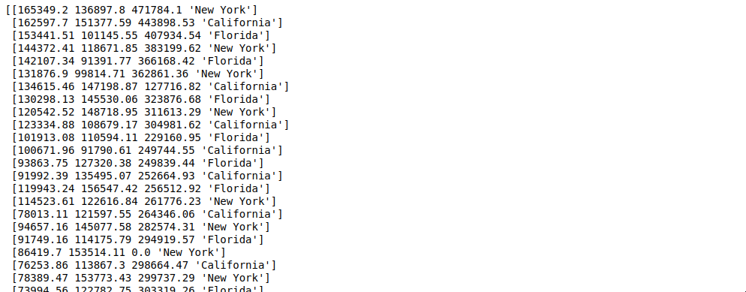
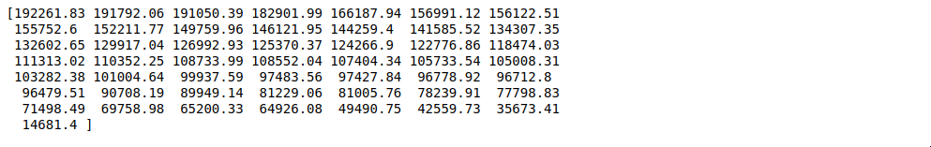
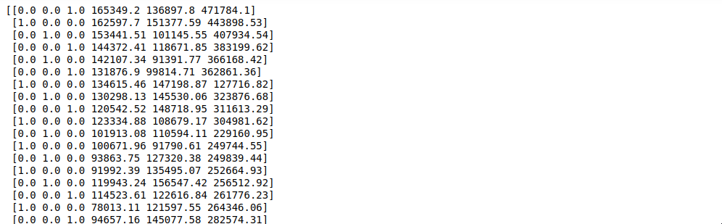
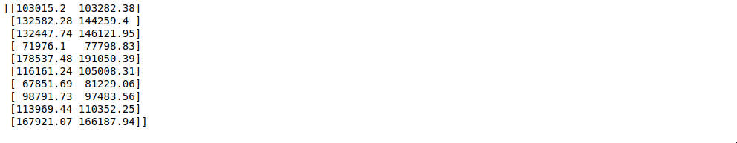

Practical 3

Aim: Write a program to implement K-nearest Neighbors (K-NN)/SVM

Code:

import matplotlib.pyplot as plt
import numpy as np
import pandas as pd

dataset = pd.read_csv('/content/Social_Network_Ads.csv')
x = dataset.iloc[:, :-1].values
y = dataset.iloc[:, -1].values

print(x)

print(y)

from sklearn.model_selection import train_test_split
x_train, x_test, y_train, y_test = train_test_split(x, y, test_size=0.25, random_state=0)

print(x_train)

print(y_train)

print(x_test)

print(y_test)

from sklearn.preprocessing import StandardScaler
sc = StandardScaler()
x_train = sc.fit_transform(x_train)
x_test = sc.transform(x_test)

print(x_train)

print(x_test)

from sklearn.svm import SVC
classifier = SVC(kernel='linear', random_state=0)
classifier.fit(x_train, y_train)

print(classifier.predict(sc.transform([[30,200000]])))

y_pred = classifier.predict(x_test)
print(np.concatenate((y_pred.reshape(len(y_pred),1), y_test.reshape(len(y_test),1)),1))

from sklearn.metrics import confusion_matrix, accuracy_score
cm = confusion_matrix(y_test, y_pred)
print(cm)
accuracy_score(y_test, y_pred)

Output:

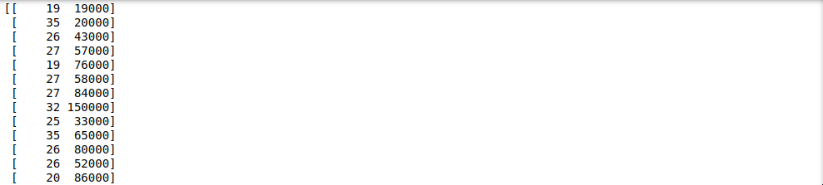
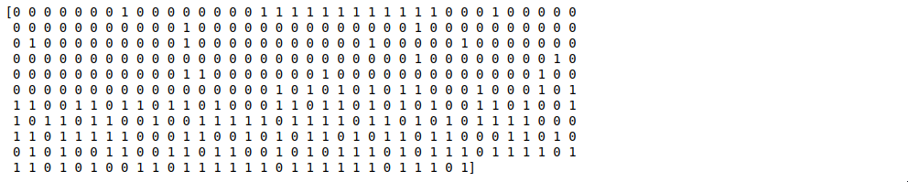
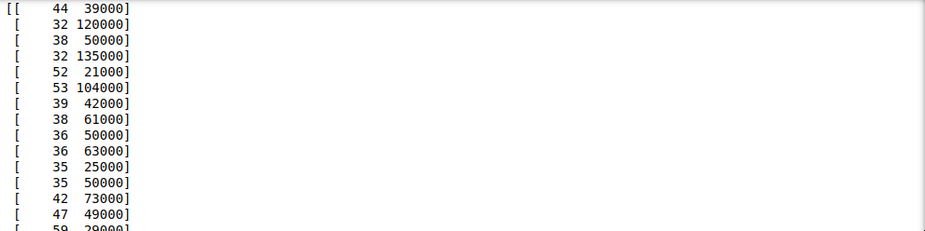
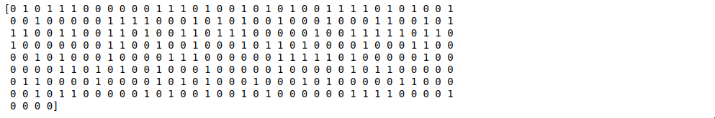
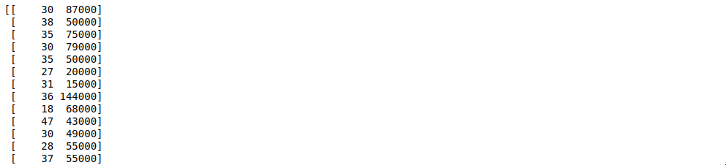
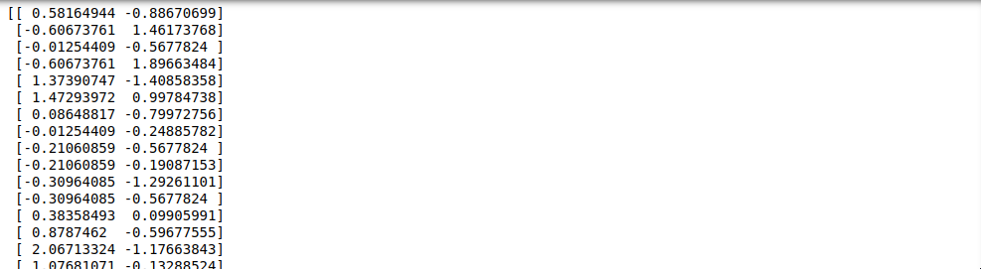
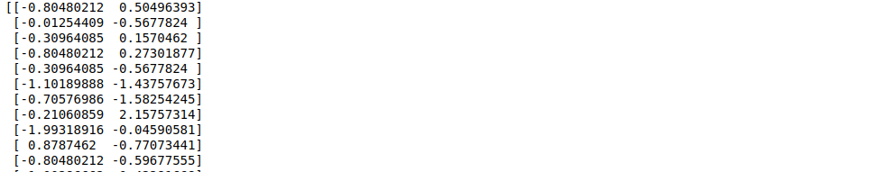
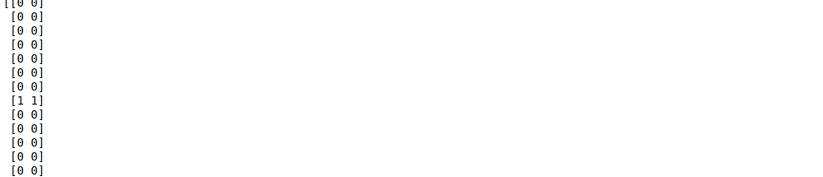
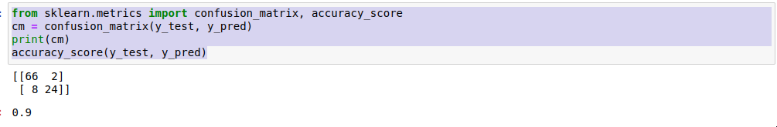

Practical 4

Aim: Write a program to implement Naïve Bayse / DT

Code:

import matplotlib.pyplot as plt
import pandas as pd
import numpy as np

dataset = pd.read_csv('/content/Social_Network_Ads.csv')
x = dataset.iloc[:, :-1].values
y = dataset.iloc[:, -1].values

print(x)

print(y)

from sklearn.model_selection import train_test_split
x_train, x_test, y_train, y_test = train_test_split(x, y, test_size=0.25, random_state=0)

print(x_train)

print(y_train)

print(x_test)

print(y_test)

from sklearn.preprocessing import StandardScaler
sc = StandardScaler()
x_train = sc.fit_transform(x_train)
x_test = sc.transform(x_test)

print(x_train)

print(x_test)

from sklearn.neighbors import KNeighborsClassifier
classifier = KNeighborsClassifier(n_neighbors=5, metric='minkowski', p=2)
classifier.fit(x_train, y_train)

print(classifier.predict(sc.transform([[40, 200000]])))

y_pred = classifier.predict(x_test)
print(np.concatenate((y_pred.reshape(len(y_pred),1), y_test.reshape(len(y_test),1)),1))

from sklearn.metrics import confusion_matrix, accuracy_score
cm = confusion_matrix(y_test, y_pred)
print(cm)
accuracy_score(y_test, y_pred)

Output:

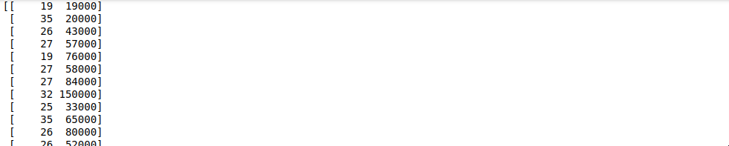
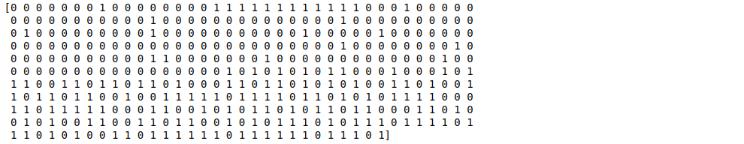
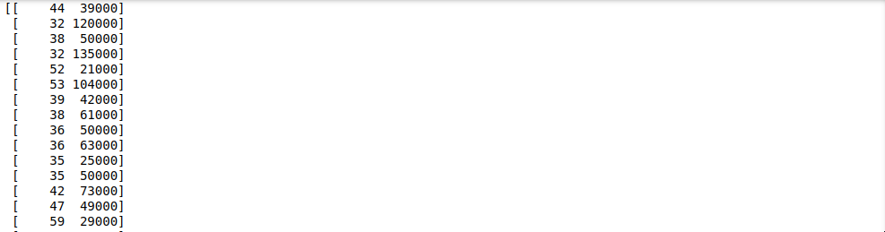
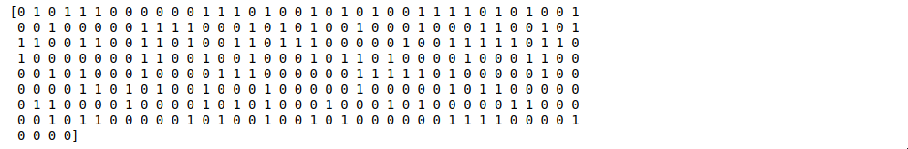
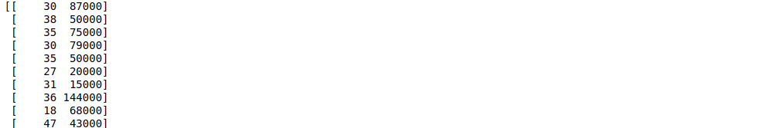

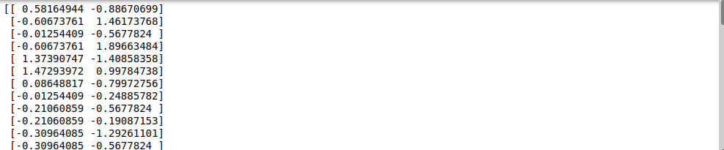
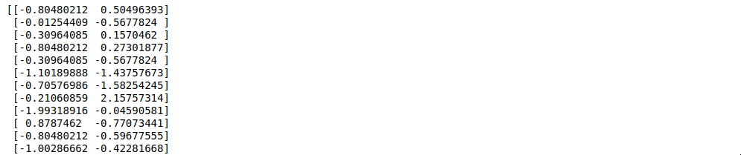
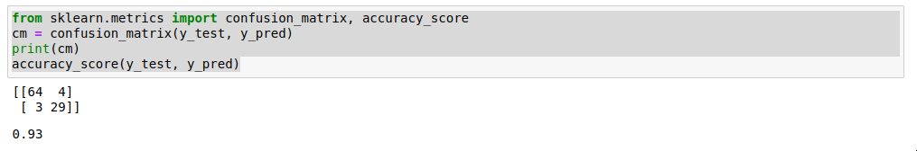

Practical 5

Aim: Write a program to implement K-means clustering.

Code:

import numpy as np
import pandas as pd
import matplotlib.pyplot as plt

dataset = pd.read_csv('/content/Mall_Customers.csv')
X = dataset.iloc[:, [3,4]].values

print(X)

from sklearn.cluster import AgglomerativeClustering
hc = AgglomerativeClustering(n_clusters=5, affinity='euclidean', linkage='ward')
y_hc = hc.fit_predict(X)

print(y_hc)

plt.scatter(X[y_hc==0,0], X[y_hc==0,1], s=100, c='red', label='Cluster 1')
plt.scatter(X[y_hc==1,0], X[y_hc==1,1], s=100, c='green', label='Cluster 2')
plt.scatter(X[y_hc==2,0], X[y_hc==2,1], s=100, c='blue', label='Cluster 3')
plt.scatter(X[y_hc==3,0], X[y_hc==3,1], s=100, c='cyan', label='Cluster 4')
plt.scatter(X[y_hc==4,0], X[y_hc==4,1], s=100, c='magenta', label='Cluster 5')
plt.title('Clusters of customers')
plt.xlabel('Annual Income (k$)')
plt.ylabel('Spending Score (1-100)')
plt.legend()
plt.show()

Output:

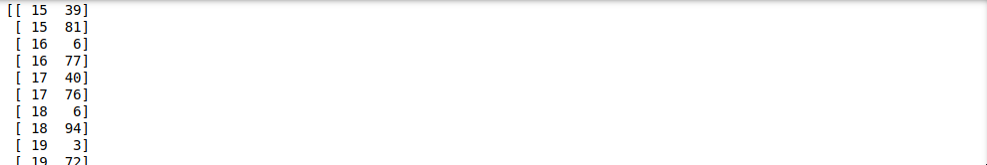
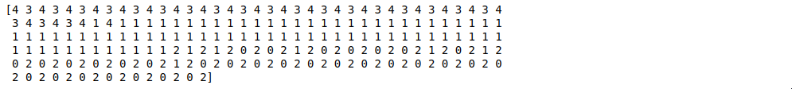

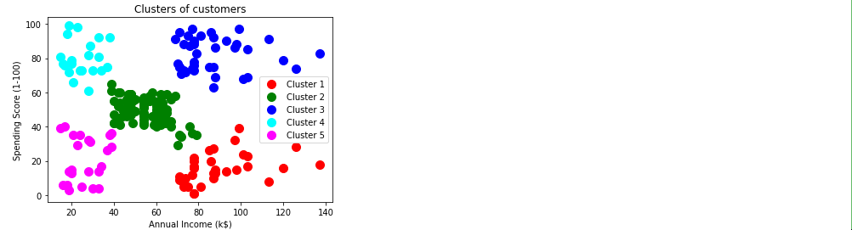

Practical 6

Aim: Write a program to implement Hierarchical clustering.

Code:

import numpy as np
import matplotlib.pyplot as plt
import pandas as pd

dataset = pd.read_csv('Mall_Customers.csv')
X = dataset.iloc[:, [3, 4]].values

from sklearn.cluster import KMeans
kmeans = KMeans(n_clusters = 5, init = 'k-means++', random_state = 42)
y_kmeans = kmeans.fit_predict(X)
print(y_kmeans)

plt.scatter(X[y_kmeans == 0, 0], X[y_kmeans == 0, 1], s = 100, c = 'red', label = 'Cluster 1')
plt.scatter(X[y_kmeans == 1, 0], X[y_kmeans == 1, 1], s = 100, c = 'blue', label = 'Cluster 2')
plt.scatter(X[y_kmeans == 2, 0], X[y_kmeans == 2, 1], s = 100, c = 'green', label = 'Cluster 3')
plt.scatter(X[y_kmeans == 3, 0], X[y_kmeans == 3, 1], s = 100, c = 'cyan', label = 'Cluster 4')
plt.scatter(X[y_kmeans == 4, 0], X[y_kmeans == 4, 1], s = 100, c = 'magenta', label = 'Cluster 5')
plt.scatter(kmeans.cluster_centers_[:, 0], kmeans.cluster_centers_[:, 1], s = 300, c = 'yellow', label = 'Centroids')
plt.title('Clusters of customers')
plt.xlabel('Annual Income (k$)')
plt.ylabel('Spending Score (1-100)')
plt.legend()
plt.show()

Output:

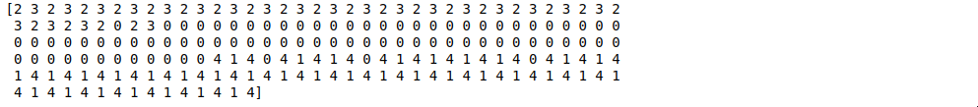
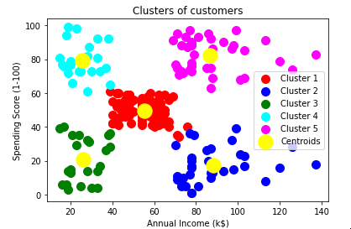

Practical 7

Aim: Write a program to build ANN.

Code:

import numpy as np
import pandas as pd
import tensorflow as tf

dataset = pd.read_csv('Churn_Modelling.csv')
X = dataset.iloc[:, 3:-1].values
y = dataset.iloc[:, -1].values

print(X)

print(y)

from sklearn.preprocessing import LabelEncoder
le = LabelEncoder()
X[:, 2] = le.fit_transform(X[:, 2])

print(X)

from sklearn.compose import ColumnTransformer
from sklearn.preprocessing import OneHotEncoder
ct = ColumnTransformer(transformers=[('encoder', OneHotEncoder(), [1])], remainder='passthrough')
X = np.array(ct.fit_transform(X))

print(X)

from sklearn.model_selection import train_test_split
X_train, X_test, y_train, y_test = train_test_split(X, y, test_size = 0.2, random_state = 0)

from sklearn.preprocessing import StandardScaler
sc = StandardScaler()
X_train = sc.fit_transform(X_train)
X_test = sc.transform(X_test)

ann = tf.keras.models.Sequential()

ann.add(tf.keras.layers.Dense(units=6, activation='relu'))

ann.add(tf.keras.layers.Dense(units=6, activation='relu'))

ann.add(tf.keras.layers.Dense(units=1, activation='sigmoid'))

ann.compile(optimizer = 'adam', loss = 'binary_crossentropy', metrics = ['accuracy'])

ann.fit(X_train, y_train, batch_size = 32, epochs = 100)

print(ann.predict(sc.transform([[1, 0, 0, 600, 1, 40, 3, 60000, 2, 1, 1, 50000]])) >0.5)

y_pred = ann.predict(X_test)
y_pred = (y_pred > 0.5)
print(np.concatenate((y_pred.reshape(len(y_pred),1), y_test.reshape(len(y_test),1)),1))

from sklearn.metrics import confusion_matrix, accuracy_score
cm = confusion_matrix(y_test, y_pred)
print(cm)
accuracy_score(y_test, y_pred)

Output:

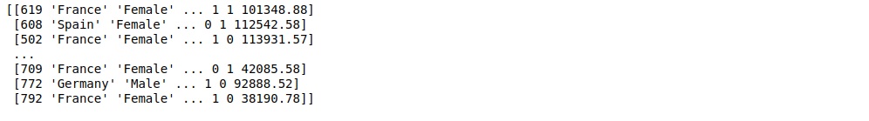
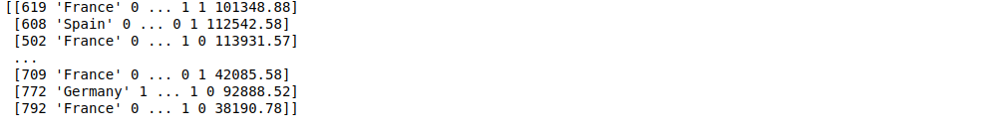
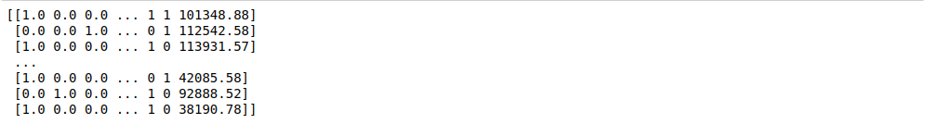
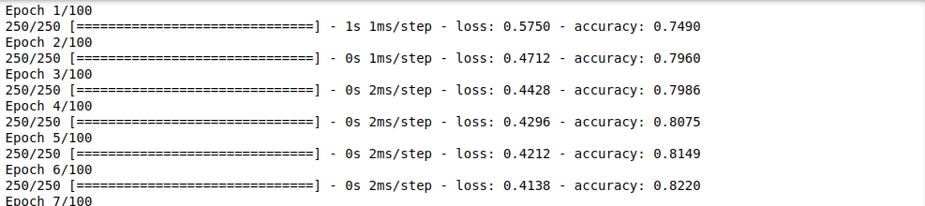

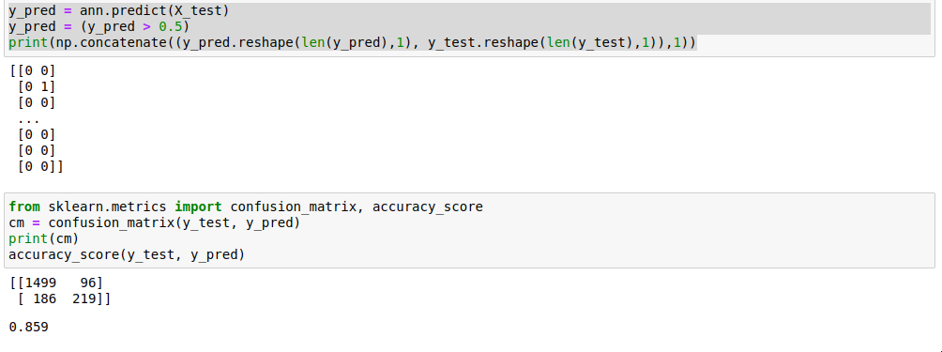

Practical 8

Aim: Write a program to build CNN.

Code:

import tensorflow as tf
from keras.preprocessing.image import ImageDataGenerator

train_datagen = ImageDataGenerator(rescale=1./255, shear_range=0.2, zoom_range=0.2, horizontal_flip=True)
training_set = train_datagen.flow_from_directory('/content/drive/MyDrive/small_dataset/training_set', target_size=(64,64), batch_size=32, class_mode='binary')

train_datagen = ImageDataGenerator(rescale=1./255, shear_range=0.2, zoom_range=0.2, horizontal_flip=True)
test_set = train_datagen.flow_from_directory('/content/drive/MyDrive/small_dataset/test_set', target_size=(64,64), batch_size=32, class_mode='binary')

cnn = tf.keras.models.Sequential()

cnn.add(tf.keras.layers.Conv2D(filters=32, kernel_size=3, activation='relu', input_shape=[64,64,3]))

cnn.add(tf.keras.layers.MaxPool2D(pool_size=2, strides=2))

cnn.add(tf.keras.layers.Conv2D(filters=32, kernel_size=3, activation='relu'))
cnn.add(tf.keras.layers.MaxPool2D(pool_size=2, strides=2))

cnn.add(tf.keras.layers.Flatten())

cnn.add(tf.keras.layers.Dense(units=128, activation='relu'))

cnn.add(tf.keras.layers.Dense(units=1, activation='sigmoid'))

cnn.compile(optimizer='adam', loss='binary_crossentropy', metrics=['accuracy'])

cnn.fit(x=training_set, validation_data=test_set, epochs=25)

import numpy as np
from keras.preprocessing import image
test_image=image.load_img('/content/drive/MyDrive/small_dataset/single_prediction/cat_or_dog_1.jpg', target_size=(64,64))
test_image=image.img_to_array(test_image)
test_image=np.expand_dims(test_image, axis=0)
result=cnn.predict(test_image)
training_set.class_indices
if result[0][0]==1:
prediction='dog'
else:
prediction='cat'

print(prediction)

Output:

