This document sets out the Part 1 planning for RaceDay: the entity relationship diagram and the reasoning behind it (Section A), the API endpoint plan (Section B), and the SQL script that creates and seeds the database (Section C). Each section opens with the reasoning behind the decisions made, followed by the actual artifact.
SECTION A Entity Relationship Diagram
Entity and Relationship Breakdown
Before any code is written, this section lays out the six entities the RaceDay system is built on, how they relate to one another, and the reasoning behind a couple of decisions that aren't obvious just from looking at the diagram alone — most notably why Organisers and Participants are kept as two separate tables rather than one shared Users table.
Entities
Organisers: One row per Organiser account (name, email, password, phone). Kept as a fully separate table from Participants rather than one shared Users table with a RoleID column, so the role split is visible in the schema itself, not just in a column value, organiser-only fields can be added later (e.g. an organization name) without touching the participant side at all.
Participants: One row per Participant account. Same shape as Organisers for now, but deliberately a separate table for the same reason: the two roles behave differently enough (what they own, what they're allowed to do) that keeping them as separate entities was worth the small duplication of shared columns.
Events: A single race, walk or ride. Always owned by exactly one Organiser (OrganiserID FK). Captures the attributes required by the brief: name, description, date, location, distance and event type (Run/Walk/Cycle).
Categories: An age or distance division within an Event (e.g. "21km Individual", "Under 20"). Always scoped to a single Event, so category names only need to be unique within their event, not system-wide.
Enrolments: The join entity recording a Participant's entry into an Event under a specific Category. It stores ParticipantID, EventID and CategoryID directly, the brief specifically asks for the link between "the Participant, the event, and the selected category" to be recorded, so EventID is kept explicit even though it's technically derivable via CategoryID → Event.
Results: A finish time and position for one specific Enrolment, captured by the organiser after the event. Results are tied to an Enrolment rather than directly to a Participant + Event, because a result only makes sense in the context of that specific race entry.
Relationships & Cardinality
Relationship | Cardinality | Description
Organisers → Events | 1 to many | An organisers can create many events; each event has exactly one owning organisers.
Events → Categories | 1 to many | An event can offer many categories; each category belongs to exactly one event.
Participants → Enrolments | 1 to many | A participant can enroll in many events; each enrolment belongs to exactly one participant.
Events → Enrolments | 1 to many | An event can have many enrolments; each enrolment is for exactly one event.
Categories → Enrolments | 1 to many | A category can have many enrolments; each enrolment selects exactly one category.
Enrolments → Results | 1 to zero-or-one | An enrolment has no result until the race is run, and at most one after; each result belongs to exactly one enrolment.

Entity Relationship diagram
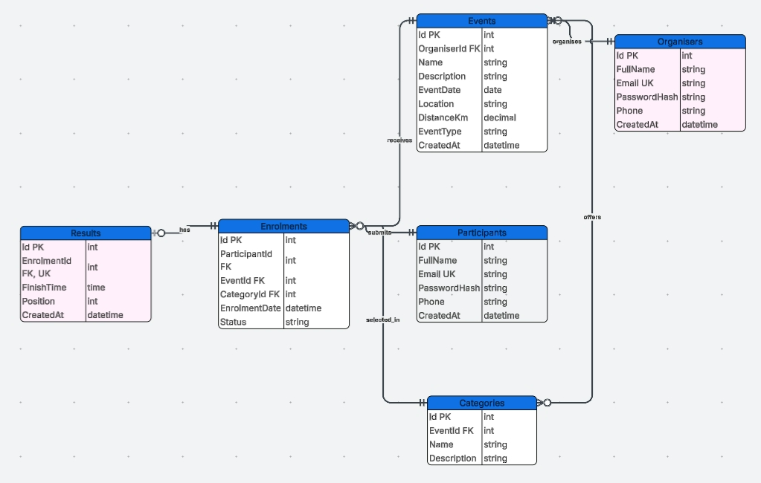

A few design decisions are worth calling out. Splitting Organisers and Participants into separate tables, rather than one shared Users table with a role column, makes the role-based design visible in the schema itself and leaves room for the two roles to diverge later. The trade-off is that the database can no longer enforce “one email = one identity” across both roles with a single constraint — that check will need to happen in application logic in Part 2.
Enrolments stores ParticipantId, EventId and CategoryId directly, rather than relying on CategoryId to imply the event, matching the brief’s own wording about what needs to be recorded. All six entities exist because a stated requirement needs them — nothing was added just to reach the minimum count.
Section B API Endpoint Plan
The 22 endpoints below are grouped into three tables — Organiser, Participant, and Shared/Public — rather than strictly two. Most endpoints belong cleanly to one role, but a handful (logging in, viewing your own profile, browsing events and categories) are used identically by both roles and don’t belong to either one exclusively; forcing those into an Organiser-or-Participant split would mean either duplicating them in both tables or misleadingly filing them under just one. The three-way grouping keeps every endpoint listed exactly once.
This is a documentation choice only — the system is still one unified API. In Part 2 the controllers will be organised by resource (an EventsController, an EnrolmentsController, and so on), not by role — a single controller will naturally have some actions restricted to Organiser and others to Participant.
A few other decisions are worth explaining. Registration is split by role because Organisers and Participants are separate tables, so registering has to know up front which table it’s writing to. Login stays a single endpoint since a returning user doesn’t state their role — it checks both tables for a match and returns the resolved role. Profile endpoints stay generic (/api/users/me) rather than per-role, since the token already resolves to the right table once someone is logged in. Categories are nested under their event for listing and creation, since a category never exists outside the context of one event. Enrolment creation takes both an event and a category id, matching how Enrolments stores both foreign keys directly. Results are captured against an enrolment rather than a participant or event directly, for the same reason Results is modelled that way in the ERD. A few endpoints go beyond the minimum, marked (additional) below, to fill gaps the functional requirements implied but didn’t spell out.
Role Required key: None = public, no token needed · Any = any authenticated user · Organiser / Participant = that role only.
organiser Endpoints
HTTP Method | Route | Description | Role Required | Request Body | Expected Response
POST | /api/auth/register/organiser | Registers a new Organiser account. | None | { fullName, email, password } | 201 Created – new organisers id; 400 Bad Request – invalid data; 409 Conflict – email already registered
POST | /api/events | Creates a new event owned by the logged-in organisers. | Organiser | { name, description, date, location, distanceKm, eventType } | 201 Created – new event; 400 Bad Request – invalid data
PUT | /api/events/{id} | Updates an event owned by the logged-in organisers. | Organiser | { name, description, date, location, distanceKm, eventType } | 200 OK – updated event; 403 Forbidden – not the owning organisers; 404 Not Found
DELETE | /api/events/{id} | Deletes an event owned by the logged-in organisers. | Organiser | None | 204 No Content; 403 Forbidden; 404 Not Found
POST | /api/events/{eventId}/categories | Adds a new category to an event owned by the organisers. | Organiser | { name, description } | 201 Created – new category; 403 Forbidden; 404 Not Found
PUT | /api/categories/{id} | Updates a category belonging to an event owned by the organisers. | Organiser | { name, description } | 200 OK – updated category; 403 Forbidden; 404 Not Found
DELETE | /api/categories/{id} | Deletes a category from an event owned by the organisers. | Organiser | None | 204 No Content; 403 Forbidden; 404 Not Found
GET | /api/events/{eventId}/enrolments | Lists all enrolments for an event owned by the organisers. | Organiser | None | 200 OK – array of enrolments; 403 Forbidden; 404 Not Found
POST | /api/enrolments/{id}/results | Captures a finish time and position for a participant's enrolment. | Organiser | { finishTime, position } | 201 Created – new result; 403 Forbidden – not the owning organisers; 404 Not Found; 409 Conflict – result already captured
PUT | /api/results/{id} | (additional) Updates a previously captured result. | Organiser | { finishTime, position } | 200 OK – updated result; 403 Forbidden; 404 Not Found
GET | /api/events/{eventId}/results | (additional) Lists all results for an event owned by the organisers. | Organiser | None | 200 OK – array of results; 403 Forbidden; 404 Not Found

Participant Endpoints
HTTP Method | Route | Description | Role Required | Request Body | Expected Response
POST | /api/auth/register/participant | Registers a new Participant account. | None | { fullName, email, password } | 201 Created – new participant id; 400 Bad Request – invalid data; 409 Conflict – email already registered
POST | /api/enrolments | Enters the logged-in participant into an event by selecting a category. Records the link between participant, event and category. | Participant | { eventId, categoryId } | 201 Created – new enrolment; 404 Not Found – event/category does not exist; 409 Conflict – already enrolled in this event
GET | /api/enrolments/me | Lists the logged-in participant's own enrolments. | Participant | None | 200 OK – array of enrolments
DELETE | /api/enrolments/{id} | (additional) Cancels the logged-in participant's own enrolment. | Participant | None | 204 No Content; 403 Forbidden – not the owning participant; 404 Not Found
GET | /api/results/me | Lists the logged-in participant's own results. | Participant | None | 200 OK – array of results

Shared / Public Endpoints
HTTP Method | Route | Description | Role Required | Request Body | Expected Response
POST | /api/auth/login | Authenticates a user by checking both Organisers and Participants for a matching email, and issues an access token. | None | { email, password } | 200 OK – token and role; 401 Unauthorized – invalid credentials
GET | /api/users/me | Retrieves the logged-in user's own profile, resolved server-side to the organiser or Participant record matching the token. | Any | None | 200 OK – profile details; 401 Unauthorized
PUT | /api/users/me | Updates the logged-in user's own profile information, in whichever table the token resolves to. | Any | { fullName, phone, email } | 200 OK – updated profile; 400 Bad Request – invalid data
GET | /api/events | Lists all events. | Any | None | 200 OK – array of events
GET | /api/events/{id} | Retrieves details for a specific event. | Any | None | 200 OK – event details; 404 Not Found
GET | /api/events/{eventId}/categories | Lists all categories defined for a specific event. | Any | None | 200 OK – array of categories; 404 Not Found – event does not exist
Together these three tables cover all 22 endpoints required to support the six functional-requirement areas — Authentication, User Profile, Events, Categories, Event Enrolments and Results — plus the small number of additional endpoints marked above.

Section C SQL Database Script
The script below creates the RaceDayDB schema and seeds it with sample data, matching the six entities in Section A exactly — same tables, same attributes, same foreign keys. It opens by creating the database only if it doesn’t already exist, then drops and recreates every table in dependency order, so it can be re-run safely in SSMS without erroring on a second pass.
A few constraints exist here that don’t show up as lines on the ERD, since ERDs conventionally only draw primary and foreign keys: a UNIQUE constraint stops two categories on the same event sharing a name, another stops a participant enrolling twice in the same event, and CHECK constraints enforce the fixed value sets for EventType and Enrolment Status directly in the database rather than only in application code.
The seed data meets the brief’s minimum — 2 Organisers, 2 Participants, 3 Events with 2 categories each, and 4 sample Enrolments — with 2 sample Results added on top to demonstrate the full chain working end to end. PasswordHash values are placeholders; real hashing only exists once Part 2’s auth endpoints are built.

CREATE DATABASE RaceDayDB;

/* ----------------------------------------------------------------
Drop tables if they already exist, child -> parent order,
so this script can be re-run safely in SSMS.
---------------------------------------------------------------- */
DROP TABLE IF EXISTS dbo.Results;
DROP TABLE IF EXISTS dbo.Enrolments;
DROP TABLE IF EXISTS dbo.Categories;
DROP TABLE IF EXISTS dbo.Events;
DROP TABLE IF EXISTS dbo.Participants;
DROP TABLE IF EXISTS dbo.Organisers;
GO

/* ----------------------------------------------------------------
CREATE TABLE statements
---------------------------------------------------------------- */

CREATE TABLE dbo.Organisers (
Id INT IDENTITY(1,1) NOT NULL,
FullName NVARCHAR(100) NOT NULL,
Email NVARCHAR(150) NOT NULL,
PasswordHash NVARCHAR(255) NOT NULL,
Phone NVARCHAR(20) NULL,
CreatedAt DATETIME2 NOT NULL DEFAULT SYSDATETIME(),
CONSTRAINT PK_Organisers PRIMARY KEY (Id),
CONSTRAINT UQ_Organisers_Email UNIQUE (Email)
);
GO

CREATE TABLE dbo.Participants (
Id INT IDENTITY(1,1) NOT NULL,
FullName NVARCHAR(100) NOT NULL,
Email NVARCHAR(150) NOT NULL,
PasswordHash NVARCHAR(255) NOT NULL,
Phone NVARCHAR(20) NULL,
CreatedAt DATETIME2 NOT NULL DEFAULT SYSDATETIME(),
CONSTRAINT PK_Participants PRIMARY KEY (Id),
CONSTRAINT UQ_Participants_Email UNIQUE (Email)
);
GO

CREATE TABLE dbo.Events (
Id INT IDENTITY(1,1) NOT NULL,
OrganiserId INT NOT NULL,
Name NVARCHAR(150) NOT NULL,
Description NVARCHAR(MAX) NULL,
EventDate DATE NOT NULL,
Location NVARCHAR(150) NOT NULL,
DistanceKm DECIMAL(6,2) NOT NULL,
EventType NVARCHAR(10) NOT NULL,
CreatedAt DATETIME2 NOT NULL DEFAULT SYSDATETIME(),
CONSTRAINT PK_Events PRIMARY KEY (Id),
CONSTRAINT FK_Events_Organisers FOREIGN KEY (OrganiserId) REFERENCES dbo.Organisers(Id),
CONSTRAINT CK_Events_EventType CHECK (EventType IN ('Run', 'Walk', 'Cycle'))
);
GO

CREATE TABLE dbo.Categories (
Id INT IDENTITY(1,1) NOT NULL,
EventId INT NOT NULL,
Name NVARCHAR(50) NOT NULL,
Description NVARCHAR(255) NULL,
CONSTRAINT PK_Categories PRIMARY KEY (Id),
CONSTRAINT FK_Categories_Events FOREIGN KEY (EventId) REFERENCES dbo.Events(Id),
CONSTRAINT UQ_Categories_Event_Name UNIQUE (EventId, Name)
);
GO

CREATE TABLE dbo.Enrolments (
Id INT IDENTITY(1,1) NOT NULL,
ParticipantId INT NOT NULL,
EventId INT NOT NULL,
CategoryId INT NOT NULL,
EnrolmentDate DATETIME2 NOT NULL DEFAULT SYSDATETIME(),
Status NVARCHAR(20) NOT NULL DEFAULT 'Confirmed',
CONSTRAINT PK_Enrolments PRIMARY KEY (Id),
CONSTRAINT FK_Enrolments_Participants FOREIGN KEY (ParticipantId) REFERENCES dbo.Participants(Id),
CONSTRAINT FK_Enrolments_Events FOREIGN KEY (EventId) REFERENCES dbo.Events(Id),
CONSTRAINT FK_Enrolments_Categories FOREIGN KEY (CategoryId) REFERENCES dbo.Categories(Id),
CONSTRAINT UQ_Enrolments_Participant_Event UNIQUE (ParticipantId, EventId),
CONSTRAINT CK_Enrolments_Status CHECK (Status IN ('Confirmed', 'Cancelled'))
);
GO

CREATE TABLE dbo.Results (
Id INT IDENTITY(1,1) NOT NULL,
EnrolmentId INT NOT NULL,
FinishTime TIME NOT NULL,
Position INT NOT NULL,
CreatedAt DATETIME2 NOT NULL DEFAULT SYSDATETIME(),
CONSTRAINT PK_Results PRIMARY KEY (Id),
CONSTRAINT FK_Results_Enrolments FOREIGN KEY (EnrolmentId) REFERENCES dbo.Enrolments(Id),
CONSTRAINT UQ_Results_Enrolment UNIQUE (EnrolmentId)
);
GO

/* ----------------------------------------------------------------
SEED DATA
IDs below assume a freshly created database, since IDENTITY
starts at 1 and increments in the order rows are inserted.
---------------------------------------------------------------- */

-- Organisers (Id 1, 2)
-- PasswordHash values are placeholders only; Part 2's auth
-- endpoints will replace these with real hashed passwords.
INSERT INTO dbo.Organisers (FullName, Email, PasswordHash, Phone) VALUES
('Thabo Nkosi', 'thabo.nkosi@raceday.co.za', '$2a$11$PLACEHOLDERHASHVALUE0001', '0821234567'),
('Lindiwe Dlamini', 'lindiwe.dlamini@raceday.co.za', '$2a$11$PLACEHOLDERHASHVALUE0002', '0837654321');
GO

-- Participants (Id 1, 2)
INSERT INTO dbo.Participants (FullName, Email, PasswordHash, Phone) VALUES
('Sipho Mokoena', 'sipho.mokoena@example.com', '$2a$11$PLACEHOLDERHASHVALUE0003', '0731112222'),
('Anja van der Merwe', 'anja.vdm@example.com', '$2a$11$PLACEHOLDERHASHVALUE0004', '0793334444');
GO

-- Events: 3 events (Id 1,2,3), owned by the two organisers above
INSERT INTO dbo.Events (OrganiserId, Name, Description, EventDate, Location, DistanceKm, EventType) VALUES
(1, 'Tshwane Half Marathon', 'A scenic half marathon through the streets of Pretoria.', '2026-09-12', 'Pretoria, Gauteng', 21.10, 'Run'),
(2, 'Cape Town Cycle Classic', 'One of the largest timed cycle races in the world.', '2026-10-04', 'Cape Town, Western Cape', 109.00, 'Cycle'),
(1, 'Jozi Fun Walk', 'A family-friendly fun walk through Johannesburg.', '2026-08-30', 'Johannesburg, Gauteng', 5.00, 'Walk');
GO

-- Categories: two per event (Id 1-6)
INSERT INTO dbo.Categories (EventId, Name, Description) VALUES
(1, '21km Individual', 'Standard individual entry for the full half marathon distance.'),
(1, 'Under 20', 'Age category for participants under 20 years old.'),
(2, '109km Individual', 'Full-distance individual entry.'),
(2, 'Seniors (50+)', 'Age category for participants 50 years and older.'),
(3, '5km Fun Walk', 'Standard entry for the fun walk.'),
(3, 'Family', 'Category for participants entering as a family group.');
GO

-- Enrolments: sample entries linking Participants to Events + Categories (Id 1-4)
INSERT INTO dbo.Enrolments (ParticipantId, EventId, CategoryId) VALUES
(1, 1, 1), -- Sipho enters Tshwane Half Marathon, 21km Individual
(2, 2, 3), -- Anja enters Cape Town Cycle Classic, 109km Individual
(1, 3, 5), -- Sipho enters Jozi Fun Walk, 5km Fun Walk
(2, 1, 1); -- Anja enters Tshwane Half Marathon, 21km Individual
GO

-- Results: sample finish data for two completed enrolments (Id 1-2)
INSERT INTO dbo.Results (EnrolmentId, FinishTime, Position) VALUES
(3, '00:28:14', 12), -- Sipho's Jozi Fun Walk result
(1, '01:38:47', 45); -- Sipho's Tshwane Half Marathon result
GO
Running this script against a fresh SQL Server instance produces a fully populated RaceDayDB with all six tables, their constraints, and enough sample data to exercise every relationship in the ERD — a participant enrolled in more than one event, an organiser running more than one event, and results captured against completed enrolments. This is the database Part 2’s API will connect to.

