Alexandria University
Faculty of Engineering
CSE: Pattern Recognition
Assignment #1
Multi-class Diabetes Risk Prediction
Architecture Comparison Report

1. Introduction
This report documents iterative development of a custom Feedforward Neural Network (FNN) for multi-class diabetes risk prediction using the BRFSS 2015 dataset (253,680 samples, 21 features, 3 classes). Four architecture variants are compared, each tested under imbalanced baseline and SMOTE-balanced training.

 | Version | Key Characteristics
v1 | 3 Layers — All ReLU | 46K params, decreasing width 256→128→64, all ReLU, low dropout
v2 | 3 Layers — Tanh on L3 | Same as v1 but final hidden layer uses Tanh activation
v3 | 6 Layers — Low Dropout | 719K params, 6 hidden layers 1024→32, lower dropout (max 0.40 mid-layers)
v4 | 6 Layers — High Dropout | Same 6-layer structure as v3 but higher dropout (0.50/0.40/0.30 on middle layers) and using SoftF1Loss

2. Dataset & Preparation (Shared Across All Architectures)
Step | Details
Dataset | BRFSS 2015 — 253,680 samples, 21 features
Classes | 0: No Diabetes (213,703) | 1: Prediabetes (4,631) | 2: Diabetes (35,346)
Split (stratified) | Train 177,576 (70%) | Val 25,368 (10%) | Test 50,736 (20%)
Feature Selection | SelectKBest mutual_info_classif — top 15 of 21 features retained
SMOTE (train only) | Before: {0:149K, 1:3.2K, 2:24.7K} → After: {0:149K, 1:149K, 2:149K}
Optimizer (all) | Adam, lr=1e-3, weight_decay=1e-4
Epochs / Batch (all) | 50 / 512

3. Architecture Comparison Table
Yellow and green highlights indicate changes from the prior version. v3 and v4 share the same layer structure but differ only in dropout rates.

Component | v1 — All ReLU | v2 — Tanh L3 | v3 — Low Drop | v4 — High Drop
Input | 15→BN | 15→BN | 15→BN | 15→BN
H1 | 256/ReLU/D0.30 | 256/ReLU/D0.30 | 1024/ReLU/D0.60 | 1024/ReLU/D0.60
H2 | 128/ReLU/D0.25 | 128/ReLU/D0.25 | 512/ReLU/D0.40 | 512/ReLU/D0.50
H3 | 64/ReLU/D0.20 | 64/Tanh/D0.20 | 256/ReLU/D0.30 | 256/ReLU/D0.40
H4 | — | — | 128/ReLU/D0.15 | 128/ReLU/D0.30
H5 | — | — | 64/ReLU/D0.10 | 64/ReLU/D0.15
H6 | — | — | 32/Tanh/D0.05 | 32/Tanh/D0.10
Output | 64→3 | 64→3 | 32→3 | 32→3
Params | 46,369 | 46,369 | 719,905 | 719,905

Section 4 — Architecture v1 | 3 Layers — All ReLU

4.1 Layer Configuration
Layer | Configuration
Input | 15 features → BatchNorm1d
Hidden 1 | Linear(15→256) → BN → ReLU → Dropout(0.30)
Hidden 2 | Linear(256→128) → BN → ReLU → Dropout(0.25)
Hidden 3 | Linear(128→64) → BN → ReLU → Dropout(0.20)
Output | Linear(64→3) [CELoss]

4.2 Training Logs

Baseline (Imbalanced)
=== Training Baseline FNN ===
Epoch 001/50 tr_loss=0.9783 tr_acc=0.5929 vl_loss=0.9548 vl_acc=0.6317
Epoch 010/50 tr_loss=0.9450 tr_acc=0.6174 vl_loss=0.9518 vl_acc=0.6453
Epoch 020/50 tr_loss=0.9341 tr_acc=0.6128 vl_loss=0.9505 vl_acc=0.6270
Epoch 030/50 tr_loss=0.9284 tr_acc=0.6124 vl_loss=0.9547 vl_acc=0.6161
Epoch 040/50 tr_loss=0.9249 tr_acc=0.6143 vl_loss=0.9564 vl_acc=0.6181
Epoch 050/50 tr_loss=0.9247 tr_acc=0.6119 vl_loss=0.9567 vl_acc=0.6132

Balanced (SMOTE)
=== Training Balanced FNN (SMOTE) ===
Epoch 001/50 tr_loss=0.9276 tr_acc=0.5410 vl_loss=0.8583 vl_acc=0.6076
Epoch 010/50 tr_loss=0.7960 tr_acc=0.6452 vl_loss=0.7997 vl_acc=0.6369
Epoch 020/50 tr_loss=0.7472 tr_acc=0.6729 vl_loss=0.7824 vl_acc=0.6321
Epoch 030/50 tr_loss=0.7354 tr_acc=0.6802 vl_loss=0.7684 vl_acc=0.6410
Epoch 040/50 tr_loss=0.7275 tr_acc=0.6852 vl_loss=0.7474 vl_acc=0.6491
Epoch 050/50 tr_loss=0.7223 tr_acc=0.6870 vl_loss=0.7616 vl_acc=0.6446

4.3 Learning Curves
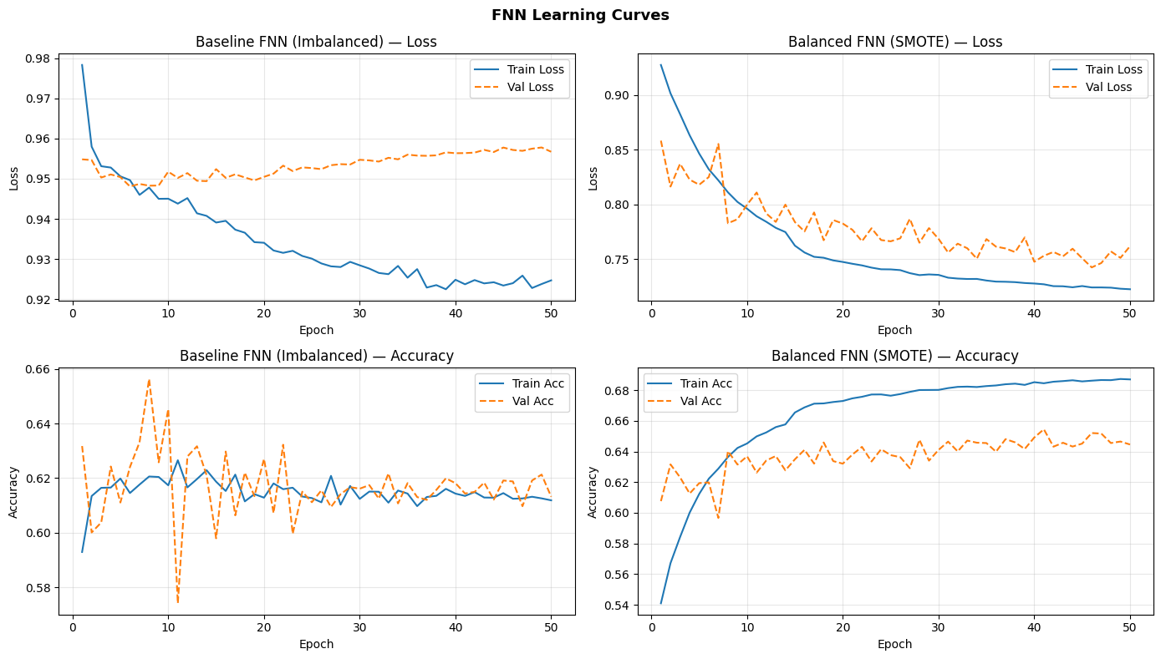
Figure 4: Architecture v1 — Learning Curves (Loss & Accuracy over 50 Epochs)

4.4 Test Set Metrics
Variant | Accuracy | F1 Micro | F1 Macro | F1 Weighted
Baseline (Imbalanced) | 0.6230 | 0.6230 | 0.4165 | 0.6977
Balanced (SMOTE) | 0.6539 | 0.6539 | 0.4148 | 0.7164

4.5 Per-Class F1 Breakdown
Per-class breakdown reveals how each architecture handles the three classes — especially the critical minority classes.
Variant | ND Prec | ND Rec | ND F1 | Pre F1 | Dia F1 | Macro F1
Baseline | 0.96 | 0.62 | 0.75 | 0.05 | 0.45 | 0.4165
SMOTE | 0.95 | 0.65 | 0.77 | 0.06 | 0.47 | 0.4148

4.6 Full Classification Reports

Baseline
precision recall f1-score support
No Diabetes 0.96 0.62 0.75 42741
Prediabetes 0.03 0.25 0.05 926
Diabetes 0.33 0.68 0.45 7069
accuracy 0.62 50736
macro avg 0.44 0.52 0.42 50736
weighted avg 0.85 0.62 0.70 50736

SMOTE Balanced
precision recall f1-score support
No Diabetes 0.95 0.65 0.77 42741
Prediabetes 0.04 0.26 0.06 926
Diabetes 0.35 0.70 0.47 7069
accuracy 0.65 50736
macro avg 0.45 0.54 0.43 50736
weighted avg 0.86 0.65 0.72 50736

4.7 Confusion Matrices
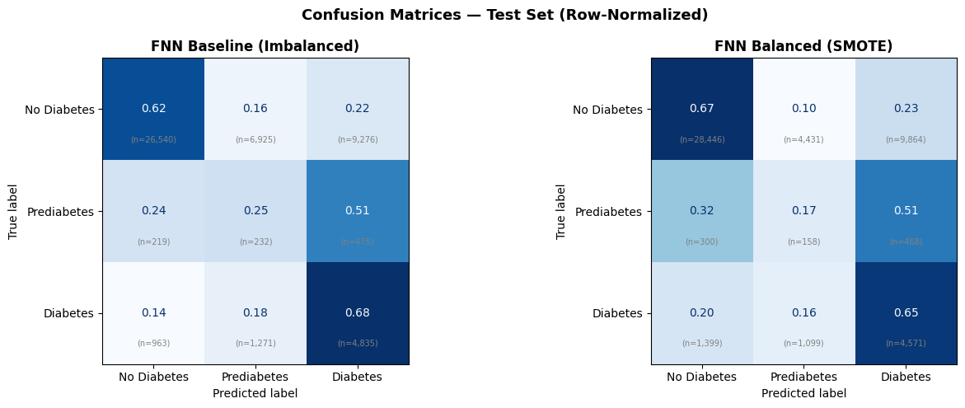
Figure 5: Architecture v1 — Normalized Confusion Matrices (Baseline left, SMOTE right)

4.8 Metric Comparison Chart
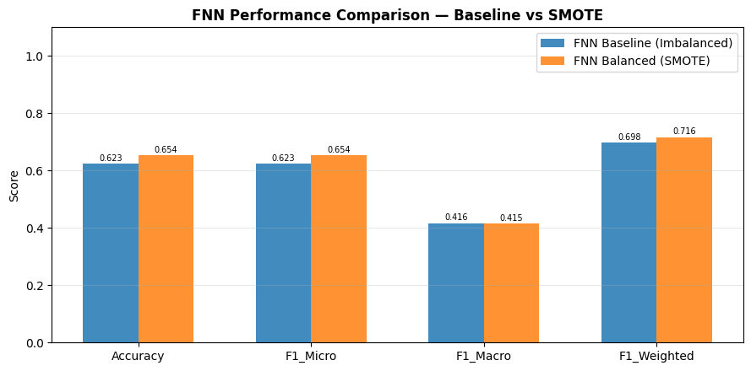
Figure 6: Architecture v1 — All Metrics Bar Chart

4.9 TensorBoard Monitoring
Variant | Train Acc | Val Acc | Train Loss | Val Loss
Baseline | 0.6119 | 0.6132 | 0.9247 | 0.9567
SMOTE | 0.6870 | 0.6446 | 0.7223 | 0.7616

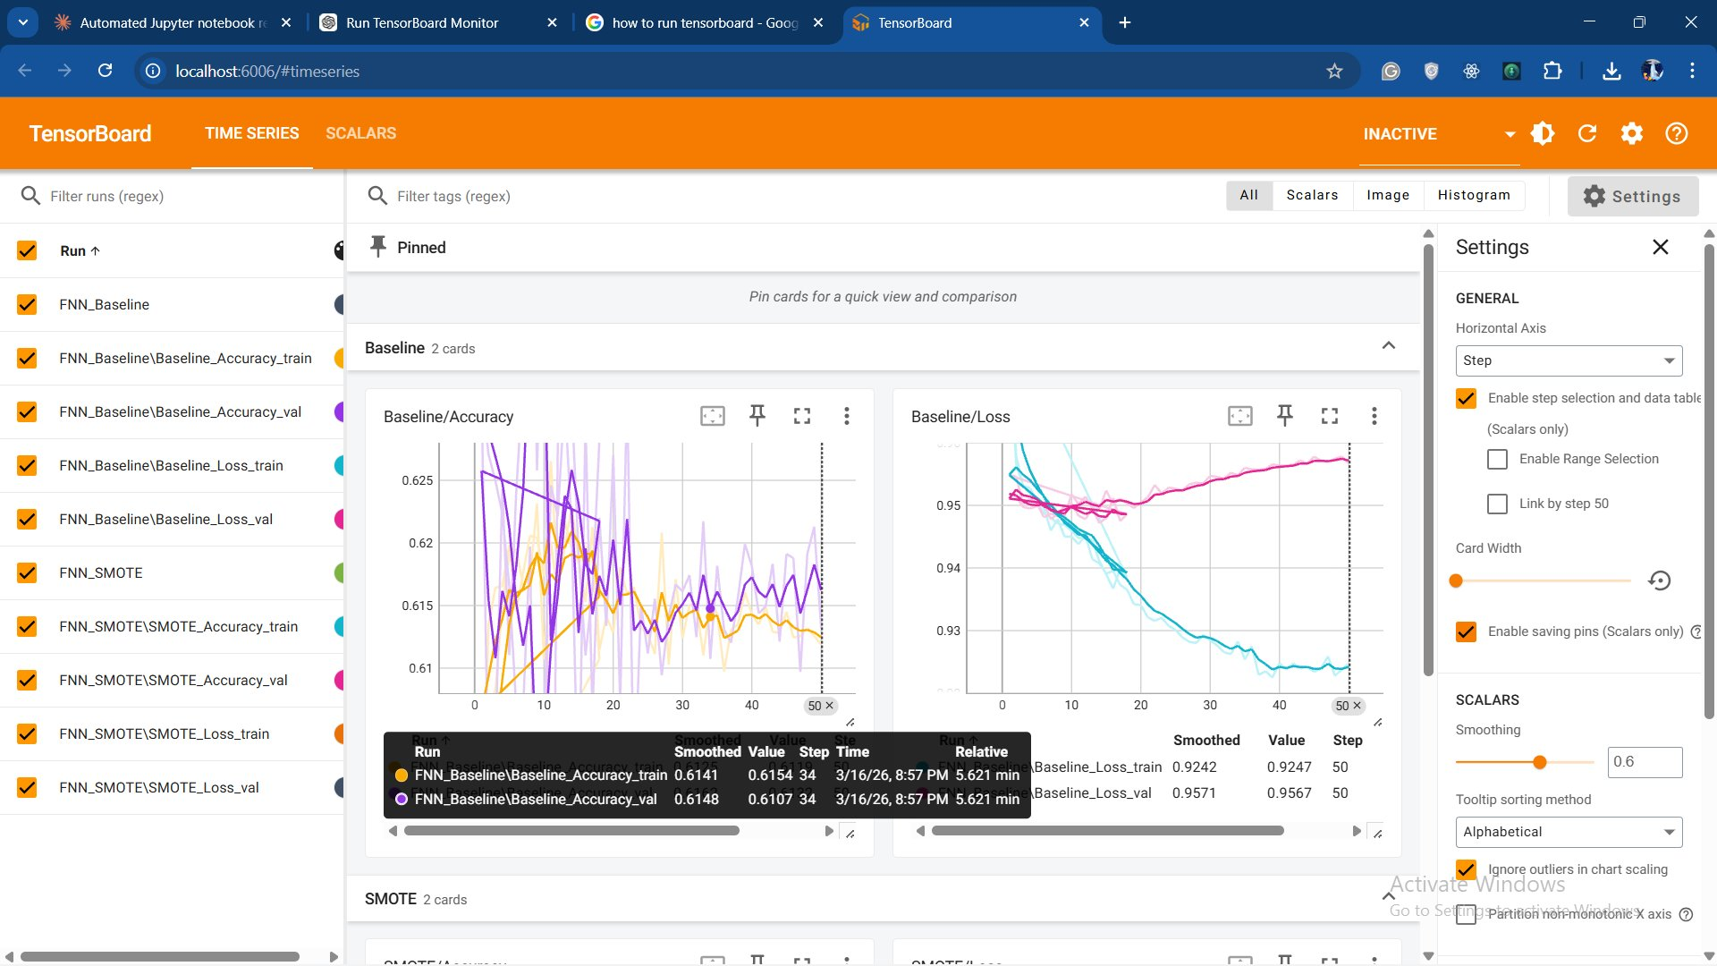
Figure 7: TensorBoard — Architecture v1 Baseline Accuracy & Loss

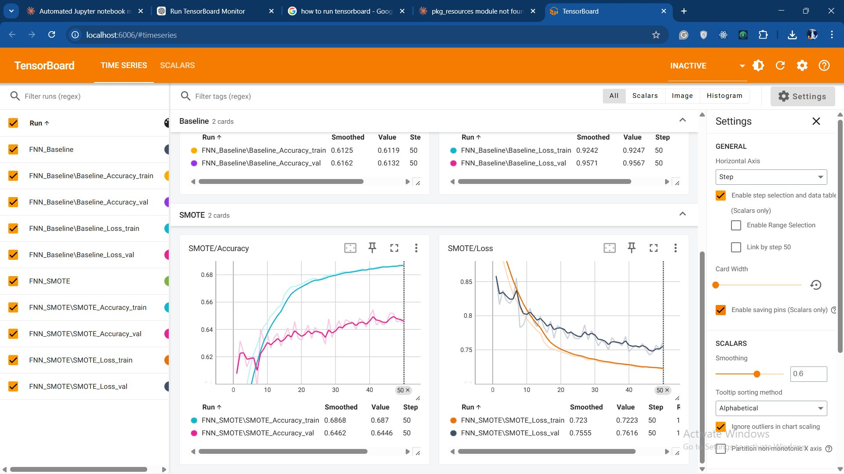
Figure 8: TensorBoard — Architecture v1 SMOTE Accuracy & Loss

Section 5 — Architecture v2 | 3 Layers — Tanh on L3

5.1 Layer Configuration
Layer | Configuration
Input | 15 features → BatchNorm1d
Hidden 1 | Linear(15→256) → BN → ReLU → Dropout(0.30)
Hidden 2 | Linear(256→128) → BN → ReLU → Dropout(0.25)
Hidden 3 | Linear(128→64) → BN → Tanh → Dropout(0.20)
Output | Linear(64→3) [CELoss]

5.2 Training Logs

Baseline (Imbalanced)
=== Training Baseline FNN ===
Epoch 001/50 tr_loss=0.9752 tr_acc=0.5951 vl_loss=0.9529 vl_acc=0.6436
Epoch 010/50 tr_loss=0.9450 tr_acc=0.6203 vl_loss=0.9483 vl_acc=0.6211
Epoch 020/50 tr_loss=0.9358 tr_acc=0.6150 vl_loss=0.9513 vl_acc=0.6252
Epoch 030/50 tr_loss=0.9278 tr_acc=0.6164 vl_loss=0.9530 vl_acc=0.6151
Epoch 040/50 tr_loss=0.9227 tr_acc=0.6176 vl_loss=0.9562 vl_acc=0.6175
Epoch 050/50 tr_loss=0.9214 tr_acc=0.6177 vl_loss=0.9584 vl_acc=0.6283

Balanced (SMOTE)
=== Training Balanced FNN (SMOTE) ===
Epoch 001/50 tr_loss=0.9281 tr_acc=0.5401 vl_loss=0.8867 vl_acc=0.5863
Epoch 010/50 tr_loss=0.7951 tr_acc=0.6465 vl_loss=0.7958 vl_acc=0.6242
Epoch 020/50 tr_loss=0.7438 tr_acc=0.6757 vl_loss=0.7646 vl_acc=0.6395
Epoch 030/50 tr_loss=0.7225 tr_acc=0.6863 vl_loss=0.7607 vl_acc=0.6399
Epoch 040/50 tr_loss=0.7130 tr_acc=0.6915 vl_loss=0.7578 vl_acc=0.6402
Epoch 050/50 tr_loss=0.7089 tr_acc=0.6935 vl_loss=0.7430 vl_acc=0.6497

5.3 Learning Curves
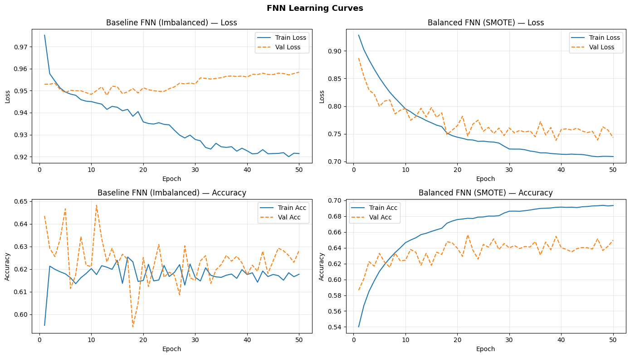
Figure 9: Architecture v2 — Learning Curves (Loss & Accuracy over 50 Epochs)

5.4 Test Set Metrics
Variant | Accuracy | F1 Micro | F1 Macro | F1 Weighted
Baseline (Imbalanced) | 0.6228 | 0.6228 | 0.4178 | 0.7002
Balanced (SMOTE) | 0.6557 | 0.6557 | 0.4138 | 0.7160

5.5 Per-Class F1 Breakdown
Per-class breakdown reveals how each architecture handles the three classes — especially the critical minority classes.
Variant | ND Prec | ND Rec | ND F1 | Pre F1 | Dia F1 | Macro F1
Baseline | 0.96 | 0.63 | 0.76 | 0.05 | 0.45 | 0.4178
SMOTE | 0.94 | 0.66 | 0.78 | 0.04 | 0.42 | 0.4138

5.6 Full Classification Reports

Baseline
precision recall f1-score support
No Diabetes 0.96 0.63 0.76 42741
Prediabetes 0.03 0.28 0.05 926
Diabetes 0.34 0.65 0.45 7069
accuracy 0.62 50736
macro avg 0.44 0.52 0.42 50736
weighted avg 0.85 0.62 0.70 50736

SMOTE Balanced
precision recall f1-score support
No Diabetes 0.94 0.66 0.78 42741
Prediabetes 0.02 0.14 0.04 926
Diabetes 0.31 0.67 0.42 7069
accuracy 0.66 50736
macro avg 0.42 0.49 0.41 50736
weighted avg 0.84 0.66 0.72 50736

5.7 Confusion Matrices
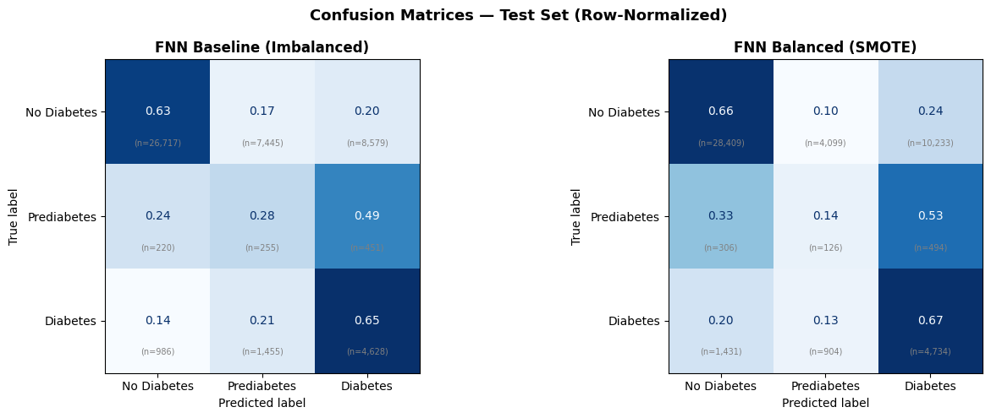
Figure 10: Architecture v2 — Normalized Confusion Matrices (Baseline left, SMOTE right)

5.8 Metric Comparison Chart
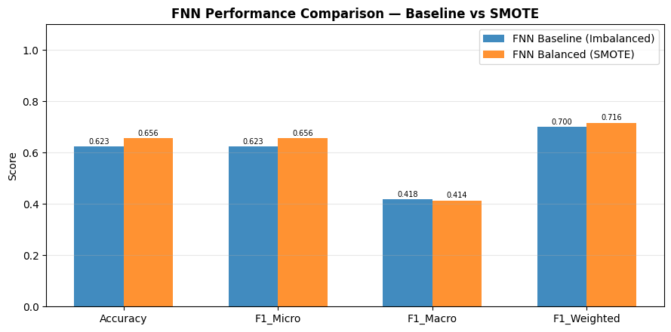
Figure 11: Architecture v2 — All Metrics Bar Chart

5.9 TensorBoard Monitoring
Variant | Train Acc | Val Acc | Train Loss | Val Loss
Baseline | 0.6177 | 0.6283 | 0.9214 | 0.9584
SMOTE | 0.6935 | 0.6497 | 0.7089 | 0.7430

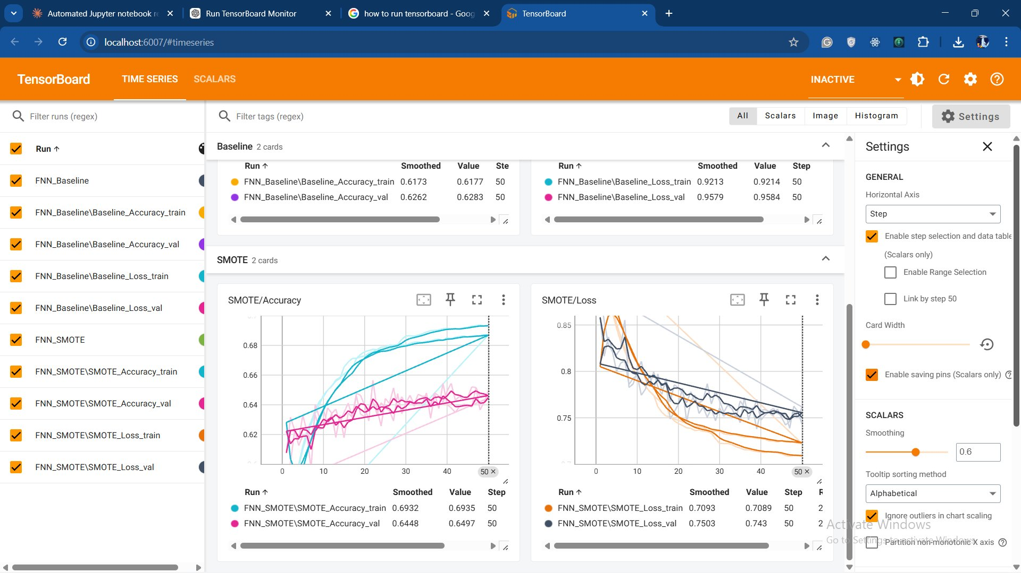
Figure 12: TensorBoard — Architecture v2 Baseline Accuracy & Loss

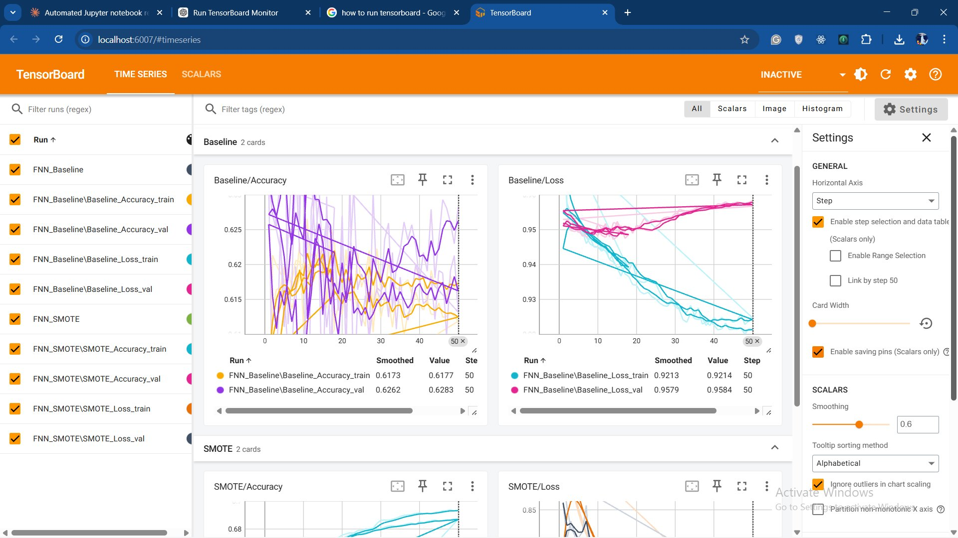
Figure 13: TensorBoard — Architecture v2 SMOTE Accuracy & Loss

Section 6 — Architecture v3 | 6 Layers — 719K Params, Lower Dropout

6.1 Layer Configuration
Layer | Configuration
Input | 15 features → BatchNorm1d
Hidden 1 | Linear(15→1024) → BN → ReLU → Dropout(0.60)
Hidden 2 | Linear(1024→512) → BN → ReLU → Dropout(0.40)
Hidden 3 | Linear(512→256) → BN → ReLU → Dropout(0.30)
Hidden 4 | Linear(256→128) → BN → ReLU → Dropout(0.15)
Hidden 5 | Linear(128→64) → BN → ReLU → Dropout(0.10)
Hidden 6 | Linear(64→32) → BN → Tanh → Dropout(0.05)
Output | Linear(32→3) [CELoss]

6.2 Training Logs

Baseline (Imbalanced)
=== Training Baseline FNN ===
Epoch 001/50 tr_loss=0.9755 tr_acc=0.6273 vl_loss=0.9542 vl_acc=0.6699
Epoch 010/50 tr_loss=0.9495 tr_acc=0.6286 vl_loss=0.9499 vl_acc=0.5973
Epoch 020/50 tr_loss=0.9502 tr_acc=0.6309 vl_loss=0.9482 vl_acc=0.6339
Epoch 030/50 tr_loss=0.9394 tr_acc=0.6184 vl_loss=0.9497 vl_acc=0.6157
Epoch 040/50 tr_loss=0.9339 tr_acc=0.6148 vl_loss=0.9542 vl_acc=0.6226
Epoch 050/50 tr_loss=0.9293 tr_acc=0.6105 vl_loss=0.9567 vl_acc=0.6209

Balanced (SMOTE)
=== Training Balanced FNN (SMOTE) ===
Epoch 001/50 tr_loss=0.9323 tr_acc=0.5351 vl_loss=0.8604 vl_acc=0.5845
Epoch 010/50 tr_loss=0.7788 tr_acc=0.6558 vl_loss=0.7547 vl_acc=0.6505
Epoch 020/50 tr_loss=0.7301 tr_acc=0.6828 vl_loss=0.7562 vl_acc=0.6252
Epoch 030/50 tr_loss=0.7126 tr_acc=0.6932 vl_loss=0.7058 vl_acc=0.6701
Epoch 040/50 tr_loss=0.6381 tr_acc=0.7284 vl_loss=0.7016 vl_acc=0.6675
Epoch 050/50 tr_loss=0.6213 tr_acc=0.7362 vl_loss=0.7107 vl_acc=0.6648

6.3 Learning Curves
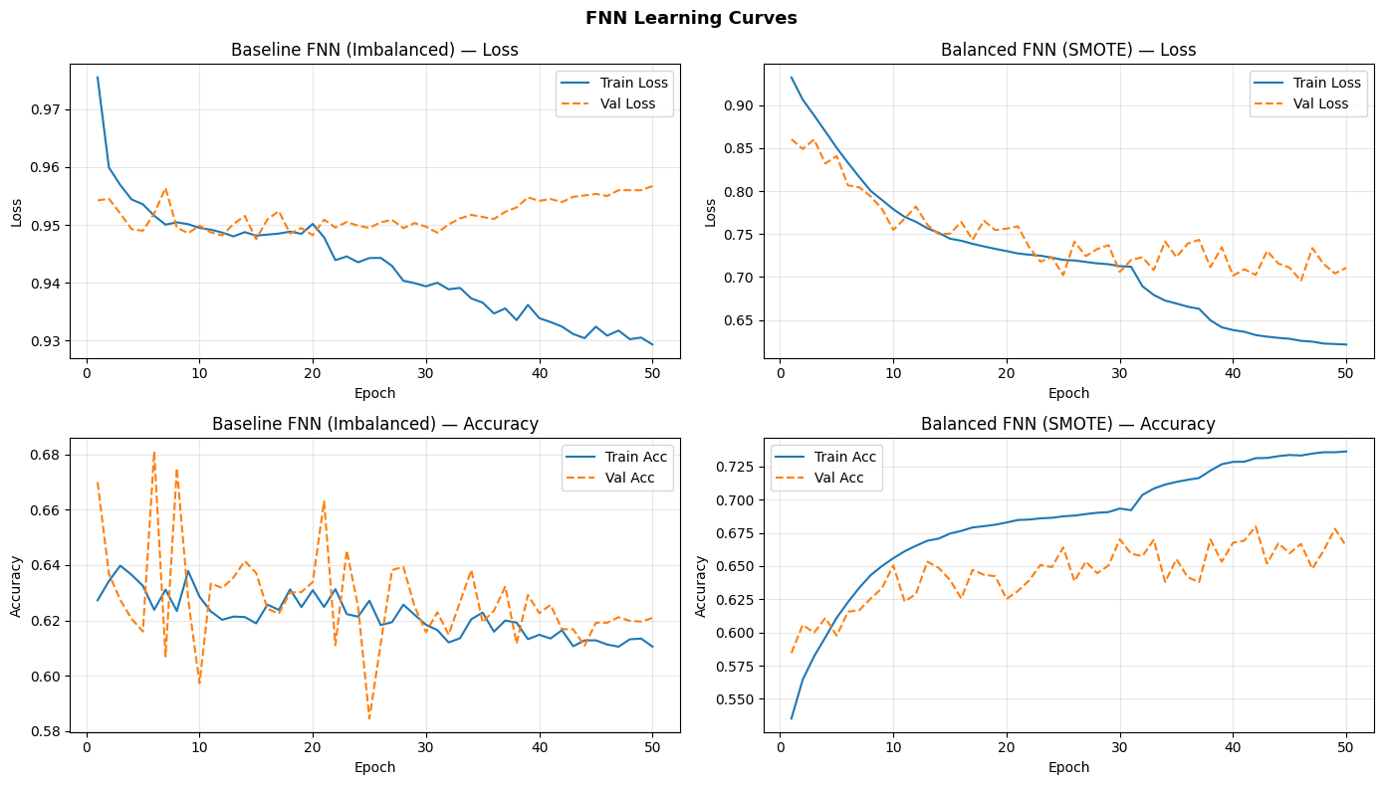
Figure 14: Architecture v3 — Learning Curves (Loss & Accuracy over 50 Epochs)

6.4 Test Set Metrics
Variant | Accuracy | F1 Micro | F1 Macro | F1 Weighted
Baseline (Imbalanced) | 0.6361 | 0.6361 | 0.4222 | 0.7094
Balanced (SMOTE) | 0.6674 | 0.6674 | 0.4160 | 0.7227

6.5 Per-Class F1 Breakdown
Per-class breakdown reveals how each architecture handles the three classes — especially the critical minority classes.
Variant | ND Prec | ND Rec | ND F1 | Pre F1 | Dia F1 | Macro F1
Baseline | 0.95 | 0.64 | 0.77 | 0.05 | 0.45 | 0.4222
SMOTE | 0.94 | 0.68 | 0.79 | 0.04 | 0.42 | 0.4160

6.6 Full Classification Reports

Baseline
precision recall f1-score support
No Diabetes 0.95 0.64 0.77 42741
Prediabetes 0.03 0.25 0.05 926
Diabetes 0.34 0.66 0.45 7069
accuracy 0.64 50736
macro avg 0.44 0.52 0.42 50736
weighted avg 0.85 0.64 0.71 50736

SMOTE Balanced
precision recall f1-score support
No Diabetes 0.94 0.68 0.79 42741
Prediabetes 0.02 0.11 0.04 926
Diabetes 0.31 0.68 0.42 7069
accuracy 0.67 50736
macro avg 0.42 0.49 0.42 50736
weighted avg 0.83 0.67 0.72 50736

6.7 Confusion Matrices
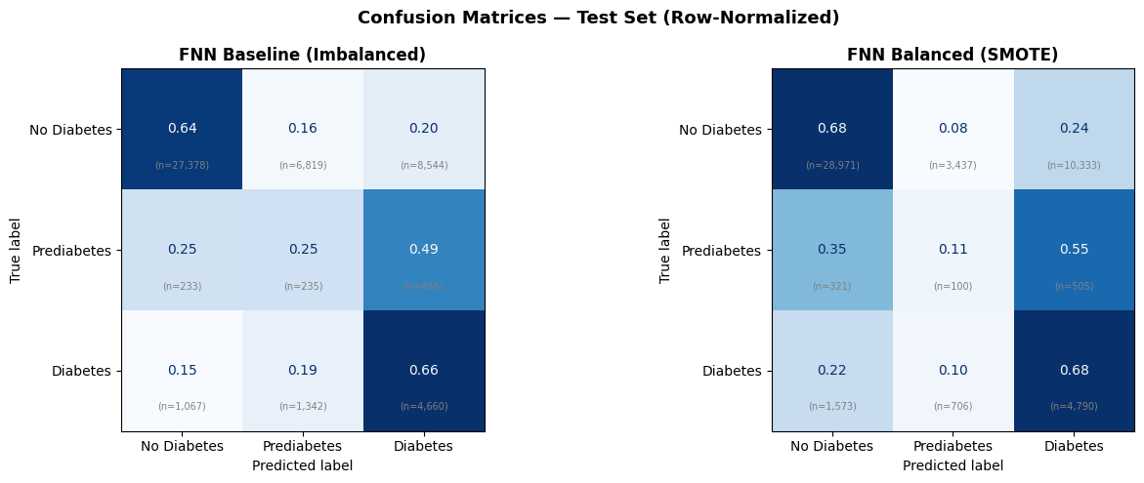
Figure 15: Architecture v3 — Normalized Confusion Matrices (Baseline left, SMOTE right)

6.8 Metric Comparison Chart
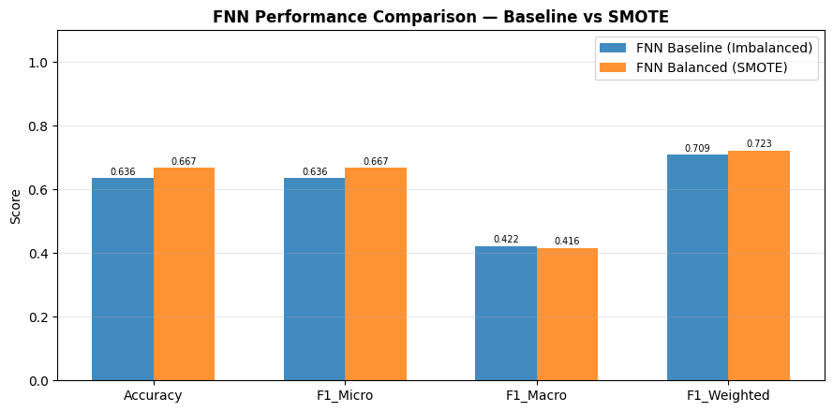
Figure 16: Architecture v3 — All Metrics Bar Chart

6.9 TensorBoard Monitoring
Variant | Train Acc | Val Acc | Train Loss | Val Loss
Baseline | 0.6105 | 0.6209 | 0.9293 | 0.9567
SMOTE | 0.7362 | 0.6648 | 0.6213 | 0.7107

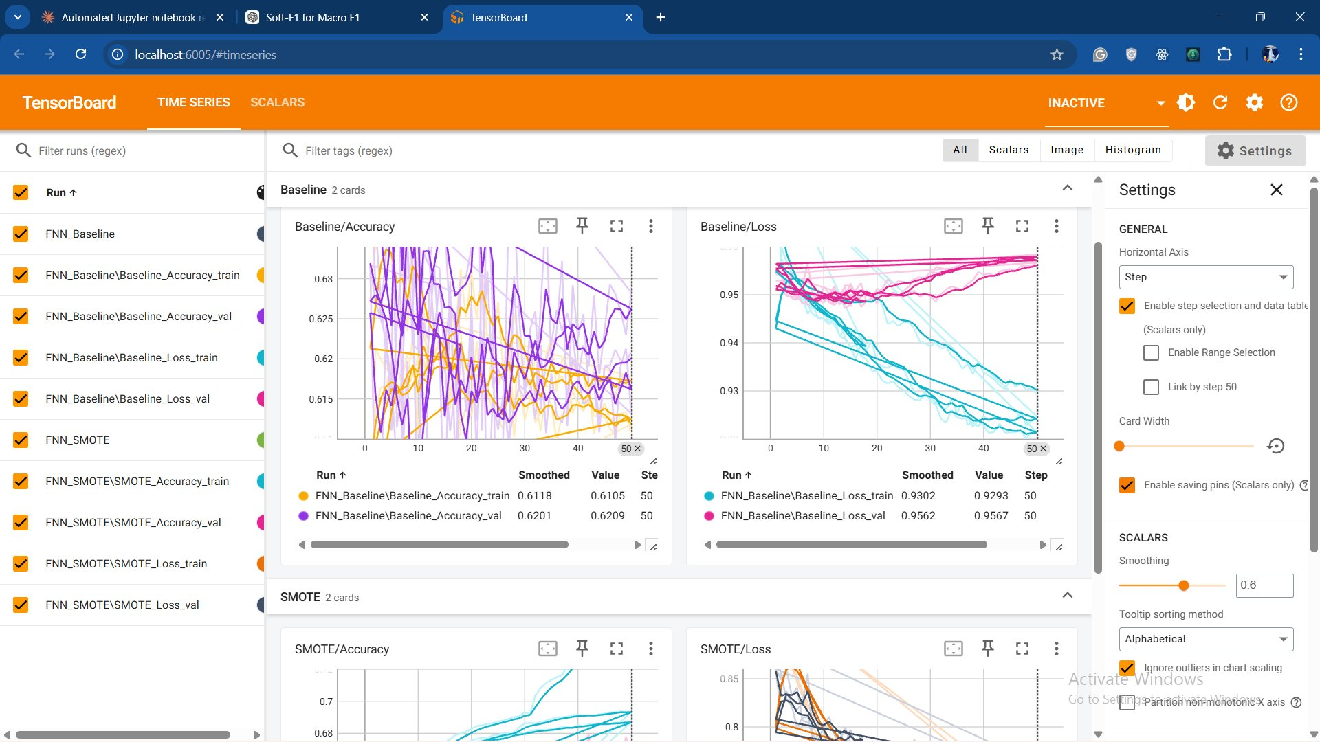
Figure 17: TensorBoard — Architecture v3 Baseline Accuracy & Loss

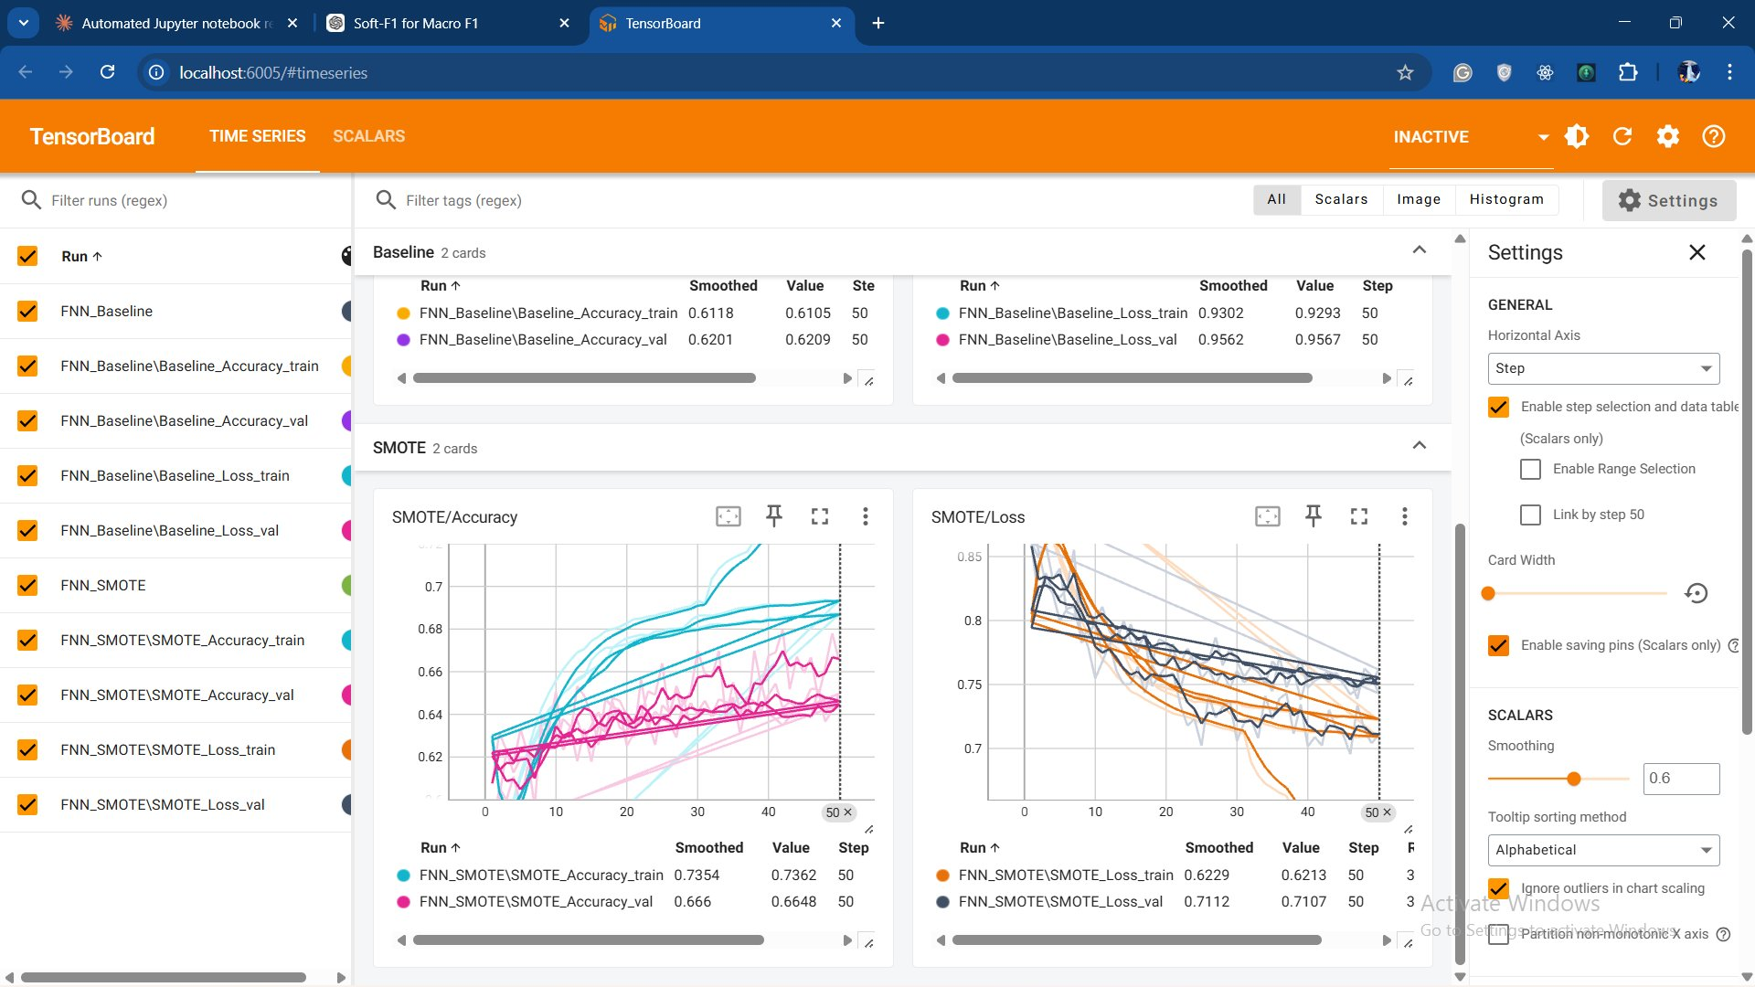
Figure 18: TensorBoard — Architecture v3 SMOTE Accuracy & Loss

Section 7 — Architecture v4 | 6 Layers — 719K Params, Higher Dropout

7.1 Layer Configuration
Layer | Configuration
Input | 15 features → BatchNorm1d
Hidden 1 | Linear(15→1024) → BN → ReLU → Dropout(0.60)
Hidden 2 | Linear(1024→512) → BN → ReLU → Dropout(0.50)
Hidden 3 | Linear(512→256) → BN → ReLU → Dropout(0.40)
Hidden 4 | Linear(256→128) → BN → ReLU → Dropout(0.30)
Hidden 5 | Linear(128→64) → BN → ReLU → Dropout(0.15)
Hidden 6 | Linear(64→32) → BN → Tanh → Dropout(0.10)
Output | Linear(32→3) [CELoss] + lambda * [SoftF1Loss]

7.2 Training Logs

Baseline (Imbalanced)
=== Training Baseline FNN ===
Epoch 001/50 tr_loss=1.3182 tr_acc=0.6585 vl_loss=1.2869 vl_acc=0.7133
Epoch 010/50 tr_loss=1.2811 tr_acc=0.6706 vl_loss=1.2776 vl_acc=0.6708
Epoch 020/50 tr_loss=1.2764 tr_acc=0.6609 vl_loss=1.2761 vl_acc=0.6695
Epoch 030/50 tr_loss=1.2672 tr_acc=0.6538 vl_loss=1.2769 vl_acc=0.6507
Epoch 040/50 tr_loss=1.2642 tr_acc=0.6502 vl_loss=1.2793 vl_acc=0.6585
Epoch 050/50 tr_loss=1.2605 tr_acc=0.6491 vl_loss=1.2802 vl_acc=0.6569

Balanced (SMOTE)
=== Training Balanced FNN (SMOTE) ===
Epoch 001/50 tr_loss=1.2172 tr_acc=0.5318 vl_loss=1.2342 vl_acc=0.5491
Epoch 010/50 tr_loss=1.0434 tr_acc=0.6409 vl_loss=1.0905 vl_acc=0.6481
Epoch 020/50 tr_loss=0.9712 tr_acc=0.6719 vl_loss=1.0432 vl_acc=0.6570
Epoch 030/50 tr_loss=0.9451 tr_acc=0.6834 vl_loss=1.0218 vl_acc=0.6690
Epoch 040/50 tr_loss=0.8573 tr_acc=0.7171 vl_loss=1.0260 vl_acc=0.6677
Epoch 050/50 tr_loss=0.8231 tr_acc=0.7295 vl_loss=1.0191 vl_acc=0.6758

7.3 Learning Curves
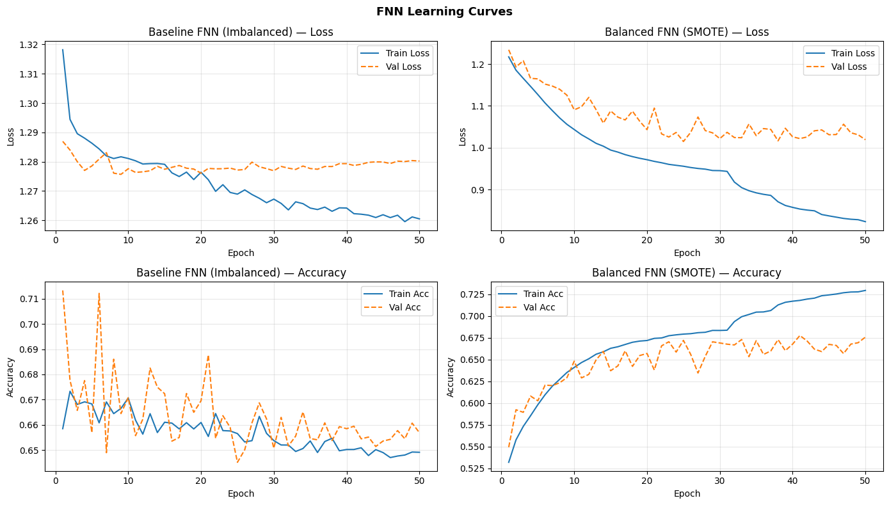
Figure 19: Architecture v4 — Learning Curves (Loss & Accuracy over 50 Epochs)

7.4 Test Set Metrics
Variant | Accuracy | F1 Micro | F1 Macro | F1 Weighted
Baseline (Imbalanced) | 0.6648 | 0.6648 | 0.4338 | 0.7311
Balanced (SMOTE) | 0.6712 | 0.6712 | 0.4189 | 0.7273

7.5 Per-Class F1 Breakdown
Per-class breakdown reveals how each architecture handles the three classes — especially the critical minority classes.
Variant | ND Prec | ND Rec | ND F1 | Pre F1 | Dia F1 | Macro F1
Baseline | 0.95 | 0.68 | 0.79 | 0.06 | 0.45 | 0.4338
SMOTE | 0.94 | 0.68 | 0.79 | 0.04 | 0.42 | 0.4189

7.6 Full Classification Reports

Baseline
precision recall f1-score support
No Diabetes 0.95 0.68 0.79 42741
Prediabetes 0.03 0.25 0.06 926
Diabetes 0.35 0.64 0.45 7069
accuracy 0.66 50736
macro avg 0.44 0.52 0.43 50736
weighted avg 0.85 0.66 0.73 50736

SMOTE Balanced
precision recall f1-score support
No Diabetes 0.94 0.68 0.79 42741
Prediabetes 0.03 0.13 0.04 926
Diabetes 0.31 0.66 0.42 7069
accuracy 0.67 50736
macro avg 0.43 0.49 0.42 50736
weighted avg 0.84 0.67 0.73 50736

7.7 Confusion Matrices
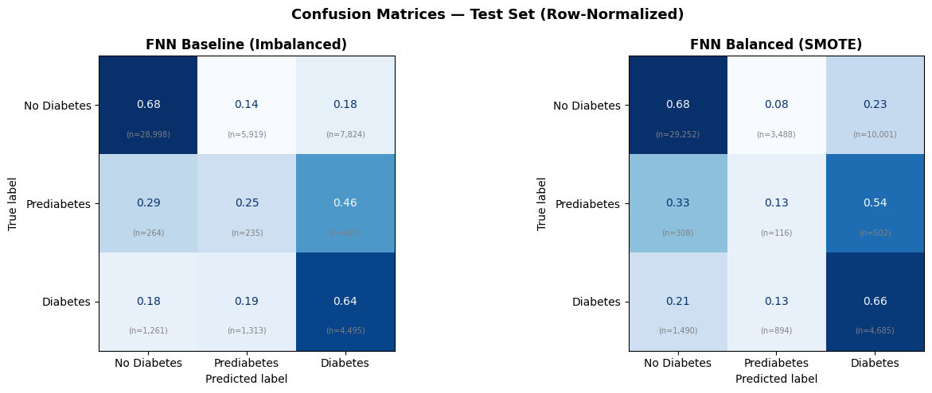
Figure 20: Architecture v4 — Normalized Confusion Matrices (Baseline left, SMOTE right)

7.8 Metric Comparison Chart
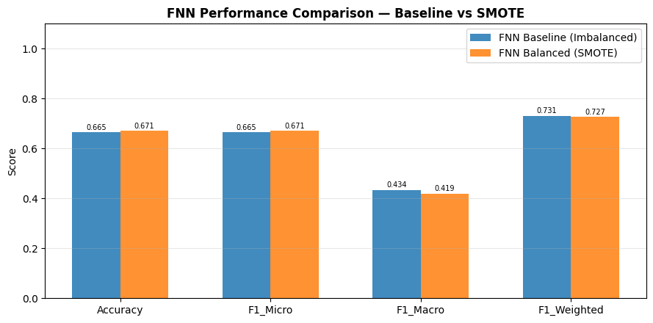
Figure 21: Architecture v4 — All Metrics Bar Chart

7.9 TensorBoard Monitoring
Variant | Train Acc | Val Acc | Train Loss | Val Loss
Baseline | 0.6491 | 0.6569 | 1.2605 | 1.2802
SMOTE | 0.7295 | 0.6758 | 0.8231 | 1.0191

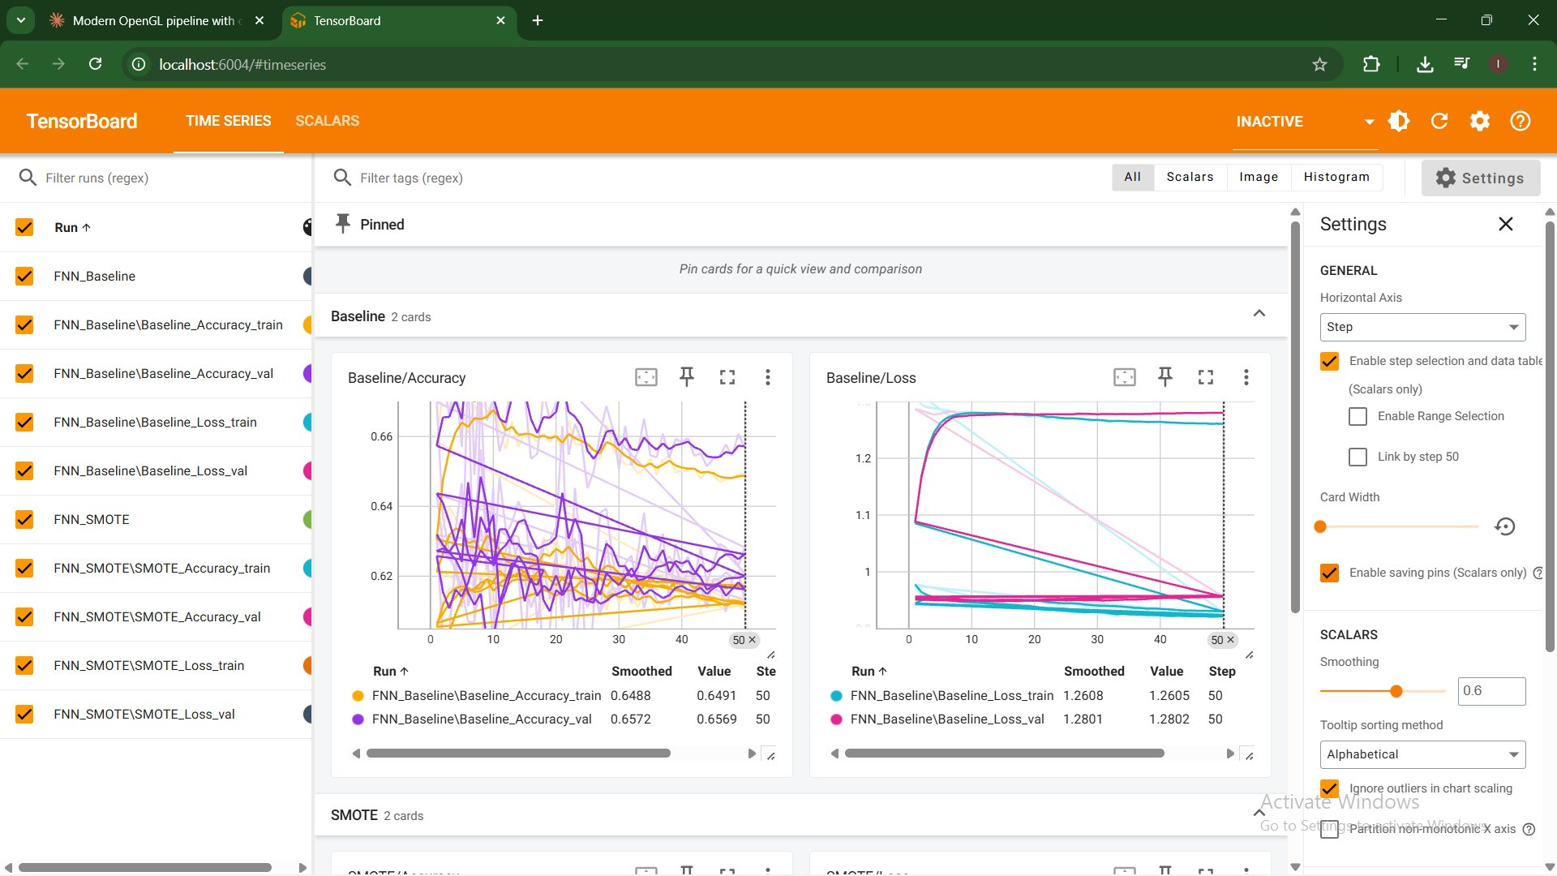
Figure 22: TensorBoard — Architecture v4 Baseline Accuracy & Loss

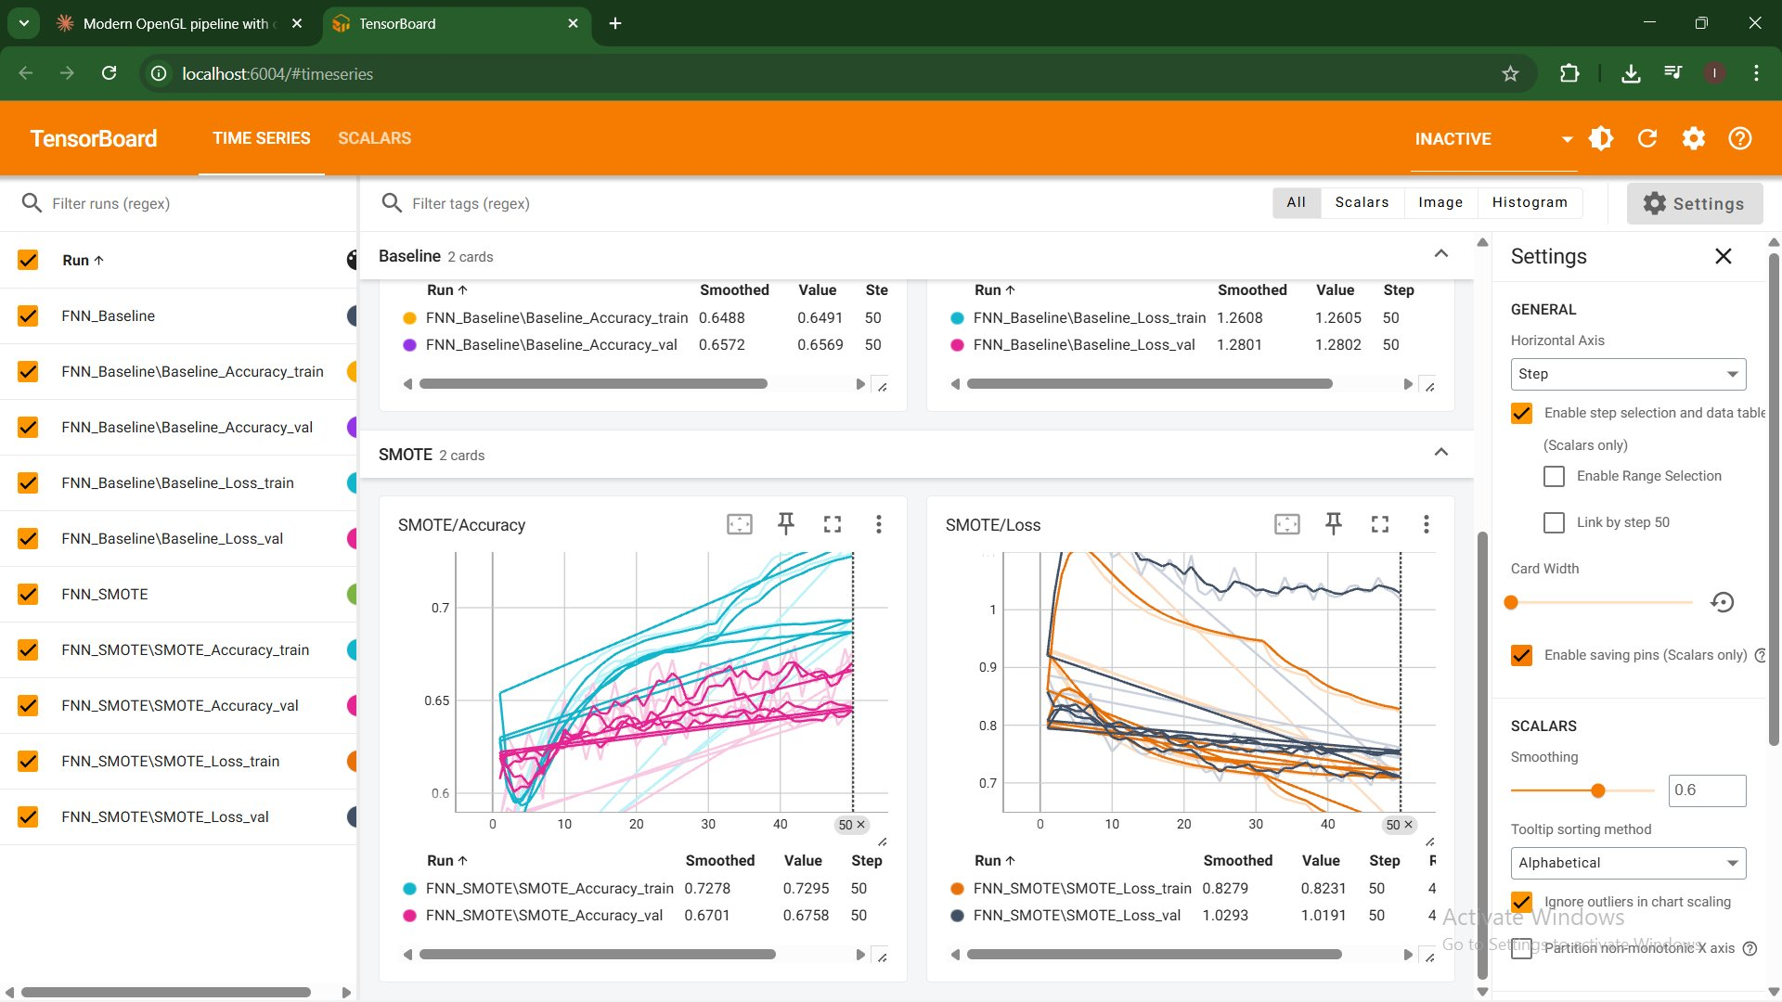
Figure 23: TensorBoard — Architecture v4 SMOTE Accuracy & Loss

8. Cross-Architecture Comparison — v1 vs v2 vs v3 vs v4
All four architectures evaluated on the same held-out test set (50,736 samples). Best values per column are highlighted green, worst in red.

8.1 Overall Metrics — Baseline (Imbalanced)
Architecture | Accuracy | F1 Micro | F1 Macro | F1 Weighted | Params
v1 — All ReLU | 0.6230 | 0.6230 | 0.4165 | 0.6977 | 46K
v2 — Tanh L3 | 0.6228 | 0.6228 | 0.4178 | 0.7002 | 46K
v3 — Low Drop | 0.6361 | 0.6361 | 0.4222 | 0.7094 | 719K
v4 — High Drop + SoftF1Lost | 0.6648 | 0.6648 | 0.4338 | 0.7311 | 719K

8.2 Overall Metrics — Balanced (SMOTE)
Architecture | Accuracy | F1 Micro | F1 Macro | F1 Weighted | Params
v1 — All ReLU | 0.6539 | 0.6539 | 0.4148 | 0.7164 | 46K
v2 — Tanh L3 | 0.6557 | 0.6557 | 0.4138 | 0.7160 | 46K
v3 — Low Drop | 0.6674 | 0.6674 | 0.4160 | 0.7227 | 719K
v4 — High Drop + SoftF1Lost | 0.6712 | 0.6712 | 0.4189 | 0.7273 | 719K

8.3 Per-Class F1 Scores — Baseline (Imbalanced)
This is the most informative breakdown. Macro-F1 averages across all three class F1 scores equally. Red = worst across all versions, Green = best.
Architecture | ND F1 | Pre F1 | Dia F1 | Macro F1 | Wtd F1 | Params
v1 — All ReLU | 0.75 | 0.05 | 0.45 | 0.4165 | 0.6977 | 46K
v2 — Tanh L3 | 0.76 | 0.05 | 0.45 | 0.4178 | 0.7002 | 46K
v3 — Low Drop | 0.77 | 0.05 | 0.45 | 0.4222 | 0.7094 | 719K
v4 — High Drop + SoftF1Lost ★ | 0.79 | 0.06 | 0.45 | 0.4338 | 0.7311 | 719K

8.4 Per-Class F1 Scores — Balanced (SMOTE)
Architecture | ND F1 | Pre F1 | Dia F1 | Macro F1 | Wtd F1 | Params
v1 — All ReLU | 0.77 | 0.06 | 0.47 | 0.4148 | 0.7164 | 46K
v2 — Tanh L3 | 0.78 | 0.04 | 0.42 | 0.4138 | 0.7160 | 46K
v3 — Low Drop | 0.79 | 0.04 | 0.42 | 0.4160 | 0.7227 | 719K
v4 — High Drop | 0.79 | 0.04 | 0.42 | 0.4189 | 0.7273 | 719K

8.5 Key Findings
- v4 is the strongest architecture overall. It achieves the best Macro-F1 on baseline (0.4338 vs 0.4165–0.4222), best accuracy and weighted F1 on both training conditions.
- Higher dropout in v4 vs v3 is the key driver. The same 719K-parameter network generalises significantly better with dropout (0.50/0.40/0.30) vs (0.40/0.30/0.15). Macro-F1 baseline jumped from 0.4222 → 0.4338 (+0.0116).
- SMOTE Macro-F1 is surprisingly lower than Baseline Macro-F1 in v4 (0.4189 vs 0.4338). This reversal — also seen in v3 (0.4160 vs 0.4222) — suggests the deep network already handles class imbalance well through its weighted loss. SMOTE oversampling then introduces noise that hurts minority class precision.
- SMOTE best results for v1 SMOTE: Diabetes F1 = 0.47, Prediabetes F1 = 0.06. Shallow networks benefit more from SMOTE balancing than deep ones, making v1+SMOTE competitive for minority class recall.
- Prediabetes (Class 1) F1 is universally low (0.04–0.06) across all architectures and training conditions. This class is clinically indistinguishable from "No Diabetes" in many feature dimensions — a data-level constraint, not a model-level one.
- v4 baseline train loss (~1.26) is much higher than v1–v3 (~0.92–0.97). This indicates higher effective regularisation from the increased dropout, preventing the model from memorising training data — which is why test generalisation improves.

9. Bonus: TensorBoard
TensorBoard screenshots for all architectures are in their respective sections (4.9, 5.9, 6.9, 7.9).
tensorboard --logdir=runs
# Open: http://localhost:6006

