A DATABASE PROJECT ON PAYROLL MANAGEMENT SYSTEM

Team Members: Rollno. :
Jenit Jain 9
Anushka Trivedi 29

Problem Statement

The term payroll encompasses every employee who recieves a regular wage or other compensation. The different payment methods are calculated by a payroll specialist and the appropriate paychecks are issued.

Payroll Managment System is basically used to build an application program that a company uses to manage the records of the employees working in the company. Only the administration department has legal rights to work with the system.

The objectives of the projects are:
- To improve efficiency of company’s administration.

- To store up-to-date information of the employees.

- To reduce extra cost for the security of the database.

- Regular deductions such as medical insurance etc, are categorized and then subtracted. The remaining balance is then converted to a check and becomes the employee’s net pay for that time period.

Abstract

A Payroll Management system consists of huge amount of data.

Remembering information like names and Ids of different employees in the company is a challenging task. One cannot rely on the error prone and inefficient method of using bundles of paper to keep track of details regarding large number of employees, employers, companies, branches and salaries.

The Payroll Management database primarily consists of entities of employees, employers, salaries, branches and companies. Employees and employers have unique Ids through which he/she can be revognized. They belong to particular companies and particular branches of that company. Each employee is assosiated with an employer. Salaries are given by an employer to the employees that work for them. All the salaries are stored in a separate table and all the additional expenses (medical allowance and incentives) are stored in that table as well.

Required Software:
MySQL database.
Netbeans IDE.
ER Diagram

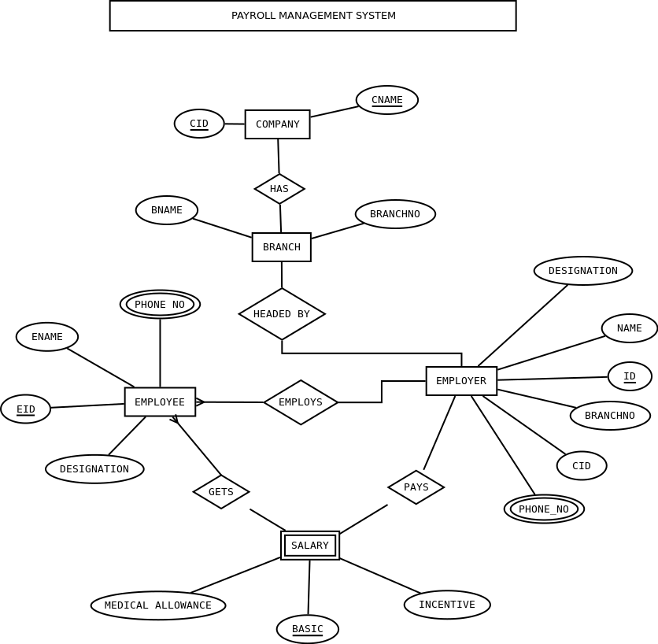

Relational Tables

- Company(cid, cname)
- Branch(cid, branchno, bname)
- Employee(eid, id, ename, edesignation, phone_no)
- Employer(id, name, designation, cid, branchno,phone_no)
- Salary(eid, id, basic, medical_allowance, incentive)

DDL Commands

create table company(
cid varchar(10) primary key,
cname varchar(20) not null);
create table branch(
cid varchar(10) not null,
branchno varchar(10),
bname varchar(20) not null,
foreign key(cid) references company(cid),
primary key(cid,branchno)
);
create table employer(
id varchar(6) primary key,
name varchar(15) not null,
designation varchar(20) not null,
cid varchar(10) not null,
branchno varchar(10),
phone_no numeric(10,0) not null,
foreign key(cid,branchno) references branch(cid,branchno)
);
create table employee(
id varchar(8)
eid varchar(6) primary key,
ename varchar(15) not null,
edesignation varchar(10) not null,
phone_no numeric(10,0) not null,
foreign key(id) references employer(id)
);
create table salary(
id varchar(8),
eid varchar(8),
medical_allowance numeric(8,2),
basic numeric(8,2),
incentive numeric(8,2),
foreign key(id,eid) references employee(id,eid),
primary key(eid,id,basic)
);

Sample data

insert into company values('C001', 'Company1');
insert into company values('C002', 'Company2');
insert into company values('C003', 'Company3');
insert into company values('C004', 'Company4');
insert into company values('C005', 'Company5');
insert into branch values('C001', '1','Mumbai');
insert into branch values('C001', '2','Bangalore');
insert into branch values('C002', '1','Mumbai');
insert into branch values('C002', '3','Delhi');
insert into branch values('C003', '2','Bangalore');
insert into branch values('C004', '1','Mumbai');
insert into branch values('C004', '2','Bangalore');
insert into branch values('C004', '3','Delhi');
insert into branch values('C005', '3','Delhi');
insert into employee values('S001','E001','RAMA','
insert into employee values('S002','E002', 'MAHESH','HELPER', 9967354629);
insert into employee values('S003','E003', 'SITA','MANAGER', 99987654321);
insert into employee values('S004','E004', 'SWARNA', 'HELPER', 7896543210);
insert into employee values('S005','E005', 'ANUSHKA', 'MANAGER', 9073894567);
insert into employee values('S001','E006', 'JENIT','HELPER', 9071597467);
insert into employer values('S001', 'RAMAL','CF0','C001','1',
insert into employer values('S002', 'MAHESHA','CEO','C002','3',
insert into employer values('S003', 'SITARAM', 'HR HEAD','C004','1',99987654321);
insert into employer values('S004', 'SAPNA', 'PRESIDENT','C005','3',
insert into employer values('S005', 'ANISH', 'VICE PRESIDENT','C003','2',
insert into salary values('S001','E001',10000,
insert into salary values('S002','E002',10000,
insert into salary values('S003','E003',10000,
insert into salary values('S004','E004',10000,
insert into salary values('S005','E005',10000,
insert into salary values('S001','E006',10000,

List of Queries

- select employer.id as ID ,name,count(*) as employees from employee,employer where employee.id=employer.id group by employer.id;
- select cname,count(*) as no_of_branches from company,branch where branch.cid=company.cid group by company.cid;
- select bname,count(*) from branch,employer where branch.branchno=employer.branchno group by branch.bname;
- select ename from employee, company, employer where employer.cid=company.cid and employee.id=employer.id and company.cid=<company.cid>;

SCREENSHOTS
Updating the salary table:
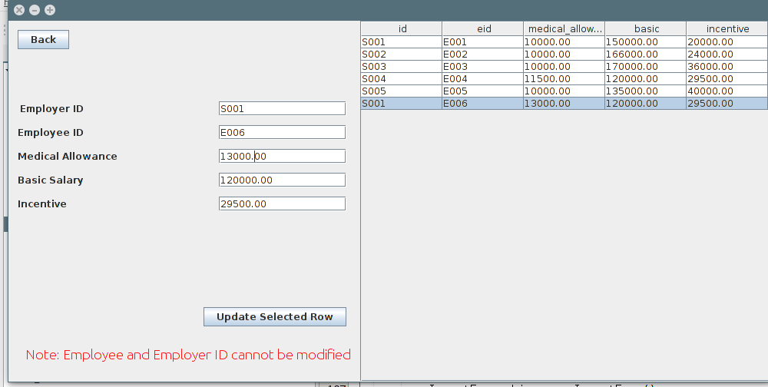

Updating Employer table:
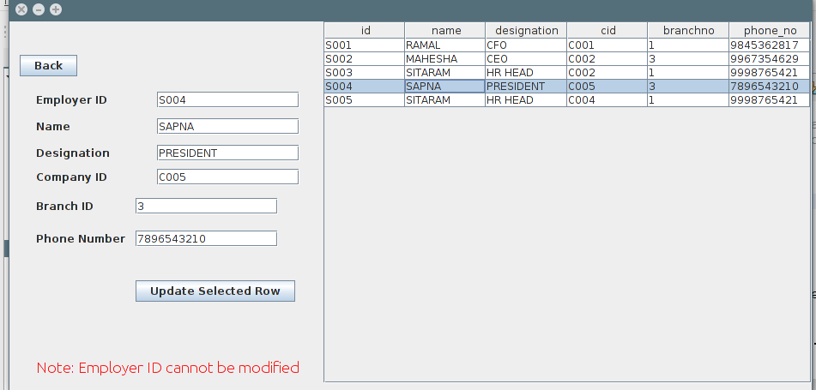

Updating Employee table:
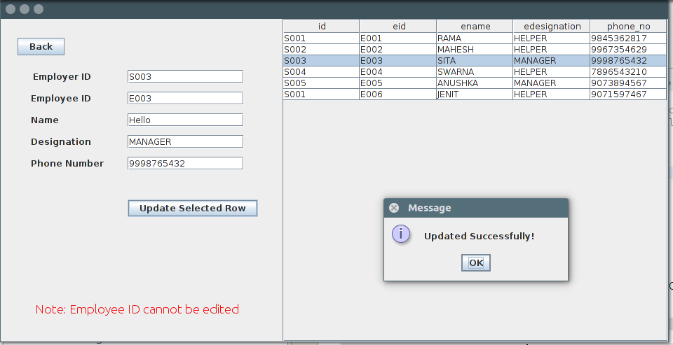

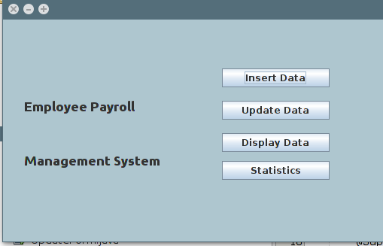
Home Page:

Insert home:
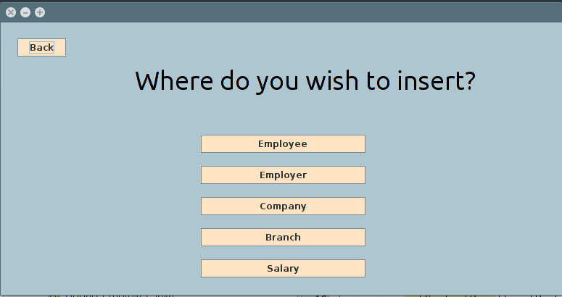

Salary insert:
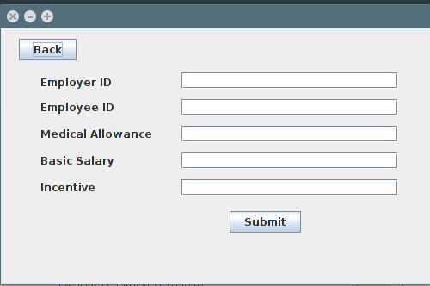

Employer insert:
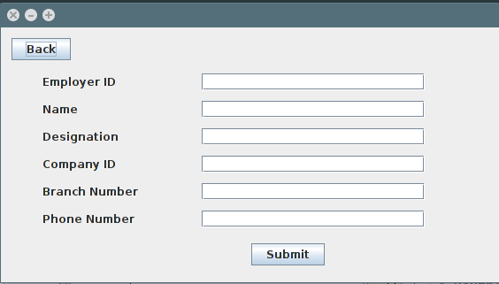

Employee insert:
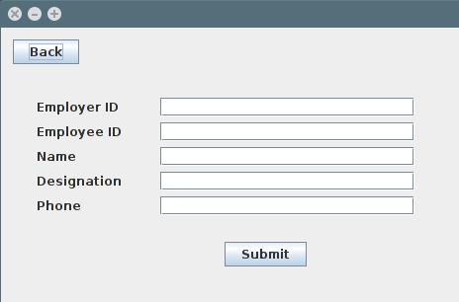

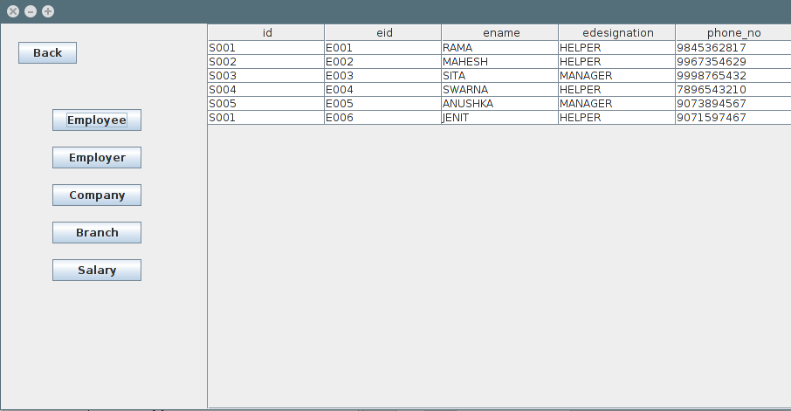
Display tables:

Branch insert:
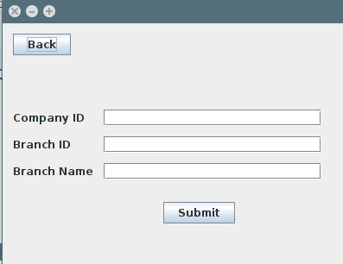

Company insert:
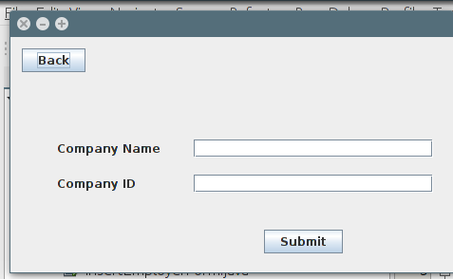

Result of running the listed queries:

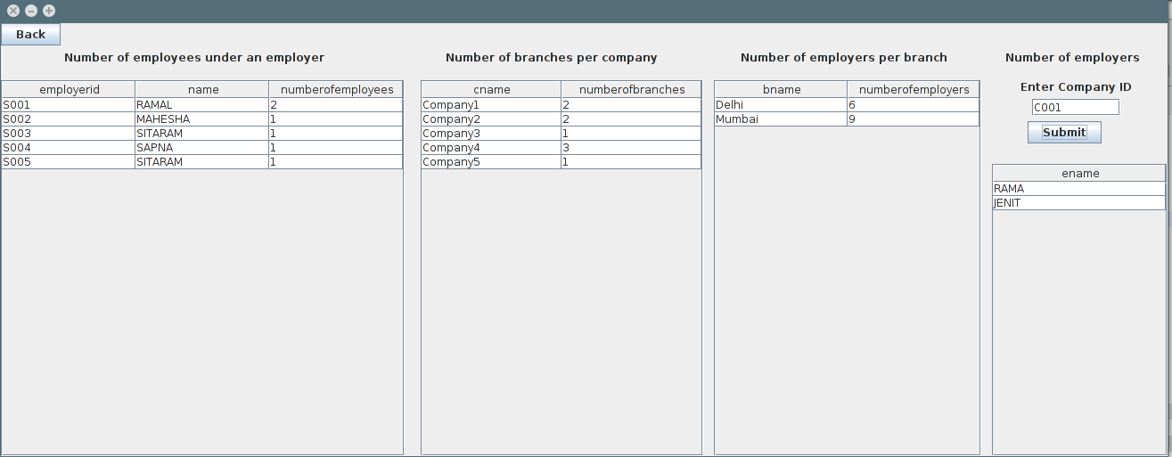

PSEUDOCODE

HOME PAGE

public class HomePageForm extends javax.swing.JFrame {
public HomePageForm() {
initComponents();
getContentPane().setBackground(new java.awt.Color(174, 198, 207));
}

//Insetion and position of buttons
//Action for the buttons

private void InsertBtnActionPerformed(java.awt.event.ActionEvent evt) {
InsertForm obj = new InsertForm();
setVisible(false);
obj.setVisible(true);
}

private void UpdateDataButtonActionPerformed(java.awt.event.ActionEvent evt) {
UpdateForm uf = new UpdateForm();
setVisible(false);
uf.setVisible(true);
}

private void DisplayBtnActionPerformed(java.awt.event.ActionEvent evt) {
DisplayForm df = new DisplayForm();
setVisible(false);
df.setVisible(true);
}

private void StatisticsBtnActionPerformed(java.awt.event.ActionEvent evt) {
Statistics s = new Statistics();
setVisible(false);
s.setVisible(true);
}
public static void main(String args[]) {
java.awt.EventQueue.invokeLater(new Runnable() {
public void run() {
new HomePageForm().setVisible(true);
}
});
}
}

INSERT HOME PAGE

public class InsertForm extends javax.swing.JFrame {
public InsertForm() {
initComponents();
getContentPane().setBackground(new java.awt.Color(174, 198, 207));
}
//Insertion and positioning of buttons and labels
//Action Performed by each element
private void InsertBtnActionPerformed(java.awt.event.ActionEvent evt) {
InsertForm obj = new InsertForm();
setVisible(false);
obj.setVisible(true);
}

private void UpdateDataButtonActionPerformed(java.awt.event.ActionEvent evt) {
UpdateForm uf = new UpdateForm();
setVisible(false);
uf.setVisible(true);
}

private void DisplayBtnActionPerformed(java.awt.event.ActionEvent evt) {
DisplayForm df = new DisplayForm();
setVisible(false);
df.setVisible(true);
}

private void StatisticsBtnActionPerformed(java.awt.event.ActionEvent evt) {
Statistics s = new Statistics();
setVisible(false);
s.setVisible(true);
}
public static void main(String args[]) {
java.awt.EventQueue.invokeLater(new Runnable() {
public void run() {
new HomePageForm().setVisible(true);
}
});
}
}

INSERT EMPLOYEE

public class InsertEmployeeForm extends javax.swing.JFrame {
public InsertEmployeeForm() {
initComponents();
}
//Insertion and positioning of buttons,text fields and labels
//Adding action performed

private void SubmitBtnActionPerformed(java.awt.event.ActionEvent evt) {
try{
Class.forName("com.mysql.jdbc.Driver");
String url="jdbc:mysql://localhost:3306/mysql";
String username="root";
String password="starofkazan";
Connection con = DriverManager.getConnection(url,username,password);
String template = "INSERT INTO employee VALUES(?,?,?,?,?)";
PreparedStatement query = con.prepareStatement(template);
query.setString(1,IDText.getText());
query.setString(2,EIDText.getText());
query.setString(3,NameText.getText());
query.setString(4,DesigText.getText());
query.setLong(5,Long.parseLong(PhoneText.getText()));
query.executeUpdate();
JOptionPane.showMessageDialog(null,"Employee added successfully!");
setVisible(false);
HomePageForm hpgf = new HomePageForm();
setVisible(false);
hpgf.setVisible(true);
}
catch(Exception e){
JOptionPane.showMessageDialog(null,e.toString());
}
}

private void BackBtnActionPerformed(java.awt.event.ActionEvent evt) {
InsertForm insf = new InsertForm();
setVisible(false);
insf.setVisible(true);
}
public static void main(String args[]) {
java.awt.EventQueue.invokeLater(new Runnable() {
public void run() {
new InsertEmployeeForm().setVisible(true);
}
});
}

DISPLAY FORM

public class DisplayForm extends javax.swing.JFrame {
public DisplayForm() {
initComponents();
}

private void EmployerActionPerformed(java.awt.event.ActionEvent evt) {
try{
Class.forName("com.mysql.jdbc.Driver");
String url="jdbc:mysql://localhost:3306/mysql";
String username="root";
String password="abcd1234";
Connection con = DriverManager.getConnection(url,username,password);
Statement st = con.createStatement();
DefaultTableModel model = new DefaultTableModel(new String[]{"id", "name", "designation","cid","branchno","phoneno"}, 0);
String query = "select * from employer";
ResultSet rs = st.executeQuery(query);
while(rs.next()){
String a = rs.getString("id");
String b = rs.getString("name");
String c = rs.getString("designation");
String d = rs.getString("cid");
String e = rs.getString("branchno");
String f = Long.toString(rs.getLong("phone_no"));
model.addRow(new Object[]{a,b,c,d,e,f});
}
DataTable.setModel(model);
}
catch(Exception e){
JOptionPane.showMessageDialog(null,e.toString());
}
}

//Similarly display of other tables

UPDATE HOME PAGE

public class UpdateForm extends javax.swing.JFrame {
public UpdateForm() {
initComponents();
}
//Insertion and positioning of form elements

private void EmployeeBtnActionPerformed(java.awt.event.ActionEvent evt) {
UpdateEmployee ue = new UpdateEmployee();
setVisible(false);
ue.setVisible(true);
}

private void BackBtnActionPerformed(java.awt.event.ActionEvent evt) {
HomePageForm hpgf = new HomePageForm();
setVisible(false);
hpgf.setVisible(true);
}

private void EmployerBtnActionPerformed(java.awt.event.ActionEvent evt) {
UpdateEmployer ue = new UpdateEmployer();
setVisible(false);
ue.setVisible(true);
}

private void SalaryBtnActionPerformed(java.awt.event.ActionEvent evt) {
UpdateSalary us = new UpdateSalary();
setVisible(false);
us.setVisible(true);
}

private void BranchBtnActionPerformed(java.awt.event.ActionEvent evt) {
UpdateBranch ub = new UpdateBranch();
setVisible(false);
ub.setVisible(true);
}

private void CompanyBtnActionPerformed(java.awt.event.ActionEvent evt) {
UpdateCompany uc = new UpdateCompany();
setVisible(false);
uc.setVisible(true);
}
public static void main(String args[]) {
java.awt.EventQueue.invokeLater(new Runnable() {
public void run() {
new UpdateForm().setVisible(true);
}
});
}
UPDATE EMPLOYEE

public class UpdateEmployee extends javax.swing.JFrame {
String b;
Connection con;
Statement st;
DefaultTableModel model;
ResultSet rs;
public UpdateEmployee() {
initComponents();
try{
Class.forName("com.mysql.jdbc.Driver");
String url="jdbc:mysql://localhost:3306/mysql";
String username="root";
String password="abcd1234";
con = DriverManager.getConnection(url,username,password);
st = con.createStatement();
model = new DefaultTableModel(new String[]{"id", "eid", "ename","edesignation","phone_no"}, 0);
String query = "select * from employee";
rs = st.executeQuery(query);
while(rs.next()){
String a = rs.getString("id");
b = rs.getString("eid");
String c = rs.getString("ename");
String d = rs.getString("edesignation");
String e = Long.toString(rs.getLong("phone_no"));
model.addRow(new Object[]{a,b,c,d,e});
}
DataTable.setModel(model);
}
catch(Exception e){
JOptionPane.showMessageDialog(null,e.toString());
}
}
private void UpdateBtnActionPerformed(java.awt.event.ActionEvent evt) {
try{
String val1 = IDText.getText();
String val2 = NameText.getText();
String val3 = DesigText.getText();
String val4 = PhoneText.getText();
String sql = "update employee set id='"+val1+"',ename='"+val2+"',edesignation='"+val3+"',phone_no='"+val4+"' where eid='"+b+"'";
PreparedStatement pst = con.prepareStatement(sql);
pst.execute();
JOptionPane.showMessageDialog(null, "Updated Successfully!");
Class.forName("com.mysql.jdbc.Driver");
String url="jdbc:mysql://localhost:3306/mysql";
String username="root";
String password="abcd1234";
con = DriverManager.getConnection(url,username,password);
st = con.createStatement();
model = new DefaultTableModel(new String[]{"id", "eid", "ename","edesignation","phone_no"}, 0);
String query = "select * from employee";
rs = st.executeQuery(query);
while(rs.next()){
String a = rs.getString("id");
b = rs.getString("eid");
String c = rs.getString("ename");
String d = rs.getString("edesignation");
String e = Long.toString(rs.getLong("phone_no"));
model.addRow(new Object[]{a,b,c,d,e});
DataTable.setModel(model);
}
}catch(Exception e){
JOptionPane.showMessageDialog(null, e.toString());
}
}

private void BackBtnActionPerformed(java.awt.event.ActionEvent evt) {
UpdateForm uf = new UpdateForm();
setVisible(false);
uf.setVisible(true);
}

private void DataTableMouseClicked(java.awt.event.MouseEvent evt) {
try{
int row = DataTable.getSelectedRow();
String click = (DataTable.getModel().getValueAt(row,1)).toString();
b = click;
Class.forName("com.mysql.jdbc.Driver");
String url="jdbc:mysql://localhost:3306/mysql";
String username="root";
String password="abcd1234";
Connection con = DriverManager.getConnection(url,username,password);
String sql = "select * from employee where eid='"+click+"'";
PreparedStatement pst = con.prepareStatement(sql);
ResultSet rs = pst.executeQuery();
if(rs.next()){
String a = rs.getString("id");
IDText.setText(a);
String b = rs.getString("eid");
EIDText.setText(b);
String c = rs.getString("ename");
NameText.setText(c);
String d = rs.getString("edesignation");
DesigText.setText(d);
String e = rs.getString("phone_no");
PhoneText.setText(e);
}
}catch(Exception e){
JOptionPane.showMessageDialog(null,e.toString());
}
}
public static void main(String args[]) {
java.awt.EventQueue.invokeLater(new Runnable() {
public void run() {
new UpdateEmployee().setVisible(true);
}
});
}
}

STATISTICS TABLE

public class Statistics extends javax.swing.JFrame {
public Statistics() {
initComponents();
try{
Class.forName("com.mysql.jdbc.Driver");
String url="jdbc:mysql://localhost:3306/mysql";
String username="root";
String password="abcd1234";
Connection con = DriverManager.getConnection(url,username,password);
Statement st = con.createStatement();
DefaultTableModel model = new DefaultTableModel(new String[]{"employerid", "name", "numberofemployees"}, 0);
String query = "select employer.id as employerid,name,count(*) as numberofemployees from employer,employee where employer.id=employee.id GROUP by employee.id;";
ResultSet rs = st.executeQuery(query);
while(rs.next()){
String a = rs.getString("employerid");
String b = rs.getString("name");
String c = rs.getString("numberofemployees");
model.addRow(new Object[]{a,b,c});
}
DataTable1.setModel(model);
model = new DefaultTableModel(new String[]{"cname", "numberofbranches"}, 0);
query = "select cname,count(*) as numberofbranches from company,branch where branch.cid=company.cid group by company.cid";
rs = st.executeQuery(query);
while(rs.next()){
String a = rs.getString("cname");
String b = rs.getString("numberofbranches");
model.addRow(new Object[]{a,b});
}
DataTable2.setModel(model);
model = new DefaultTableModel(new String[]{"bname", "numberofemployers"}, 0);
query = "select bname,count(*) as numberofemployers from branch,employer where branch.branchno=employer.branchno group by branch.bname";
rs = st.executeQuery(query);
while(rs.next()){
String a = rs.getString("bname");
String b = rs.getString("numberofemployers");
model.addRow(new Object[]{a,b});
}
DataTable3.setModel(model);
}
catch(Exception e){
JOptionPane.showMessageDialog(null,e.toString());
}

}private void SubmitBtnActionPerformed(java.awt.event.ActionEvent evt) {
String a = CIDText.getText();
try{
Class.forName("com.mysql.jdbc.Driver");
String url="jdbc:mysql://localhost:3306/mysql";
String username="root";
String password="abcd1234";
Connection con = DriverManager.getConnection(url,username,password);
Statement st = con.createStatement();
DefaultTableModel model = new DefaultTableModel(new String[]{"ename"}, 0);
String query = "select ename from employer,employee,company where employer.id=employee.id and employer.cid=company.cid and company.cid='"+a+"'";
ResultSet rs = st.executeQuery(query);
while(rs.next()){
String b = rs.getString("ename");
model.addRow(new Object[]{b});
}
DataTable4.setModel(model);
}
catch(Exception e){
JOptionPane.showMessageDialog(null,e.toString());
}
}

private void jButton1ActionPerformed(java.awt.event.ActionEvent evt) {
HomePageForm hpgf = new HomePageForm();
setVisible(false);
hpgf.setVisible(true);
}
public static void main(String args[]) {
java.awt.EventQueue.invokeLater(new Runnable() {
public void run() {
new Statistics().setVisible(true);
}
});}

References

- www.stackoverflow.com
- www.netbeans.org
- www.youtube.com
- www.tutorialspoint.com

