不懂为啥2017的自己看两遍kmp就懂了。。现在我才看懂了最长前缀后缀和的意思
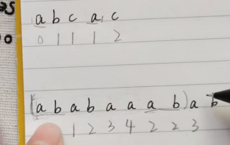

#include<bits/stdc++.h>
#define ll long long
using namespace std;
char a[1000010],c[1000010];
char b[1002],d[1002];
int nextt[1002];

int main()
{
int ans=0;
int j;
cin>>c>>d;
int len1=strlen(c);
int len2=strlen(d);
for(int i=1;i<=len1;i++) a[i]=c[i-1];
for(int i=1;i<=len2;i++) b[i]=d[i-1];
nextt[1]=0;
j=0;
for(int i=2;i<=len2;i++)
{
while(j!=0&&b[i]!=b[j+1]) j=nextt[j];
if(b[i]==b[j+1]) j++;
nextt[i]=j;
}j=0;
for(int i=1;i<=len1;i++)
{
while(j!=0&&a[i]!=b[j+1]) j=nextt[j];
if(a[i]==b[j+1]) j++;
if(j==len2)
{
cout<<i-j+1<<endl; j=nextt[j];}
}
for(int i=1;i<=len2;i++)
cout<<nextt[i]<<" ";
return 0;

}

#include<bits/stdc++.h>
#define ll long long
using namespace std;
char a[1000010];
char b[1002];
int nextt[1002];
void KMP(char *x,int *nextt)
{
nextt[0]=-1; nextt[1]=0;
int len=strlen(x);
int i=1,j=0;
while(i<len&&j<len)
{
if(j==-1||x[i]==x[j]) nextt[++i]=++j;
else j=nextt[j];
}
}
int main()
{
cin>>a>>b;
KMP(b,nextt);
int j=0;int i=0;
int len1=strlen(a);
int len2=strlen(b);
while(i<len1&&j<len2)
{
if(j==-1||a[i]==b[j]) {i++;j++;}
else
j=nextt[j];
if(j==len2) {cout<<i-j+1<<endl; j=nextt[j];}
}
for(int j=1;j<=len2;j++)
cout<<nextt[j]<<" ";
return 0;
}

