corrosim — multiscale corrosion-inhibitor report
Substrate: Fe(110) | Medium: 1 M HCl | DFT level: B3LYP/6-311++G(d,p) (ddCOSMO:water) | Generated 2026-07-14 16:36
The molecules modelled here are screened in silico as representative candidates, not a verified analysis of any real sample. Confirm the actual composition experimentally (e.g. by LC-MS/GC-MS) before drawing firm conclusions.

1. Overview
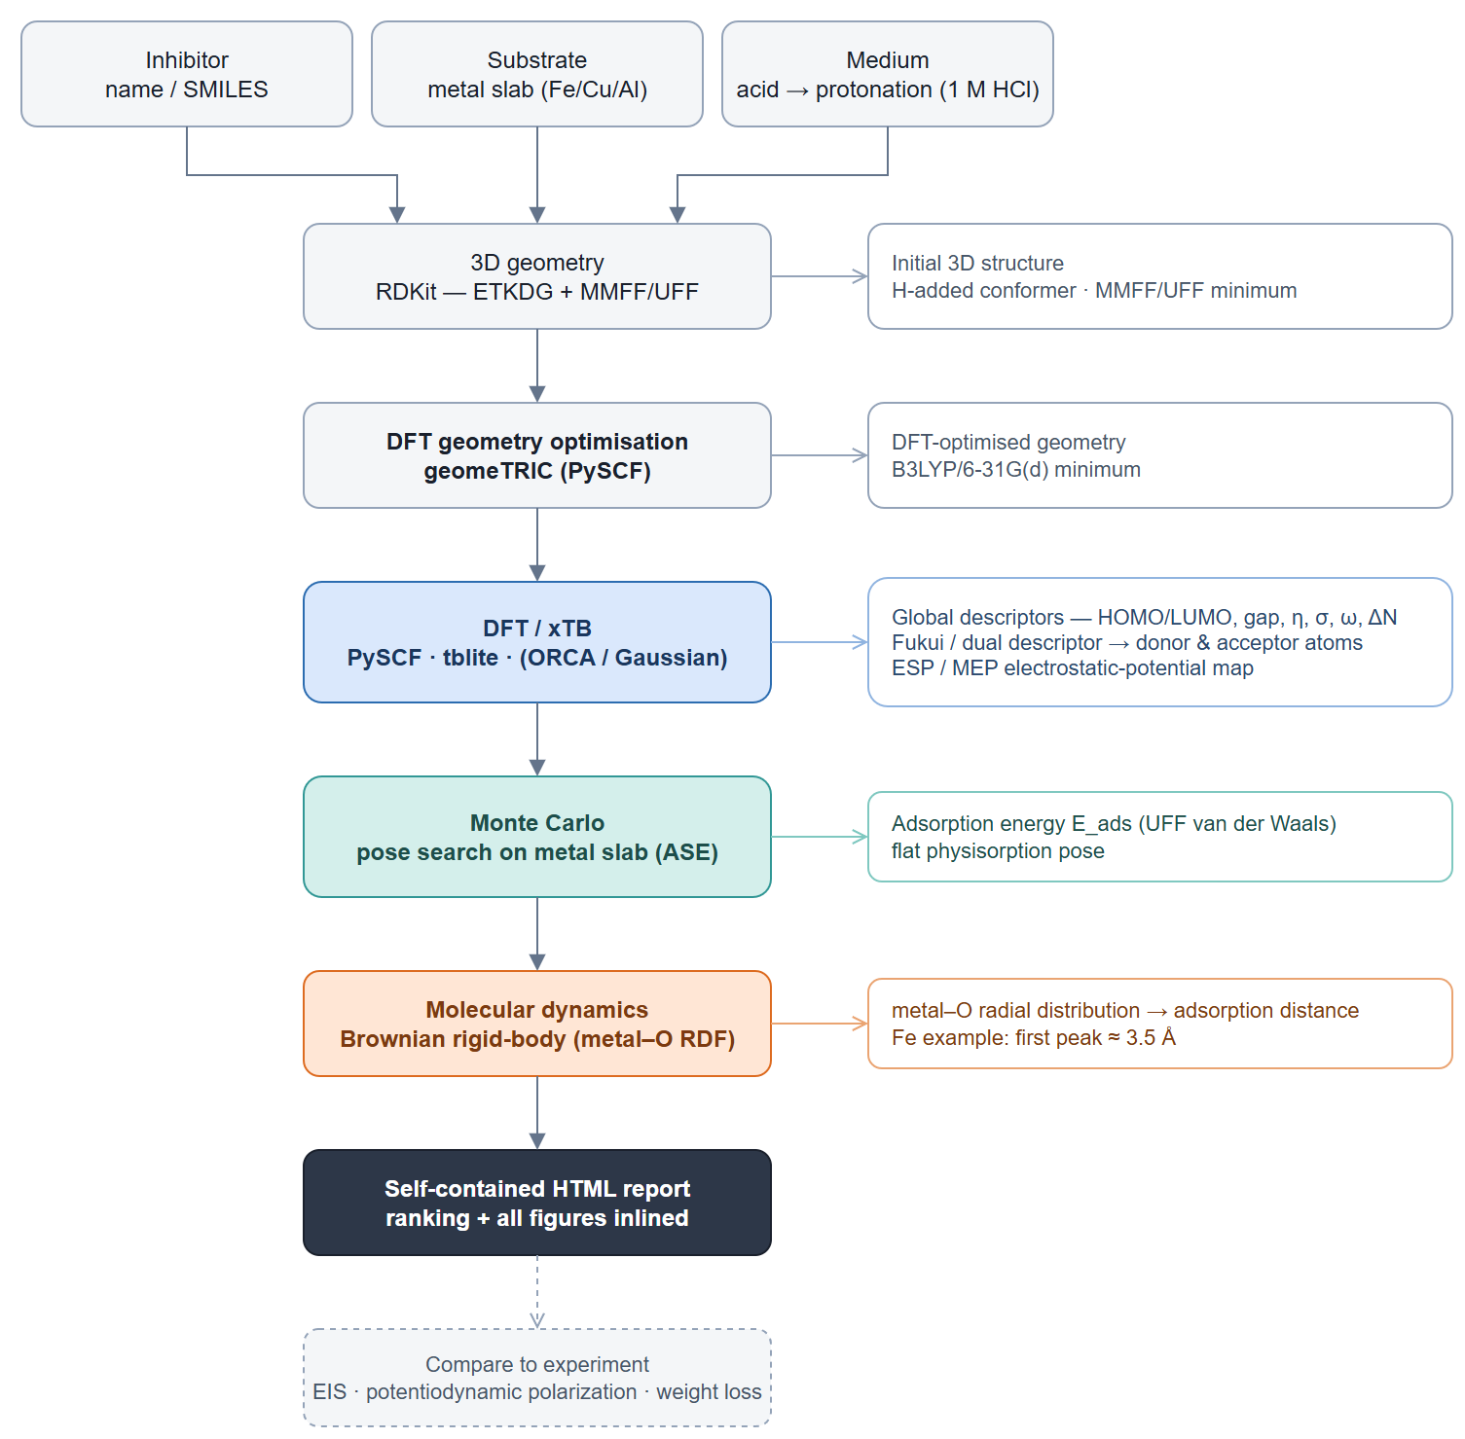
corrosim pipeline

2. Summary & ranking
Of the 3 molecules screened, quercetin ranks highest on the composite electronic score (+1.39), combining the smallest HOMO–LUMO gap (3.59 eV) with the highest softness — the most readily polarised, electron-donating candidate of the set. It adsorbs flat on Fe in the physisorption regime (E_ads ≈ -16 kJ/mol). The lead holds across all 4 descriptor bases evaluated (geometry and protonation). This is a computational screening prediction requiring electrochemical confirmation (see the Method section and caveats).
 | quercetin | isorhamnetin | kaempferol
Gap (eV) | 3.594 ✓ | 3.666 | 3.682
Hardness η (eV) | 1.797 ✓ | 1.833 | 1.841
Softness σ (1/eV) | 0.557 ✓ | 0.546 | 0.543
ΔN | 0.191 | 0.226 | 0.182
E_ads (kJ/mol) | -15.97 | -16.74 ✓ | -16.55
Fe–O (Å) | 3.25 | 3.75 | 3.15
Score | 1.391 ✓ | -0.475 | -0.916
Ranking basis | Top candidate
force-field geometry, neutral | quercetin
force-field geometry, pH-weighted | quercetin
DFT-relaxed geometry, neutral | quercetin
DFT-relaxed geometry, pH-weighted | quercetin
Lead robust: the same candidate tops all 4 descriptor bases (geometry and protonation).
Scored on the HOMO–LUMO gap, hardness and softness of the canonical basis (DFT-relaxed geometry, pH-weighted; z-scored; higher = stronger). The geometry / protonation panels below are a sensitivity check, not separate rankings. E_ads and the Fe–O distance validate the lead, they do not enter the score. Full method: docs/pipeline.md.

3. DFT electronic descriptors
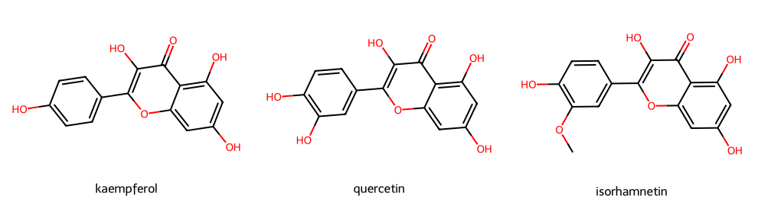
Modelled molecules
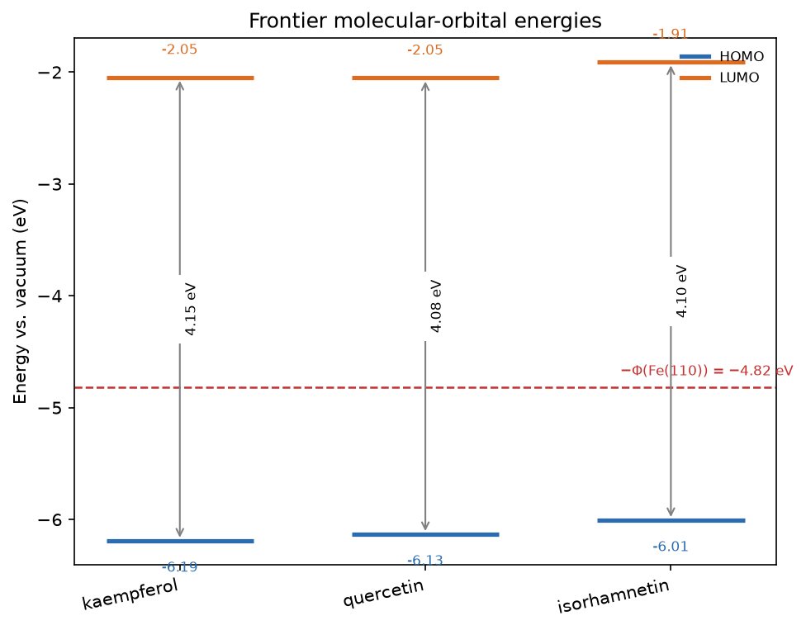
Frontier-orbital energies vs the metal work function

3.1 Frontier-orbital isosurfaces (HOMO / LUMO)
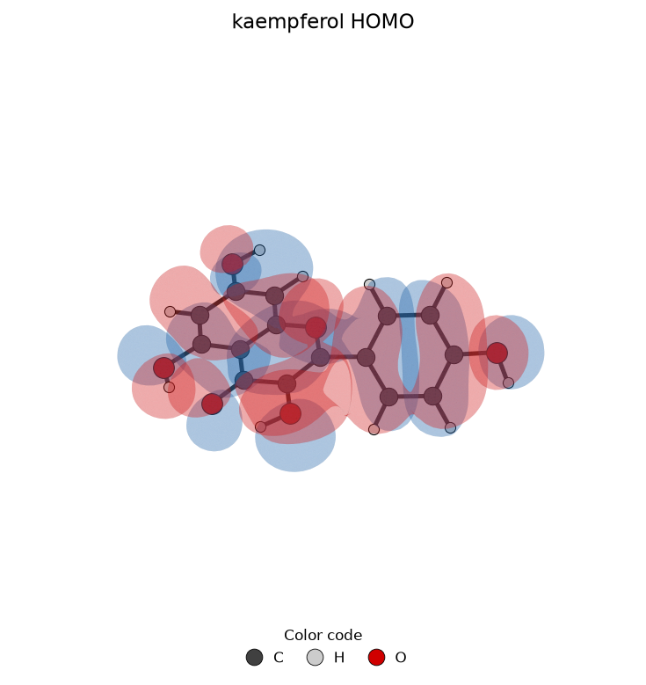
kaempferol HOMO
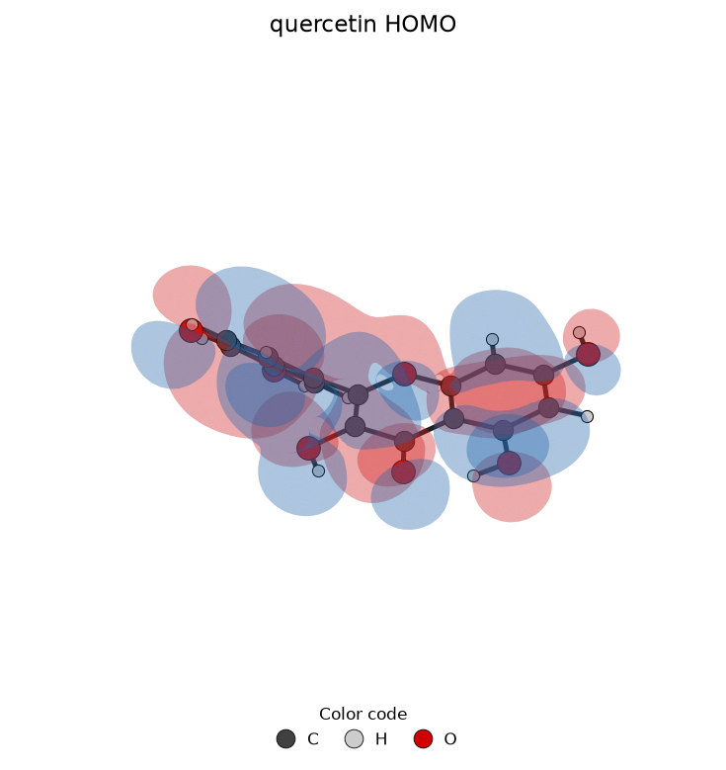
quercetin HOMO
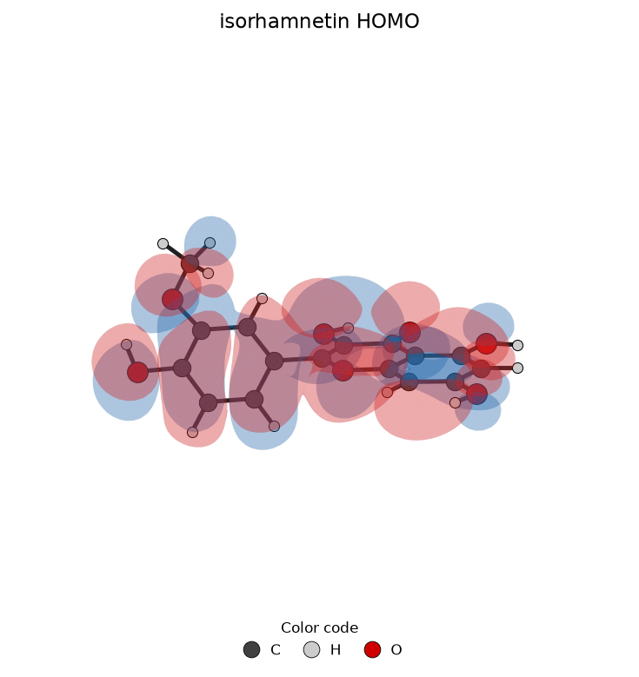
isorhamnetin HOMO
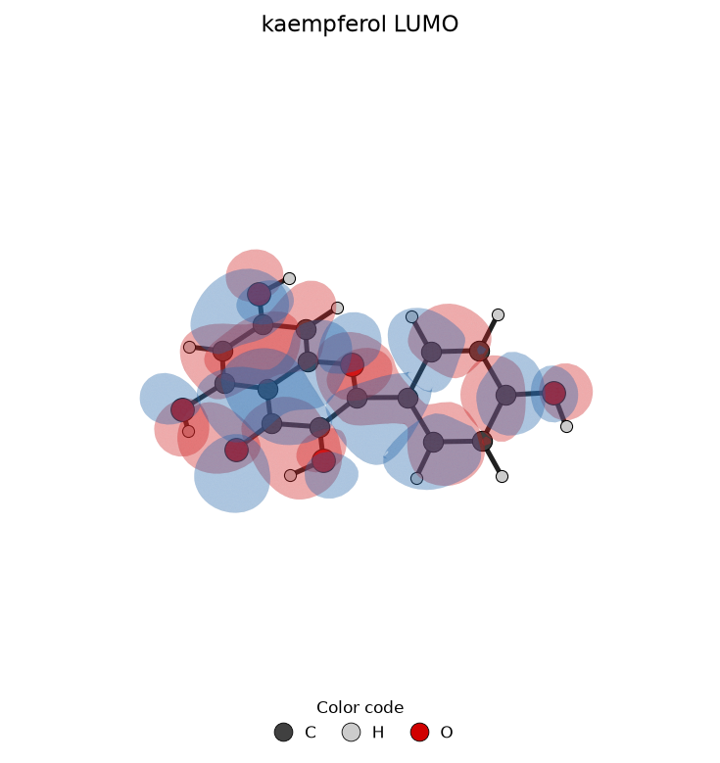
kaempferol LUMO
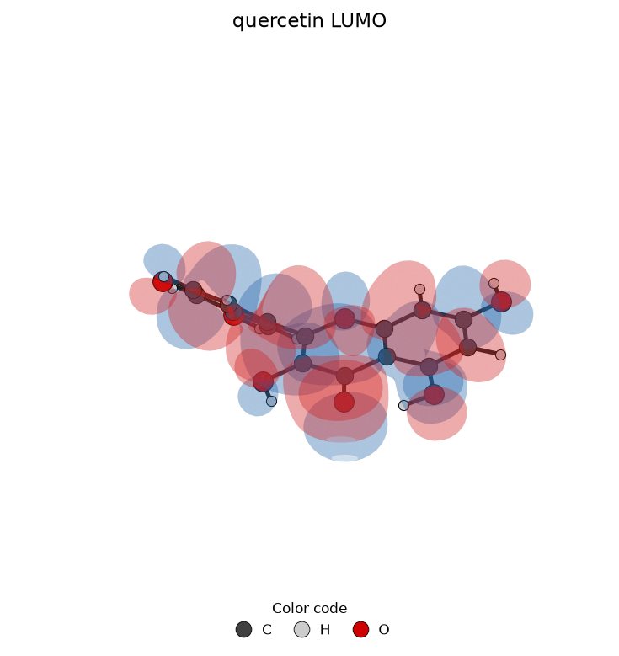
quercetin LUMO
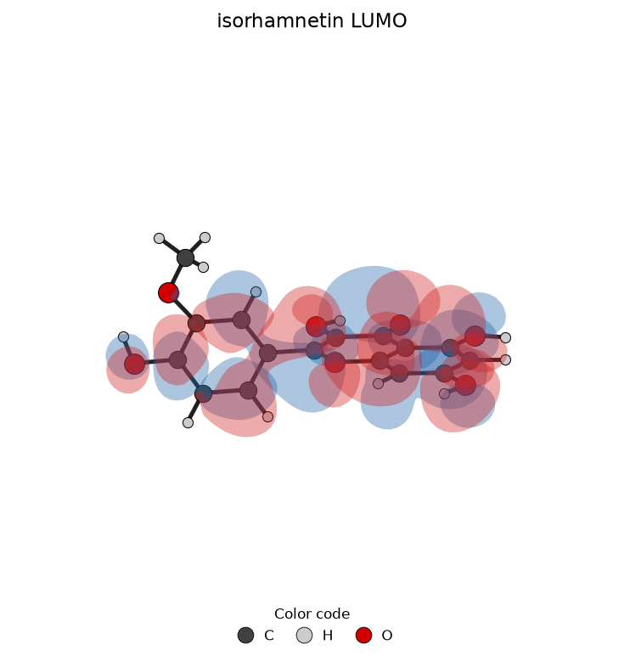
isorhamnetin LUMO
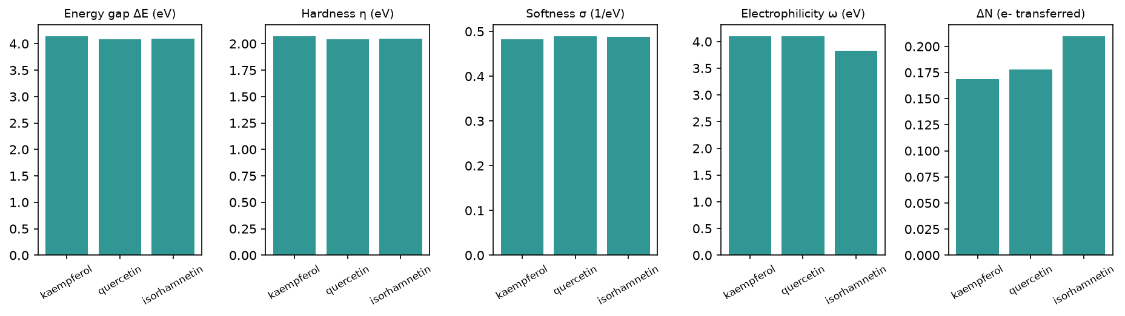
Reactivity descriptors
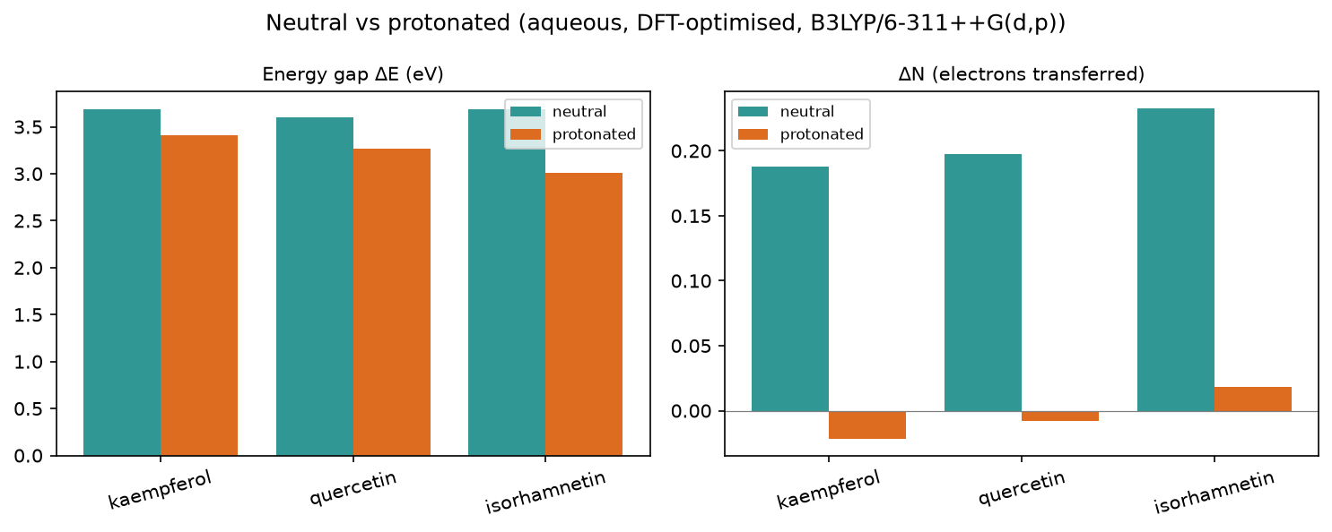
Protonation effect

3.2 Full descriptor table (neutral, aqueous)
Descriptor | kaempferol | quercetin | isorhamnetin
Formula | C15H10O6 | C15H10O7 | C16H12O7
HOMO (eV) | -6.193 | -6.134 | -6.009
LUMO (eV) | -2.047 | -2.052 | -1.91
Gap ΔE (eV) | 4.146 | 4.082 | 4.099
η hardness (eV) | 2.073 | 2.041 | 2.049
σ softness (1/eV) | 0.482 | 0.49 | 0.488
χ electronegativity (eV) | 4.12 | 4.093 | 3.959
ω electrophilicity (eV) | 4.094 | 4.104 | 3.824
ΔN | 0.169 | 0.178 | 0.21
E_back-donation (eV) | -0.518 | -0.51 | -0.512
TNC | -4.422 | -4.714 | -5.525
E_ads (kJ/mol) | -16.55 | -15.97 | -16.74

3.3 Geometry refinement (FF vs DFT-optimised)
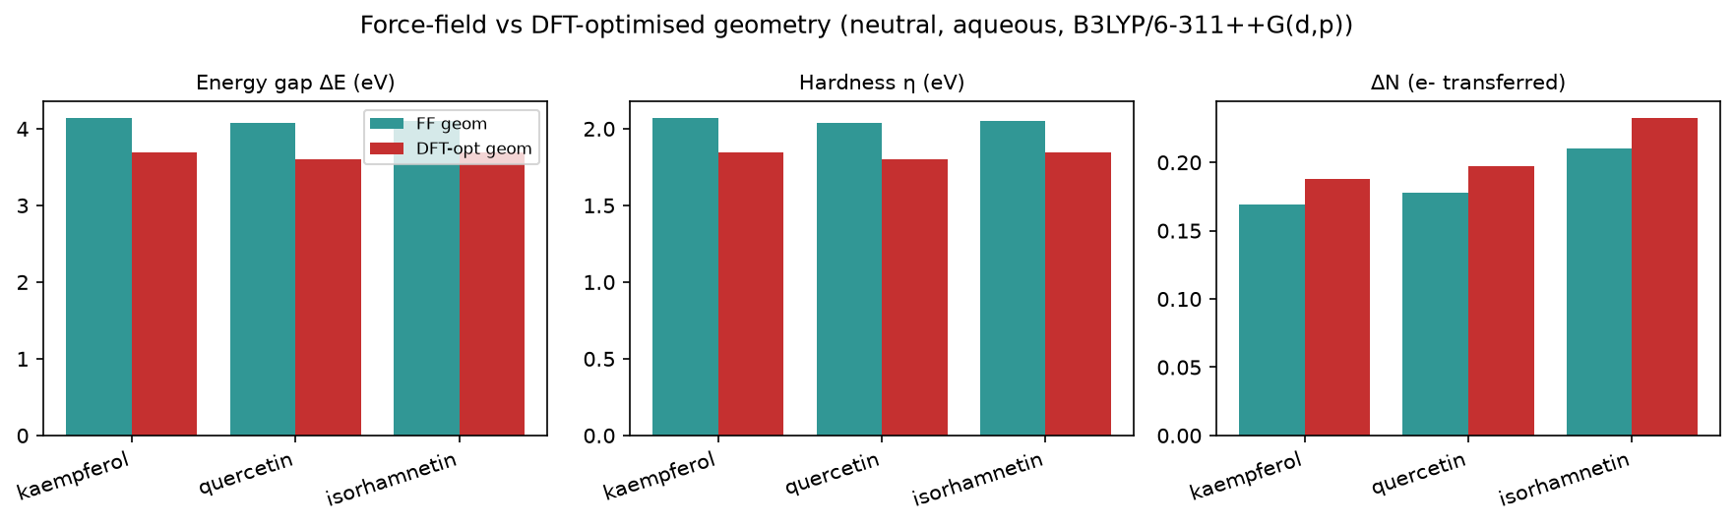
Force-field vs DFT-optimised geometry

3.4 Optimised-geometry descriptors (DFT-relaxed)
Descriptor | kaempferol | quercetin | isorhamnetin
Formula | C15H10O6 | C15H10O7 | C16H12O7
HOMO (eV) | -5.971 | -5.911 | -5.805
LUMO (eV) | -2.281 | -2.307 | -2.118
Gap ΔE (eV) | 3.69 | 3.604 | 3.687
η hardness (eV) | 1.845 | 1.802 | 1.843
σ softness (1/eV) | 0.542 | 0.555 | 0.542
χ electronegativity (eV) | 4.126 | 4.109 | 3.962
ω electrophilicity (eV) | 4.613 | 4.685 | 4.257
ΔN | 0.188 | 0.197 | 0.233
E_back-donation (eV) | -0.461 | -0.451 | -0.461
TNC | -6.092 | -6.552 | -6.85
Sensitivity: descriptors on the DFT-relaxed geometry (the geometry axis of the ranking ensemble). The headline ranks on the canonical basis; see the Summary.

Optimised protonated cations (in-acid)
Descriptor | kaempferol+H+ | quercetin+H+ | isorhamnetin+H+
Formula | C15H11O6+ | C15H11O7+ | C16H13O7+
HOMO (eV) | -6.601 | -6.477 | -6.269
LUMO (eV) | -3.188 | -3.214 | -3.261
Gap ΔE (eV) | 3.413 | 3.263 | 3.008
η hardness (eV) | 1.707 | 1.631 | 1.504
σ softness (1/eV) | 0.586 | 0.613 | 0.665
χ electronegativity (eV) | 4.894 | 4.846 | 4.765
ω electrophilicity (eV) | 7.018 | 7.196 | 7.547
ΔN | -0.022 | -0.008 | 0.018
E_back-donation (eV) | -0.427 | -0.408 | -0.376
TNC | -4.205 | -4.754 | -7.044

3.5 Species in the acidic medium (protonated cation)
Descriptor | kaempferol+H+ | quercetin+H+ | isorhamnetin+H+
Formula | C15H11O6+ | C15H11O7+ | C16H13O7+
HOMO (eV) | -6.881 | -6.668 | -6.427
LUMO (eV) | -3.277 | -3.324 | -3.295
Gap ΔE (eV) | 3.604 | 3.344 | 3.132
η hardness (eV) | 1.802 | 1.672 | 1.566
σ softness (1/eV) | 0.555 | 0.598 | 0.639
χ electronegativity (eV) | 5.079 | 4.996 | 4.861
ω electrophilicity (eV) | 7.157 | 7.465 | 7.546
ΔN | -0.072 | -0.053 | -0.013
E_back-donation (eV) | -0.451 | -0.418 | -0.391
TNC | -4.014 | -4.438 | -4.993
Protonated +1 cation descriptors in 1 M HCl; a component of the pH-weighted canonical basis (see the Summary), shown here on its own.

3.6 Speciation in 1 M HCl (pH ≈ -0.0)
97% neutral / 3% protonated at this pH — the neutral form dominates. Population-weighted descriptors (the speciation axis of the ranking ensemble; the headline ranks on the canonical basis):
Descriptor | kaempferol | quercetin | isorhamnetin
Formula | C15H10O6 | C15H10O7 | C16H12O7
HOMO (eV) | -6.214 | -6.151 | -6.022
LUMO (eV) | -2.085 | -2.091 | -1.952
Gap ΔE (eV) | 4.129 | 4.06 | 4.069
η hardness (eV) | 2.064 | 2.03 | 2.035
σ softness (1/eV) | 0.485 | 0.493 | 0.492
χ electronegativity (eV) | 4.149 | 4.121 | 3.987
ω electrophilicity (eV) | 4.188 | 4.207 | 3.938
ΔN | 0.162 | 0.171 | 0.203
E_back-donation (eV) | -0.516 | -0.507 | -0.509
TNC | -4.41 | -4.705 | -5.509
 | kaempferol | quercetin | isorhamnetin
computed pKaH | -12.9 | -13.3 | -3.9
% protonated | 0.00% | 0.00% | 0.01%
Computed pKaH (DFT cycle, frequency-corrected).

3.7 Local reactivity (Fukui)
kaempferol: O3 (f⁻=0.116), O12 (f⁻=0.055), O19 (f⁻=0.053)
quercetin: O3 (f⁻=0.090), O9 (f⁻=0.088), O11 (f⁻=0.040)
isorhamnetin: O9 (f⁻=0.094), O3 (f⁻=0.093), O11 (f⁻=0.043)
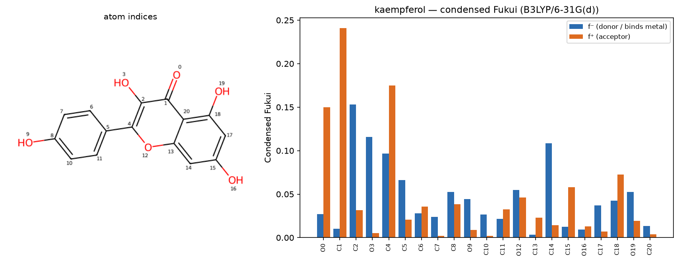
kaempferol — condensed Fukui
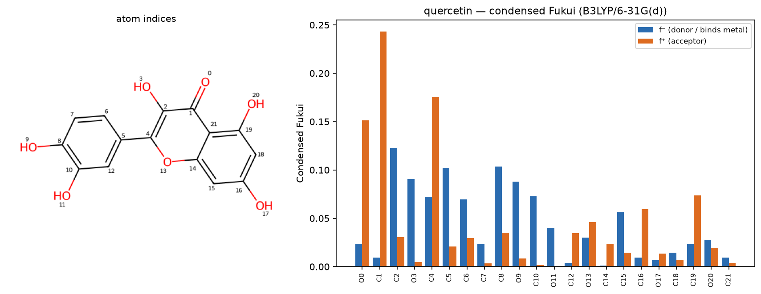
quercetin — condensed Fukui
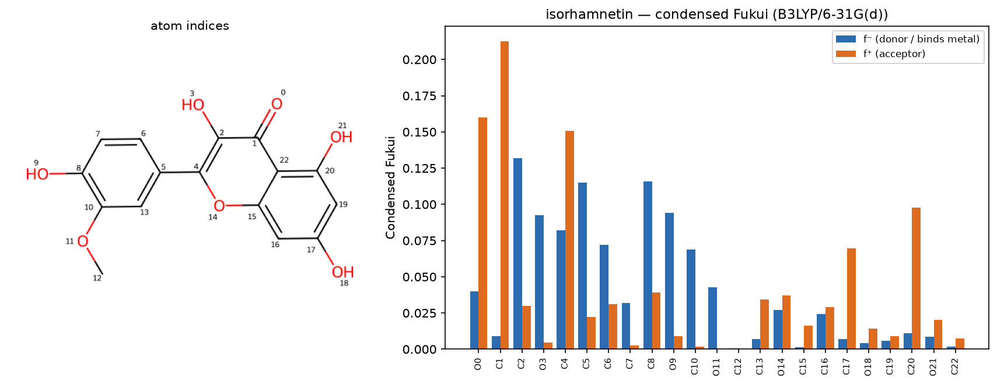
isorhamnetin — condensed Fukui

3.8 Electrostatic-potential (ESP) map
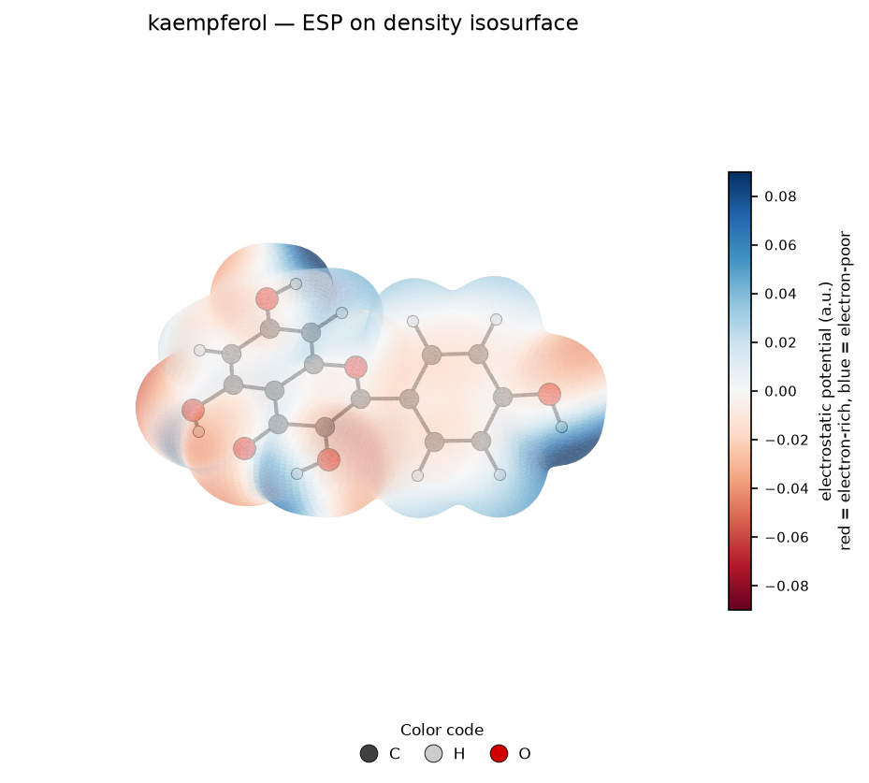
kaempferol — ESP map
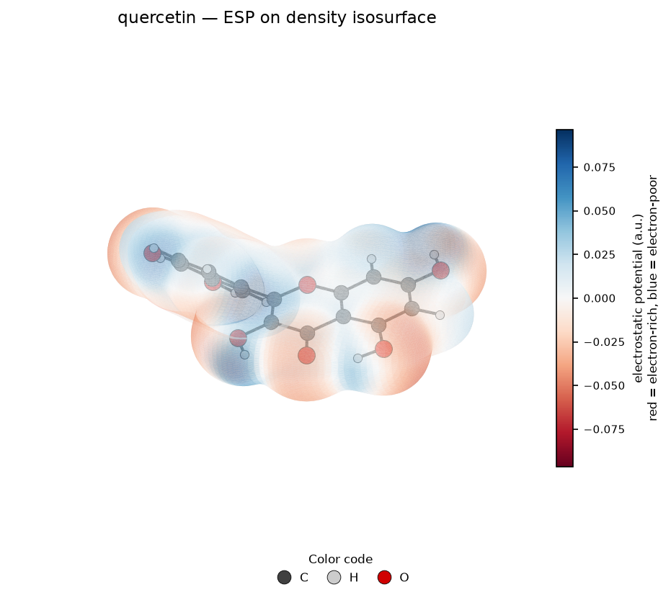
quercetin — ESP map
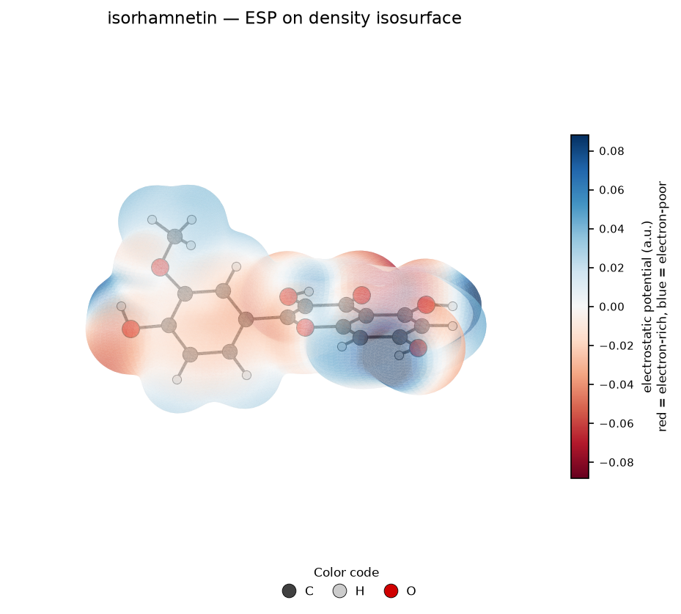
isorhamnetin — ESP map

4. Monte Carlo adsorption
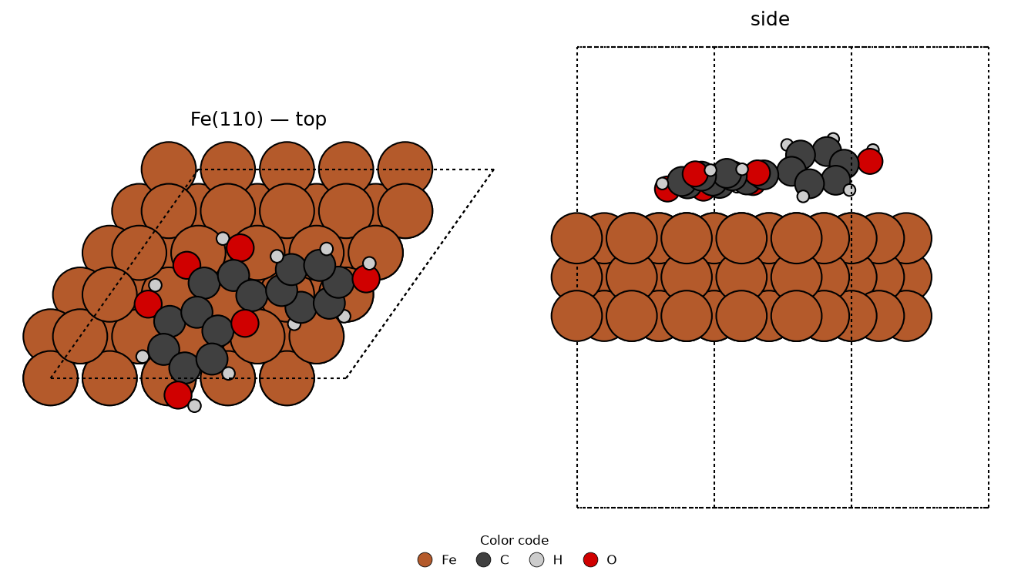
kaempferol — best pose
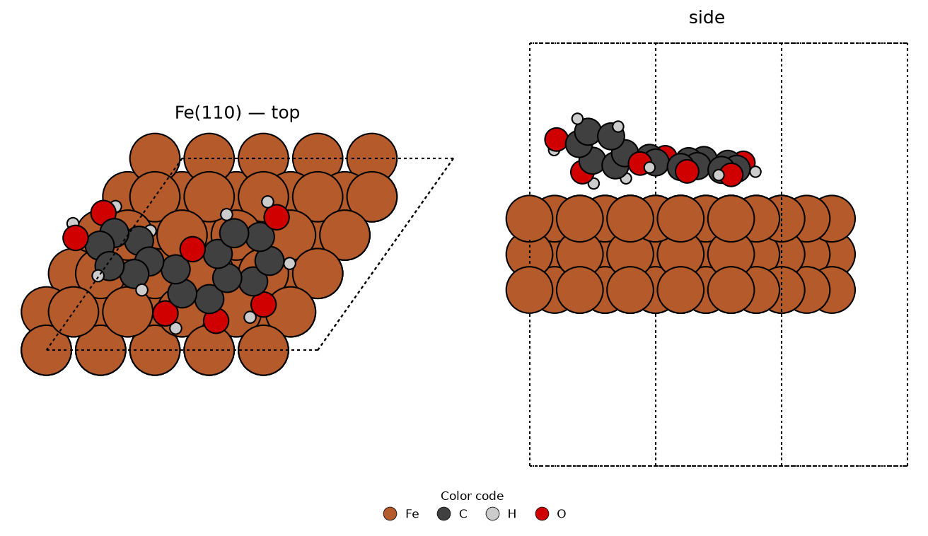
quercetin — best pose
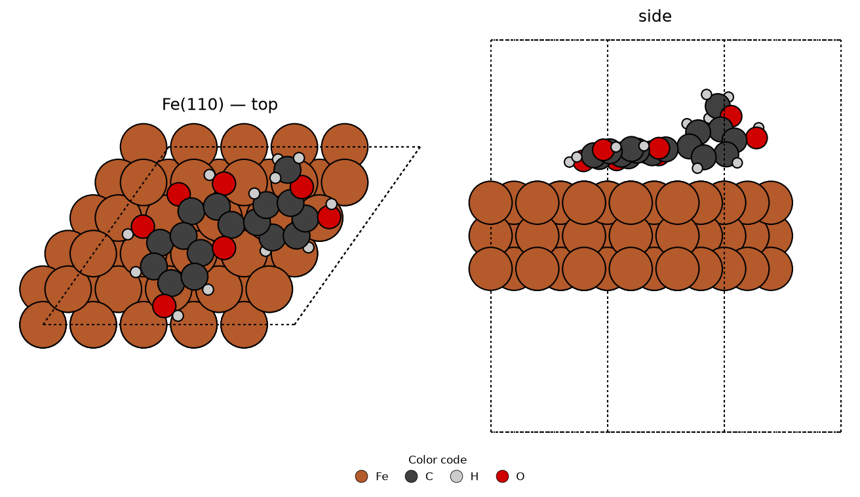
isorhamnetin — best pose
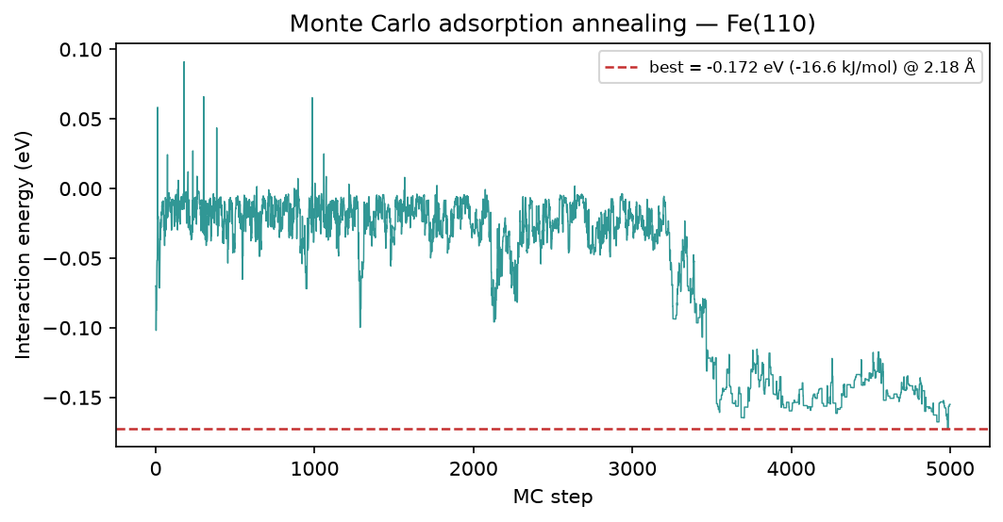
kaempferol — MC annealing
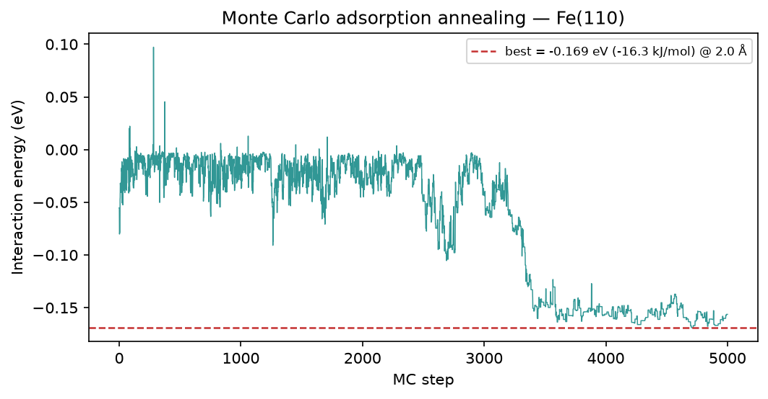
quercetin — MC annealing
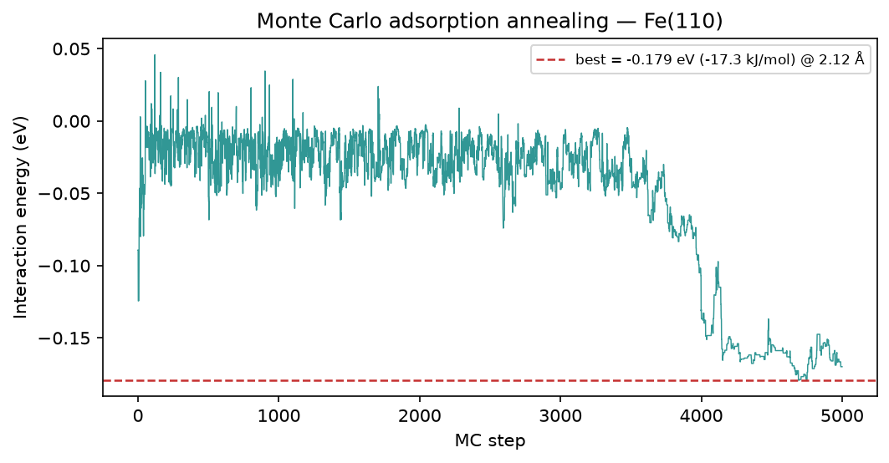
isorhamnetin — MC annealing

5. Brownian MD (Fe-O RDF)
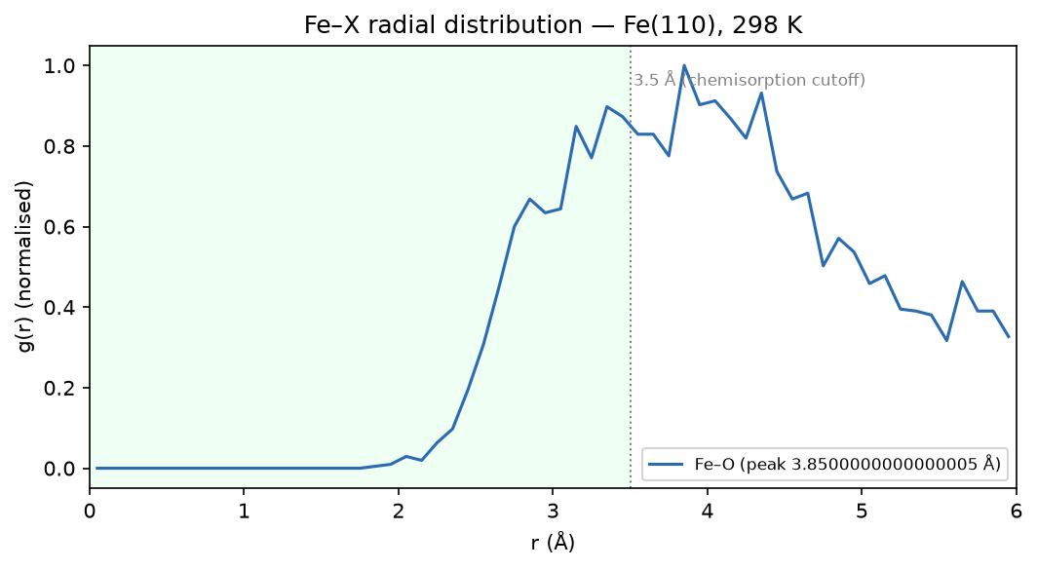
kaempferol — Fe-O RDF
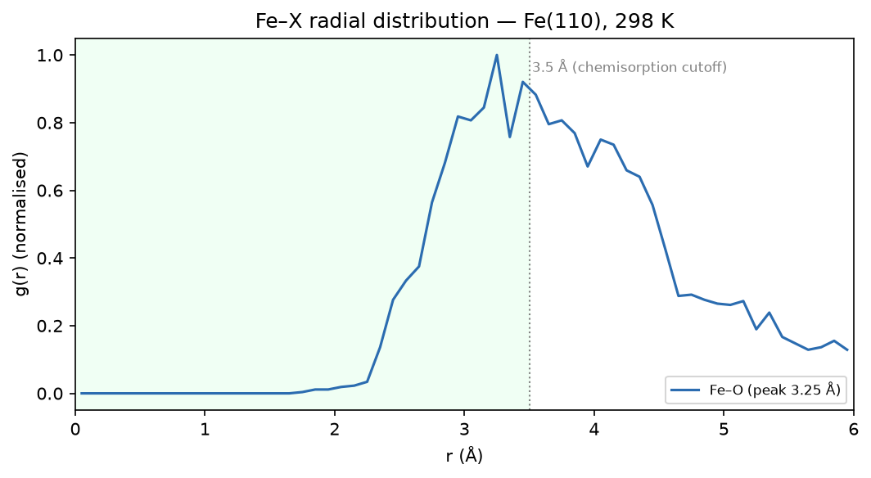
quercetin — Fe-O RDF
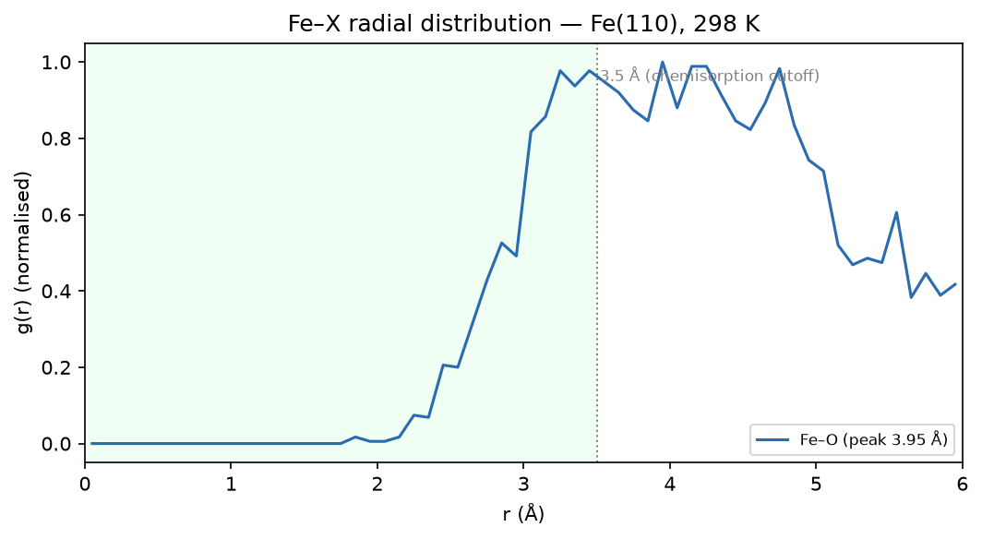
isorhamnetin — Fe-O RDF

6. Method & caveats
DFT level: B3LYP/6-311++G(d,p) (ddCOSMO:water). Global descriptors come from the frontier-orbital energies via Koopmans' theorem; ΔN uses the metal work function with η(metal) = 0. The Monte-Carlo and Brownian-MD stages use a classical van-der-Waals adsorption model — a physics-based screening surrogate, not a substitute for periodic DFT or for electrochemical validation. The composite ranking is a heuristic that orders candidates; it does not prove inhibition. Full methodology: docs/pipeline.md; validation record: docs/validation.md.

