corrosim — multiscale corrosion-inhibitor report
Substrate: Fe(110) | Medium: 1 M HCl | DFT level: B3LYP/6-311++G(d,p) (ddCOSMO:water) | Generated 2026-07-08 09:09
The molecules modelled here are screened in silico as representative candidates, not a verified analysis of any real sample. Confirm the actual composition experimentally (e.g. by LC-MS/GC-MS) before drawing firm conclusions.

1. Overview
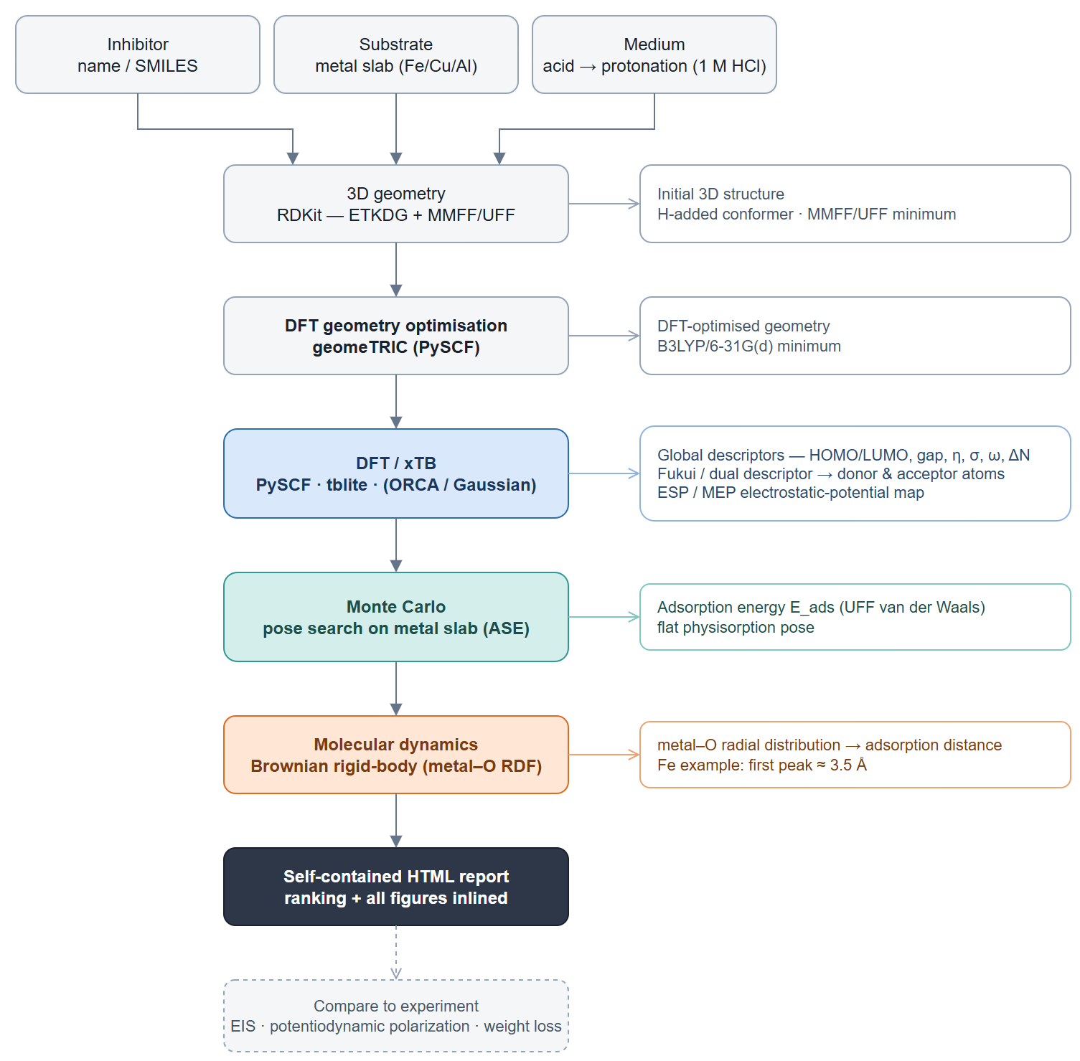
corrosim pipeline

2. Summary & ranking
Of the 3 molecules screened, quercetin ranks highest on the composite electronic score (+0.99), combining the smallest HOMO–LUMO gap (4.08 eV) with the highest softness — the most readily polarised, electron-donating candidate of the set. It adsorbs flat on Fe in the physisorption regime (E_ads ≈ -16 kJ/mol). This is a computational screening prediction requiring electrochemical confirmation (see the Method section and caveats).
Inhibitor | Gap (eV) | Hardness η (eV) | Softness σ (1/eV) | ΔN | E_ads (kJ/mol) | Fe–O (Å) | Score
quercetin | 4.082 | 2.041 | 0.49 | 0.178 | -15.97 | 3.25 | 0.995
isorhamnetin | 4.099 | 2.049 | 0.488 | 0.21 | -16.74 | 3.75 | 0.373
kaempferol | 4.146 | 2.073 | 0.482 | 0.169 | -16.55 | 3.15 | -1.368
Scored on the neutral HOMO–LUMO gap, hardness and softness (z-scored; higher = stronger). E_ads and the Fe–O distance validate the lead, they do not enter the score. Full method: docs/pipeline.md.

3. DFT electronic descriptors
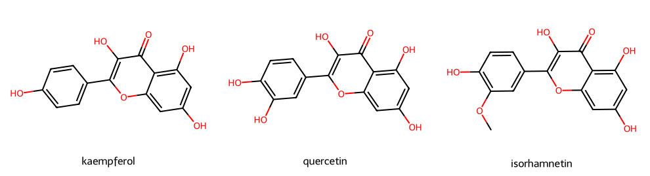
Modelled molecules
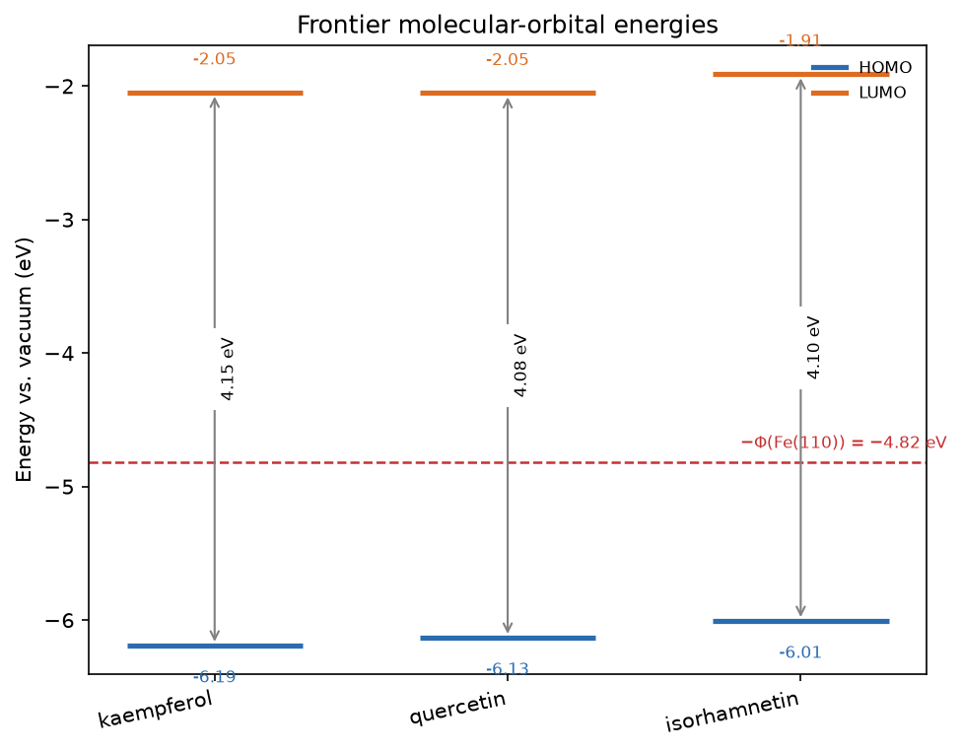
Frontier-orbital energies vs the metal work function

3.1 Frontier-orbital isosurfaces (HOMO / LUMO)
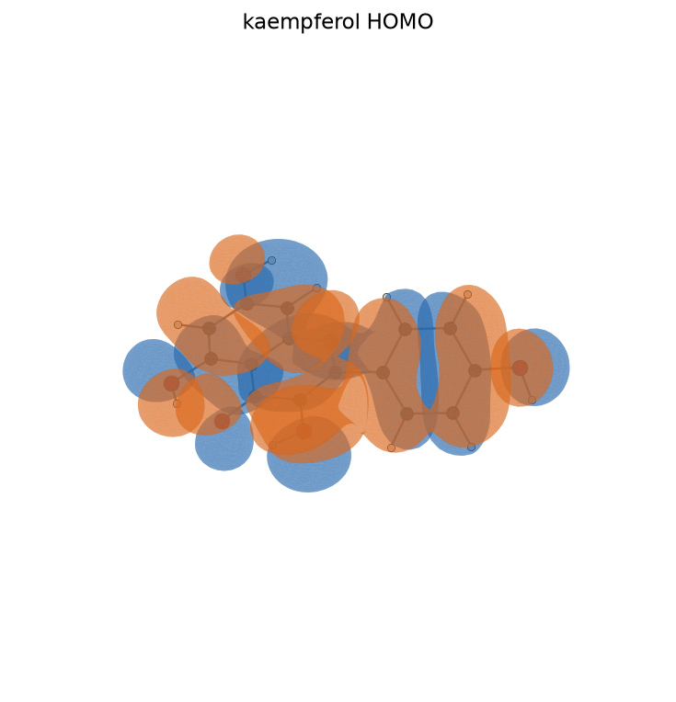
kaempferol HOMO
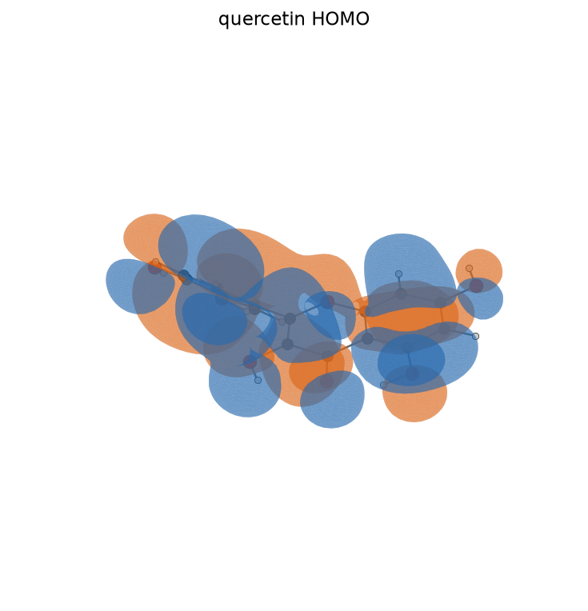
quercetin HOMO
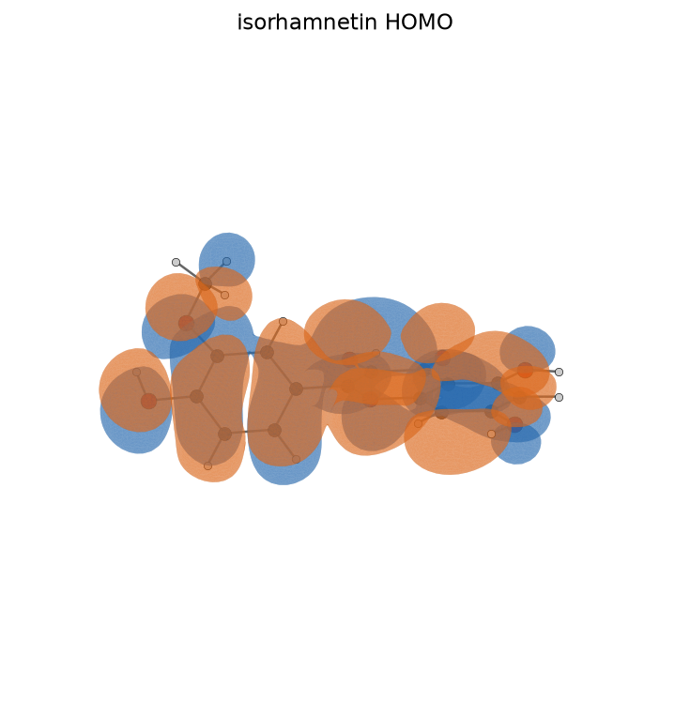
isorhamnetin HOMO
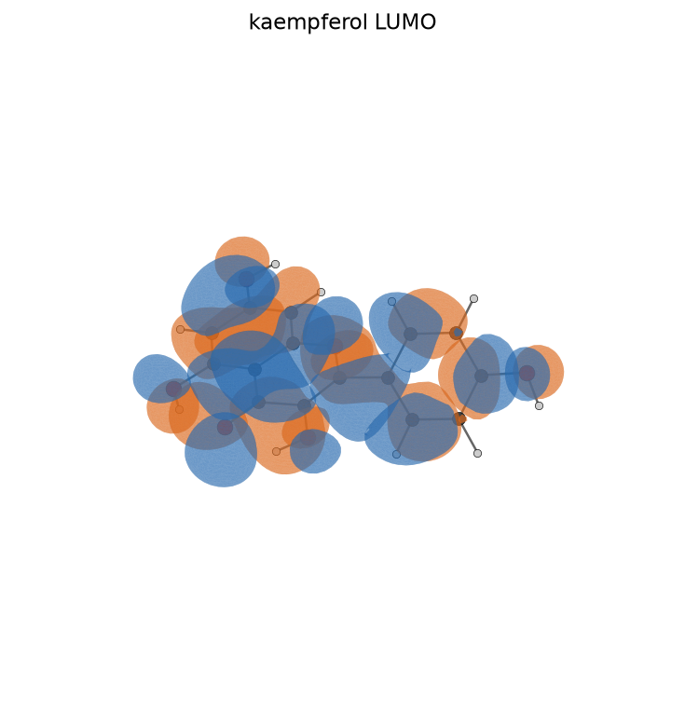
kaempferol LUMO
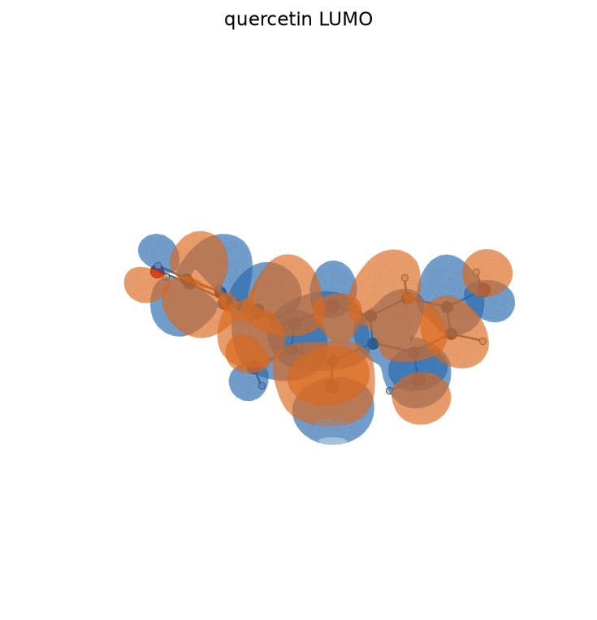
quercetin LUMO
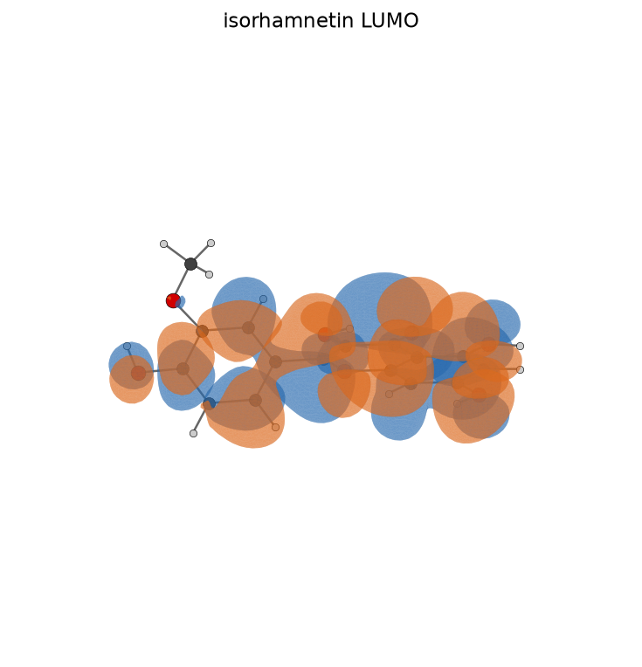
isorhamnetin LUMO
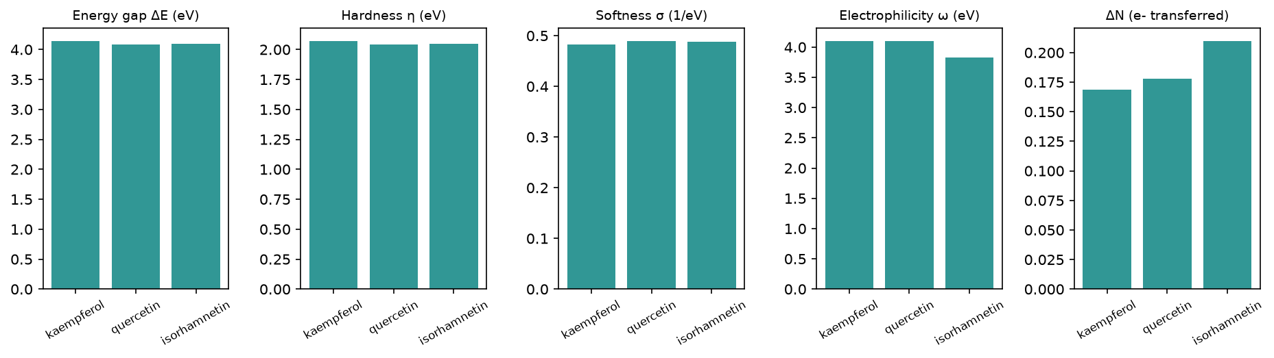
Reactivity descriptors
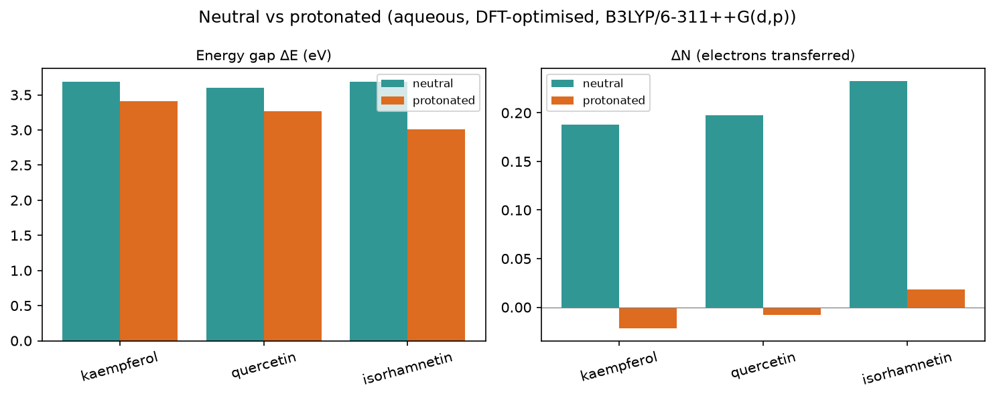
Protonation effect

3.2 Full descriptor table (neutral, aqueous)
name | formula | charge | level | homo_ev | lumo_ev | gap_ev | hardness_ev | softness_inv_ev | electronegativity_ev | electrophilicity_ev | delta_n | back_donation_ev | tnc | e_ads_kjmol
kaempferol | C15H10O6 | 0 | B3LYP/6-311++G(d,p) (ddCOSMO:water) | -6.193 | -2.047 | 4.146 | 2.073 | 0.482 | 4.12 | 4.094 | 0.169 | -0.518 | -4.422 | -16.55
quercetin | C15H10O7 | 0 | B3LYP/6-311++G(d,p) (ddCOSMO:water) | -6.134 | -2.052 | 4.082 | 2.041 | 0.49 | 4.093 | 4.104 | 0.178 | -0.51 | -4.714 | -15.97
isorhamnetin | C16H12O7 | 0 | B3LYP/6-311++G(d,p) (ddCOSMO:water) | -6.009 | -1.91 | 4.099 | 2.049 | 0.488 | 3.959 | 3.824 | 0.21 | -0.512 | -5.525 | -16.74

3.3 Geometry refinement (FF vs DFT-optimised)
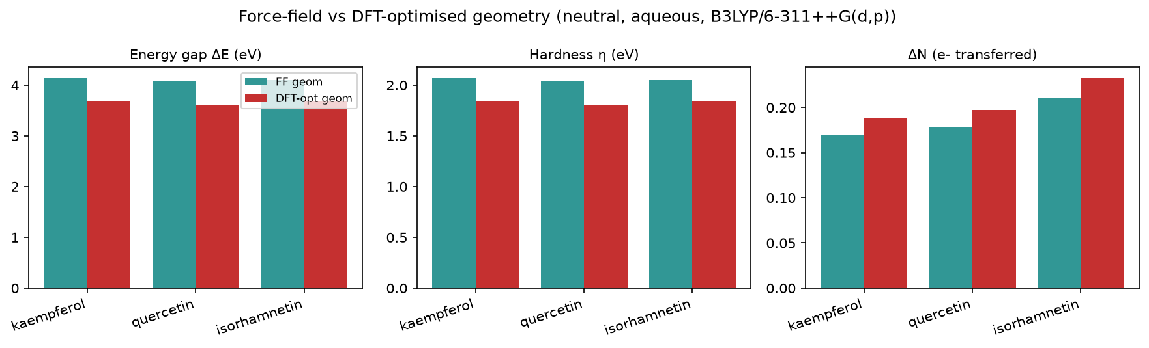
Force-field vs DFT-optimised geometry

3.4 Optimised-geometry descriptors (DFT-relaxed)
name | gap_ev | hardness_ev | softness_inv_ev | delta_n | tnc | score
quercetin | 3.604 | 1.802 | 0.555 | 0.197 | -6.552 | 1.413
isorhamnetin | 3.687 | 1.843 | 0.542 | 0.233 | -6.85 | -0.665
kaempferol | 3.69 | 1.845 | 0.542 | 0.188 | -6.092 | -0.748

Optimised protonated cations (in-acid)
name | formula | charge | level | homo_ev | lumo_ev | gap_ev | hardness_ev | softness_inv_ev | electronegativity_ev | electrophilicity_ev | delta_n | back_donation_ev | tnc
kaempferol+H+ | C15H11O6+ | 1 | B3LYP/6-311++G(d,p) (ddCOSMO:water) | -6.601 | -3.188 | 3.413 | 1.707 | 0.586 | 4.894 | 7.018 | -0.022 | -0.427 | -4.205
quercetin+H+ | C15H11O7+ | 1 | B3LYP/6-311++G(d,p) (ddCOSMO:water) | -6.477 | -3.214 | 3.263 | 1.631 | 0.613 | 4.846 | 7.196 | -0.008 | -0.408 | -4.754
isorhamnetin+H+ | C16H13O7+ | 1 | B3LYP/6-311++G(d,p) (ddCOSMO:water) | -6.269 | -3.261 | 3.008 | 1.504 | 0.665 | 4.765 | 7.547 | 0.018 | -0.376 | -7.044

3.5 Species in the acidic medium (protonated cation)
name | formula | charge | level | homo_ev | lumo_ev | gap_ev | hardness_ev | softness_inv_ev | electronegativity_ev | electrophilicity_ev | delta_n | back_donation_ev | tnc
kaempferol+H+ | C15H11O6+ | 1 | B3LYP/6-311++G(d,p) (ddCOSMO:water) | -6.881 | -3.277 | 3.604 | 1.802 | 0.555 | 5.079 | 7.157 | -0.072 | -0.451 | -4.014
quercetin+H+ | C15H11O7+ | 1 | B3LYP/6-311++G(d,p) (ddCOSMO:water) | -6.668 | -3.324 | 3.344 | 1.672 | 0.598 | 4.996 | 7.465 | -0.053 | -0.418 | -4.438
isorhamnetin+H+ | C16H13O7+ | 1 | B3LYP/6-311++G(d,p) (ddCOSMO:water) | -6.427 | -3.295 | 3.132 | 1.566 | 0.639 | 4.861 | 7.546 | -0.013 | -0.391 | -4.993
Protonated +1 cation descriptors in 1 M HCl; the headline ranking stays on the neutral form (see docs/pipeline.md).

3.6 Speciation in 1 M HCl (pH ≈ -0.0)
97% neutral / 3% protonated at this pH — the neutral form dominates. Population-weighted descriptors (blended lead quercetin):
name | formula | charge | level | homo_ev | lumo_ev | gap_ev | hardness_ev | softness_inv_ev | electronegativity_ev | electrophilicity_ev | delta_n | back_donation_ev | tnc
kaempferol | C15H10O6 | 0 | B3LYP/6-311++G(d,p) (ddCOSMO:water) | -6.214 | -2.085 | 4.129 | 2.064 | 0.485 | 4.149 | 4.188 | 0.162 | -0.516 | -4.41
quercetin | C15H10O7 | 0 | B3LYP/6-311++G(d,p) (ddCOSMO:water) | -6.151 | -2.091 | 4.06 | 2.03 | 0.493 | 4.121 | 4.207 | 0.171 | -0.507 | -4.705
isorhamnetin | C16H12O7 | 0 | B3LYP/6-311++G(d,p) (ddCOSMO:water) | -6.022 | -1.952 | 4.069 | 2.035 | 0.492 | 3.987 | 3.938 | 0.203 | -0.509 | -5.509
molecule | computed pKaH | % protonated
kaempferol | -12.9 | 0.00%
quercetin | -13.3 | 0.00%
isorhamnetin | -3.9 | 0.01%
Computed pKaH (DFT cycle, frequency-corrected).

3.7 Local reactivity (Fukui)
kaempferol: O3 (f⁻=0.116), O12 (f⁻=0.055), O19 (f⁻=0.053)
quercetin: O3 (f⁻=0.090), O9 (f⁻=0.088), O11 (f⁻=0.040)
isorhamnetin: O9 (f⁻=0.094), O3 (f⁻=0.093), O11 (f⁻=0.043)
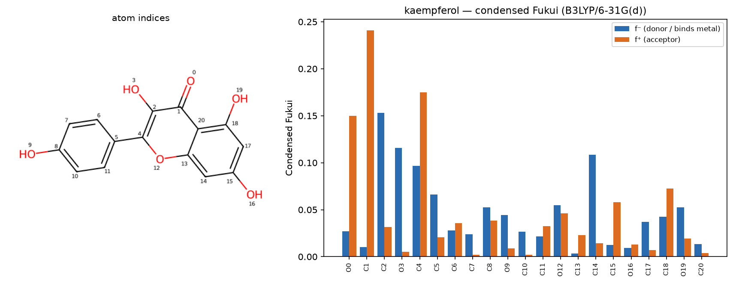
kaempferol — condensed Fukui
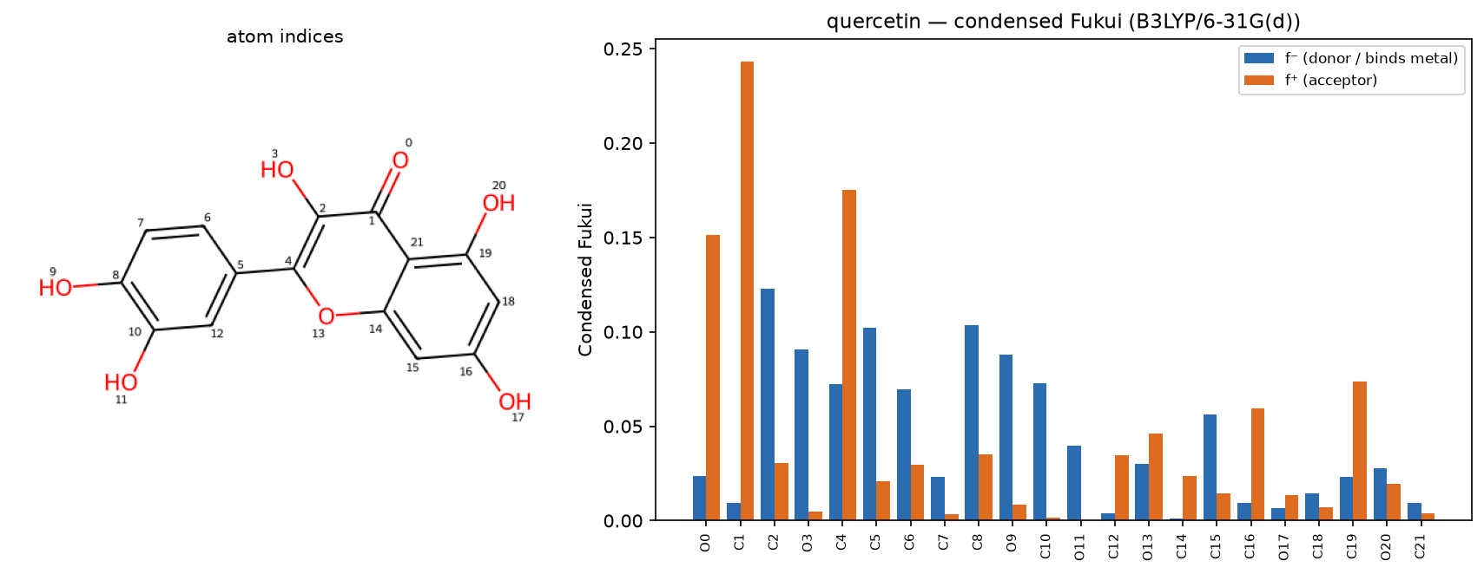
quercetin — condensed Fukui
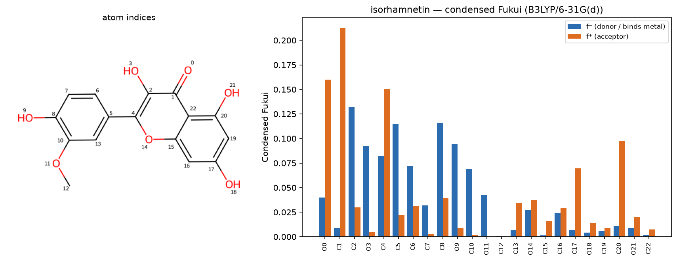
isorhamnetin — condensed Fukui

3.8 Electrostatic-potential (ESP) map
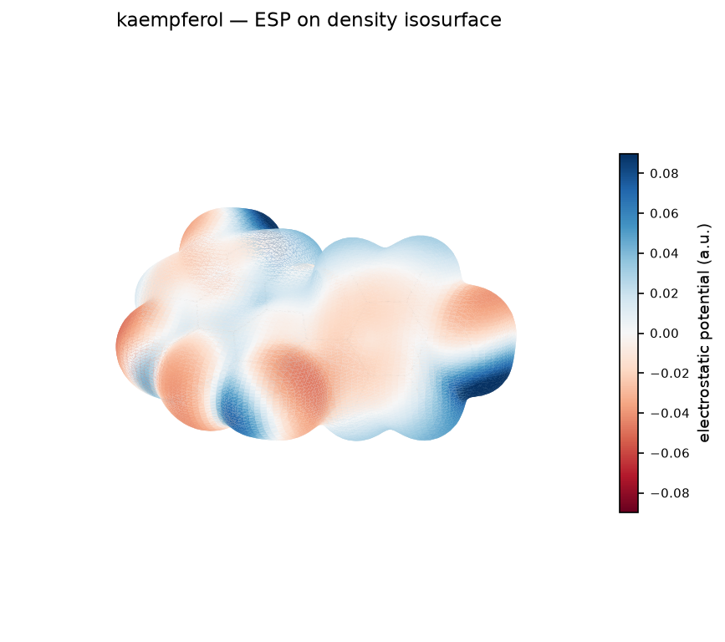
kaempferol — ESP map
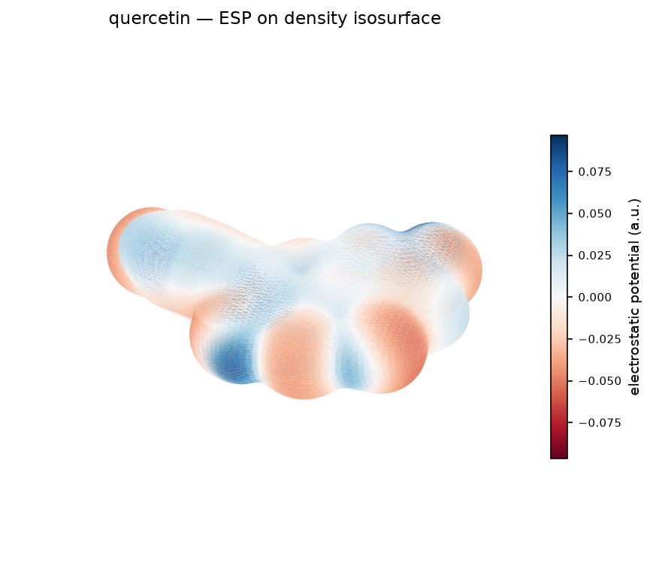
quercetin — ESP map
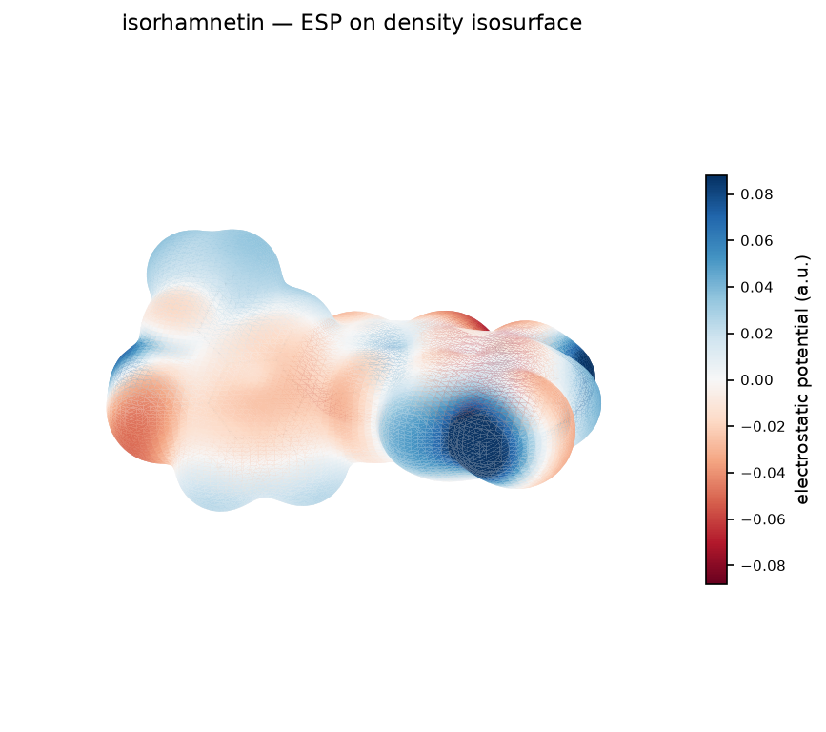
isorhamnetin — ESP map

4. Monte Carlo adsorption
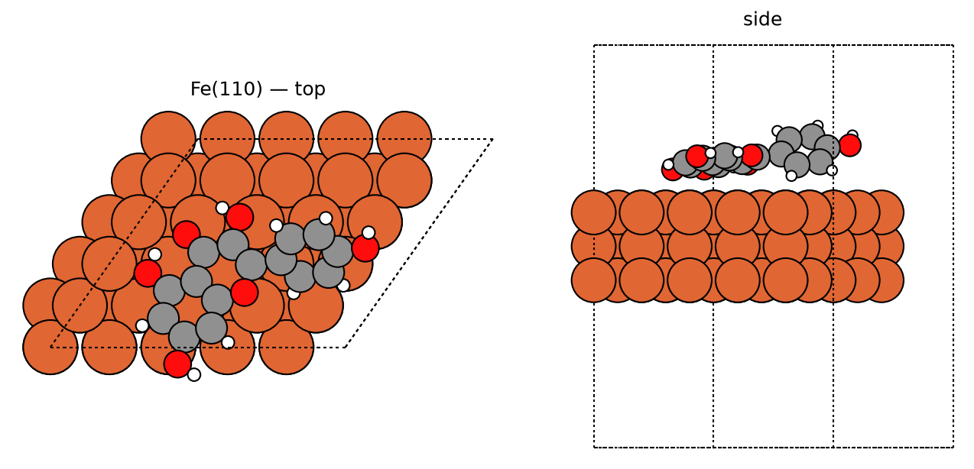
kaempferol — best pose
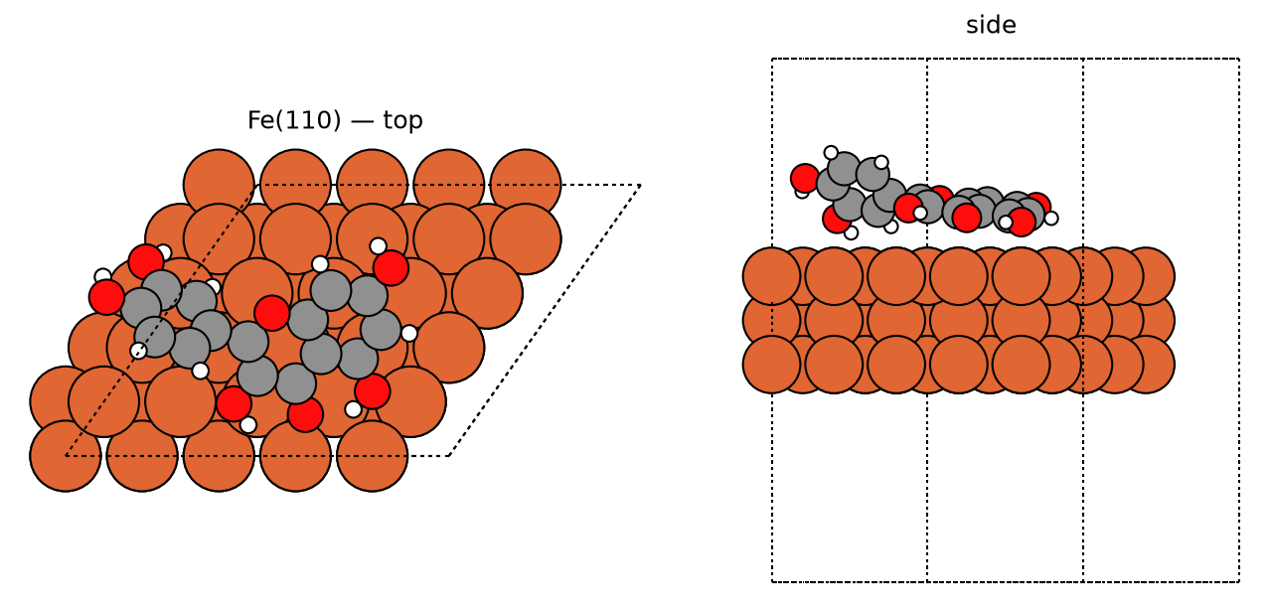
quercetin — best pose
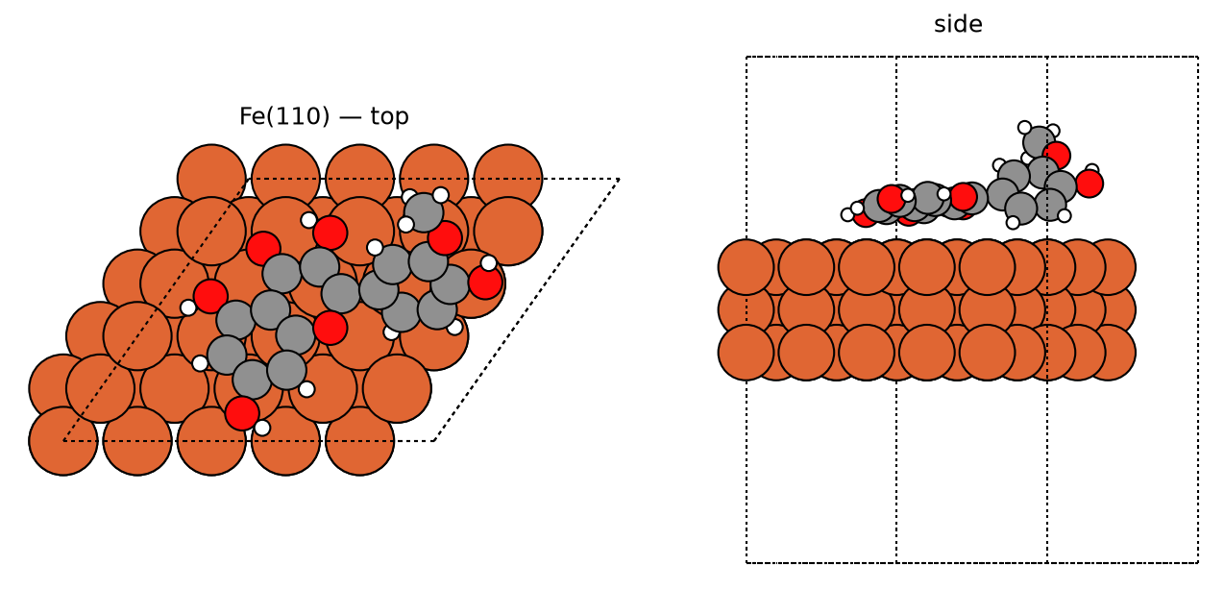
isorhamnetin — best pose
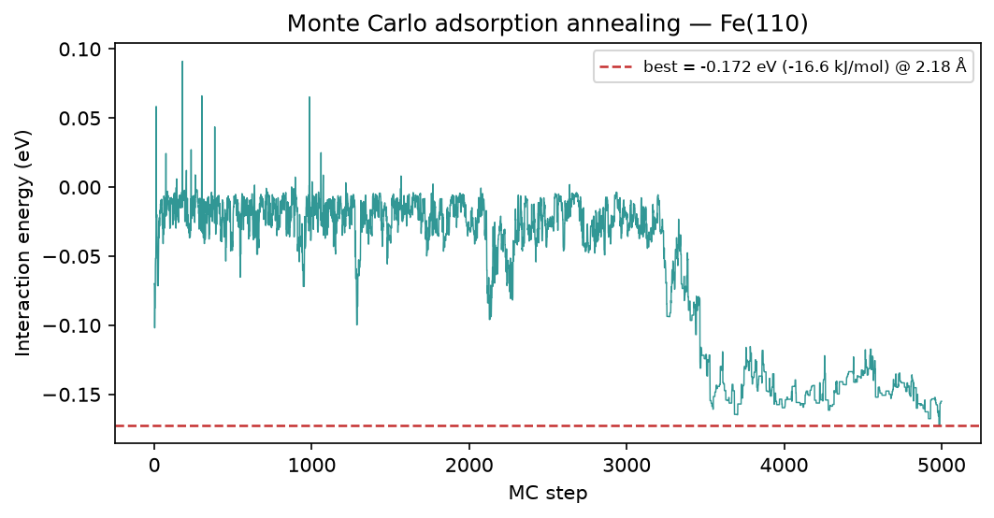
kaempferol — MC annealing
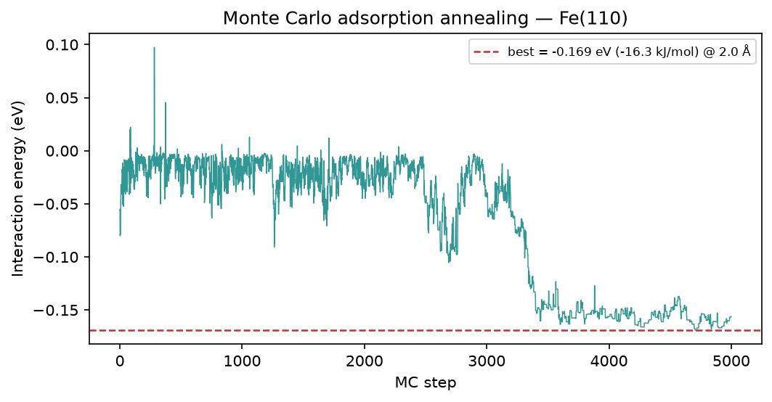
quercetin — MC annealing
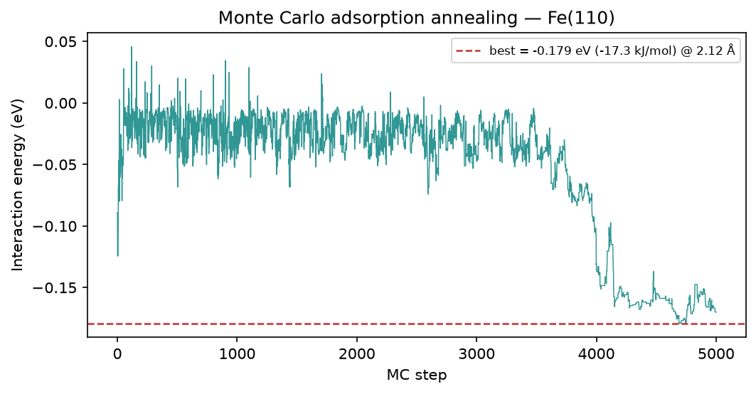
isorhamnetin — MC annealing

5. Brownian MD (Fe-O RDF)
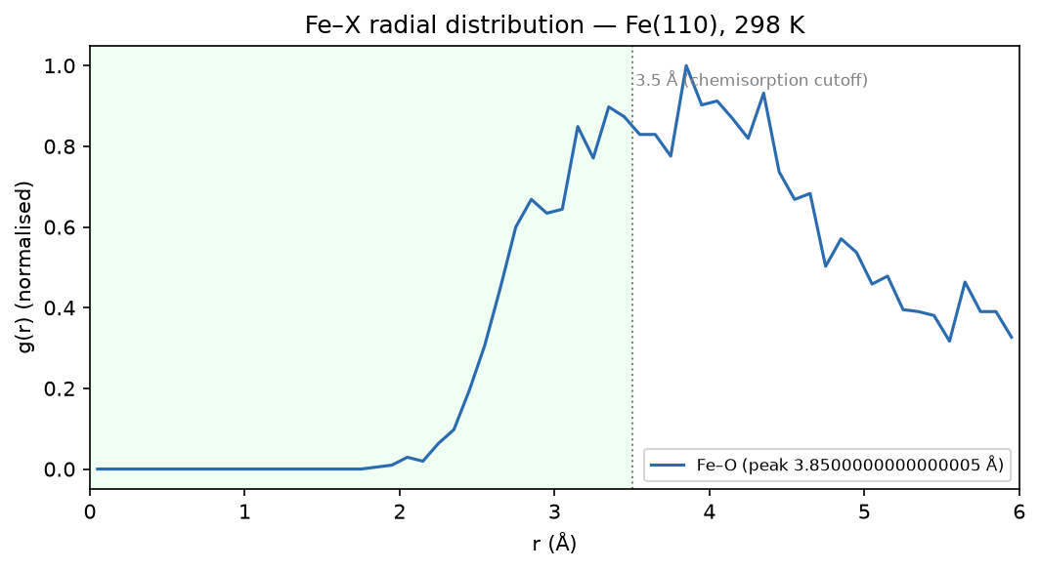
kaempferol — Fe-O RDF
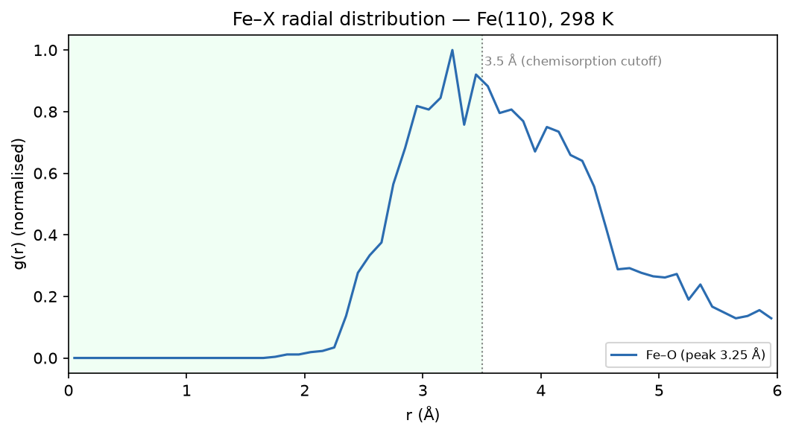
quercetin — Fe-O RDF
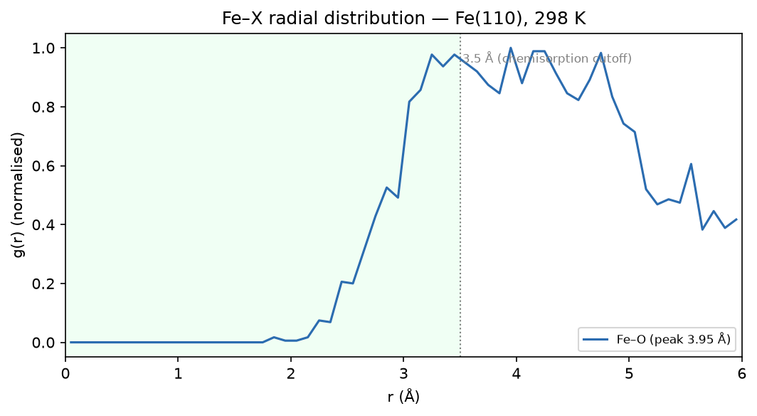
isorhamnetin — Fe-O RDF

6. Method & caveats
DFT level: B3LYP/6-311++G(d,p) (ddCOSMO:water). Global descriptors come from the frontier-orbital energies via Koopmans' theorem; ΔN uses the metal work function with η(metal) = 0. The Monte-Carlo and Brownian-MD stages use a classical van-der-Waals adsorption model — a physics-based screening surrogate, not a substitute for periodic DFT or for electrochemical validation. The composite ranking is a heuristic that orders candidates; it does not prove inhibition. Full methodology: docs/pipeline.md; validation record: docs/validation.md.

