corrosim — multiscale corrosion-inhibitor report
Substrate: Fe(110) | Medium: 0.5 M H2SO4 | DFT level: B3LYP/6-31G(d) (ddCOSMO:water) | Generated 2026-07-10 18:29
The molecules modelled here are screened in silico as representative candidates, not a verified analysis of any real sample. Confirm the actual composition experimentally (e.g. by LC-MS/GC-MS) before drawing firm conclusions.

1. Overview
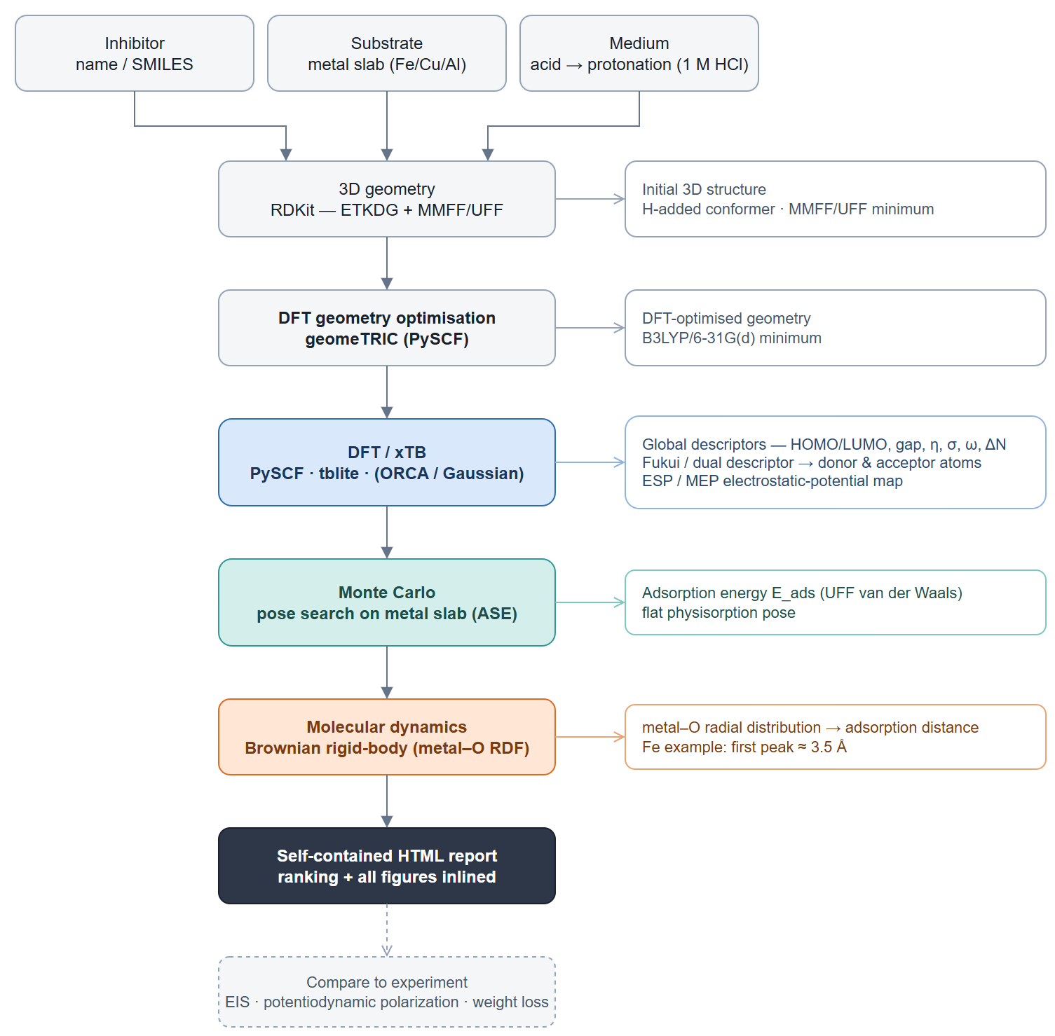
corrosim pipeline

2. Summary & ranking
Of the 1 molecules screened, phytic acid ranks highest on the composite electronic score (+0.00), combining the smallest HOMO–LUMO gap (8.02 eV) with the highest softness — the most readily polarised, electron-donating candidate of the set. It adsorbs flat on Fe in the physisorption regime (E_ads ≈ -11 kJ/mol). This is a computational screening prediction requiring electrochemical confirmation (see the Method section and caveats).
 | phytic acid
Gap (eV) | 8.023 ✓
Hardness η (eV) | 4.011 ✓
Softness σ (1/eV) | 0.249 ✓
ΔN | 0.091
E_ads (kJ/mol) | -11.49 ✓
Fe–O (Å) | 3.25
Score | 0.0 ✓
Scored on the neutral HOMO–LUMO gap, hardness and softness (z-scored; higher = stronger). E_ads and the Fe–O distance validate the lead, they do not enter the score. Full method: docs/pipeline.md.

3. DFT electronic descriptors
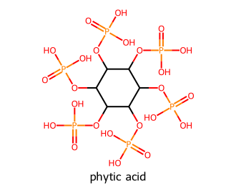
Modelled molecules
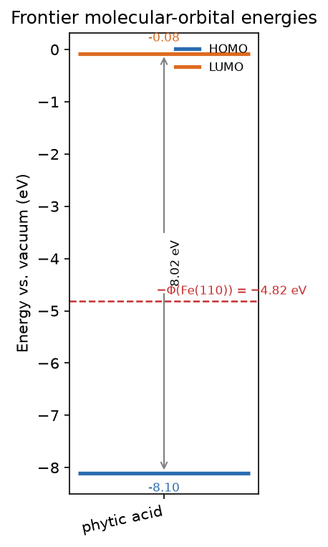
Frontier-orbital energies vs the metal work function

3.1 Frontier-orbital isosurfaces (HOMO / LUMO)
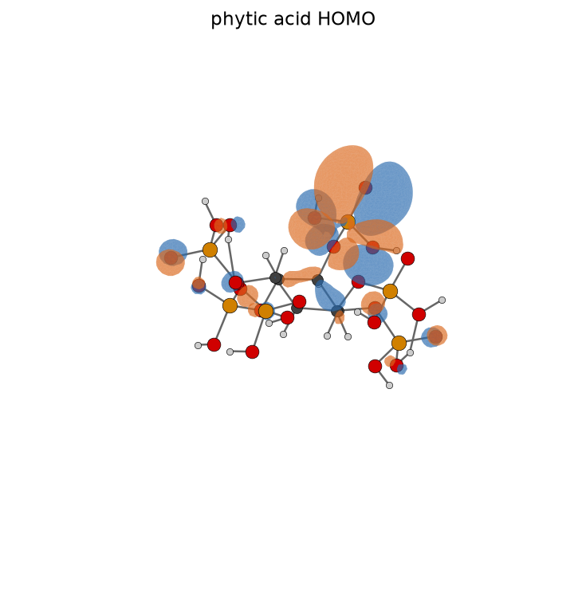
phytic acid HOMO
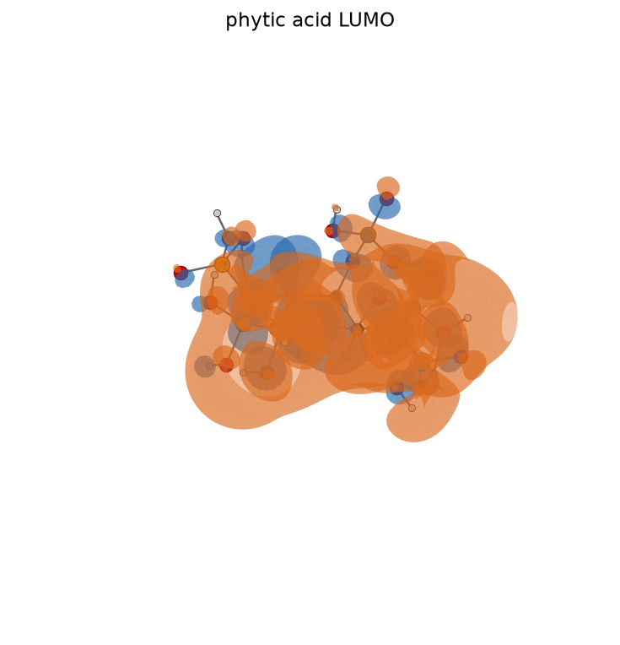
phytic acid LUMO
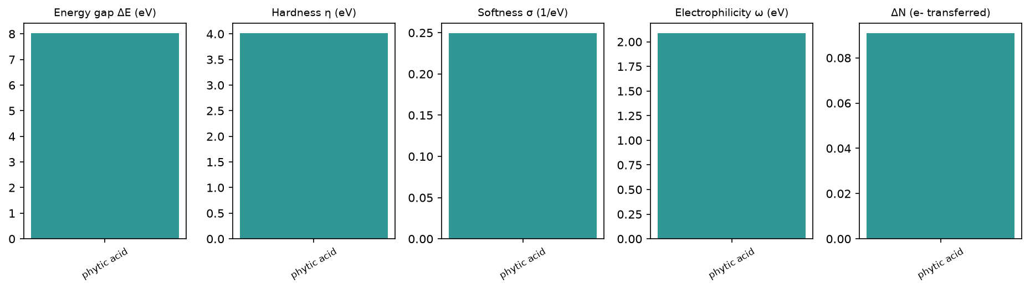
Reactivity descriptors
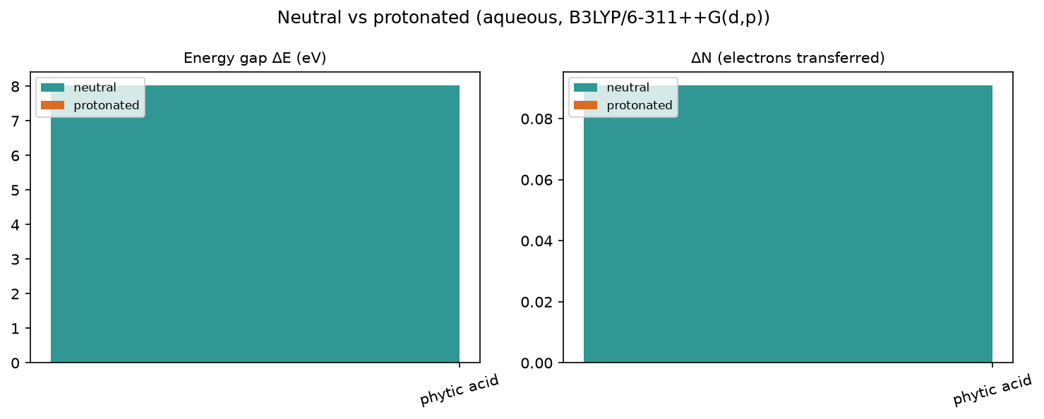
Protonation effect

3.2 Full descriptor table (neutral, aqueous)
Descriptor | phytic acid
Formula | C6H18O24P6
HOMO (eV) | -8.103
LUMO (eV) | -0.08
Gap ΔE (eV) | 8.023
η hardness (eV) | 4.011
σ softness (1/eV) | 0.249
χ electronegativity (eV) | 4.091
ω electrophilicity (eV) | 2.086
ΔN | 0.091
E_back-donation (eV) | -1.003
TNC | -14.927
E_ads (kJ/mol) | -11.49

3.3 Local reactivity (Fukui)
phytic acid: O9 (f⁻=0.707), O11 (f⁻=0.099), O10 (f⁻=0.058)
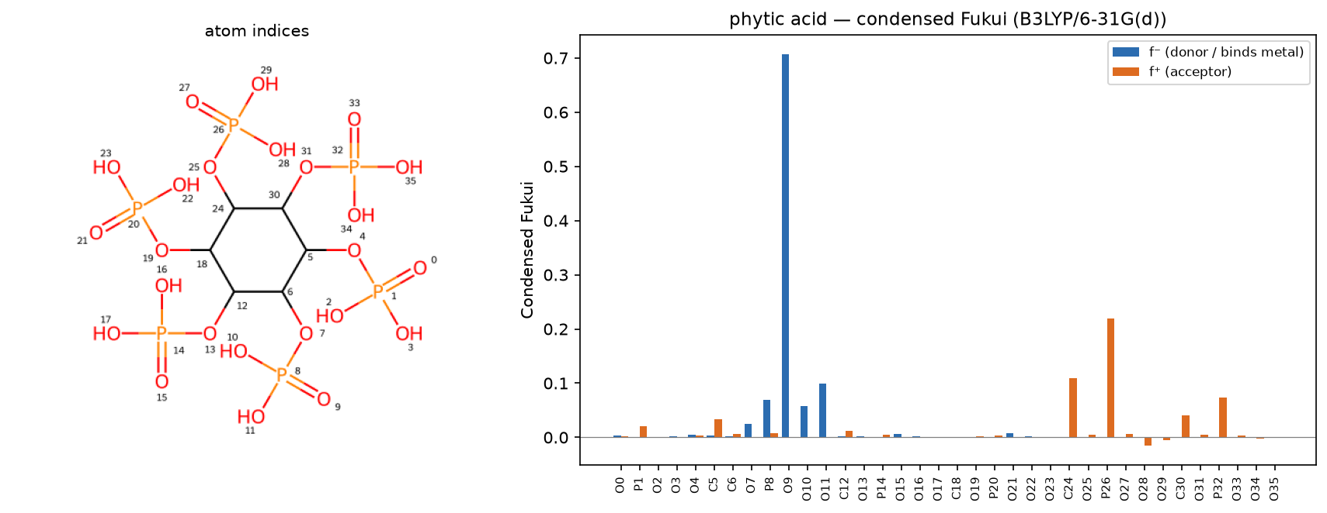
phytic acid — condensed Fukui

3.4 Electrostatic-potential (ESP) map
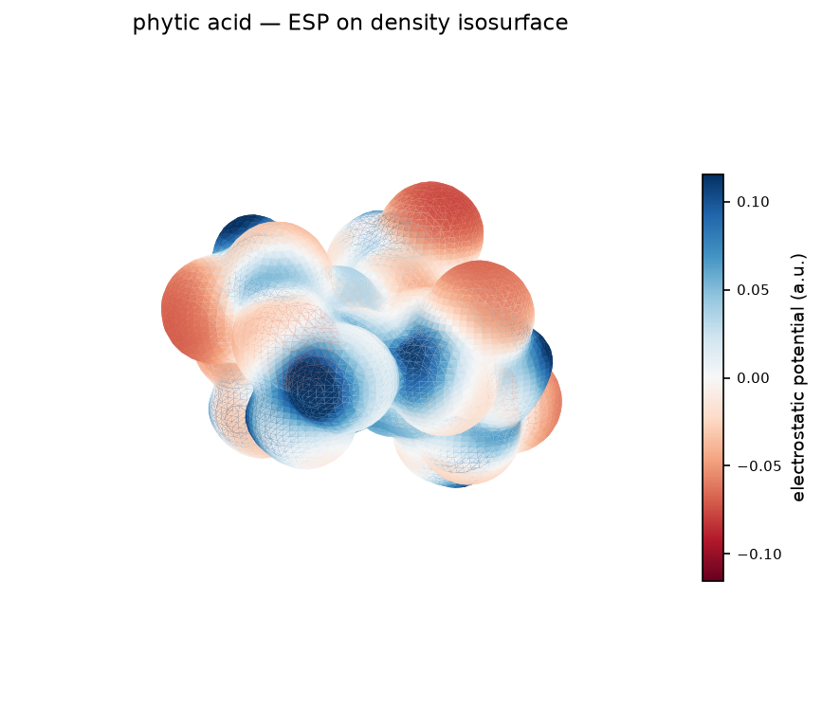
phytic acid — ESP map

4. Monte Carlo adsorption
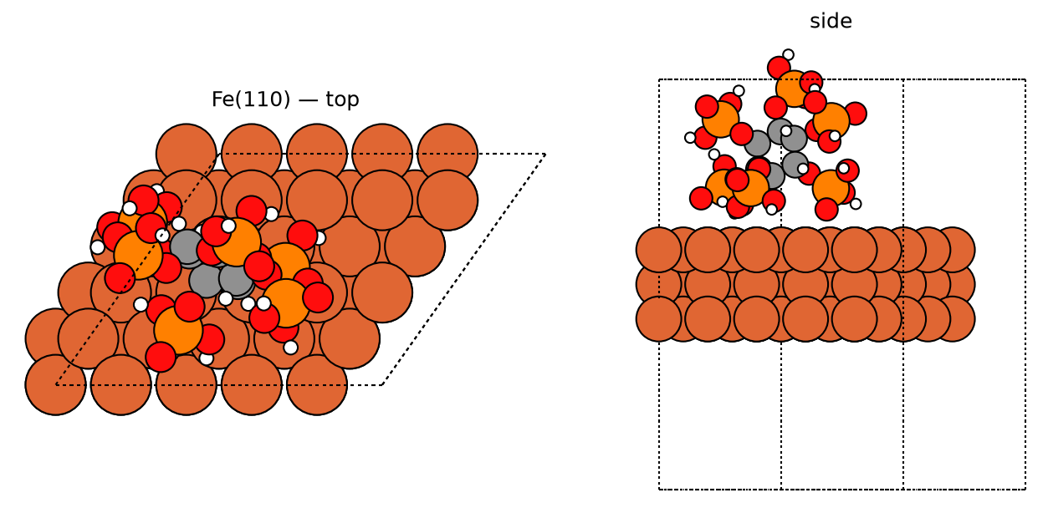
phytic acid — best pose
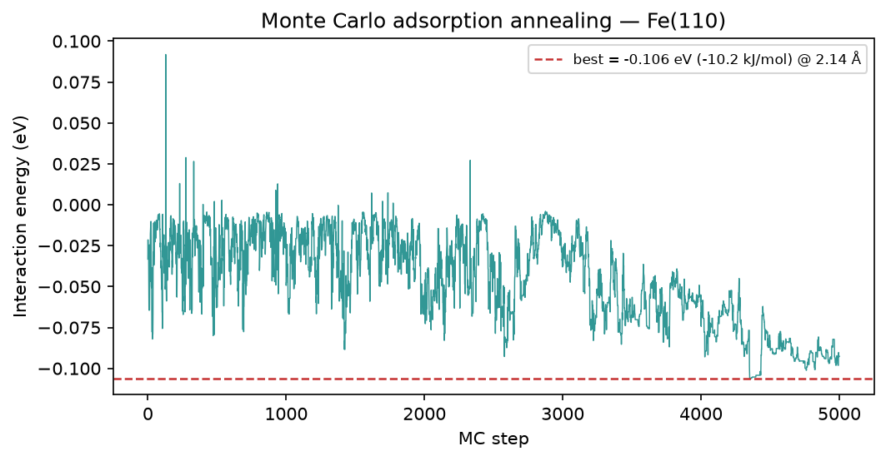
phytic acid — MC annealing

5. Brownian MD (Fe-O RDF)
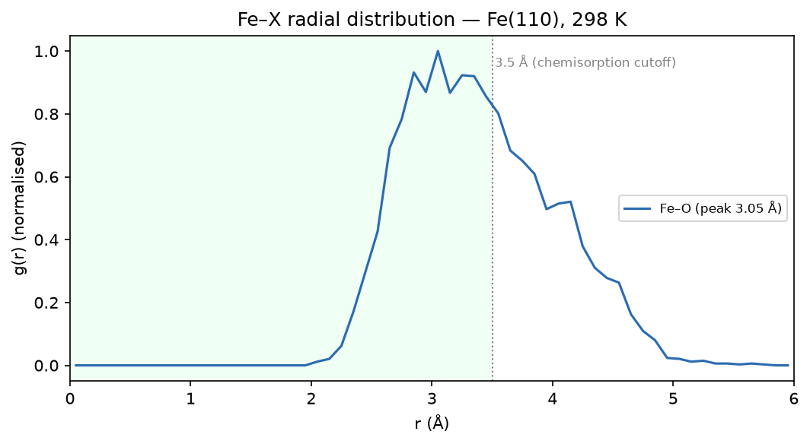
phytic acid — Fe-O RDF

6. Method & caveats
DFT level: B3LYP/6-31G(d) (ddCOSMO:water). Global descriptors come from the frontier-orbital energies via Koopmans' theorem; ΔN uses the metal work function with η(metal) = 0. The Monte-Carlo and Brownian-MD stages use a classical van-der-Waals adsorption model — a physics-based screening surrogate, not a substitute for periodic DFT or for electrochemical validation. The composite ranking is a heuristic that orders candidates; it does not prove inhibition. Full methodology: docs/pipeline.md; validation record: docs/validation.md.

