corrosim — multiscale corrosion-inhibitor report
Substrate: Al(111) | Medium: 1 M HCl | DFT level: B3LYP/6-311++G(d,p) (ddCOSMO:water) | Generated 2026-07-12 21:14
The molecules modelled here are screened in silico as representative candidates, not a verified analysis of any real sample. Confirm the actual composition experimentally (e.g. by LC-MS/GC-MS) before drawing firm conclusions.

1. Overview

2. Summary & ranking
Of the 2 molecules screened, no single lead is robust: sulfamethoxazole and trimethoprim rank within the method's resolution of one another — the top candidate changes across the 2 descriptor bases (geometry and protonation), so they are reported as a tie rather than ordered. This is a computational screening prediction requiring electrochemical confirmation (see the Method section and caveats).
 | sulfamethoxazole | trimethoprim
Gap (eV) | 4.02 | 4.154
Hardness η (eV) | 2.01 | 2.077
Softness σ (1/eV) | 0.498 | 0.482
ΔN | -0.07 | -0.038
E_ads (kJ/mol) | -99.66 | -130.18
Al–O (Å) | 3.55 | 3.55
Score | 1.0 | -1.0
Ranking basis | Top candidate
force-field geometry, neutral | trimethoprim
force-field geometry, pH-weighted | sulfamethoxazole
Lead not robust: the top candidate changes across the 2 bases, so the top group is within method resolution and reported as a tie.
Scored on the HOMO–LUMO gap, hardness and softness of the canonical basis (force-field geometry, pH-weighted; z-scored; higher = stronger). The geometry / protonation panels below are a sensitivity check, not separate rankings. E_ads and the Al–O distance validate the lead, they do not enter the score. Full method: docs/pipeline.md.

3. DFT electronic descriptors
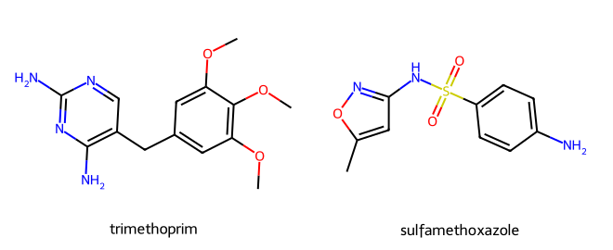
Modelled molecules
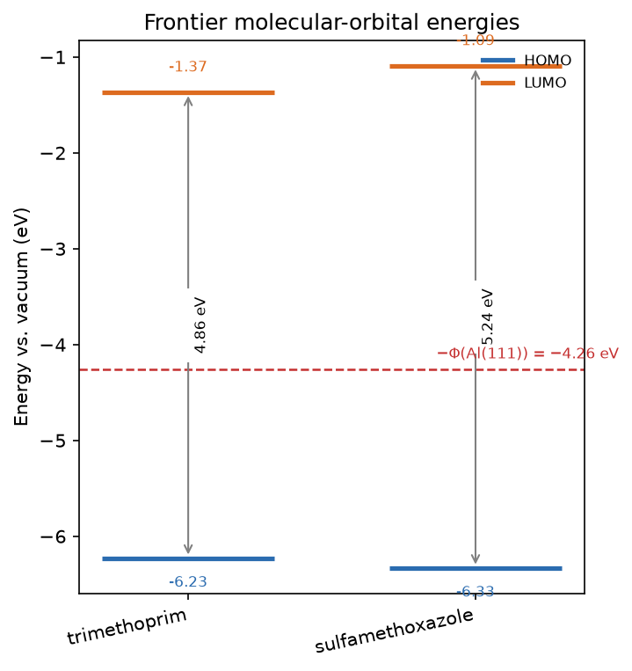
Frontier-orbital energies vs the metal work function

3.1 Frontier-orbital isosurfaces (HOMO / LUMO)
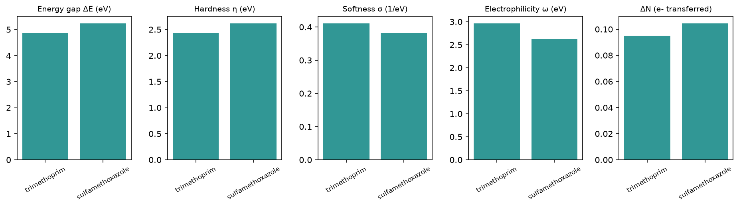
Reactivity descriptors
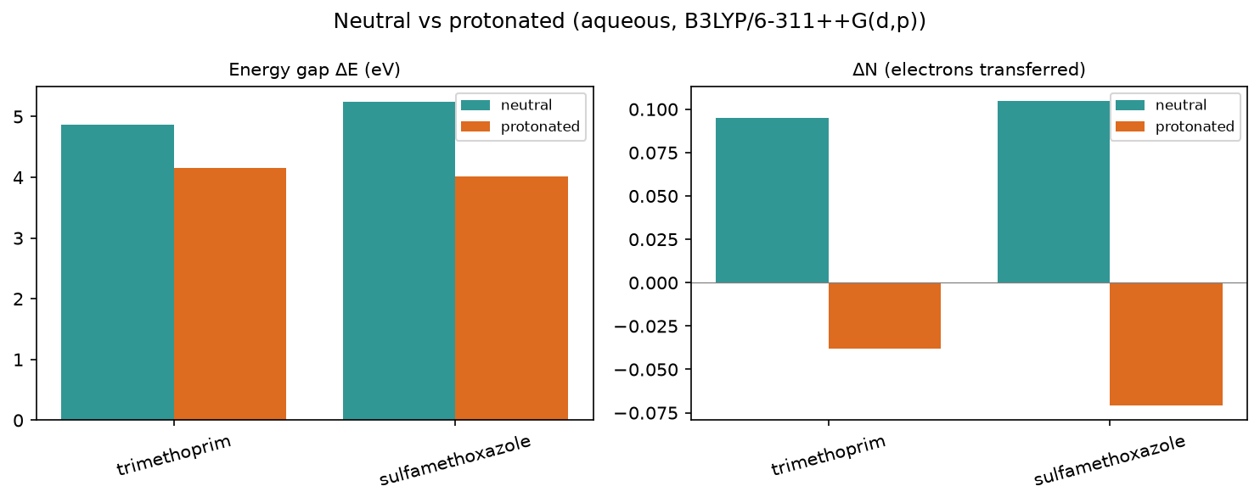
Protonation effect

3.2 Full descriptor table (neutral, aqueous)
Descriptor | trimethoprim | sulfamethoxazole
Formula | C14H18N4O3 | C10H11N3O3S
HOMO (eV) | -6.229 | -6.332
LUMO (eV) | -1.367 | -1.092
Gap ΔE (eV) | 4.862 | 5.24
η hardness (eV) | 2.431 | 2.62
σ softness (1/eV) | 0.411 | 0.382
χ electronegativity (eV) | 3.798 | 3.712
ω electrophilicity (eV) | 2.967 | 2.63
ΔN | 0.095 | 0.105
E_back-donation (eV) | -0.608 | -0.655
TNC | -6.741 | -4.28
E_ads (kJ/mol) | -130.18 | -99.66

3.3 Species in the acidic medium (protonated cation)
Descriptor | trimethoprim+H+ | sulfamethoxazole+H+
Formula | C14H19N4O3+ | C10H12N3O3S+
HOMO (eV) | -6.494 | -6.554
LUMO (eV) | -2.34 | -2.534
Gap ΔE (eV) | 4.154 | 4.02
η hardness (eV) | 2.077 | 2.01
σ softness (1/eV) | 0.482 | 0.498
χ electronegativity (eV) | 4.417 | 4.544
ω electrophilicity (eV) | 4.698 | 5.135
ΔN | -0.038 | -0.071
E_back-donation (eV) | -0.519 | -0.502
TNC | -5.686 | -3.614
Protonated +1 cation descriptors in 1 M HCl; a component of the pH-weighted canonical basis (see the Summary), shown here on its own.

3.4 Speciation in 1 M HCl (pH ≈ -0.0)
0% neutral / 100% protonated at this pH — the protonated form dominates. Population-weighted descriptors (the speciation axis of the ranking ensemble; the headline ranks on the canonical basis):
Descriptor | trimethoprim | sulfamethoxazole
Formula | C14H18N4O3 | C10H11N3O3S
HOMO (eV) | -6.494 | -6.554
LUMO (eV) | -2.34 | -2.534
Gap ΔE (eV) | 4.154 | 4.02
η hardness (eV) | 2.077 | 2.01
σ softness (1/eV) | 0.482 | 0.498
χ electronegativity (eV) | 4.417 | 4.544
ω electrophilicity (eV) | 4.698 | 5.136
ΔN | -0.038 | -0.07
E_back-donation (eV) | -0.519 | -0.502
TNC | -5.686 | -3.614

3.5 Local reactivity (Fukui)

3.6 Electrostatic-potential (ESP) map

4. Monte Carlo adsorption
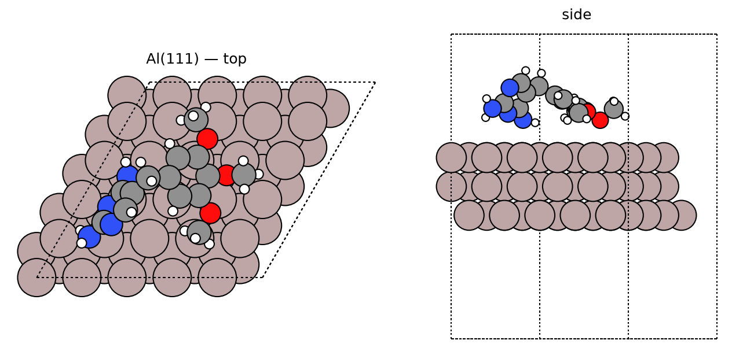
trimethoprim — best pose
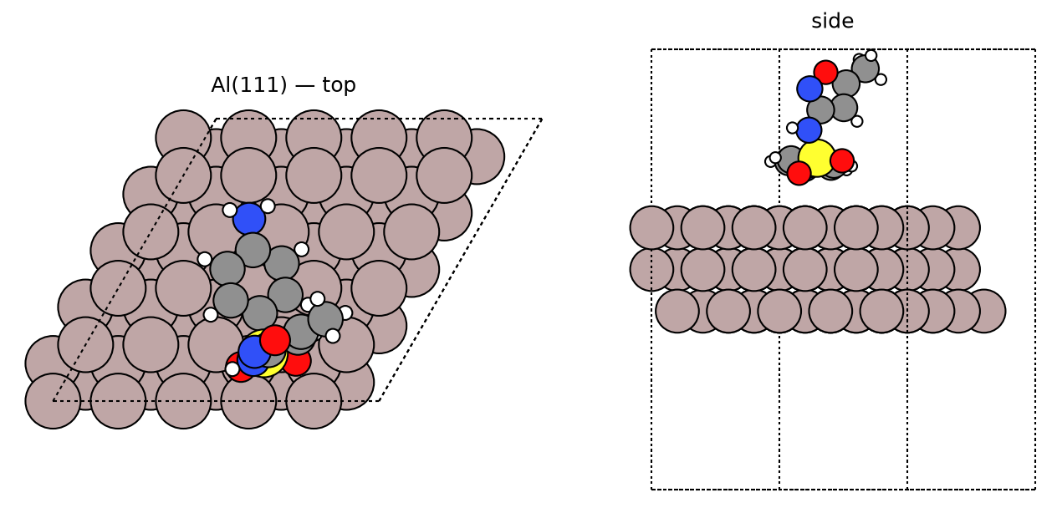
sulfamethoxazole — best pose
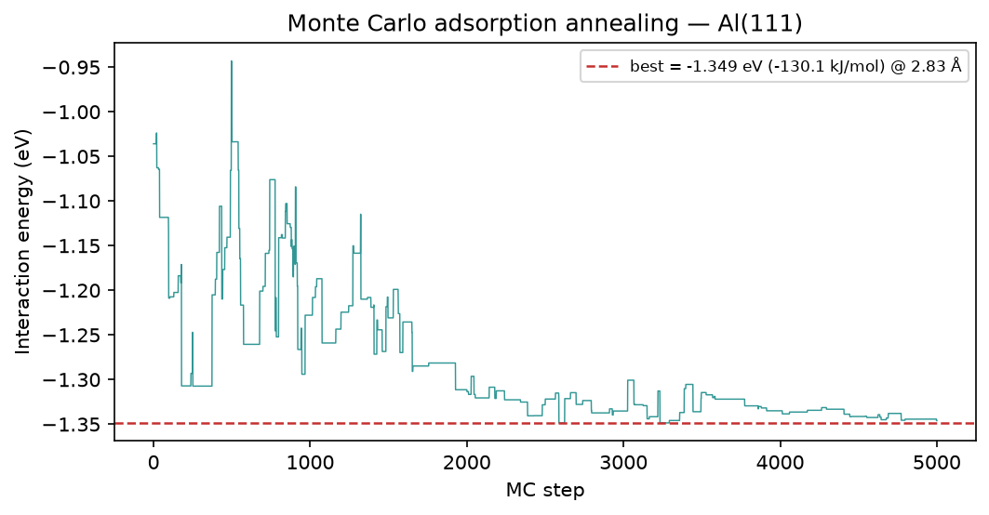
trimethoprim — MC annealing
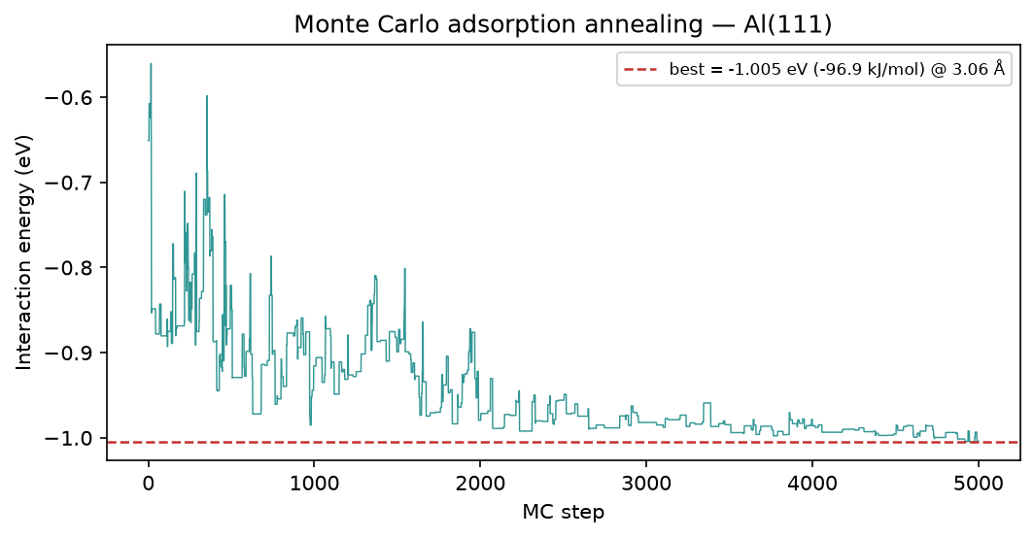
sulfamethoxazole — MC annealing

5. Brownian MD (Al-O RDF)
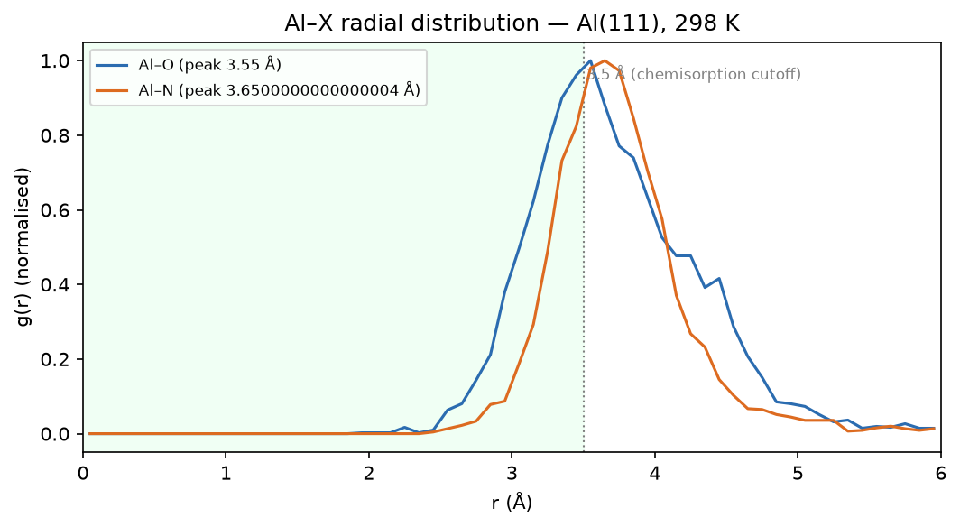
trimethoprim — Al-O RDF
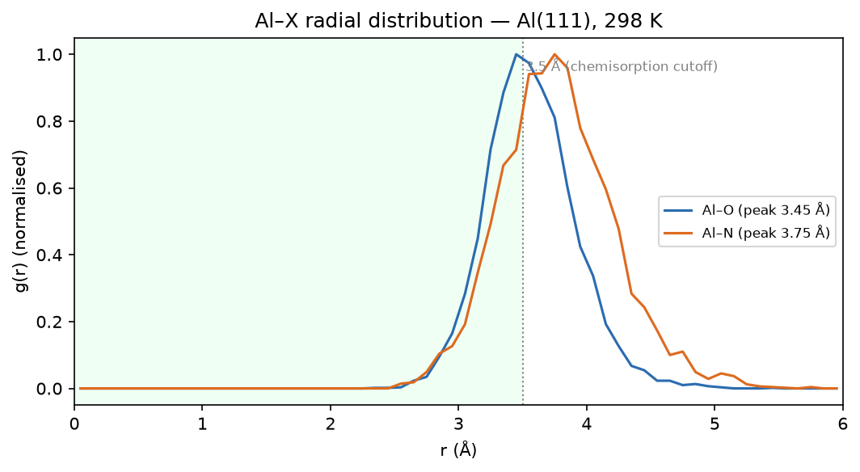
sulfamethoxazole — Al-O RDF

6. Method & caveats
DFT level: B3LYP/6-311++G(d,p) (ddCOSMO:water). Global descriptors come from the frontier-orbital energies via Koopmans' theorem; ΔN uses the metal work function with η(metal) = 0. The Monte-Carlo and Brownian-MD stages use a classical van-der-Waals adsorption model — a physics-based screening surrogate, not a substitute for periodic DFT or for electrochemical validation. The composite ranking is a heuristic that orders candidates; it does not prove inhibition. Full methodology: docs/pipeline.md; validation record: docs/validation.md.

