corrosim — multiscale corrosion-inhibitor report
Substrate: Fe(110) | Medium: 1 M HCl | DFT level: B3LYP/6-311++G(d,p) (ddCOSMO:water) | Generated 2026-07-10 15:37
The molecules modelled here are screened in silico as representative candidates, not a verified analysis of any real sample. Confirm the actual composition experimentally (e.g. by LC-MS/GC-MS) before drawing firm conclusions.

1. Overview
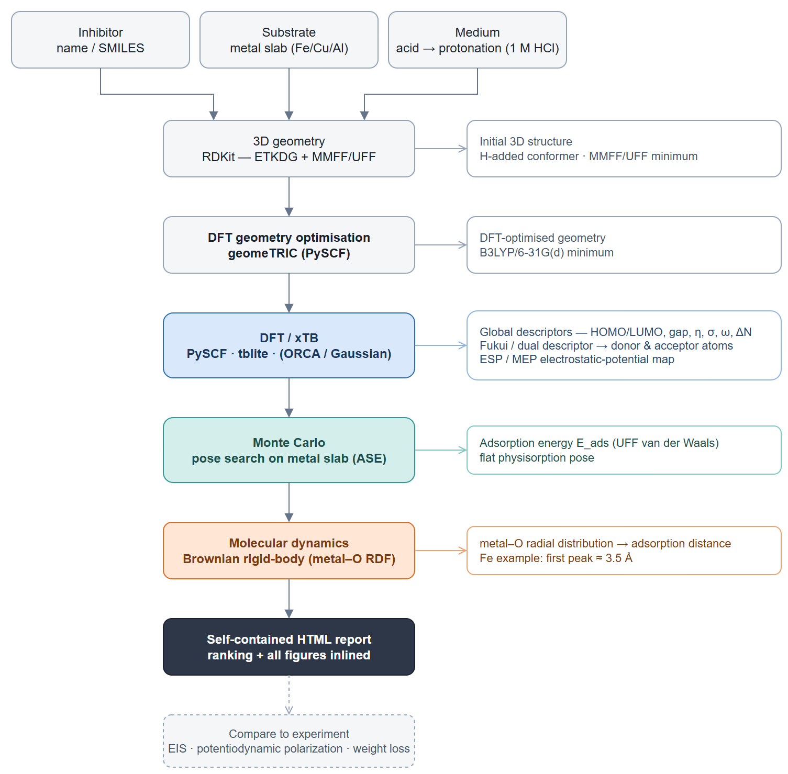
corrosim pipeline

2. Summary & ranking
Of the 3 molecules screened, pyrazolopyrimidine ethyl ester ranks highest on the composite electronic score (+0.76), combining the smallest HOMO–LUMO gap (4.47 eV) with the highest softness — the most readily polarised, electron-donating candidate of the set. It adsorbs flat on Fe in the physisorption regime (E_ads ≈ -9 kJ/mol). This is a computational screening prediction requiring electrochemical confirmation (see the Method section and caveats).
 | pyrazolopyrimidine ethyl ester | pyrazolopyrimidine propanoic acid | pyrazolopyrimidine propanamide
Gap (eV) | 4.471 ✓ | 4.471 | 4.48
Hardness η (eV) | 2.235 ✓ | 2.235 | 2.24
Softness σ (1/eV) | 0.447 ✓ | 0.447 | 0.446
ΔN | 0.171 | 0.169 | 0.172
E_ads (kJ/mol) | -8.81 | -20.42 ✓ | -15.55
Fe–O (Å) | 3.95 | 3.85 | 3.85
Score | 0.756 ✓ | 0.657 | -1.413
Scored on the neutral HOMO–LUMO gap, hardness and softness (z-scored; higher = stronger). E_ads and the Fe–O distance validate the lead, they do not enter the score. Full method: docs/pipeline.md.

3. DFT electronic descriptors
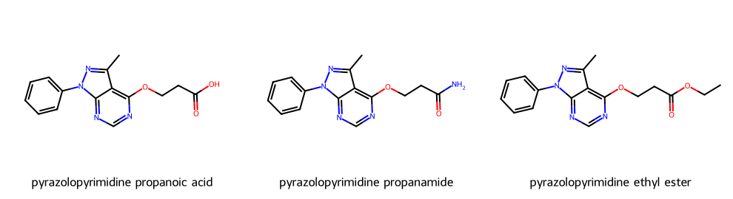
Modelled molecules
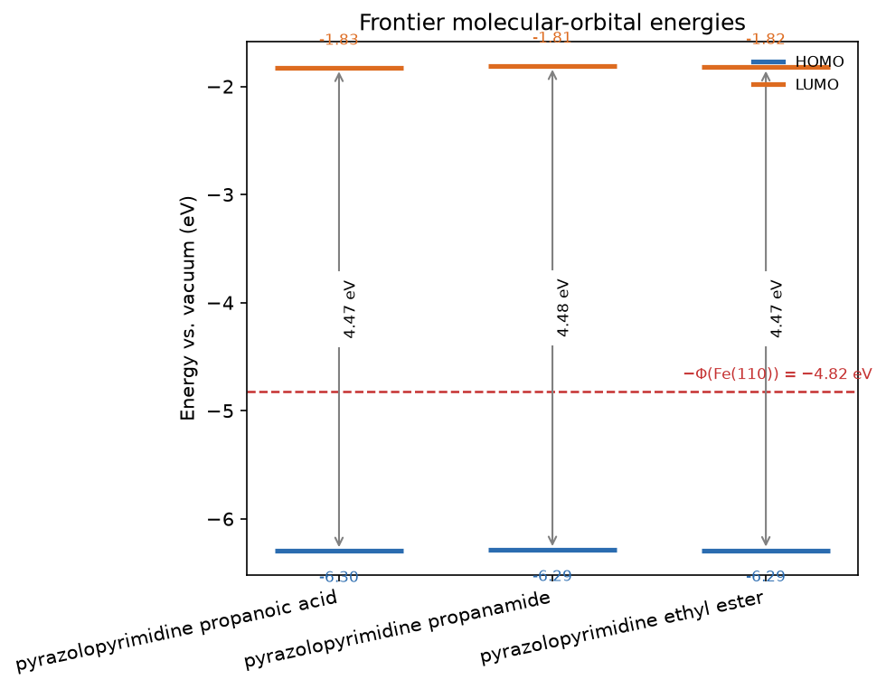
Frontier-orbital energies vs the metal work function

3.1 Frontier-orbital isosurfaces (HOMO / LUMO)
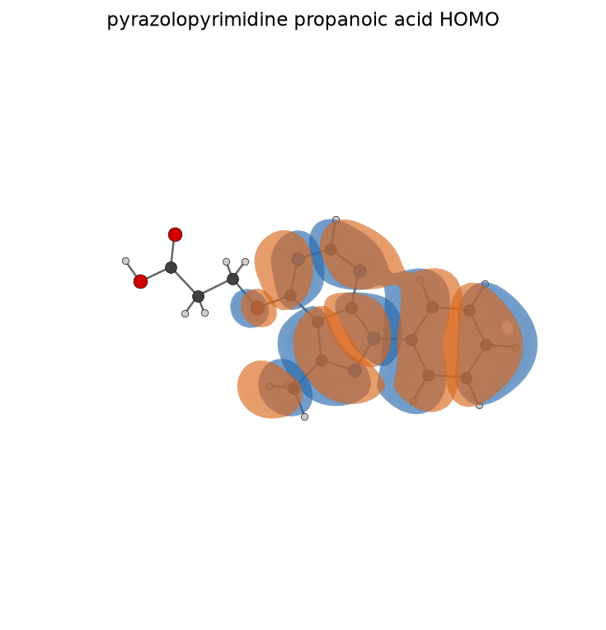
pyrazolopyrimidine propanoic acid HOMO
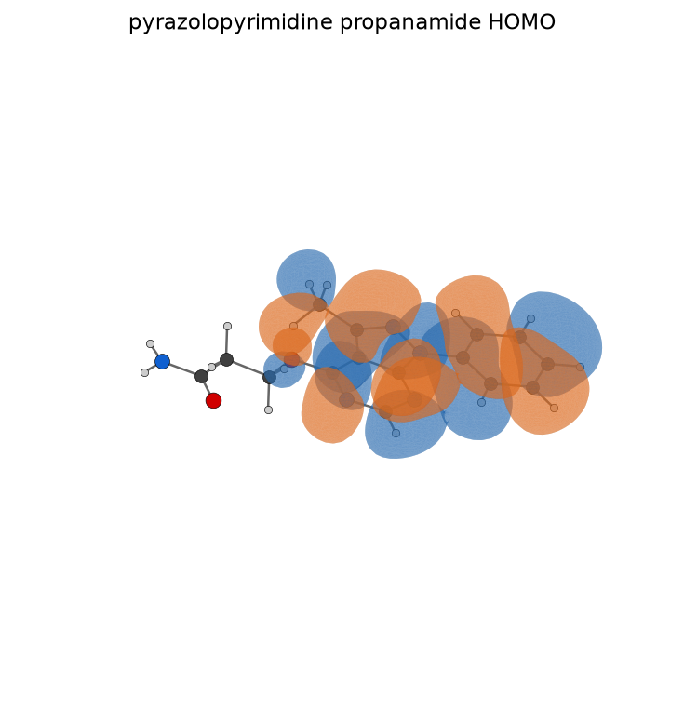
pyrazolopyrimidine propanamide HOMO
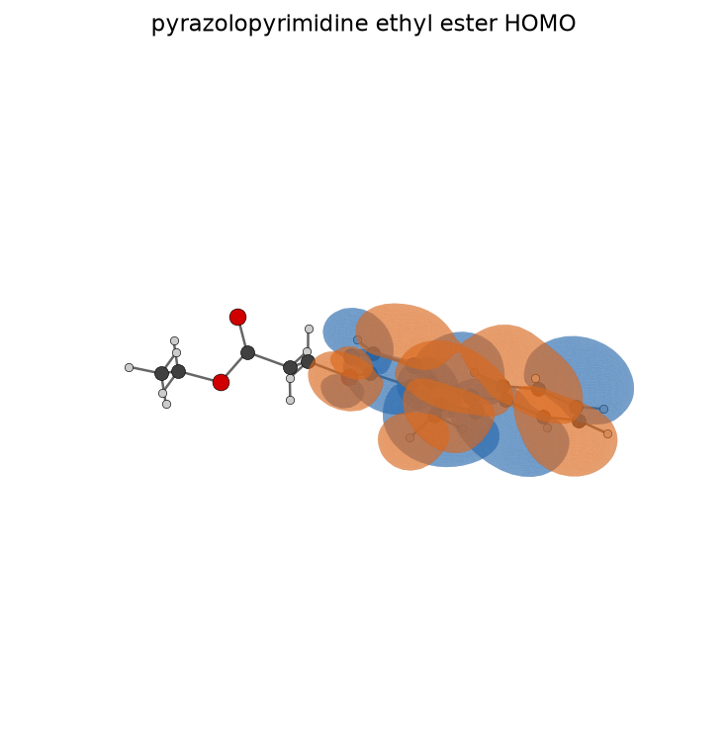
pyrazolopyrimidine ethyl ester HOMO
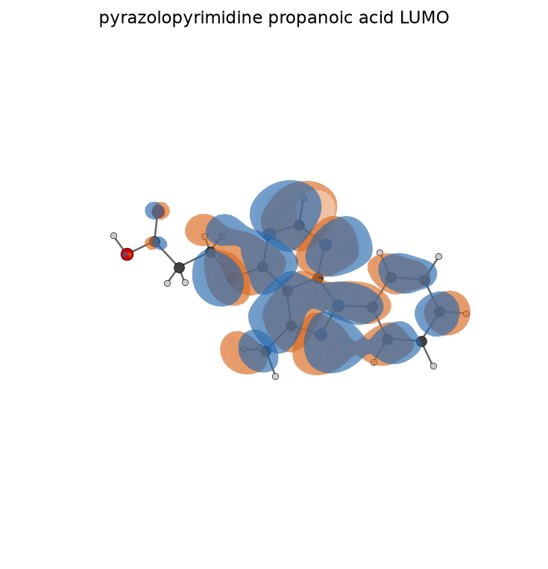
pyrazolopyrimidine propanoic acid LUMO
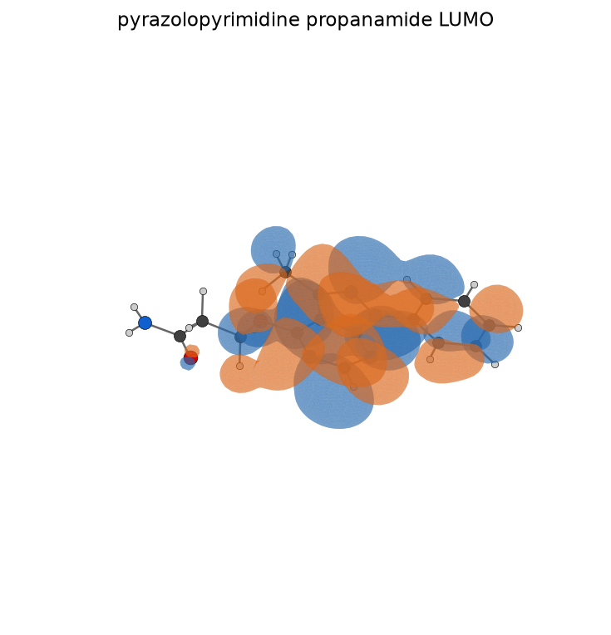
pyrazolopyrimidine propanamide LUMO
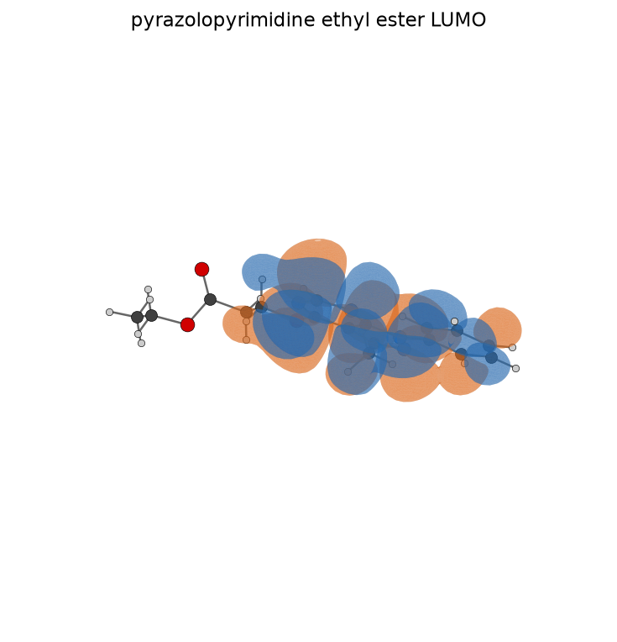
pyrazolopyrimidine ethyl ester LUMO
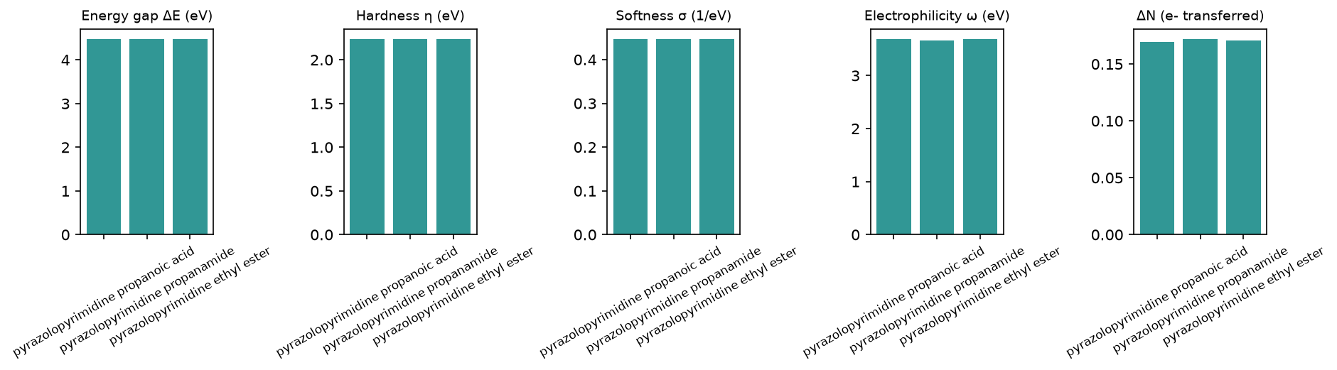
Reactivity descriptors
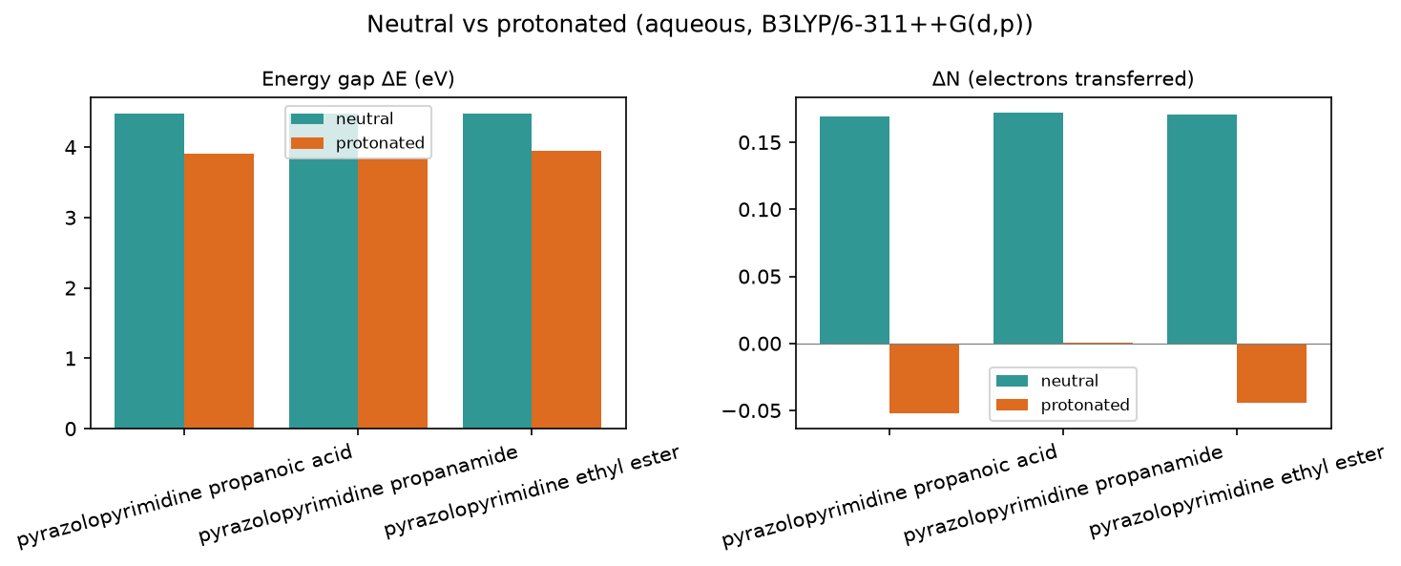
Protonation effect

3.2 Full descriptor table (neutral, aqueous)
Descriptor | pyrazolopyrimidine propanoic acid | pyrazolopyrimidine propanamide | pyrazolopyrimidine ethyl ester
Formula | C15H14N4O3 | C15H15N5O2 | C17H18N4O3
HOMO (eV) | -6.298 | -6.289 | -6.293
LUMO (eV) | -1.827 | -1.809 | -1.822
Gap ΔE (eV) | 4.471 | 4.48 | 4.471
η hardness (eV) | 2.235 | 2.24 | 2.235
σ softness (1/eV) | 0.447 | 0.446 | 0.447
χ electronegativity (eV) | 4.063 | 4.049 | 4.057
ω electrophilicity (eV) | 3.692 | 3.659 | 3.683
ΔN | 0.169 | 0.172 | 0.171
E_back-donation (eV) | -0.559 | -0.56 | -0.559
TNC | -4.001 | -4.268 | -4.565
E_ads (kJ/mol) | -20.42 | -15.55 | -8.81

3.3 Species in the acidic medium (protonated cation)
Descriptor | pyrazolopyrimidine propanoic acid+H+ | pyrazolopyrimidine propanamide+H+ | pyrazolopyrimidine ethyl ester+H+
Formula | C15H15N4O3+ | C15H16N5O2+ | C17H19N4O3+
HOMO (eV) | -6.978 | -6.736 | -6.965
LUMO (eV) | -3.071 | -2.902 | -3.024
Gap ΔE (eV) | 3.908 | 3.834 | 3.941
η hardness (eV) | 1.954 | 1.917 | 1.97
σ softness (1/eV) | 0.512 | 0.522 | 0.507
χ electronegativity (eV) | 5.025 | 4.819 | 4.994
ω electrophilicity (eV) | 6.46 | 6.056 | 6.329
ΔN | -0.052 | 0.0 | -0.044
E_back-donation (eV) | -0.488 | -0.479 | -0.493
TNC | -4.247 | -4.562 | -4.704
Protonated +1 cation descriptors in 1 M HCl; the headline ranking stays on the neutral form (see docs/pipeline.md).

3.4 Speciation in 1 M HCl (pH ≈ -0.0)
97% neutral / 3% protonated at this pH — the neutral form dominates. Population-weighted descriptors (blended lead pyrazolopyrimidine propanoic acid):
Descriptor | pyrazolopyrimidine propanoic acid | pyrazolopyrimidine propanamide | pyrazolopyrimidine ethyl ester
Formula | C15H14N4O3 | C15H15N5O2 | C17H18N4O3
HOMO (eV) | -6.319 | -6.303 | -6.313
LUMO (eV) | -1.866 | -1.842 | -1.859
Gap ΔE (eV) | 4.454 | 4.46 | 4.454
η hardness (eV) | 2.227 | 2.23 | 2.227
σ softness (1/eV) | 0.449 | 0.449 | 0.449
χ electronegativity (eV) | 4.092 | 4.072 | 4.086
ω electrophilicity (eV) | 3.777 | 3.732 | 3.764
ΔN | 0.162 | 0.167 | 0.164
E_back-donation (eV) | -0.557 | -0.558 | -0.557
TNC | -4.008 | -4.278 | -4.569

3.5 Local reactivity (Fukui)
pyrazolopyrimidine propanoic acid: O15 (f⁻=0.005), O19 (f⁻=0.000), O20 (f⁻=0.000)
pyrazolopyrimidine propanamide: O15 (f⁻=0.005), O19 (f⁻=0.000)
pyrazolopyrimidine ethyl ester: O15 (f⁻=0.005), O19 (f⁻=0.000), O20 (f⁻=0.000)
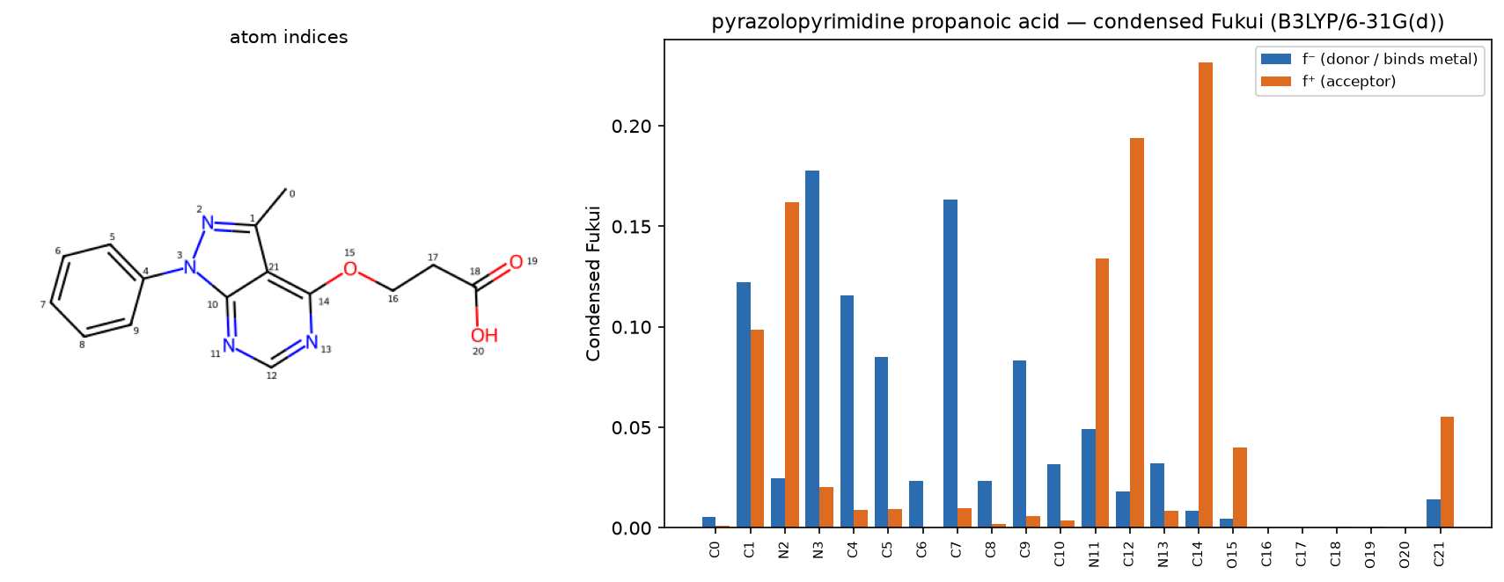
pyrazolopyrimidine propanoic acid — condensed Fukui
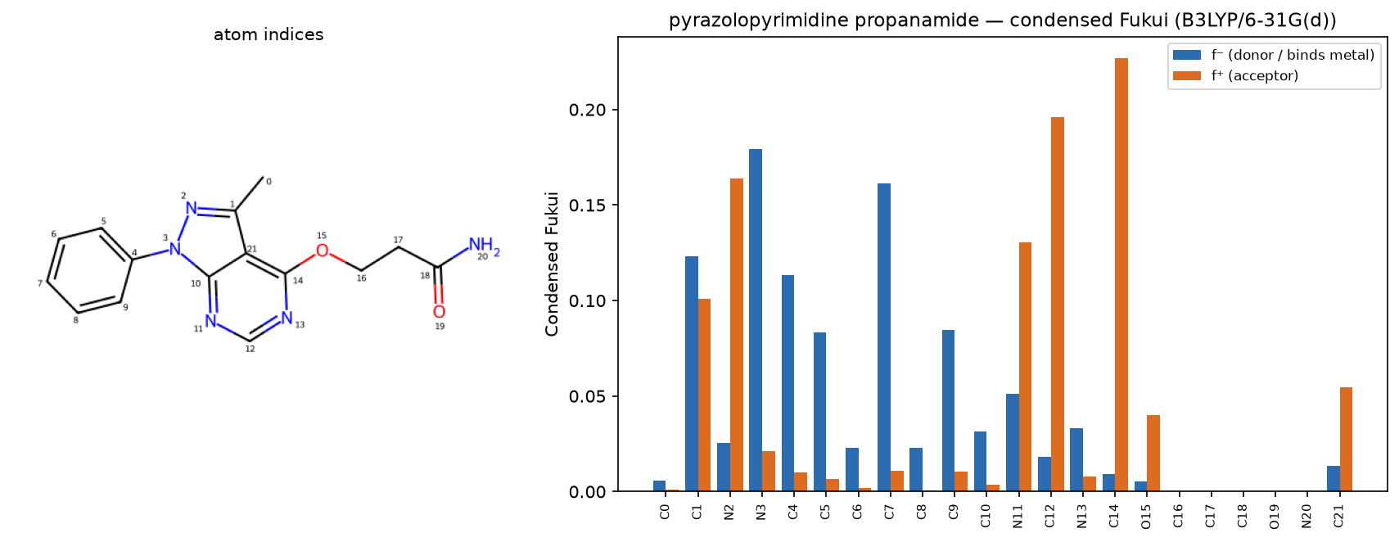
pyrazolopyrimidine propanamide — condensed Fukui
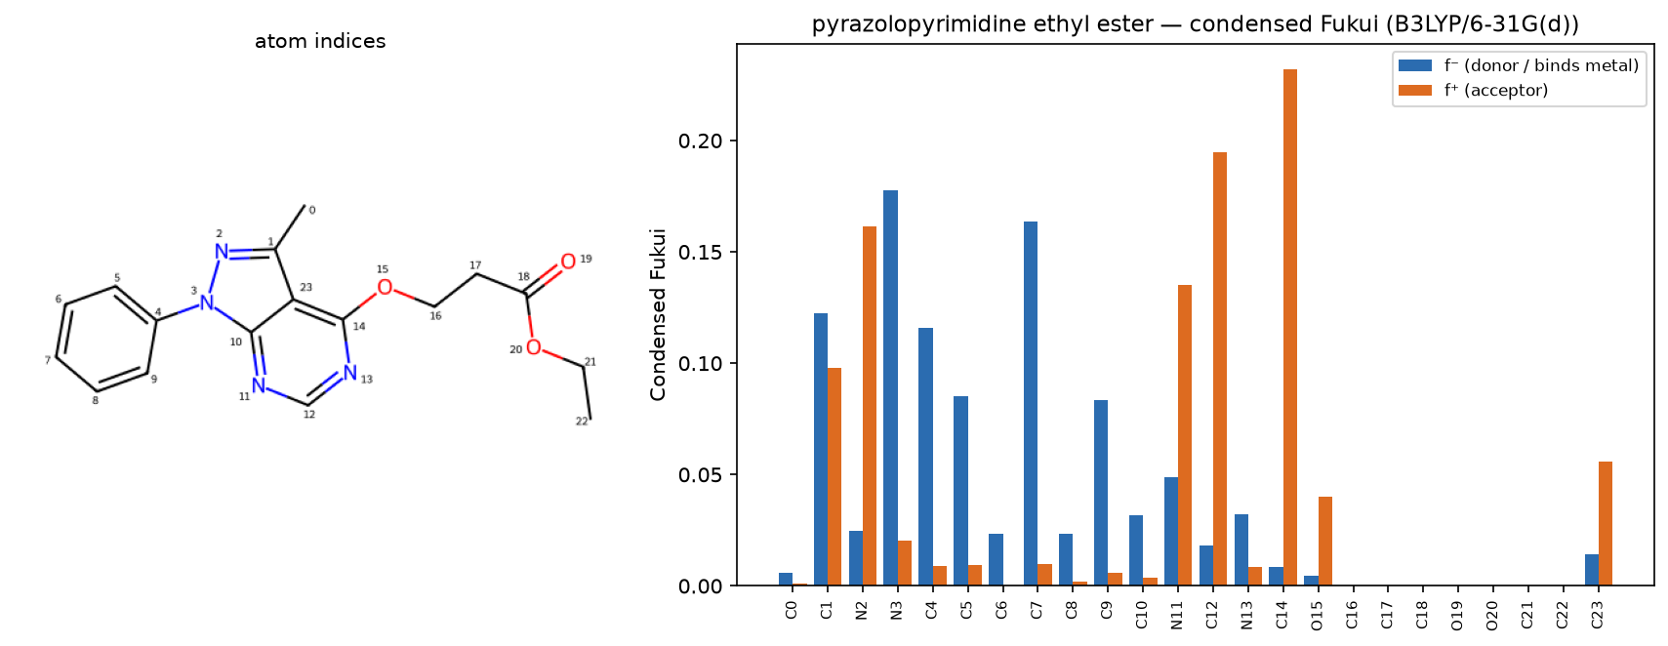
pyrazolopyrimidine ethyl ester — condensed Fukui

3.6 Electrostatic-potential (ESP) map
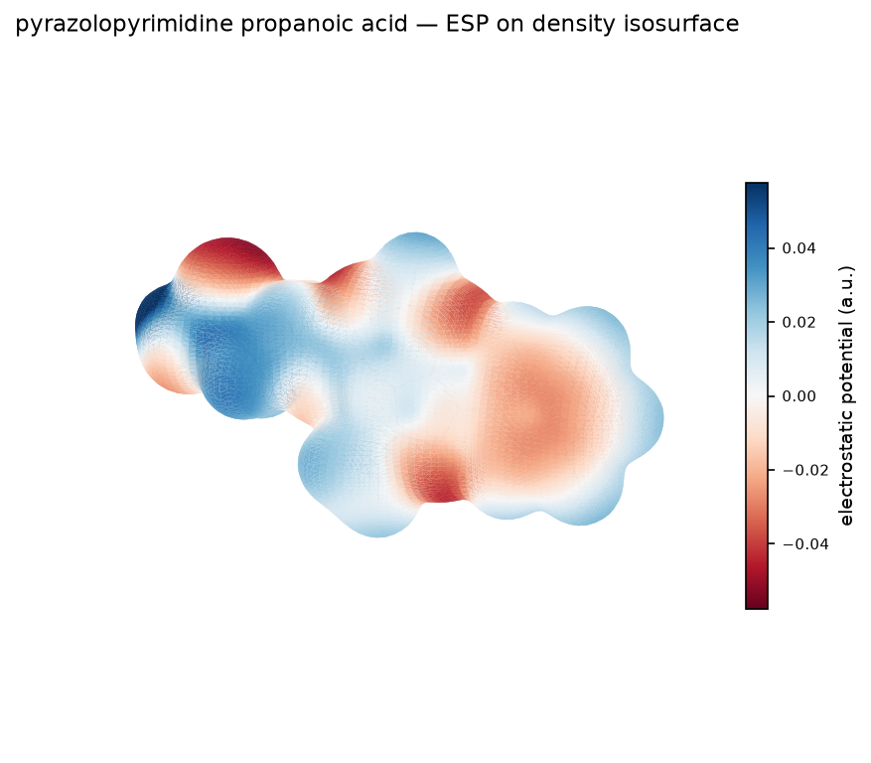
pyrazolopyrimidine propanoic acid — ESP map
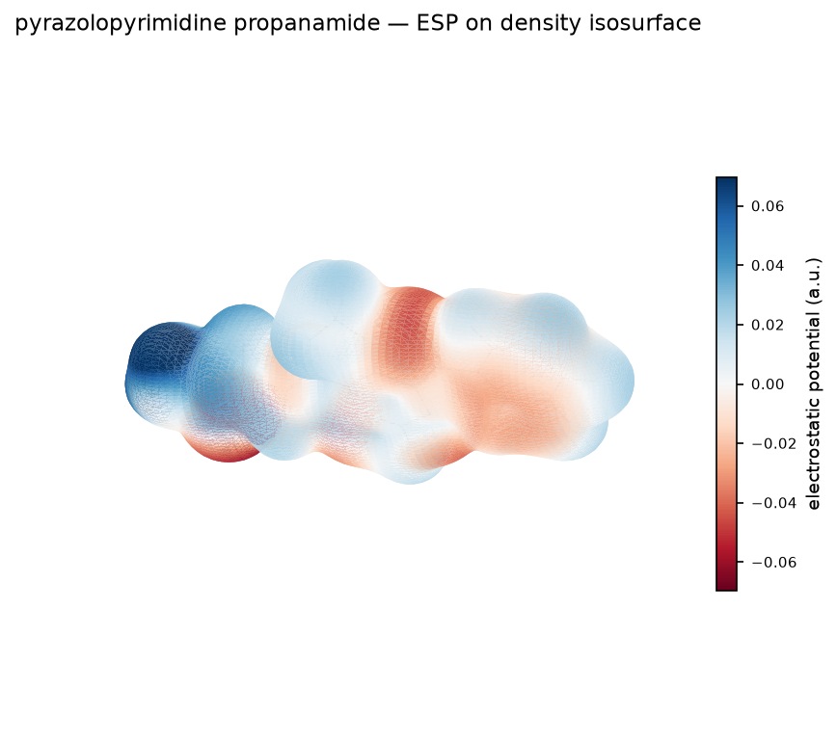
pyrazolopyrimidine propanamide — ESP map
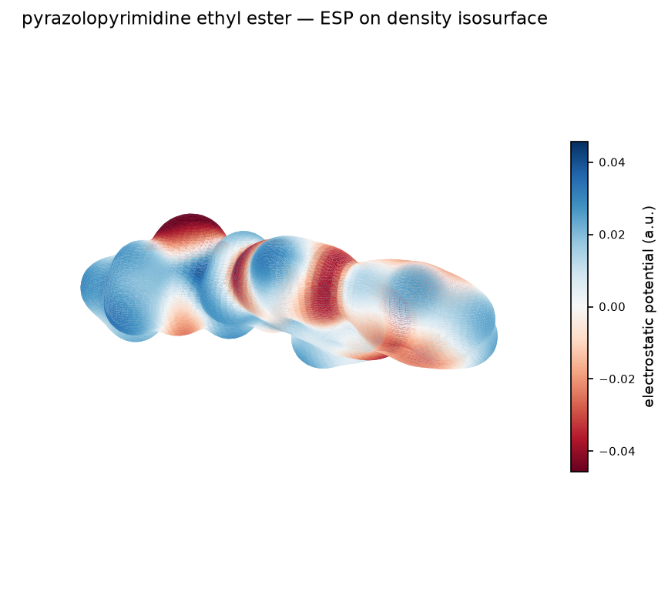
pyrazolopyrimidine ethyl ester — ESP map

4. Monte Carlo adsorption
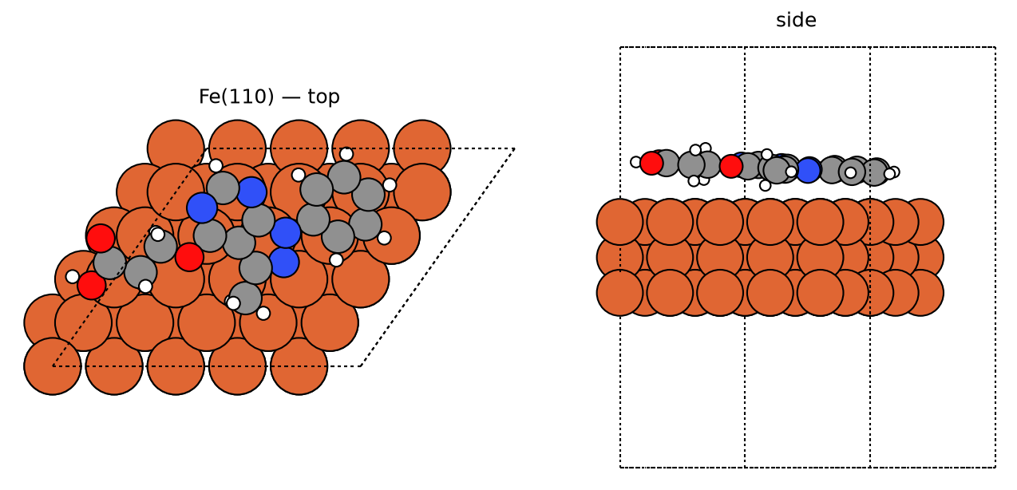
pyrazolopyrimidine propanoic acid — best pose
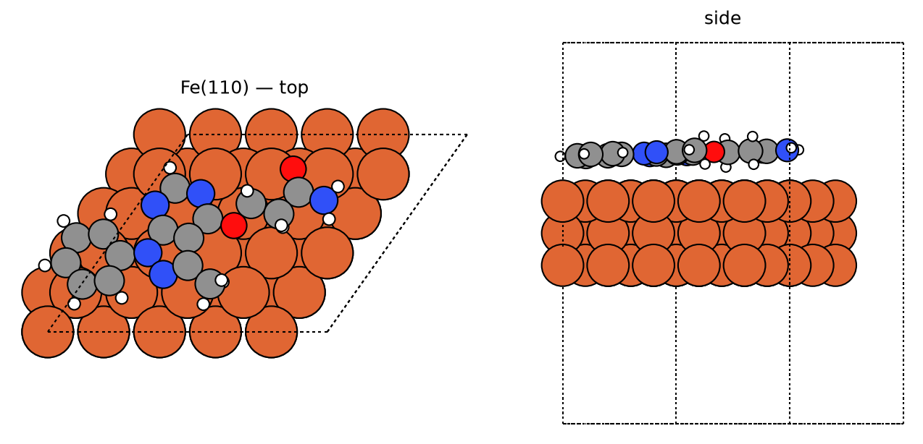
pyrazolopyrimidine propanamide — best pose
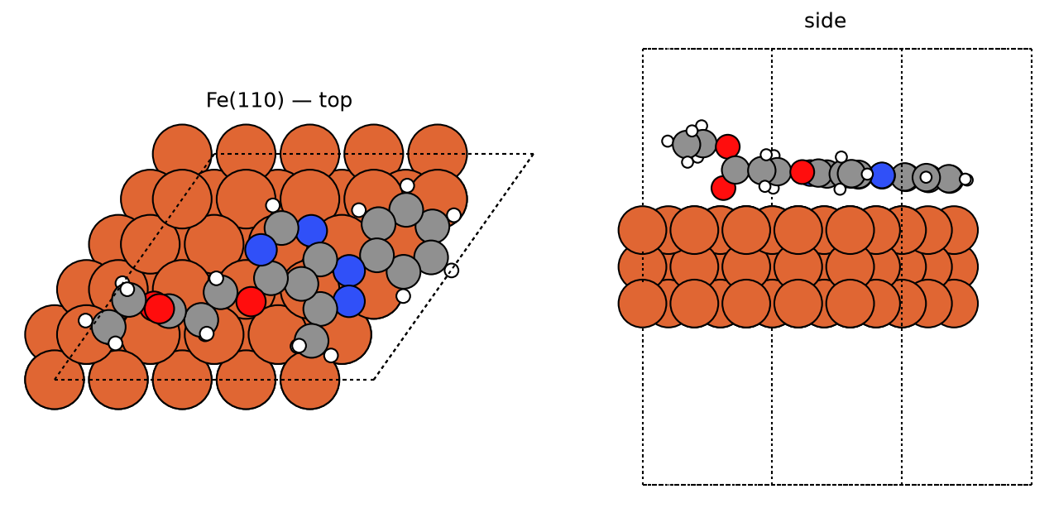
pyrazolopyrimidine ethyl ester — best pose
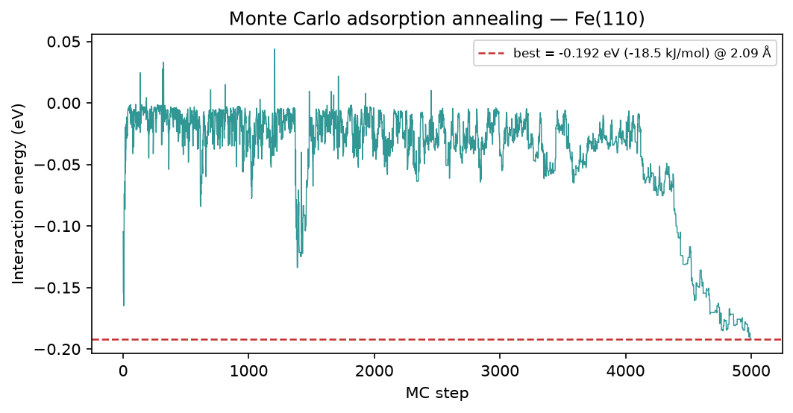
pyrazolopyrimidine propanoic acid — MC annealing
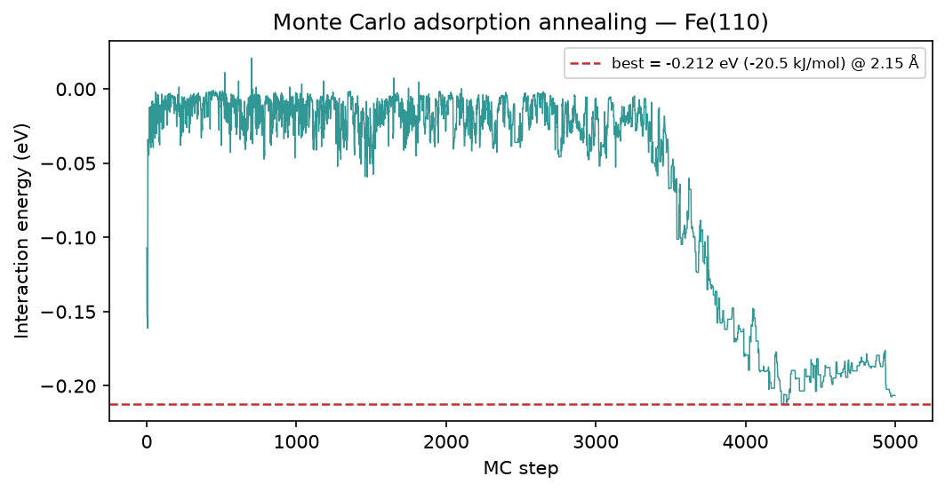
pyrazolopyrimidine propanamide — MC annealing
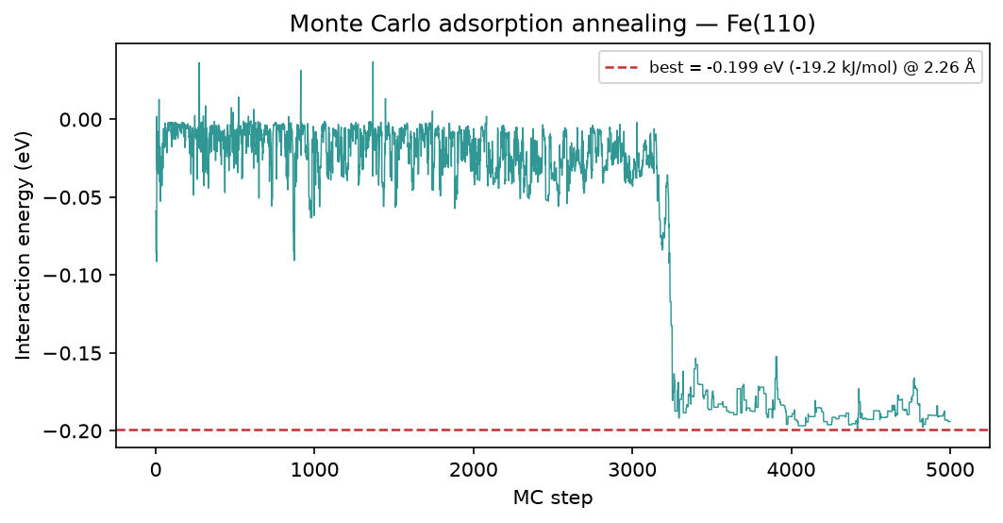
pyrazolopyrimidine ethyl ester — MC annealing

5. Brownian MD (Fe-O RDF)
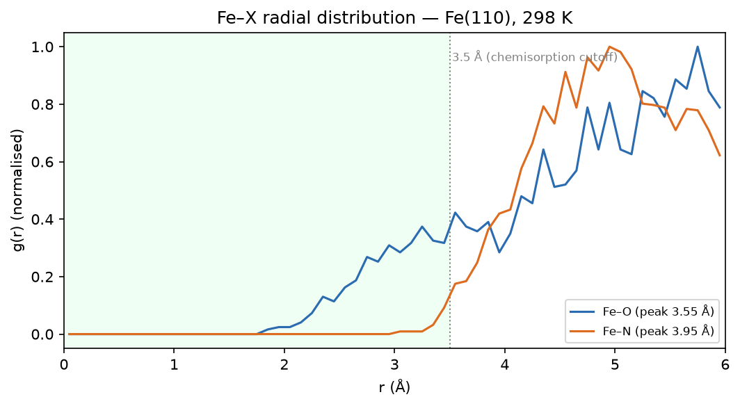
pyrazolopyrimidine propanoic acid — Fe-O RDF
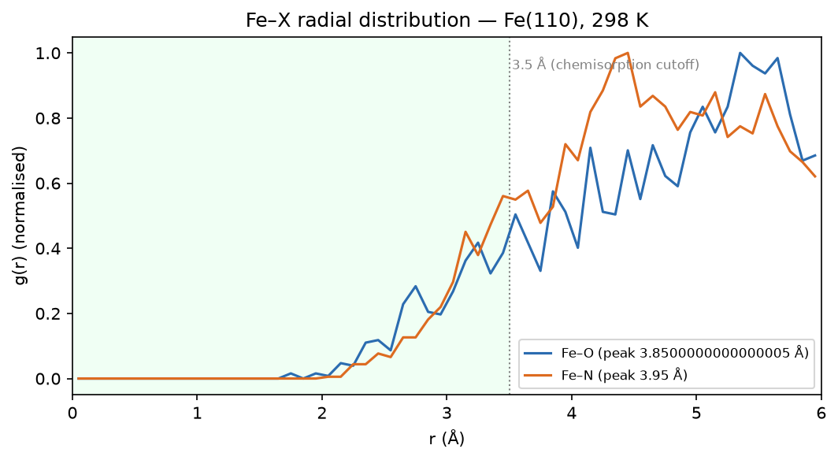
pyrazolopyrimidine propanamide — Fe-O RDF
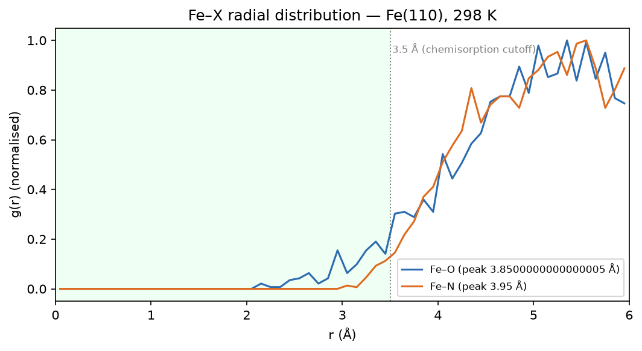
pyrazolopyrimidine ethyl ester — Fe-O RDF

6. Method & caveats
DFT level: B3LYP/6-311++G(d,p) (ddCOSMO:water). Global descriptors come from the frontier-orbital energies via Koopmans' theorem; ΔN uses the metal work function with η(metal) = 0. The Monte-Carlo and Brownian-MD stages use a classical van-der-Waals adsorption model — a physics-based screening surrogate, not a substitute for periodic DFT or for electrochemical validation. The composite ranking is a heuristic that orders candidates; it does not prove inhibition. Full methodology: docs/pipeline.md; validation record: docs/validation.md.

