corrosim — multiscale corrosion-inhibitor report
Substrate: Cu(111) | Medium: 1 M HCl | DFT level: B3LYP/def2-SVP (ddCOSMO:water) | Generated 2026-07-13 04:01
The molecules modelled here are screened in silico as representative candidates, not a verified analysis of any real sample. Confirm the actual composition experimentally (e.g. by LC-MS/GC-MS) before drawing firm conclusions.

1. Overview

2. Summary & ranking
Of the 5 molecules screened, no single lead is robust: pyrazolylnucleoside chloro and pyrazolylnucleoside methoxy rank within the method's resolution of one another — the top candidate changes across the 2 descriptor bases (geometry and protonation), so they are reported as a tie rather than ordered. This is a computational screening prediction requiring electrochemical confirmation (see the Method section and caveats).
 | pyrazolylnucleoside methoxy | pyrazolylnucleoside methyl | pyrazolylnucleoside bromo | pyrazolylnucleoside chloro | pyrazolylnucleoside fluoro
Gap (eV) | 5.457 | 5.655 | 5.768 | 5.851 | 6.047
Hardness η (eV) | 2.728 | 2.827 | 2.884 | 2.926 | 3.023
Softness σ (1/eV) | 0.366 | 0.354 | 0.347 | 0.342 | 0.331
ΔN | 0.217 | 0.15 | 0.169 | 0.17 | 0.174
E_ads (kJ/mol) | -9.13 | -7.66 | -10.52 | -9.15 | -9.23
Cu–O (Å) | 3.35 | 3.55 | 3.75 | 3.45 | 3.65
Score | 1.532 | 0.504 | -0.076 | -0.495 | -1.465
Ranking basis | Top candidate
force-field geometry, neutral | pyrazolylnucleoside chloro
force-field geometry, pH-weighted | pyrazolylnucleoside methoxy
Lead not robust: the top candidate changes across the 2 bases, so the top group is within method resolution and reported as a tie.
Scored on the HOMO–LUMO gap, hardness and softness of the canonical basis (force-field geometry, pH-weighted; z-scored; higher = stronger). The geometry / protonation panels below are a sensitivity check, not separate rankings. E_ads and the Cu–O distance validate the lead, they do not enter the score. Full method: docs/pipeline.md.

3. DFT electronic descriptors
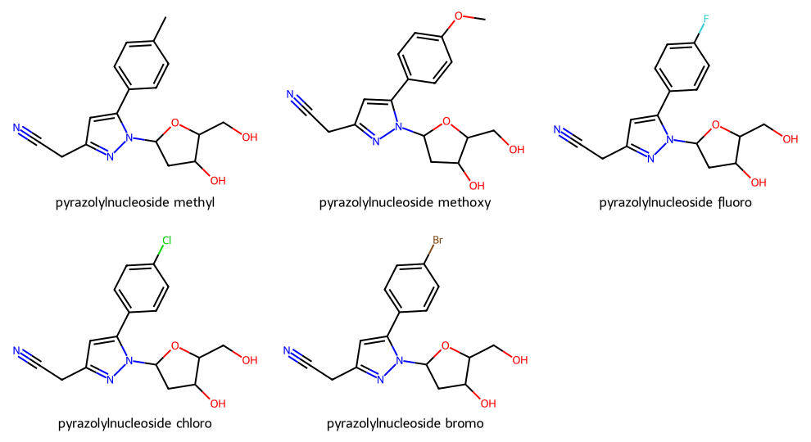
Modelled molecules
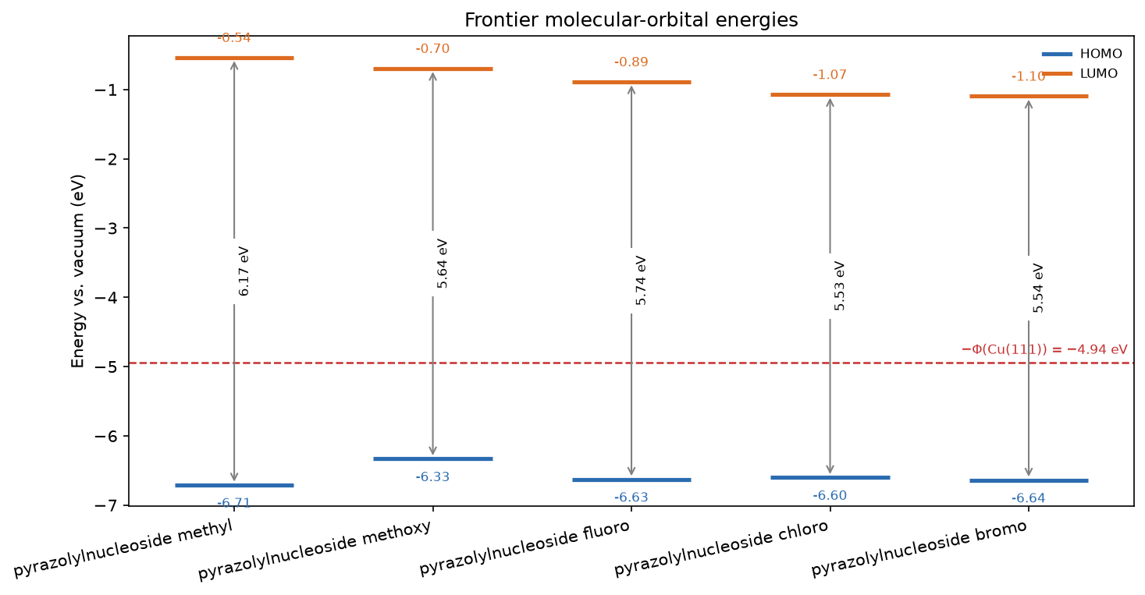
Frontier-orbital energies vs the metal work function

3.1 Frontier-orbital isosurfaces (HOMO / LUMO)
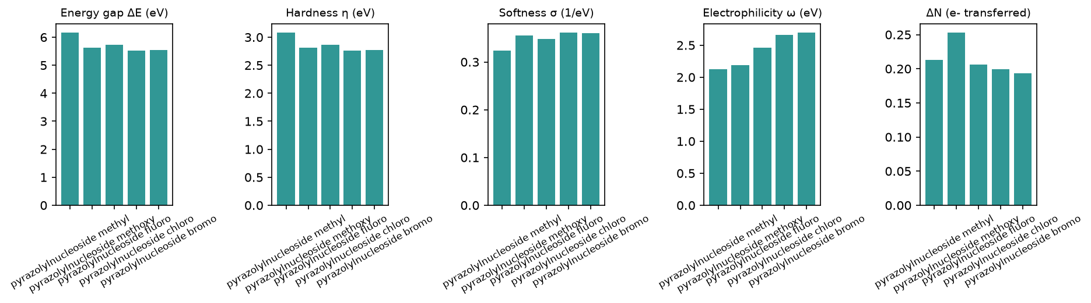
Reactivity descriptors
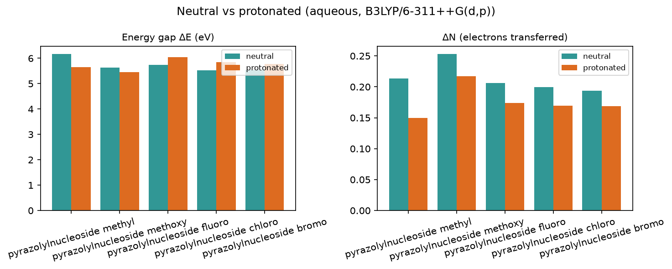
Protonation effect

3.2 Full descriptor table (neutral, aqueous)
Descriptor | pyrazolylnucleoside methyl | pyrazolylnucleoside methoxy | pyrazolylnucleoside fluoro | pyrazolylnucleoside chloro | pyrazolylnucleoside bromo
Formula | C17H19N3O3 | C17H19N3O4 | C16H16FN3O3 | C16H16ClN3O3 | C16H16BrN3O3
HOMO (eV) | -6.709 | -6.331 | -6.626 | -6.6 | -6.638
LUMO (eV) | -0.538 | -0.696 | -0.889 | -1.072 | -1.097
Gap ΔE (eV) | 6.171 | 5.635 | 5.738 | 5.528 | 5.541
η hardness (eV) | 3.085 | 2.818 | 2.869 | 2.764 | 2.771
σ softness (1/eV) | 0.324 | 0.355 | 0.349 | 0.362 | 0.361
χ electronegativity (eV) | 3.624 | 3.513 | 3.758 | 3.836 | 3.867
ω electrophilicity (eV) | 2.128 | 2.19 | 2.461 | 2.662 | 2.699
ΔN | 0.213 | 0.253 | 0.206 | 0.2 | 0.194
E_back-donation (eV) | -0.771 | -0.704 | -0.717 | -0.691 | -0.693
TNC | -2.125 | -2.477 | -2.262 | -2.065 | -2.031
E_ads (kJ/mol) | -7.66 | -9.13 | -9.23 | -9.15 | -10.52

3.3 Species in the acidic medium (protonated cation)
Descriptor | pyrazolylnucleoside methyl+H+ | pyrazolylnucleoside methoxy+H+ | pyrazolylnucleoside fluoro+H+ | pyrazolylnucleoside chloro+H+ | pyrazolylnucleoside bromo+H+
Formula | C17H20N3O3+ | C17H20N3O4+ | C16H17FN3O3+ | C16H17ClN3O3+ | C16H17BrN3O3+
HOMO (eV) | -6.918 | -6.483 | -6.914 | -6.874 | -6.851
LUMO (eV) | -1.265 | -1.026 | -0.866 | -1.022 | -1.082
Gap ΔE (eV) | 5.653 | 5.456 | 6.048 | 5.852 | 5.769
η hardness (eV) | 2.827 | 2.728 | 3.024 | 2.926 | 2.884
σ softness (1/eV) | 0.354 | 0.367 | 0.331 | 0.342 | 0.347
χ electronegativity (eV) | 4.092 | 3.755 | 3.89 | 3.948 | 3.967
ω electrophilicity (eV) | 2.961 | 2.584 | 2.502 | 2.663 | 2.727
ΔN | 0.15 | 0.217 | 0.174 | 0.17 | 0.169
E_back-donation (eV) | -0.707 | -0.682 | -0.756 | -0.732 | -0.721
TNC | -1.797 | -2.142 | -1.985 | -1.767 | -1.722
Protonated +1 cation descriptors in 1 M HCl; a component of the pH-weighted canonical basis (see the Summary), shown here on its own.

3.4 Speciation in 1 M HCl (pH ≈ -0.0)
0% neutral / 100% protonated at this pH — the protonated form dominates. Population-weighted descriptors (the speciation axis of the ranking ensemble; the headline ranks on the canonical basis):
Descriptor | pyrazolylnucleoside methyl | pyrazolylnucleoside methoxy | pyrazolylnucleoside fluoro | pyrazolylnucleoside chloro | pyrazolylnucleoside bromo
Formula | C17H19N3O3 | C17H19N3O4 | C16H16FN3O3 | C16H16ClN3O3 | C16H16BrN3O3
HOMO (eV) | -6.918 | -6.482 | -6.913 | -6.873 | -6.85
LUMO (eV) | -1.263 | -1.025 | -0.866 | -1.022 | -1.082
Gap ΔE (eV) | 5.655 | 5.457 | 6.047 | 5.851 | 5.768
η hardness (eV) | 2.827 | 2.728 | 3.023 | 2.926 | 2.884
σ softness (1/eV) | 0.354 | 0.366 | 0.331 | 0.342 | 0.347
χ electronegativity (eV) | 4.09 | 3.754 | 3.889 | 3.948 | 3.966
ω electrophilicity (eV) | 2.959 | 2.582 | 2.502 | 2.663 | 2.727
ΔN | 0.15 | 0.217 | 0.174 | 0.17 | 0.169
E_back-donation (eV) | -0.707 | -0.682 | -0.756 | -0.731 | -0.721
TNC | -1.798 | -2.144 | -1.986 | -1.768 | -1.723

3.5 Local reactivity (Fukui)

3.6 Electrostatic-potential (ESP) map

4. Monte Carlo adsorption
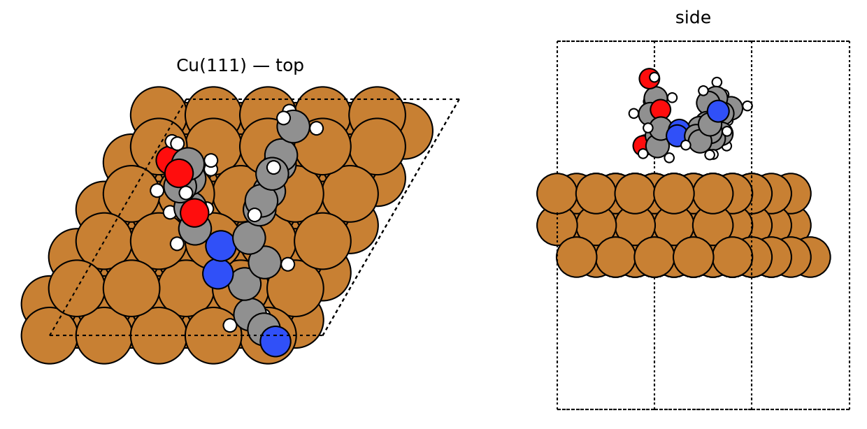
pyrazolylnucleoside methyl — best pose
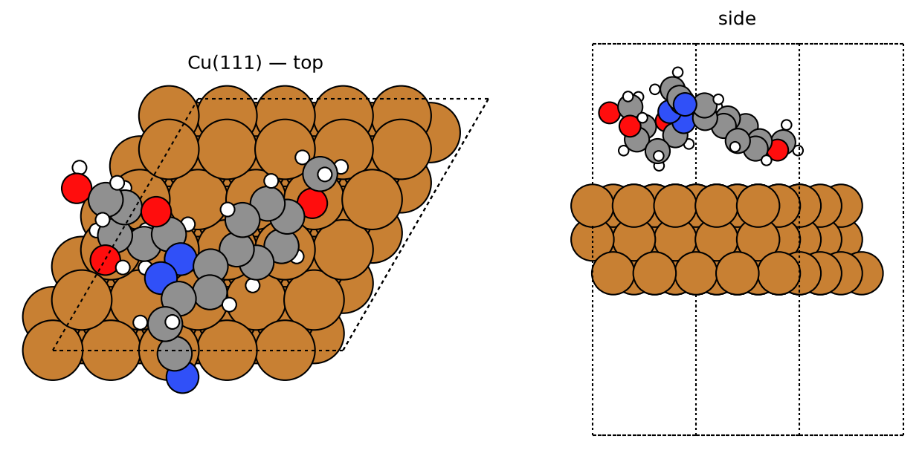
pyrazolylnucleoside methoxy — best pose
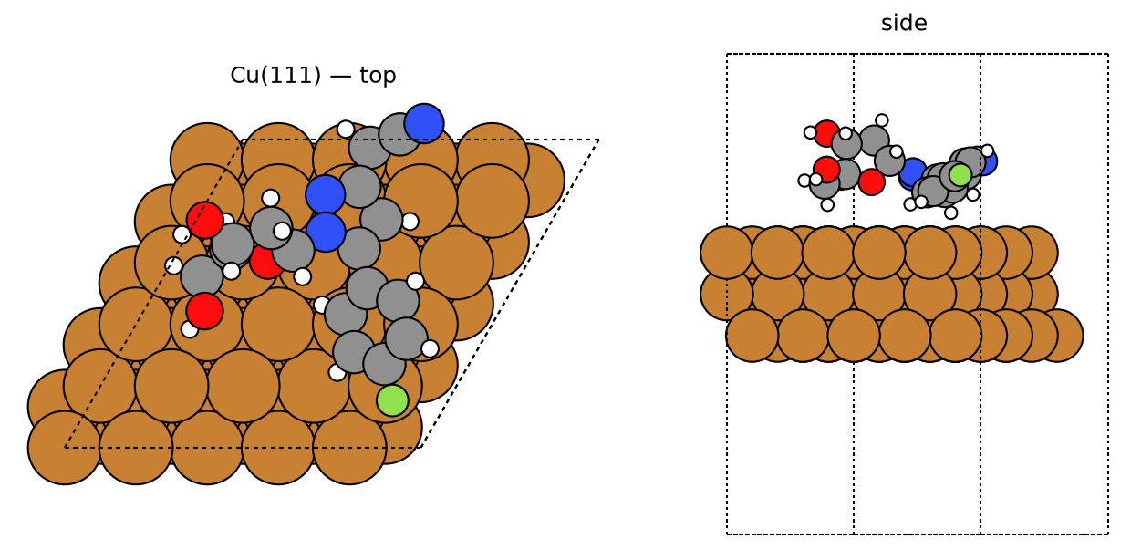
pyrazolylnucleoside fluoro — best pose
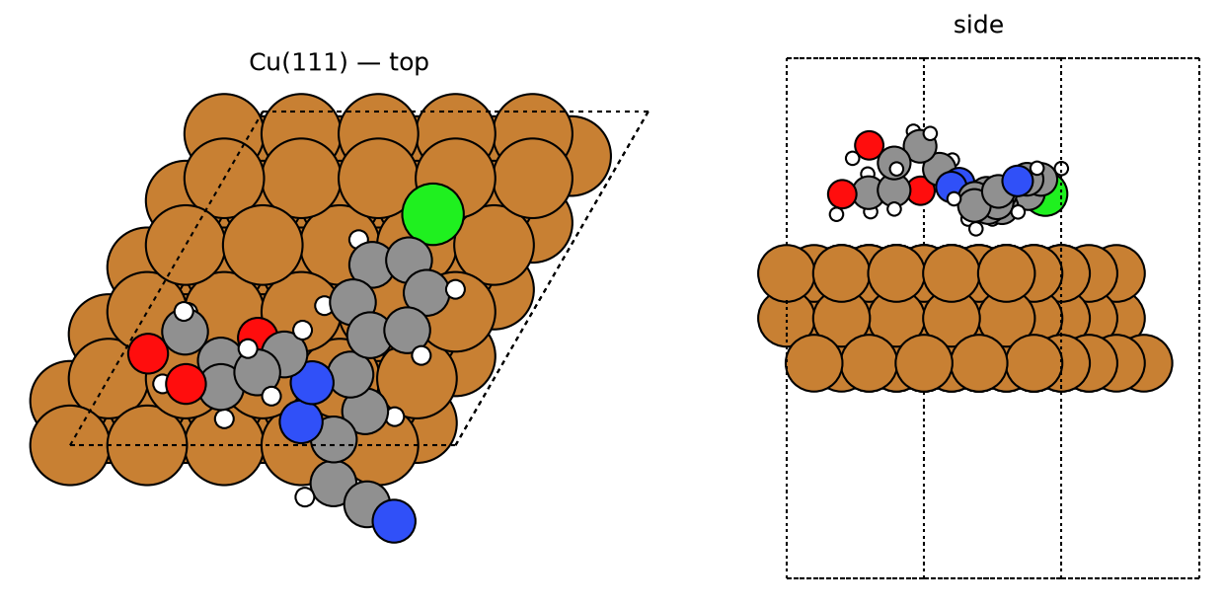
pyrazolylnucleoside chloro — best pose
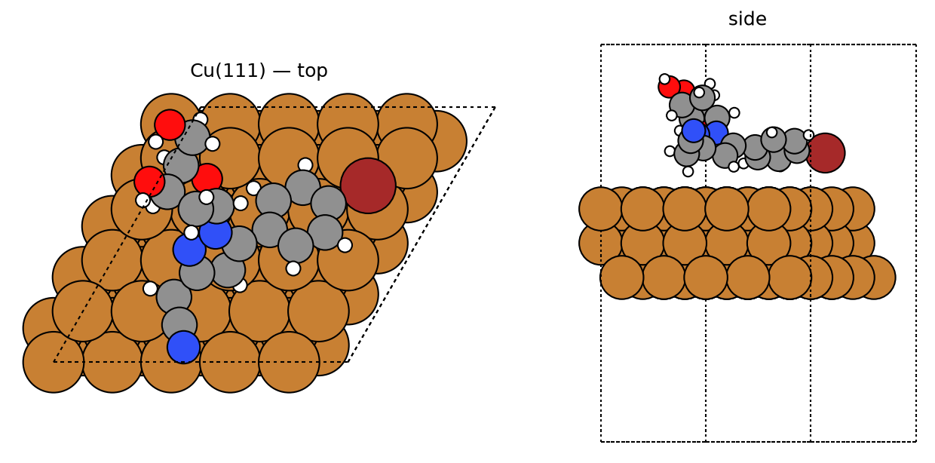
pyrazolylnucleoside bromo — best pose
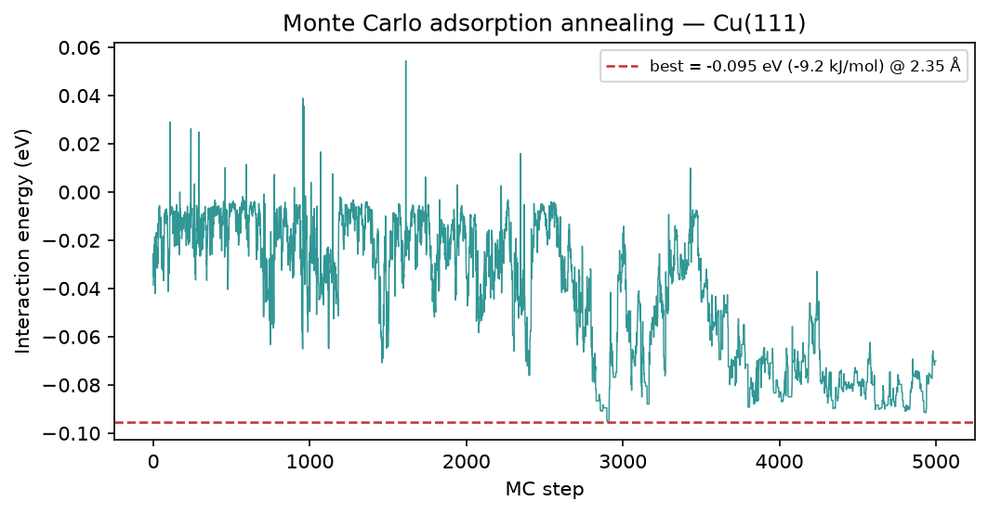
pyrazolylnucleoside methyl — MC annealing
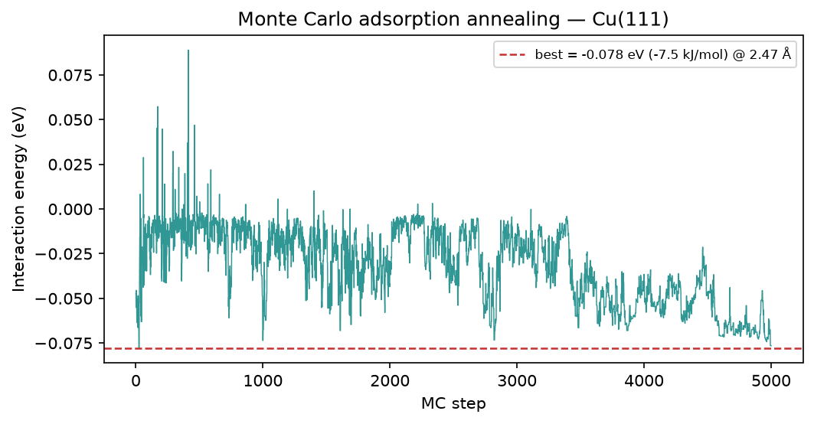
pyrazolylnucleoside methoxy — MC annealing
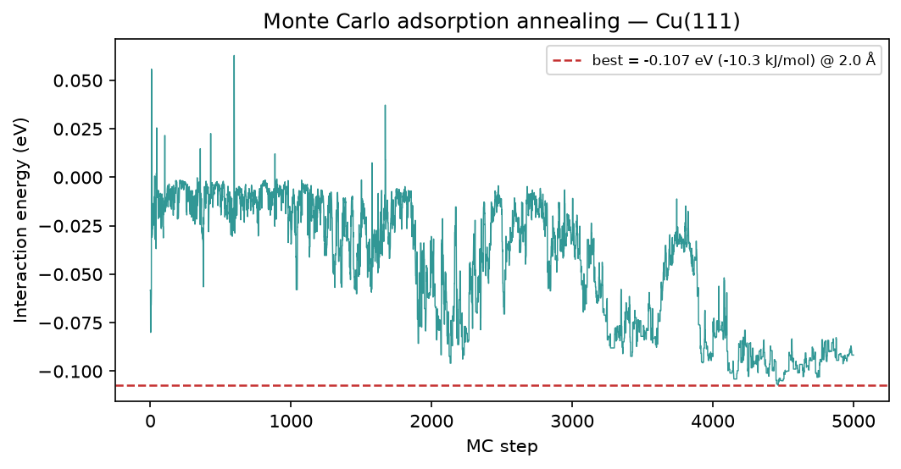
pyrazolylnucleoside fluoro — MC annealing
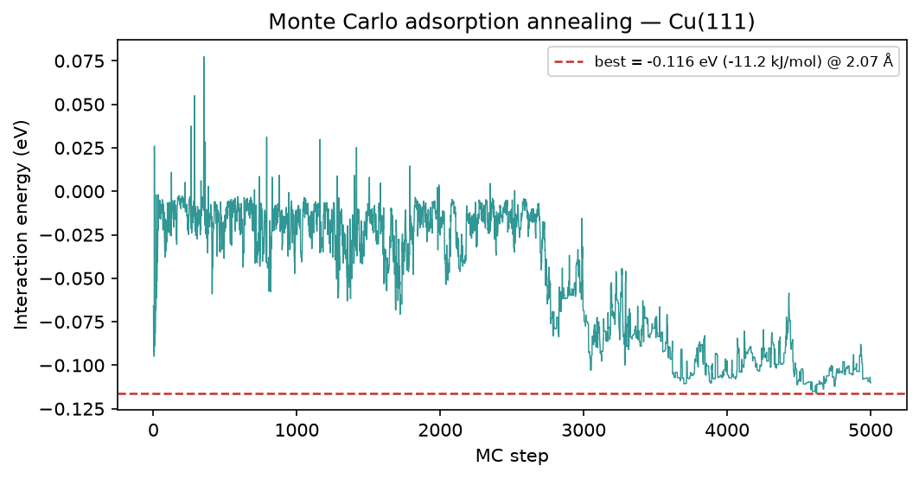
pyrazolylnucleoside chloro — MC annealing
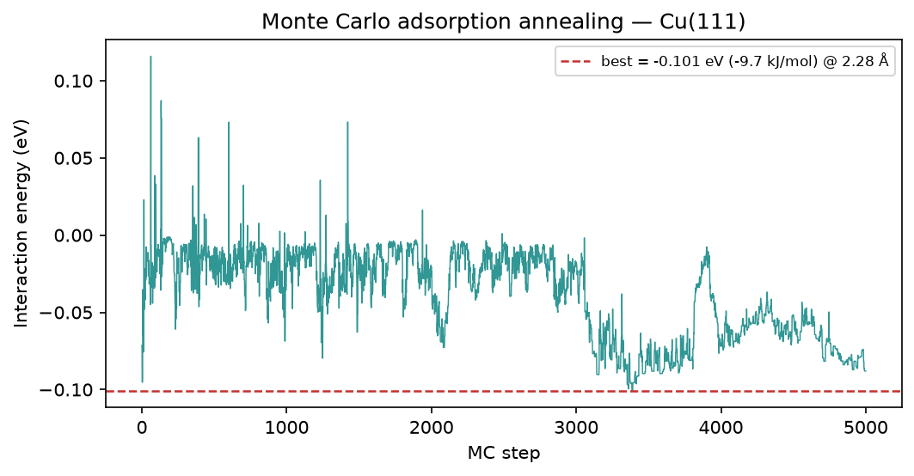
pyrazolylnucleoside bromo — MC annealing

5. Brownian MD (Cu-O RDF)
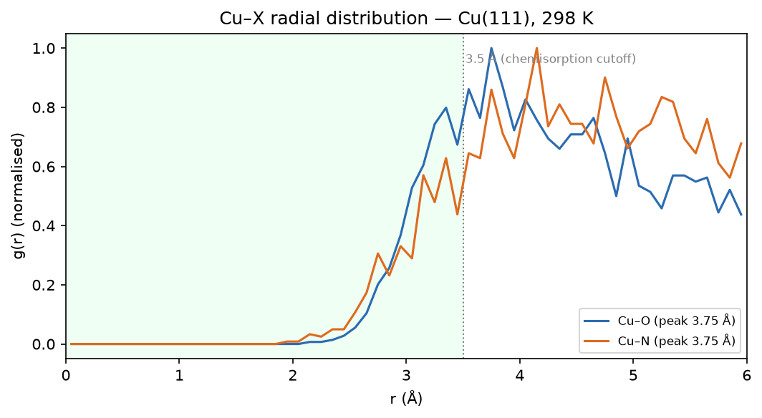
pyrazolylnucleoside methyl — Cu-O RDF
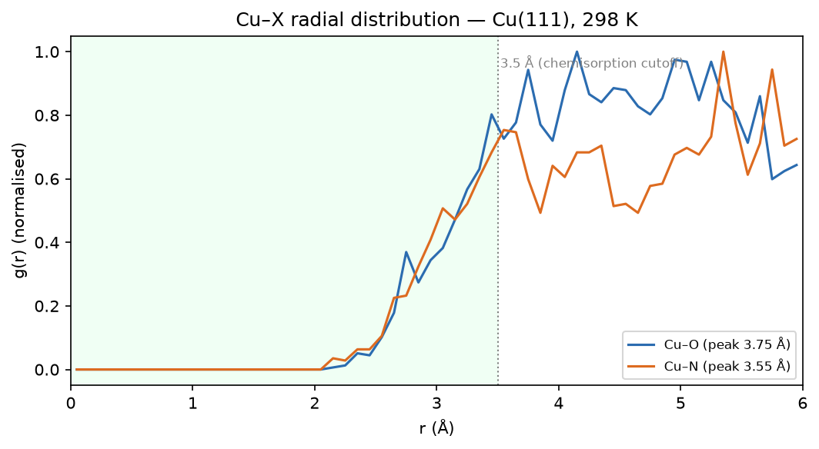
pyrazolylnucleoside methoxy — Cu-O RDF
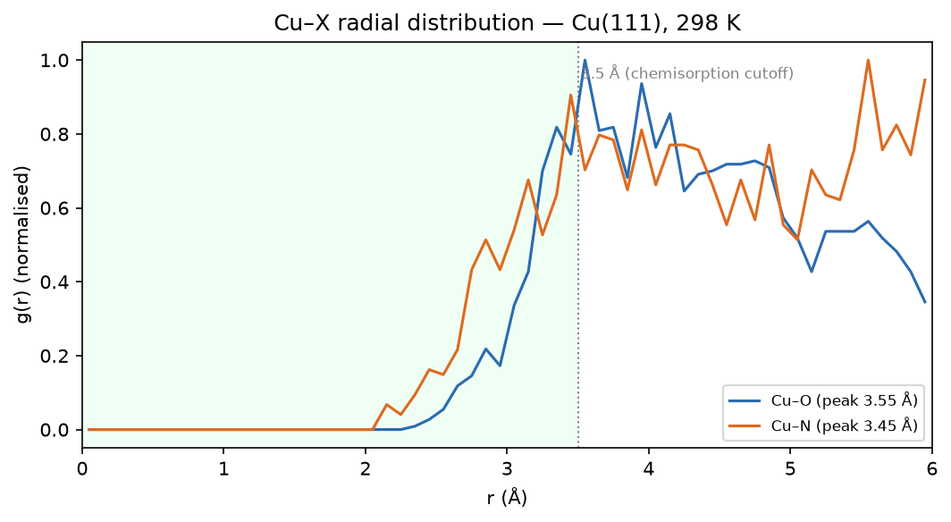
pyrazolylnucleoside fluoro — Cu-O RDF
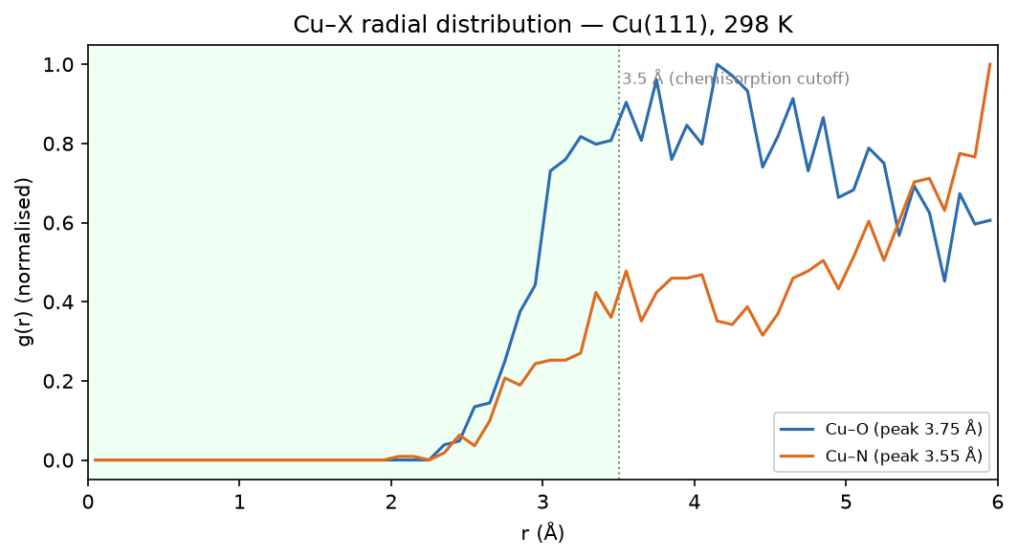
pyrazolylnucleoside chloro — Cu-O RDF
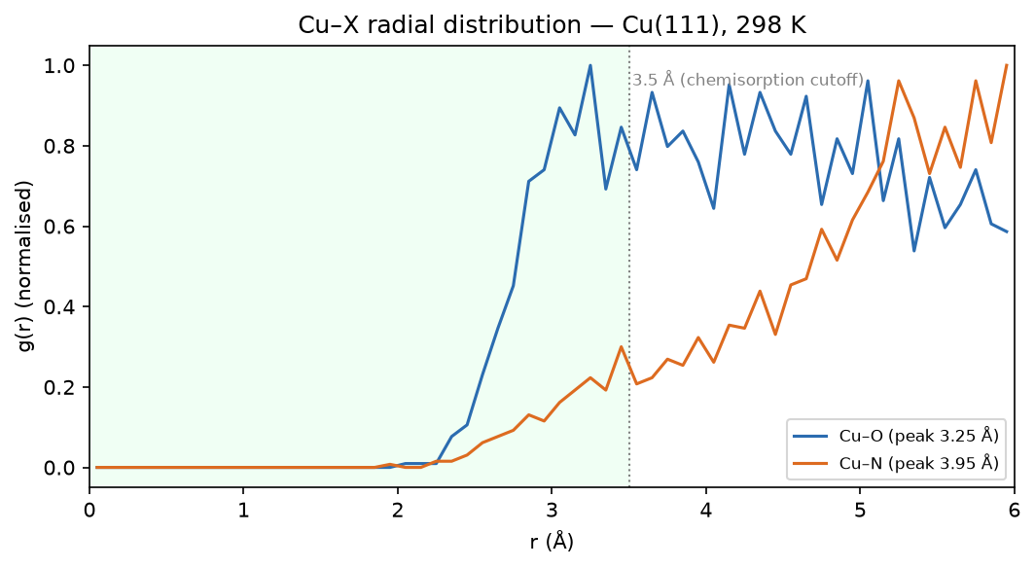
pyrazolylnucleoside bromo — Cu-O RDF

6. Method & caveats
DFT level: B3LYP/def2-SVP (ddCOSMO:water). Global descriptors come from the frontier-orbital energies via Koopmans' theorem; ΔN uses the metal work function with η(metal) = 0. The Monte-Carlo and Brownian-MD stages use a classical van-der-Waals adsorption model — a physics-based screening surrogate, not a substitute for periodic DFT or for electrochemical validation. The composite ranking is a heuristic that orders candidates; it does not prove inhibition. Full methodology: docs/pipeline.md; validation record: docs/validation.md.

