corrosim — multiscale corrosion-inhibitor report
Substrate: Cu(111) | Medium: 1 M HNO3 | DFT level: B3LYP/6-311++G(d,p) (ddCOSMO:water) | Generated 2026-07-13 00:23
The molecules modelled here are screened in silico as representative candidates, not a verified analysis of any real sample. Confirm the actual composition experimentally (e.g. by LC-MS/GC-MS) before drawing firm conclusions.

1. Overview

2. Summary & ranking
Of the 4 molecules screened, 1-phenyl-5-mercaptotetrazole ranks highest on the composite electronic score (+0.79), combining the smallest HOMO–LUMO gap (5.11 eV) with the highest softness — the most readily polarised, electron-donating candidate of the set. It adsorbs flat on Cu in the physisorption regime (E_ads ≈ -10 kJ/mol). The lead holds across all 2 descriptor bases evaluated (geometry and protonation). This is a computational screening prediction requiring electrochemical confirmation (see the Method section and caveats).
 | 1-phenyl-5-mercaptotetrazole | 5-phenyltetrazole | 5-aminotetrazole | tetrazole
Gap (eV) | 5.107 ✓ | 5.268 | 5.44 | 7.186
Hardness η (eV) | 2.554 ✓ | 2.634 | 2.72 | 3.593
Softness σ (1/eV) | 0.392 ✓ | 0.38 | 0.368 | 0.278
ΔN | 0.088 | 0.108 | 0.153 | -0.039
E_ads (kJ/mol) | -10.26 ✓ | -9.09 | -4.48 | -3.76
Cu–O (Å)
Score | 0.789 ✓ | 0.575 | 0.346 | -1.71
Ranking basis | Top candidate
force-field geometry, neutral | 1-phenyl-5-mercaptotetrazole
force-field geometry, pH-weighted | 1-phenyl-5-mercaptotetrazole
Lead robust: the same candidate tops all 2 descriptor bases (geometry and protonation).
Scored on the HOMO–LUMO gap, hardness and softness of the canonical basis (force-field geometry, pH-weighted; z-scored; higher = stronger). The geometry / protonation panels below are a sensitivity check, not separate rankings. E_ads and the Cu–O distance validate the lead, they do not enter the score. Full method: docs/pipeline.md.

3. DFT electronic descriptors
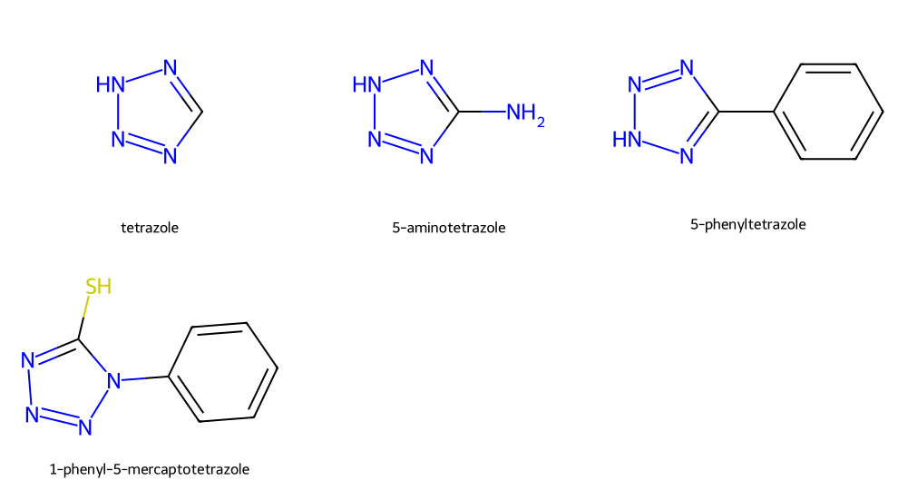
Modelled molecules
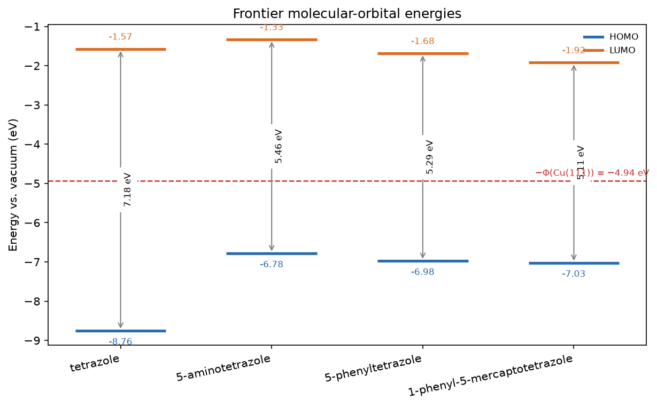
Frontier-orbital energies vs the metal work function

3.1 Frontier-orbital isosurfaces (HOMO / LUMO)
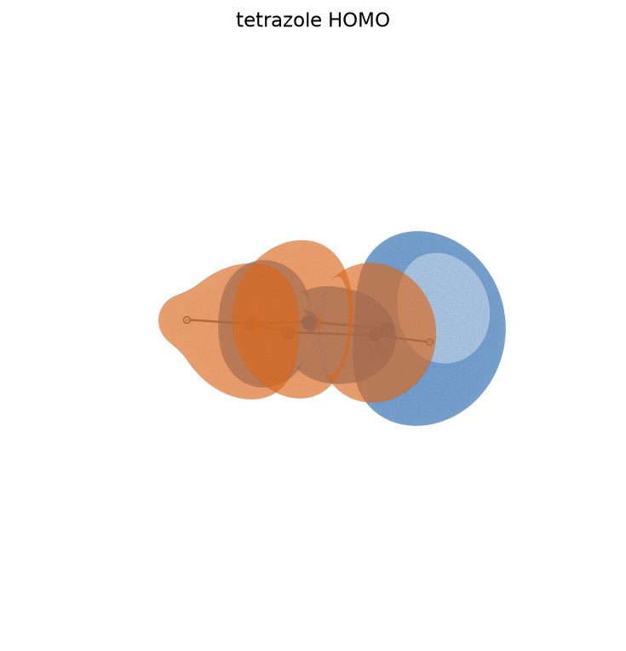
tetrazole HOMO
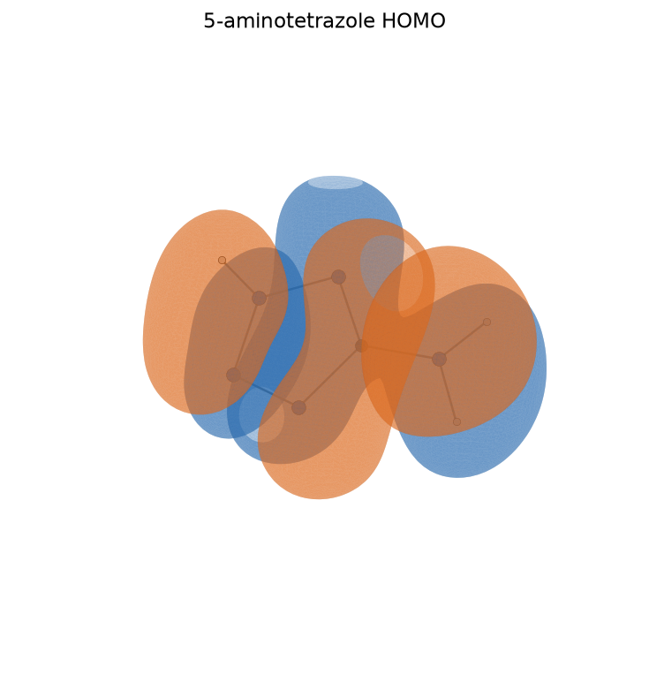
5-aminotetrazole HOMO
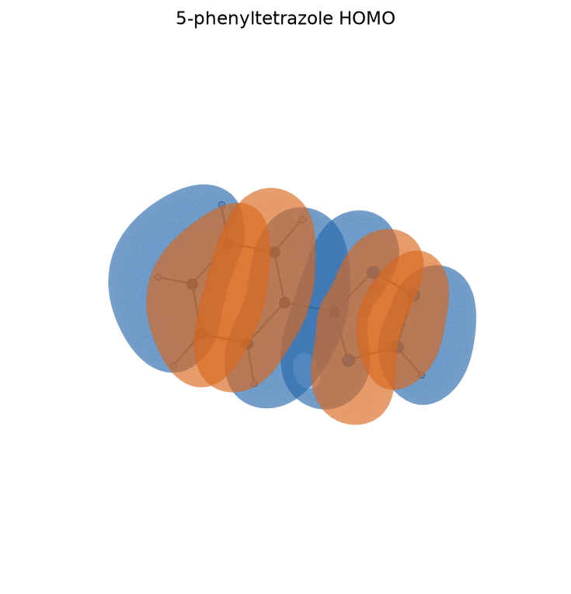
5-phenyltetrazole HOMO
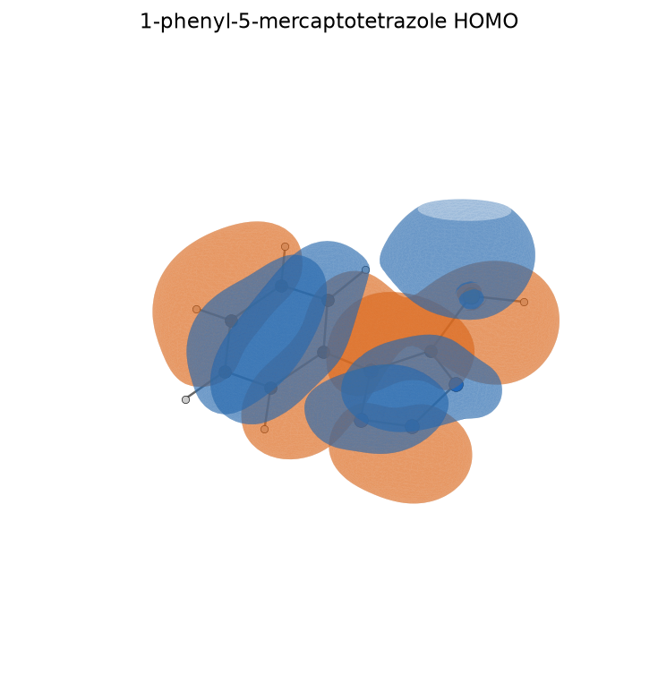
1-phenyl-5-mercaptotetrazole HOMO
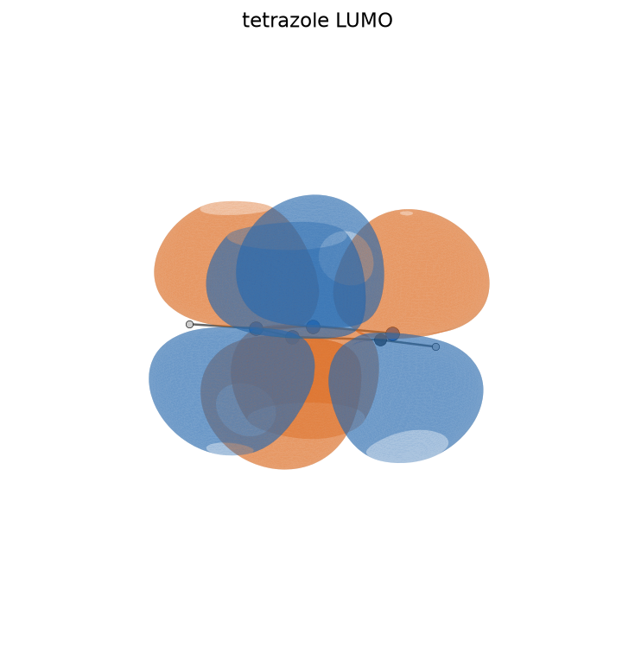
tetrazole LUMO
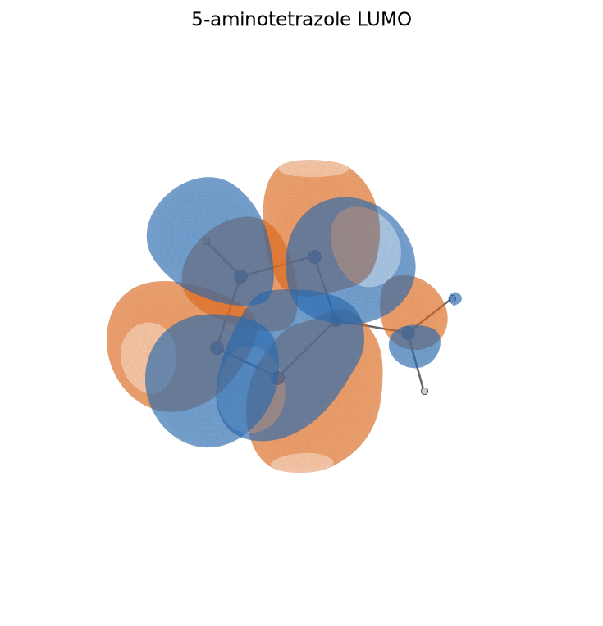
5-aminotetrazole LUMO
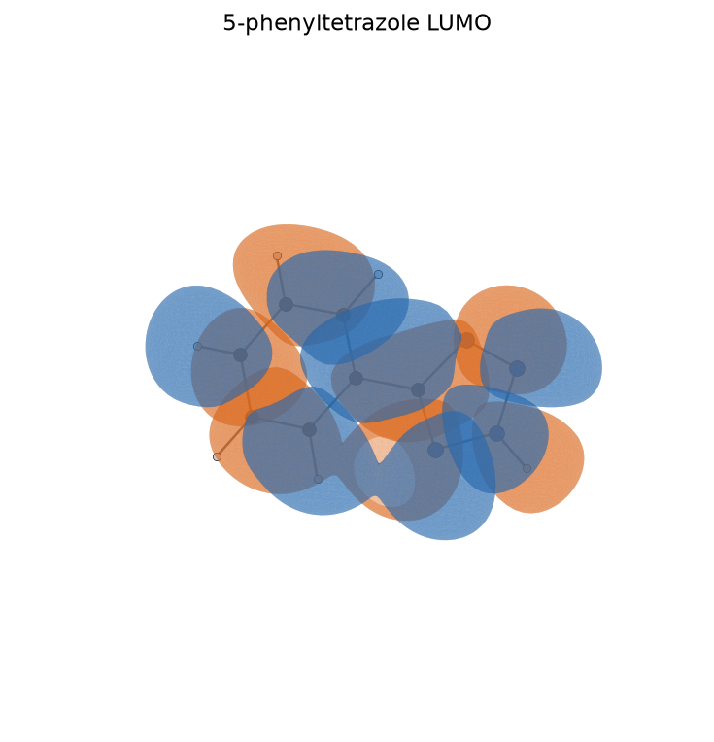
5-phenyltetrazole LUMO
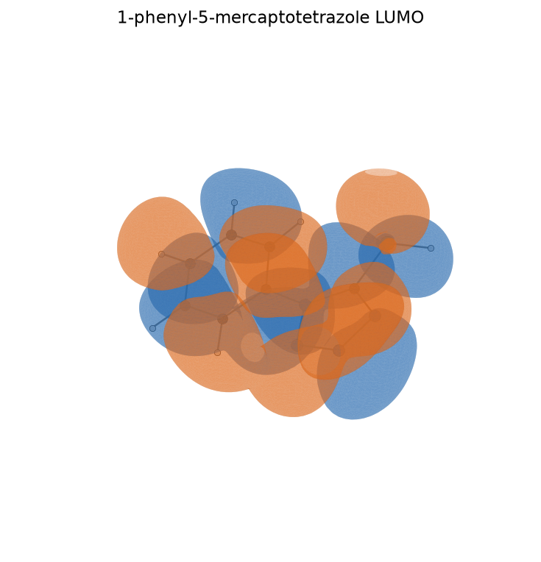
1-phenyl-5-mercaptotetrazole LUMO
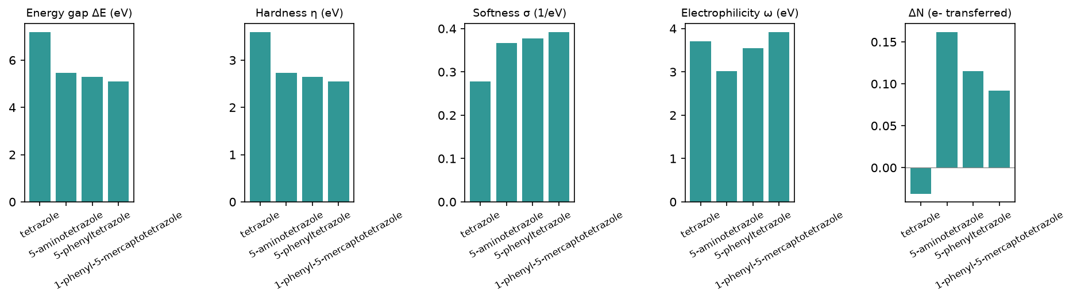
Reactivity descriptors
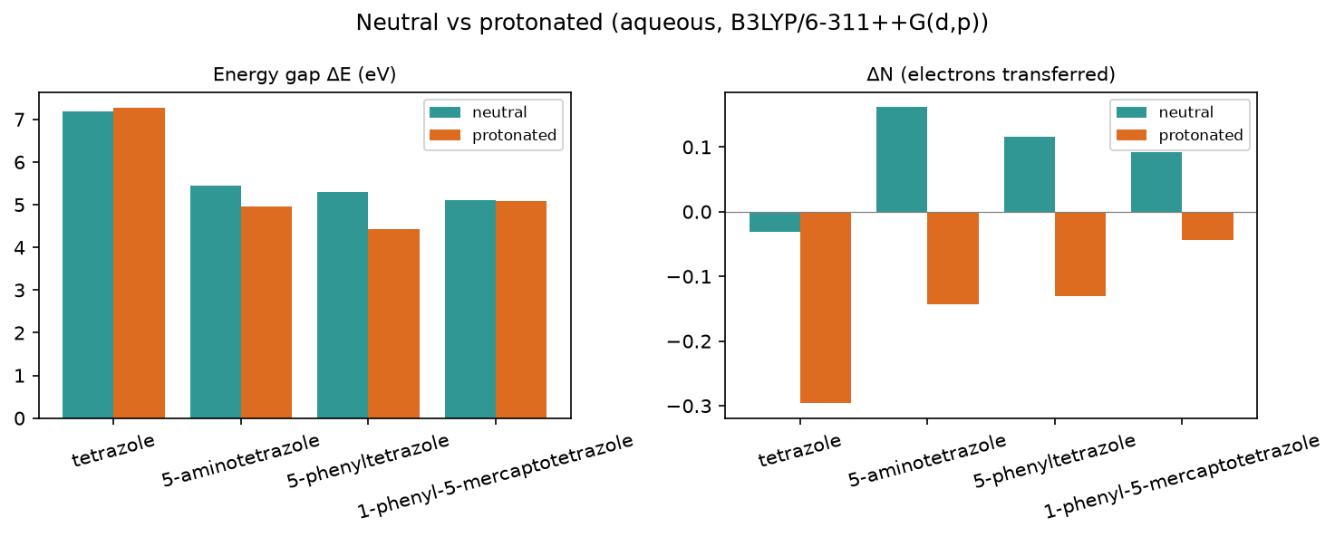
Protonation effect

3.2 Full descriptor table (neutral, aqueous)
Descriptor | tetrazole | 5-aminotetrazole | 5-phenyltetrazole | 1-phenyl-5-mercaptotetrazole
Formula | CH2N4 | CH3N5 | C7H6N4 | C7H6N4S
HOMO (eV) | -8.755 | -6.784 | -6.977 | -7.026
LUMO (eV) | -1.572 | -1.329 | -1.683 | -1.918
Gap ΔE (eV) | 7.183 | 5.455 | 5.294 | 5.108
η hardness (eV) | 3.591 | 2.728 | 2.647 | 2.554
σ softness (1/eV) | 0.278 | 0.367 | 0.378 | 0.392
χ electronegativity (eV) | 5.164 | 4.056 | 4.33 | 4.472
ω electrophilicity (eV) | 3.712 | 3.016 | 3.541 | 3.915
ΔN | -0.031 | 0.162 | 0.115 | 0.092
E_back-donation (eV) | -0.898 | -0.682 | -0.662 | -0.638
TNC | -0.608 | -1.0 | -3.031 | -1.83
E_ads (kJ/mol) | -3.76 | -4.48 | -9.09 | -10.26

3.3 Species in the acidic medium (protonated cation)
Descriptor | tetrazole+H+ | 5-aminotetrazole+H+ | 5-phenyltetrazole+H+ | 1-phenyl-5-mercaptotetrazole+H+
Formula | CH3N4+ | CH4N5+ | C7H7N4+ | C7H7N4S+
HOMO (eV) | -10.733 | -8.127 | -7.736 | -7.704
LUMO (eV) | -3.457 | -3.167 | -3.301 | -2.619
Gap ΔE (eV) | 7.276 | 4.96 | 4.435 | 5.085
η hardness (eV) | 3.638 | 2.48 | 2.217 | 2.542
σ softness (1/eV) | 0.275 | 0.403 | 0.451 | 0.393
χ electronegativity (eV) | 7.095 | 5.647 | 5.518 | 5.162
ω electrophilicity (eV) | 6.918 | 6.429 | 6.867 | 5.24
ΔN | -0.296 | -0.143 | -0.13 | -0.044
E_back-donation (eV) | -0.909 | -0.62 | -0.554 | -0.636
TNC | -0.299 | -0.843 | -3.228 | -1.487
Protonated +1 cation descriptors in 1 M HNO3; a component of the pH-weighted canonical basis (see the Summary), shown here on its own.

3.4 Speciation in 1 M HNO3 (pH ≈ -0.0)
97% neutral / 3% protonated at this pH — the neutral form dominates. Population-weighted descriptors (the speciation axis of the ranking ensemble; the headline ranks on the canonical basis):
Descriptor | tetrazole | 5-aminotetrazole | 5-phenyltetrazole | 1-phenyl-5-mercaptotetrazole
Formula | CH2N4 | CH3N5 | C7H6N4 | C7H6N4S
HOMO (eV) | -8.816 | -6.825 | -7.0 | -7.046
LUMO (eV) | -1.63 | -1.385 | -1.732 | -1.939
Gap ΔE (eV) | 7.186 | 5.44 | 5.268 | 5.107
η hardness (eV) | 3.593 | 2.72 | 2.634 | 2.554
σ softness (1/eV) | 0.278 | 0.368 | 0.38 | 0.392
χ electronegativity (eV) | 5.223 | 4.105 | 4.366 | 4.493
ω electrophilicity (eV) | 3.811 | 3.121 | 3.643 | 3.955
ΔN | -0.039 | 0.153 | 0.108 | 0.088
E_back-donation (eV) | -0.898 | -0.68 | -0.658 | -0.638
TNC | -0.598 | -0.995 | -3.037 | -1.82

3.5 Local reactivity (Fukui)
tetrazole:
5-aminotetrazole:
5-phenyltetrazole:
1-phenyl-5-mercaptotetrazole:
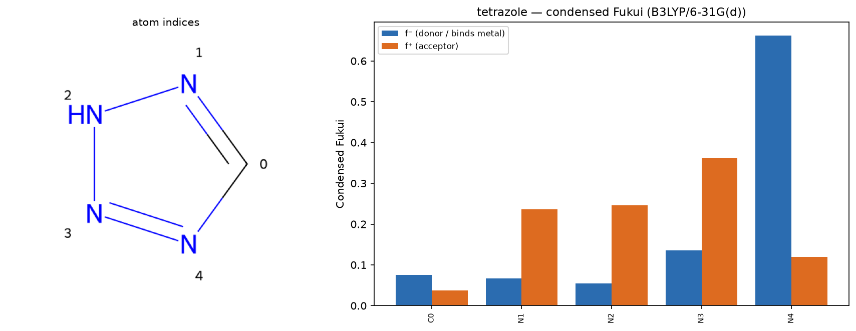
tetrazole — condensed Fukui
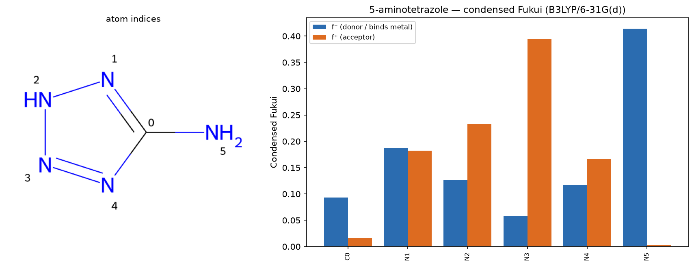
5-aminotetrazole — condensed Fukui
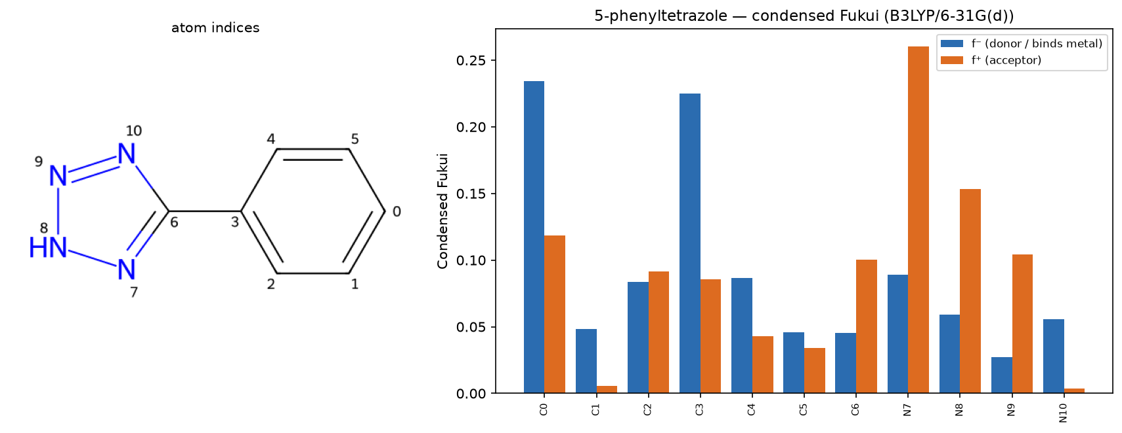
5-phenyltetrazole — condensed Fukui
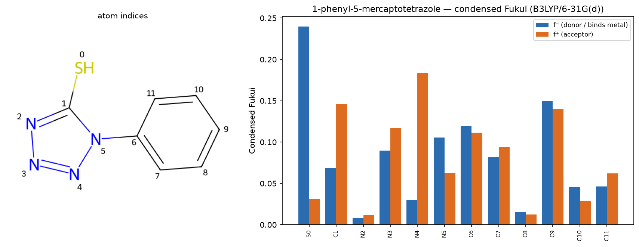
1-phenyl-5-mercaptotetrazole — condensed Fukui

3.6 Electrostatic-potential (ESP) map
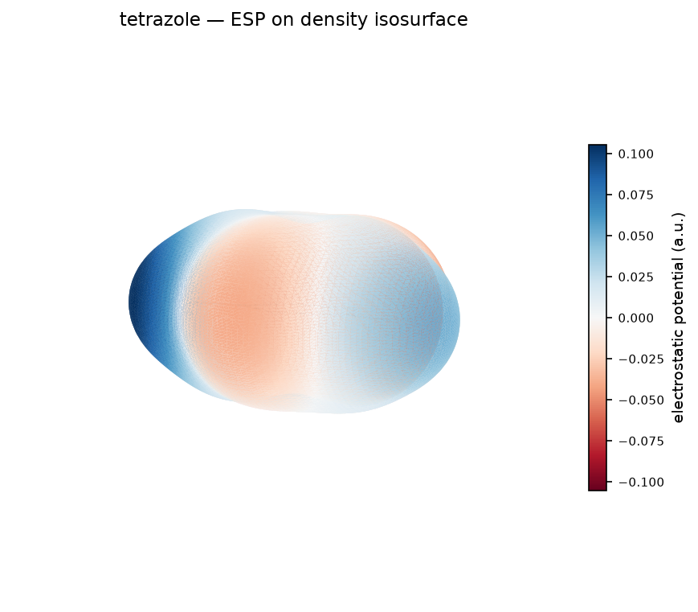
tetrazole — ESP map
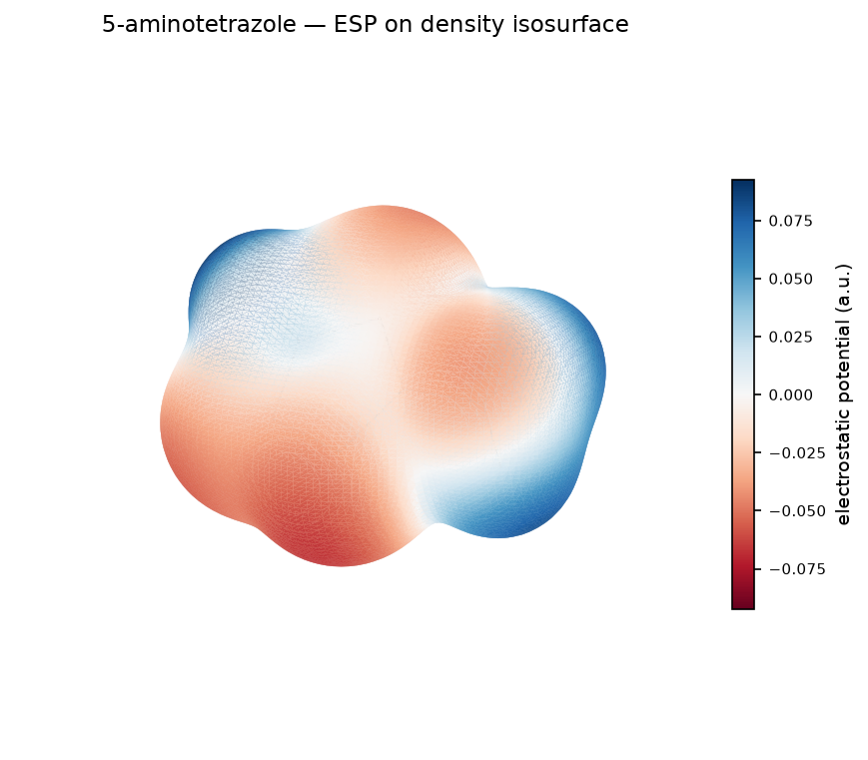
5-aminotetrazole — ESP map
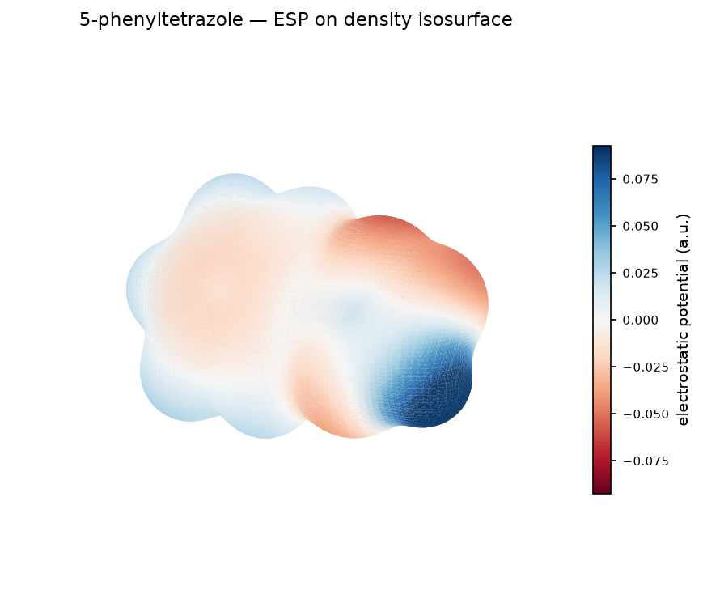
5-phenyltetrazole — ESP map
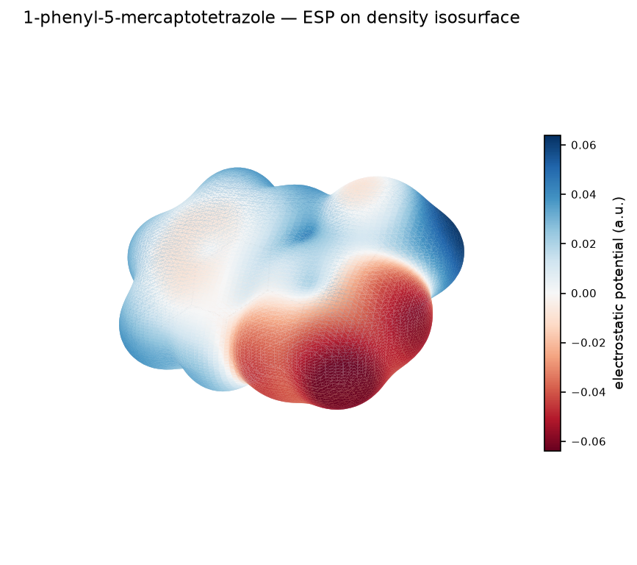
1-phenyl-5-mercaptotetrazole — ESP map

4. Monte Carlo adsorption
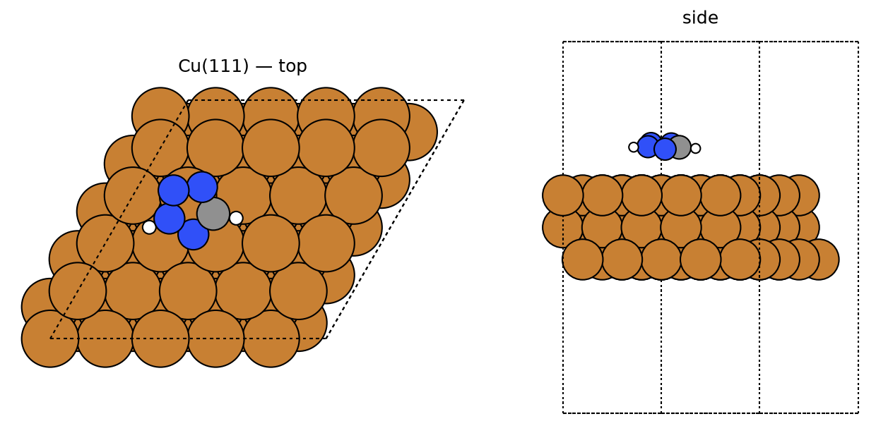
tetrazole — best pose
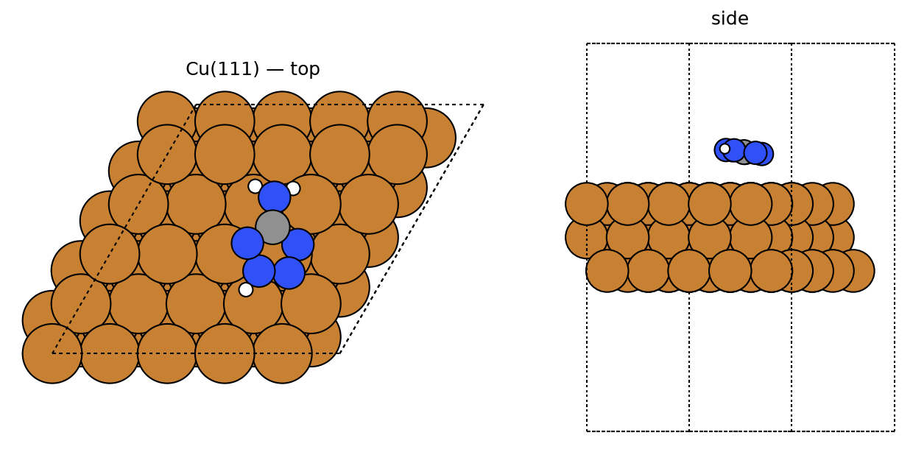
5-aminotetrazole — best pose
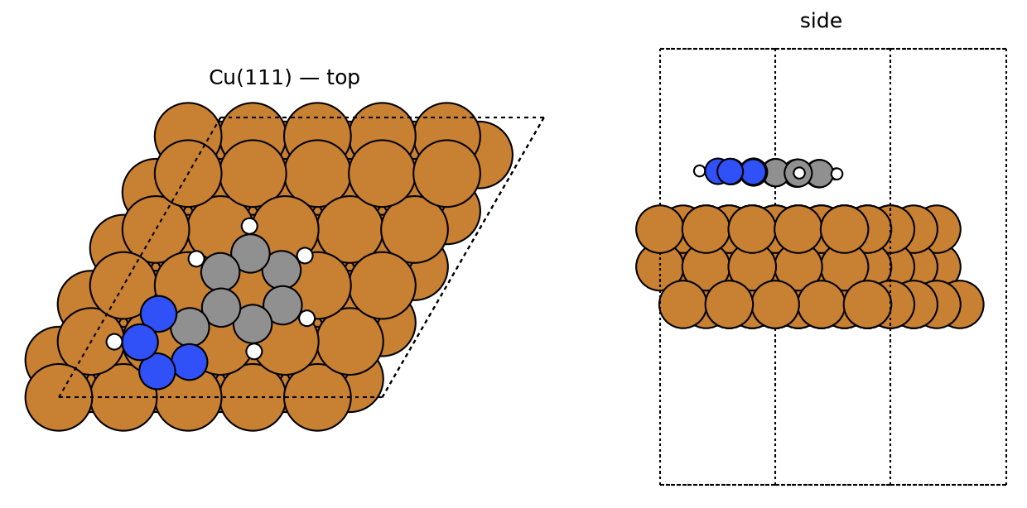
5-phenyltetrazole — best pose
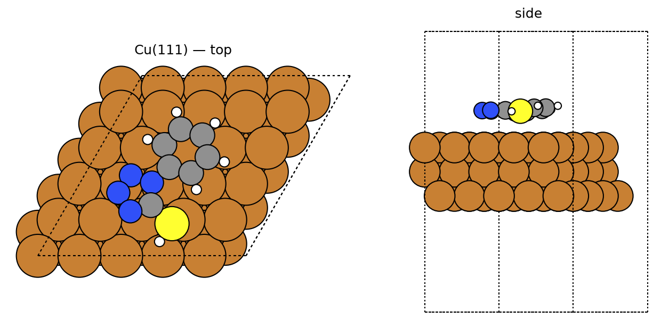
1-phenyl-5-mercaptotetrazole — best pose
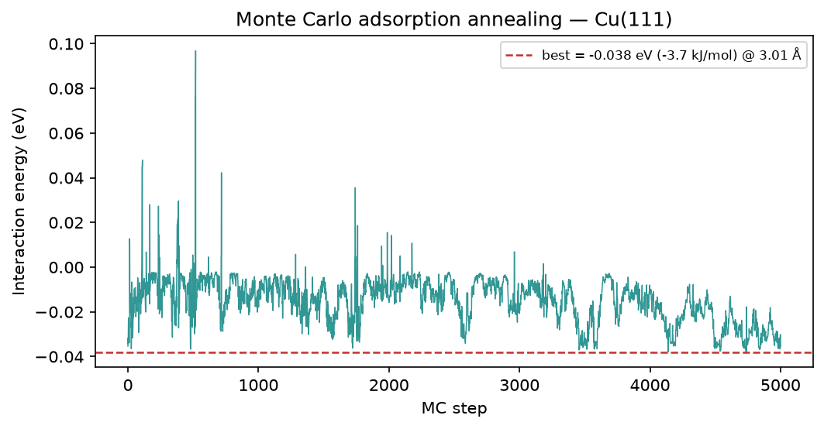
tetrazole — MC annealing
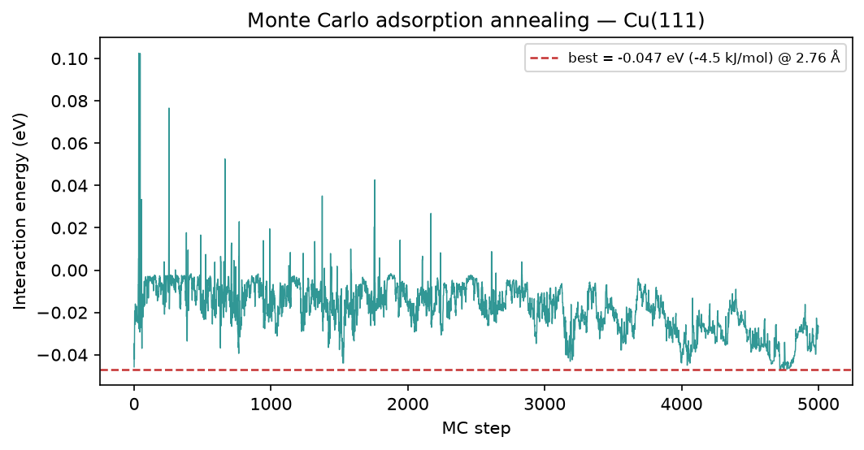
5-aminotetrazole — MC annealing
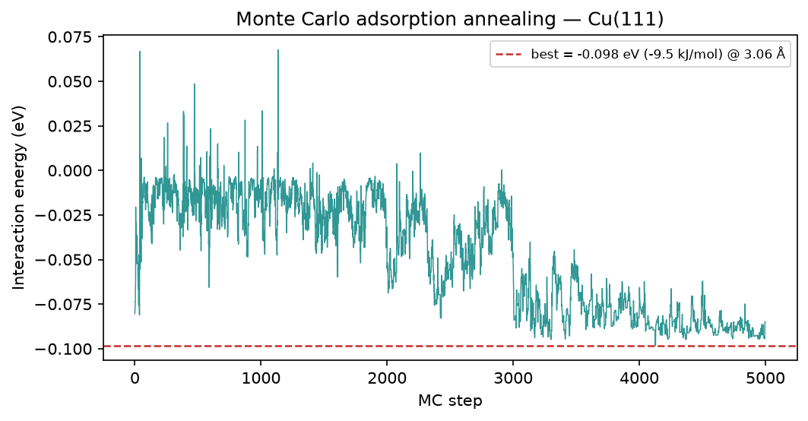
5-phenyltetrazole — MC annealing
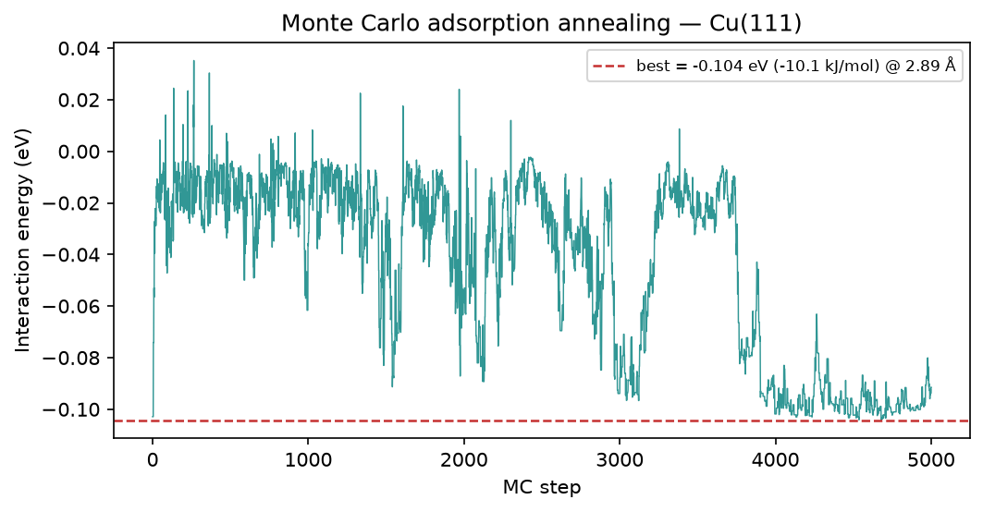
1-phenyl-5-mercaptotetrazole — MC annealing

5. Brownian MD (Cu-O RDF)
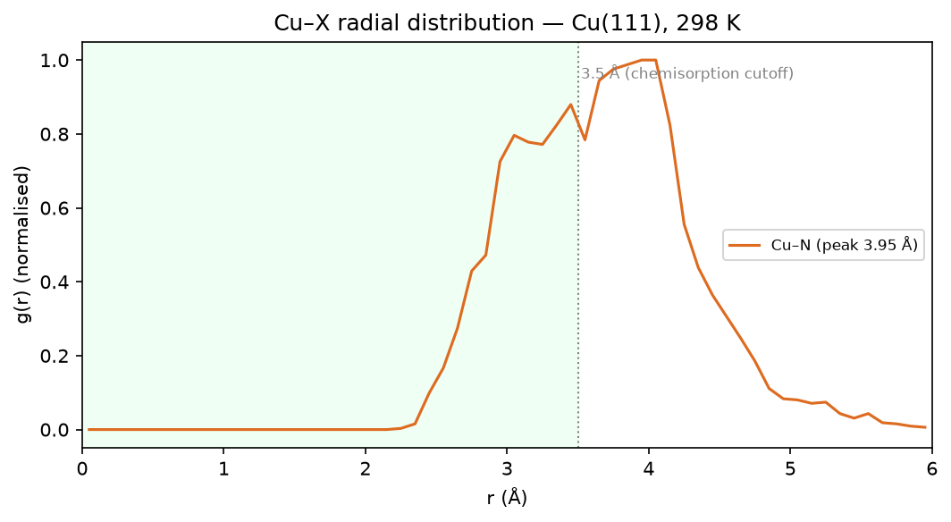
tetrazole — Cu-O RDF
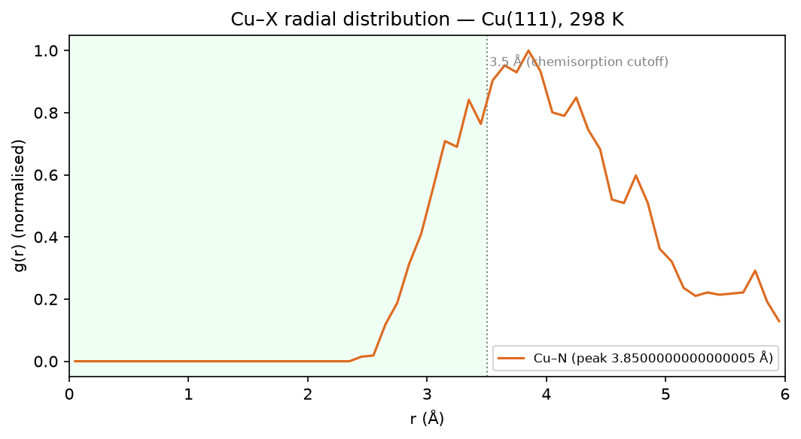
5-aminotetrazole — Cu-O RDF
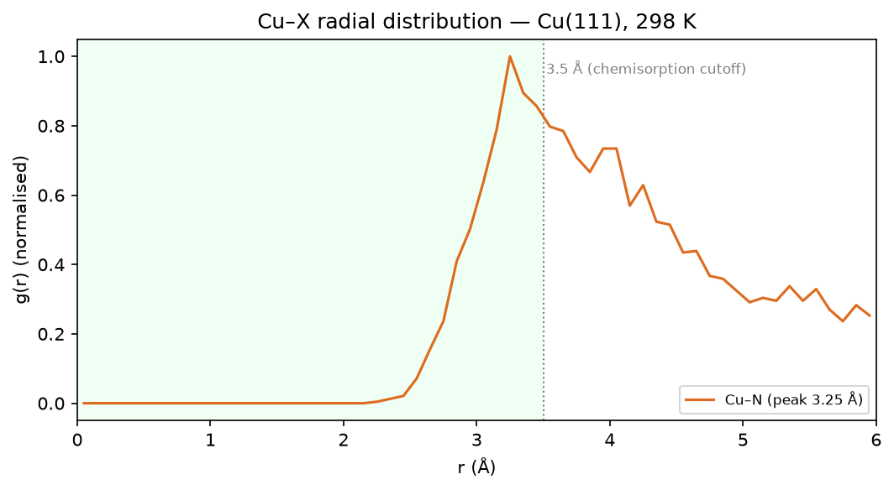
5-phenyltetrazole — Cu-O RDF
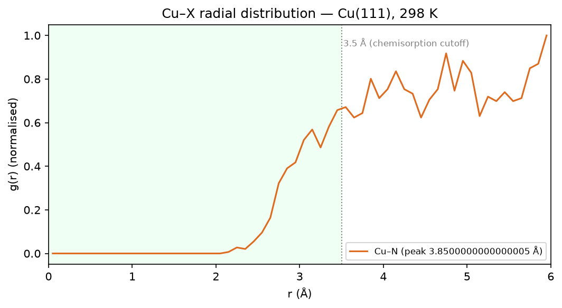
1-phenyl-5-mercaptotetrazole — Cu-O RDF

6. Method & caveats
DFT level: B3LYP/6-311++G(d,p) (ddCOSMO:water). Global descriptors come from the frontier-orbital energies via Koopmans' theorem; ΔN uses the metal work function with η(metal) = 0. The Monte-Carlo and Brownian-MD stages use a classical van-der-Waals adsorption model — a physics-based screening surrogate, not a substitute for periodic DFT or for electrochemical validation. The composite ranking is a heuristic that orders candidates; it does not prove inhibition. Full methodology: docs/pipeline.md; validation record: docs/validation.md.

