corrosim — multiscale corrosion-inhibitor report
Substrate: Fe(110) | Medium: 1 M HCl | DFT level: B3LYP/6-311++G(d,p) (ddCOSMO:water) | Generated 2026-07-02 07:18
The flavonoids modelled here (kaempferol, quercetin, isorhamnetin) are documented major constituents of the Arghel (Solenostemma argel) extract, simulated as representatives — not a verified profile of a specific sample. Confirm composition by LC-MS/GC-MS before publication.

1. Overview
corrosim screens a green corrosion inhibitor by zooming in over three stages, each answering one question about how strongly the molecule sticks to the metal. Stage 1 studies the isolated molecule with quantum chemistry (which electrons it will share, and from which atoms). Stage 2 searches for its best pose on the metal surface. Stage 3 lets that pose settle at room temperature and reads off the adsorption distance. The sections below follow that order; every figure is explained on its own, and the governing equations are collected in the Scientific basis section.
The three-stage pipeline: a molecule (name or SMILES), a substrate metal and a corrosive medium go in; DFT reactivity descriptors, a Monte-Carlo adsorption pose, a Brownian-MD adsorption distance, a ranking and this report come out.
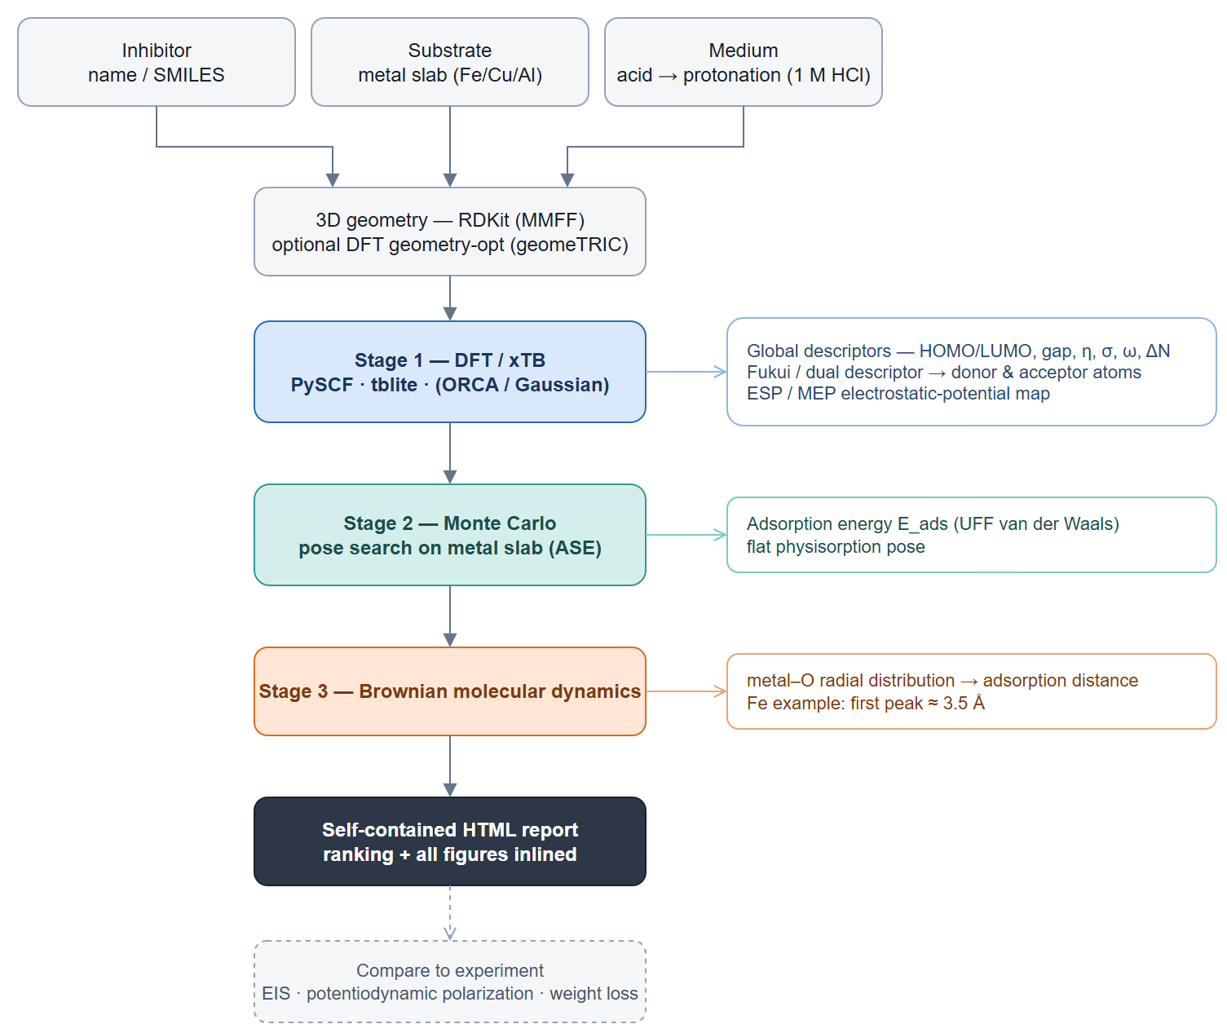
corrosim pipeline

2. Summary & ranking
name | gap_ev | hardness_ev | softness_inv_ev | delta_n | e_ads_kjmol | ads_dist_A | score
quercetin | 4.082 | 2.041 | 0.49 | 0.178 | -15.97 | 3.65 | 0.995
isorhamnetin | 4.099 | 2.049 | 0.488 | 0.21 | -16.74 | 3.75 | 0.373
kaempferol | 4.146 | 2.073 | 0.482 | 0.169 | -16.55 | 3.35 | -1.368
Composite score z-scores a smaller gap, lower hardness and higher softness (higher = stronger predicted reactivity); E_ads (Stage 2) and the Fe-O distance (Stage 3) are shown alongside.

3. Stage 1 — DFT electronic descriptors
Density-functional theory solves the molecule's electronic structure and gives the frontier orbitals — the HOMO (the electrons most willing to be shared with the metal) and the LUMO (the lowest empty level that can accept metal back-donation). Their energies yield the global reactivity descriptors (gap, hardness η, softness σ, electronegativity χ, electrophilicity ω, and the charge transfer ΔN) used to rank the candidates. See the Scientific basis section for each definition.
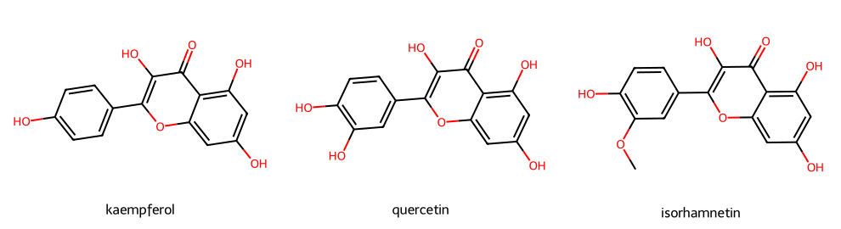
Modelled flavonoids
The 2D structures of the modelled flavonoids. All three share the flavonol core (a 4-oxo chromone with a 3-OH and a B-ring); they differ in B-ring substitution — quercetin's catechol (3',4'-diOH), kaempferol's single 4'-OH, and isorhamnetin's 3'-OMe/4'-OH — which is what shifts their descriptors.
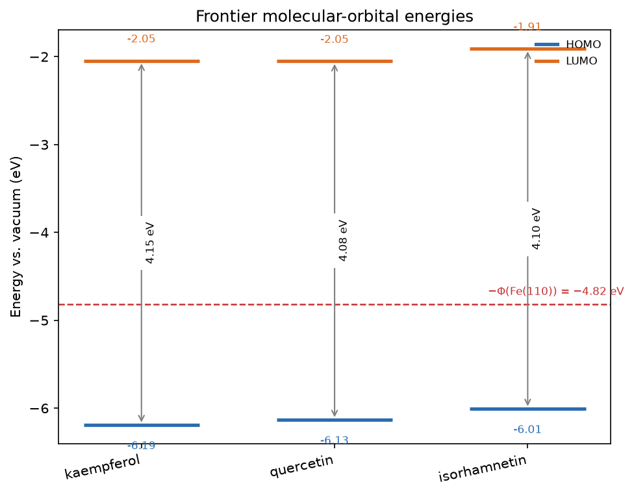
Frontier-orbital energies vs Fe(110) work function
Frontier-orbital energy levels (HOMO below, LUMO above, gap arrowed) for each molecule, with the Fe(110) Fermi level (−Φ = −4.82 eV) as the dashed reference. A HOMO lying near −Φ and a small gap favour electron sharing with the metal.

3.1 Frontier-orbital isosurfaces (HOMO / LUMO)
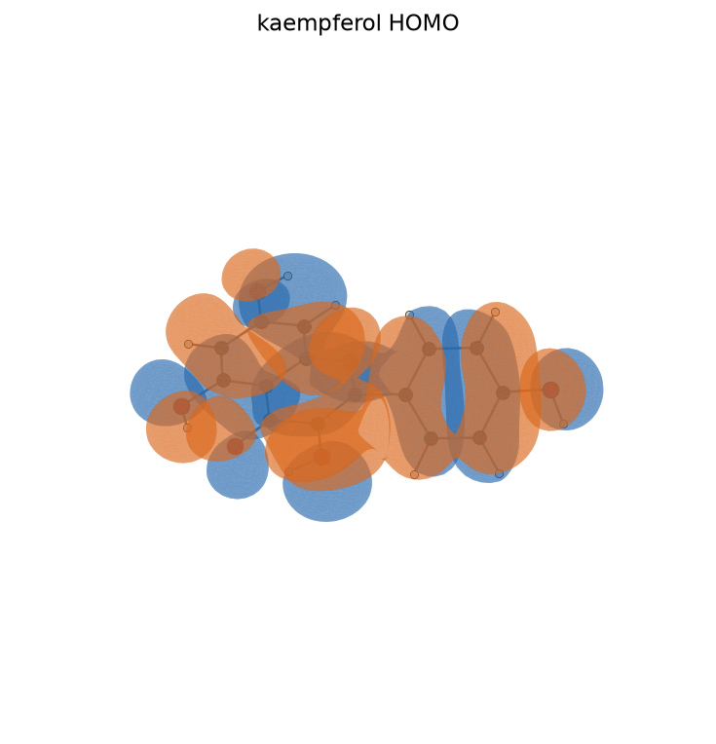
kaempferol HOMO
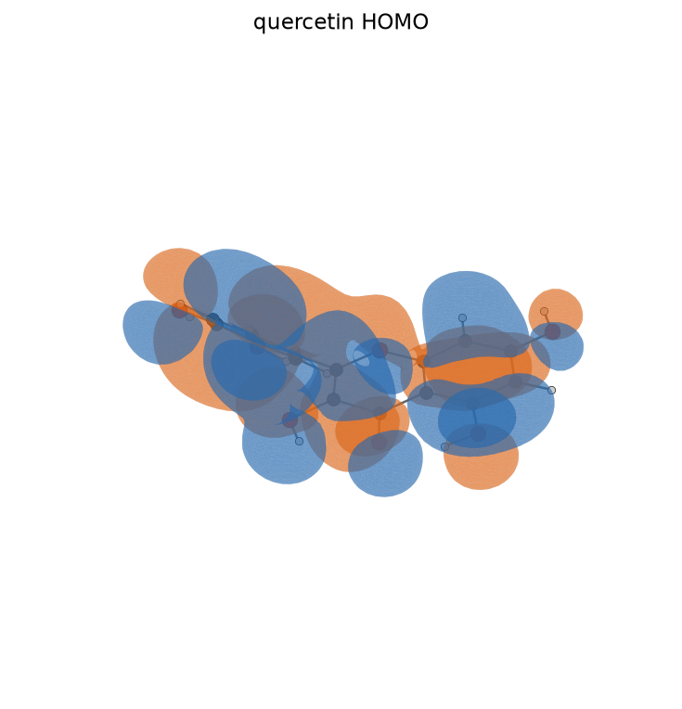
quercetin HOMO
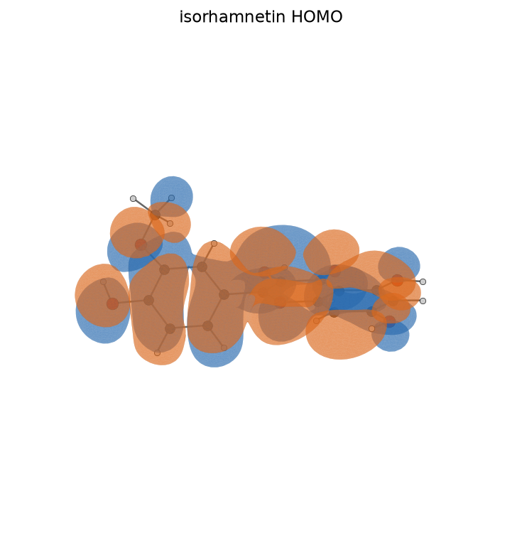
isorhamnetin HOMO
The HOMO isosurface — the spatial shape of the electrons the molecule is most ready to donate to the metal. Its lobes sit over the electron-rich oxygen and ring systems that anchor adsorption.
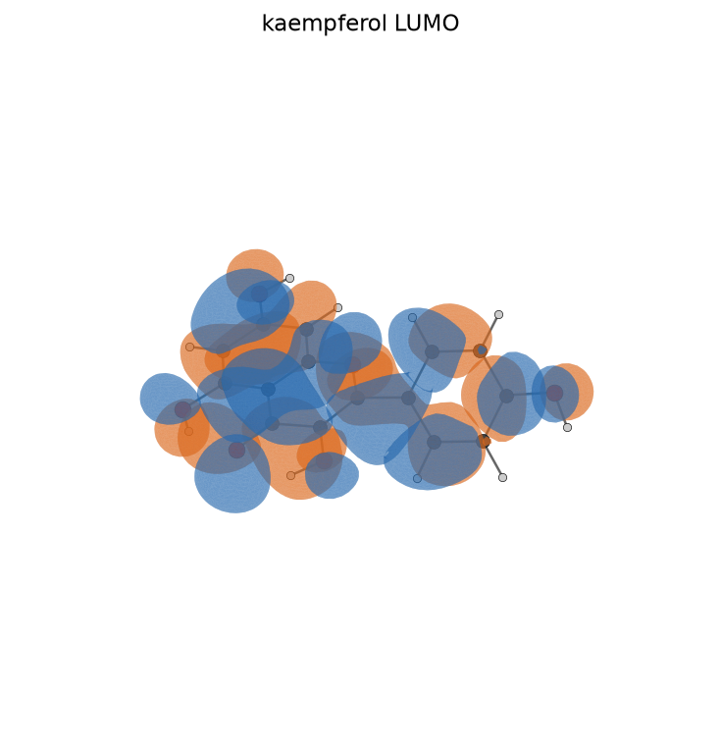
kaempferol LUMO
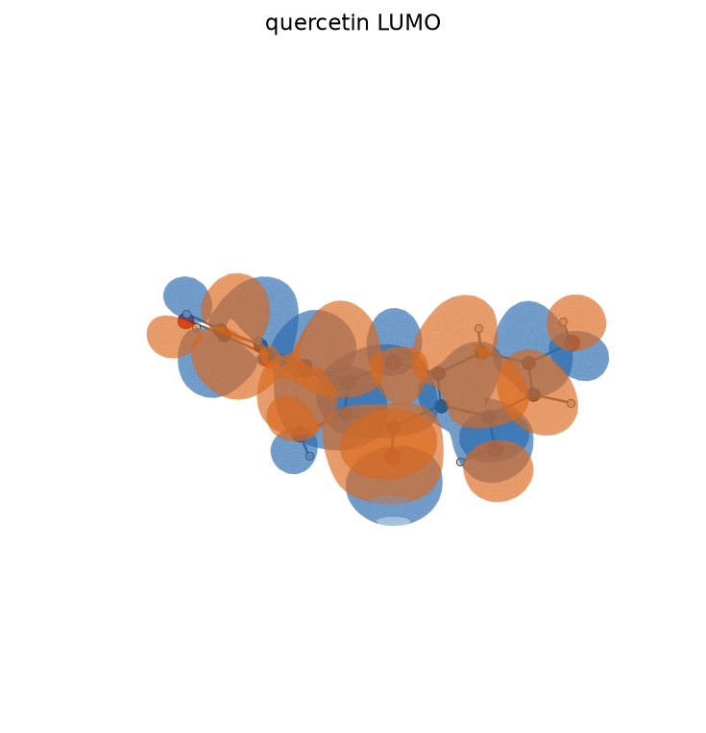
quercetin LUMO
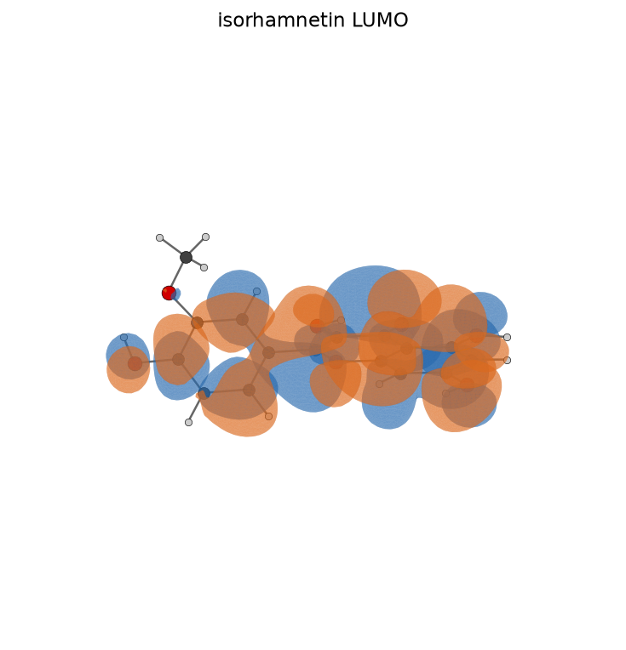
isorhamnetin LUMO
The LUMO isosurface — the lowest empty level that accepts back-donation from the metal d-electrons, the complementary half of the donor-acceptor adsorption bond.
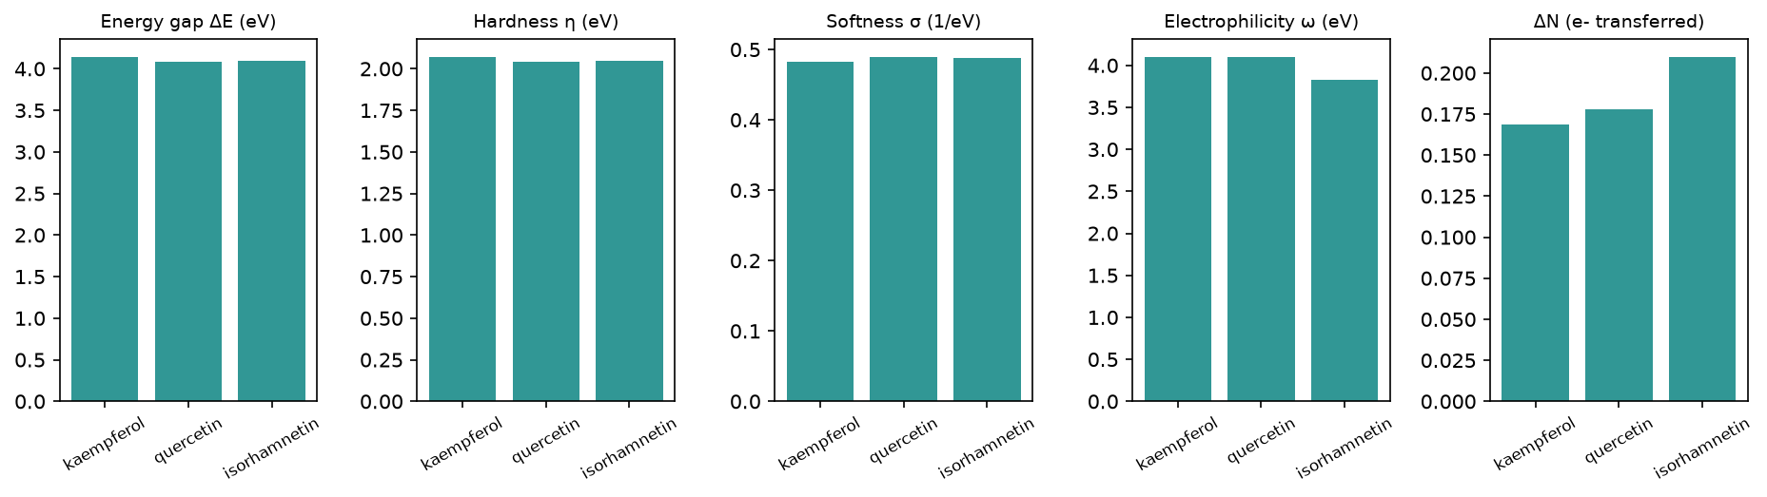
Reactivity descriptors
The global reactivity descriptors side by side. Read together: a small gap and low hardness with high softness mark an easily-polarised, strongly-adsorbing inhibitor; a positive ΔN in the Lukovits window (0 < ΔN < 3.6) marks net electron donation to the metal.
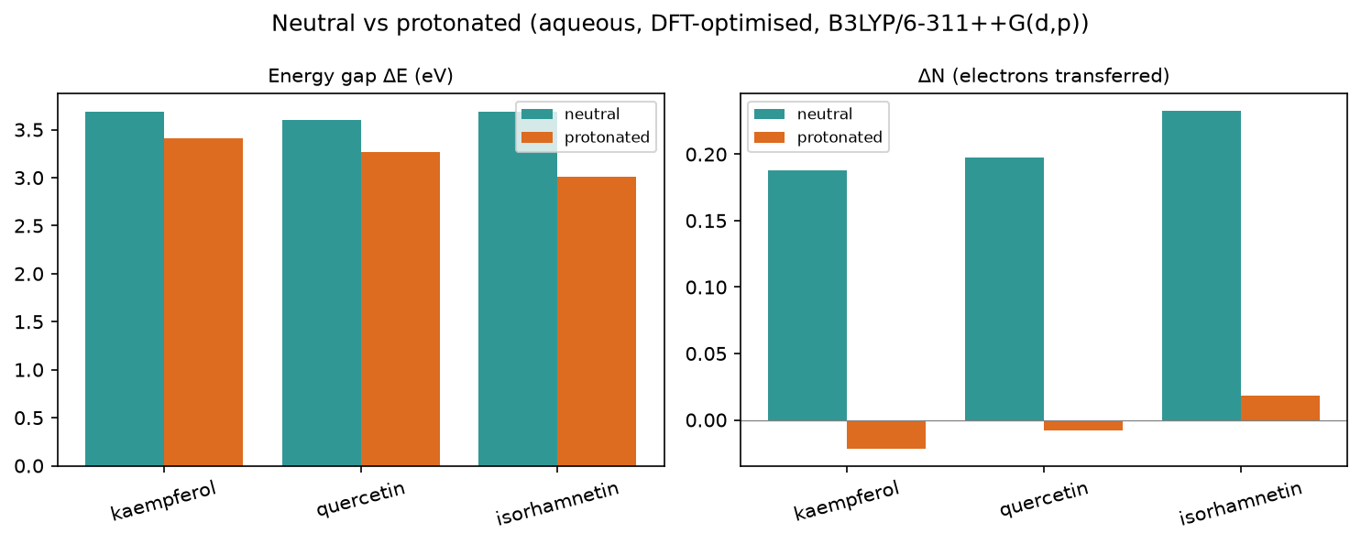
Protonation effect (1 M HCl)
Gap and ΔN for the neutral molecule vs its +1 cation in the acidic medium. Protonation lowers the gap and drives ΔN negative — the electron-poor cation stops donating — which is why the headline ranking is stated on the neutral form (ADR 0003), the species that actually dominates here (see Speciation).

3.2 Full descriptor table (neutral, aqueous)
name | formula | charge | level | homo_ev | lumo_ev | gap_ev | hardness_ev | softness_inv_ev | electronegativity_ev | electrophilicity_ev | delta_n | back_donation_ev | tnc | e_ads_kjmol
kaempferol | C15H10O6 | 0 | B3LYP/6-311++G(d,p) (ddCOSMO:water) | -6.193 | -2.047 | 4.146 | 2.073 | 0.482 | 4.12 | 4.094 | 0.169 | -0.518 | -4.422 | -16.55
quercetin | C15H10O7 | 0 | B3LYP/6-311++G(d,p) (ddCOSMO:water) | -6.134 | -2.052 | 4.082 | 2.041 | 0.49 | 4.093 | 4.104 | 0.178 | -0.51 | -4.714 | -15.97
isorhamnetin | C16H12O7 | 0 | B3LYP/6-311++G(d,p) (ddCOSMO:water) | -6.009 | -1.91 | 4.099 | 2.049 | 0.488 | 3.959 | 3.824 | 0.21 | -0.512 | -5.525 | -16.74

3.3 Geometry refinement (FF vs DFT-optimised)
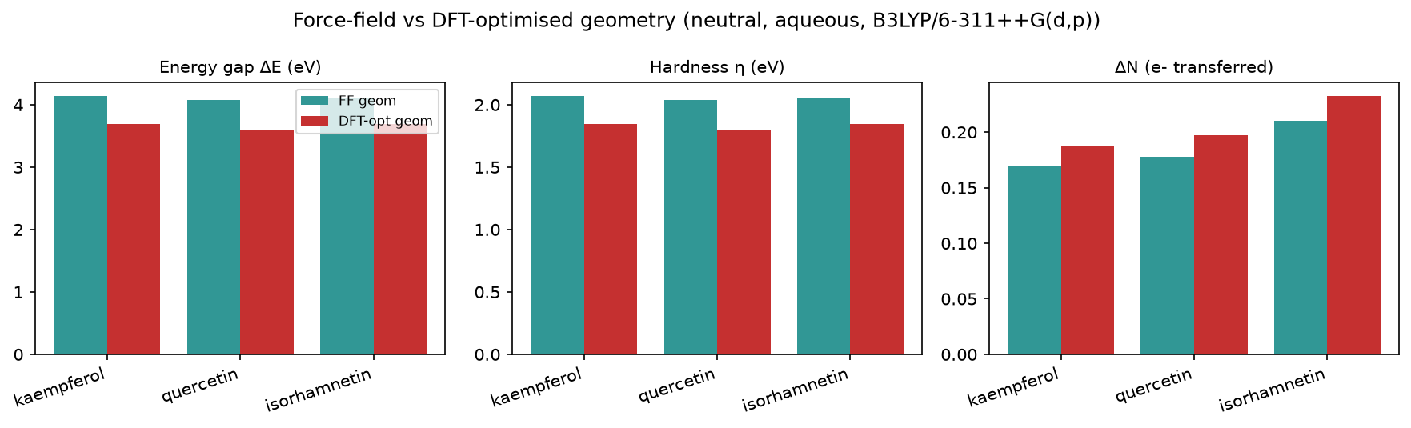
Force-field vs DFT-optimised geometry
Descriptors on force-field vs DFT-optimised geometries. Relaxing each structure at B3LYP/6-31G(d) lowers the gap (~0.4–0.5 eV) and hardness and raises ΔN, but leaves both the gap and ΔN rankings unchanged — the lead assignments are geometry-robust.

3.4 Optimised-geometry descriptors (DFT-relaxed)
Descriptors on DFT-optimised geometries; the ranking is unchanged — the lead is geometry-robust.
name | gap_ev | hardness_ev | softness_inv_ev | delta_n | tnc | score
quercetin | 3.604 | 1.802 | 0.555 | 0.197 | -6.552 | 1.413
isorhamnetin | 3.687 | 1.843 | 0.542 | 0.233 | -6.85 | -0.665
kaempferol | 3.69 | 1.845 | 0.542 | 0.188 | -6.092 | -0.748

Optimised protonated cations (in-acid)
name | formula | charge | level | homo_ev | lumo_ev | gap_ev | hardness_ev | softness_inv_ev | electronegativity_ev | electrophilicity_ev | delta_n | back_donation_ev | tnc
kaempferol+H+ | C15H11O6+ | 1 | B3LYP/6-311++G(d,p) (ddCOSMO:water) | -6.601 | -3.188 | 3.413 | 1.707 | 0.586 | 4.894 | 7.018 | -0.022 | -0.427 | -4.205
quercetin+H+ | C15H11O7+ | 1 | B3LYP/6-311++G(d,p) (ddCOSMO:water) | -6.477 | -3.214 | 3.263 | 1.631 | 0.613 | 4.846 | 7.196 | -0.008 | -0.408 | -4.754
isorhamnetin+H+ | C16H13O7+ | 1 | B3LYP/6-311++G(d,p) (ddCOSMO:water) | -6.269 | -3.261 | 3.008 | 1.504 | 0.665 | 4.765 | 7.547 | 0.018 | -0.376 | -7.044

3.5 Species in the acidic medium (protonated cation)
In 1 M HCl the inhibitor is present largely as its +1 cation. The headline ranking uses the neutral form (ADR 0003); the protonated-cation descriptors are tabulated here for comparison.
name | formula | charge | level | homo_ev | lumo_ev | gap_ev | hardness_ev | softness_inv_ev | electronegativity_ev | electrophilicity_ev | delta_n | back_donation_ev | tnc
kaempferol+H+ | C15H11O6+ | 1 | B3LYP/6-311++G(d,p) (ddCOSMO:water) | -6.881 | -3.277 | 3.604 | 1.802 | 0.555 | 5.079 | 7.157 | -0.072 | -0.451 | -4.014
quercetin+H+ | C15H11O7+ | 1 | B3LYP/6-311++G(d,p) (ddCOSMO:water) | -6.668 | -3.324 | 3.344 | 1.672 | 0.598 | 4.996 | 7.465 | -0.053 | -0.418 | -4.438
isorhamnetin+H+ | C16H13O7+ | 1 | B3LYP/6-311++G(d,p) (ddCOSMO:water) | -6.427 | -3.295 | 3.132 | 1.566 | 0.639 | 4.861 | 7.546 | -0.013 | -0.391 | -4.993

3.6 Speciation in 1 M HCl (pH ≈ -0.0)
The most basic site (4-oxo carbonyl, pKaH ≈ -1.5) is a very weak base, so by Henderson-Hasselbalch the inhibitor is 97% neutral / 3% protonated — the neutral form dominates, which is why the headline ranking uses the neutral form. Population-weighted lead: quercetin.
name | formula | charge | level | homo_ev | lumo_ev | gap_ev | hardness_ev | softness_inv_ev | electronegativity_ev | electrophilicity_ev | delta_n | back_donation_ev | tnc
kaempferol | C15H10O6 | 0 | B3LYP/6-311++G(d,p) (ddCOSMO:water) | -6.214 | -2.085 | 4.129 | 2.064 | 0.485 | 4.149 | 4.188 | 0.162 | -0.516 | -4.41
quercetin | C15H10O7 | 0 | B3LYP/6-311++G(d,p) (ddCOSMO:water) | -6.151 | -2.091 | 4.06 | 2.03 | 0.493 | 4.121 | 4.207 | 0.171 | -0.507 | -4.705
isorhamnetin | C16H12O7 | 0 | B3LYP/6-311++G(d,p) (ddCOSMO:water) | -6.022 | -1.952 | 4.069 | 2.035 | 0.492 | 3.987 | 3.938 | 0.203 | -0.509 | -5.509
Sensitivity: the composite lead changes from quercetin to isorhamnetin at only ~7% protonation (pKaH ≈ -1.1) — the protonation pKa is the key uncertainty.
Computed pKaH (DFT deprotonation cycle, frequency-corrected) resolves it: the most basic flavonoid is only 0.00% protonated, so every species is essentially fully neutral and the headline lead is robust.
molecule | computed pKaH | % protonated
kaempferol | -12.9 | 0.00%
quercetin | -13.3 | 0.00%
isorhamnetin | -5.1 | 0.00%
results/pka.json (ADR 0005).

3.7 Local reactivity (Fukui)
Global descriptors say how reactive a molecule is; the condensed Fukui functions say where. f⁻ locates the electron-donating atoms that coordinate the metal, f⁺ the electron-accepting (back-donation) atoms. For these flavonoids the highest-f⁻ sites are the catechol B-ring and 3-OH oxygens.
kaempferol: O3 (f⁻=0.116), O12 (f⁻=0.055), O19 (f⁻=0.053)
quercetin: O3 (f⁻=0.090), O9 (f⁻=0.088), O11 (f⁻=0.040)
isorhamnetin: O9 (f⁻=0.094), O3 (f⁻=0.093), O11 (f⁻=0.043)
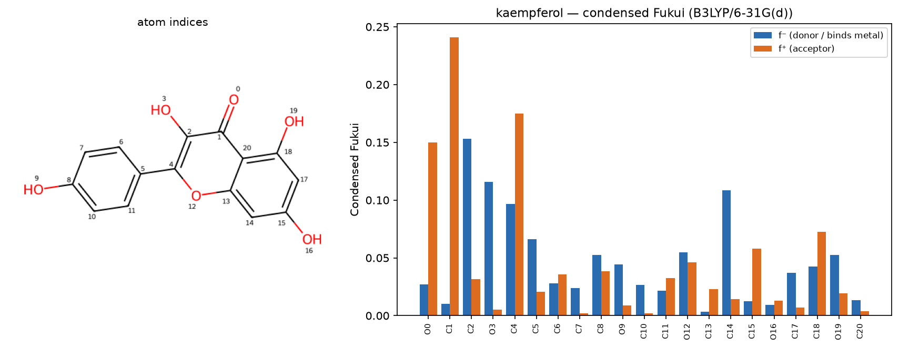
kaempferol — condensed Fukui
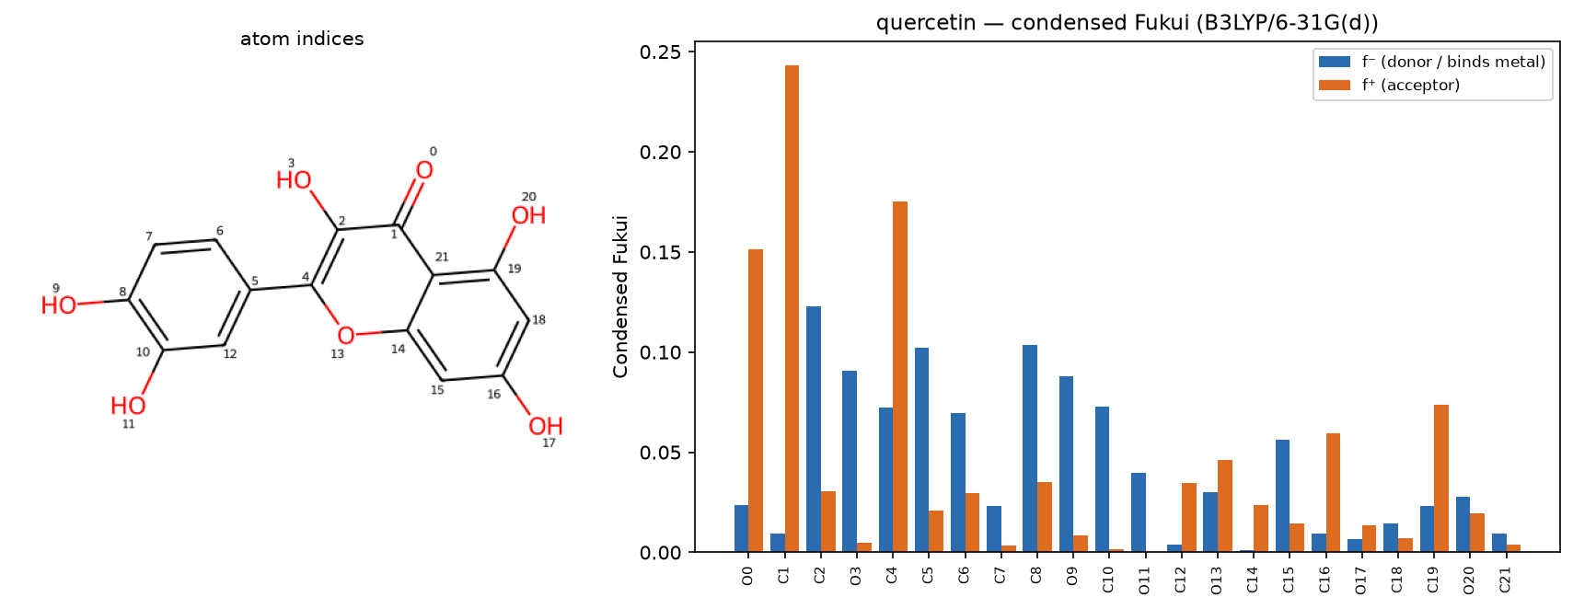
quercetin — condensed Fukui
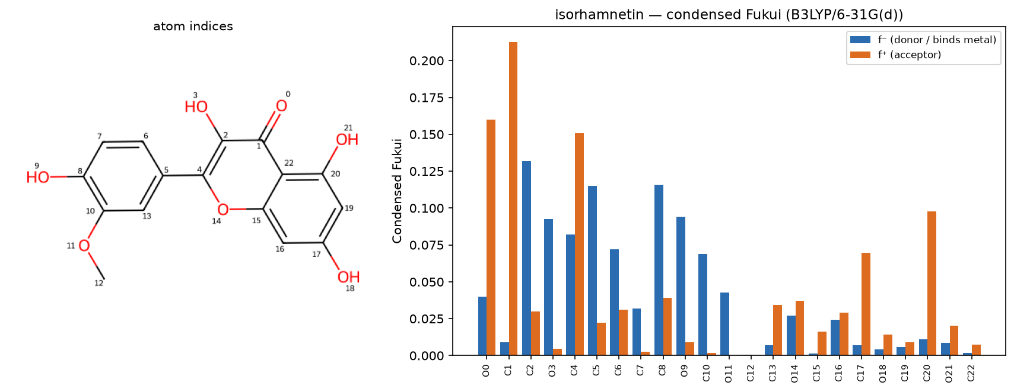
isorhamnetin — condensed Fukui
Condensed Fukui functions per heavy atom: f⁻ (donor, binds the metal) and f⁺ (acceptor). The tallest f⁻ bars are the oxygens that coordinate the surface; the atom indices match the structure panel.

3.8 Electrostatic-potential (ESP) map
The molecular electrostatic-potential (ESP) map colours the electron-density surface by potential: red (negative) regions are electron-rich and nucleophilic — the metal-coordinating patches — corroborating the Fukui donor analysis.
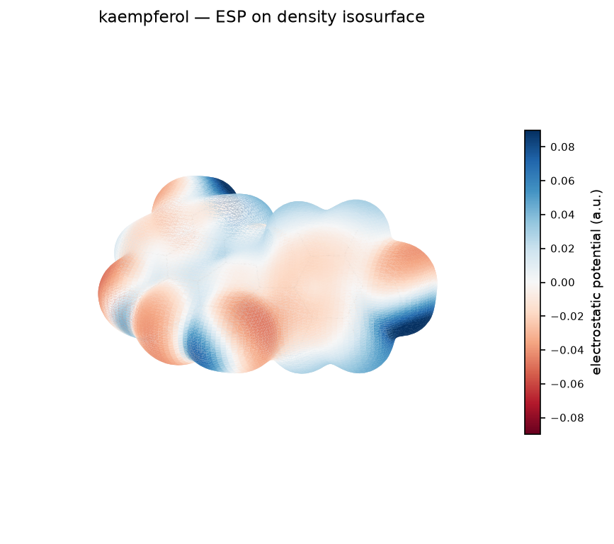
kaempferol — ESP map
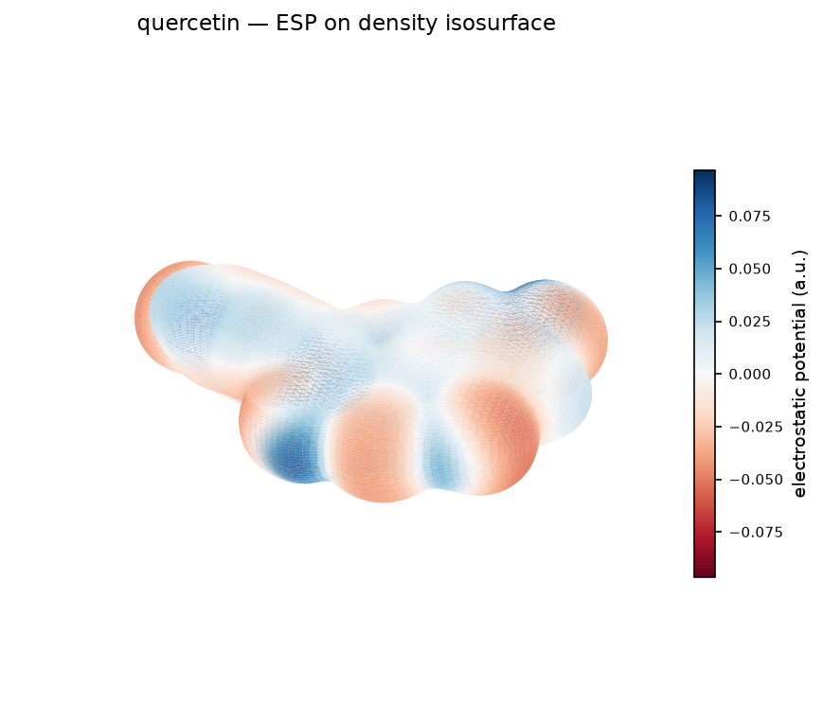
quercetin — ESP map
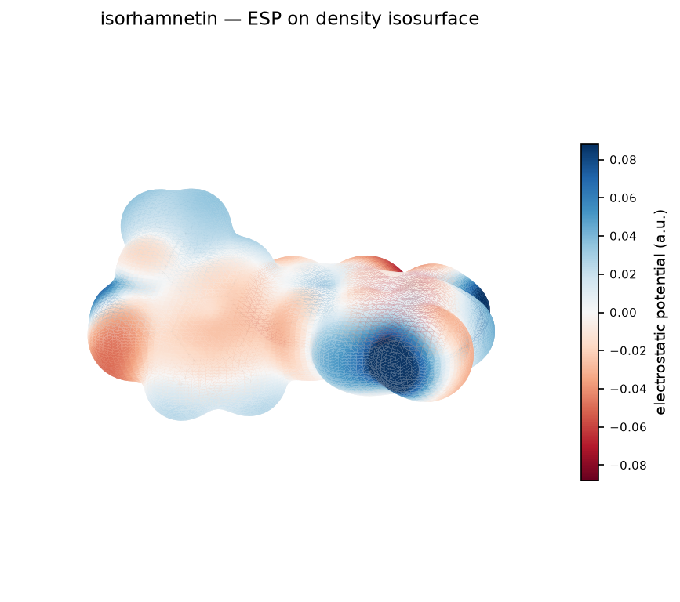
isorhamnetin — ESP map
The electron-density isosurface coloured by electrostatic potential. Red over the catechol and carbonyl oxygens is the electron-rich, metal-binding region; blue is electron-poor — a spatial confirmation of the Fukui donor sites.

4. Stage 2 — Monte Carlo adsorption
A Metropolis / simulated-annealing Monte-Carlo search nudges and rotates the rigid molecule thousands of times over an Fe(110) slab to find the lowest-energy pose, scored with the UFF van-der-Waals interaction. The flavonoids settle flat/parallel to the surface; the adsorption energy E_ads ≈ −16 kJ/mol places them in the physisorption regime.
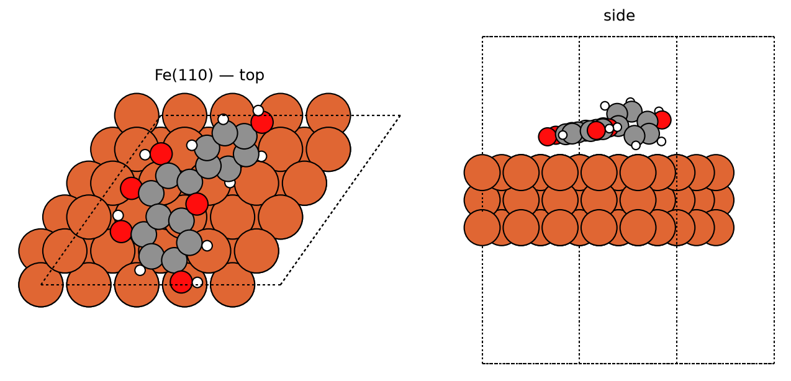
kaempferol — best pose
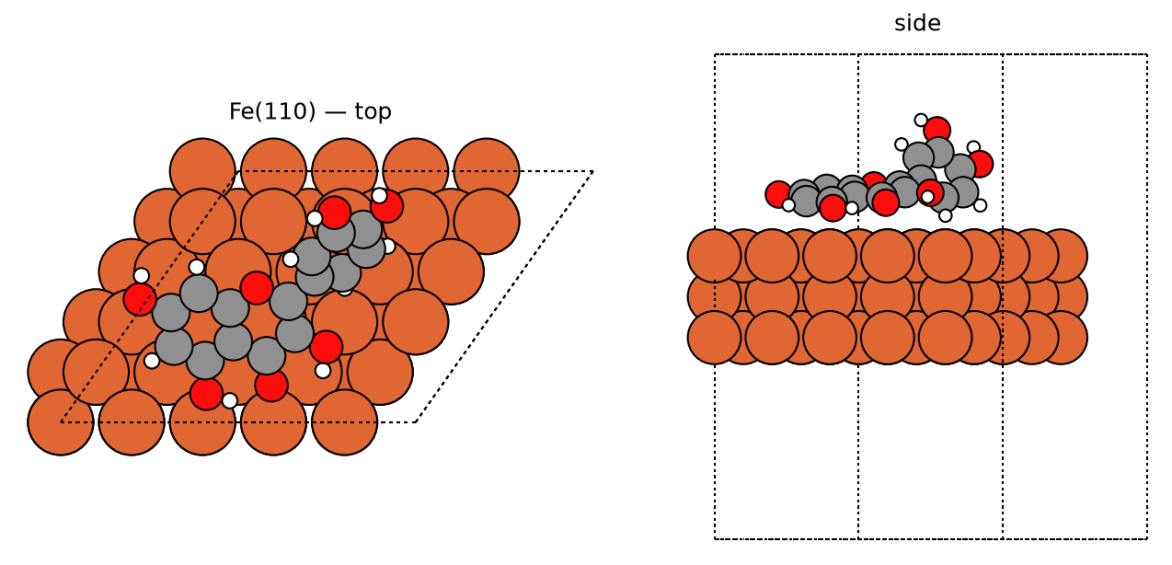
quercetin — best pose
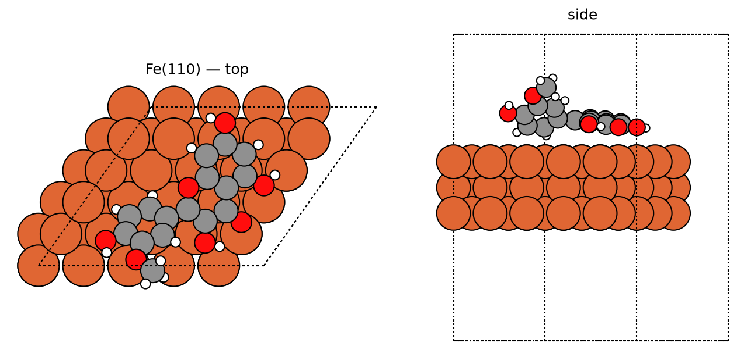
isorhamnetin — best pose
Top and side views of the lowest-energy Monte-Carlo adsorption pose. The molecule lies flat/parallel to the Fe(110) slab, maximising oxygen contact with the surface — the geometry expected for physisorption.
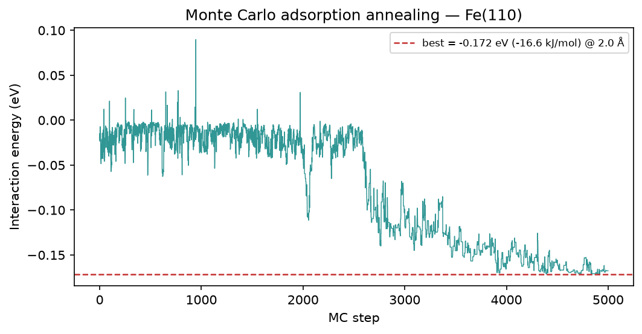
kaempferol — MC annealing
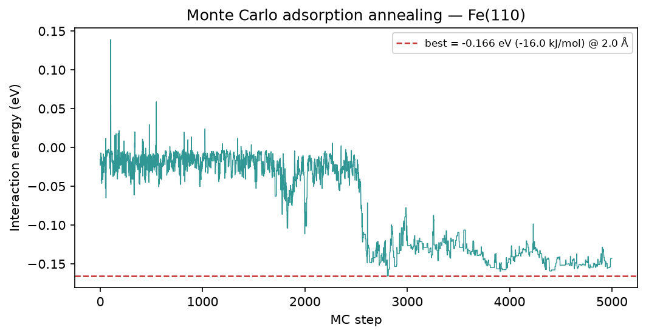
quercetin — MC annealing
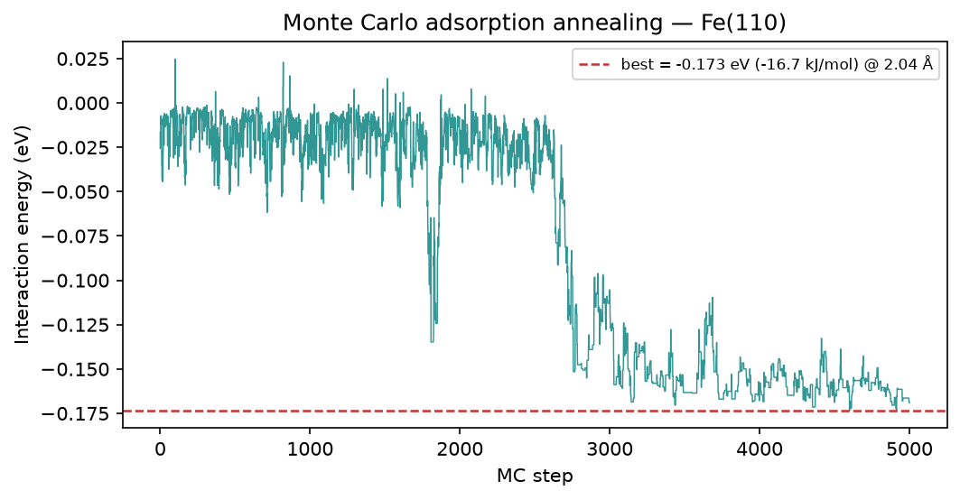
isorhamnetin — MC annealing
The simulated-annealing energy trace: interaction energy vs Monte-Carlo step, converging to the best adsorption energy (dashed). The plateau near −16 kJ/mol is the reported E_ads.

5. Stage 3 — Brownian MD (Fe-O RDF)
Starting from the best Monte-Carlo pose, a Brownian rigid-body molecular-dynamics run lets the molecule jiggle at 298 K. The first peak of the metal-O radial distribution function g(r) sets the adsorption distance; a peak near 3.5 Å is physisorption range (a chemisorbed contact would sit closer).
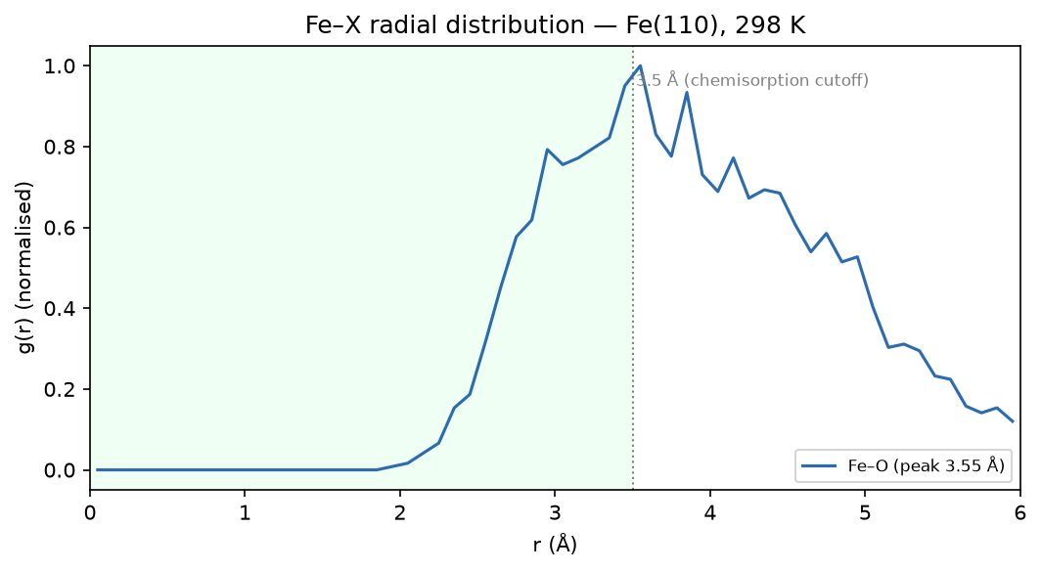
kaempferol — Fe-O RDF
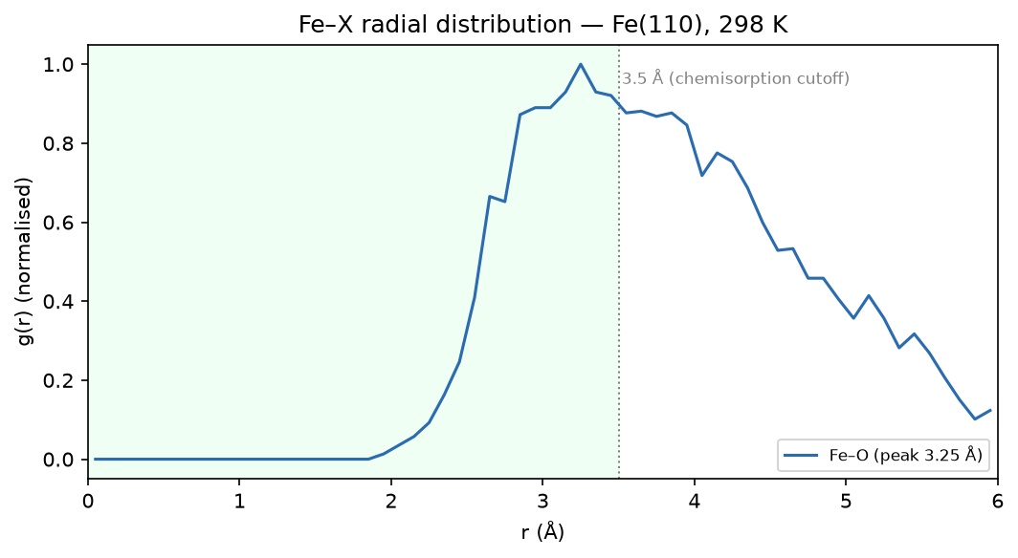
quercetin — Fe-O RDF
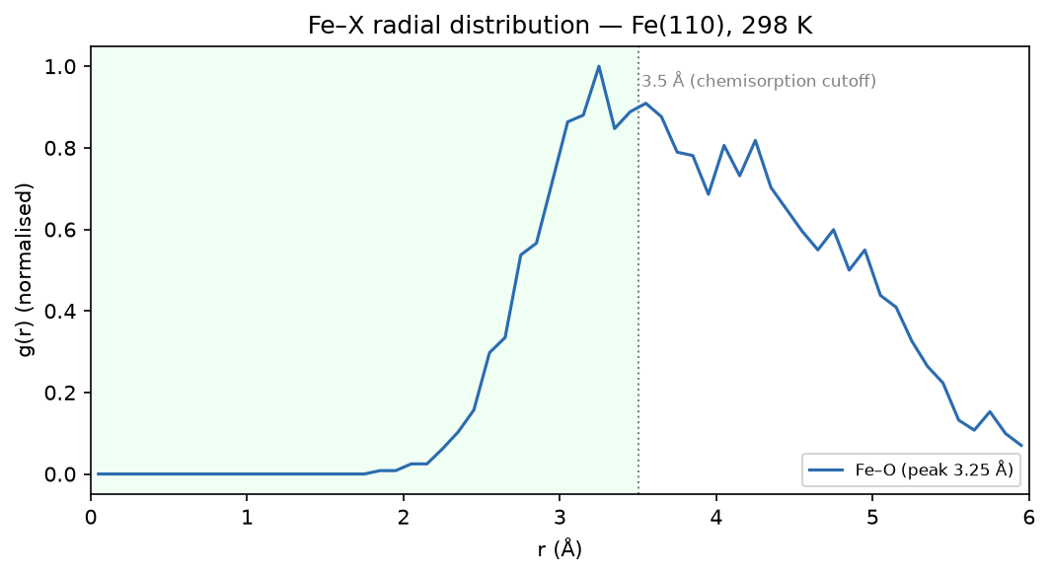
isorhamnetin — Fe-O RDF
The metal-O radial distribution function from the Brownian-MD trajectory. The first peak (green physisorption band, ~3.5 Å) is the adsorption distance; the shaded cutoff marks the chemisorption threshold it stays above.

6. Scientific basis & validation
This section consolidates the scientific basis (docs/pipeline.md) and the validation record (docs/validation.md) so the report is self-explanatory. The pipeline screens and explains; it does not prove inhibition — a candidate should still be confirmed electrochemically.

6.1 Governing equations
Stage 1 turns the two frontier-orbital energies into the standard reactivity descriptors via Koopmans' theorem; Stage 1b localises reactivity with the condensed Fukui functions; the speciation layer fixes the protonation state; and Stages 2–3 quantify adsorption. The full set is collected below.

Stage 1 — global reactivity descriptors (Koopmans' theorem)
$E_{gap}=E_{LUMO}−E_{HOMO}$
Energy gap ΔE — Frontier HOMO-LUMO separation; a smaller gap means a more reactive, more easily polarised inhibitor.
$IP=−E_{HOMO}$
Ionization potential — Koopmans' theorem: the energy to remove the highest-energy electron.
$EA=−E_{LUMO}$
Electron affinity — Koopmans' theorem: the energy released on adding an electron.
$χ=\frac{IP+EA}{2}$
Electronegativity χ — Mulliken electronegativity; drives the direction of charge transfer to the metal.
$η=\frac{IP−EA}{2}=\frac{E_{gap}}{2}$
Chemical hardness η — Resistance to charge redistribution; softer (lower η) molecules adsorb more readily.
$σ=\frac{1}{η}$
Chemical softness σ — Inverse hardness; higher σ tracks stronger adsorption.
$μ=−χ$
Chemical potential μ — The electronic chemical potential (negative electronegativity).
$ω=\frac{μ^{2}}{2η}$
Electrophilicity ω — Propensity to accept electron density (back-donation channel).
$ΔN=\frac{Φ_{metal}−χ}{2(η_{metal}+η)}$
Fraction of electrons transferred ΔN — Charge donated to the metal; the Lukovits window 0 < ΔN < 3.6 marks electron donation that strengthens inhibition. Φ is the metal work function, with η_metal ≈ 0.
$ΔE_{back}=−\frac{η}{4}$
Back-donation energy ΔE_back — Energy of the metal → molecule back-donation that accompanies donor-acceptor adsorption.

Stage 1 — local reactivity (condensed Fukui)
$f_{k}^{−}=q_{k}(N−1)−q_{k}(N)$
Nucleophilic Fukui f⁻ — Per-atom susceptibility to electrophilic attack; the highest-f⁻ oxygens are the electron-donating, metal-coordinating sites.
$f_{k}^{+}=q_{k}(N)−q_{k}(N+1)$
Electrophilic Fukui f⁺ — Per-atom susceptibility to nucleophilic attack; the back-donation (electron-accepting) sites.
$Δf_{k}=f_{k}^{+}−f_{k}^{−}$
Dual descriptor Δf — Δf < 0 marks a net electron donor, Δf > 0 a net acceptor.

Acid-base speciation and conjugate-acid pKaH
$f_{prot}=\frac{1}{1+{10}^{pH−pK_{aH}}}$
Protonated fraction (Henderson-Hasselbalch) — Population of the +1 cation at a given pH for a basic site of conjugate-acid pKₐH.
$pK_{aH}=\frac{ΔG_{aq}^{*}}{RTln10}$
pKaH from a DFT cycle — Conjugate-acid pKₐH from the aqueous deprotonation free energy.
$ΔG_{aq}^{*}=G^{*}(B)+G^{*}(H^{+})−G^{*}(BH^{+})$
Deprotonation free energy — For BH⁺ ⇌ B + H⁺, from ddCOSMO aqueous energies and the standard aqueous proton free energy.

Stage 2/3 — adsorption observables
$E_{ads}=E_{slab+mol}−(E_{slab}+E_{mol})$
Adsorption energy E_ads — Interaction energy of the best Monte-Carlo pose; more negative = a stronger grip. Values near −16 kJ/mol indicate physisorption.
$E_{ads}[kJmol^{−1}]=96.485×E_{ads}[eV]$
Unit conversion — The Monte-Carlo objective is reported in kJ/mol.
$r^{*}=\backslash arg\max_{r}g_{M−O}(r)$
Adsorption distance r* — First-peak position of the metal-O radial distribution g(r) from the Brownian-MD trajectory; r* ≈ 3.5 Å is physisorption range.

6.2 Descriptor results (B3LYP/6-311++G(d,p), neutral, aqueous)
All three flavonoids show a positive ΔN inside the Lukovits window (0 < ΔN < 3.6): they donate electron density to the steel. Quercetin has the smallest gap and highest softness (the composite lead); isorhamnetin has the highest ΔN and total negative charge (electron-richest, via its methoxy group); kaempferol is third.
Molecule | HOMO (eV) | LUMO (eV) | Gap (eV) | η (eV) | ΔN | TNC
quercetin | −6.134 | −2.052 | 4.082 | 2.041 | +0.178 | −4.71
isorhamnetin | −6.009 | −1.910 | 4.099 | 2.049 | +0.210 | −5.52
kaempferol | −6.193 | −2.047 | 4.146 | 2.073 | +0.169 | −4.42
Stage-1 DFT descriptors. Smallest gap = quercetin; highest ΔN/TNC = isorhamnetin.

6.3 Protonation resolved by a computed pKaH
The most basic site is the 4-oxo carbonyl, a very weak base. A frequency-corrected DFT deprotonation cycle (B3LYP/6-311++G(d,p) + ddCOSMO on gas opt+freq geometries) gives pKaH ≈ −13.3 (quercetin), −12.9 (kaempferol) and −5.1 (isorhamnetin) — all far below the 5–7% crossover — so every flavonoid is under 0.1% protonated in 1 M HCl. The neutral form is physically dominant, so the neutral-basis ranking is robust, not merely conventional; the ZPE/thermal/entropy correction moved every value more negative (more neutral) than the uncorrected cycle.
*Caveat:* quercetin and kaempferol are clean minima (no imaginary frequencies); the isorhamnetin cation retained one small imaginary mode (a methoxy/hydroxyl torsion), so its value is less tightly determined — but it stays neutral and is not the lead. The lead (quercetin) rests on a clean, imaginary-frequency-free calculation.

6.4 Cross-check against published Fe(110) studies
corrosim's Stage-2 adsorption energies (−16.0 / −16.6 / −16.7 kJ/mol for quercetin / kaempferol / isorhamnetin) and Stage-3 Fe-O RDF first peaks (3.65 / 3.35 / 3.75 Å) agree with an independent black-tea-extract DFT study on Fe(110) (ΔGads ≈ −20 kJ/mol, quercetin strongest) and a lady's-mantle study (kaempferol reference) — same regime, same order.

6.5 Experimental anchor — Mohammed 2014 (Arghel on mild steel, 1 M HCl)
A direct experiment on the *same* system (Arghel methanolic extract on mild steel in 1 M HCl, 27 °C; PDP + EIS) reports inhibition efficiency rising to 99.62% at 150 ppm, with a Langmuir adsorption free energy ΔG°ads ≈ −32.5 to −34.5 kJ/mol and a small (+26 mV) E_corr shift — a mixed-type inhibitor adsorbing physically. This validates the medium, the substrate, the overall efficacy and the physisorption mechanism.
C_inh (ppm) | I_corr (µA/cm²) | −E_corr (mV) | IE% (PDP) | R_ct (Ω·cm²) | IE% (EIS)
blank | 447.0 | 496 | — | 11.78 | —
25 | 14.7 | 484 | 96.71 | 126.4 | 90.68
50 | 10.67 | 480 | 97.60 | 135.6 | 91.31
75 | 1.99 | 472 | 99.55 | 142.7 | 91.74
125 | 1.90 | 470 | 99.57 | 198.1 | 94.05
150 | 1.66 | 470 | 99.62 | 258.3 | 95.43
Mohammed (2014), MSc, Alexandria University — the approved experimental-validation source.

6.6 What this does and does not settle
Confirmed: the medium/substrate match, the physisorption mechanism (Langmuir, |ΔG°ads| ≳ 32 kJ/mol) consistent with the Stage-2 E_ads and the Stage-3 ~3.5 Å contact, and strong extract-level inhibition. Not settled: the extract study has no LC-MS/GC-MS, so it validates the extract, not the individual flavonoids — the quercetin > isorhamnetin > kaempferol ranking remains a computational prediction pending LC-MS plus isolated-compound electrochemistry. Note E_ads (single-molecule vdW) and ΔG°ads (whole-extract isotherm free energy) are different observables: they agree on regime and order of magnitude, not on the number.

7. Method & caveats
DFT level: B3LYP/6-311++G(d,p) (ddCOSMO:water). Global descriptors come from the frontier-orbital energies via Koopmans' theorem; ΔN uses the metal work function with η(metal) = 0. The Monte-Carlo and Brownian-MD stages use a classical van-der-Waals adsorption model — a physics-based screening surrogate, not a substitute for periodic DFT or for electrochemical validation. The composite ranking is a heuristic that orders candidates; it does not prove inhibition.

