Research Methods and Evidence
A structured stress test for native equations, merged tables, footnotes, nested lists, links, and images.

Experimental design
PRESERVE_RESEARCH_START. Cost is $47.35; 23% is uncertain. Literal symbols: & _ # { } ~ ^ \.
- Primary observations
- Nested measurement with emphasis and a bold conclusion.
- Secondary observations

Native equations
$\frac{a+b}{c}$
$\sqrt{x}$
$\left(\begin{matrix}1 & 2 \\ 3 & 4\end{matrix}\right)$

Measured outcomes
Group | Mean | Spread
Merged vertical group | 18.25 | 0.37
Merged vertical group | 19.42 | 0.28
 | Merged horizontal result
Control | 17.63 | 0.41
PRESERVE_TABLE_END
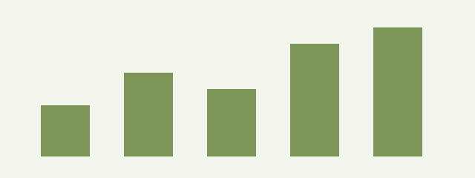
Figure 1 Observations across five cohorts
The note is attached to this sentence
Documentation: Pandoc manual
PRESERVE_RESEARCH_FINISH

PRESERVE_FOOTNOTE. Measurements were repeated independently.

