**Noah Brackenbury, Abha Laddha, Aman Panda**

**CS 257 Software Design Project Proposal**

**A brief description of the data set you plan to use. This description should include links to the source of the data, something that indicates that you are allowed to use this data for academic purposes, and information on how you will acquire the data.**

Our dataset is climate change data from the World Development Indicators and Climate Change Knowledge Portal on climate systems, exposure to climate impacts, resilience, greenhouse gas emissions, and energy use. We are using the following subset of this data: CO2 emissions of most countries in the world over the period of 1990 - 2008. The data is presented in the following three forms, all of which will be used: CO2 emissions in total, CO2 emissions per capita, and CO2 emissions per units of GDP.

Data has been sourced and downloaded from: <http://data.worldbank.org/data-catalog/climate-change>

This data belongs to the World Bank, who provide an open license. The website states that one is free to copy, distribute, adapt, display or include the data in other products for commercial and noncommercial purposes at no cost subject to certain limitations summarized below[1].

**A brief description of the intended audience for your application. In other words, who might be interested in this data, and what might they be interested in understanding about this data?**

Given the impact of climate change, every human being should be interested in understanding how their country has contributed to this apocalyptic phenomenon. This data puts into perspective how the emissions have increased over time, emissions per person in the country, and as per a country’s GDP.

Some specific cases:

* A Classroom environment:
  + A teacher/professor uses our website to illustrate to students in a compelling visual manner the change over time of CO2 emissions around the world. Particularly, the website would immediately make its increase very clear.
  + A student may use the website to better understand climate change and learn about the contributions of different countries with regards to CO2 emissions.
* For research of climate change, particularly in terms of CO2 emissions in the world categorized by country.
  + A policy makers would use the website with particular interest in per capita and per GDP unit numbers to drive changes in policy.
  + A politician, similar to a policy make, would use the website to inform themselves about climate change in their goal to reach out to their constituencies to better inform people’s opinions. Also, they would use the visual data provided in the website as an aid to convince other politicians who may think climate change is a farce. Hence a politician would use the website to show their political adversaries that CO2 emissions are increasing at an unprecedented rate.
* NGOs, student organizations, and other groups working on climate change awareness:
  + An activist would use the website to better inform themselves about the state of CO2 emissions in the world.
  + An activist would also use our website to help in driving their point across by showing illustrative visuals to their audience.

**A list of the key functional (and, if applicable, non-functional) requirements of the system. These should come out of the use cases you've developed with your audience in mind. This does not have to be an exhaustive list---just give me the highlights as to what the system must do and of whatever other parameters (usability, etc) are important.**

Functional requirements:

* Rendition of a world map such that it can clearly show the colors that will correlate to CO2 emissions.
  + The webapp will initialize the map and its colors for the data that corresponds to 1990.
  + The time slider in the bottom will trigger rerenders of the world map to colors that correspond to whichever year is selected by the user (A year between 1990 - 2008 inclusive)
* Radio buttons will allow users to trigger between the options listed below. On selection, the webapp will re-render the map and its colors for the data that corresponds to whichever year is selected currently by the time slider and whichever of the following options that was selected.
  + Total CO2 emissions
  + CO2 emissions per capita
  + CO2 emissions per GDP unit
* A search bar in the top right will allow users to query statistics of one specific country. After the typing the query, on pressing enter/the magnifying glass, statistics of the queried country will popup on the screen where the country in located on the map. Note: If we are unable to have the popup be directly on the country (as this would require a second data set mapping coordinates on the screen for each country), the data will popup on a fixed part of the screen.

Non-functional requirements:

* Performance
  + To have minimal response time to queries.
  + Our slider to show change over time should be extremely responsive - particularly, the slider should feel snappy, while the change in color in the picture should be as smooth as possible.
  + The images that are used should be of high quality.
* Usability:
  + Make use of conventions, and an easy to use and understandable user interface.
  + Account for color blindness with color choices. We will do more research on this do figure out what works best with regards to this.
* Reliability:
  + Show consistent results in terms of the colors assigned to each country depending on their levels of CO2 emissions.
* Supportability:
  + Support different web browsers such as Chrome, Mozilla Firefox, Safari, etc.
  + Possible compatibility with mobile phones.

**A list of the key features your system will include, based off the functional requirements. These should be prioritized.**

* Be able to look at the change over time in CO2 emissions (1990 - 2008) across all countries of the world for the following three criteria:
  + CO2 emissions in relation to a country’s GDP
  + CO2 emissions per capita
  + CO2 emissions in total
* Have a graphical representation of this data. Particularly, an image of a world map with a user controlled slider in the bottom that will select the year for which the user would like to see the state of CO2 emissions in the world. Once a year is selected, the image will rerender to illustrate CO2 emissions with different colors. There will be a legend in the bottom left of the screen that will show the amount of CO2 emissions with relation to each color. On the top right of the screen, there will be radio buttons so that the user can select between the three aforementioned data subsets: (CO2 emissions in relation to GDP, CO2 emissions per capita, CO2 emissions in total).
* Have search functionality in the top right corner of the page. A user should be able to search for a country and that will result with a popup that will contain exact numbers for each country for each statistic (illustrated in our mockup). We will also attempt for user clicks on countries to activate this popup, but this will be a secondary goal.

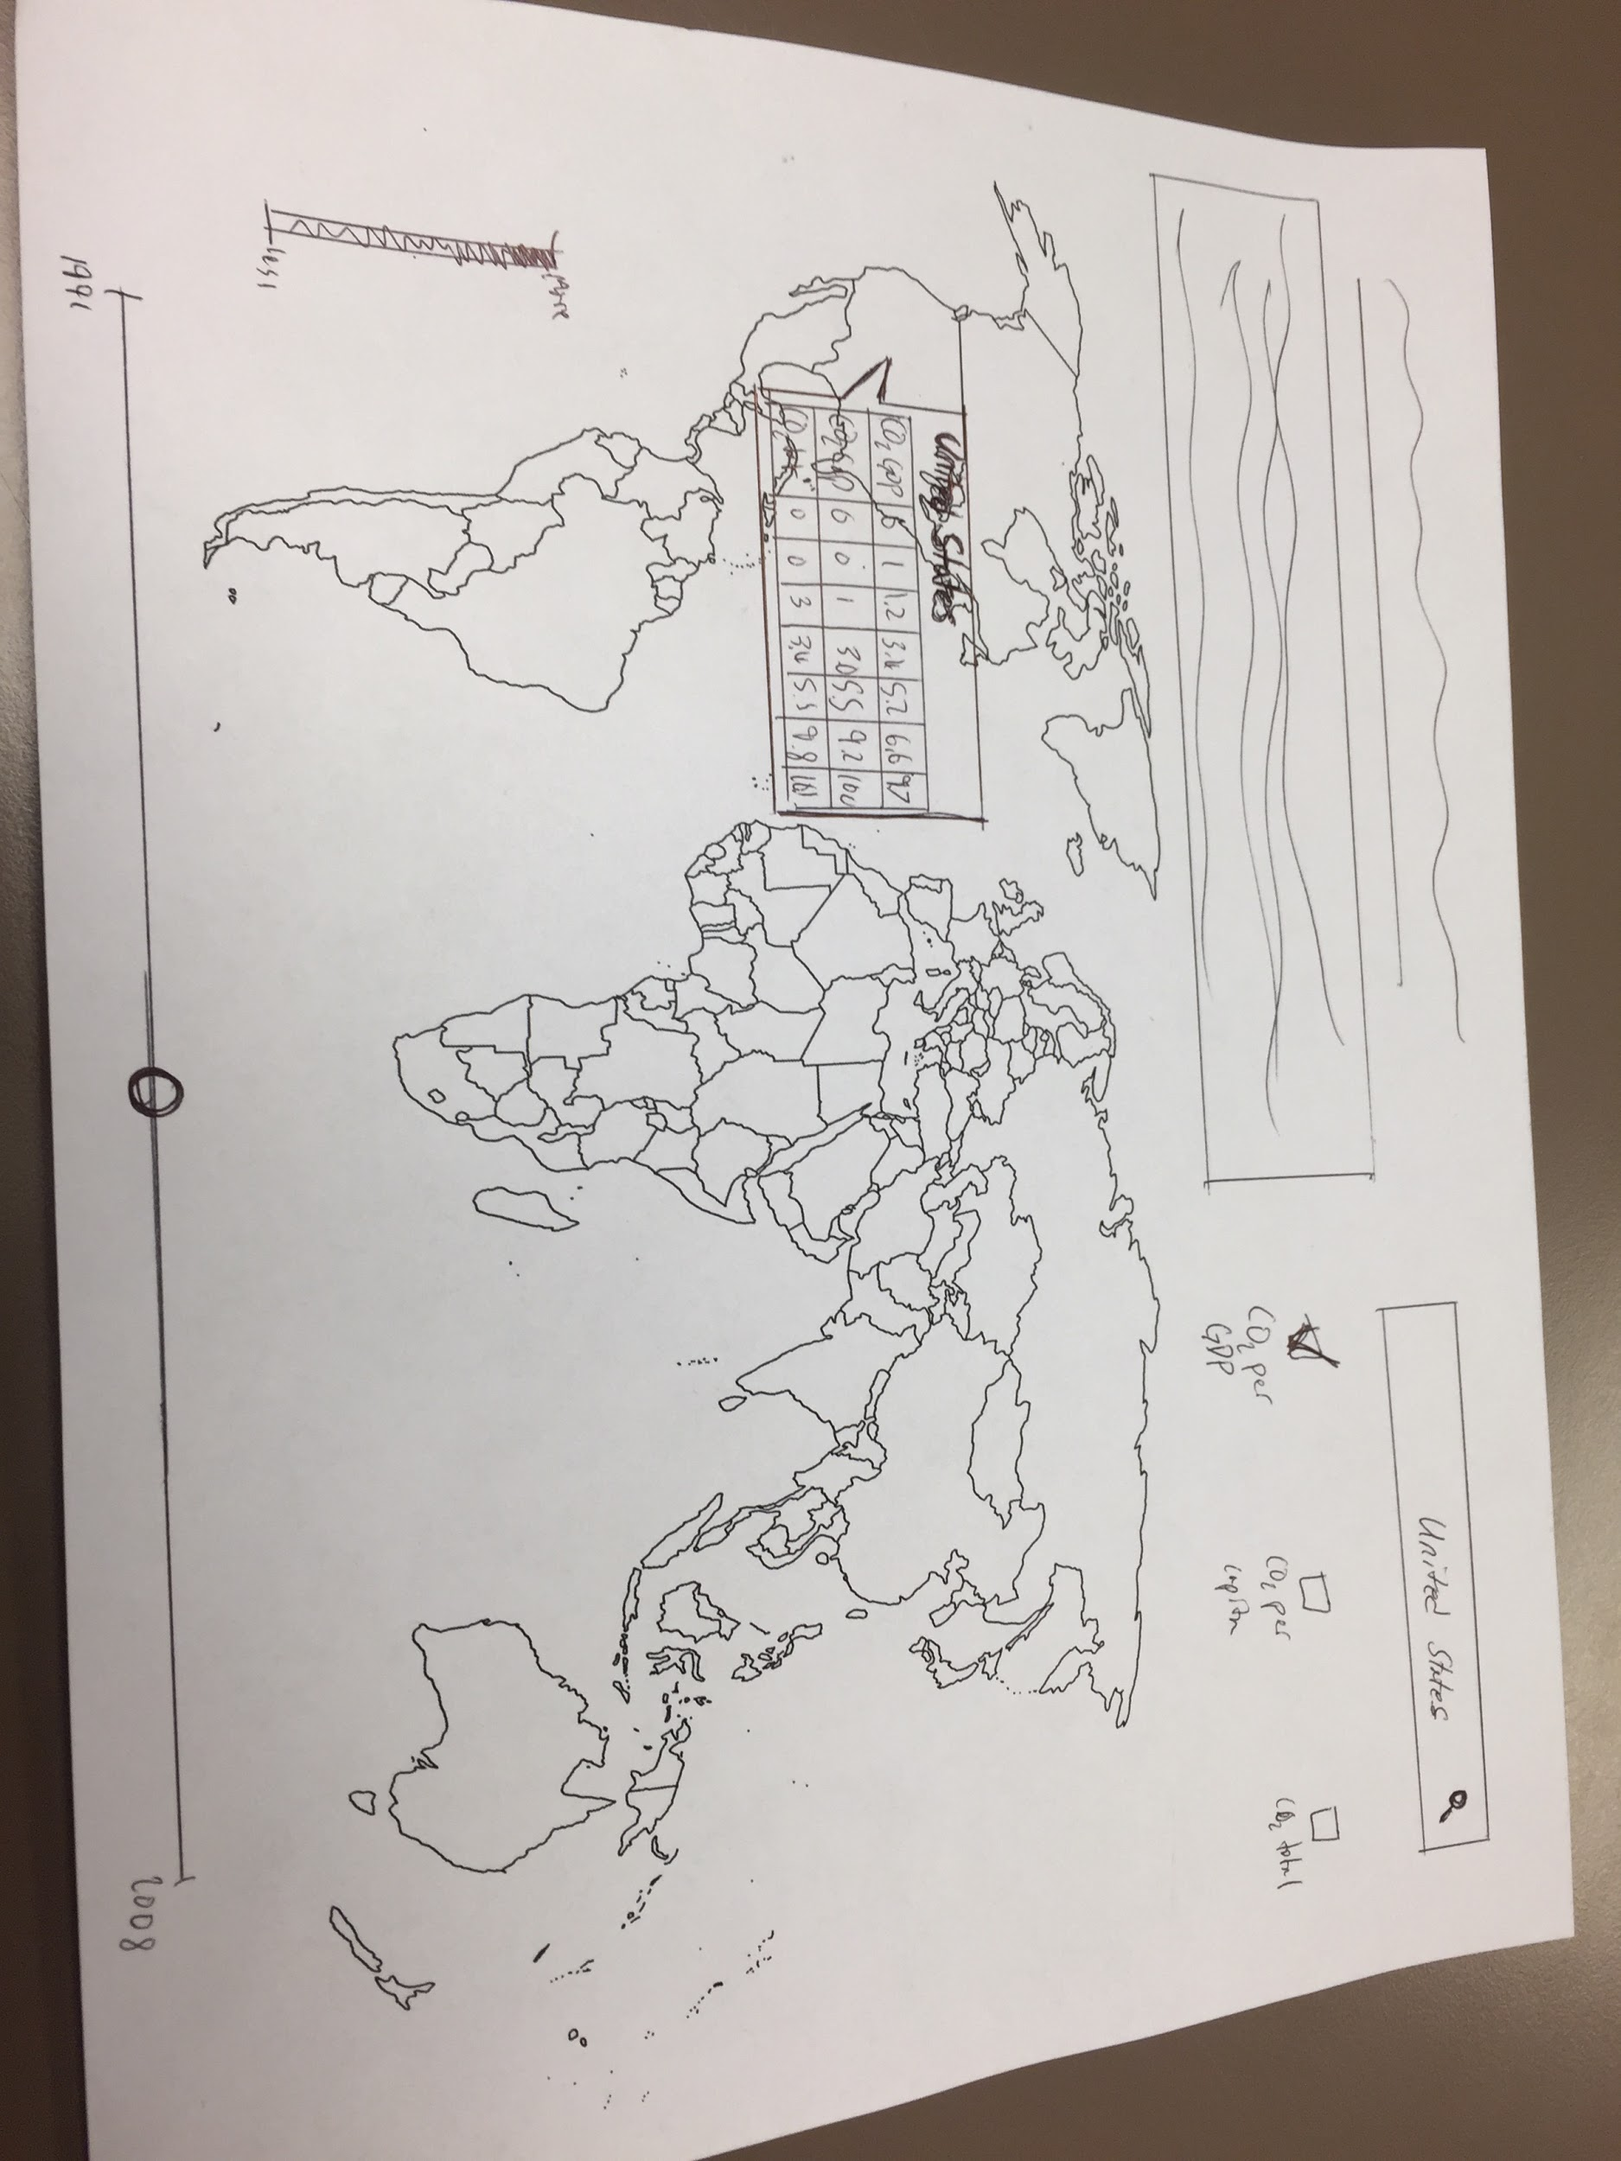

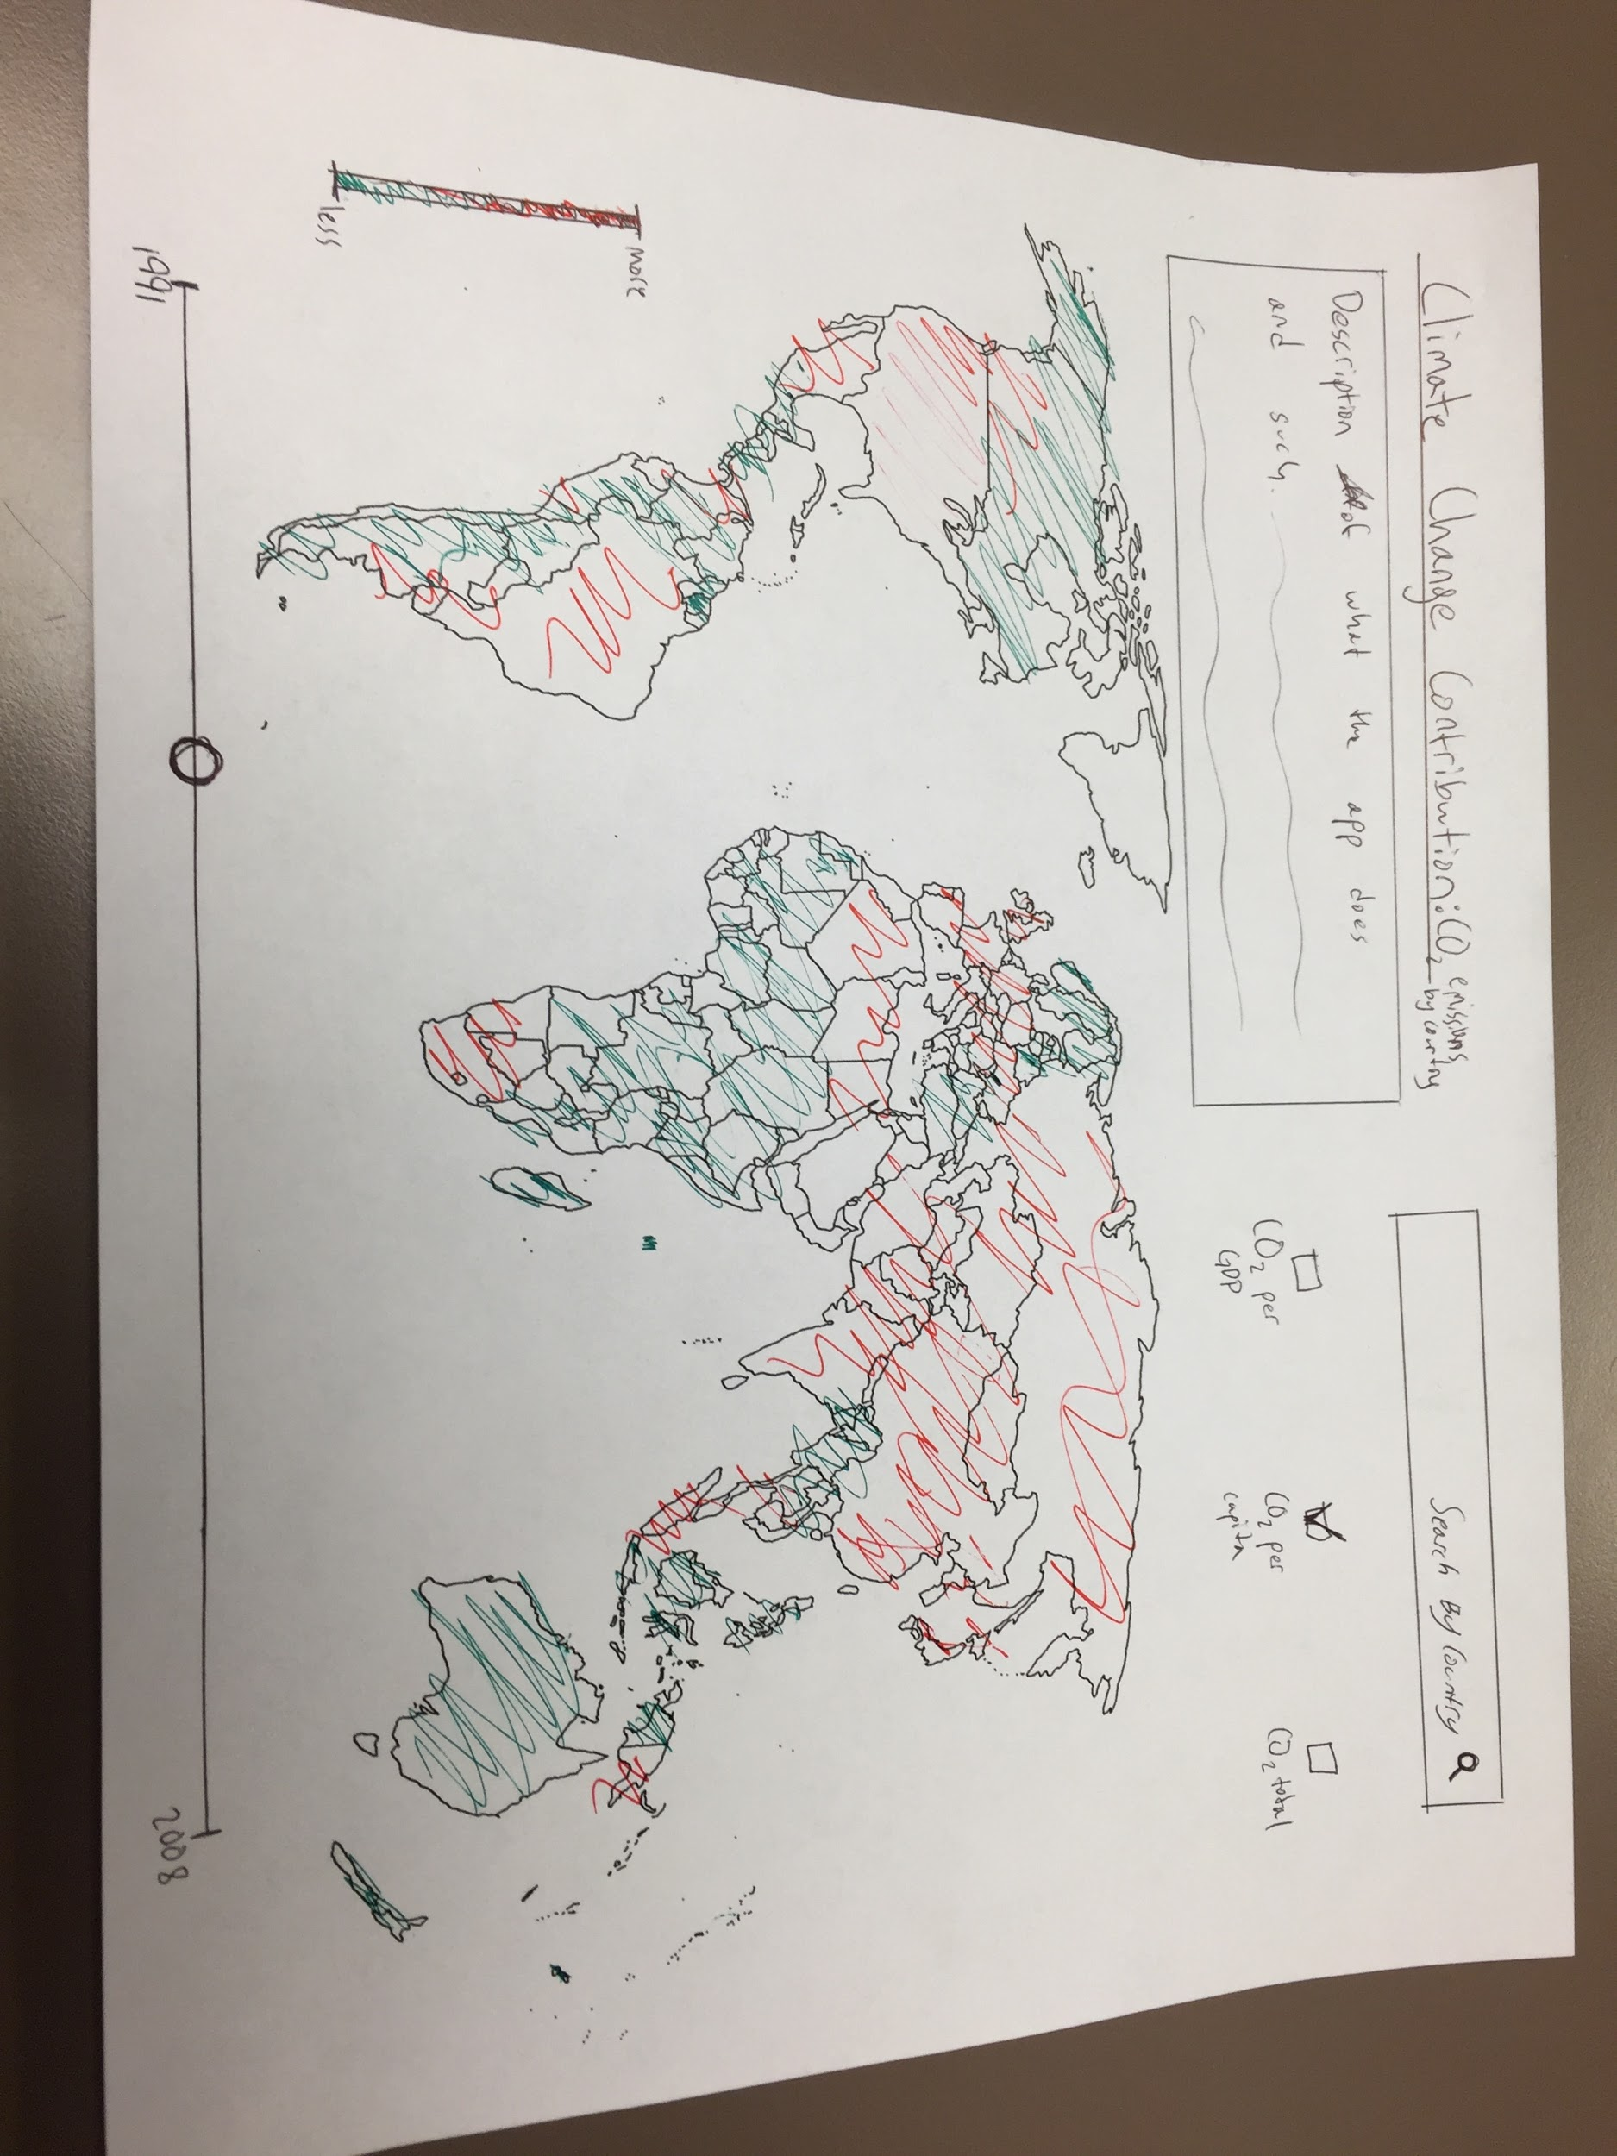

1. http://data.worldbank.org/summary-terms-of-use