Exercise 1
From Infix to Postfix

Exercise 2
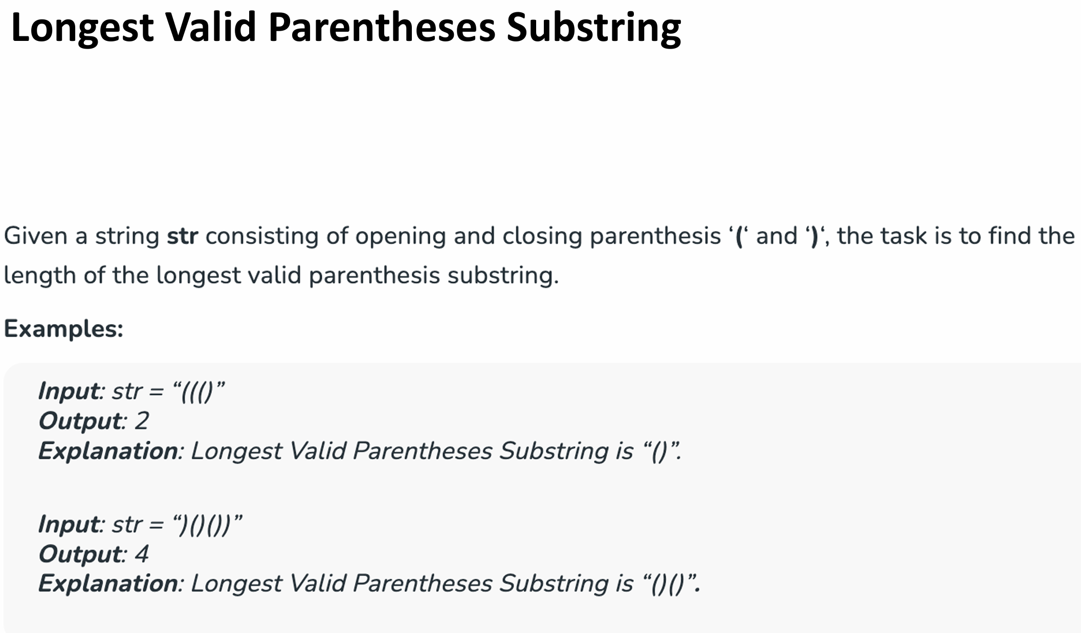
Solution：
// C++ program to find length of the
// longest valid substring

#include <iostream>
#include <stack>
using namespace std;

int maxLength(string s) {
stack<int> st;

// Push -1 as the initial index to
// handle the edge case
st.push(-1);
int maxLen = 0;

// Traverse the string
for (int i = 0; i < s.length(); i++) {

// If we encounter an opening parenthesis,
// push its index
if (s[i] == '(') {
st.push(i);
} else {

// If we encounter a closing parenthesis,
// pop the stack
st.pop();

// If stack is empty, push the current index
// as a base for the next valid substring
if (st.empty()) {
st.push(i);
} else {

// Update maxLength with the current length
// of the valid parentheses substring
maxLen = max(maxLen, i - st.top());
}
}
}

return maxLen;
}

int main() {
string s = ")()())";
cout << maxLength(s) << endl;

return 0;
}

Exercise 3
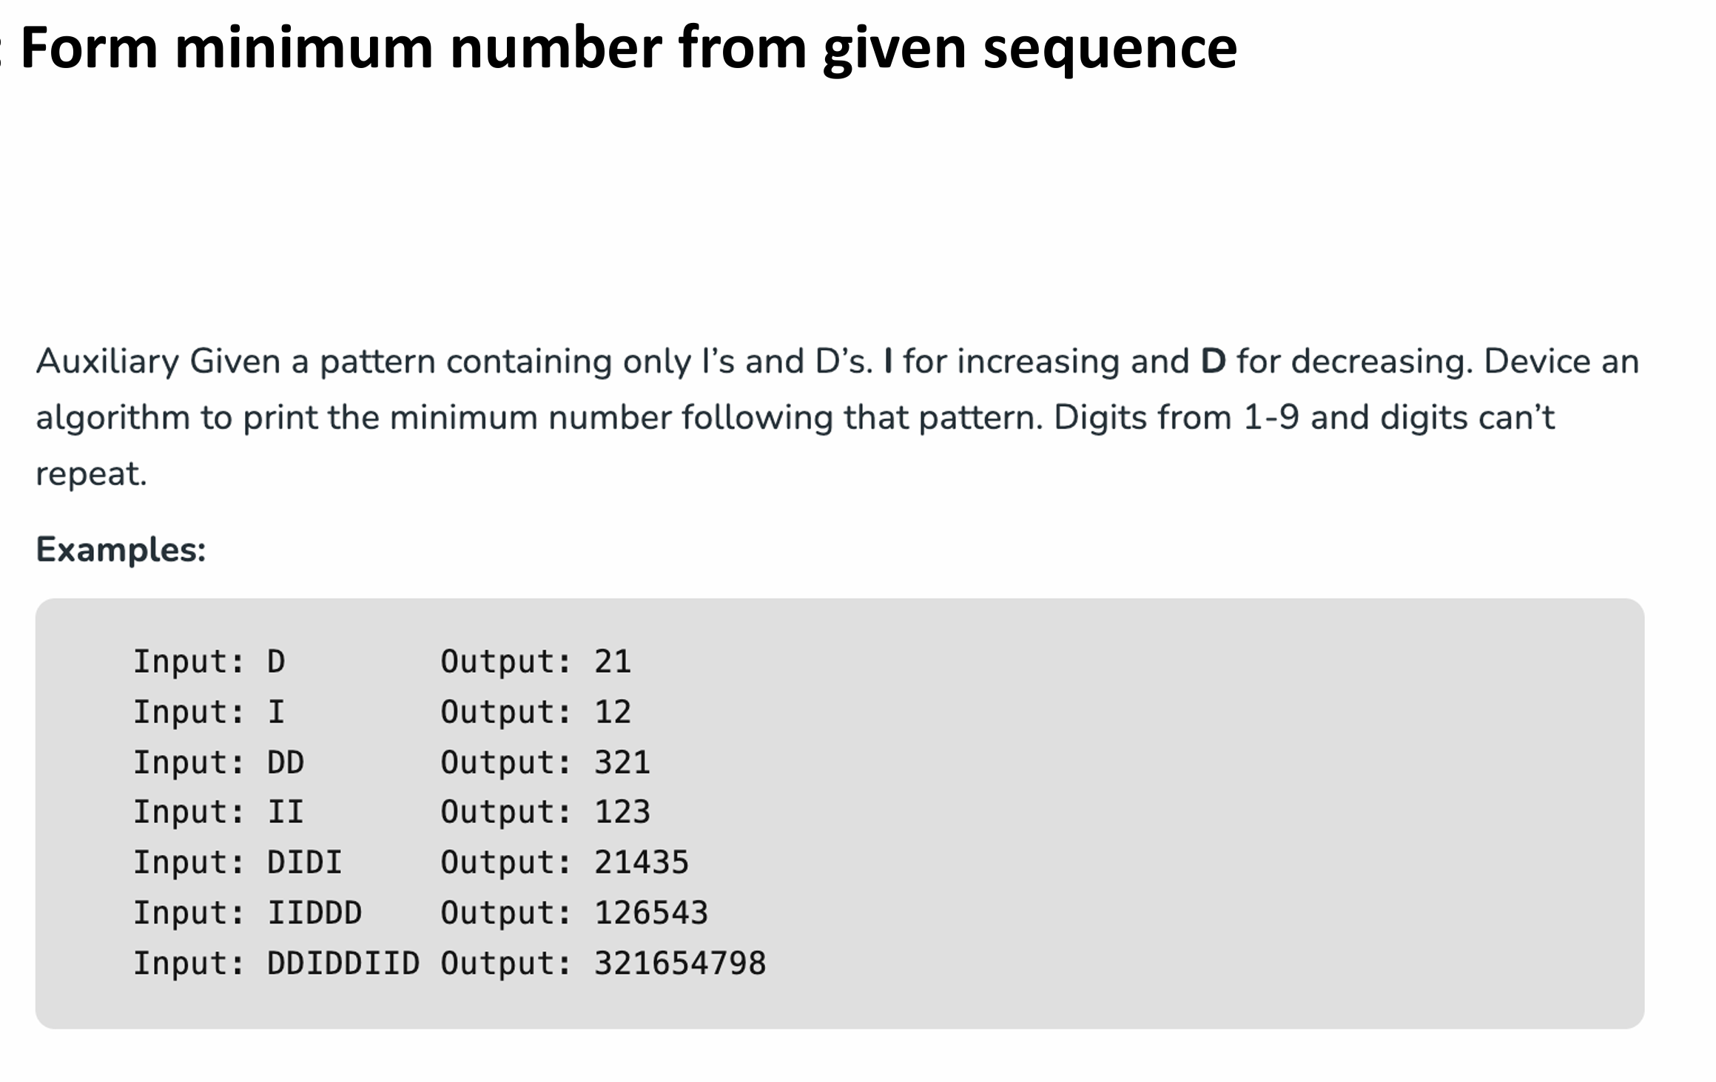
Solution：
// C++ program to print minimum number that can be formed
// from a given sequence of Is and Ds
#include <bits/stdc++.h>
using namespace std;

// Function to decode the given sequence to construct
// minimum number without repeated digits
void PrintMinNumberForPattern(string seq)
{
// result store output string
string result;

// create an empty stack of integers
stack<int> stk;

// run n+1 times where n is length of input sequence
for (int i = 0; i <= seq.length(); i++)
{
// push number i+1 into the stack
stk.push(i + 1);

// if all characters of the input sequence are
// processed or current character is 'I'
// (increasing)
if (i == seq.length() || seq[i] == 'I')
{
// run till stack is empty
while (!stk.empty())
{
// remove top element from the stack and
// add it to solution
result += to_string(stk.top());
result += " ";
stk.pop();
}
}
}

cout << result << endl;
}

// main function
int main()
{
PrintMinNumberForPattern("IDID");
PrintMinNumberForPattern("I");
PrintMinNumberForPattern("DD");
PrintMinNumberForPattern("II");
PrintMinNumberForPattern("DIDI");
PrintMinNumberForPattern("IIDDD");
PrintMinNumberForPattern("DDIDDIID");
return 0;
}

Exercise 4
Longest Valid Parentheses Substring
Problem Statement:
Given a string s, return one of the longest palindromic substring in s.
Example 1:
Input: "babad"
Output: "bab" or "aba"
- Both "bab" and "aba" are valid longest palindromic substrings in the string "babad".
- Example 2:
Input: "cbbd"
Output: "bb"
- The longest palindromic substring in "cbbd" is "bb".

Exercise 5
Shortest Subarray to be Removed to Make Array Sorted
Problem Statement:
Given an integer array arr, remove a subarray (can be empty) from arr such that the remaining elements in arr are non-decreasing. Return the length of the shortest subarray to remove. A subarray is a contiguous subsequence of the array.
Example 1:
Input: arr = [1,2,3,10,4,2,3,5]
Output: 3
Explanation: The shortest subarray we can remove is [10,4,2] of length 3. The remaining elements after that will be [1,2,3,3,5] which are sorted. Another correct solution is to remove the subarray [3,10,4].
Example 2:
Input: arr = [5,4,3,2,1]
Output: 4
Explanation: Since the array is strictly decreasing, we can only keep a single element. Therefore we need to remove a subarray of length 4, either [5,4,3,2] or [4,3,2,1].
Solution：
class Solution {
public:
int findLengthOfShortestSubarray(vector<int>& arr) {
int n = arr.size();
int left = 0, right = n - 1;

// 左边最长非递减前缀
while (left + 1 < n && arr[left] <= arr[left + 1]) ++left;

if (left == n - 1) return 0; // 已经是非递减的

// 右边最长非递减后缀
while (right > 0 && arr[right - 1] <= arr[right]) --right;

int ans = min(n - left - 1, right); // 删除左边或右边

int i = 0, j = right;
while (i <= left && j < n) {
if (arr[i] <= arr[j]) {
ans = min(ans, j - i - 1);
++i;
} else {
++j;
}
}

return ans;
}
};

Exercise 6
Addition and Extraction of the array-based Maxheap.

